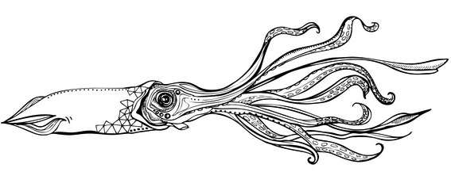 | Quote
Moss Landing Boat Works |  | Date: December 7, 2015
To  7501 Sandholdt Road  Moss Landing, CA 95039  831-633-2417 |  |  | MBARI  Jared Figurski

Boat | Job | Payment Terms | Due Date
Paragon 36’ | Waterline to trim

Qty | Description | Unit Price | Line Total
20 | Sand and prep hull, fill and fair hull scratches, mask for paint | $80.00 | $1600.00
8 | Spray Gelcoat - 2 coats, buff topsides after cure | $80.00 | $640.00
1 | 3M Filler | $63.79 | $63.79
2 | Primer Gallon | $69.99 | $69.99
1 | Gelcoat Gallon | $89.99 | $89.99
1 | High Gloss Additive Gallon | $69.99 | $69.99
1 | Misc Materials (tape, sandpaper, masking, etc.) | $100.00 | $100.00
 |  | Subtotal | $2633.76
 |  | Sales Tax | 0.00
 |  | Total | $2633.76

Quotation prepared by: Andrew Hippert
This is a quotation on the goods named, subject to the conditions noted below:

Thank you for your business!
Moss Landing Boat Works 7501 Sandholdt Rd, Moss Landing, CA 95039 831-633-2417

