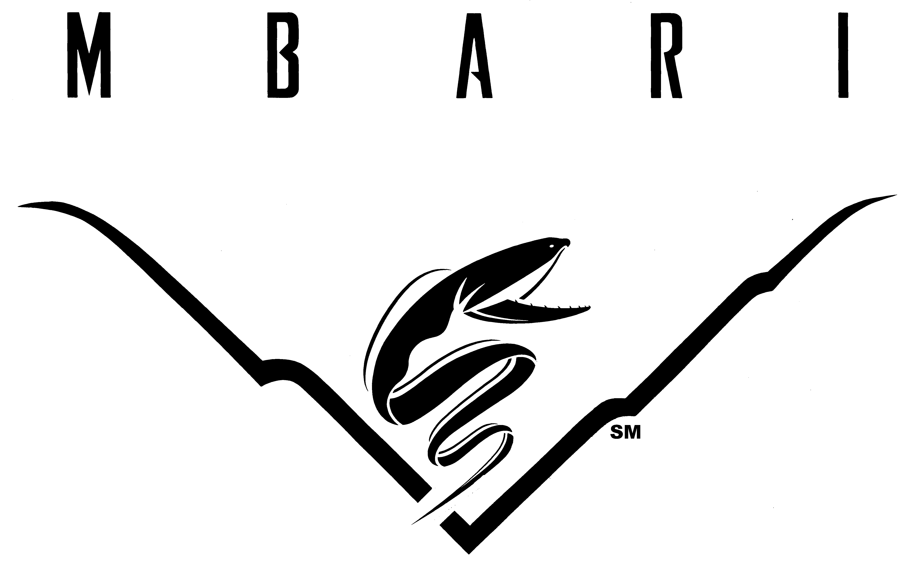

Monterey Bay Aquarium Research Institute
Operator Manual for R/V Paragon

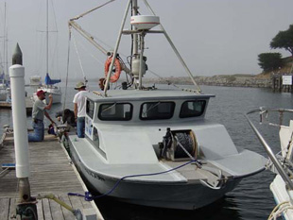

Drafted by Jared Figurski, October 2012

Monterey Bay Aquarium Research Institute

Operator Manual for R/V Paragon

Table of Contents:

I. Overview………………………………………………………………
II. Vessel Description…………………………………………………………………...
1. Specifications………………………………………………………………………………………
2. Engineering Machinery ………………………………………………………………………………
3. Deck Machinery…………………………………………………………………………………………
4. Safety Equipment………………………………………………………………………………………
5. Electronics and Communications………………………………………………………………
III. Operator Requirements…………………………………………………………………………
IV. Pre-cruise and Sign Up Procedure…………………………………………………
V. Allowed Area and Times of Operation………………………
VI. Guidelines for Weather Considerations…………………………………
VII. Safety Guidelines…………………………………………………………………
VIII. Fuel Use Policy………………………………………………………………………
IX. Docking and Vessel Access…………………………………………………………………
- Dock Location…………………………………………………………………………………………
- Vessel Access……………………………………………………………………………………………
X. Operator Violations………………………………………………………………………
XI. Emergency Communication…………………………………………………
- USCG……………………………………………………………………………………………………
- Emergency response…………………………………………………………………
- Vessel Assist…………………………………………………………………………………………
- Recreational Boaters……………………………………………………..
- Moss Landing Harbor…………………………………………………………………………………
- Santa Cruz Harbor……………………………………………………………………………………
- Monterey Harbor………………………………………………………………………………………
XII. MBARI Contact Information…………………………………………………………………
- Steve Etchemendy (Director of Marine Operations) …………………………………
- Jared Figurski (Ocean Observatory Technician) ………………………………………
- Eric Fitzgerald (Dock Foreman/ Deckhand) …………………………………………

I. Overview:

R/V Paragon was purchased from a commercial urchin diver in Oxnard, CA in 2001 by the Partnership for Interdisciplinary Studies of Coastal Oceans (PISCO) at the University of California, Santa Cruz (UCSC). PISCO repowered and customized the vessel for near shore scientific scuba diving and oceanographic research. For ten years it served as a research platform for kelp forest monitoring and process studies, oceanography, and education. In 2012, Dr. Mark Carr of PISCO-UCSC offered to lease the R/V Paragon to MBARI for a minimum of one year. UCSC retains ownership of the vessel during this period and MBARI is responsible for its operation and upkeep. R/V Paragon offers a unique opportunity for MBARI researchers to access near coastal waters reliably, quickly, and inexpensively. This document contains the regulations, requirements and guidelines for the operation of the R/V Paragon.

II. Vessel Description:

1. Specifications:

Official Number: 993613
Make: H & F Boats; Bandon, Oregon
Year:1993
Material: Fiberglass/ Wood
Length: Hull (32 feet), Overall (36 feet)
Tonnage: 10 Gross ton, 8 Net ton
Working Deck Dimensions: 8.5 x 15 feet
Beam: 10 feet
Draft: 3 feet
Overhead Clearance: Mast up (17.5 feet), Mast down (10 feet)
Occupancy: 8 people total
Horsepower: 500 hp (twin 250 hp Yamaha Outboards)
Fuel Capacity: 550 gallons (pairs of 120 gal saddle tanks and 50 and 55 gal aft tanks)
Speed: 25 knots cruising (29 knots max)
Economy: 0.72 nm/gal (@ 5000 rpm (20 kts) to 5800 rpm (29 kts))
Endurance: ~400 nm
Freshwater: ~50 gallons (fiberglass tank, not potable)
Head: Porta Potti

2. Engineering Machinery:

Honda GX340 (11 HP Four Stroke Engine)- powers hydraulics
Vickers Vane Pump (VTM42 60 75 15 MD R1 14)
Capacity: 6.0 US GPM
Controlled Flow: 7.5 US GPM
Relief Pressure: 1500 PSI

3. Deck Machinery:

Deck boom
Operated by hand lines (side to side, up down)
Safe to 500 lb.
Max lifting capacity TBD.
Fitted with 12V electric winch (1500 lb.)
Fitted with 5” hydraulic capstan
Fitted with a 9” hydraulic line pinch (3/4”-1”)
7” Hydraulic Capstan (to 500 lb lift capacity, max lift TBD)
3” Windlass
Hydraulic Anchor Drum (20 pound bruce anchor)
Collapsible mast for restricted overhead situations

4. Safety Equipment:

1 ACR EPIRB (M/N RLB-33 Cat. 1)
UIN: 2DCC3632CCFFBFF
S/N: 6502
8 Type III Stearns work vests
8 Plastic Hard Hats
8 Type I PFD vests
4 Survival Suits (Size Universal Adult)
3 Fire Extinguishers
House
Type A size 1; B-C size 2
Type A size 1; B-C size 10
Aft Compartment
Type A size 1; B-C size 10
Compressed Air Horn
Electric Horn
Flares
3 Handheld
1 Daytime Visual Distress Signal
2 Mirrors
Diver Down Flag
Alpha Flag
First Aid Kit
Throwable Life Ring (Type IV)

5. Electronics and Communications:

12 V starter bank
4 ACDelco M27MF
6 V auxillary bank
4 Westmarine DeepCycle 215 (6 V)
Garmin GPSMAP 4208
Raytheon R 20x Rasterscan
1750 W Xantrex ProWatt Inverter
1000 W Xantrex Sine Wave Inverter (110 V; 60 Hz)
2 VHF radios (IC-M302)
Furuno Color Video Sounder (FCV-292)

III. Operator Requirements:

- All operators must have either taken the Motorboat Operator Certification Course (MOCC) or hold a current USCG certification (OUPV or Master Near Coastal)
- All operators must be checked out on the operation, maintenance, and safety equipment of R/V Paragon
(The MOCC course may cover this if completed on the R/V Paragon)
- Once these criteria are met, operators must receive official authorization by the Director of Marine Operations (DMO)
- Operators must maintain “recency” by operating R/V Paragon at least once in a 6-month period.
- Operators that do not maintain “recency” are not authorized to use R/V Paragon until they have passed a refresher checkout with Jared Figurski or Eric Fitzgerald. Checkouts include a refresher of R/V Paragon systems, updates on changes, and an evaluation of the operator’s ability to operate R/V Paragon from power up to clean up.
- The DMO can revoke an operator’s privileges for any reason (See MBARI Boating Manual for further details)

IV. Pre-cruise and Sign Up Procedure:

- MBARI employees may check for vessel availability on the ship’s calendar and sign it out (Zimbra Calendar: MBARI/Ships/Paragon)
- An authorized operator must be identified
- A pre-cruise plan must be submitted (http://www.mbari.org/dmo/cruise_planning/precruise_postcruise.htm)
- Cruises that exceed the allowable area and time of operation (see section V) require special permission from the DMO
- A float plan must be completed and left in the dock box on the R/V Western Flyer dock. Float plan must indicate date, time of departure, time of return, operator, crew, on-board cell phone and shore contact information.

To avoid delays, it is recommended that a pre-cruise plan be submitted 5 business days in advance of the cruise. For cruises that require special permissions, it is recommended that the pre-cruise plan be submitted 15 business days in advance.

V. Allowed Area and Times of Operation:

R/V Paragon is authorized for general use within the area bounded by Ano Nuevo (N 37.148), to the north, and Point Lobos, to the south (N 36.500), and out 30 nm from shore (nearest distance). Operations that are planned outside of this zone require special permission from the DMO.
R/V Paragon can be operated from sunrise to sunset. Users that desire to run the boat outside of this time frame need to obtain special permission from the DMO in advance.

VI. Guidelines for Weather Considerations:

Good judgment and decisions are the foundation of safety. The first most important decision comes when deciding whether the marine forecast is favorable for operations using the R/V Paragon. MBARI provides some general guidelines below and more detailed regulations in the MBARI Boating Manual, however be advised that it is the responsibility and authority of the operator to cancel or terminate a cruise based on his/her assessment of the marine weather. Hazardous conditions may exist below the thresholds presented here:

Weather Modified Allowable Area of Operation

Full Range: winds <20 kts and swell <12 ft
Inner Bay Only: winds 20-25 kts and swell <12 feet
Advised No Go: winds >25 knots or swell >12 feet

VII. Safety Guidelines:

- A single operator must be identified for any given cruise. If two qualified operators are onboard, it must be decided who is the operator for the day prior to departure.
- The operator is responsible for following safety regulations set forth by the US Coast Guard and MBARI.
- Negligence in adhering to safety regulations may result in the suspension or revocation of operator status for the R/V Paragon and will be decided by the DMO.

VIII. Fuel Use Policy:

- R/V Paragon must be refueled after each cruise when possible
- For operations within the allowable area, typically only saddle tanks will be required (220 gal capacity; ~130 nm endurance).
- If an endurance of >130 nm is anticipated, special permission is required from the DMO. Jared Figurski or Eric Fitzgerald must be consulted about the status of aft fuel tanks and weight distribution before filling.
- Saddletanks are to be refueled to 110 gal in each tank after each trip.
- Fueling can be delayed if and only if:
  - Fuel dock is closed
  - R/V Paragon will be used by the same research group the following day (allowing a single refuel for multiple days of work)
  - An arrangement is made with the next user.
  - It is authorized by the DMO, Jared Figurski, or Eric Fitzgerald
- If R/V Paragon is not fueled and must be done by someone else, the research group is responsible for the cost of the fuel and the operator’s time.

IX. Docking and Access:

1. Dock Location:

Dock space at MBARI is limited and requires coordination to insure that all four research vessels are accommodated. For now, R/V Paragon is docked at one of two locations:
- Northernmost portion of the R/V Western Flyer floating dock. Two positions are safe at any tide:
  - The eastern side of the dock
  - End tied with the mid-ship cleat in line with the northwestern dock cleat. Any further forward and the boat may ground on rocks at a -1 ft tide.
- On E dock (Zephyr dock).

Operators must check with Chris Grech and/or Eric Fitzgerald for instruction on where R/V Paragon should be docked on return. This is required so as not to block the scheduled arrival or departure of other vessels.

2. Vessel Access:

- Operators will be notified of the combination to the door on R/V Paragon.
- In addition, the R/V Paragon door combo and Zephyr dock key will be stored in a safe box mounted just outside and to the right of B247 (Steve Etchemendy’s office)
- Operators will be notified of the combination to the safe box.
- The key for the Zephyr dock must be returned to the safe box.

X. Operator Violations:
To operate the R/V Paragon requires handling skills, good judgment, attention to detail and diligence. First and foremost, an operator is responsible for the safety of those onboard and for the condition of the boat. The privilege to operate R/V Paragon can be suspended or revoked at any point at the discretion of the DMO. Circumstances that warrant review include, but are not limited to:

- Displays of poor boatmanship and/or judgement
- Violations of MBARI safety regulations
- Violations of USCG safety regulations
- Negligence in the upkeep and maintenance of R/V Paragon
- Negligence to properly document cruises and/or report problems

XI. Using R/V Paragon in an Emergency:

R/V Paragon is available for emergency response. Of the MBARI fleet, R/V Paragon is the fastest, requires the least amount of startup time, and if necessary, can be operated with a single operator. R/V Paragon is ideal for time sensitive operations such as locating lost equipment, keeping equipment from washing ashore, delivering/receiving supplies or personnel from R/V Western Flyer and R/V Rachel Carson.

- For permission to use R/V Paragon in an emergency, attempt to contact the DMO first, then Jared Figurski or Eric Fitzgerald (see below for contact information)
- If after hours, call cell phone numbers (see below for contact information).
- R/V Paragon may not be used if permission has not been obtained.
- If dire conditions exist and R/V Paragon is used without permission, all possible avenues to acquire permission must be exhausted. The circumstances will be subject to review by the DMO.
- Jared Figurski and Eric Fitzgerald are pre-authorized for overtime in the event that they are required as operators for emergencies

XII. Emergency Communication:

In the event of an emergency at sea, the operator should take all necessary precautions to stabilize the situation. The operator must then notify appropriate emergency responders and MBARI contacts (listed below) as soon as possible. Many resources are available to assist mariners at sea.

1. US Coast Guard
VHF 16
(415) 399-3300
EPIRB
2. Emergency Response
911
3. Vessel Assist
VHF 16
(800)-391-4869
4. Recreational Boaters
VHF 11
5. Moss Landing Harbor
VHF 16
Office: (831) 633-2461
Nights/Weekends/Emergencies: 831-970-3334
6. Santa Cruz Harbor
VHF 16/9
Office: (831) 475-6161
After Hours: (831) 212-4261
7. Monterey Harbor
VHF 16/5
Office: (831) 646-3950
After Hours: (831) 594-7760

XIII. MBARI Contact Information:

1. Steve Etchemendy (Director of Marine Operations)
Work: (831) 775-1902
Cell: (831) 229-6119
Office: B247
etst@mbari.org

2. Jared Figurski (Ocean Observatory Technician)
Work: (831) 775-1967
Cell: (831) 818-2769
Office: B147, B149, Buoy Assembly Room,
jared@mbari.org

3. Eric Fitzgerald (Dock Foreman/Deckhand)
Work: (831) 775-1934
Cell: (831) 601-1408
Office: B108.23
Pager: efitz-pager@mbari.org
efitzgerald@mbari.org

