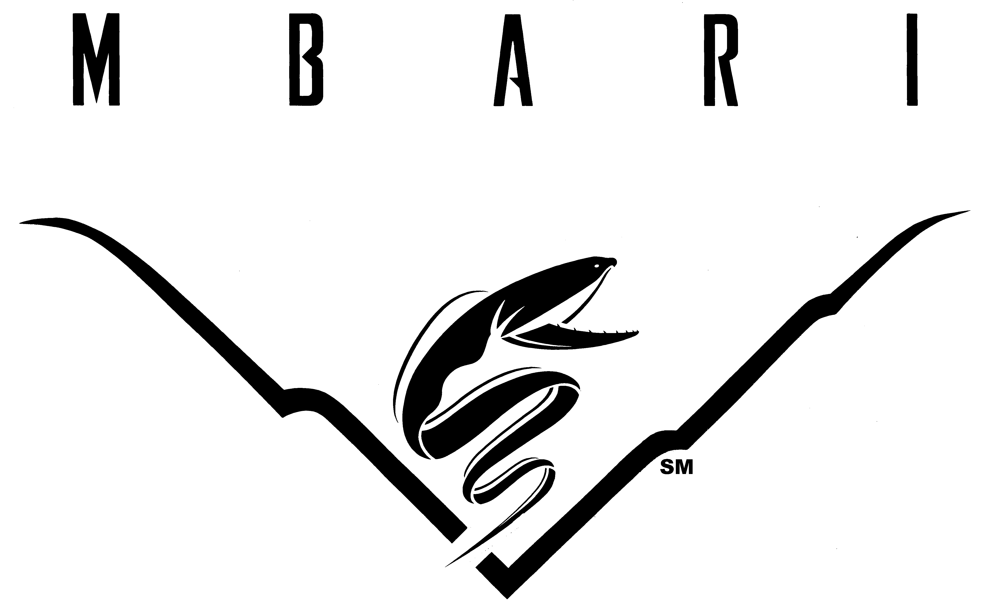

Monterey Bay Aquarium Research Institute
Operator Manual for R/V Paragon

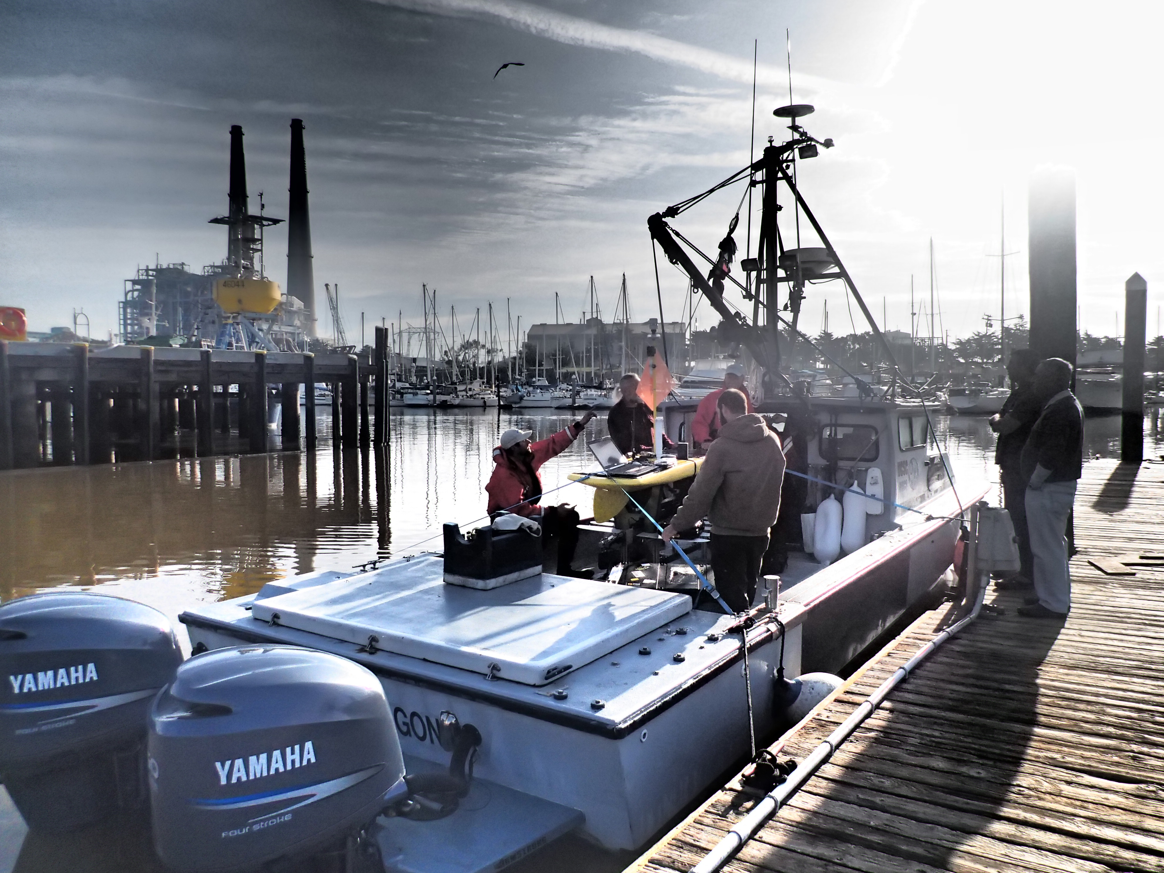

Drafted by Jared Figurski, October 2012
Revision by Jared Figurski March 2016
Revision by Jared Figurski April 2018

Monterey Bay Aquarium Research Institute

Operator Manual for R/V Paragon

Table of Contents:

I. Overview………………………………………………………………………………... 2
II. Vessel Description…………………………………………………………………... 2
1. Specifications…………………………………………………………………………. 2
2. Engineering Machinery.………………………………………………………….. 2
3. Deck Machinery……………………………………………………………………… 3
4. Safety Equipment…………………………………………………….……………... 3
5. Electronics and Communications…………………………………………….. 3
III. Personnel Requirements…………………………………………………………..4
- Operators………………………………………………………………………………...4
- Passengers……………………………………………………………………………… 5
IV-a. Pre-cruise and Sign Up Procedure…………………………………………..5
IV-b. Float Plan………………………………………………………………………………5
V. Allowed Area and Times of Operation………………………………………. 6
VI. Guidelines for Weather Considerations…………………………………...... 7
VII. Safety Guidelines……………………………………………………………….…….. 7
VIII. Fuel Use Policy ...……………………………………………………………………… 8
IX. Docking and Vessel Access..….…………………………………………………… 8
- Dock Location…………………………………………………………….…………… 8
- Vessel Access………………………………………………………………………….. 8
X. Operator Violations…………………………………………………………………... 9
XI. Using R/V Paragon in an Emergency…………………………………………. 9
XII. Emergency Communication…………………………………………………..…. 9
- USCG……………………………………………………………………………………… 10
- Emergency response………………………………………………………………. 10
- Vessel Assist………………………………………………………………...………… 10
- Recreational Boaters……………………………………………………………….10
- Moss Landing Harbor……………………………………………………………... 10
- Santa Cruz Harbor………………………………………………………………….. 10
- Monterey Harbor…………………………………………………………………… 10
XIII. MBARI Contact Information………………………………………………………10
- Steve Etchemendy (Director of Marine Operations) ………………… 10
- Jared Figurski (Ocean Observatory Technician) ……………………… 10
- Eric Fitzgerald (Dock Foreman/ Deckhand).……………………………. 11
- Teresa Cardoza (Logistics Support Specialist)…………………………..11

I. Overview:

R/V Paragon was purchased from a commercial urchin diver in Oxnard, CA in 2001 by the Partnership for Interdisciplinary Studies of Coastal Oceans (PISCO) at the University of California, Santa Cruz (UCSC). PISCO repowered and customized the vessel for near shore scientific scuba diving and oceanographic research. For ten years it served as a research platform for kelp forest monitoring and process studies, oceanography, and education. In 2012, Dr. Mark Carr of PISCO-UCSC offered to loan R/V Paragon to MBARI for a minimum of one year. In 2013, the loan agreement was extended for an additional 5 years. UCSC retains ownership of the vessel during this period and MBARI is responsible for its operation and upkeep. R/V Paragon offers a unique opportunity for MBARI researchers to access near coastal waters reliably, quickly, and inexpensively. This document contains the regulations, requirements and guidelines for the operation of the R/V Paragon.

II. Vessel Description:

1. Specifications:

Official Number: 993613
Make: H & F Boats; Bandon, Oregon
Year Built: 1993
Material: Fiberglass/ Wood
Length: Hull (32 feet), Overall (36 feet)
Tonnage: 10 Gross ton, 8 Net ton
Working Deck Dimensions: 8.5 x 15 feet
Beam: 10 feet
Draft: 3 feet
Overhead Clearance: Mast up (21.5 feet), Mast down (10 feet)
Occupancy: 8 people total
Horsepower: 700 hp (twin F350 hp Yamaha Outboards)
Fuel Capacity: 550 gallons (pairs of 120 gal saddle tanks and 50 and 55 gal aft tanks)
Speed: 25-32 knots cruising (40 knots max)
Economy: 0.8 – 0.9 nm/gal (@ 4200 rpm (23 kts) to 4900 rpm (32 kts))
Endurance: ~400 nm
Freshwater: ~50 gallons (fiberglass tank, not potable)
Head: Porta-Potti

2. Engineering Machinery:

Honda GX390 (11.7 HP Four Stroke Engine)- powers hydraulics
Pressure Compensated Pump (VTM42 60 75 15 MD R1 14)
Capacity: 8.0 US GPM
Relief Pressure: 1500 PSI

3. Deck Machinery:

Deck boom
Operated by hand lines (side to side, up down)
Max lifting capacity 500 lbs. (static)
Fitted with 12V WARN DC1000 electric hoist (1000 lb.)
Fitted with 5” hydraulic capstan
Fitted with a 9” hydraulic line pinch (3/4”-1”)
7” Hydraulic Capstan (to 500 lb lift capacity, max lift TBD)
3” Windlass
Hydraulic Anchor Drum (20 pound bruce anchor)
Canon Digi-Troll 10 (for light use to 800’)
Collapsible mast for restricted overhead situations
Gunwale-mounted pole for acoustic instrumentation
Launch and Recovery cradle (LARS) for LRAUV
Deck plate with 12” centers

4. Safety Equipment:

1 ACR EPIRB (M/N RLB-33 Cat. 1)
UIN: 2DCC7 528B0 FFBFF
S/N: 6502
SPOT emergency beacon
Garmin AIS 600 Class B (viewable on MarineTraffic.com & ODSS)
Fireboy CO monitor
8 Type III Stearns work vests
4 Plastic Hard Hats
8 Type I PFD vests
8 Survival Suits (Size Universal Adult)
2 Fire Extinguishers (Type B-I)
Compressed Air Horn
Electric Horn
Flares
3 Hand Flares
1 SOLAS Red Hand Flare
4 Aerial Flares
1 Daytime Visual Distress Signal
2 Mirrors
Diver Down Flag
Alpha Flag
First Aid Kit
Throwable Life Ring (Type IV)
Throwable Life Sling (Type IV)
Throw rope
Recovery cargo net
First Aid Kit
Automated external defibrillator (AED)
Ditch Bag
Handheld VHF radio (6 Watt Boost)
2 Emergency Strobes
1 Solas Orange Floating Smoke Signal
1 Solas Red Hand Flare
8 Emergency Blankets
16 pints of water
Snack bars

5. Electronics and Communications:

12 V starter bank batteries
4 AC Delco M27MF
6 V auxiliary bank batteries
4 Westmarine Heavy Duty Deep Cycle 230Ah (6 V)
Garmin GPSMAP 7612xsv
Garmin GPSMAP 7608xsv
Garmin B265LH (Traditional Chirp Transducer)
Garmin GT51M-THP (Down-vu and Side-vu Chirp transducer)
Garmin Marine Heading Sensor (010-11417-00)
Garmin GMR24 xHD Radome
3000 W Xantrex ProWatt Inverter
1000 W Xantrex Sine Wave Inverter (110 V; 60 Hz)
1 VHF radios (IC-M302)
1 Garmin VHF 200 NMEA 2000 – allows Digital Selective Calling and SOS
Sterling Power ProCharge Ultra (12V)
12v Power port (Scotty/Marinco) – Port is female

III. Requirements for Personnel:

1) Operators

- All operators must have either taken the Motorboat Operator Certification Course (MOTC) or hold a current USCG certification (OUPV or Master Near Coastal)
- All operators must maintain current First Aid/CPR/AED and Blood-Borne Pathogen training.
- All operators must be checked out by Jared Figurski on the operation, maintenance, and safety equipment of R/V Paragon
(The MOTC course may cover this if completed on the R/V Paragon)
- Once these criteria are met, operators must receive official authorization by the Director of the Department of Marine Operations (DMO)
- Operators must maintain “recency” by operating R/V Paragon at least once in a 6-month period.
- Operators who do not maintain “recency” are not authorized to use R/V Paragon until they have passed a refresher checkout with Jared Figurski. Checkouts include a refresher of R/V Paragon systems, updates on changes, and an evaluation of the operator’s ability to operate R/V Paragon from power up to clean up.

2) Passengers

- All passengers must be 18 years or older due to insurance requirements.
- Non-MBARI employees are required to fill out a Visiting Participants Release Form and Medical History Form. Hard copies are provided on the boat and an electronic version is available on the R/V Paragon home page. These forms must be deposited in the manifest box prior to departure.

IV-a. Pre-cruise and Sign Up Procedure:

- MBARI employees may check for vessel availability on the ship’s calendar (Zimbra Calendar: MBARI/Ships/Paragon). Only DMO administration and Jared Figurski can update the calendar.
- An authorized operator must be identified
- A pre-cruise plan must be submitted. Refer to “Cruise Planning” on the R/V Paragon home page
- Remember the max load is 8 people.
- Any participants that are not MBARI staff must sign the Visiting Participants Release Form and Medical History Form. This is an absolute requirement and violations may result in revocation of the operator’s status as a R/V Paragon Captain.
- Cruises that exceed the allowable area, or time of operation (see section V) require special permission from the Director or Deputy director of DMO.

To avoid delays, it is recommended that a pre-cruise plan be submitted 5 business days in advance of the cruise. For cruises that require special permissions, it is recommended that the pre-cruise plan be submitted 15 business days in advance.

IV-b. Float Plan
A float plan is a list of critical information about each operation and is left ashore. The float plan can be used by anyone to quickly determine who the standing shore contact is and also to learn pertinent information about the operation. It is especially important should the R/V Paragon be in distress, unresponsive and need support from the USCG or other rescue outfit.
The shore contact is responsible for alerting authorities should the vessel be both late for its indicated time of return and unresponsive by cell and/or VHF.

- A float plan must be completed and left in the Manifest Box located on the MBARI dock prior to every operation (i.e., each time the vessel leaves the harbor). Float plan forms can be found aboard the R/V Paragon and can be printed from the R/V Paragon home page.

A float plan must include:
    - Date
    - Time of departure
    - Time of return
    - Name of operator
    - Names of crew
    - On-board cell phone number
    - Name of shore contact
    - Phone number of shore contact

- Shore contacts must satisfy the following criteria
  - Must be MBARI employees.
  - Must be accessible by phone throughout the duration of the operation.
  - Must be made aware of:
    - Details of the operation
      - Time of return
      - Number of people aboard
      - On-board cell phone number
      - Approximate route of the operation
    - Location of the float plan.
    - Procedure to follow should the R/V Paragon be late and unresponsive. Instructions for shore contacts can be found on the vessel and on the R/V Paragon home page.
  - Must acknowledge that they agree to serve as shore contact for each operation.

V. Allowed Area and Times of Operation:

R/V Paragon is authorized for general use within the area bounded by Año Nuevo (N 37.148), to the north, and Point Lobos, to the south (N 36.500), and out 30 nm from shore (nearest distance). Operations that are planned outside of this zone require special permission from the Director of DMO.
Normal operating times for the R/V Paragon are from sunrise to sunset on normal MBARI business days (Mon – Fri) including off Fridays, but excluding officially recognized MBARI holidays. Operators who desire to run the boat outside of this time frame need to obtain special permission from the Director of DMO in advance.

VI. Guidelines for Weather Considerations:

Good judgment and decisions are the foundation of safety. The first most important decision comes when deciding whether the marine forecast is favorable for operations using the R/V Paragon. MBARI provides some general guidelines below, however be advised that it is the responsibility and authority of the operator to cancel or terminate a cruise based on his/her assessment of the marine weather. Hazardous conditions may exist below the thresholds presented here:

Weather Modified Allowable Area of Operation

Full Range: winds <20 kts and swell <12 ft
Inner Bay Only: winds 20-25 kts and swell <12 feet
Advised No Go: winds >25 knots or swell >12 feet

VII. Safety Guidelines:

- A single operator must be identified for any given cruise. If two qualified operators are onboard, it must be decided prior to departure who the operator is for the day.
- Of the MBARI fleet, R/V Paragon is the fastest, requires the least amount of startup time, and if necessary, can be operated with a single operator, however unless absolutely necessary (See section XI.) at least two people shall be on board during operations for safety reasons.
- When being used for diving or mooring maintenance a certified operator is required to stay with the boat, therefore this may require two certified operators on board if one is going to dive or get on the mooring for maintenance.
- The R/V Paragon is limited to eight persons on board. Of that number, one person must be a certified operator and aboard at all times.
- When the vessel is underway everyone outside the R/V Paragon cabin must have a work vest on. For scuba diving operations a wet suit is a viable alternative for a work vest.
- All scuba diving missions require permission from Kim Reisenbichler, the MBARI diving officer.
- The operator is responsible for following safety regulations set forth by the US Coast Guard and MBARI.
- Negligence in adhering to safety regulations may result in the suspension or revocation of operator status for the R/V Paragon as decided by the Director of DMO.

VIII. Fuel Use Policy:

- R/V Paragon must be refueled after each cruise whenever possible. Use your MBARI credit card and code the fuel cost to 367000 5350 Supplies Fuel, DMO.
- For operations within the allowable area, typically only saddle tanks will be required (220 gal capacity; ~130 nm endurance).
- If an endurance of >130 nm is anticipated, special permission is required from the Director of DMO. Jared Figurski must be consulted about the status of aft fuel tanks and weight distribution before filling.
- Saddle tanks are to be refueled to 100 gal in each tank when onboard fuel drops below 100 gallons.
- Fueling can be delayed if and only if:
  - Fuel dock is closed
  - R/V Paragon will be used by the same project group the following day (allowing a single refuel for multiple days of work).
  - An arrangement is made with the next user.
  - It is authorized by Jared Figurski.
- If R/V Paragon is not fueled and must be done by someone else, the project group is responsible for the operator’s time.

IX. Docking and Access:

1. Dock Location:

Dock space at MBARI is limited and requires coordination to insure that all four research vessels are accommodated. For now, R/V Paragon is docked at one of two locations:
- R/V Western Flyer floating dock. The R/V Western Flyer cannot enter or depart the slip with the R/V Paragon moored. Operators must confirm that the R/V Western Flyer is not scheduled to transit to or from her berth before mooring to the floating dock.
  - Consult the Zimbra calendar for the ship’s schedule
  - Consult with Chris Grech, Eric Fitzgerald or Jared Figurski

- On E dock (Zephyr dock). R/V Paragon must be tied as far west as possible to allow R/V Rachel Carson to enter her slip.

2. Vessel Access:

- Operators will be notified of the combination to the door on R/V Paragon.
- In addition, the R/V Paragon door combo and Zephyr dock key will be stored in a safe box mounted just outside and to the right of B247.
- Operators will be notified of the combination to the safe box.
- The key for the Zephyr dock must be returned to the safe box.

X. Operator Violations:
To operate the R/V Paragon requires handling skills, good judgment, attention to detail and diligence. First and foremost, an operator is responsible for the safety of those onboard and for the condition of the boat. The privilege to operate R/V Paragon can be suspended or revoked at any point at the discretion of the Director of DMO. Circumstances that warrant review include, but are not limited to:

- Displays of poor boatmanship and/or judgment
- Violations of MBARI safety regulations
- Violations of USCG safety regulations
- Negligence in the upkeep and maintenance of R/V Paragon
- Negligence to properly document cruises and/or report problems

XI. Using R/V Paragon in an Emergency:

R/V Paragon can be used to respond to an emergency (defined as a situation requiring the R/V Paragon that cannot wait until normal operating times (see Section V.)) Of the MBARI fleet, R/V Paragon is the fastest, requires the least amount of startup time, and if necessary, can be operated with a single operator. R/V Paragon is ideal for time sensitive operations such as locating lost equipment, keeping equipment from washing ashore, delivering/receiving supplies or personnel from R/V Western Flyer and R/V Rachel Carson.

- For permission to use R/V Paragon in an emergency, attempt to contact the Director or Deputy Director of DMO first, Jared Figurski, and Eric Fitzgerald in this order (see below for contact information).
- If after hours, call cell phone numbers (see below for contact information).
- R/V Paragon may not be used if permission has not been obtained.
- If dire conditions exist and R/V Paragon is used without permission, all possible avenues to acquire permission must be exhausted. The circumstances will be subject to review by the Director of DMO.
- Jared Figurski and Eric Fitzgerald are pre-authorized for overtime in the event that they are required as operators for emergencies.

XII. Emergency Communication:

In the event of an emergency at sea, the operator should take all necessary precautions to stabilize the situation. The operator must then notify appropriate emergency responders and MBARI contacts (listed below) as soon as possible. Many resources are available to assist mariners at sea.

1. US Coast Guard
VHF 16
(415) 399-3300
EPIRB
DSC SOS
2. Emergency Response
911
3. Vessel Assist
VHF 16
(800)-391-4869
4. Recreational Boaters
VHF 11
5. Moss Landing Harbor
VHF 16
Office: (831) 633-2461
Nights/Weekends/Emergencies: 831-970-3334
6. Santa Cruz Harbor
VHF 16/9
Office: (831) 475-6161
After Hours: (831) 212-4261
7. Monterey Harbor
VHF 16/5
Office: (831) 646-3950
After Hours: (831) 594-7760

XIII. MBARI Contact Information:

1. Michael Kelly (Director of Marine Operations)
Work: (831) 775-1902
Cell: (973) 452-5203
Office: B247
mkelly@mbari.org

2. Chris Grech (Deputy Director of Marine Operations)
Work: (831) 775-1909
Cell: (831) 917-0303
Office: B241
grch@mbari.org

3. Jared Figurski (Ocean Observatory Technician)
Work: (831) 775-1967
Cell: (831) 818-2769
Office: B147, B149, Buoy Assembly Room,
jared@mbari.org

4. Eric Fitzgerald (Dock Foreman/Deckhand)
Work: (831) 775-1934
Cell: (831) 601-1408
Office: B108.23
Pager: efitz-pager@mbari.org
efitzgerald@mbari.org

5. Teresa Cardoza (Logistics Support Specialist)
Work: (831) 775-1933
Office: B239.05
terri@mbari.org

