Measurement of hull of R/V Paragon:
François Cazenave - 08/01/2017
Basic measurements of the hull of the Paragon were made while it was out of the water. The drawing below shows a cross section of the hull and the 4 locations (A, B, C, D) where the height relative to the ground was measured, every 3ft from the back of the boat. Measurements are shown in the table below (in inches).
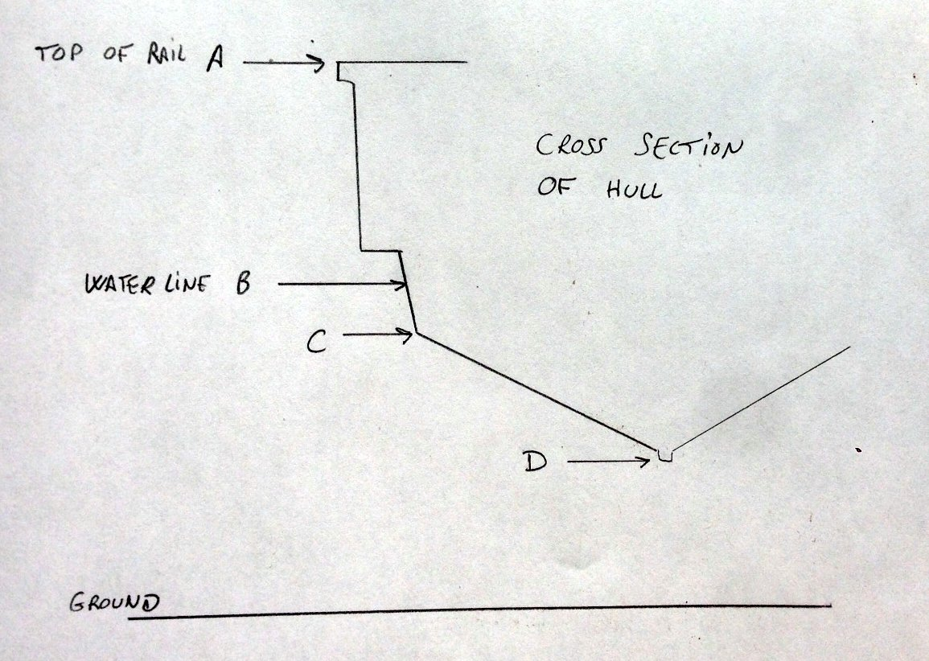
Distance from back (ft) | A | B | C | D
0 | 78 | 53 | 48 | 30.5
3 | 79 | 53 | 48.5 | 29.5
6 | 80 | 53 | 49 | 27.5
9 | 81 | 53 | 49.5 | 26.5
12 | 82 | 53 | 50 | 24.5
15 | 82 | 53 | 51.5 | 24
18 | 82 | 53 | 52.5 | 24.5
21 | 83 | 53 | 54 | 29
24 | 84 | 53 | 56 | 38.5
27 | 85 | 53 | 59 | 51
30 | 85 |  | 60.5 | 71

