ADDITIVE MANUFACTURING OF HYDROSTATIC PRESSURE CASES
MBARI Technical Report xxxx
May 2015
Jon Erickson
Farley Shane
Jim Scholfield

Introduction
The goal of this project was to investigate the production of plastic pressure cases for under water use using additive manufacturing techniques.
Additive manufacturing, involves repetitively placing layers of base material and support material to develop the accurate shape of the object to be produced. Ideally, the additive build should require no additional machining operations to finish the part.
In this particular instance, the build required two separate parts; the pressure case itself, and the end cap with an o-ring groove to provide a water tight seal.
The questions to be pursued, were:
- What material was to be used? This in turn governed, or limited the manufacturing process.
- What stress levels could be achieved and consequently what Safety Factors were necessary.
- What were the long term loading limits based on material creep.
- What were the effects of loading rate on failure pressures.
The project evolved into four parts.
The first part involved theoretical calculations designed to bound the yield stress values and displacement, as well as, possible buckling failure modes based on the given case dimensions.
The second part involved materials characterization. The testing of standard coupons of the material to determine the real differences in mechanical properties based on build orientation, machine resolution, and direction of loading (tensile or compressive).
Thirdly, a pressure testing program was initiated, consisting of multiple duplicate cases pressurized to a series of test pressures to span the short term high load tests ending in failure, and long term lower stress tests for creep.
Finally, an attempt was made to produce a Finite Element Model of the test case, using “real” material properties. These “real” material properties were generated from the materials characterization testing done previously. The model test results were then compared to the real world pressure tests conducted previously. These FEA material properties could then be used for modeling any parts to be designed with this material.

Background
The availability of commercial rapid-prototyping (RP) systems has permitted MBARI to acquire two machines and employ them with a focus on the unique issues encountered in ocean technology. The RP technology has its’ origins as a technique used to reduce the extensive time required for tooling in the process of producing product prototypes. Fundamentally, a 3D object is created in a CAD program where the object is then defined as a series of horizontal slices. The object is re-created one slice at a time starting from the bottom to the top. The initial intent of RP was to quickly create a three-dimensional object that could be used to determine manufacturability, evaluate aesthetics, make quick modifications, acquire dimensional data, and finally to create injection molds for high production consumer items. The utility of the item made by the actual RP process was only as a step in the process of creating the final product. The first RP process and still the most popular is the use of stereolithography (SL or SLA (the “A” is for apparatus)). This method uses a photo reactive resin, a vertically moving platform, and a UV laser. The laser defines an area on the surface of the resin which causes the resin to harden. The platform incrementally moves down where the process is repeated until the object is completed. Although this method gives a very good surface finish, it is very slow and a structure must be added as part of the build process to support the item as each layer is cured.
This form of rapid-prototyping or alternately Additive Manufacturing (AM) eliminates the machining of bulk materials and the consequent waste in the form of chips. Since the machines run independent of an operator/machinist, they eliminate a significant part of the labor expense of producing finished parts.
Among the subsequent developments for rapid-prototyping (RP) is Fused Deposition Modeling (FDM). FDM was commercialized by Stratasys in 1990 and is the second most popular process. Prior experience with additive manufacturing materials both in-house at MBARI and from outside vendors had shown that parts made from Fused Deposition Modeling (FDM) materials were not one hundred percent dense. This made them porous to sea water in the surface voids and anecdotally made them weaker.
The alternative materials available here at MBARI, were the SLA PolyJet type materials. The specific material available for our Projet machine and the one we had the most experience with was VisiJet M3 Crystal. As excerpted from ProJet 3500 SD & HD Professional 3D Printers, the advertised material properties are listed in Table 1. This material and process yields a part which has good strength and very low porosity.
For hydrostatic pressure cases, in any given material, the maximum stresses and therefore the depth limits are governed by the interior dimensions and wall thickness. In this instance, the dimensions were chosen to satisfy the requirements of another project internal to MBARI. For the assembly print with dimensions, see RP_Case_Assem, Fig. 1.

Theoretical Considerations
With the interior pressure case dimensions fixed, the initial pressure case calculations were done with MBARI calculation tools and the results checked with the software package “Under Pressure” from Deep Sea Power and Light. Note that all these calculations are based on the formulas from “Roark’s Formulas for Stress & Strain”, Sixth edition. The Tables and Case numbers listed are specific to the Sixth Edition, and will be different for subsequent editions.
The calculations for the tube of the pressure case uses Roark & Young, Table 32 “Formulas for thick-walled vessels under internal and external loading,” Case 1d “Uniform external pressure in all directions; ends capped.” See Page ?, and Fig. ?, for Under Pressure.
The blind end of the case design uses Table 24, Case 10b, “Solid circular plate Fixed support; uniformly distributed pressure from r₀ to a.” In this case, the “r₀” dimension is zero. The fixed support is required as there are moments generated in the joint between the tube and the blind end.
The end cap design is sized using Table 24, Case 10a, “Solid circular plate simply supported; uniformly distributed pressure from r₀ to a.” Again the “r₀” dimension is zero. There was no closure mechanism or restraint holding the end cap when assembled onto the end of the tube. See Fig. 1, thus leaving the tab or shoulder free to rotate.
The thickness (t) of the blind case end and the end cap were chosen to produce a higher failure value than the thick wall tube calculation.
For a full listing of the MBARI calculations, see Appendix “A”.
Using the published VisiJet materials Tensile Strength properties (6120psi) in these calculations produces a Thick Wall Yield Failure at 1,704 psi. hydrostatic pressure (1166m). This is a Hoop stress failure not Von Mises stress. Under Pressure ignores the Von Mises stress values (Max Equiv. Stress) for all plastic materials, and we followed suit using the Hoop Stress as the failure criteria. This is a conservative approach.
At a later date after the materials testing was completed, a second set of calculations was done using the measured compressive yield strength instead of the published ultimate tensile strength number (7,321 psi. vs. 6,120 psi.) This calculation yielded a Thick Wall Yield Failure at 2,037 psi. hydrostatic pressure (1395m). Since under hydrostatic loading, the pressure case is everywhere in compression, this should more accurately reflect the true stresses in the material.

Materials Testing
The mechanical material properties for the VisiJet M3 Crystal material were determined using standard ASTM materials testing procedures.
Tensile Tests:
Tensile tests were done based on ASTM D638-10 Standard Test Method for Tensile Properties of Plastics. These “Dog Bone” tests were conducted by an outside testing firm to assure consistency of procedure. The “Dog Bone” specimens were manufactured on a 3d Systems ProJet 3500 machine in the following resolutions:
- UHD, 750 x 750 x 890 DPI (x,y,z), 29 micron layers
- XHD, 750 x 750 x 1600 DPI (x,y,z), 16 micron layers
As noted in the construction print (Fig.3), there were two “build” directions specified in an attempt to capture differences in the material properties based on the build (additive) direction. The XHD resolution build only allowed for a horizontal orientation, build direction #1, based on the machines’ limitations.
Table #2 shows the tensile strength at Break and Yield as well as the Tangent Modulus for each test specimen. The graphs for each specimen test are shown in Appendix “B”, (pp’s 46 – 48). The UHD resolution build produced specimens that were noticeably softer and more flexible than specimens produced in the XHD resolution. This is reflected in the soft slopes of the stress-strain curves and the lack of a discernable yield point (pp’s 46-47). Similarly, the build direction had a significant effect on the Tangent modulus. With the build direction and tensile test direction the same, the tangent modulus was reduce to as much as five-eights’ of the maximum values.
Compressive Tests:
Since, for our application of a hydrostatic pressure case, the material making up the case is everywhere in compression. An additional set of tests were run with specimens in compression.
These Compression tests were done based on ASTM D695-10 Standard Test Method for Compressive Properties of Rigid Plastics. These “cube” tests were conducted by an outside testing firm to assure consistency of procedure. As noted on the construction print (Fig. 4), there was only one build direction specified, as the cubes could be tested in any orientation to capture differences in the material properties based on the build (additive) direction. Based on the previous tensile tests, only one build resolution, XHD, was used, as the UHD was shown to be significantly weaker in all directions. The tests were conducted at a vendor selected 0.05 inch per minute speed.
Table #3 shows the compressive strength at yield and at fifty percent deflection (defined as failure) as well as the Compressive Modulus for both testing directions (sign side down and sign on the side). The graphs for each specimen test are shown in Appendix “B”, (pp’s 49 – 51).

Discussion:
For the tensile test series, looking at the averaged values of each of the UHD builds, there is a twenty-four percent difference in Breaking Strength based on the build direction, Dir. #1 – 4333 psi. vs. Dir. #2 – 3498 psi. Where the X-Y horizontal direction, normal to the build direction, is stronger. The curves for the UHD build resolutions do not produce enough of a slope break for the testing firm to pick a yield stress. Anecdotally the UHD build specimens were significantly softer and more flexible than the XHD specimens. In addition, the higher resolution XHD specimens were another twenty-four percent stronger than the UHD specimens for the same build orientation, XHD – 5360 psi. vs. UHD – 4333 psi.
Looking at the averaged values for each compressive test series, there are virtually no differences in Yield Strength based on build direction, and all the test values are thirty-six percent higher than the tensile strengths in the same build resolutions, XHD – 7321 psi. compressive vs. XHD – 5360 psi. tensile.
Additional Compressive Tests:
Based on subsequent pressure testing of pressure tight cases of this material, additional compressive tests were done at a reduced rate, or speed, in an attempt to simulate the loading rates available for our pressure testing equipment at MBARI. These tests were conducted at a cross head speed of .02 inch per minute as opposed to the initial tests of .05 inch per minute. The attached table (Table #4), shows an insignificant difference in average compressive yield strength between the two testing speeds, 7321 psi. vs. 7201 psi.

Finite Element Analysis
A Finite Element Model of the test case was created using “real” material properties. These “real” material properties were generated from the materials characterization testing done previously. The model test results were then compared to the real world pressure tests conducted previously. These FEA material properties could then be used for modeling any parts to be designed with this material.
Coupon test data values (average compressive strength at yield and Average Compressive Modulus) from the .05 inch / minute compressive tests were imported into the SolidWorks Material Properties (See Fig. 5) as linear elastic properties, and used as the basis for a FEA linear static stress analysis. Referring to Fig. 6, in comparison with the Under Pressure analytical calculations, SolidWorks Simulation produced an inner wall stress of 7528 psi at a hydrostatic pressure of 2393 psi. This compares to 2044 psi. hydrostatic pressure, yielding a predicted thick wall failure at a hoop stress of 7,322 psi. in the analytical calculations.
It is to be expected, that using the same material properties numbers in an analytical calculation and a Finite Element model should produce the similar results. This is the case with both the static stress analysis results as well as the displacement results. The displacement results shown in Fig.7 are the radial displacement values with respect to the cylindrical axis. Compare this to the radial displacement values generated by Under Pressure in figure 2
For comparison purposes, both a linear buckling analysis using the linear compressive material properties, and a non-linear buckling analysis were also run in SolidWorks Simulation.
The linear buckling analysis produced a first mode buckling failure at 1,721 psi. which is considerably lower than the thick wall failure value and thus obviously irrelevant.
For the non-linear buckling analysis the coupon test data in the form of the tensile and compressive graphs, 3Horiz-XHD_R5, pp.47, and CompSide_R6, pp.49, respectively, were digitized into data tables and the tables imported into SolidWorks Material Properties Editor as a non-linear material. The resulting stress strain curve is shown in Fig. 8.
The resulting non-linear analysis produced a non-linear response curve showing a distinct bend into non-linear distortion at 2250 psi. hydrostatic pressure. This is well above the thick wall failure value. See Fig. 9.

Pressure Tests
Additive manufacturing models of the required pressure case were fabricated on the ProJet machine in the VisiJet M3 Crystal material. Since the materials testing demonstrated that the material strength was orthotropic based on build direction, these cases were manufactured in the two possible build directions. First with the cylindrical axis parallel to the build direction (z), see Fig. 10, in which vertical striations along the case wall are clearly visible. Second with the build direction across the diameter with the case axis in a horizontal (x-y) direction, see Fig.11, the surface finish left by the wax support material is clearly visible on the lower half.
The pressure cases were blind end tubes closed with an end cap and single radial o-ring. One of the major advantages of this type manufacturing, is that no additional operations were necessary to finish the parts. Once the parts were removed from the machine and cleaned, the o-ring was installed and the cases assembled. See the assembly print (Fig. 1).
Tables #5-6-7 tabulate all the pressure tests and values in the discussion below.
The initial pressure test, labeled (H0), was conducted at an unknown pressurization rate to failure. Failure occurred at 3,350 psi. hydrostatic pressure, equivalent to a Hoop Stress at the inner surface of the cylinder of 12,040 psi., or twice the vendors rated tensile strength.
The first test of the subsequent test series (H1,V1) was conducted at 300 psi. per minute to failure. Failure for the horizontal build item occurred at 3,100 psi. hydrostatic pressure, equivalent to a Hoop Stress in the cylinder of 11,140 psi. The vertical build item was slightly higher at 3,200 psi. hydrostatic pressure, equivalent to a Hoop Stress in the cylinder of 11,500 psi.
The second, third and fourth test series (H2, V2, H3, V3, H4, V4) were conducted at 1000 psi per minute to 2,200 psi., then 100 psi. per minute to failure. The resulting failure pressures show an average value of 2,740 psi hydrostatic for the horizontal build and 2,910 psi hydrostatic for the vertical build. (Tables #5&6).
Subsequent pressure tests (H5, H1C-H4C) pursued the long term loading/creep performance of this material. The pressurization rate of all five tests articles was 1000 psi per minute to test pressure and held to failure (Table #6).
Notice that the H4C test was run at 2000 psi. hydrostatic, equivalent to a hoop stress of 7188psi.. very nearly equal to the tested compressive yield strength of the material.
The graph shows this as H3C

Discussion
Referring to the graph in Fig. 12. This graph plots the failure stresses as hoop stress against the hydrostatic pressure at failure. Clearly the slower application of pressure yielded lower failure values. Our initial pressure testing plotted here, appeared to show a progression in failure based on the rate of applied loading, but once the lab compression tests are included this is less clear. See Fig. 13.
In this graph, the hydrostatic pressures at failure are plotted for each test. Included in this graph are the Von Mises stresses calculated from the initial pressurization rates / per minute, i.e. 300 psi/min and 1000 psi/min. This was done to allow the inclusion of the compression tests which were run at .05 and .02 inches /per minute or 6688 and 3828 psi/min over the initial linear range of the material.
It is not clear, that the uni-axial stresses from coupon tests and the hoop stresses from the real article testing can be related.
Finally, the graph in Fig 14, plots all failure pressures against time.
Clearly, lower pressures produce longer times to failure.
Obviously there were not enough vertical build unit tests to extend the failure curve out along the flattening portion of the curve at long time periods. But from the horizontal build items, it would appear that the curve never really becomes flat.
The hook or fall-off at the end of the horizontal build curve may be a softening of the plastic due to absorption of the oil it was immersed in during test. No pressure tests were done in water to assess the possible differences and no attempts were made to seal the surface of the M3 crystal material to prevent any absorption.

Conclusions
Vendor published material properties appear to be averaged numbers between the tensile and compressive test values.
Coupon tests may not yield the same results as real world item tests.
Choice of stress values at failure or failure conditions, i.e. buckling failures etc. may not reflect real world conditions. Using the Under Pressure failure criteria of 1/10 the yield stress may be overly conservative in the other direction. Other direction?
The slower application of pressure yields lower failure pressure values. This is presumed to be due to material creep under load.
Lower working pressures extend the time to failure, but there appears to be no reasonable infinite life value.
FEA results are only as good as the material properties values. In our case the tested material properties, specifically compressive stress at failure, did not match the real item failure values. If this is the case, the FEA derived failure stress will not match the real item failures.

References
Young, Warren C. “Roark’s formulas for stress and strain,” Sixth Ed., McGraw-Hill Pub., 1989.

FIGURES

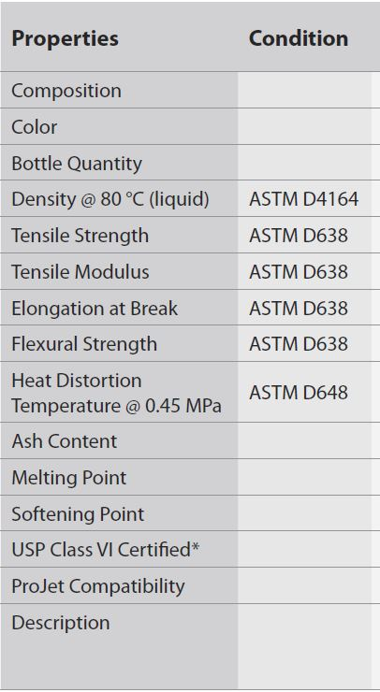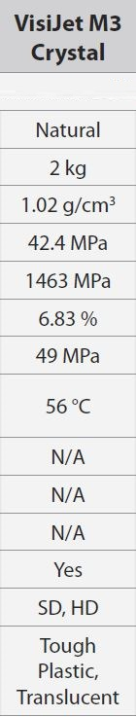
Table 1

Figure 1
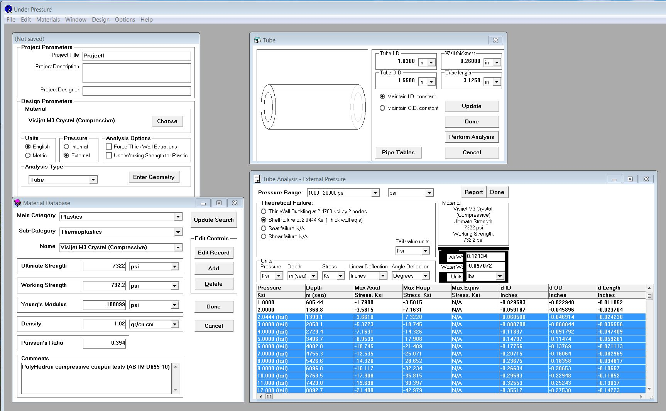Figure 2

Figure 3
Table 2

Figure 4

Table 3
Table 4

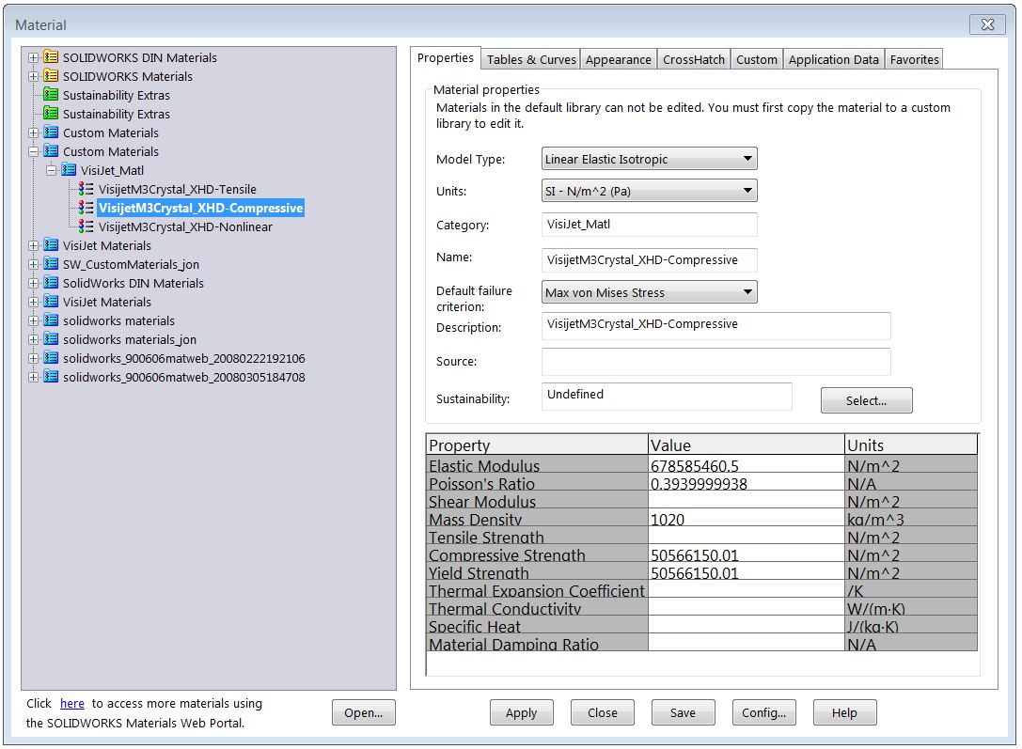
Figure 5 Visijet M3 Crystal SolidWorks Linear Material Properties

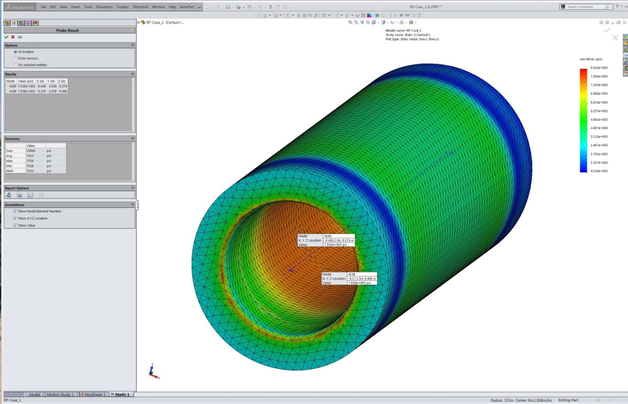
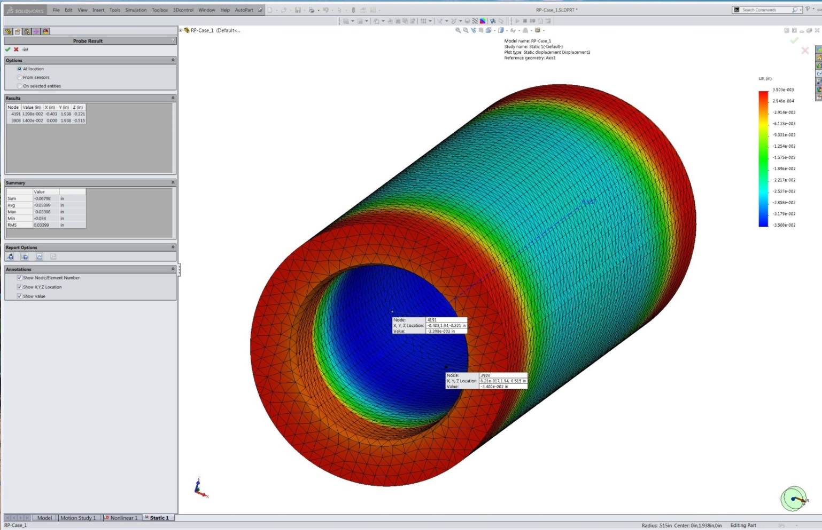
Figure 6
Figure 7

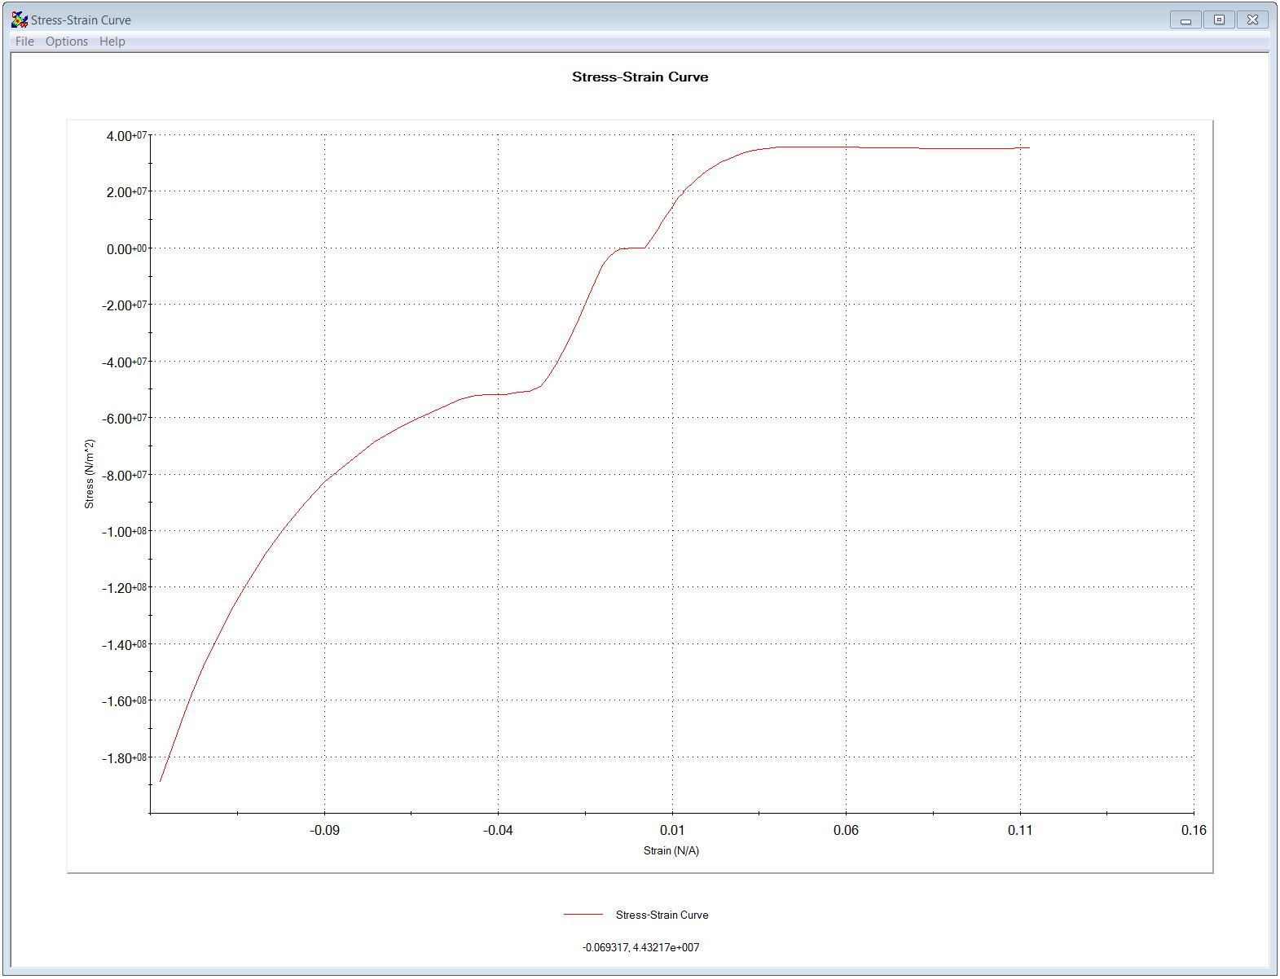
Figure 8 SolidWorks FEA Stress-Strain Curve from Coupon Test Data.

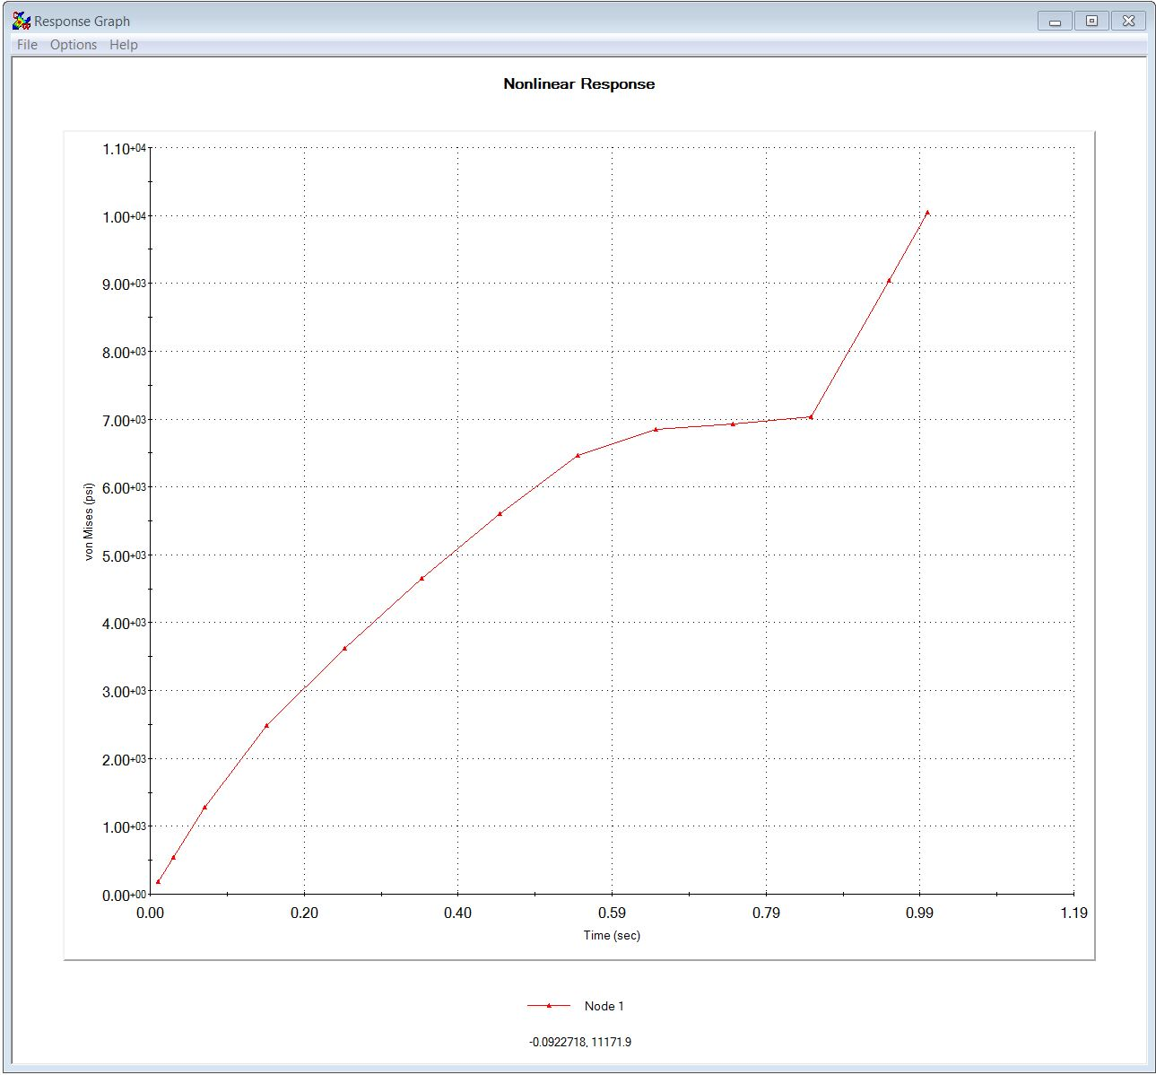
Figure 9 SolidWorks FEA Model Non-linear Response Curve

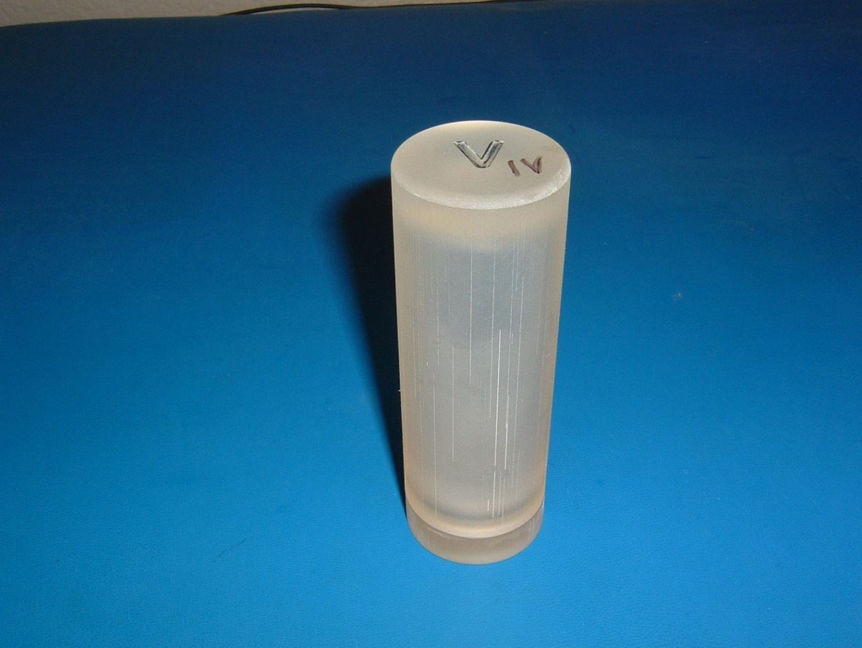
Figure 10 Visijet Case Vertical Build.

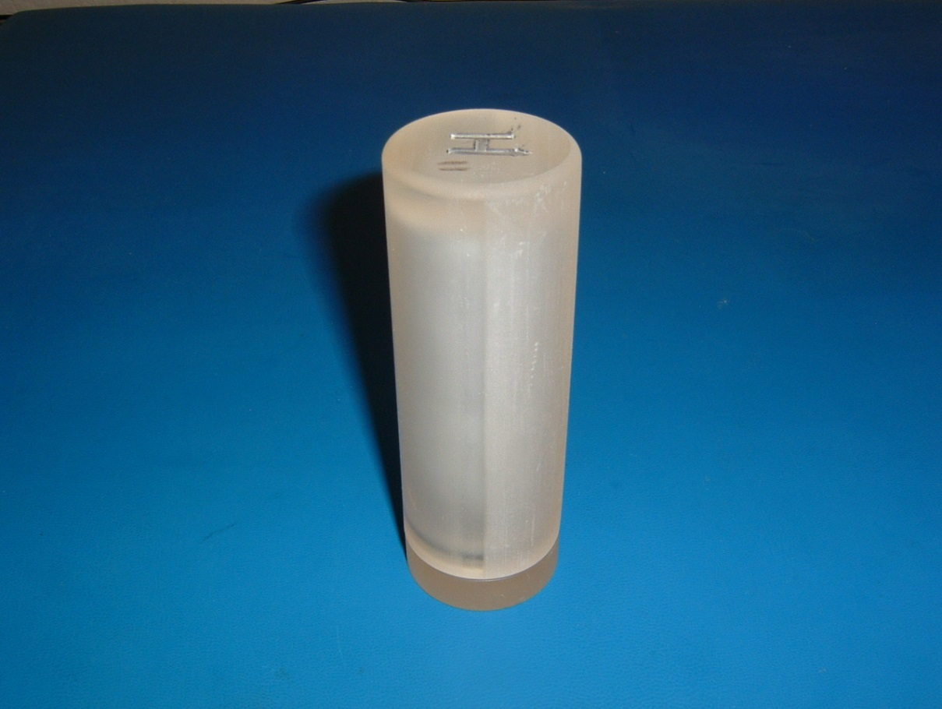
Figure 11 Visijet Case Horizontal Build.

3D PRINTED VISIJET M3 CRYSTAL-TEST CYLINDERS PRESSURE TEST DATA

 | CAMTAG Horiz. Build
Test No. | Label | Failure Press. (psi) | VonMises Stress (psi) | Hoop Stress (psi) | Loading Rate (psi/min) | Time to Failure (Min.)
0 | H0 | 3350 | 10423 | 12040 | UNK | UNK
Table 5
 | Horiz. Build
Test No. | Label | Failure Press. (psi) | VonMises Stress (psi) | Hoop Stress (psi) | Loading Rate (psi/min) | Time to Failure (Min.)
1 | H1 | 3100 | 9646 | 11140 | 300 | 10.3
2 | H2 | 2760 | 8587 | 9916 | 1000/100 | 7.8
3 | H3 | 2750 | 8556 | 9879 | 1000/100 | 7.7
4 | H4 | 2710 | 8433 | 9738 | 1000/100 | 7.3
5 | H5 | 2250 | 7002 | 8085 | 1000 | 19.5
6 | H3C | 2000 | 6225 | 7188 | 1000 | 960
7 | H4C | 1700 | 5289 | 6107 | 1000 | 7860
8 | H2C | 1600 | 4980 | 5750 | 1000 | 12600
9 | H1C | 1500 | 4666 | 5388 | 1000 | 15000
Table 6
 | Vert. Build
Test No. | Label | Failure Press. (psi) | VonMises Stress (psi) | Hoop Stress (psi) | Loading Rate (psi/min) | Time to Failure (Min.)
1 | V1 | 3200 | 9955 | 11500 | 300 | 10.7
2 | V2 | 2930 | 9114 | 10520 | 1000/100 | 9.5
3 | V3 | 2930 | 9114 | 10520 | 1000/100 | 9.5
4 | V4 | 2870 | 8928 | 10310 | 1000/100 | 8.9
Table 7
NOTE: | test 1 @ 300 psi/min = 933 VM stress / min
 | Test 2-4 @ 1000psi/min to 2200 psi = 3112 VM stress/min then 100 psi/min to failure = 311 VM stress/min
 | Test 5-9 @ 1000psi/min to test pressure & hold

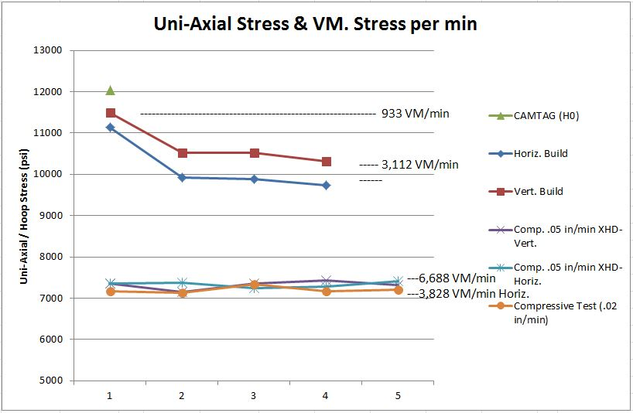
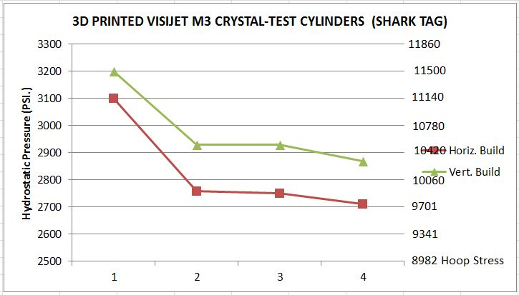
Figure 12

Figure 13
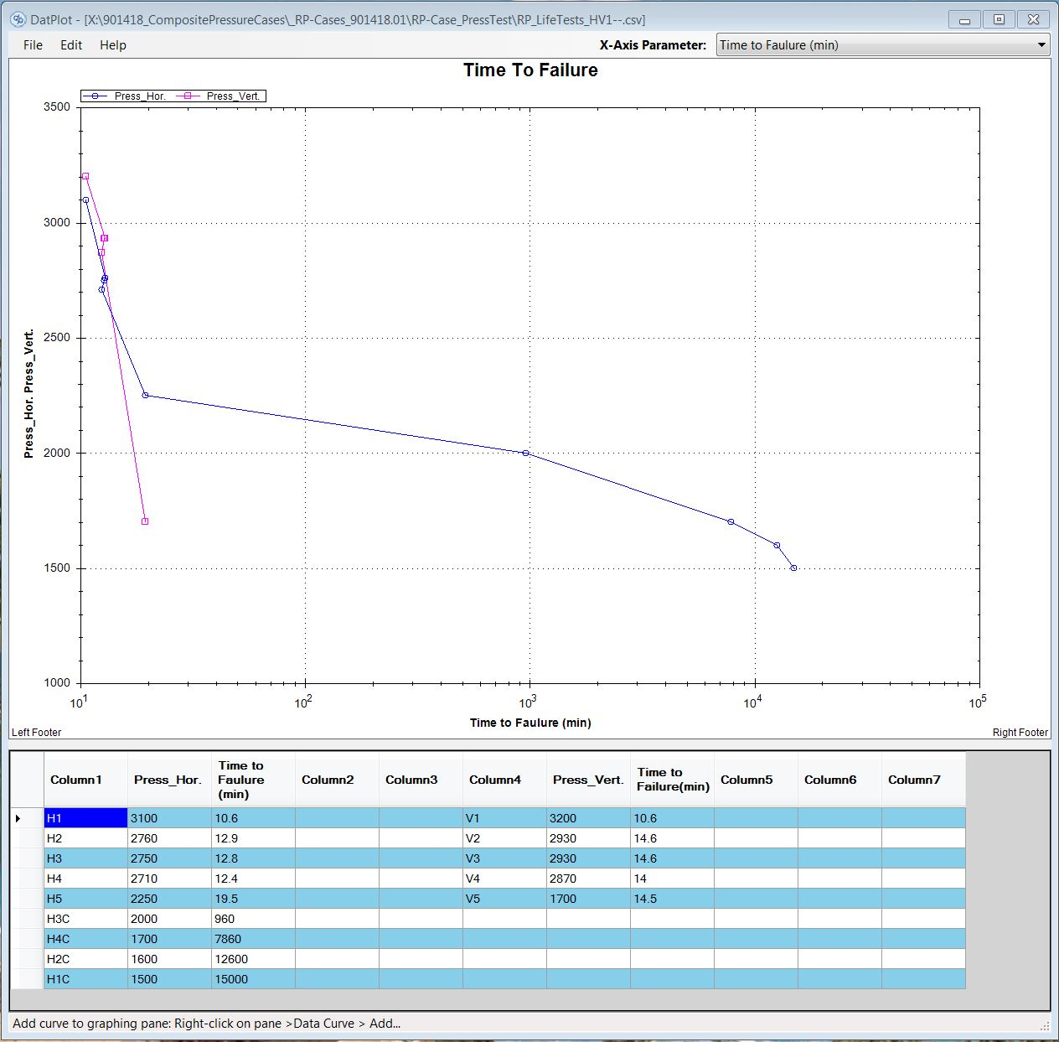
Figure 14 Test Duration In Minutes To Failure.

APPENDIX “A”

PRESSURE VESSEL CALCULATIONS
PROJECT: CAMTAG Press. Case DATE: Jan 26, 2014 ANALYST: J.E.

Revisions: (last rev date 1/24/08)
1)Added first ten buckling modes for determination of critical buckling pressure.
2) Corrected maximum bending stress equation for cap
3) Added von Mises calculation and corrected buckling calculation
4) Corrected von Mises equation
5) Added O-ring groove diameter for diametral clearance and tab bending calculations.
6) Corrected index problem with radial moment equations
7) Added end cap tab bearing stress and tab shear thru.
8)Added Connector Line Load to End Cap Deflection/Stress calculation (Table 24 Case 1a).
9)Added Von Mises stress @ Critical Buckling Pressure.
10)Added Fixed case End Cap (Fixed Base) calc.

The following calculations are for determining the margin of safety for a pressure vessel at a given depth. The equations are mostly from Roark's Formulas for Stress and Strain (Sixth Edition) and are referenced when used. The user must input the dimensions, material properties, and design depth. A factor of safety will be included in the calculations to determine the minimum margin of safety. The minimum margin of safety must be greater than zero for the design to be suitable for the depth desired.

The format for this analysis package will be as follows:
A) Input of design parameters including dimensions, material properties, and design depth
B) Calculations for deformation and stresses in cylinders (check for thin wall or thick wall condition)
C) Buckling calculations for cylinders
D) Calculations for deformations and stresses in end plates,
E) Weight & displacement calculation.
F) Summary of input and list of results including diametral gap, stresses, and weight.

Note: The minimum margin of safety will be determined based upon the lowest margin calculated in the sections above. Thus, for a give pressure vessel, the maximum working pressure may be limited by the end plate thickness while for another it may be limited by the length of the cylindrical section. Therefor, if a desired allowable working depth is not reached, the limiting factor needs to be determined in order to effectively iterate the design to meet the requirements. Also, the diametral gap must be checked for the different pressures to assure that it falls within the maximum allowable from the o-ring vendor.

A) Design parameters:
(pp02)
1) Dimensional input:
Enter cylinder dimensions:
Inside Diameter :
Outside Diameter:
O-ring surface diameter:
Case Length:
Cylinder Base Thickness:
Wall thickness:
Enter end cap and gland dimensions (O-Ring #2-118)
Plug Diameter:
Groove Width:
Groove Diameter:
Groove Base Thickness:
End Cap OD:
End Cap Thickness:
Tab Thickness:
Connector Diameter:
2) Material properties:
Enter material properties:
Material:
RP-VisiJet_M3_Crystal
Modulus of elasticity:
Material density:
Poisson's ratio:
Yield Stress:
Water density:
3) Design depth and resulting pressure:
Number of pressure steps:
Pressure:
4) Factors of safety to be used:
for buckling:
for stress:

B) Formulas for deformation and stresses in cylinders:
1) Thick walled cylinder calculations:
Table 32 Formulas for thick-walled vessels under internal and external loading
Case 1d
Cylindrical disk or shell; uniform external pressure in all directions, ends capped
Cylindrical disk or shell
Calculated dimensions:
Formulas for change in outer and inner radii, and change in length:
Outer radius:
Inner radius:
Length:
Formulas for normal stresses
as a function of radial thickness, r:
radius range variable

Longitudinal stress:
Circumferential stress:
Radial stress:
Shear stress @ b:
Diametral clearance (extrusion gap):
Pressure step:
Extrusion gap (radial):

The pressure at which the extrusion gap (GAPthick) is equal to the change in interior radius (Δbthick)
PRESS. CASE BASE (FREE):
Table 24 Case 10a
Solid circular plate simply supported; uniformly distributed pressure from ro to a
Solid circular plate
Uniformly distributed pressure from ro to a
CLOSED END CYLINDER BASE CALCS:
Cylinder Base Thickness:
If assumed simply supported:
Check stress in bottom:
Plate Constant:

Margin:
check small deflection assumption
(deflection < t/2)
PRESS. CASE BASE (FIXED EDGE):
Table 24 Case 10b
Solid circular plate Fixed support; uniformly distributed pressure from ro to a

END CAP DEFLECTION AND STRESSES:
Superposition of pressure loading of the annulus and line loading of the connector/penetrator hole in the center.
Table 24 Formulas for shear, moment and deflection of flat circular plates of constant thickness
Annular plate with uniformly distributed pressure q over the portion from ro to a; outer edge simply supported
Annular plate with a uniformly distributed pressure q over the portion from ro to a
Outer edge simply supported, inner edge free 2a
Plate dimensions:
thickness:
outer radius:
inner radius:
Shear modulus:
in*lbf / in
in*lbf / in
Plate Constant
in*lbf / in

Transverse Bending moment / stress
check small deflection assumption
(deflection < t/2)
Should be < 1
CONNECTOR LINE LOAD:
Table 24 Formulas for shear, moment and deflection of flat circular plates of constant thickness
Annular plate with uniform annular line load w at radius ro; outer edge simply supported
Annular plate with a uniform annular line load w at a radius ro
Outer edge simply supported, inner edge free 1a
Area of Connector:
Force on the connector:
Line load on Conn. Hole (w):

Transverse Bending moment / stress
in*lbf / in
By Superposition:

Stresses in tabs:
For a conservative approach, assume the outer edge of the tabs are free and the inner edge fixed
A) Top tab:
Table 24 Formulas for shear, moment and deflection of flat circular plates of constant thickness
Annular plate with uniform annular line load w at radius ro; outer edge free
Case 1l:
Outer edge free, inner edge fixed
Loading on tab:

B) O-ring groove tab:
Table 24 Formulas for shear, moment and deflection of flat circular plates of constant thickness
Annular plate with uniform annular line load w at radius ro; outer edge free
Case 1l:
Outer edge free, inner edge fixed
For o-ring tab:
Loading on tab:

E) WEIGHT & DISPLACEMENT CHANGE CALCULATION:
1. Case Weight Calc.:
Cylinder:
cross sectional area:
internal volume:
external volume:
weight:
End Cap:
volume:
Tab:
Plug:
Cap:
Weight:
Total Weight:

(pp16)
SUMMARY
Thick Wall Calcs
Axial Stress:
Change in OD (radius):
Hoop Stress:
Change in ID (radius):
Radial Stress:
Change in Length:
Shear Stress:
Closed End Cylinder Base Calcs (Edges Free):
Closed End Cylinder Base Calcs (Edges Fixed):
END CAP Calcs
END CAP Circular Plate
Pressure Load:
Conn. Line Load:
Combined Loading:
END CAP tabs:
O-RING tab:
CASE WEIGHTS
Case + 2ea. Caps =

EndCap Flange/Case Bearing Stress: Where the allowable bearing stress =
(pp17)
Bearing Area:
End Cap Force:
Bearing Stress:
Margin of safey:
EndCap Flange Shear Thru Stress
Flange Shear Area:
End Cap Force:
Shear Stress:
Margin of Safety:

APPENDIX “B”
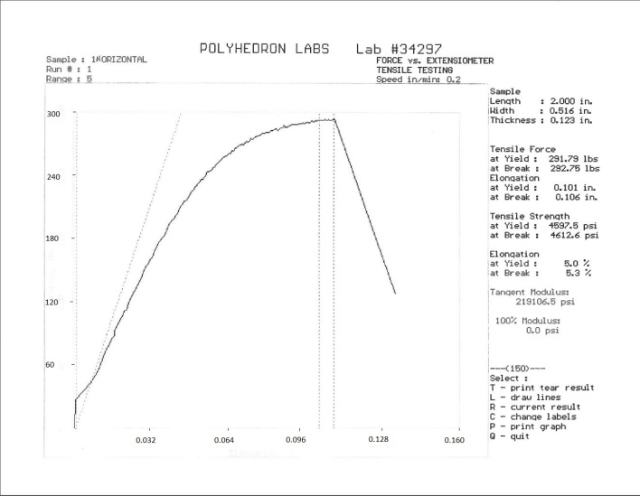
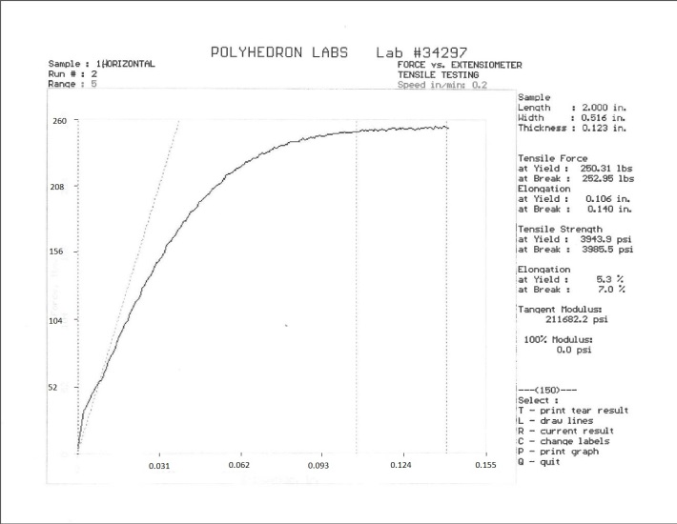
Tensile Test – Build Direction #1 - UHD Resolution
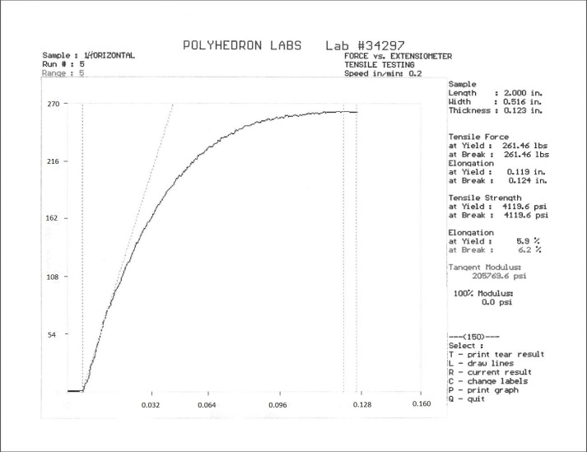
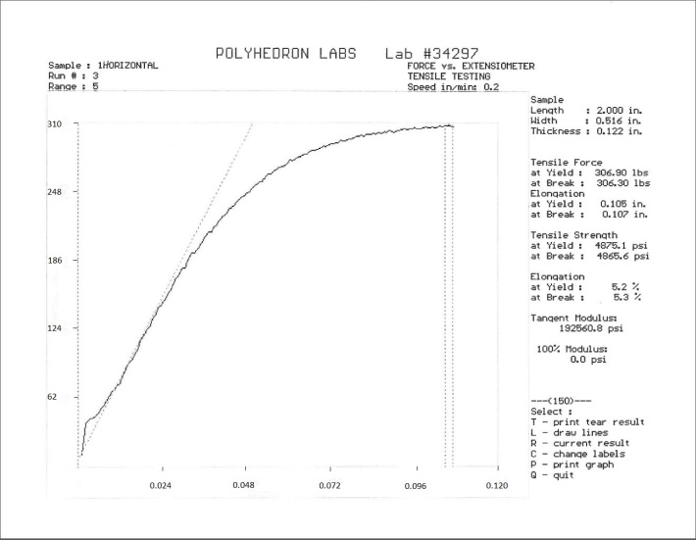
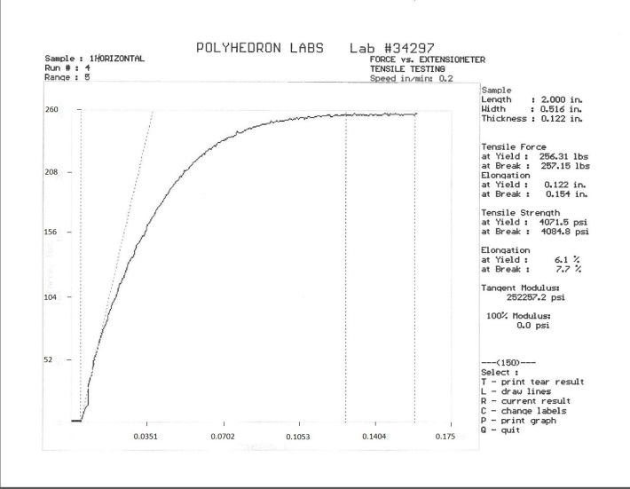
Tensile Test - Build Direction #2 - UHD Resolution
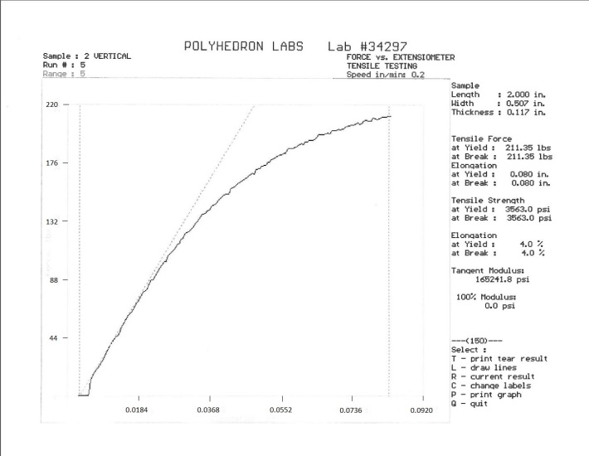
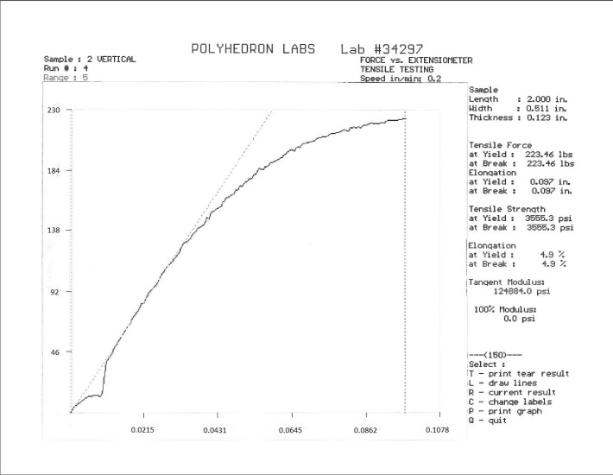
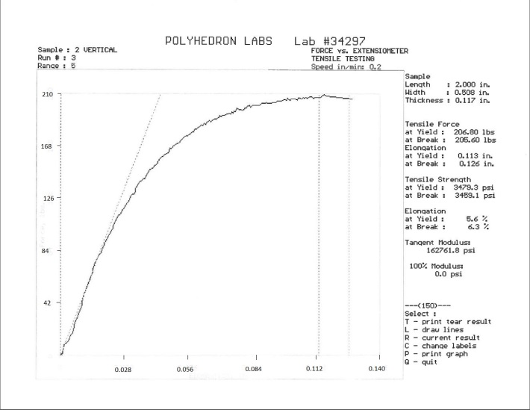
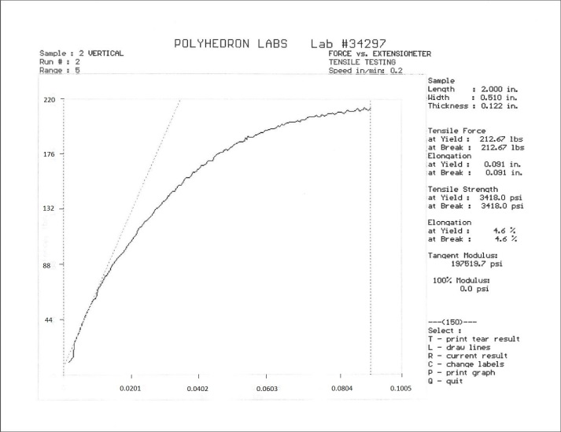
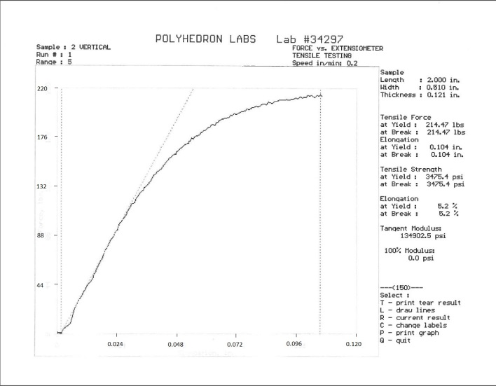
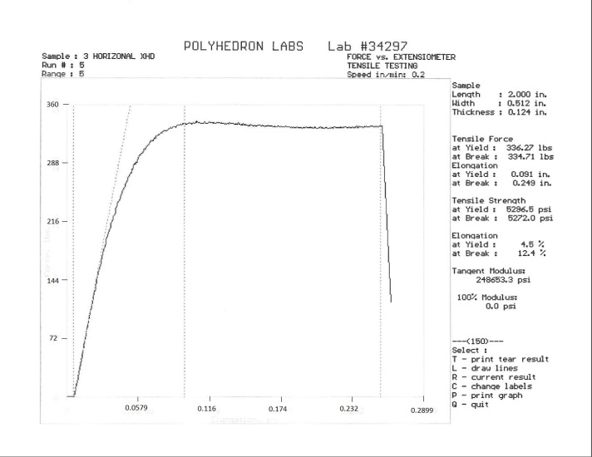
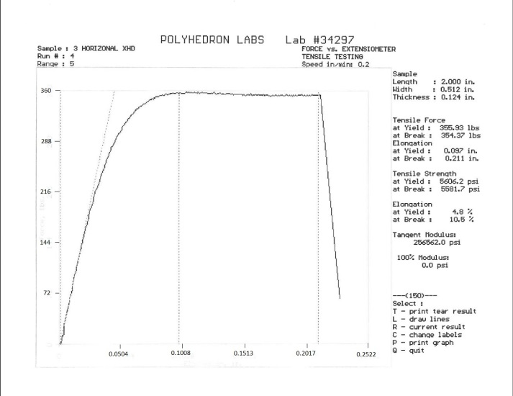
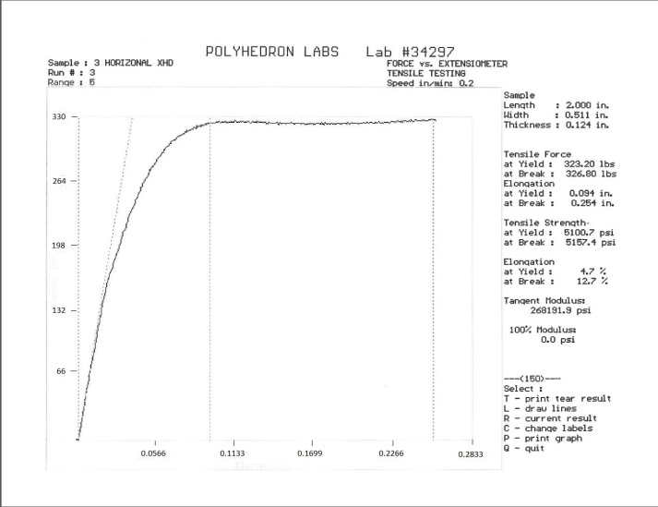
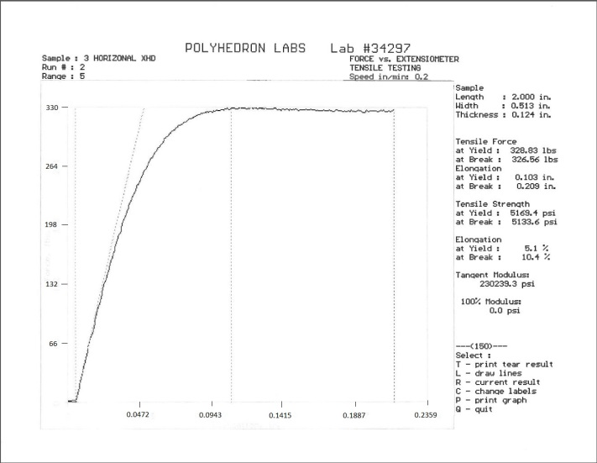
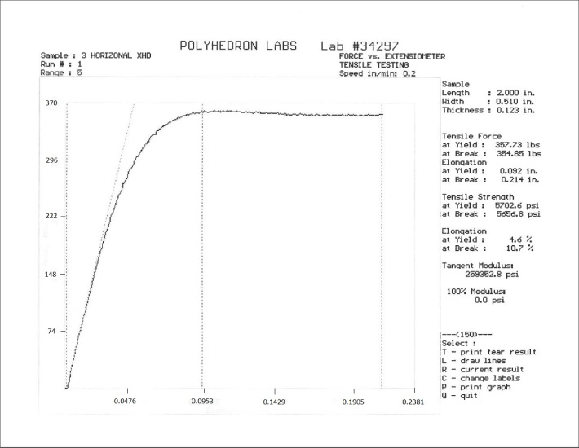
Tensile Test - Build Direction #1 - XHD Resolution

Compressive Test - XHD Resolution - .05 in/min
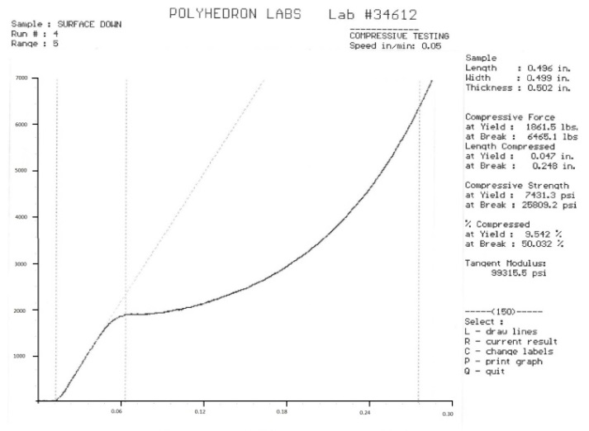
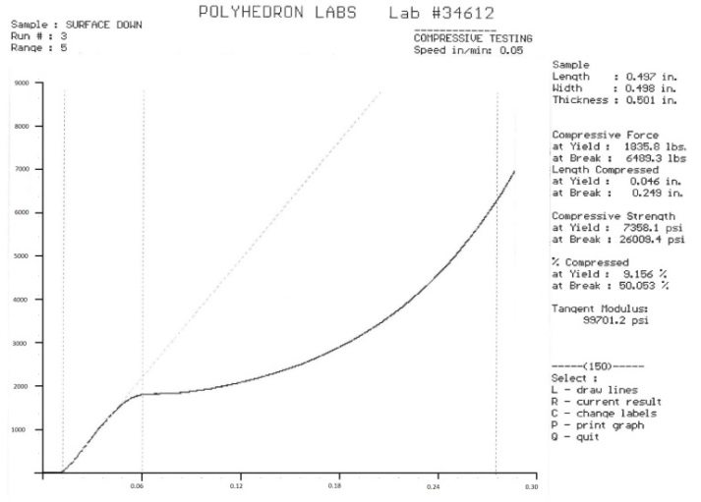
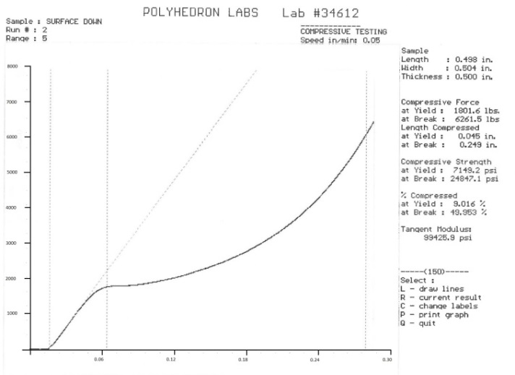
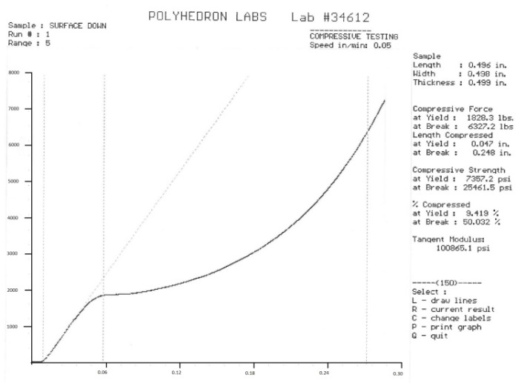
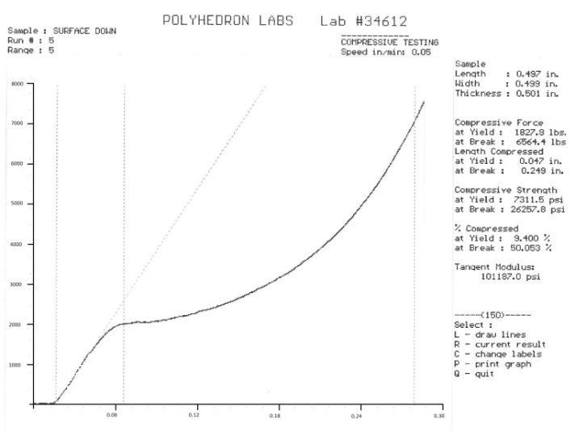
Compressive Test – XHD Resolution - .05 in/min
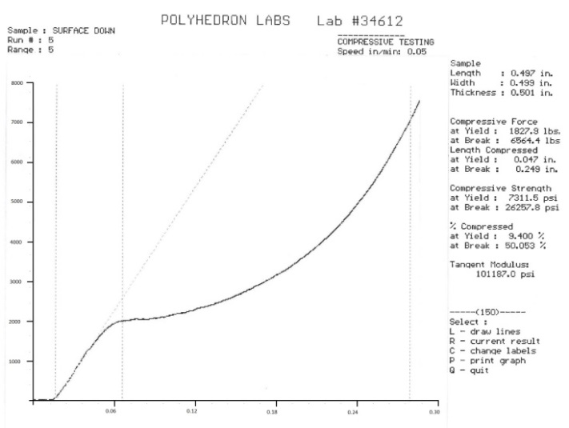
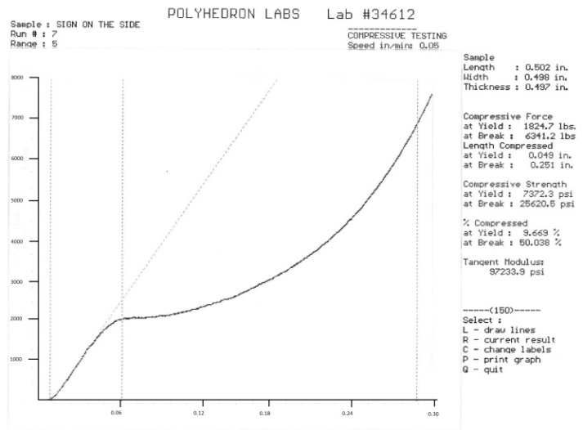
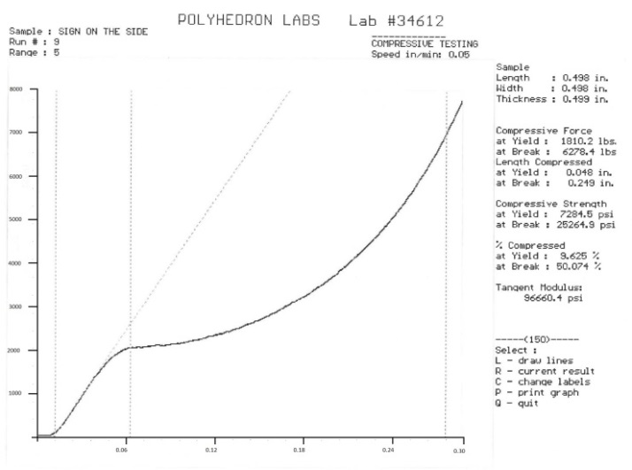
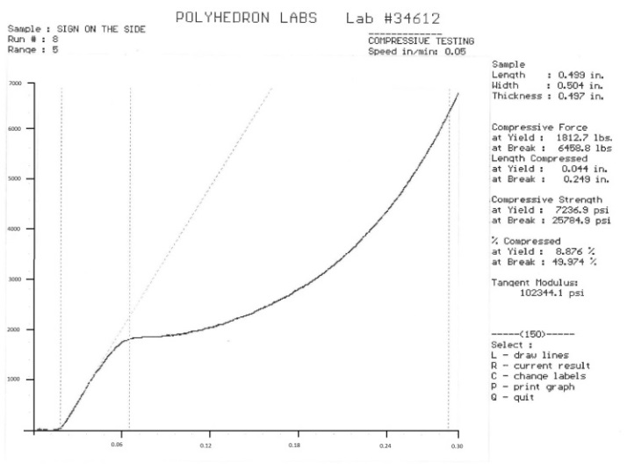
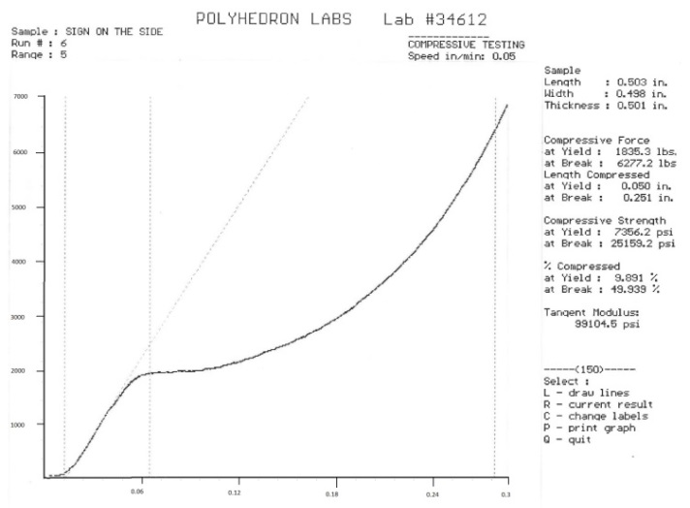
Compressive Test – XHD Resolution - .02 in/min.
