Cut, Pin & Sealing Procedures for LRAUV Antenna 2/20/14
The latest as delivered units lack ¼-20 thrds in the centerline so use a pair of ¼-20 screws in the holes to locate the shoe as a jig to xfer punch the locations of the new mounting screws, 4 x 10-24 tapped holes.
- Drill 4 X 0.150”- 0.55”DP. Bottom tap 10-24, carefully, urethane is somewhat brittle. A drill stop set to 1” worked very nicely against the shoe.
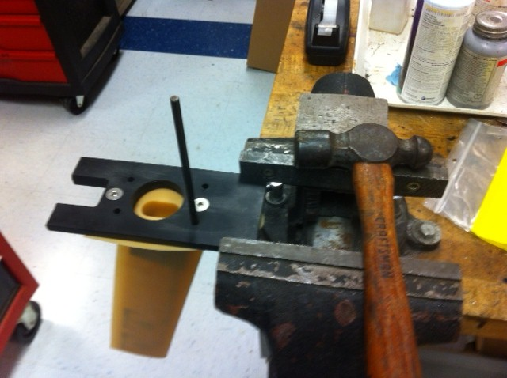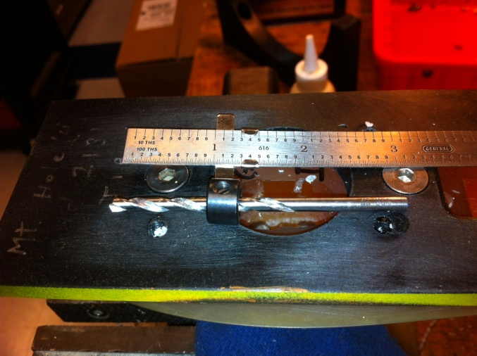
Materials needed for Cut & Pin:
Milling machine,
0.116”, drill,
0.124” and 0.126”reamers,
2x 1.5” x 1/8” SS pins or 1/8” welding rod
Two jigs, with 3 pieces
The larger jig, which includes a removable sawing guide is used for parting the antenna.
- Attach antenna with 4 x 1.75 x 10-24 SHCS.
- Attach sawing guide.
- Use fence on bandsaw to gently hold block against the blade.
- Slowly run the antenna thru the saw ensuring the guide stays flush to the bandsaw fence.
- See image of result

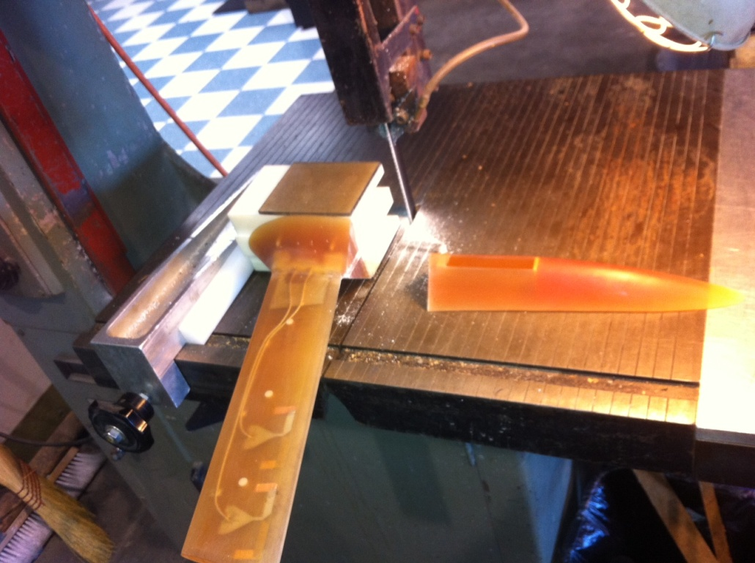
- Attach tail section to other jig.
- Remove saw guide from 1st jig.
- Scribe a concentric line 0.250” from curved lower surface on both antenna pieces.
- Mounting either jig squarely in the vise, find center of part with the center finder resting in the part’s center groove (cut hole)
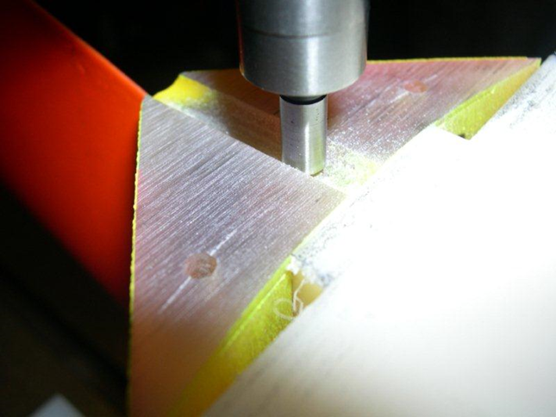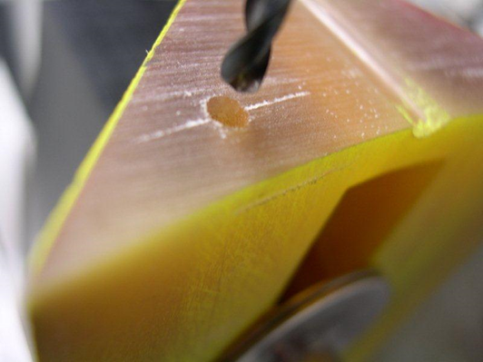
Image shows holes already drilled, note scribed concentric lines.

- Flip the center finder to locate point on the scribed line 0.750” from center.
- Drilling is similar on both sections, assure perpendicularity of face.
- In the front section, drill 0.55” Deep. +-0.750 from Center line

p.3
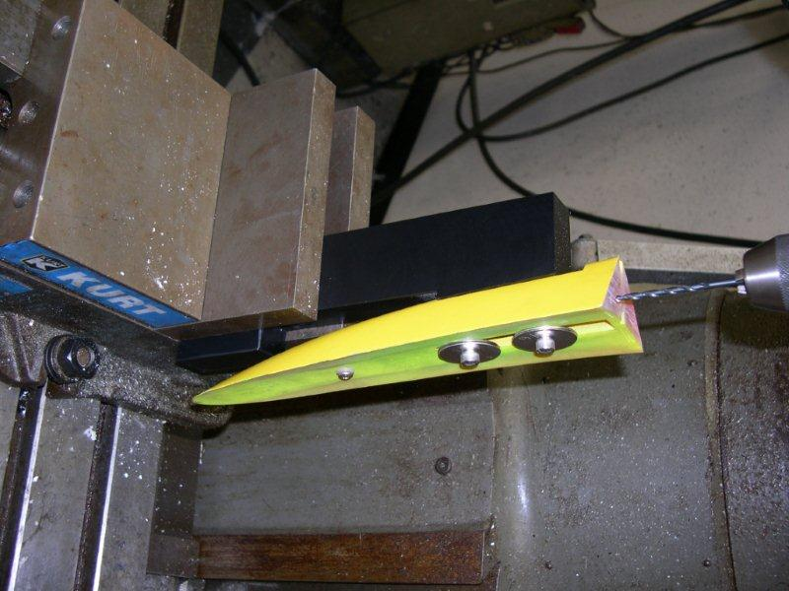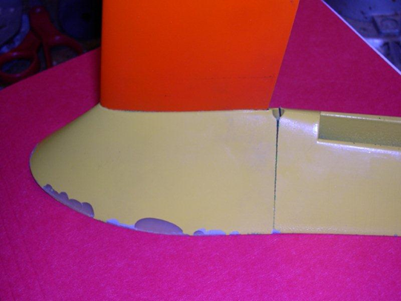

- In the aft section, drill 1.0” Deep.
- Ream the aft section 1.0 deep holes 0.124” and the forward 0.55 deep holes 0.126”
- Place pins and check fit.

Materials needed for Modification of the Tail Section:
0.170” , 0.234” drills
3/16” , 3/8” mills
8-32 x ~1.25” pan head screw, may have to trim length so does not penetrate into vehicle when installed.
Brass Thermal Insert, Lipped, 8-32 x .312 deep
Aft section jig.
Procedure:
- ReMount aft section in jig (below) and place in vice so bottom mounting face at location of screw is now perpendicular to mill axis.
- locate hole center, drill 0.170” thru
- Use 3/16 mill to form a pocket ~.15” deep, ~1” X 0.5”. From Hole center, 0.7” Fwd and 0.3 aft. Pocket to clear brass screw insert when mounted in aft LRAUV shell
p.4
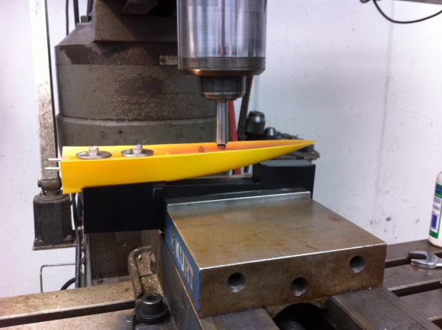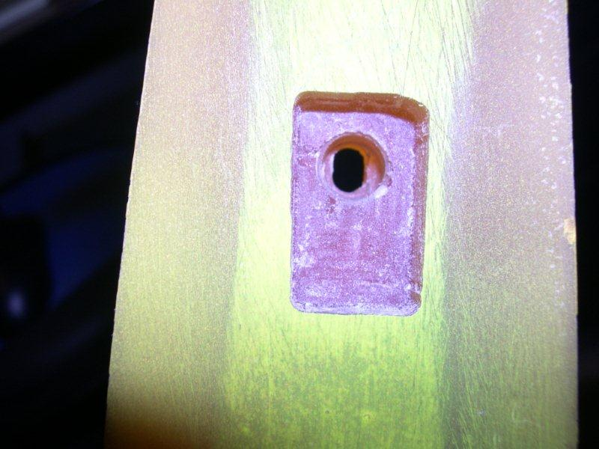

- Flip aft section of antenna, remount, oriented perpendicular to underside face as before, located at screw hole.
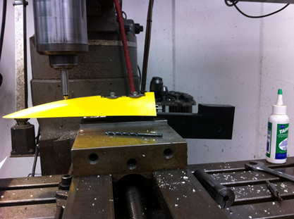

- Use 3/16 mill to form a short slot, +-.1” from center, thru
- Use 3/8” mill to form a flat ~0.120” Deep at front edge to make space for pan head screw

See following images:

p.5
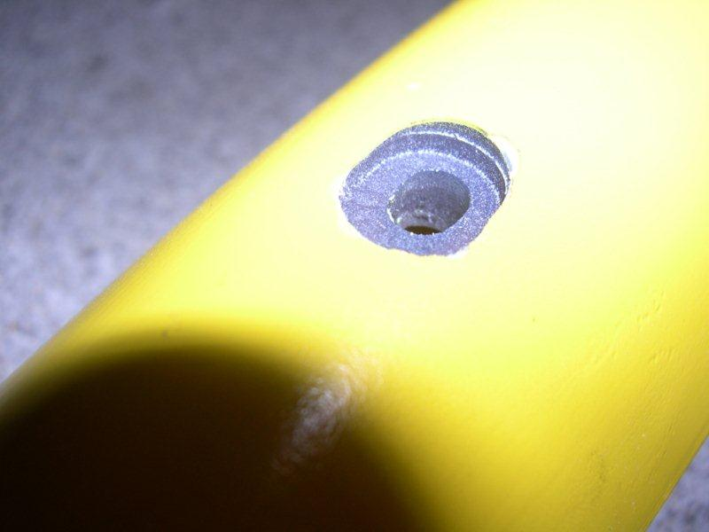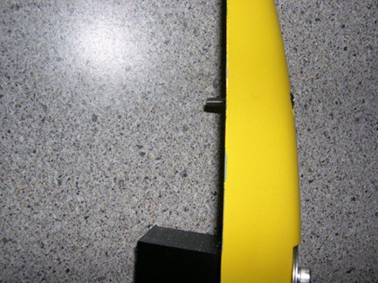
- Place 4 x 10-24 transfer points in mount holes. Carefully test fit and line up the antenna to the long axis. Bring points in contact. These will indicate where to drill 4 x 0.204 mount holes in the skin. (Image shows completed potting)
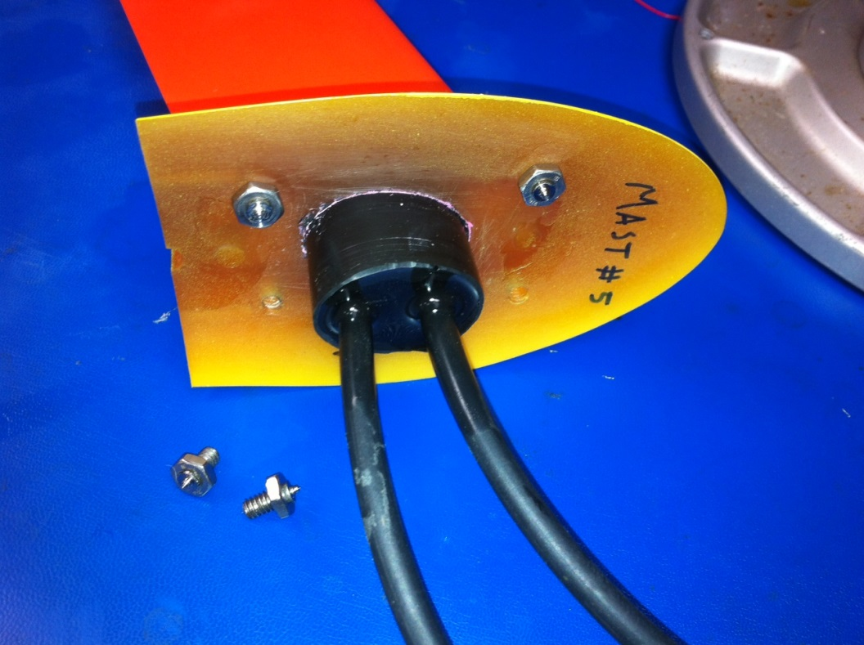
- Assemble and mount Antenna, Use 0.234” drill to enlarge hole in aft LRAUV skin to take Brass insert.
- Check fit, use structural epoxy such as 3M 420, Devcon 2 ton to hold in position.

p.6
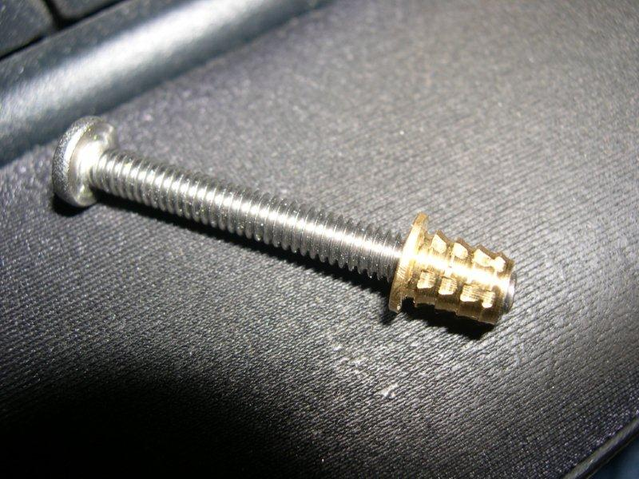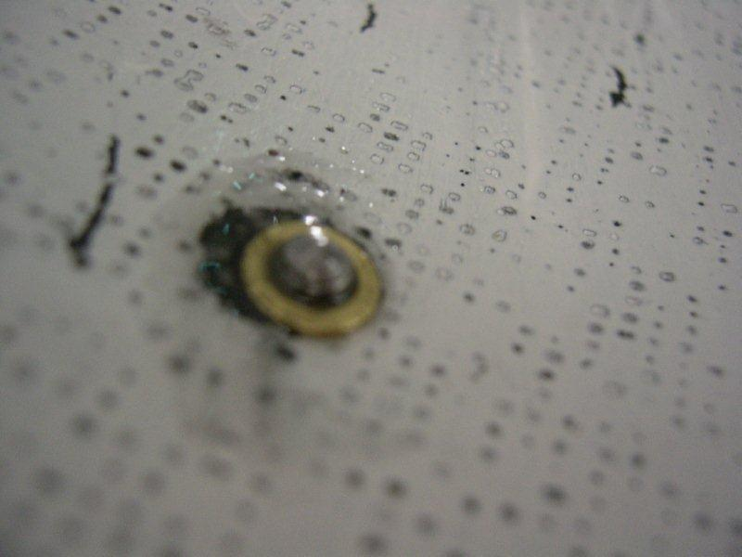
2nd image is inside the aft fairing, screw trimmed.
- Check fit of 8-32 pan head, trim length as req’d.

Sealing Procedures –

Materials needed- Scotchcast 2131, Acetone, 100 & 240 sandpaper, Loctite U -09FL or 3M DP 100 or 105, sulfur-free clay, thin foam, plastic/Teflon shim material.

- Lightly abraid the SMA connectors and wires, acetone clean.
- Lightly abraid the inner surface of the SMA recess and acetone wipe.
- Install connectors with SMA tool.
- Use the shoe again to build a circular form for pouring a seal with Scotchcast 2131

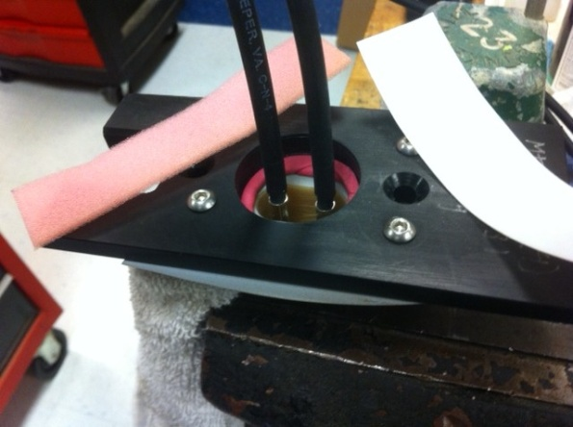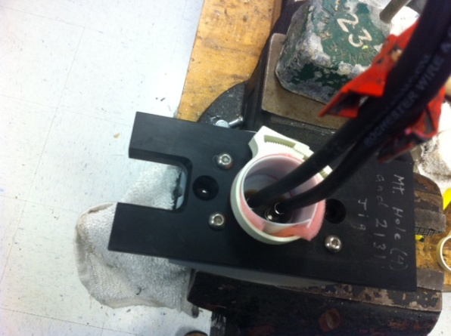

p.7
- Use epoxy safe clay to form a seal at the bottom, use foam to space the plastic or Teflon circular form. Press the form down to the urethane surface and remove the clay from the inside. Support the wires. 2nd image above.
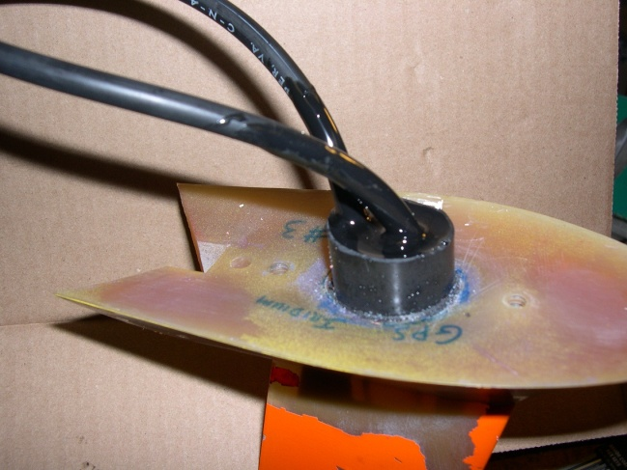
Completed 2131 seal on early version (no 4 x 10-24s)

- Important Last step. Ream original 2 X ¼-20 mount holes to eliminate threads, solvent clean, carefully pour a flowable epoxy such as 3M DP-100 or 105 to completely seal holes.
- NOTE: These holes penetrate far enough to intersect delrin SMA Mounting block and so provide a sneak water path if not totally sealed.
- Check that the DG Obrien connectors have a face oring installed and a blanking plug available.
- Antenna is now ready for electrical checks prior to SW pressure testing.

