ESP E/M Cable Tear-down, 2/16/12 J.Scholfield 2/28/12
In recovering a couple of the cone pieces, maybe more, of a well used E/M cable, I documented what I found as I disassembled the parts. This was the B end. Wiring cavity looked dry with a slight amount of corrosion in the o’ring areas. Note the darkened Cu wires (2) .
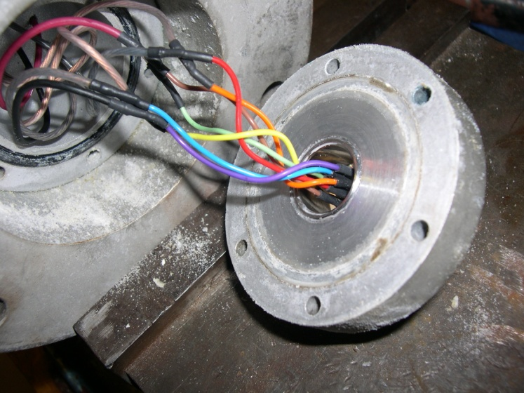

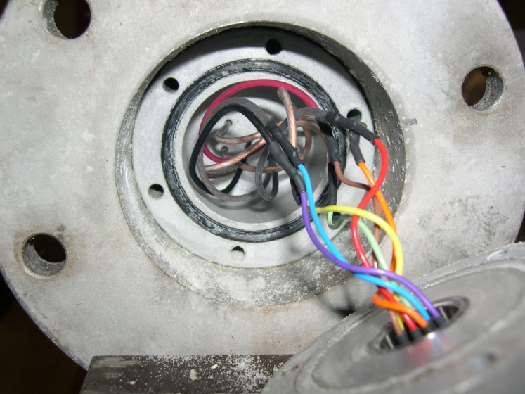
I checked the wires 14” down the wire, only 1 was dark , same as very dark one above. No shorts to housing. 3”x6-32 removed easily, aqua lube works.
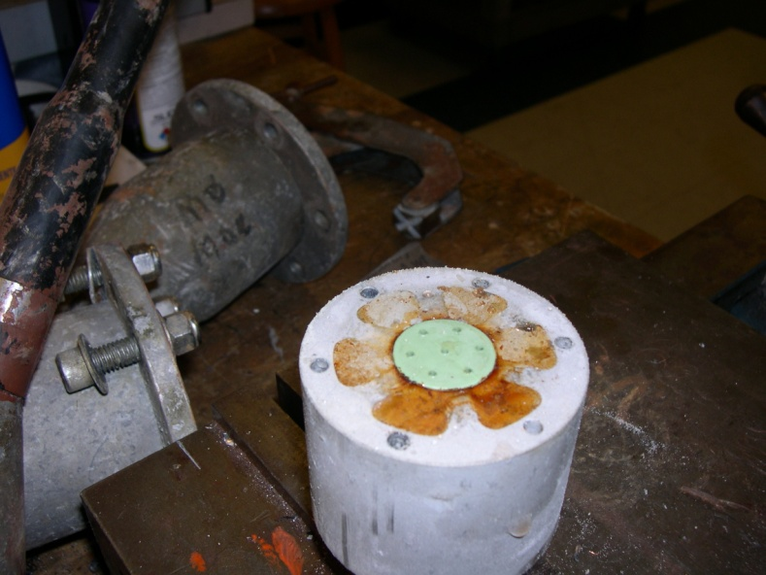
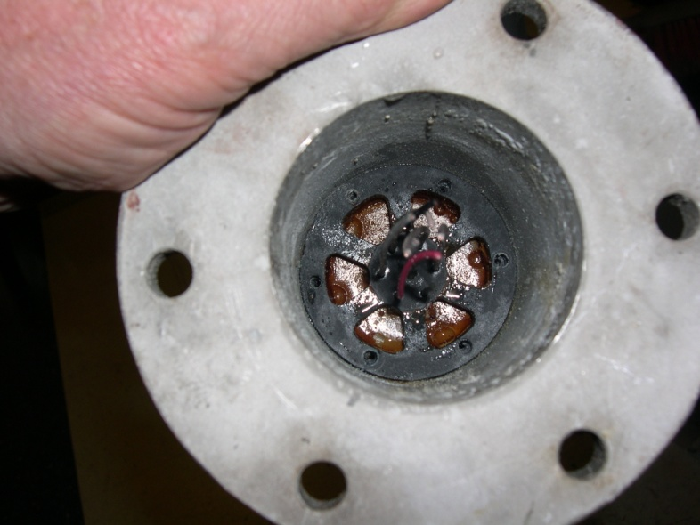
Plenty of water below Morrison as expected. Still B end.

Slight amount above where shouldn’t be. See below.
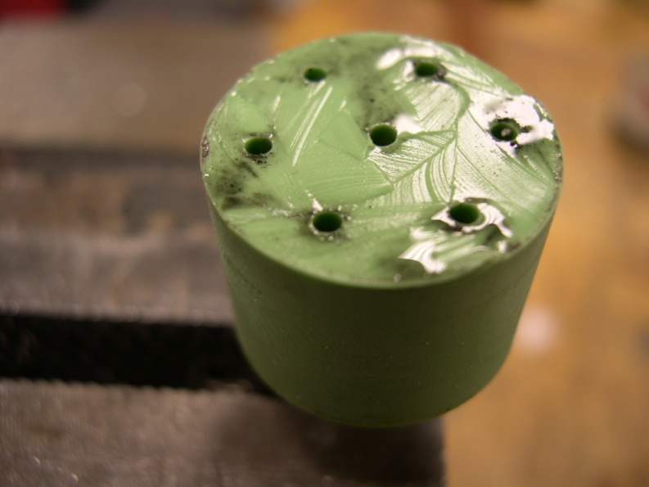
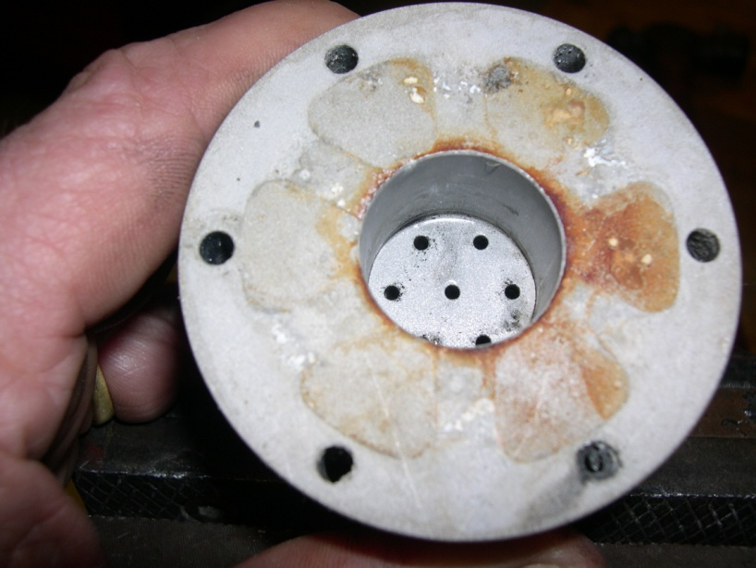
FYI- wire hole diameters in installed Morrison approx. .058. Cast as .070.
B end.

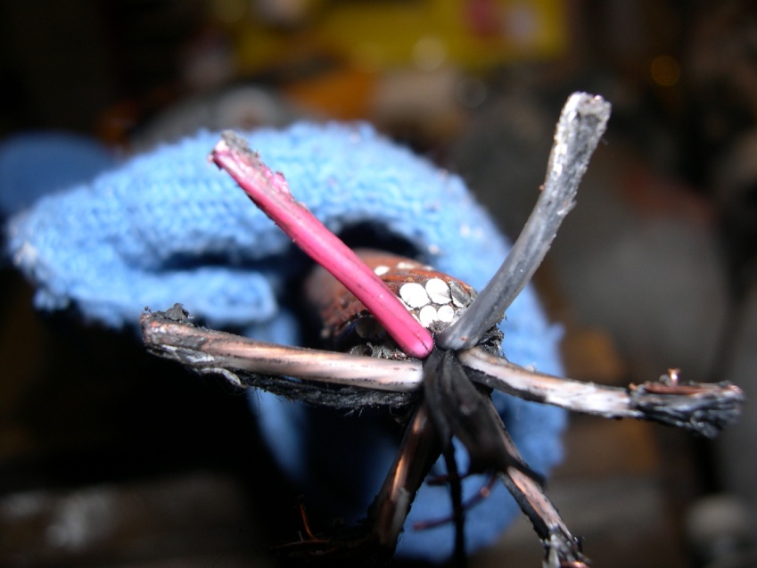
Dark wire, 14” down. Right of Red.

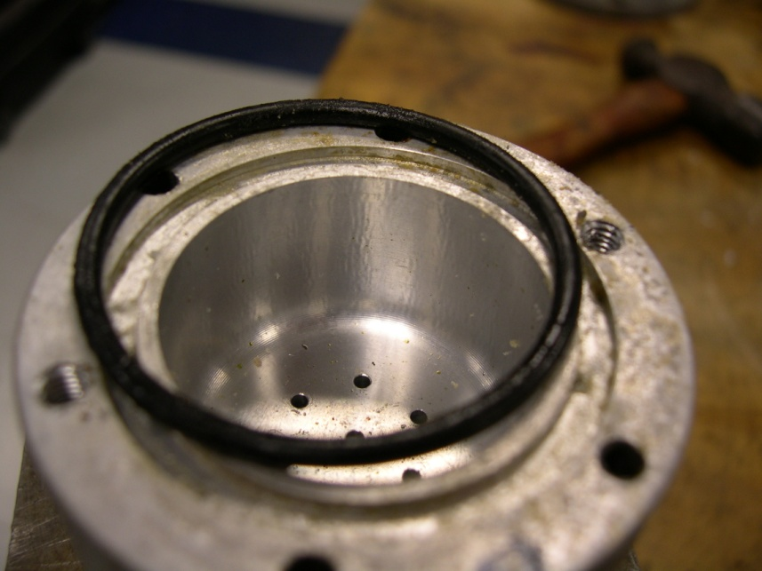
A end, “gritty” oring and land. Sl. Corrosion in cavity. 3 of the 3” 6-32’s were frozen in, used Kroil to tease them out the next day.
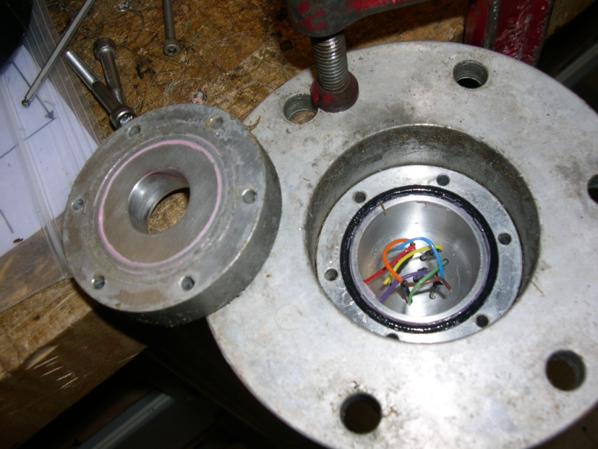

Big BSR cable, Dry! 3 of the long 6-32’s broke off, even after soak overnite in Kroil.

