IT’S BETTER FOR ME TO BREAK IT THAN…… 11/19/14
At sea during a multithousand dollar trip offshore.

A short bit of background info-
MBARI designs and fabricates equipment that is most often used on our own ROV’s but may be deployed anywhere in the world’s oceans. Our two ROV’s, VENTANA and DOC RICKETTS have maximum depth ratings of 1800 meters and 4000 meters respectively. In addition, most of the smaller pieces of equipment that need to be pressure checked are tested in-house as well.

MBARI has two hi-pressure test chambers, they are used to :
-validate pressure housing designs,
-check for seal integrity, especially on modified housings,
-pressure screen electrical and mechanical equipment before it is assembled.
- check electro/mech. function of oceanographic equipment before going to sea.

The smaller chamber can test items that are up to 6.5 “ diameter and 23 “ long to 15000 psi. The large chamber can test items 9.4 “ diameter and 40 “ long to 10,000 psi.

Most of the time, the housings tested to not fail catastrophically because of best engineering practices being followed during design and fabrication. However, when these practices are not followed - The following image is from many years ago but is very telling and these housings are still here in the Pressure Test Facility.
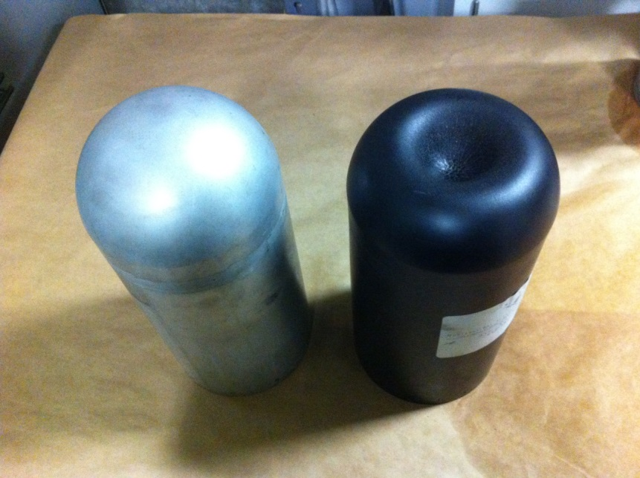
TIBURON Thruster Housings-These were sent out to a local fabricator for machining from a single billet (solid block) of Aluminum 6061 T6. The fabricator decided (without an OK) to weld the hemispherical end bells onto the cylindrical portion. Welding reduced the strength of the material ( designated by the T6 call-out) to something only 30-50% as strong. We were interested in what we did have so we checked them out. At 5100 psi the end bell inverted to this very unusual shape, normal is on the left. T6 aluminum just does not bend like this, it breaks, so this is very strange. We rejected the parts.
Jim Scholfield Sr. Mechanical Technician

