LRAUV Antenna SMA Connector Sealing 5/3/12

Difficulty with S.W. incursion into the SMA connectors to Tethys antenna after a deep dive to 280 meters on March 8, 2012 disallowed reestablishing communication and the vehicle was searched for but not found. Tethys was adrift for nearly 2 weeks until recovered by a fishing boat. The seal at that time was 3M Fast Seal 5200 which had worked fine during multiple ~50meter shallower dives. During the
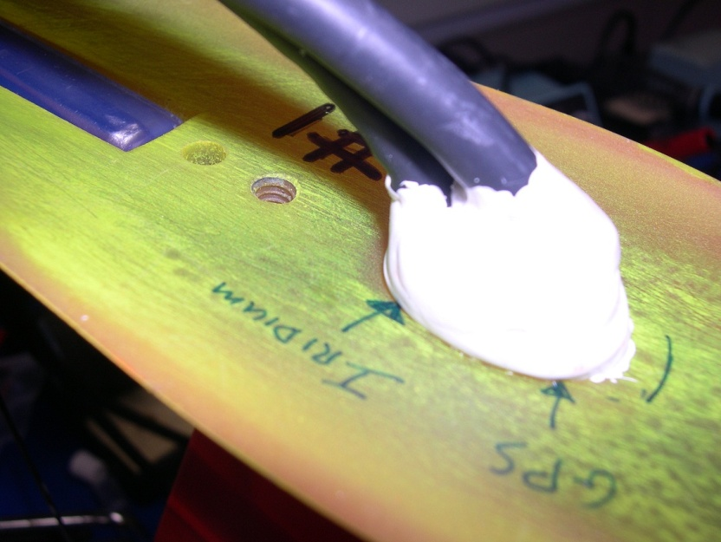
deep dive the 3M 5200 seal had apparently pulled away from the wire and heat shrink over the crimp on the SMA connector allowing S.W. to seep in. It was thought that the high viscosity allowed a large enough air bubble to exist within which collapsed under pressure and caused the seal to be compromised. To reduce trapped bubbles a new idea of cutting the 5200 1/5 with Acetone gave a honey like flowability. Trials gave apparent good adhesion and workability on abraded and cleaned surfaces. The antenna wire is Rochester C-N-4 neoprene coated coax.
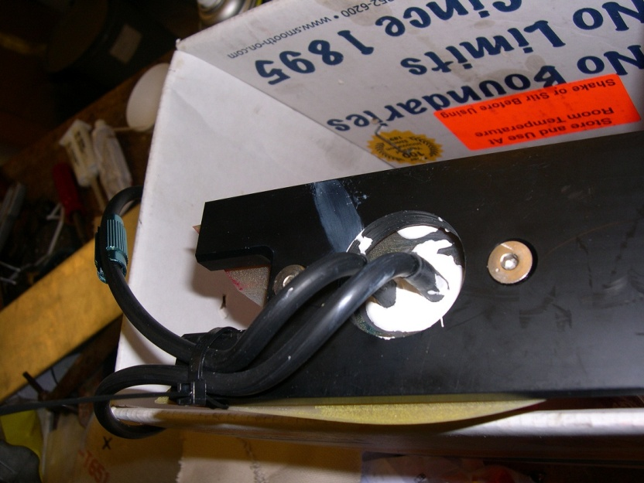
p.2
The well interior was abraded and a chamfer added to the upper edge then acetone wiped. The ferrule ends of wire covered with 0.5” length of adhesive lined heat shrink to equalize wire diameter and cover ferrule, 1.5” adhesive lined heat shrink over that. Assembled and preset wires to final positions. Connectors and heat shrink acetone wiped. 15 gm of 5200 cut with 3 gms acetone, well mixed. Degas to pop bubbles, ~15-20 in Hg . Quick to reduce loss of volatiles. Poured carefully into cavity to a slightly mounded shape and left to cure in vertical position at Room temperature. Unit double bagged in test-tank S.W. and cycled 5X to 500 psi @ 100psi/min. Adhesion to the urethane mast very good but poor to heat shrink and metal connectors which resulted in water leakage and air bubbling in post testing. The varied substrates were proving to be troublesome.
A couple of conformal sealing coatings designed for electronic environmental protection were evaluated to improve adhesion and/or sealing to the heat shrink and metal. A product from Omega Industrial Supply was very rubbery but did not improve adhesion.
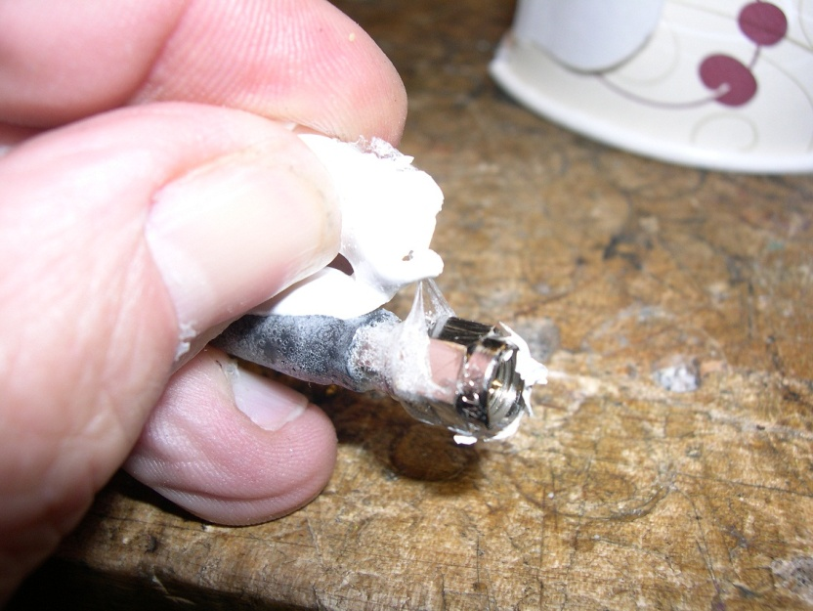
The other from McMaster-Carr called Techspray Turbo-Coat was used in conjunction with a metal primer called Devcon FL-10. It was a very thin brittle coating which gave very good adhesion to the metal and heat shrink. It’s disadvantage was the brittleness that cracked when the wires and heat shrink were bent.
Some time before the March 8 incident 3M Scotchcast 2123 re-enterable Gel had been tried but did not seem suitable because it seemed too “crumbly” to affect a good seal. Doubt existed as to the product being out of date because it is supposed to have a 400% stretch before tearing. It is a very soft product.
A fresh package of 3M 2123 was obtained from McMaster-Carr. A test pour seemed to cure properly so a test with 2123 poured over the Techspray Turbo-Coat was tried. The advantage of the re-enterable is the ability to access the SMA connectors for easier changes and checks to the mast and antennas. Adhesive lined Heat shrink was applied over the metal ferrules then acetone cleaned. The SMA
p.3
connectors were bead blasted, FL-10 primer applied. The urethane well was abraded and acetone cleaned. The SMA test leads screwed into the antenna base then 3 coats of Turbo-Coat were applied to coat the connections. The ScotchCast 2123 was properly mixed and poured in then allowed to set overnight.
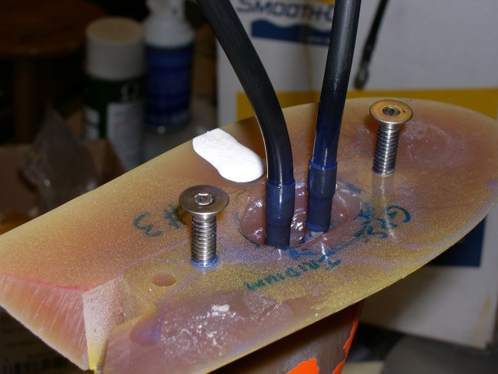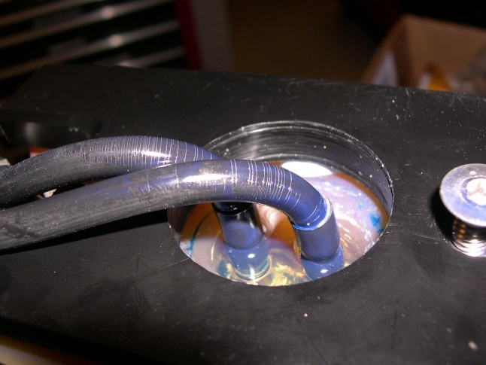

Note cracks in the Turbo-Coating on the neoprene wire covering. As before the unit was double bagged in test-tank S.W. and cycled 5X to 500 psi @ 100psi/min. This time no leakage of water upon inspection or air leakage during post cycling testing was noted. The adhesive in the heatshrink worked well.
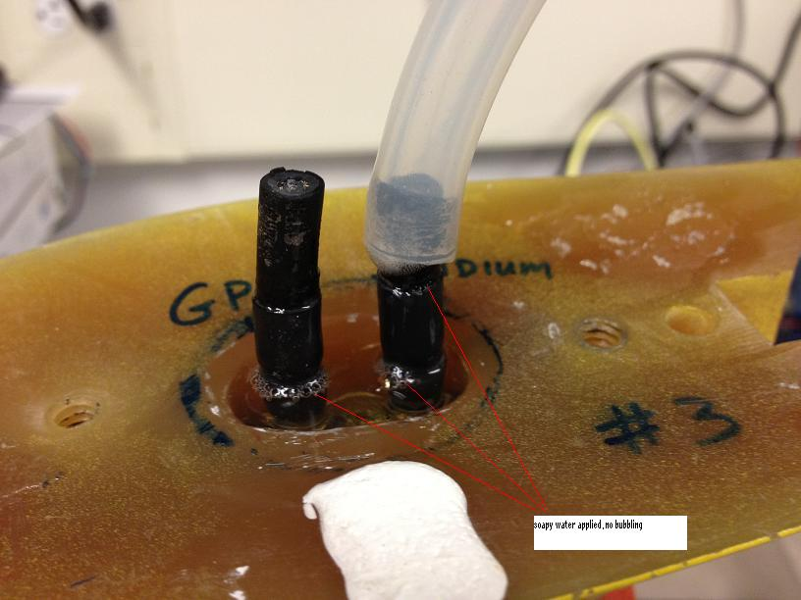

p.4
We had a workable re-enterable seal but were not completely satisfied about the robustness over time which included multiple removals of the tail cone.
An additional test for a permanent, no access, solution was also performed. A shorter piece of heat shrink over the metal ferrule but with only 0.15” overlap onto the wire covering was installed. The SMA connector was bead blasted then FL-10 primer applied. The heat shrink was abraded then acetone cleaned. No conformal coatings were applied. The well area and cabling were abraded and acetone cleaned then the SMA test leads were installed. Since a deeper seal was desired to improve contact to the wires and form a strain relief a temporary circular casting form was installed above the antenna well. This was made of foam and metal shim materials.
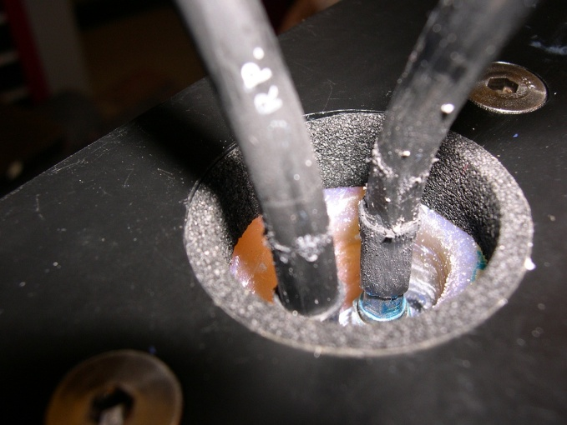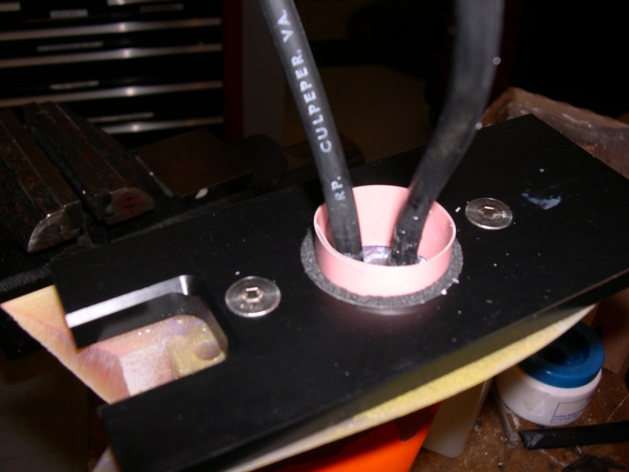
The antenna attachment “shoe” was used to hold the casting form in place. 3M ScotchCast 2130 was poured and allowed to cure. This sealed very well but other problems with the antenna were found.
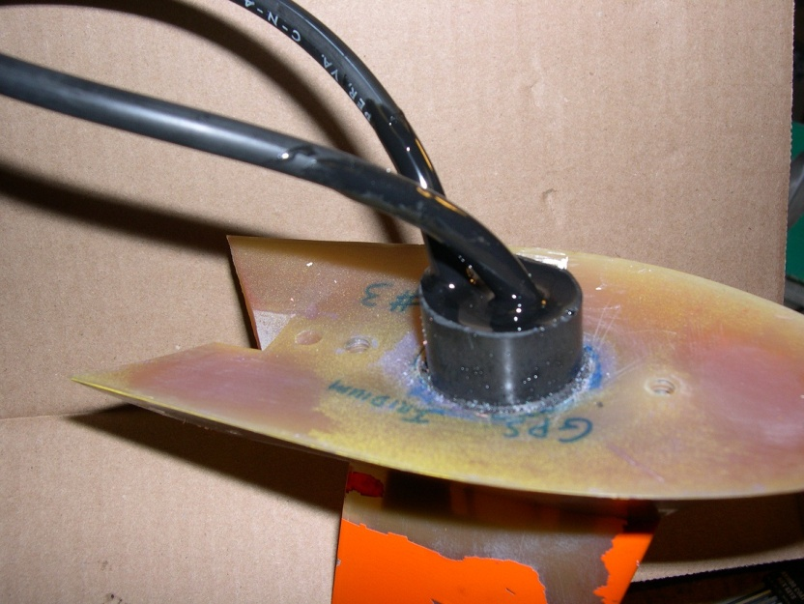
p.5
A pin hole in the upper portion of the mast was admitting water after the antenna had been in use for awhile which cracked the urethane in a thin section. Also, cutting apart our test article revealed the urethane had poor adhesion to the (ABS) SMA Mount Block which allowed water to enter the base of the antenna by travelling up the ¼-20 shoe mounting threads up to the poor interface surface within the antenna base structure.
The ¼-20 mounting arrangement was changed to 4 x 10-24’s and the ¼-20 holes were backfilled. On 4/27/12 a new antenna was wired and prepared as above, cycled 5X to 500 psi in S.W. with perfect results. It was installed on Daphne in preparation for her next sea trials.

