MBARI PRESSURE TEST 2014 11/19/14
At sea during a multithousand dollar trip offshore.

MBARI designs and fabricates equipment that is most often used on our own ROV’s but may be deployed anywhere in the world’s oceans. Our two ROV’s, VENTANA and DOC RICKETTS have maximum depth ratings of 1800 meters and 4000 meters respectively. In addition, most of the smaller pieces of equipment that need to be pressure checked are tested in-house as well.

To get an idea of how much pressure those depths generate, simply multiply the depth in meters by 1.5 to get the approximate pressure per square inch of surface.

DEPTH (meters) X 1.5 ~ pressure in psi.

So for DOC RICKETTS, 4000 meters X 1.5 is ~6000 psi. The actual pressure at 4000 meters is 5840 psi but 6000 is a good estimate. Since these are the pressures on each square inch of surface, large forces can result for any device or housing with a useable size volume inside. Even a small cylindrical pressure housing of only 4 inches Diameter will have a force of nearly 75,000 pounds pushing on just the endcaps.

MBARI has two hi-pressure test chambers, they are used to :
-validate pressure housing designs,
-check for seal integrity, especially on modified housings,
-pressure screen electrical and mechanical equipment before it is assembled.
- check electro/mech. function of oceanographic equipment before going to sea.

Both test chambers are filled with oil and the oil is pressurized by pumping in additional oil by a small piston pump, 20-30 psi is generated with each stroke. The piston pump is actuated by air pressure, it only takes about 40 psi air to develop 6000 psi oil pressure in the test chamber. Oil (and water) are not compressible like air is so it is much safer to generate large test pressures with oil. It is safer because a leak or broken tube on the test chamber will only leak a small amount of oil as the pressure is lost.

The smaller chamber can test items that are up to 6.5 “ diameter and 23 “ long to 15000 psi. The large chamber can test items 9.4 “ diameter and 40 “ long to 10,000 psi.

The large chamber is actually a surplus naval 16 “ projectile of the type fired by a WWII battleship. This projectile is made of Stainless Steel, weighs 2000 lbs. This particular one was modified as a test chamber and used at China Lake Naval Weapons Facility for decades. The Naval Post-Graduate School Dept. of Oceanography then used it for checking their own equipment at their Beach Lab for many years. MBARI acquired the large chamber in 1995 and has periodically upgraded the original manual control to the current sophisticated LabView based automated control which allows smooth pressure transitions and holds at desired pressure levels.

Most of the time, the housings tested to not fail catastrophically because of best engineering practices being followed during the design and subsequent testing. However, surprises due happen and occasionally we do take some housings to failure. The following images are some of the notable incidents and results. Note the golf balls inside some housings which limit the volume change and reduce the stresses on the test facility just in case an implosion occurred.

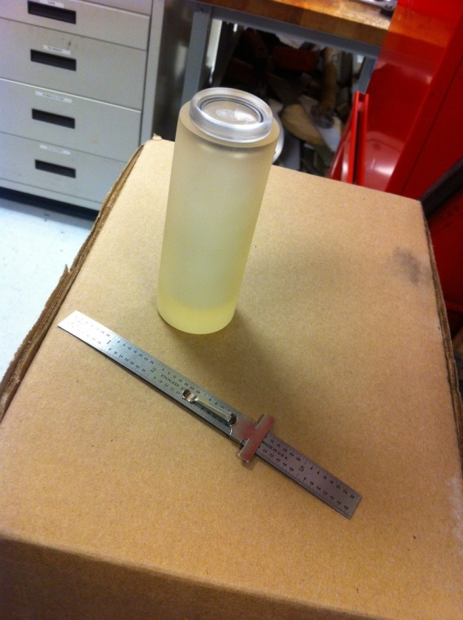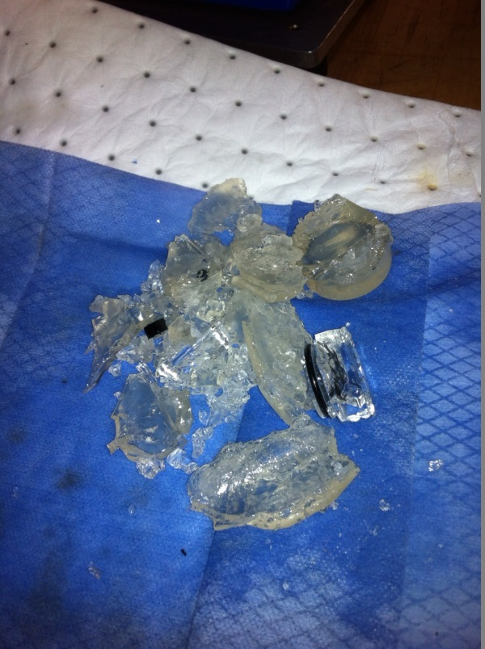
3 D printed plastic Great White Shark video tag. Failure (2700 psi) testing of a test cylindrical housing during development of an inexpensive tag. This is an ongoing project.

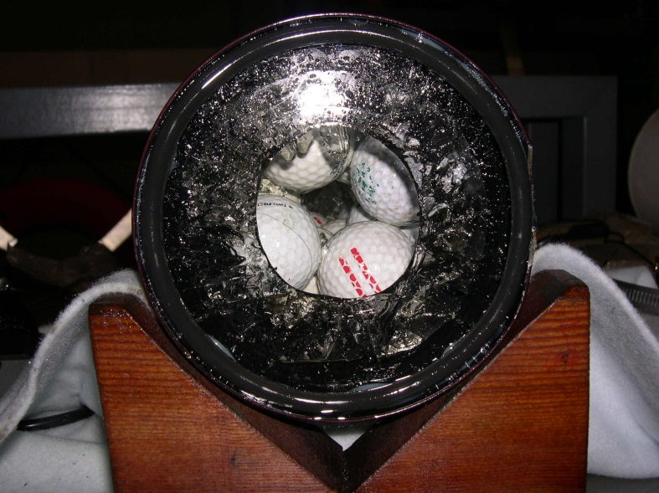
Phantom ROV Camera Housing-I think we have an issue……..

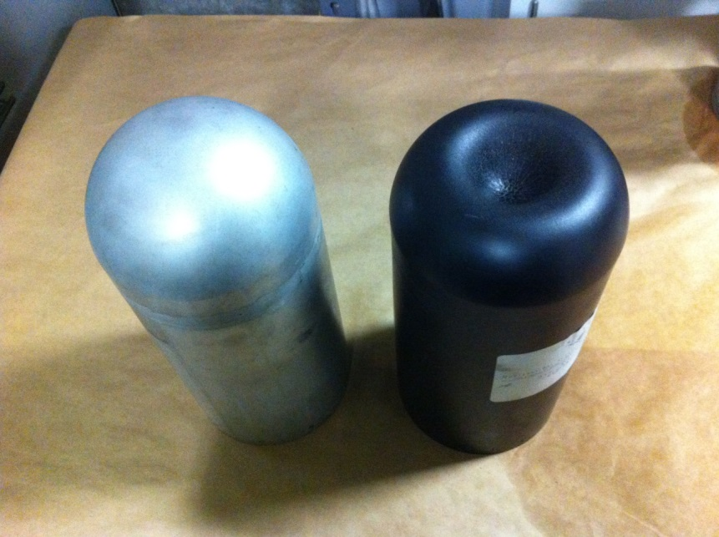
TIBURON Thruster Housings-These were sent out to a local fabricator for machining from a single billet (solid block) of Aluminum 6061 T6. The fabricator decided (without an OK) to weld the hemispherical end bells onto the cylindrical portion. Welding reduced the strength of the material ( designated by T6 call-out) to something much less. At 5100 psi the end bell inverted to this very unusual shape, normal on left. T6 aluminum just does not bend like this, it breaks, so this is very strange. We rejected the parts.

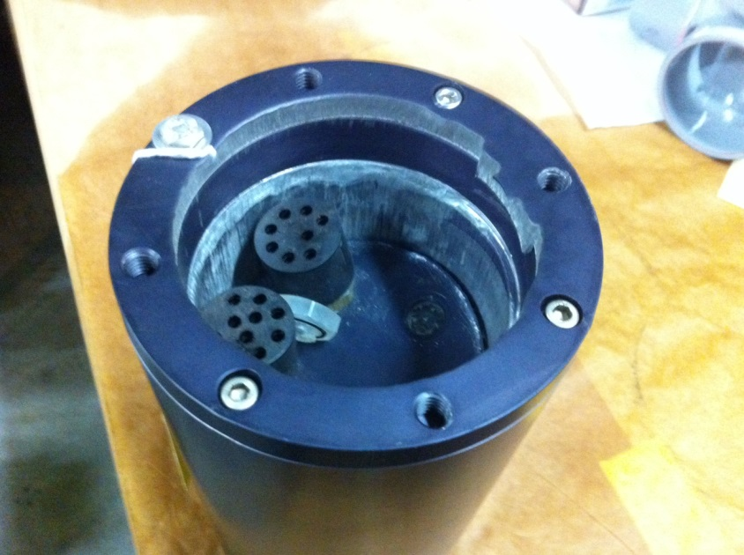
What did you say that end plate was rated to? 1996

Jim Scholfield Sr. Mechanical Technician

