PENETRATIONS ON PVC VAN STONE BLIND END CAPS 12/13/13
This instruction will help with installing connectors and heat flow rods on the end caps of a Van Stone flange and blind end cap based PVC Housing. Tools used are common shop tools in a well equipped shop. No milling machines or lathes were used. Hand held die grinders, drills, band saw, drill press, large belt and an orbital sander, a good tap and die set and the knowledge to safely use these items are a requirement. The example was a Van Stone Blind End Cap for a 10” PVC pipe. Techniques should be applicable to any size similar end cap.
Please see additional resources in the MBARI XFoce Library for tips on preparing and gluing Van Stone based housings together and determining how many heat rejection Cu/Ni rods are necessary for a particular electronic system.
VAN STONE PVC BLIND END CAP--
For our application a Sch. 40 clear ~10” ID PVC pipe was assembled into a housing. The surprise on receival was the rib structure on the outside face of the blind end cap. Fortunately only one end of our housing had to be modified in the following manner. (Smaller dia. end caps might not have this problem). This ribbing had to be carefully removed to give a reasonably smooth face for the Cu/Ni rods and care had to be taken NOT TO DAMAGE the 3 spots for the Oring sealed SubCon connector locations. Those 3 spots were located and protected by tape. A small ¼” shaft die grinder with a conical tip designed for plastic removal was used for rough material removal.
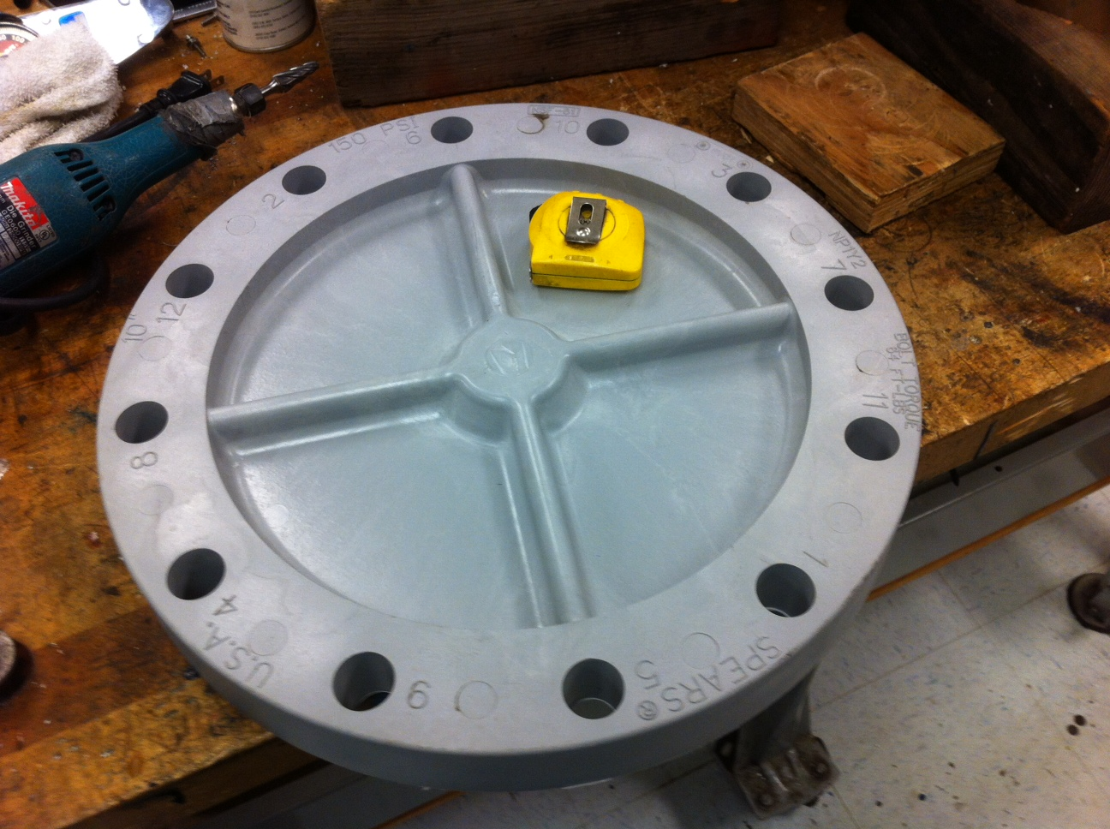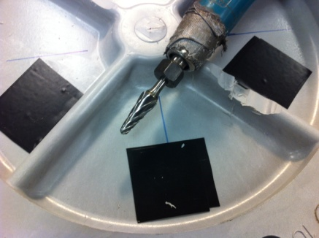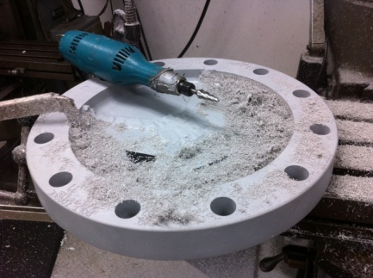
This was followed up with a 4” die grinder with a rough abrasive wheel. This worked very well however take plenty of time and use eye and dust protection.
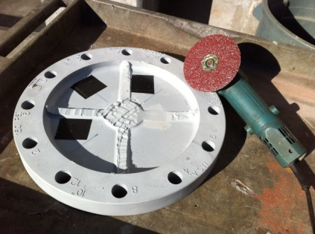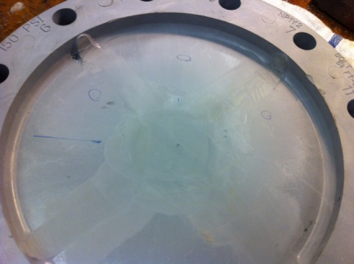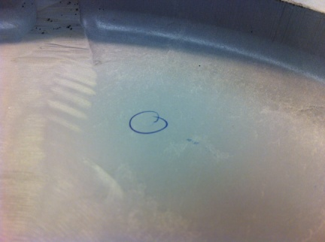
The 3 connector locations were hand sanded with 120 grid in a circular pattern to maintain the original flatness of each spot. This was followed up with 240 grit to provide a very fine surface finish appropriate for oring seals. These spots were then protected by a reapplication of tape.
P2
A rough sprue area in the middle of the inside surface was sanded flat as well.
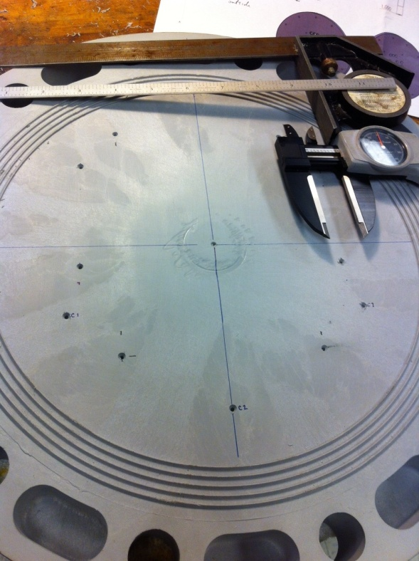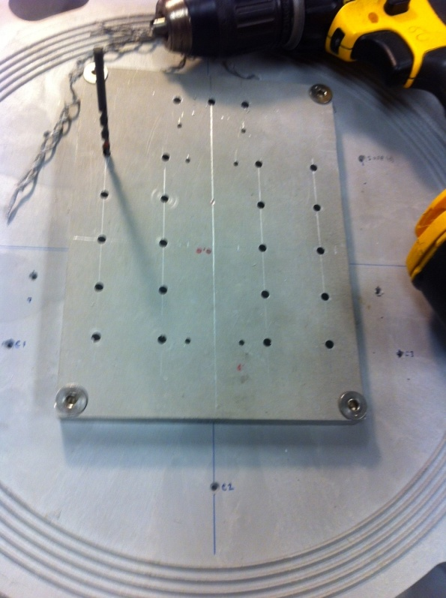
ALUM 6061 HEAT TRANSFER PLATE-
The 4 key mount locations of the Heat Transfer Plate and the 3 Connectors were carefully laid out on the inside surface of the Blind Flange. Likewise, the corner mount holes and the Cu/Ni rod mount locations were laid out on the Transfer Plate. In both cases, note the Center Reference Lines from which all dimensions were referenced. Since the Plate was cut with a bandsaw, the edges are not perfectly flat and edge to edge dimensions are not accurate enough to serve as a ref. for the many holes, working outward from the 90 deg. Center Ref. lines allow much more accurate dimensioning.
Just .128” dia. pilot holes were drilled in the transfer Plate for now. Likewise, just 2 of the 6 x 4-40 pilot holes were drilled for each of the 3 Vicor power supplies we have in our design.
PILOT HOLES IN THE PVC END PLATE-
Since the PVC Flange is just .85” thick, great care must be taken when drilling pilot holes for the ¼-20 mounts for the Plate and stand-offs, these cannot be allowed to pass thru, so they were carefully depth

P3
controlled to 0.65” inch and Bottom tapped to 0.55”. A regular tap is used first then a bottom tap to gain a few more threads.
The transfer plate was mounted then the pilot holes served as a very good drill guide for drilling .125” pilot holes thru the PVC flange for all 23 of the Cu/Ni rods required by our design.
½-20 THREADS IN THE HEAT TRANSFER PLATE-
The Transfer Plate was removed for additional work. The Vicors were mounted so the balance of the 4-40 mount screws could be accurately located with a transfer punch.
The 23 x ½-20 threads were drilled and tapped. Note using the drill press and a spring tap guide to maintain perpendicularity. A similar procedure was used on the many 4-40 threads.
The 3 connector 1/2-20 threads in the PVC end plate were also done similarly to maintain perpendicularity which is required for a proper face seal. Note the tap guide.
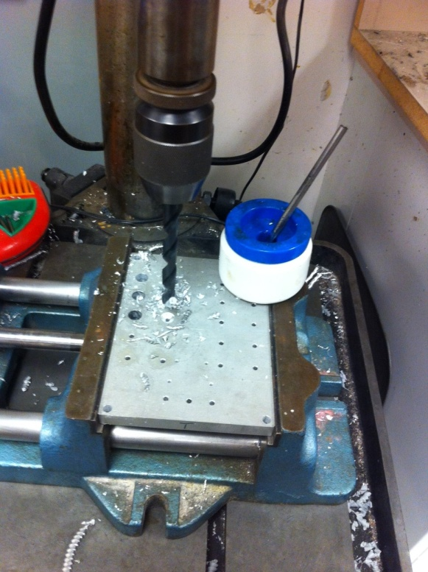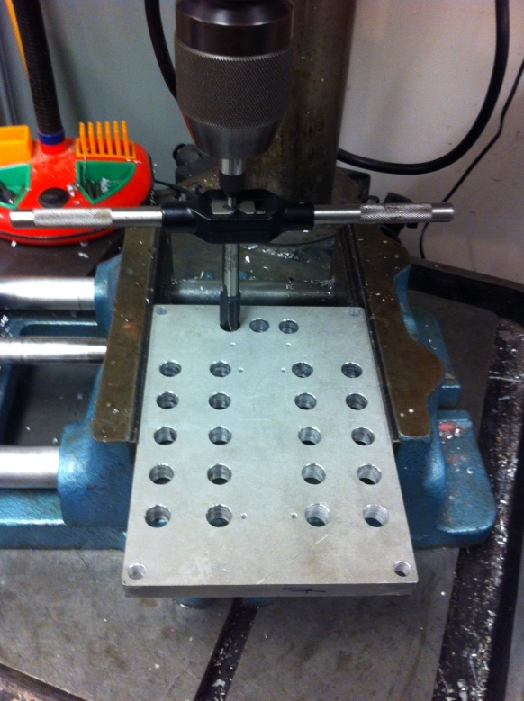
END CAP CU/NI ROD CLEARANCE HOLES-
It is very important to securely hold the PVC Flange down when enlarging the holes for the 23 Cu/Ni rods. Note the large clamps which were moved for each hole. A small pilot hole helps but large drills, 0.562” here, have a strong tendency to grab the work and cause damage. The drill was run slowly with a vertical bobbing motion only letting the bit remove a small amount of material with each contact. This operation is virtually impossible with a hand held drill. Take your time and work carefully.

P4
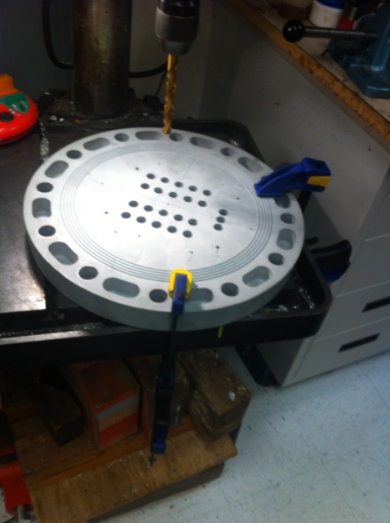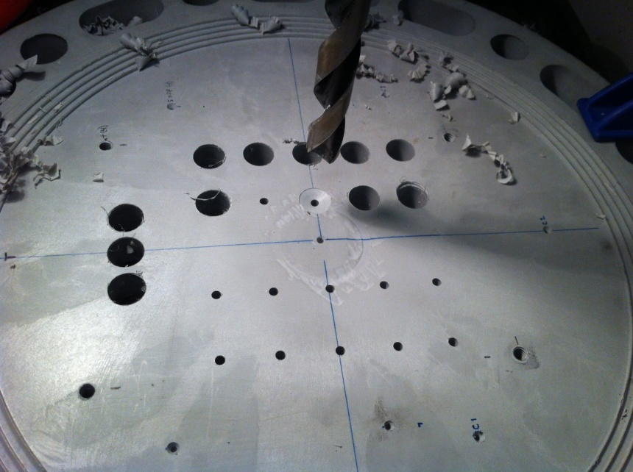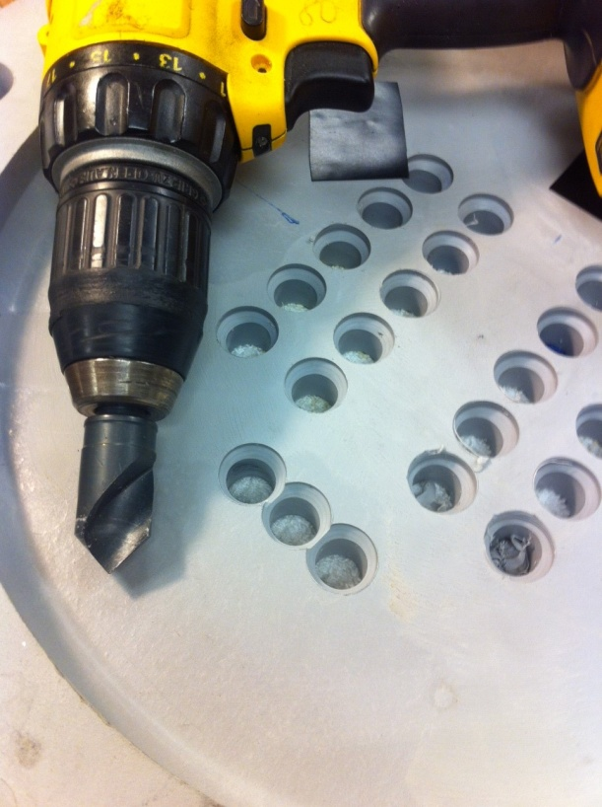

The outer surface edge for each Cu/Ni rod hole was countersunk ¾ x ~0.25 “ to allow a better penetration of the epoxy seal around the rods in a forthcoming step.
CU/NI RODS-CUTTING AND FIXTURING-
Our application indicated the use of 23 x 5” rods, 0.5” diameter with a ½-20 thread cut into the last 0.7”. A large band saw with fluid cooling was set to ~300 ft/min. Cu is a “gummy” material and resists being cut with dry small toothed saws. DO NOT hand hold while cutting. It can also be cut with a wet abrasive cut-off saw.
A fixture was required to hold the rods vertically in a vise for threading. Alum is preferred due to better friction and less clamping pressure. A block ~1” x 2” x 4” with a flat bottom and sides was selected. A pilot hole was followed by a ½” drill all the way thru. A bandsaw cut thru the hole and extending roughly an inch into the block was done as shown.
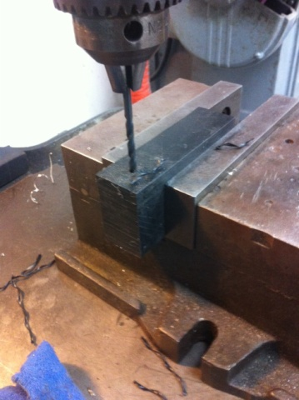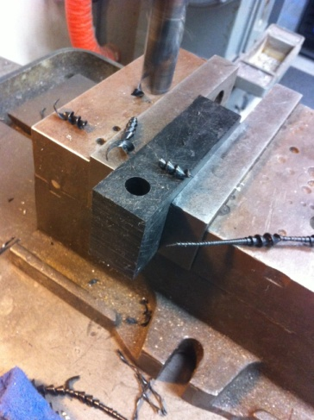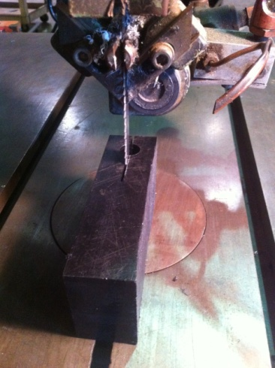

THREADING the RODS- P5
The drill press was NOT powered on. The jaws of the check were retracted giving a flat surface which was used as a way of applying pressure and keeping the threading die square to the rod held firmly in the threading fixture. This is important because if the threads are not square, the rod will not be square to the heat transfer plate and will not align well with the holes in the PVC end plate.
Just the 1st few turns of the die need to be aligned. Use a good (not worn) die with a good thread cutting lube. Care and patience yield good results.
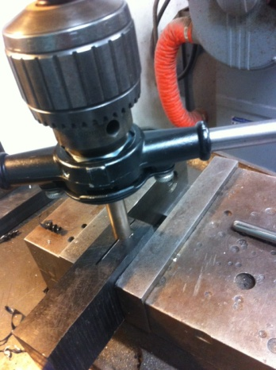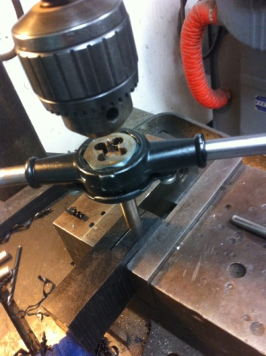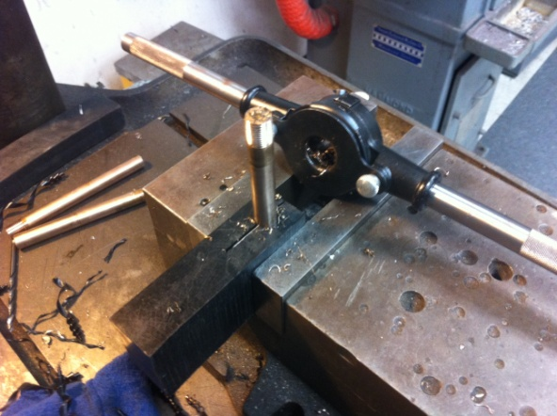

ASSEMBLING THE HEAT TRANSFER PLATE-
To help with heat transfer a heat conductive paste was applied to the threads before assembly. This material is common in electronics shops. We used DC 340.
The rods next need to be sanded, cleaned on the bonding surfaces, screwed in till just ~.005” or so proud of the aluminum surface, peened to lock their positions, then carefully sanded to a uniform flat surface. The electronics are mounted to this flat surface.
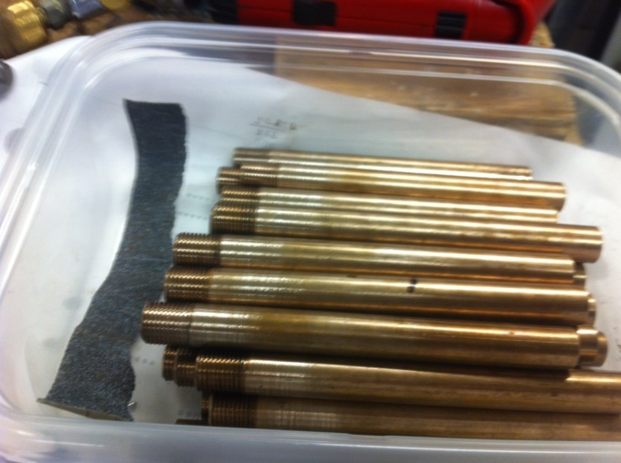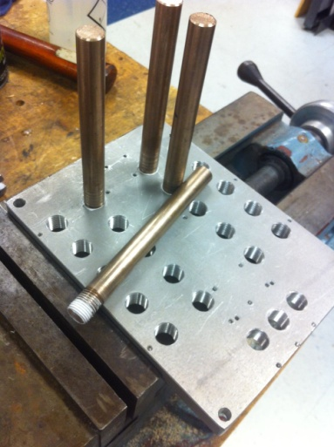

P6
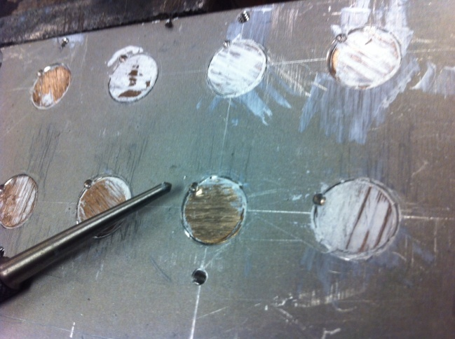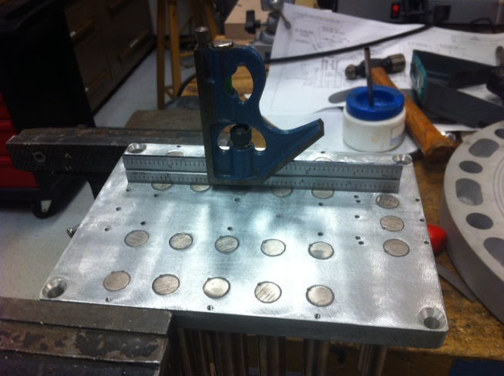
A small Center Punch was used to “peen” the rods. Several light passes with a disc sander worked well, and/or a flat orbital sander would work well too.
PREPARATION FOR SEALING AND ADHESIVES-
The epoxy bonding surfaces of both the PVC and the Cu/Ni rods need to be lightly roughened and solvent cleaned. The sanding was already done on the rods before installation.
A silicon seal bead was applied on the inside as a 2nd barrier as shown. We let that dry for a few hours, solvent cleaned the rods, then we used Scotch-Weld DP 105, a low viscosity, multiple substrate, flexible, quick setting epoxy for the external seal. A construction type sealant could be used for very shallow immersion, however they are messy and will not flow into the gap between the rod and the PVC.

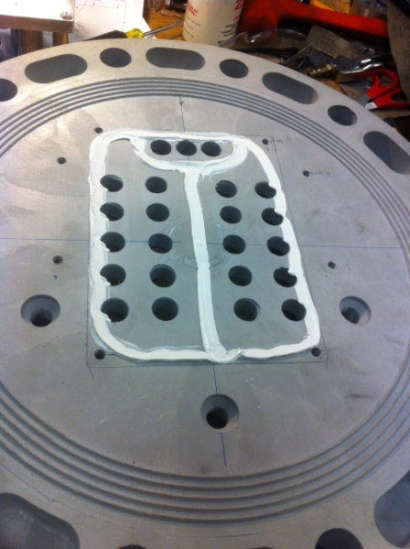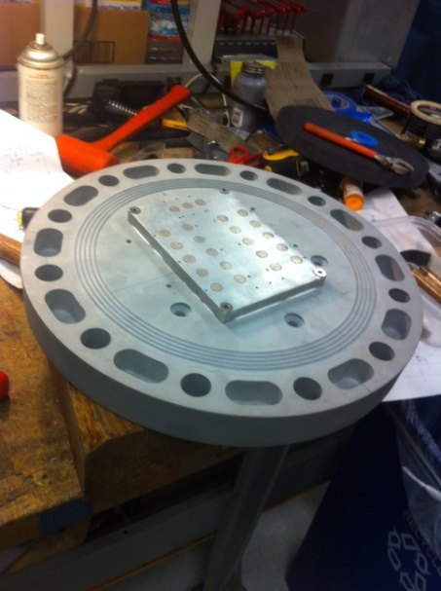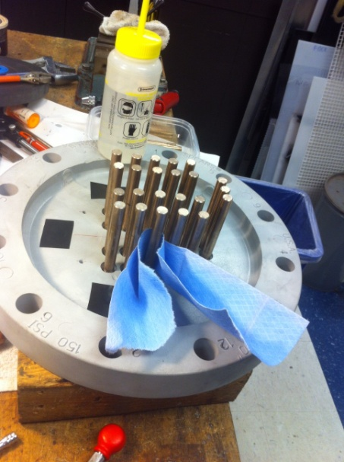
DP 105 EPOXY- P7
This epoxy is applied easily with the 1.7 oz. dual cartridges and mixing tube. I applied a small amount into the side of each hole so the epoxy would have a chance to flow into the gaps. 1st image. Applying too much would not allow air to leave making room for the adhesive. I continued moving from hole to hole in turn slowly filling each hole. This epoxy has only a 4 minute working time so at times it was starting to gel in the mixing tube. To restore the desired low viscosity, I simply pushed more material into the tube and let the thicker epoxy drip out as waste. Then continued adding a small amount hole to hole.
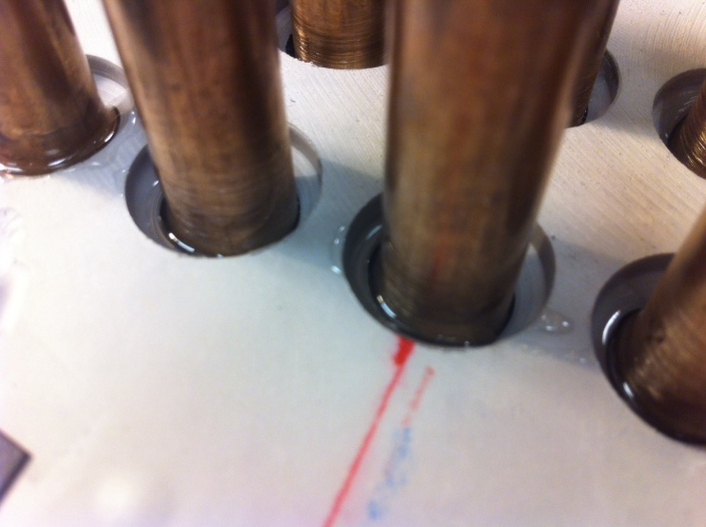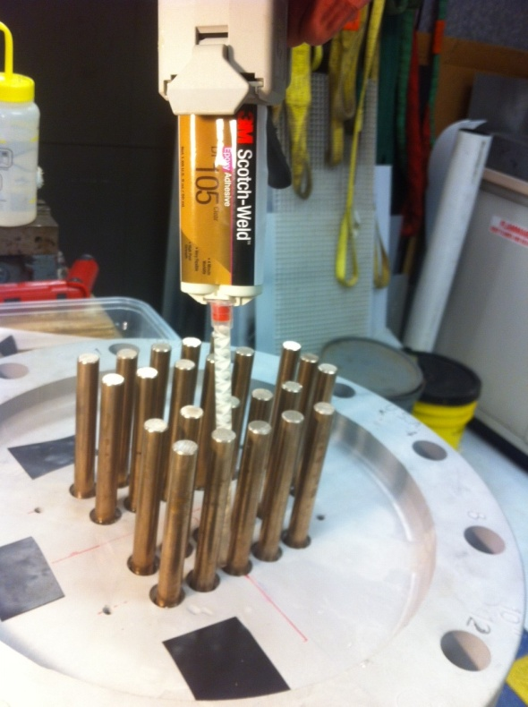
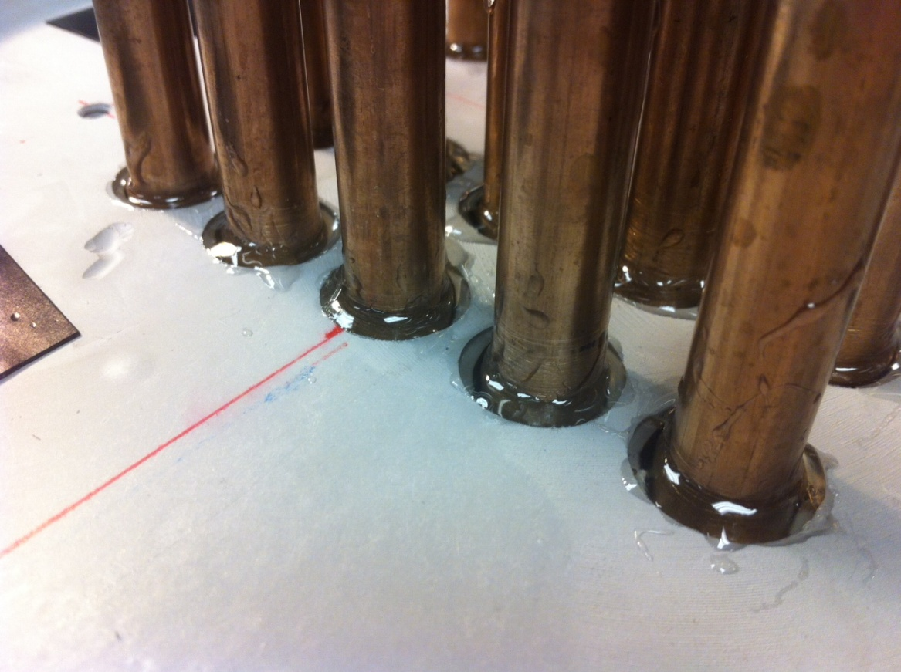 Finished with a nice bead.
P8
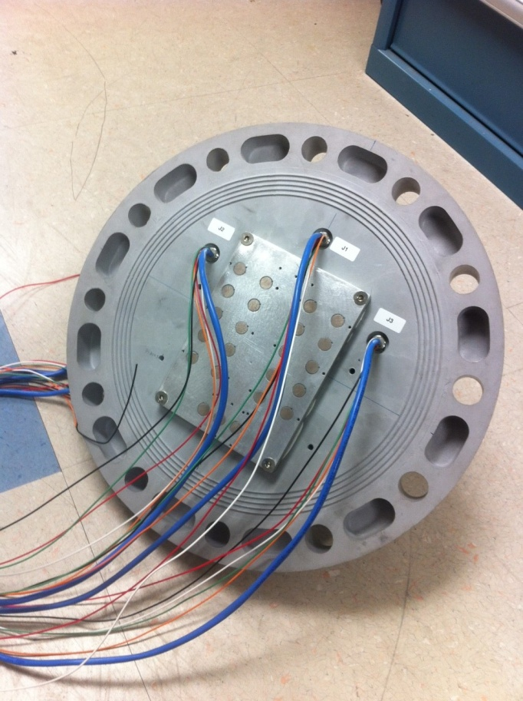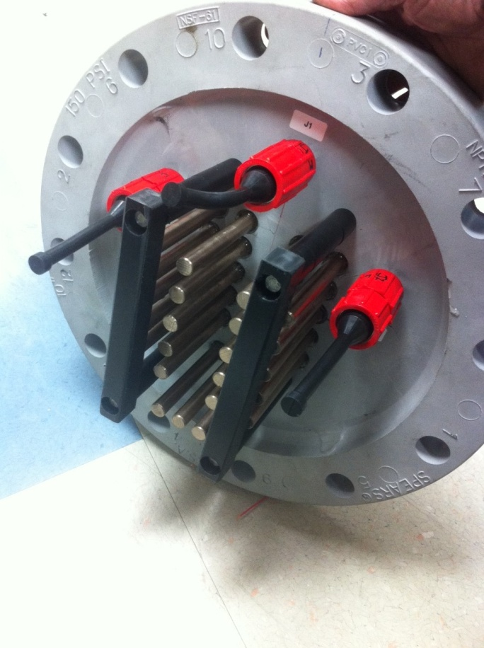
Finishing up with SubCon connectors and UHMW protective brackets (not handles) over the rods.
The installation of the internal electronics can proceed from this point.
-See also LARGE DIAMETER PVC PIPE ENCLOSURE ASSEMBLY in the MBARI swFOCE library for info on Van Stone Flange and similar PVC enclosures.

