TAILCONE SCREW INSERT INSTALLATION/REPAIR 10/15/13
Jim Scholfield
3M DP 100 Plus epoxy
Devcon 1 minute Epoxy Gel
P-200497-08.DWG
McM. 93090250 6-32 SS clinch nuts used as inserts
History-Some original ¼” inserts had failed when the syntactic foam fractured in a conical shape. 2 appeared to be an older fracture and the remaining 2 probably failed when Tethys hit the surf line 9/13. A repair was done and deeper ½” inserts installed.
Conical fracture areas or new surface sanded and cleaned.
3M DP100 plus was chosen for low viscosity, strong bond and a slight flexibility. A cork (sprayed with silicon) sealed up the center hole and scotch tape made a temporary outer edge. Overnight cure for strength.
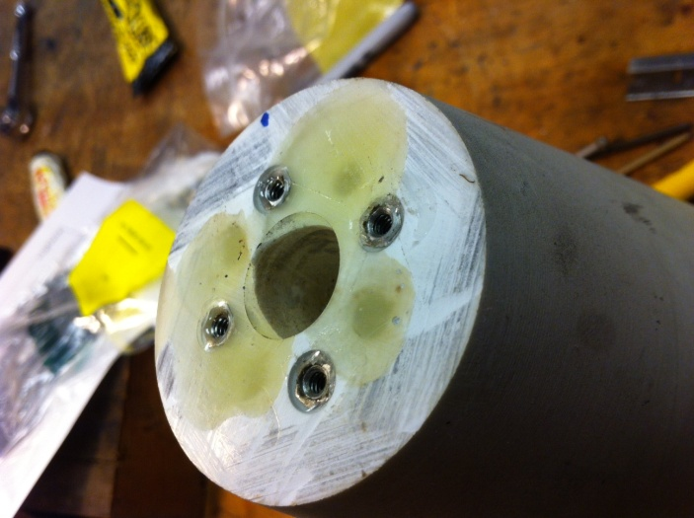
The resulting surface was milled/filed back to original deck height. This image shows the end result but this was a 2 step process.

The holes are on a 1.219” Bolt Circle, bored 0.221 dia. 0.65” deep. In addition a 0.060” deep counterbore provided room for the head of the insert allowing for a flush finish. A mill was used to ensure accuracy.
Since the inserts were thru bored a short bottom seal of 1 minute epoxy was used and allowed to cure for an hour before installation.

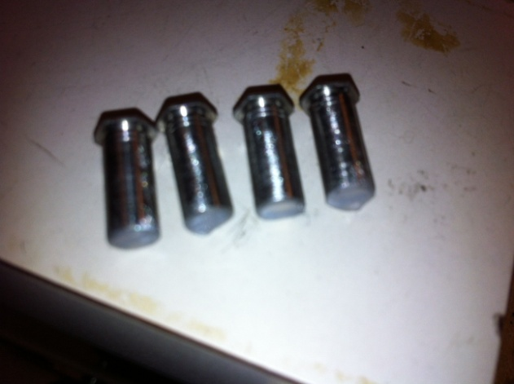

The 6-32 screws were silicon sprayed so no adhesion occurred in the next step.
This step aligns the inserts to the screws. The inserts were threaded on a few turns so the black plastic bearing carrier could be spaced away from the tailcone. A 0.1” spacing worked well. A small amount of DP 100 plus was placed in the hole and on the inserts, work quickly, only a 4 minute work time.
Align and push the inserts into their respective holes with a slight twisting motion, push all the way in with the screw heads and hold for a few minutes till the adhesive starts to set. Air in the hole could push the insert back out. In 20-30 minutes make sure the screws can be turned without twisting the insert. Let set overnight. Remove screws, file or mill mating surface flat, reassemble.

