swFOCE THRUSTER MODIFICATION -revised 8/3/15

Navigator Trolling Motor, 35lb. thrust, 12VDC, 120Watt, Model 3500, Stainless Steel version, ~$670
MarineTech Products. They are available from many sources, Amazon, Cabela’s, etc.
They are designed for extended operation in Salt Water so some of the exposed parts (shafting, cotter pins) are made of Stainless Steel. These units however are only designed for 1-2 ft of submergence so the shaft seals are likely the most common type, 5 psi across the seal. We modified the thruster by replacing the outermost (of two) shaft seals with one designed for 50 psi to allow use in salt water up to 30 meters deep. We found a SKF seal of the correct size, .375” ID, .75” OD, .25 Deep, StainlessSteel Spring. Additional sealing was also done. Additional flat seals, if necessary- AS568A 041
Tools and Parts-
- SKF seal P/N 3689 or equiv. ( CRW5 R),
-1/16th MNPT to tube adaptor (SwageLok SS-400-1-1, or equiv.
Device for providing 10 psi, MityVac or equiv.
-offset screwdriver or tool as pictured,
-silicon or waterproof grease
-small soft blow hammer
-1/4” nut driver or socket
-RTV silicon sealant, ,
- LocTite Gasket Sealant2, Modified proc.
-protective gloves
-self fusing tape, 3M Scotch 70, 130C (or equiv.)
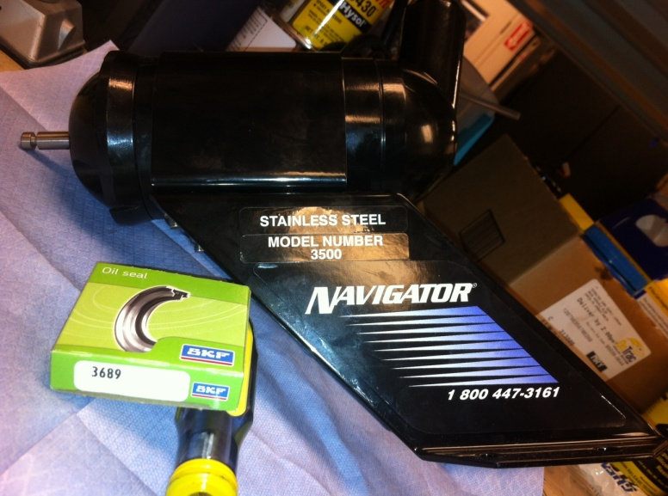
P2
Procedure-
-Add some alignment marks for easier reassembly, front and rear seals
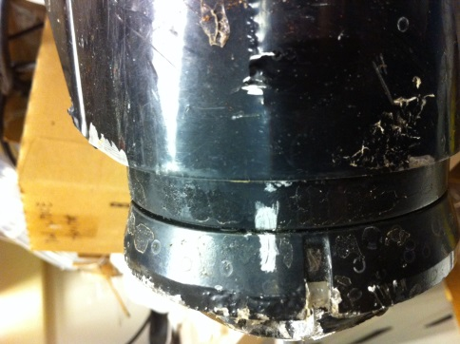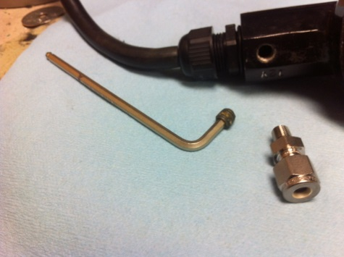
-remove the allen 1/16th MNPT plug on the inside of the wire entry section of the rear cover. It may be very tight.
-Remove 2 ass’y bolts on the front cover.
-Lube motor shaft lightly to minimize damage to seals
-Holding shaft steady so motor does not move (Other end has the brushes and should not be pulled apart), slowly with a twisting motion slide the front endcap away from the housing. Continue till completely off the shaft.
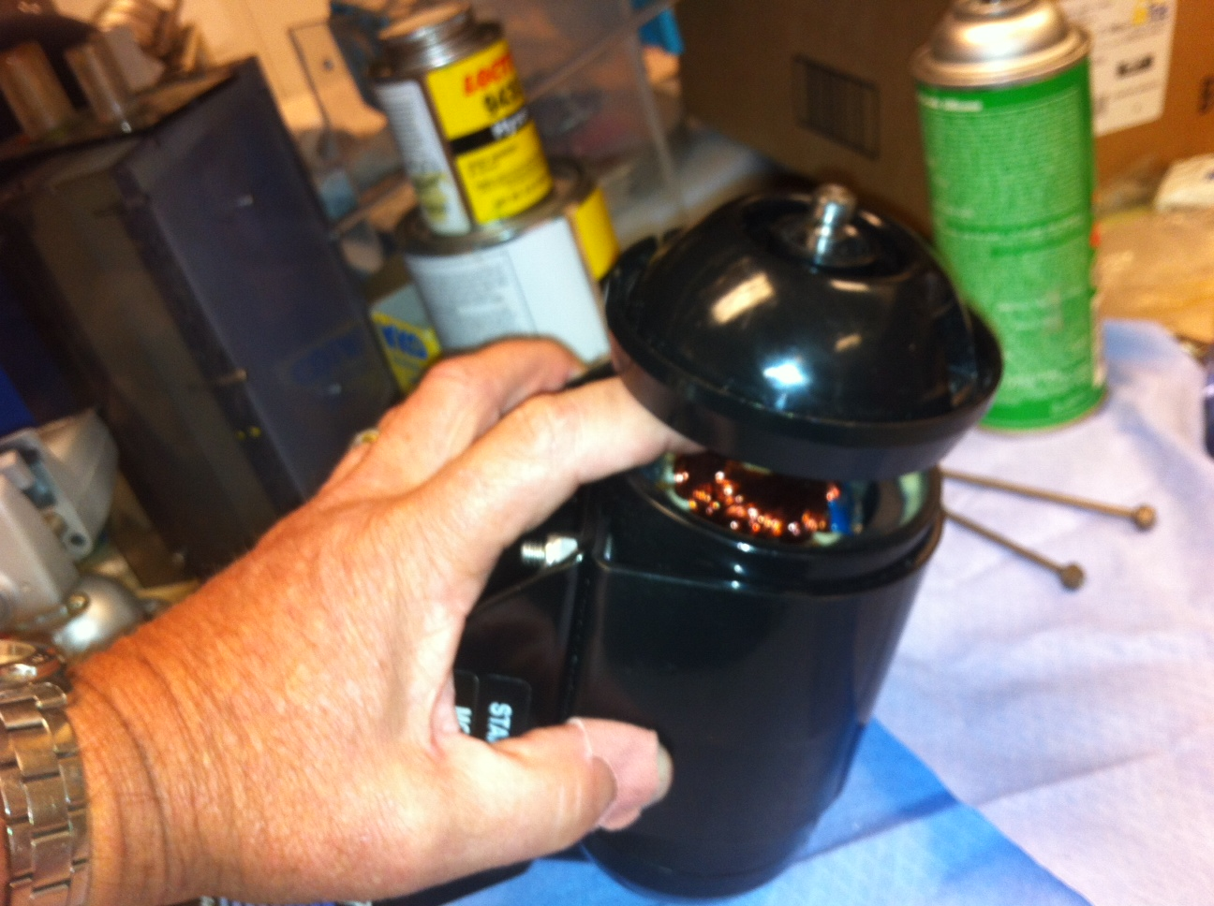
-Make sure any spacers (fiber and Steel washers) that may have stuck to the inside of the endcap are placed back on the shaft.
P3
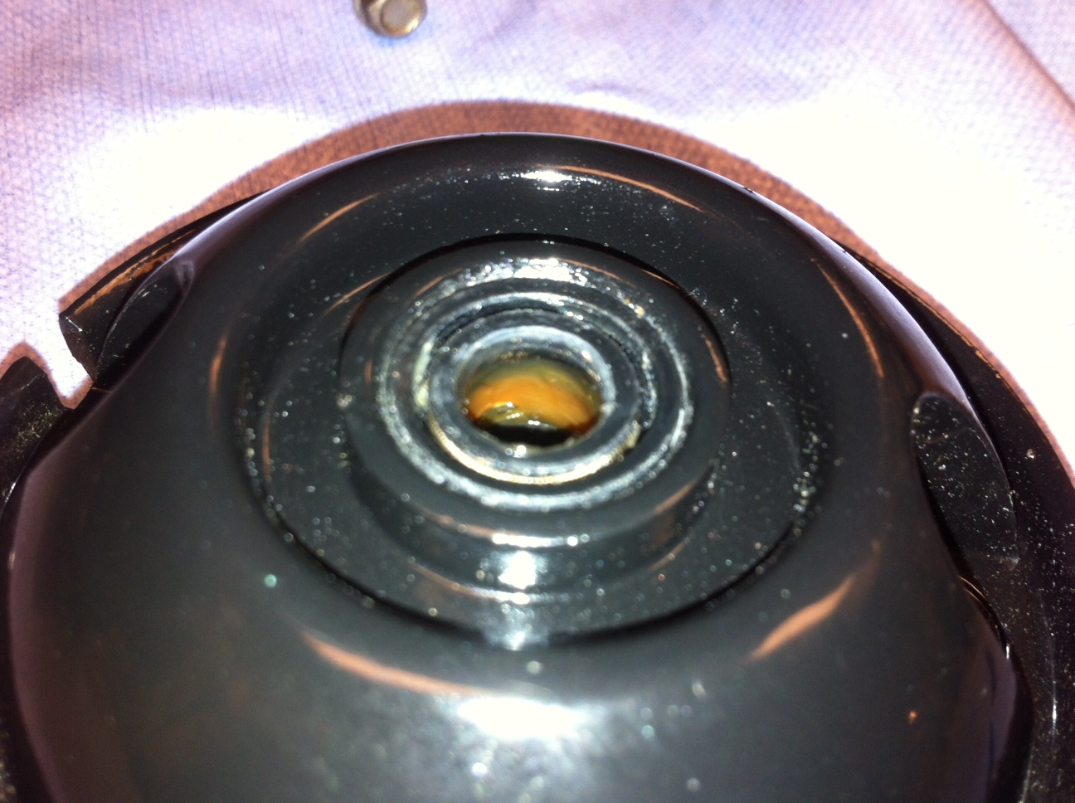
Original seal- NOTE: lip and spring are towards the water (pressure) side.
The water pressure increases the seal effectiveness, new seal must be installed identically.
Remove the original seal- The seals are a tight fit when installed so they require some prying to remove. Be careful not to damage the housing seal wall area. The original seal will be destroyed, note the spring popped out. I pried in several directions before it started to move. A small screwdriver works too.
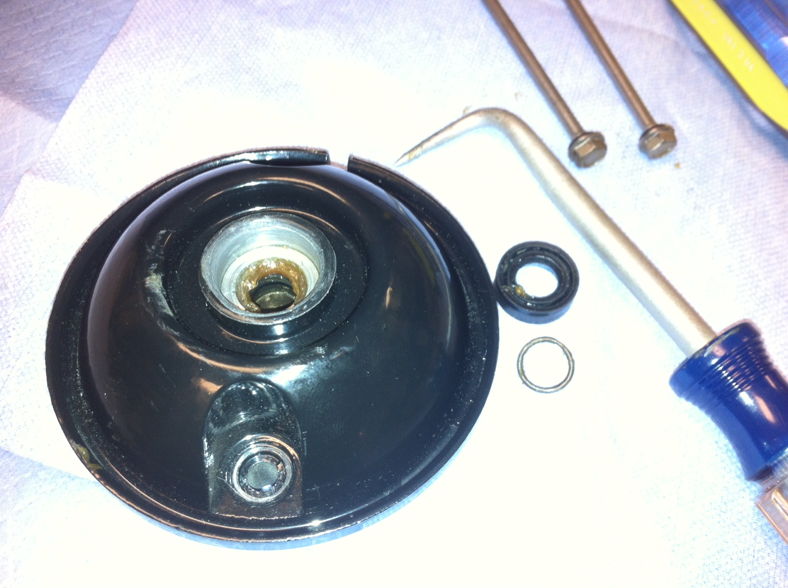

Do not damage the inner (2nd) seal.
P4
Install new shaft seal-
-add a thick film of Silicon grease in the cavity.
-Orient seal with lip and spring visible to the outside
-Drive carefully, square and evenly, the flat back of a large socket works well, using a soft blow hammer until fully seated.

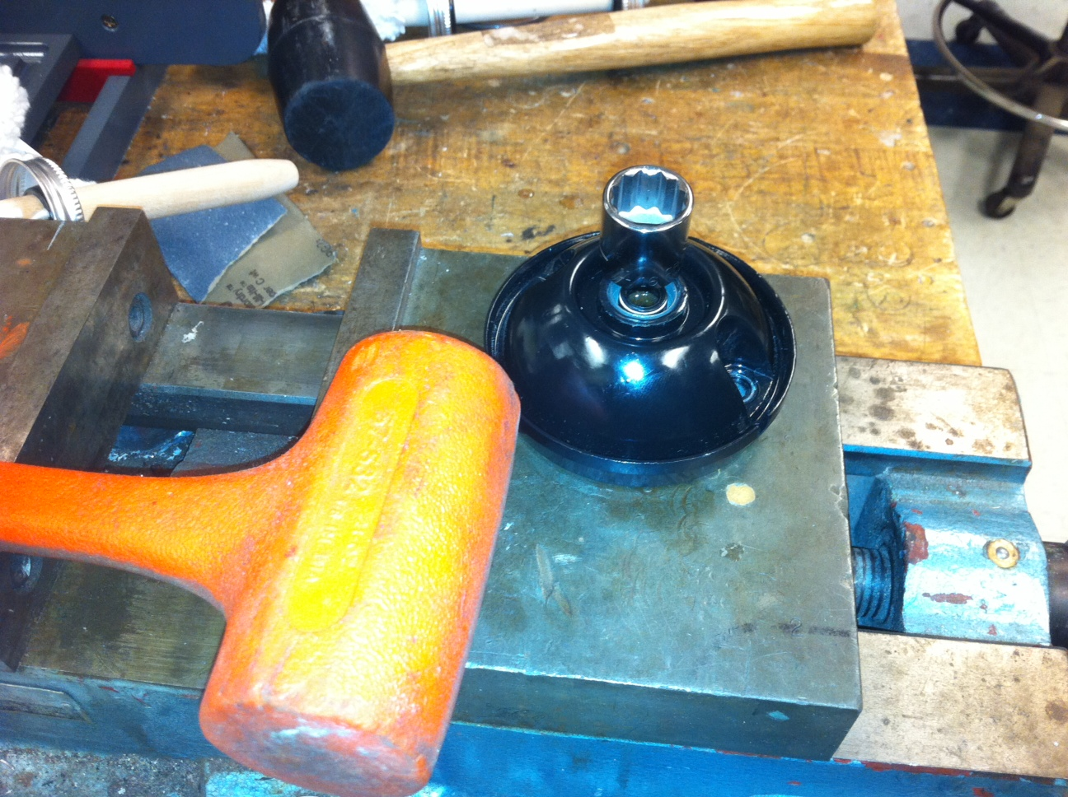

P5
Additional Sealing -
The wire compression seal, body flat seals , the small 1/16th NPT plug and the ass’y bolts are all additional leak points.
-If you wish to reorient the wire, this can be done carefully at this time. No need to crack the rear seal if not reorienting the wire.
(Placing the motor with the shaft down against a firm surface, tap on the body to crack the rear seal. Do Not pull the rear cap, you will pull the brushes off of the commutator because the rotor is held strongly by the magnets. ( If this happens pull the rotor out of the magnet housing, reassemble the brushes to the commutator, then reassemble holding the rotor shaft firmly as it enters the magnet housing.))

Reassembly-
-Lightly lube shaft, Hold whole assembly so back cover does not fall off, same basic procedure as when removing the front cap.
-Note the orientation of the gaps in the magnets in the main housing where the bolts gain access to the threads in the rear endcap. Alignment marks a big help here.
-with a twisting motion slowly slide endcap back onto shaft, line up with the gaps
-Make sure the flat rubber ring seals of either endcap(s) is not twisted, Note front seal is in a groove.
Note on inserting the bolts, a little grease on their threads and rubber seals. Align marks - carefully slide and twist endcap and move bolts till they engage the threads.
Before tightening the bolts, Introduce a bead of Loctite Gasket Sealer2 smoothly around the entire outside of the flat seal area, both covers. Not necessary to smear on rubber seal sides, wear gloves as this material is messy but can be removed with Acetone.
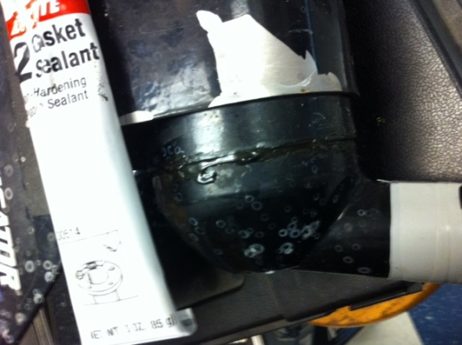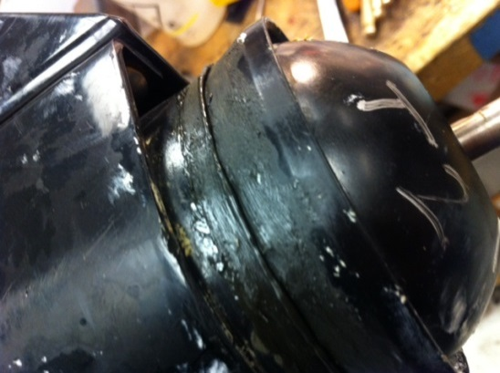
Similarly, cover the front seal with Gasket Sealer2, image shows sealer after bolts tightened.
P6
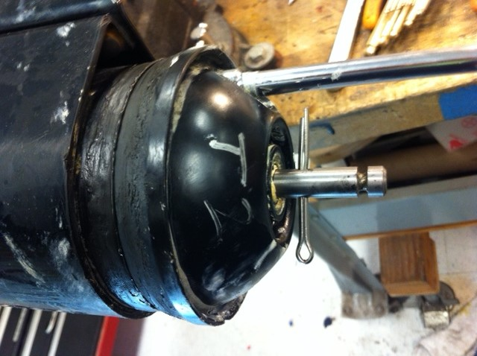
- NOTE: when reassembling, use shaft pin or cotter pin thru hole in shaft to allow turning the shaft manually to maintain easiest motion when aligning and tightening case bolts. The slightest misalignment will cause binding, easy to sense when turns freely.
NOTE: Gasket Sealer beading out of the gap as the case bolts are tightened, this provides an extra seal.
Fill lip gap on shaft where spring is with silicon grease, helps decrease corrosion of the spring.
Test -Motor should run normally and identically to performance prior to seal change, Do not run “dry”, except for quick check for a few minutes, seal needs lubrication.
-unscrew the wire seal nut, squeeze in a bit of RTV or gasket sealer and distribute over the wire and rubber seal
-reassemble, carefully wipe the outside clean and wipe with a mild solvent like alcohol

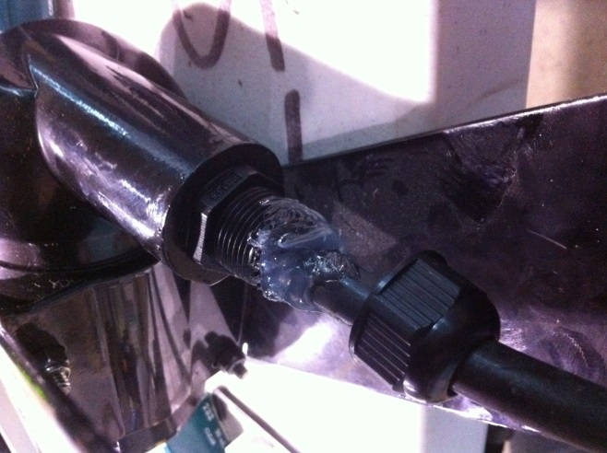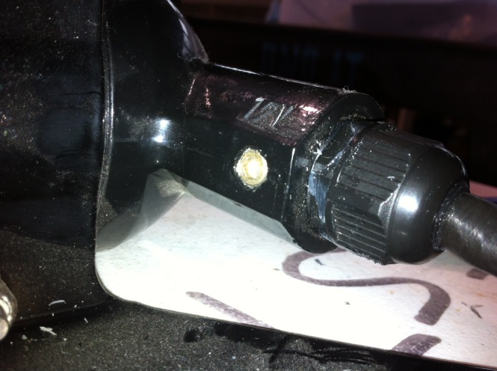

Bubble Leak test- p7
Using the A SwagLok SS-400-1-1 NPT to tube adaptor ( or equiv.)
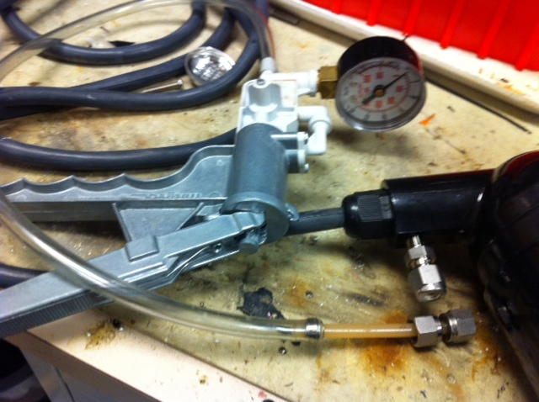
Using a MityVac or equiv. device, apply 5-10 psi.
Squirt a soapy solution over the seals and wires and observe for leaks in the form of small bubbles. Applying vacuum is not as good an indicator because the unit itself leaks so system does not hold a vacuum. If no continuous bubbles-
Dry unit-
-wrap the self fusing tape over the wire seal and housing rear seal, follow manufacturer’s directions. Generally, zero tension on the 1st wrap then 50% stretch with half laps until the last zero stretch wrap.

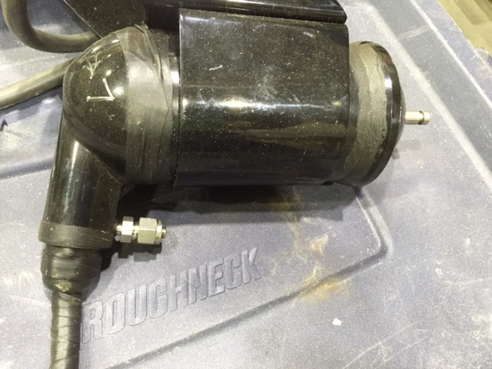
P8
2 different types are shown, either will work. ( Grey is high voltage.)
The tape on the rear seal prevents the rear seal from extruding out of the gap.
The Modification to this procedure using Gasket Sealer2 , bubble checking and applying self fusing tape was done when several units had slow leaks.

Installed in duct housing in the MBARI shFOCE thruster housing
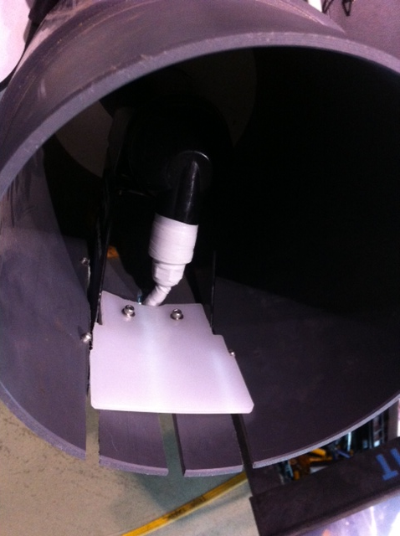

NOTE about choice of sealant: Use of grease and Fast Cure 5200 directly on the flat seals acted as a lubricant and the rear seal extruded out of position causing instant leaks. Use of an oring did the same thing. The front seal is captured so was not a problem in this way. 5200 is an excellent sealant but is extremely messy and had the above effect as well . It did not set up even overnight when applied directly to the seals, lack of air in that location perhaps. Use of Silicon RTV could work in place of the preferred LocTite GasketSealer 2, but has the disadvantage of destroying the adhesion of the self-fusing tape at the rear seal location. GasketSealer 2 is very thick and works best in a bead type application so does not form a film on surfaces the way a grease does. It did not work well when we tried smearing a film on all sides of the flat seals. Spreading a small bead at the body (and wire) seal locations then tightening the bolts formed a nice outer seal. It can also be easily removed with acetone.

