xFOCE Mechanical Design Trade-offs 3/27/12

ENCLOSURE MAT’L- Attributes - clear for good light transmission, strength, workability
Polycarbonate-colored or clear
-nearly unbreakable
-relatively easy to fabricate,E.G. drilling, tapping, however, sawing difficult. Holes can be drilled/tapped with good results <0.5” from edges
- Overall perpendicular visible light transmission good ~86%, about 5% less than Acrylic
-UV transmittance falls off rapidly at about 350nm, about the same as general purpose Acrylic. Note: in SeaWater, 300nm UV is 99% attenuated @30m, 350nm @87m, 400nm @ 220m, so some UV can penetrate deeply into the photic zone.
-yellows more quickly than acrylic when exposed to daylight UV.

Acrylic- colored or clear
-tougher than glass but will break easily at stressed points
-harder to fabricate- cutting, drilling needs to be done carefully with a non-solvent based cutting fluid paying special attention to heat generation.
-holes should be >0.5” from edges to avoid breakout
- Overall perpendicular visible light transmission is very good, 92%
-UV transmission of general purpose Acrylic falls off rapidly at ~350 nm however a version is available, G UVT, which has a 275 nm cut-off when this aspect is important, especially in shallow deployments.
-less yellowing effect when exposed to daylight UV
-can be bonded with methyl chloride, or easily obtainable Weld-On #16
NOTE ON FABRICATION- drilling holes in plastics, polycarbonate and especially acrylic can be difficult because the drill tends to grab and “dig” into the material. Modify the cutting edge of the drill’s flutes by filing or sanding the cutting edge to a more vertical “scraping” edge. Keep it sharp and a very nice hole without breakout on the back surface will be the result. See image.

p.2

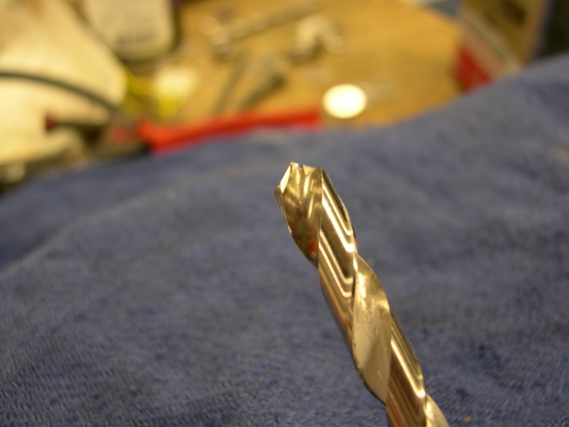
Drill bit mod for plastics

FRAME- Attributes – strong, light, corrosion resistant
FRP-fiber reinforced plastic (fiberglass) – easily worked material that is available in structural shapes like angles, sheets and round or square tubes. Almost impervious to SW.
-FRP is destructive to tooling so cutting/boring tools need to be replaced often as they become dull. Does not hold threads very well, sheet metal screws can be used in >.25 “ thick materials
6061 Aluminum- if Anodized, holds up well. Corrosion issues when in contact with SS fasteners, insulating washers help.
PVC – can be obtained some places. Common shapes are sheets, bars, tubes, some sizes of angles. Can be found in a clear version so when angles used for reinforcing edges, less blockage of light.
-PVC is easily fabricated and can be drilled/tapped easily. Can also be bonded. It is not as strong as FRP.
UHMW-nearly inert in SW, easy to fabricate, common shapes are sheets, bars, rods. Lighter than SW.
Any of the plastics can be obtained in black to preclude light transmission and improve resistance to UV degradation when at or very near the surface .

LATCHES - sturdy, corrosion resistant, easy for diver to manipulate
-Cabinet type, SS. ,
-Block and pin, plastic SS
- fabricated custom design-cam lock, single or paired

HINGES - sturdy, corrosion resistant
-piano type, SS
-solid rubber, 1/8-1/4” thick, screwed in with facing plate

THRUSTERS – hi reliability, select appropriate thrust/GPM rating, convenient power req. (AC/DC, Watts?), easy to control, cost
-Small Boat Submersible Bilge Pumps, At shallow depth most any of the big names should work. (rule, attwood, lovett, Johnson, jobsco...) They are very inexpensive, get the non-auto on/off. They may, however, have to be changed out every few months. They are not designed for constant use. 12,24,36 VDC. Largest flows available are 3500-4000 GPH for ~$200. (Flow ratings are with 0 head or backpressure).

CrustCrawler 400 HFL - $600, 0-50 VDC, 400 watts, lip seals, 300 ft

Technadyne Model 520 DC Brushless - $3700, 520 Watts, various voltages available, analog or digital control, magnetically coupled prop

ANCHORS – auger types easiest, Plate type “earth anchors” need to be dug out to retrieve.

-Screw-It Beach anchor, removable handle, Corrosion resistant - $70, RoxyMarineMart

-Ironwood Pacific – 21”, 4” helix, powder coated steel, $40 each

-Helix – set of 4 for $23. MilSpec Anchors

-Triangular earth Anchors with Galvanized cables, set of 4. ~$40

-Corkscrew Types probably OK in stiffer soils

Ducting – Most often used for air handling. Various kinds of plastics with copper, steel wire or urethane reinforcement. 2 “ - 12” diameter, various pressure/vac ratings.

E.G. of FOCE Test Chamber Fabrication- Use of these materials maximizes light transmission into the test chamber.

-1/4” Clear Acrylic Panels

-3/16” x 1.5” x 1.5” clear PVC angle used as outside support structure.
-3/16” x1.25” x1.25” clear PVC used inside.

-8-32 x 5/8” screws tapped into inner PVC pieces, 6”C/C.

