OCEAN ENGINEERING DEPARTMENT
ELECTRICAL FABRICATION WORK REQUEST
Procedure:
- Rename document, updating italicized text below and removing request rev:
YYYY-MM-DD Project X.X JOB DESCRIPTION Work Request Rev1.00.docx
2022-03-21 DOT Buoy 1.0 SN4 Wiring Harness Assembly Work Request Rev1.00.docx
- Fill out table, file paths (if on OE server), and work description below
- Print out request and drawings and deliver to technician along with any needed parts
- E-mail this document and drawings to technician and to OE Dept Head
(this procedure list can be deleted to make more space for work description below)

Originator | Brenton Salmi
Project | MARS2 – Inductor PCB
Job Description | Build QTY=6 & clean PCB’s
Submitted Date | 2024-10-04
Estimated Hours | 4
Desired Completion Date | 2024-10-09
Worktag | AC103988

Drawing file paths and names:

Altium Project
https://applied-physics-lab.365.altium.com/designs/C6927E92-64B6-45B6-9633-1B37E7A51055?variant=[No+Variations]&activeDocumentId=Top.SchDoc(1)&activeView=SCH&location=[1,97.45,22.31,28.87]#design

Work Description:

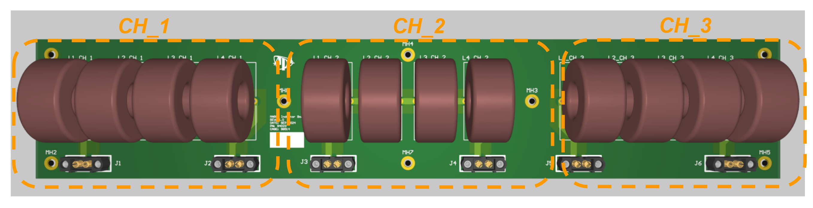

Build a total of 6 PCBs in 2 configurations:
- QTY=4 Fully Populated
- QTY=2 only CH_1 and CH_2 populated
  - CH_3 DO NOT POPULATE

Components Needed
- Loctite 271
- PCB Components
- PCBS

Installation Instructions

Installing the inductors

- Place inductors into PCB locations
- Solder inductors

Installing connectors

- Coat Harwin connector 2mm screws (threads) with Loctite 271
- Place connectors into PCB and tighten sufficiently each screw
- Solder connectors

Cleaning PCBs

Use IPA or appropriate flux remover to remove all of the solder flux from the PCB.

