OCEAN ENGINEERING DEPARTMENT
ELECTRICAL FABRICATION WORK REQUEST

Originator | Brenton Salmi
Project | MARS2
Job Description | Rework board to final version
Submitted Date | 10/17/2024
Estimated Hours | 4
Desired Completion Date | 10/23/2024
Worktag | AC103988

Drawing file paths and names:

- IPB 2.0 Altium 365 Page:
  - https://applied-physics-lab.365.altium.com/designs/5E0754B9-CAC2-48C8-9605-B51A46C520B0?variant=[No+Variations]&activeView=SCH&activeDocumentId=Top.SchDoc(1)&location=[1,98.47,15.41,19.94]#design

Work Description

High Level

- Components will be DNP’d
- Components will be installed
- Components will be replaced
- Flywire(s) added
- Clean Boards

This will be performed on a QTY=5 PCBA’s.

Board SN | Configuration | Notes
1 | IPB 1 | Channel D has prior rework. Please remove all prior rework and perform new rework.
2 | IPB 1
3 | IPB 2 (Requires Jumper Modification)
4 | IPB 2 (Requires Jumper Modification)
5 | IPB 1

DNP Component(s)

For ALL boards

REF DES | QTY Total
Q7_A  Q7_B  Q7_C  Q7_D | 4
R92_A  R92_B  R92_C  R92_D | 4

For boards SN:3 and SN:4

REF DES | QTY Total
R33 | 1
R37 | 1
R39 | 1
R3 | 1
R7 | 1
R11 | 1
R15 | 1
R19 | 1
R23 | 1
R27 | 1
R31 | 1
R4 | 1
R8 | 1
R12 | 1
R16 | 1
R20 | 1
R24 | 1
R28 | 1
R32 | 1

Install Component(s)

REF DES | Part Number | QTY Total
R104_A  R104_B  R104_C  R104_D | RHM220PCT-ND | 4

For boards SN:3 and SN:4

REF DES | Part Number | QTY Total
R36 |  | 1
R38 |  | 1
R40 |  | 1
R5 |  | 1
R9 |  | 1
R13 |  | 1
R17 |  | 1
R21 |  | 1
R25 |  | 1
R29 |  | 1
R34 |  | 1
R6 |  | 1
R10 |  | 1
R14 |  | 1
R18 |  | 1
R22 |  | 1
R26 |  | 1
R30 |  | 1
R35 |  | 1

Replace Component(s)

REF DES | Part Number | QTY Total
U21_A  U21_B  U21_C  U21_D | SN74LVC1G04DCKR | 4
R69_A  R69_B  R69_C  R69_D  R69_E | ERJ-3EKF4990V | 5
C26_A  C26_B  C26_C  C26_D  C26_E | 885012106017 | 5
R68_A  R68_B  R68_C  R68_D  R68_E | ERJ-3EKF3322V | 5
C25_A  C25_B  C25_C  C25_D  C25_E | 885012207103 | 5

Flywires

REF DES | Description | QTY Total
Q7_A Flywire  Q7_B Flywire  Q7_C Flywire  Q7_D Flywire | Flywire between Q7 pin 3 and R92 pin 1 | 4
R(Hysteresis)_A  R(Hysteresis)_B  R(Hysteresis)_C  R(Hysteresis)_D  R(Hysteresis)_E | Part Number: RNF18FTD15K0  This is placed across U7_x and achieved by soldering to pads on C26_x and R68_x. | 5

Q7 Flywire Details

- Make this clean and short
- Note that R92 will be DNP’d
- Stake use hot-glue when completed and board is cleaned

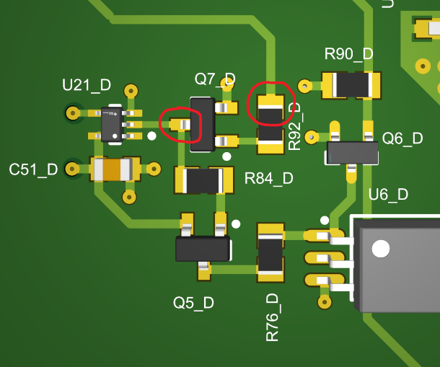

Flywire below is an example – please make this as clean and short as reasonable.

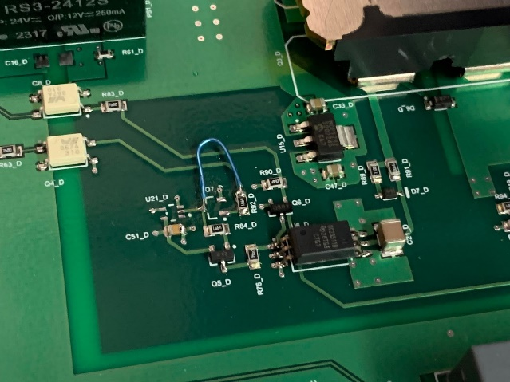

R(Hysteresis) Flywire Details

Note that this flywire contains a resistor and there are 5 locations with this modification:

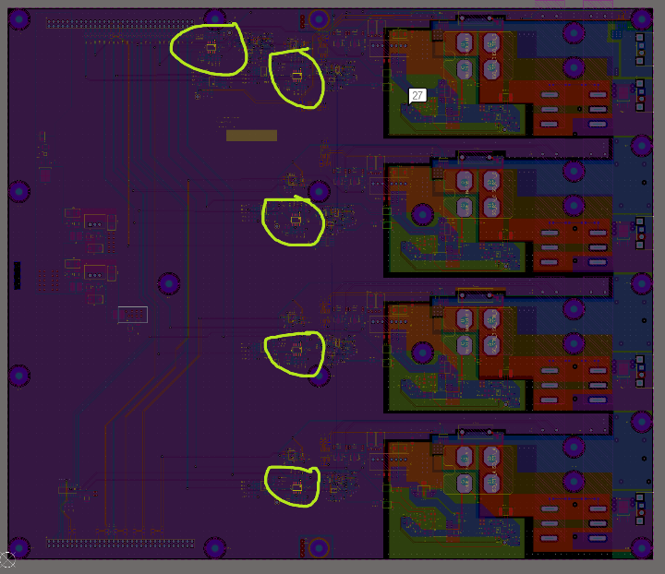

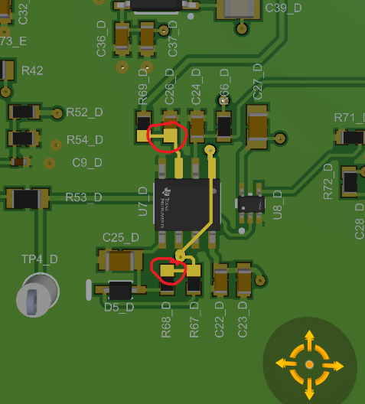

- Make this clean and short
- Stake use hot-glue when completed and board is cleaned

Prepare the resistor by splicing 32AWG wire to the terminals and encase in heat-shrink. Attach the resistor flywires between C26_x PIN1 and R68_x PIN2.
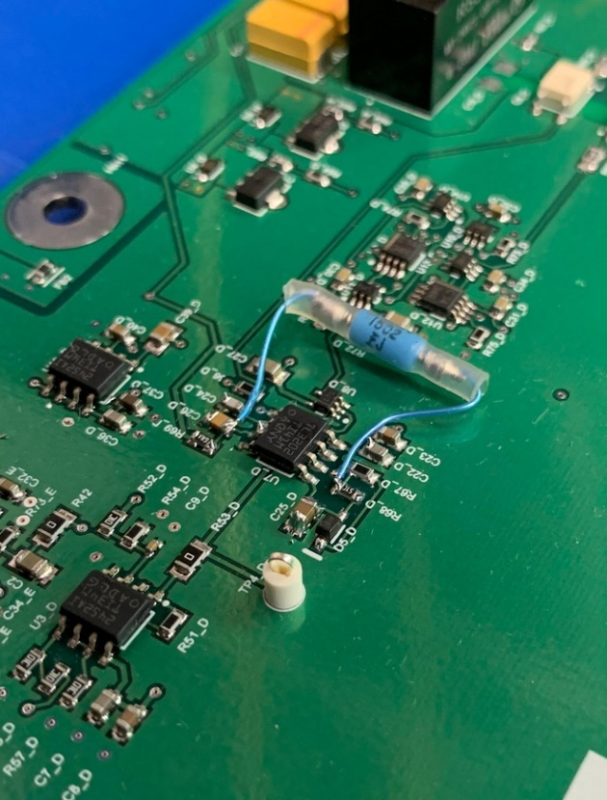

Cleaning The PCB
- Use IPA to clean flux
- Perform a general cleaning of the PCB both in the areas reworked AND all other areas. Pay attention to all through-hole components as these may have come back from the assembler without a complete cleaning.

