OCEAN ENGINEERING DEPARTMENT
ELECTRICAL FABRICATION WORK REQUEST

Originator | Brenton Salmi
Project | MARS2
Job Description | Rework board to final version
Submitted Date | 10/17/2024
Estimated Hours | 2
Desired Completion Date | 10/23/2024
Worktag | AC103988

Drawing file paths and names:

- BOB V2 Altium 365 Page:
  - https://applied-physics-lab.365.altium.com/designs/96784F5C-C826-43BF-A453-D7CE2F0ACD9C?activeView=SCH&variant=[No+Variations]&activeDocumentId=Coversheet.SchDoc(1)&location=[1,98.47,15.41,19.94]#design

Work Description

High Level

- Components will be DNP’d
- Components will be installed

DNP Component(s)

REF DES | QTY Total
TP1 | 1

Install Flywire(s)

- Use 30AWG for the flywires
- Stake the wires using hot-glue as appropriate

The final result should look something like this except that TP1 will be removed:
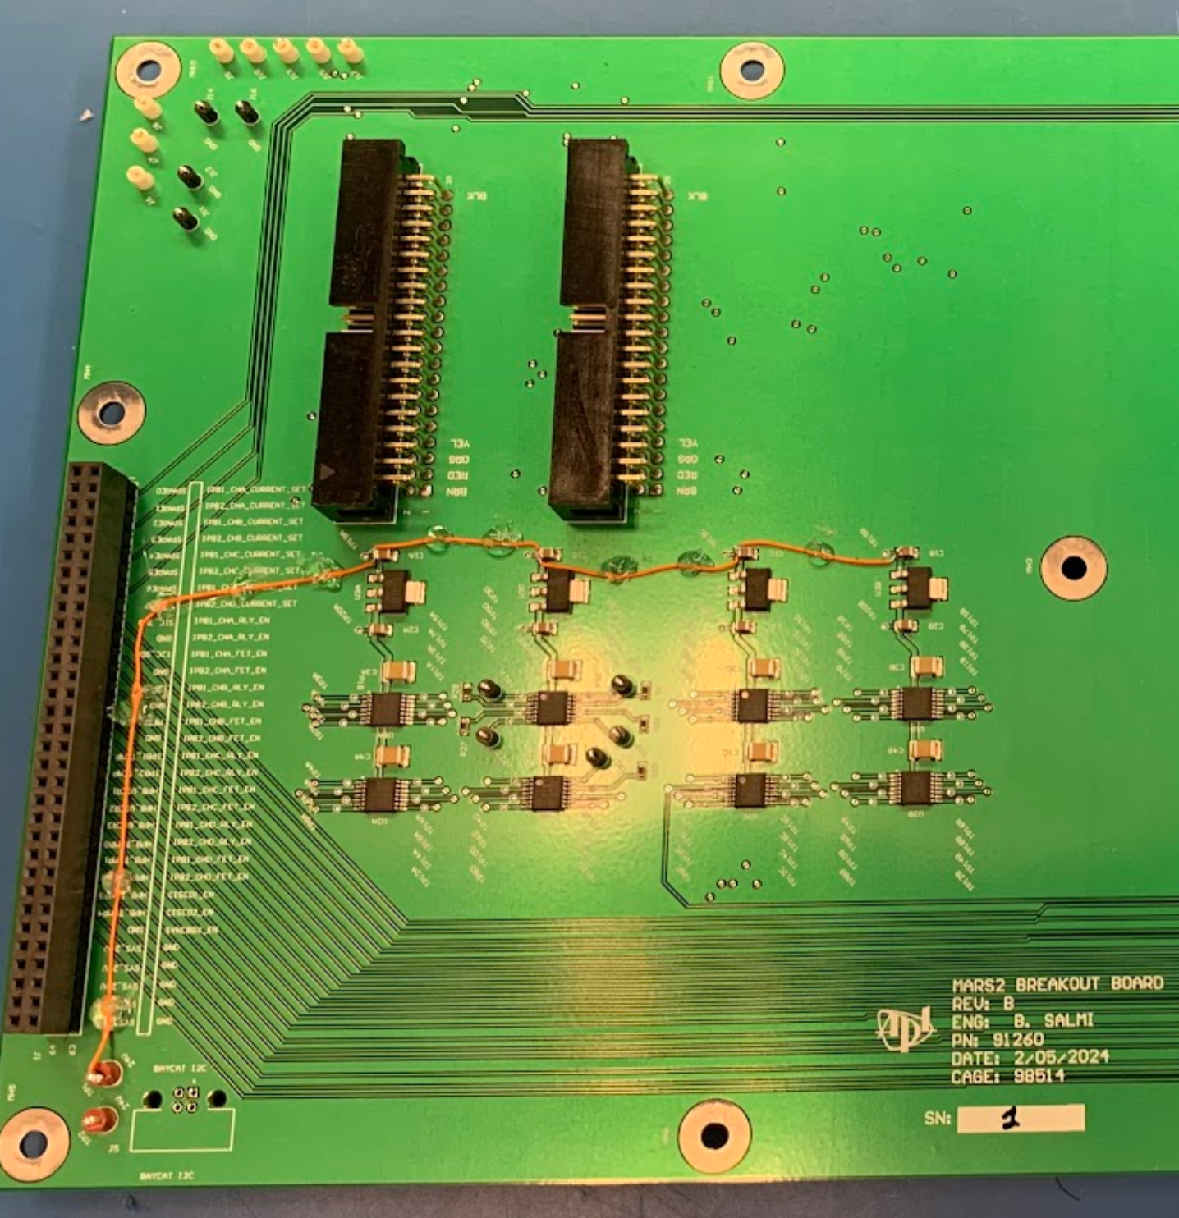

Between TP1 and C1A(PIN2 – TP19A)
Insert the flywire into the TP1 through hole.

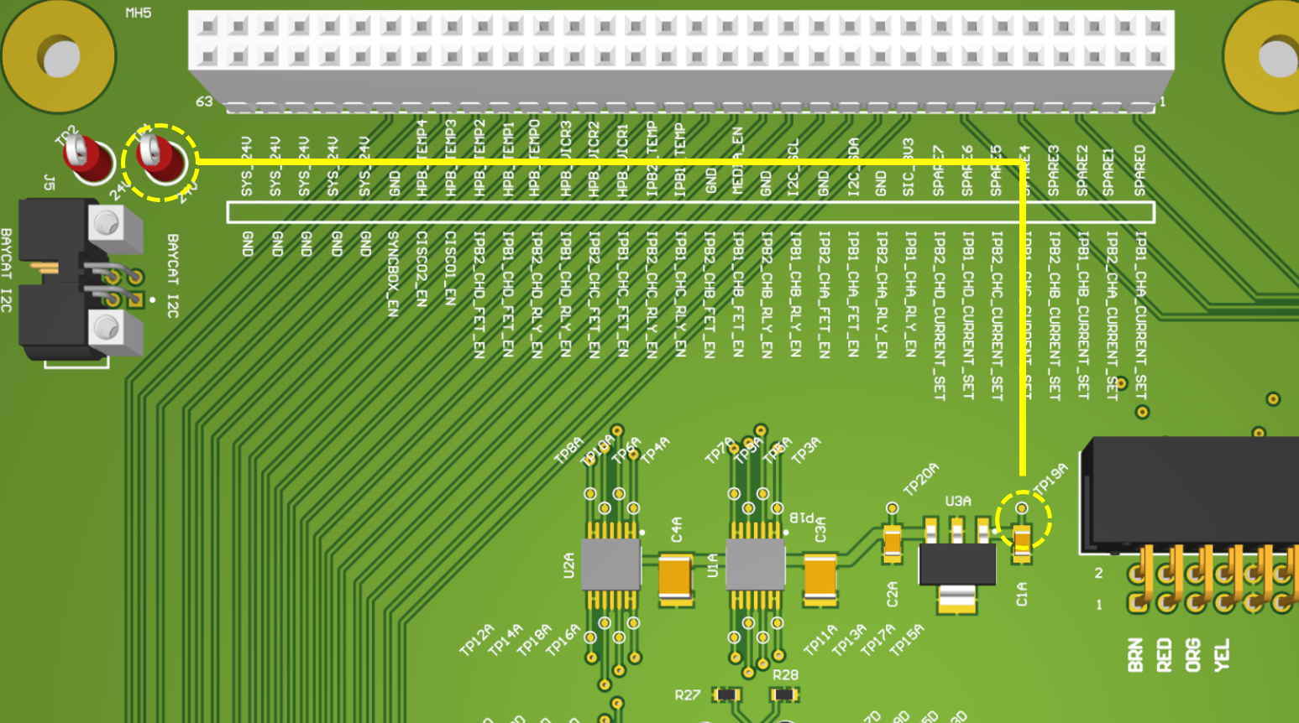

Between C1A(PIN2 – TP19A) and C1D(PIN2 – TP19D)

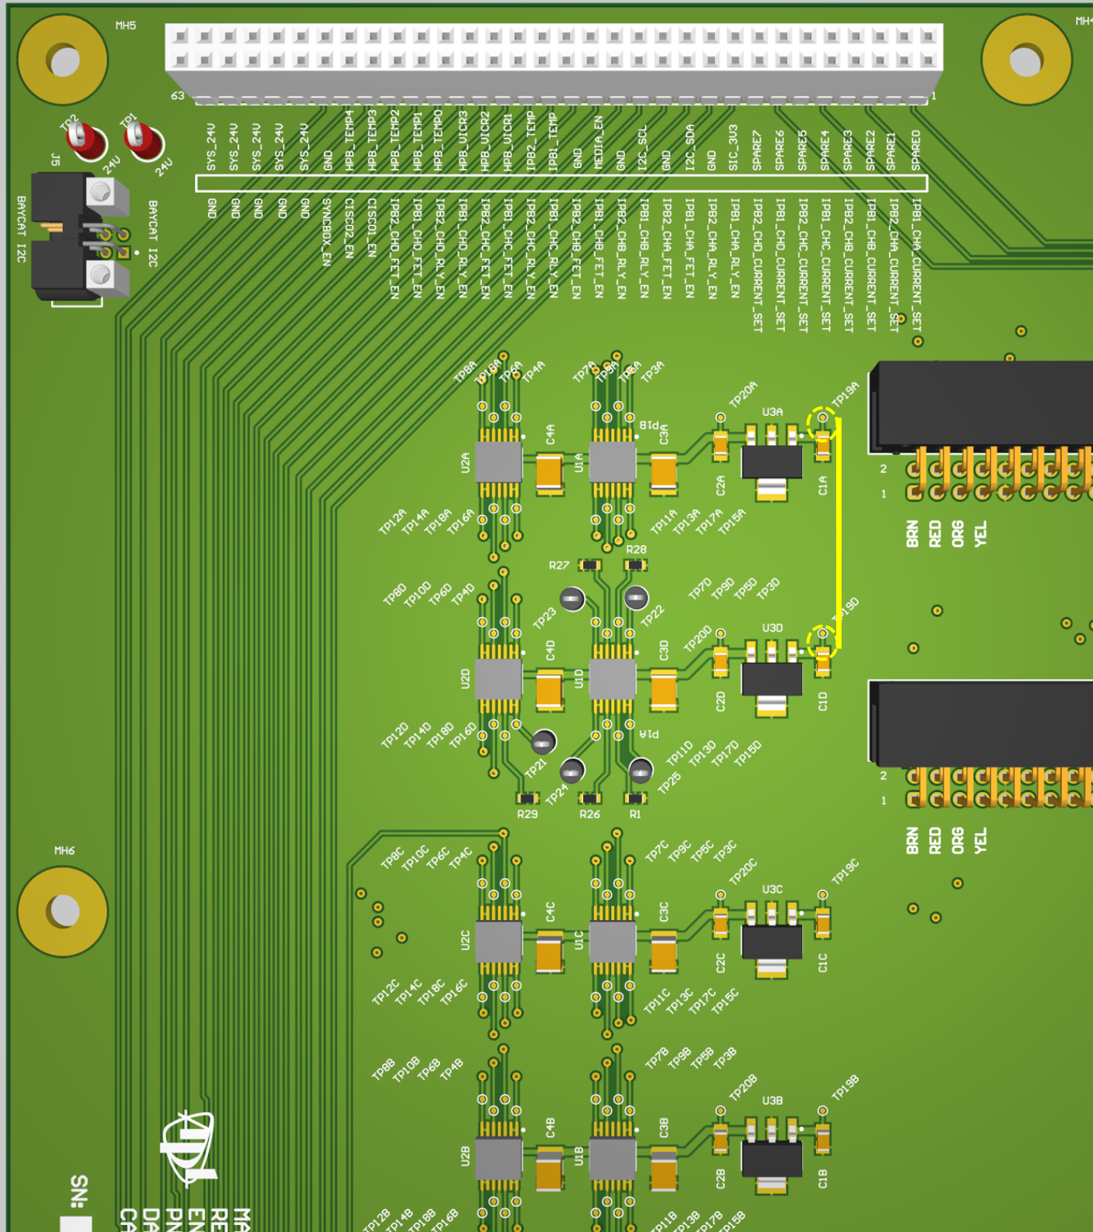

Between C1D(PIN2 – TP19D) and C1C(PIN2 – TP19C)
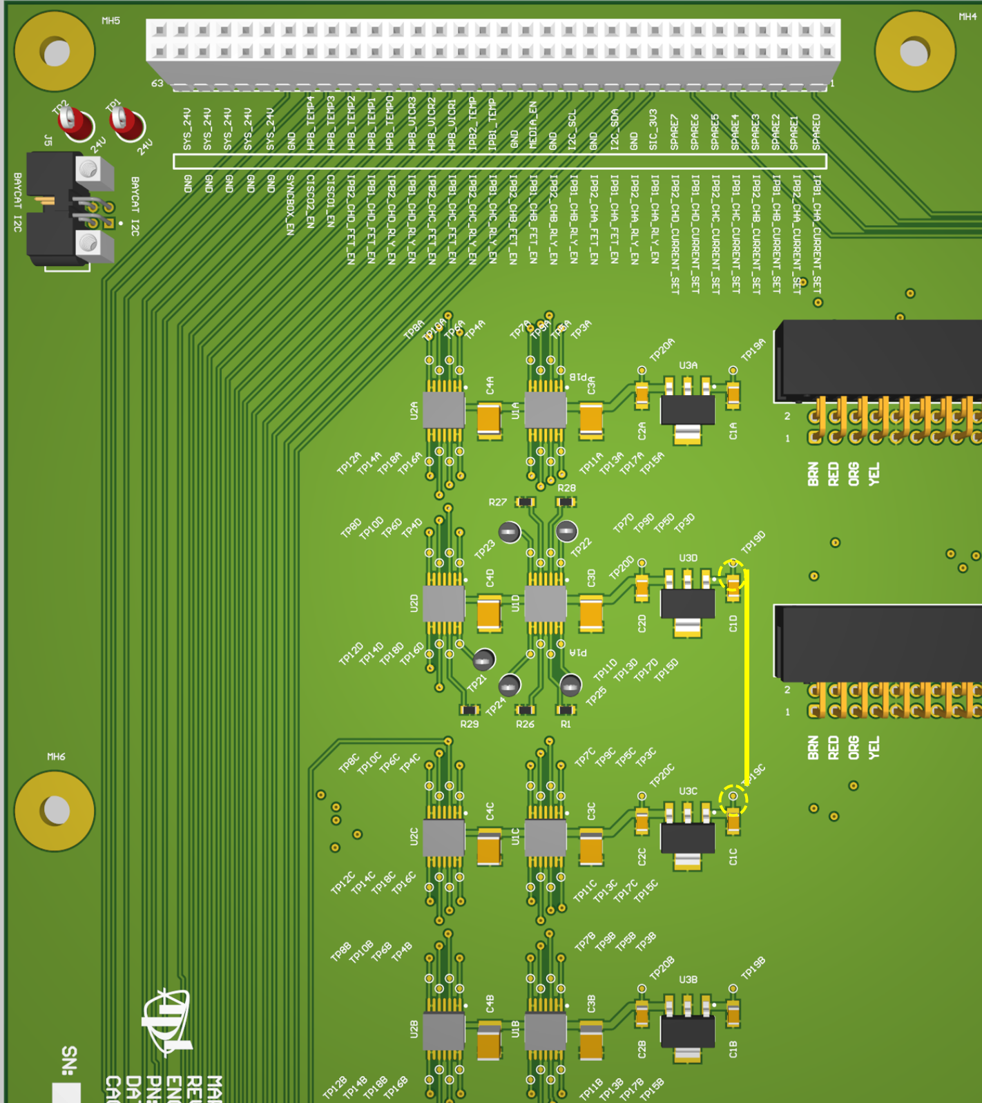

Between C1C(PIN2 – TP19C) and C1B(PIN2 – TP19B)

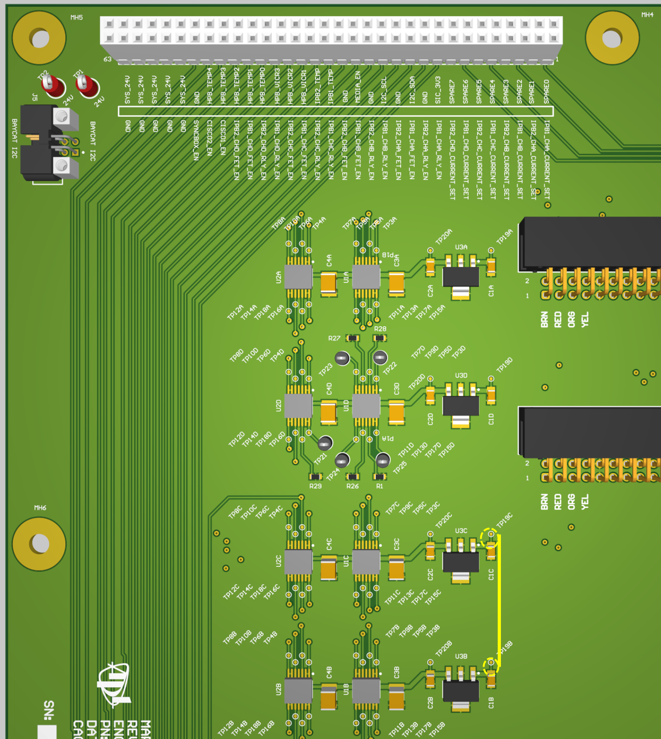

Final

Clean the boards accordingly.

