MARS Low Voltage Power Supply Development Annual Report - DRAFT Date: Apr 17, 2024

- Introduction
UW-APL was contracted to build the Low Voltage Power Supply (LVPS) for the MARS Seafloor Observatory Upgrade. UW-APL built the similar LVPS for the original MARS Observatory Seafloor Junction Box.
The basic functions of the LVPS are as follows:
- Take the 375VDC from the tow MBARI Medium Voltage Converters (MVC) and condition, measure and control the 375VDC power to 8 external science instruments
- Convert the 375VDC from the MVC to lower voltages and provide power monitoring and switching to the MBARI networking, time distribution and other electronics
- Provide a graphical user interface for the operators on shore to control and monitor the LVPS
- Provide a shoreside server to archive the data from the seafloor LVPS in a database archive

- LVPS Electronics Hardware
The LVPS consists of the following circuit boards:
  - Input / Ground Fault Board (IGB)
The IGB receives 375VDC power from the two Medium Voltage Converters (MVCs), monitors the system voltage and current, protects against over-voltage and over-current and measures any ground fault current that might result from a leaky underwater connector or faulted external instrument.
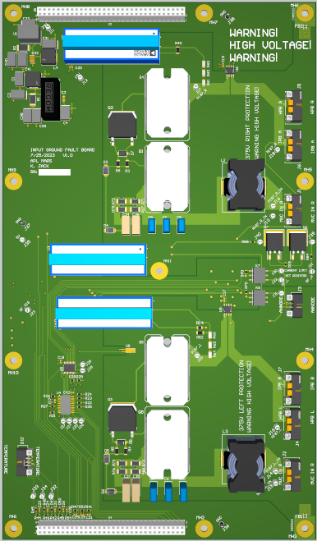
Figure 1 - Rendering of Input / Ground Fault Board (IGB)

  - Hotel Power Board (HPB)
The HPB receives the 375VDC from the IGB, converts the 375VDC to lower voltages (5VDC & 24VDC), distributes, monitors and controls the lower voltage power to the Hotel Loads and provides remotely controlled power switching to several of the Hotel Loads.
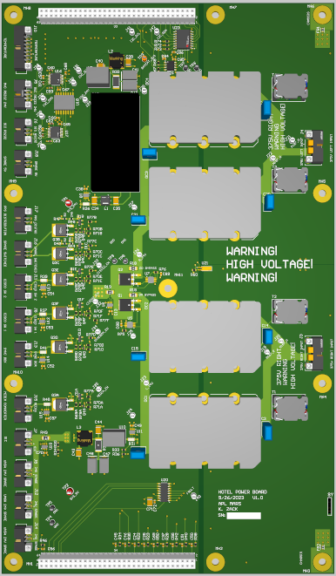
Figure 2 – Rendering of Hotel Power Board (HPB)

  - Instrument Power Board (IPB)

There will be two IPBs in the system. Each IPB will control and monitor 4 channels of 375VDC power to four external instruments that will connect using ROV-mateable Science Connectors. The IPB will allow user control of the power to the instruments by a switching FET and galvanic isolation of the instruments by switching mechanical relays on both the positive and negative legs of the power circuits. The IPB will monitor the current to the instrument and will provide fixed and user-settable high current protection.
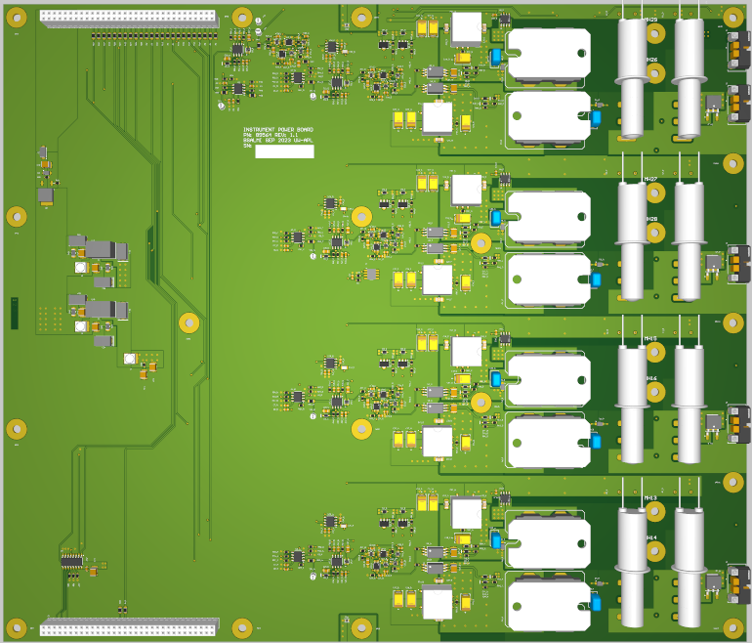
Figure 3 - Rendering of Instrument Power Board (IPB)
  - Breakout Board (BOB)
The BOB is a mostly passive board that provides the interface between the IGB, HPB & IPB and the PC104 Analog & Digital Input/Output boards. During system testing, it was determined that some signals required additional buffering circuitry and the BOB was a convenient place to put that circuitry so the BOB design was updated and new circuit boards were fabricated.

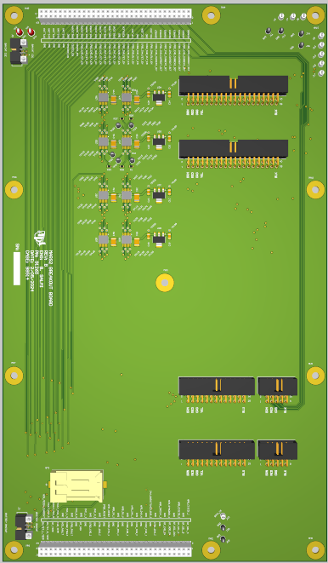
Figure 4 - Rendering of Breakout Board (BOB)

All of the electronics hardware has been built and assembled in the chassis and is going through extensive system testing. As of this writing, the system is set up on a lab bench and is being cycled to switch power on and off to an external dummy load. The cycle time is 5 minutes with a 50% duty cycle with a load of 375VDC/1.25A/468W.
The only issue that has been encountered is that the system does not have adequate protection in the event of a hard short circuit. The system has user settable over current protection but if there was a hard, zero resistance short circuit – due to a failed connector, cut cable or similar – there is a possibility of damage to the electronics. We are currently working on a design modification to add that short circuit protection feature, which will be implemented and fully tested before delivery.
We will be building 3 sets of boards:
1 set of “Engineering” boards – currently assembled in the chassis and undergoing engineering tests. These boards will be replaced with the Flight boards for delivery and deployment. The Engineering board will be used in the MBARI Dry Node Simulator for lab testing of science instruments before installation on the MARS System
1 set of “Flight” boards that will be installed and used in the Factory Acceptance Test, delivered and deployed
1 set of “Spare” boards that will be fully bench testing and then packaged in anti-static packaging and stored for possible future use.

- LVPS Seafloor Controller
The Seafloor Controller Board Stack will consist of the following boards:
  - Power Supply Board – converts the 24VDC input to the voltages required for the PC104 boards

  - Seafloor Controller CPU Board – runs the software and graphical user interface that controls and monitors the LVPS and communicates with the Shore Server

  - Analog/Digital Input/Output Boards (2) – will generate the digital outputs to control the load switching for the hotel loads and external science instruments, the analog outputs to set the adjustable over-current trip limit, the analog inputs from the system voltage and current monitoring sensors

Similar to the other electronics, we will be delivering 3 sets of the Seafloor Controller Board Stack - Engineering, Flight and Spare.
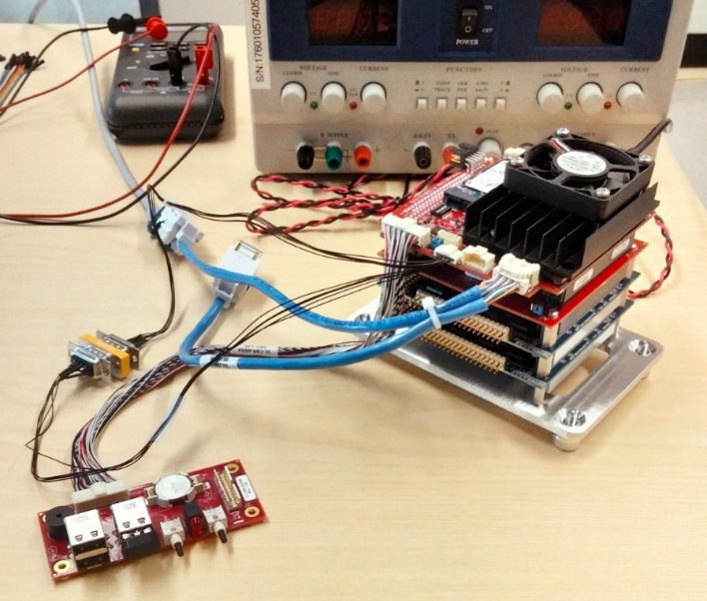
Figure 5 - PC104 Seafloor Controller Board Stack

- Mechanical
The original plan had been to recover the existing MARS Seafloor Node, reuse the existing MARS Electronics Chassis and modify it to mount the new electronics hardware. The decision was made to leave the operating MARS Node on the seafloor longer than planned and APL has been asked to design and build a new replacement chassis.
The seafloor electronics chassis has been assembled with the engineering boards, as shown in the photo below:

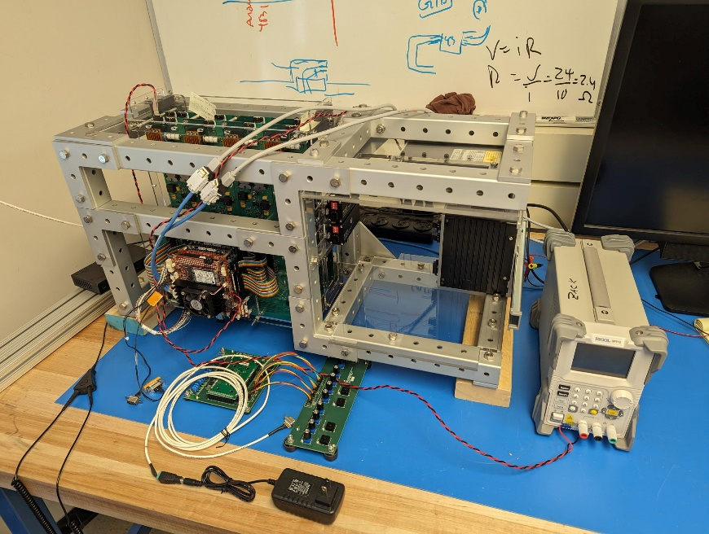
Figure 6 - Seafloor Electronics Chassis with the electronics installed on the lab bench

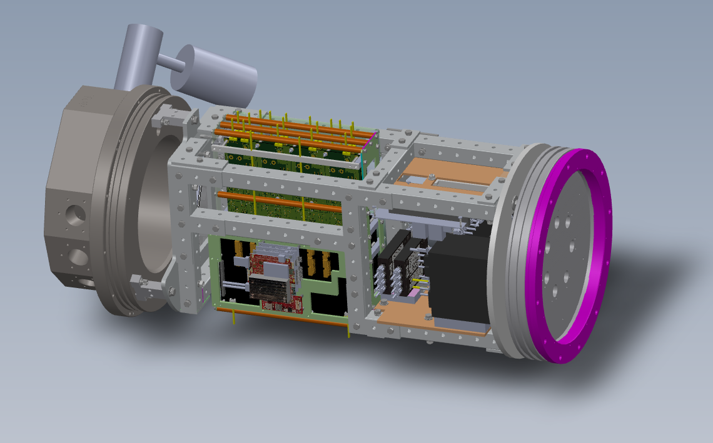
Figure 7 – Model of the Complete Seafloor Electronics Chassis and Pressure Housing Endcap

- Software

  - Seafloor Controller Software
The Seafloor Controller software is written in C++, using the Qt application framework. An Engineering graphical interface (GUI) provides command and control of the system (e.g. turning ports on/off) and lower-level monitoring data (voltages, currents, etc.). The GUI will be accessible to remote users via a VNC remote desktop, with the possibility of multiple access levels. The access levels could have options like “Full control” (turn ports on/off, set over-current thresholds, etc.) or “Observer only” (view voltages, currents, internal environmental data).
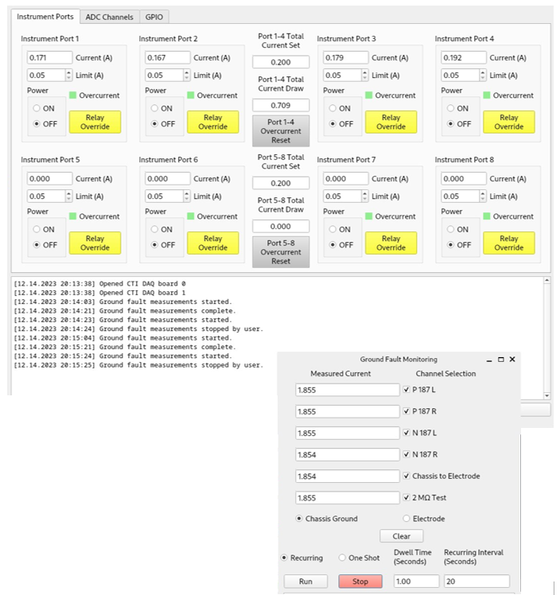
Figure 8 - Seafloor Controller Main GUI display screen – also showing the Ground Fault Monitoring screen

  - Shoreside Data Display and Archive Server Computer
A Dell PowerEdge R350 rackmount server computer has been purchased, the Linux Debian Operating system has been installed and development of the software has been initiated.
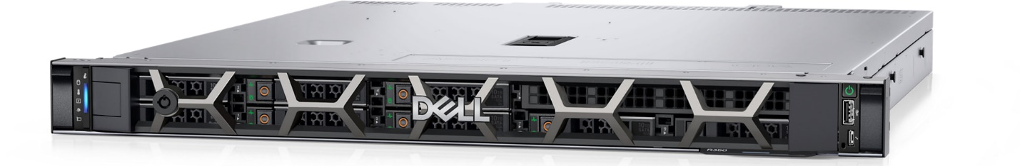
Figure 9 – Shoreside Data Archive Rackmount Computer

  - Shoreside Data Display and Archive Software
The Shoreside computer will receive data from the Seafloor Controller, display the data in a user-configurable dashboard and archive the data.
In conjunction with the MBARI IT staff, the decision was made for the seafloor data to use the InfluxDB database format and be transported to shore using the ZeroMQ protocol.
The real-time data displays, plots, trends, etc. will be viewed using Grafana, a standard off-the-shelf and user-configurable viewer tool.
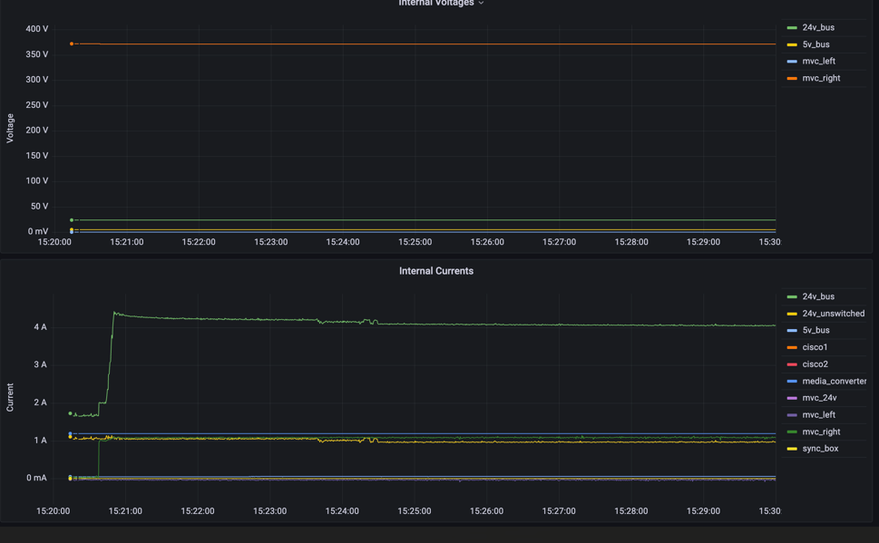
Figure 10 - Example of Grafana Real-Time Data Displays

