Simulation of NewMVC_Complete

Date: Monday, March 29, 2021
Designer: Gene Massion
Study name: Thermal 1
Analysis type: Thermal(Steady state)
Table of Contents
Description 1
Assumptions 2
Model Information 2
Study Properties 3
Units 3
Material Properties 4
Thermal Loads 4
Contact Information 5
Mesh information 6
Sensor Details 7
Study Results 8
Conclusion 8

Description
No Data

Assumptions

Model Information

Model name: NewMVC_Complete
Current Configuration: FEA
Solid Bodies
Document Name and Reference | Treated As | Volumetric Properties | Document Path/Date Modified
Cut-Revolve1 | Solid Body | Mass:29.7567 lb  Volume:185.979 in^3  Density:0.16 lb/in^3  Weight:29.7365 lbf | X:\MARSO&M\DACR_upgrade docs\SchaeferMVC\Mechanicals\NewMVC_Endcap.SLDPRT  Mar 29 12:08:37 2021
Split Line3 | Solid Body | Mass:56.6554 lb  Volume:580.82 in^3  Density:0.0975437 lb/in^3  Weight:56.6169 lbf | X:\MARSO&M\DACR_upgrade docs\SchaeferMVC\Mechanicals\NewMVC_Heatsink_top.SLDPRT  Mar 12 15:18:54 2021
Cut-Revolve1 | Solid Body | Mass:28.1282 lb  Volume:175.801 in^3  Density:0.16 lb/in^3  Weight:28.1092 lbf | X:\MARSO&M\DACR_upgrade docs\SchaeferMVC\Mechanicals\NewMVC_Housing.SLDPRT  Mar 12 15:44:02 2021
CBORE for 5/16 Socket Head Cap Screw1 | Solid Body | Mass:5.78626 lb  Volume:59.3197 in^3  Density:0.0975437 lb/in^3  Weight:5.78234 lbf | X:\MARSO&M\DACR_upgrade docs\SchaeferMVC\Mechanicals\NewMVC_T_Leg_Inv.SLDPRT  Mar 12 15:18:53 2021
Fillet1 | Solid Body | Mass:82.1162 lb  Volume:513.226 in^3  Density:0.16 lb/in^3  Weight:82.0605 lbf | X:\MARSO&M\DACR_upgrade docs\SchaeferMVC\Mechanicals\NewMVC_Tube.SLDPRT  Mar 12 15:44:01 2021

Study Properties
Study name | Thermal 1
Analysis type | Thermal(Steady state)
Mesh type | Solid Mesh
Solver type | Direct sparse solver
Solution type | Steady state
Contact resistance defined? | No
Result folder | SOLIDWORKS document (c:\swsimulationresults)

Units
Unit system: | English (IPS)
Length/Displacement | in
Temperature | Fahrenheit
Angular velocity | Hertz
Pressure/Stress | psi

Material Properties
Model Reference | Properties | Components
 |  | SolidBody 1(Cut-Revolve1)(NewMVC_Endcap-1),  SolidBody 1(Cut-Revolve1)(NewMVC_Housing-1),  SolidBody 1(Fillet1)(NewMVC_Tube-1)
  Name: | Ti-6Al-4VSolution treated and aged (SS)
  Model type: | Linear Elastic Isotropic
  Default failure criterion: | Unknown
  Thermal conductivity: | 8.96108e-05 BTU/(in.s.F)
  Specific heat: | 0.14 Btu/(lb.F)
  Mass density: | 0.16 lb/in^3
Curve Data:N/A
 |  | SolidBody 1(Split Line3)(NewMVC_Heatsink_top-1),  SolidBody 1(CBORE for 5/16 Socket Head Cap Screw1)(NewMVC_T_Leg_Inv-1)
  Name: | 6061-T6 (SS)
  Model type: | Linear Elastic Isotropic
  Default failure criterion: | Unknown
  Thermal conductivity: | 0.00223225 BTU/(in.s.F)
  Specific heat: | 0.214047 Btu/(lb.F)
  Mass density: | 0.0975437 lb/in^3
Curve Data:N/A

Thermal Loads

Load name | Load Image | Load Details
Temperature-1
  Entities: | 9 face(s)
  Temperature: | 5 Celsius
Heat Power-1
  Entities: | 4 face(s)
  Heat Power Value: | 150 W (per face)

Contact Information

Contact | Contact Image | Contact Properties
Contact Set-5
  Type: | Bonded contact pair
  Entities: | 2 face(s)
Global Contact
  Type: | Bonded
  Components: | 1 component(s)
  Options: | Compatible mesh

Mesh information
Mesh type | Solid Mesh
Mesher Used: | Curvature-based mesh
Jacobian points | 4 Points
Maximum element size | 0.3 in
Minimum element size | 0.06 in
Mesh Quality Plot | High
Remesh failed parts with incompatible mesh | Off

Mesh information - Details
Total Nodes | 1719955
Total Elements | 1120487
Maximum Aspect Ratio | 2,439.8
% of elements with Aspect Ratio < 3 | 91.1
% of elements with Aspect Ratio > 10 | 3.23
% of distorted elements(Jacobian) | 0
Time to complete mesh(hh;mm;ss): | 00:00:47
Computer name: | KAVACHI
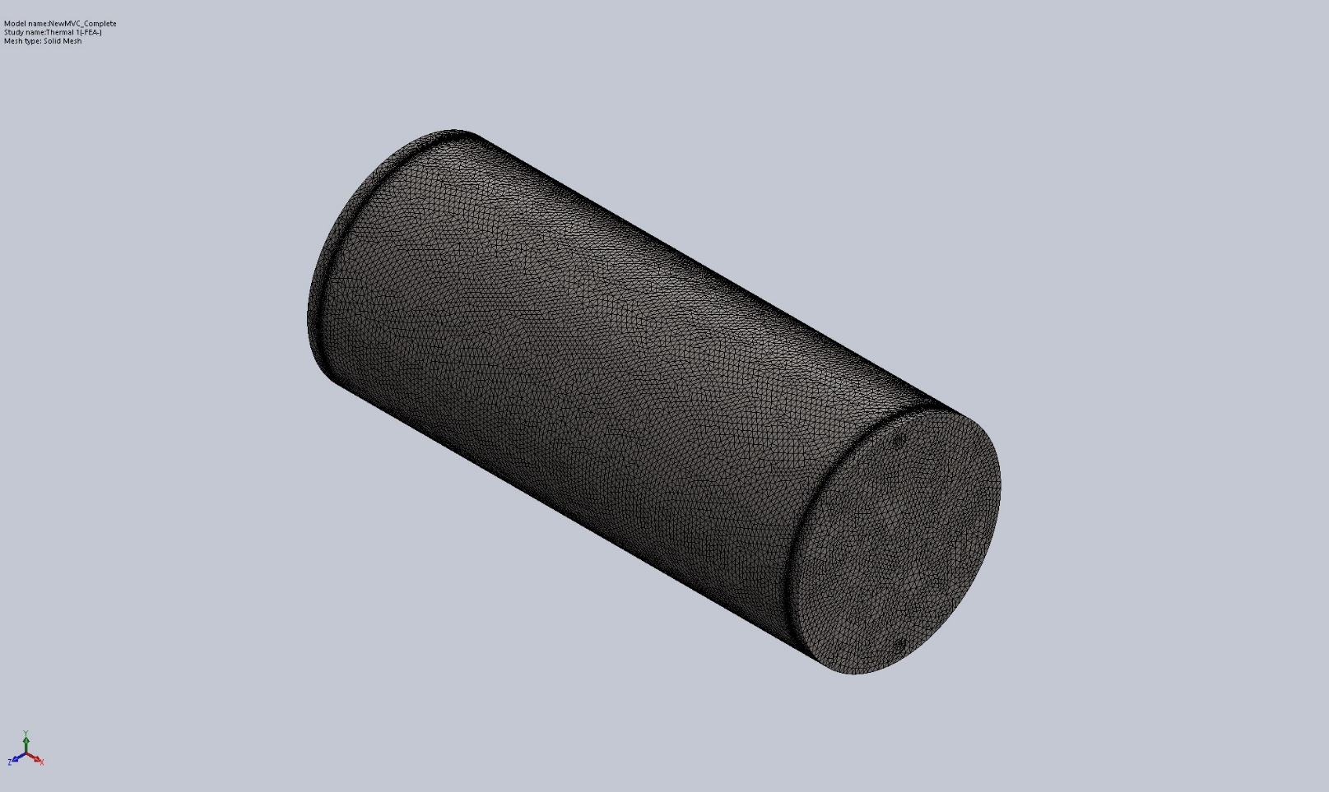

Sensor Details
No Data

Study Results

Name | Type | Min | Max
Thermal1 | TEMP: Temperature | 5.000e+00 Celsius  Node: 769574 | 2.143e+01 Celsius  Node: 454794
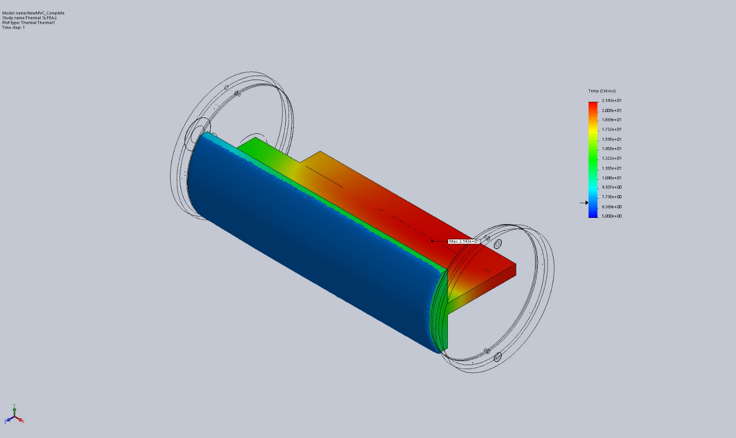
NewMVC_Complete-Thermal 1-Thermal-Thermal1

Conclusion

