Applicant and Project Information

  - Project Title

Development of Chemical Sensors and In-Situ Calibration: Enhanced Monitoring and Measurement of pH and Redox in Diffuse Flow Hydrothermal Systems
  - Applicant Information – Provide name, title, address, telephone number, fax number, email address, and institutional affiliation of the primary applicant/principal investigator and any co-applicants. In addition, list the name and affiliation of any additional colleagues authorized to do work under the permit.
PI:
Dr. Kang Ding, (Sr. Research Associate)
310 Pillsbury Dr. SE, Mpls, MN 55455
Department of Geology and Geophysics, University of Minnesota
(612) 626-1860 (O); (612) 625-3819 (Fax); mlcd@umn.edu
Co-PI:
Dr. William E. Seyfried, Jr., (Professor)
310 Pillsbury Dr. SE, Mpls, MN 55455
Department of Geology and Geophysics, University of Minnesota
(612) 624-0340 (O); (612) 625-3819 (Fax); wes@umn.edu
Student:
Chunyang Tan
310 Pillsbury Dr. SE, Mpls, MN 55455
Department of Geology and Geophysics, University of Minnesota
Tanxx241@umn.edu

  - Project Abstract – Abstract of approximately 250 words summarizing the project including objectives, methods, and project significance. The abstract shall be suitable for use in the public press.
This project is supported by NSF for development, calibration and testing of pH and redox sensors that have recently been incorporated into a novel auto‐calibration system. pH and redox can control mass transfer between geochemical and biological systems, as exist, for example, in diffuse flow hydrothermal habitats at mid‐ocean ridges. To understand the linkages between these systems, however, requires longer term observations, underscoring the need for in‐situ calibration. With the rapidly expanding availability of power sources at/near deep ‐sea vents provided by cabled observatories, instrumentation involving in‐situ measurement and calibration will be necessary to transform qualitative observations to quantitative processes. Here we identify an integrated program of instrument development and testing that takes full advantage of results of field tests from two recent research cruises‐ one to EPR 9°N, and the other to vents on the Mid‐Atlantic Ridge (MAR). The project involves both field and lab programs with the overarching objective being improved performance of chemical sensors in complex chemical and biological systems at low to moderate temperatures.
  - Objectives – Describe the specific objectives of the proposed project.
The first phase of the project involves technical upgrades to the in‐situ calibration device recently deployed at diffuse flows vent sites visited during our past EPR and MAR cruises. In general, reconfiguration of the computer controlled fluid delivery and sampling systems to permit calibration during high‐resolution applications will be emphasized. The modification will also be made to sustain the sensor calibration system for longer term deployment, and to make it ready for seafloor connection to cabled observatory. This task will be conducted first through linkage to MARS observatory to set the base for future application at at hydrothermal vent sites.
Based on the first phase development, a second key objective will entail reconfiguration of the stand alone calibration unit for real-time measurement at hydrothermal vent sites.
Laboratory studies are planned along with field effort, which involves experiments and testing of solid state pH electrochemical sensor systems and development of a new pH reference electrode that may be particularly suitable for chemical (H2S‐bearing), physical and temporal conditions consistent with long term monitoring applications at diffuse flow hydrothermal vent sites.
  - Intended Use of Results – Describe how the products/outcomes will be used, including any anticipated commercial use.
The sensor calibration system tested and improved through the deployment at MARS observatory, will be used and deployed at mid-ocean ridge hydrothermal systems for monitoring vent fluid chemistry. The data and results will be posted on the website and presented/published through scientific conferences and journals.
Methods – Describe how the proposed methods and analytical techniques will achieve the activity objectives. This description should include the following, as applicable:
  - Procedures – Describe the proposed activity design that addresses the stated objectives. Explain the methods and protocols to be employed in the field. Include descriptions and diagrams of any instrumentation or equipment to be used and deployment duration. Describe all phases of activity, including equipment removal. Include activity frequency (e.g., daily, monthly) as appropriate.

Planed procedures which involve MARS observatory are: (1) deployment of in-situ sensor calibrator system with ROV for its connection with MARS science node. The deployment will involve wet plugging of the system with the node. One ship day is required for this deployment. (2) Real time connection and data collection for one up to three months through individual IP address. System intervention will also be performed through the internet to make changes in the run schedule. (3) Recovery, which also involves one ship day to remove the sensor system from the seafloor.
  - Collections – If applicable, describe the type, size, and quantity of specimens or materials to be collected, sampled, or captured. Include collection methods, handling, frequency, and replicates required for each experiment. If aware that specimens of the proposed types already exist in a repository, explain why additional collecting is necessary. Provide scientific nomenclature where possible. Provide information on all other applicable federal or state permits where required.
No geological and biological specimens will be collected at MARS site. However, the water samples will be collected during the sensor deployment.
  - Schedule – Provide a schedule that includes start of project, approximate dates or seasons of fieldwork, analysis, reporting, and completion dates. Include the requested start and stop dates for the authorization.
This NSF funded project runs from 08/01/2009 to 07/31/2012. The MARS related field deployment is expected in the last season in 2011. Then, the recovery could be arranged in the following 1~3 month, depanding on the weather and ship availability.
Funding: Provide contract number, performance period, and name of sponsoring agency, as applicable.
Sponsoring agency: NSF OCE - OCEAN TECH & INTERDISC COORDIN, project number 0927615
Performance period: 08/01/2009 to 07/31/2012
Environmental Impacts: Summarize the direct and indirect impacts (effects) of the proposed activity. Direct impacts are those caused by the permitted action that occur at the same time and place. Indirect impacts are those caused by the action that are later in time or farther removed in distance, but still reasonably foreseeable. Explain how the benefits of the research will outweigh the disadvantages or environmental consequences in both the short and long term.
No environment impacts are expected, as the system is build with inert material and no parts will be left behind after the recovery.
Photographs or schematic representations of equipment to be deployed: Please provide images or drawings that will help to visualize the proposed equipment to be deployed. Also indicate weights, dimensions, or any other information that would assist with understanding the size of the system to be deployed.

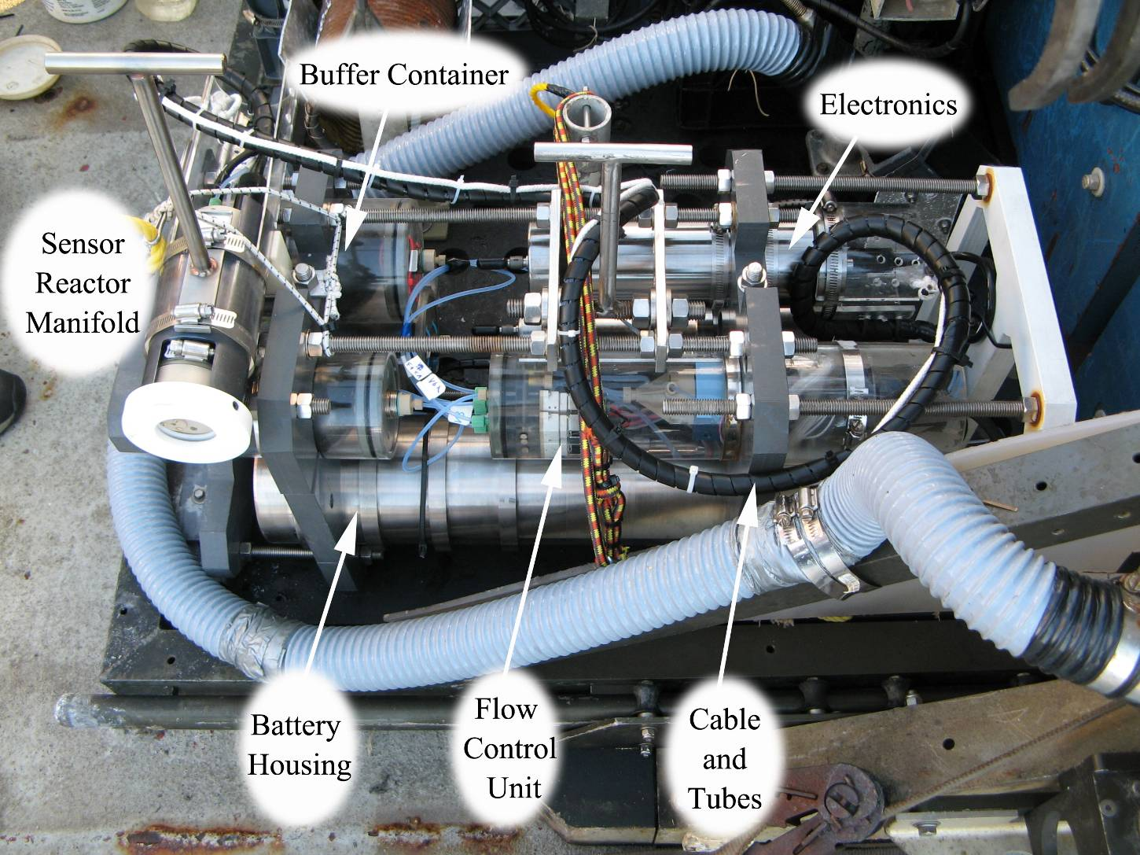
Fig. 1 pH calibrator assembly, 29’’x11.6’’x12.7’’, weight in seawater ~26 Kg. (Falmat and ODI cables are not included, which will be in a total length of ~70 meters. )
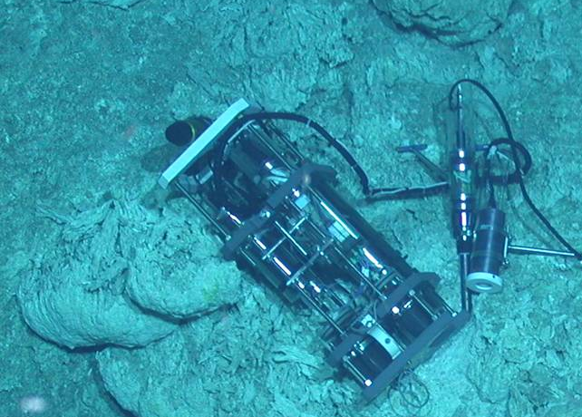
Fig. 2, pH Calibrator deployed on the seafloor.
Fig. 3, the connection sketch shows how to connect the pH Calibrator to the Mars wet-mateable connector.

