1. PN 1033243 – Converted to new part number with penetrator
a. What is the required hose length for the new assembly?
We would like the hose to be seven feet.
b. Please confirm the material for the penetrator.
The penetrator needs to be titanium.
c. What is the intended deployment life of the assembly after refurbishment?
The MARS installation has another 17 years of planned life.
QUESTION: This connector is to be mounted on a panel. Are there adapters to do this? I’m assuming there are as the current connector is mounted to the panel.
2. PN 1041049
a. Can this assembly be dissected, and the penetrator used for converted PN 1033243?
Yes this is an acceptable solution. The connector would then be available for ODI’s testing. MBARI NEEDS THE RESULTS OF THIS TESTING TO DEFINE WHAT VOLTAGE THE CONNECTOR ASSEMBLY CAN SAFELY HANDLE.
3. PN 1033245
a. Two options may be available here:
i. Retest as is per current bench top testing (no PD). PD not conducted on lower level. Question: Is this refurbished assembly only to be used topside on the bench, and is this level of repair acceptable for the intended use?
This connector is meant to be used topside in the lab and in the test tank. Only the connector end of the assembly goes into the water. The main reason for returning this connector was to ensure it could safely mate to the connector on the node without damaging it.
ii. Rebuild connector with new internal components and add test box (missing on return).

4. PN 1029909
a. Two options may be possible
i. Option 1 – Use connector only to interface to bulkhead. Option 1 not permissible if application pressure too high….Verify maximum intended pressure
ii. Option 2 - Add hose and penetrator to connector – this means also adding splice canister too. Please provide what the hose length needs to be on either side of the splice canister.
Of these two options, Option 2 is the preferred method. The hose length on either side of the canister would be four feet. However, we have a question about assembly 1033240-2 that was also returned. Why would it not be possible to refurb that assembly for use? It has the hose and penetrator already.
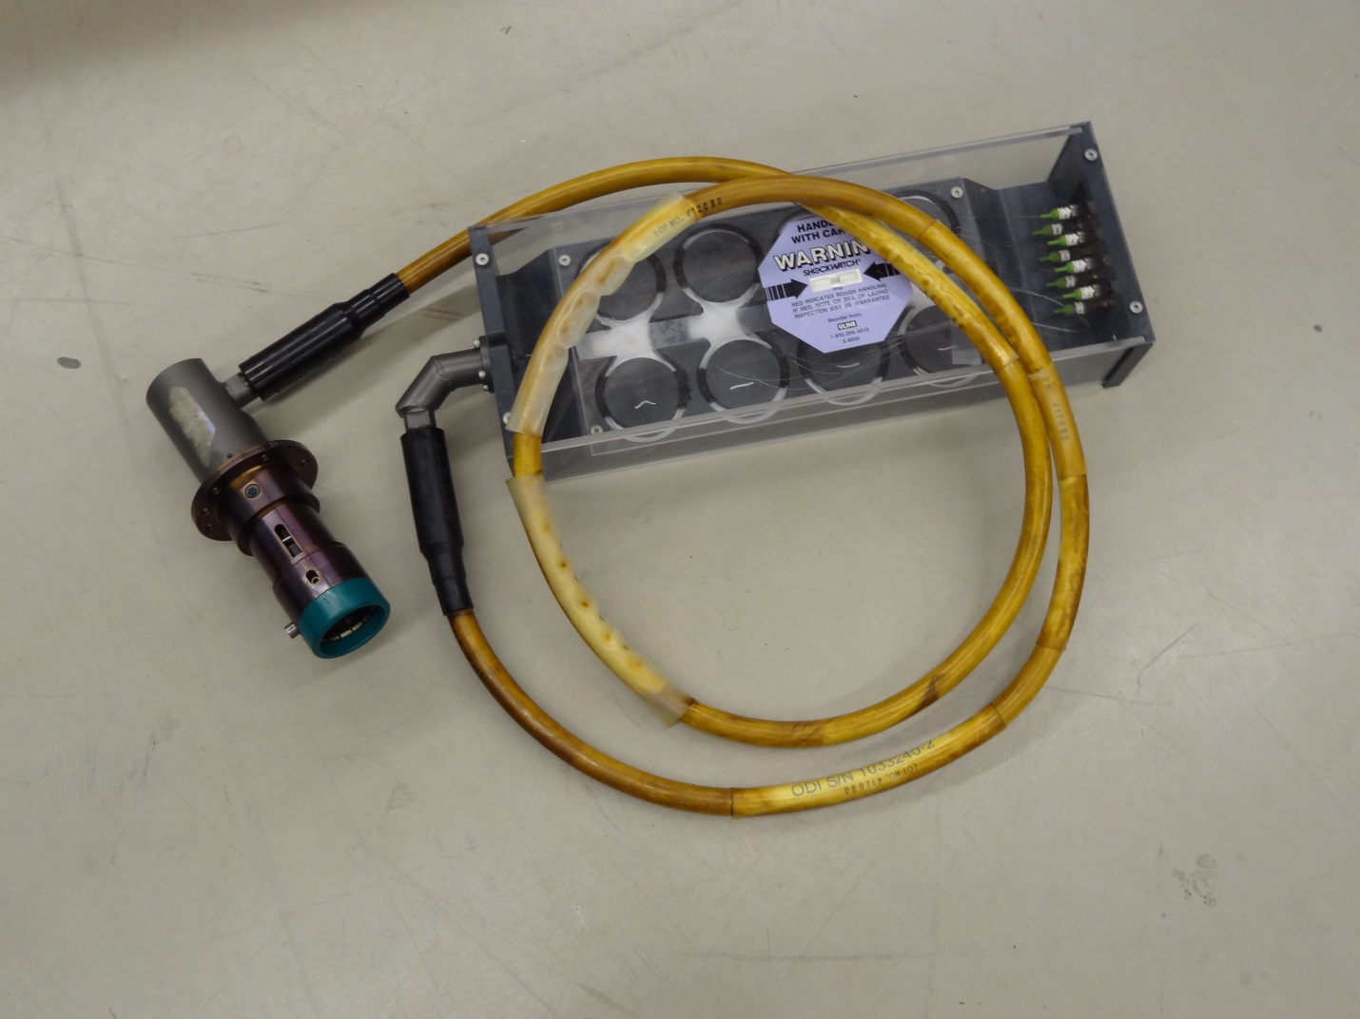
Figure 1 - Assembly 1033240-2

