Quick Summary
The MARS Port Test Tool (PTT) is based upon a NI CompactRIO. The CompactRIO is a reconfigurable embedded control and acquisition system. The CompactRIO, along with its support hardware, is mounted an old Schilling controller can. The CompactRIO is controlled by a Windows computer on the surface. Communications between the CompactRIO and the surface computer is via Ethernet. The PTT includes an optional load can to load both the 375 volts as well as the 48 volts. The PTT measures the DC voltages, the AC component of the DC voltages, provides ground fault insertion and can measure the 1PPS. Comparison to a 1PPS provided by the ROV is also possible.

Ground Fault Insertion
The MARS node monitors for ground faults on +375 vdc, 375 com, +48 vdc and the 48 com. The PTT does not measure ground fault condition but rather creates a known ground fault for the MARS node to measure. The ground fault is created by connecting a resister between the appropriate power line and seawater reference. In the case of the PTT, seawater reference is the Schilling can. The port console has eight buttons to select the desired ground fault condition. There is the ability to select 60 ma or 200 ma for each of the power lines. The button for the desired amount of ground fault is pressed and then the node is monitored to verify proper detection.

Voltage Monitoring
The PTT continuously displays the value of the node 375 volts and the node 48 volts as well as the value of the ac component of both voltages. The voltage from the ROV port is neither monitored nor displayed.

PTT Power
The PTT can be powered from either the ROV port or the node port. Even if the PTT is powered from the ROV port, once 48 volts is applied to the node port, the PTT will automatically switch to using the node 48 volts for power. Once node 48 volts is switched off, the PTT will automatically switch back to ROV power. The PTT consumes less than 1 amp at 48 volts.

1 PPS Measurement
The PTT has a toggle button to enable 1 PPS measurements. The button actually enables the voltage to the pull up resister on the 1 PPS line. It is extremely important to neither have the 1 PPS enable switch on when the ODI connector is not plugged into the node port. If the 1 PPS switch is on with the ODI connector in the water, the 1 PPS pin will very quickly be damaged, destroying the ODI connector. The PTT displays two values for the 1 PPS. One is the period of the 1 PPS. The other is the time from receiving the ROV 1 PPS until the node 1 PPS is received.

Load Can
The PTT can provide an optional load for both the 48 volts and the 375 volts. There is a single toggle switch that controls both loads. The load can may not be switched on or off when any node power is applied. The PTT monitors the node power and will not switch the load if node power is applied. The load can provides the following loads:

Ethernet Connection
The Ethernet connection can either be through the ROV or through the port on the node being tested. There is a hub inside the subsea can that connects the two ports and the internal network devices. To be able to communicate through the node port, the PTT IP addresses must be within the valid address range for the port under test. The IP address of the CompactRIO and the surface computer must be set to the appropriate range. In addition, the PTT software running on the surface computer must be told what IP address the CompactRIO was set to.

PTT Interconnections
The PTT has three MINK 10/L connectors.

ROV Pin Out
1 120 VAC
2 TX+
3 TX-
4 RX+
5 RX-
6 1PPS RS232 Ret
7 1PPS TxRS232
8 +48 VDC
9 48 Com
10 120 VAC

Node Port Pin Out
1 +48 VDC
2 TX+
3 TX-
4 RX+
5 RX-
6 1PPS-
7 1PPS+
8 +375 VDC
9 375 Com
10 48 Com

Load Can Pin Out
1 Node +48 VDC
2 Load Can Temperature
3 +5 VDC
4 Ground
5 Load_Ena_H
6 +12 VDC
7 NC
8 Node +375 VDC
9 Node 375 Com
10 Node 48 Com

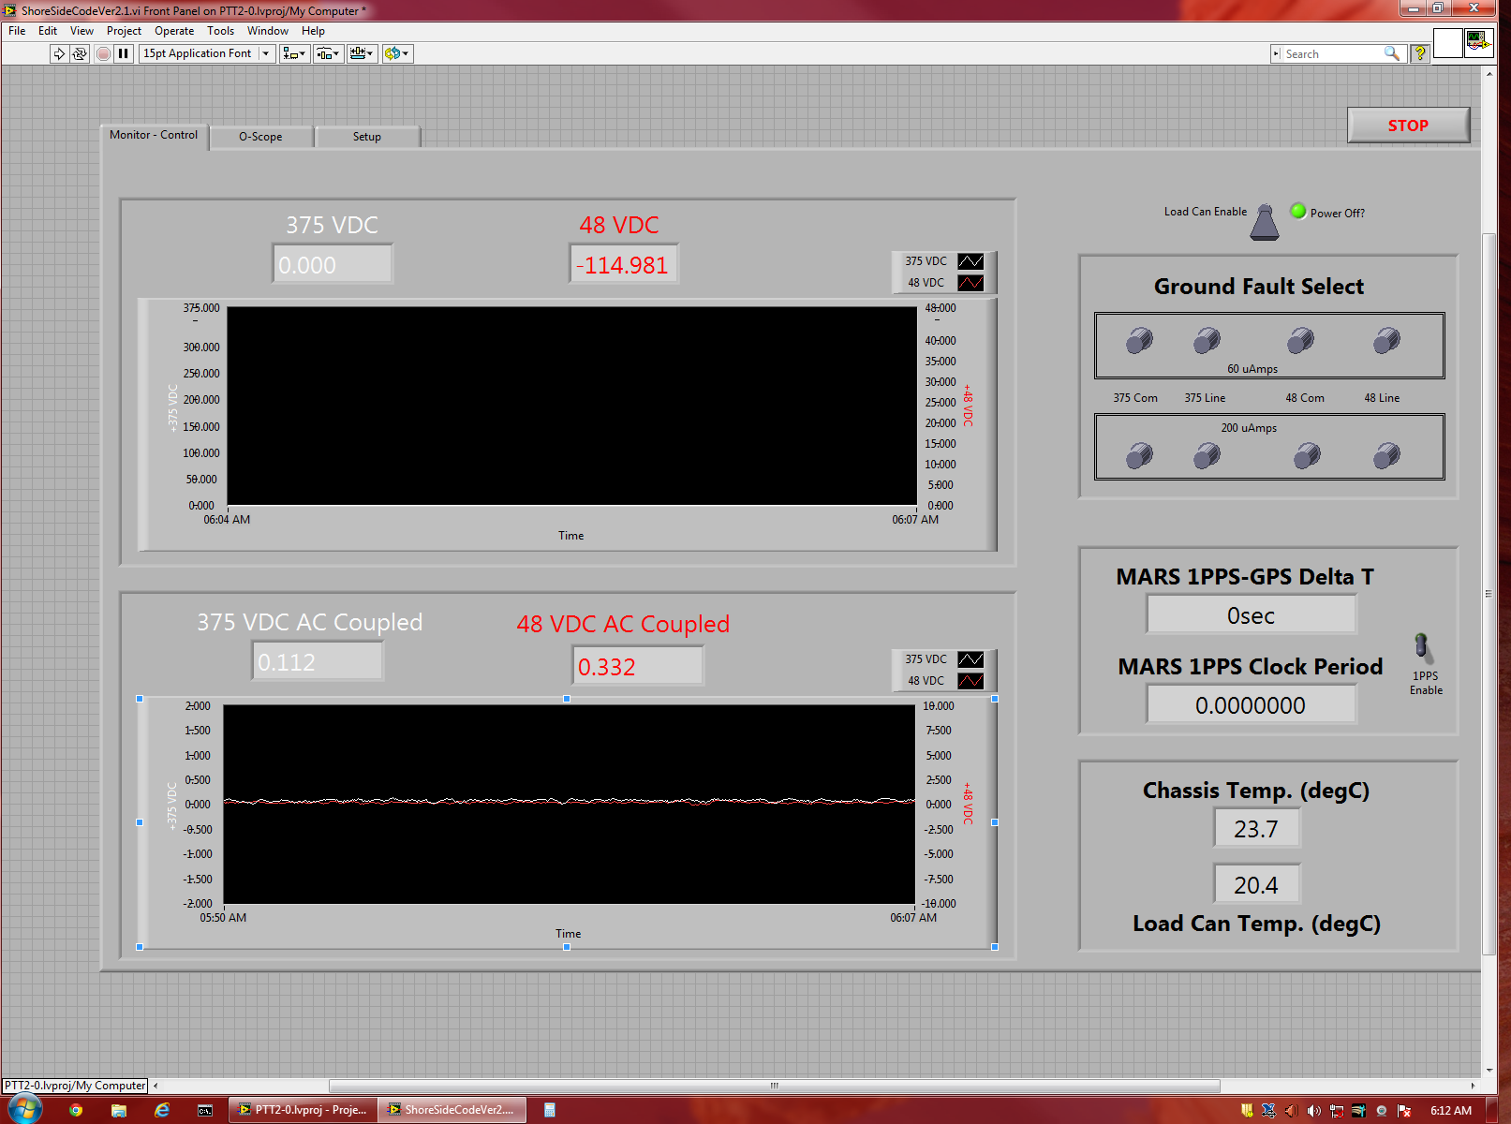

PTT IP Addresses
The PTT two IP addresses associated with it. One address is for the CompactRIO that is located in the subsea can. The other address is for the surface computer that runs the PTT software. The IP addresses of the PTT need to match up to the address range of the port that is being tested. The addresses chosen for this testing are as follows:
Port Gateway CompactRIO Surface Computer
E1 10.158.41.1 10.158.41.10 10.158.41.11
E2 10.158.42.1 10.158.42.10 10.158.42.11
E3 10.158.43.1 10.158.43.10 10.158.43.11
E4 10.158.44.1 10.158.44.10 10.158.44.11
E5 10.158.45.1 10.158.45.10 10.158.45.11
E6 Not to be tested
E7 10.158.47.1 10.158.47.10 10.158.47.11
E8 10.158.48.1 10.158.48.10 10.158.48.11

Prior to deployment, the CompactRIO and the surface computer should be set to the same port, preferably the first one that is going to be tested.

PTT Test Configuration
The Schilling can will be mounted on the ROV. Connection to the ROV is via the ROV connecter. Note that the ROV connecter and the MARS Port connecter are NOT interchangeable.
Connection to the Aloha port will be via an ODI connecter attached to the MARS connecter.
NOTE: The 1 PPS enable should be turned off anytime the ODI connecter is not attached to a port!
The control computer will be located on the ship.
The basic procedure for testing is:
- Power up surface computer.
- Double click the LabVIEW 2012 SP1 icon
- In the LabView window, click on C:\LabviewVI\PTT2-0.lvproj
- In the project explorer window double click ShoreSideCodeView2.1.vi
- In the ShoreSideCodeView2.1.vi window, click the Monitor Control tab
- Power up Schilling can and wait 15 to 20 seconds
- Click on the run button located near the upper left of the ShoreSideCodeView2.1.vi window. The run button looks like a right arrow
- Ensure the 1 PPS enable button is off.
- The system is now ready to test. It is assumed the PTT is addressed for the first port to be tested.
- Have the ROV connect the ODI connecter to the port to be tested.
- The PTT will display the value for the 48 volts and 375 volts continuously.
- Enabling the 1 PPS will display the period of the 1 PPS signal received.

Ground Fault Testing
The PTT does not test ground faults but rather creates ground faults to ensure the observatory can detect them. Ground fault testing only needs to occur once for each voltage. Ground faults are inserted by pressing the desired button. The 60 µa vs 200 µa values are based upon the MARS ground fault circuit. The idea of two values is to ensure the ground fault circuit can detect varying ground fault conditions. Exact value is not important.

Changing Ports
To test the next port, the IP addresses of the PTT must be changed. The order of setting the addresses is very important to make sure communications can be maintained. The CompactRIO in the subsea can is set first. Then the new CompactRIO address is changed in the surface software and finally the address of the surface computer is changed. Following is a procedure that works even when a CompactRIO problem occurs.

IP Address Setting Procedure
- Press the stop button in the upper left of the window (stop sign two icons to the right of the start button)
- Click the Tools pull down
- Select the Measurement and Automation Explorer
- If (when) an error occurs, simply select continue
- Click on the arrow head in the left column next to Remote Systems
- Click on the NI-cRIO9022-014C9009
- Ensure the Network Settings tab is selected at the bottom
- Set the new IP address
- Set the new gateway
- Click save button at top
- If you get a window asking of you want to restart
  - click yes
  - Then close the Measurement and Automation Explorer window
- If you get an error saving, close the Measurement and Automation Explorer window
- In the the ShoreSideCodeView2.1.vi window, select the window pull down and select Block Diagram
- Scroll to the upper left of the block diagram.
- Double click on IP address in the I/O rio block
- Change the IP address to the one just set into the CompactRIO
- Close the block diagram window.
- Click the Windows start button
- Click control panel
- Click Network and Sharing
- Click change adapter settings
- Right click on Local Area Network and select Properties
- Select Internet Protocol Version 4
- Click on properties button
- Set IP address
- Set Gateway
- Click okay button
- Click close button
- Close control panel
- Go to step 7 of basic testing procedure

