1. blue whale  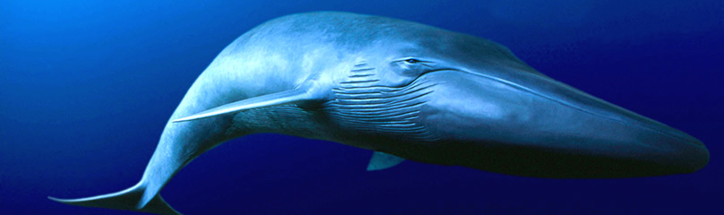  Photo: WWF  - largest animal: adults up to ~ 100 ft / 380,000 pounds  - endangered, ~ 15,000 individuals  - globally, the eastern North Pacific hosts greatest concentration  - life span 80 – 90 years  - gestation: 11 – 12 months (birth announcement: 25 ft, 3,000 pounds)  - nursing calf gains 200 pounds / day  - forage: krill, can eat up to 8000 pounds/day | 2. fin whale  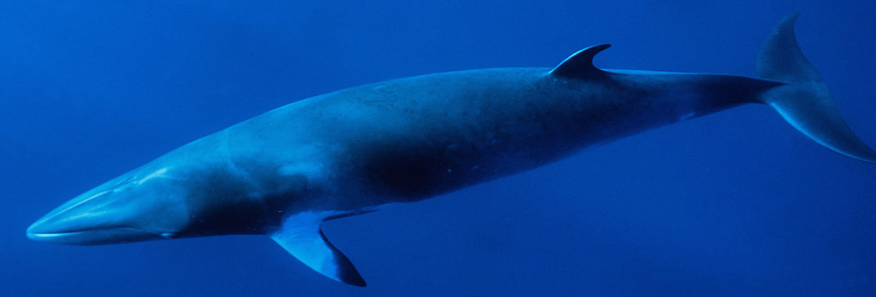  Photo: Whales Forever  - 2nd largest animal; adults up to ~ 90 ft / 160,000 lbs  - endangered  - life span can exceed 130 years  - gestation: 11 – 12 months  - Forage: schooling fish, squid, crustaceans  - “greyhound of the sea” can sustain 25 mph, bursts to 29 mph recorded | 3. humpback whale  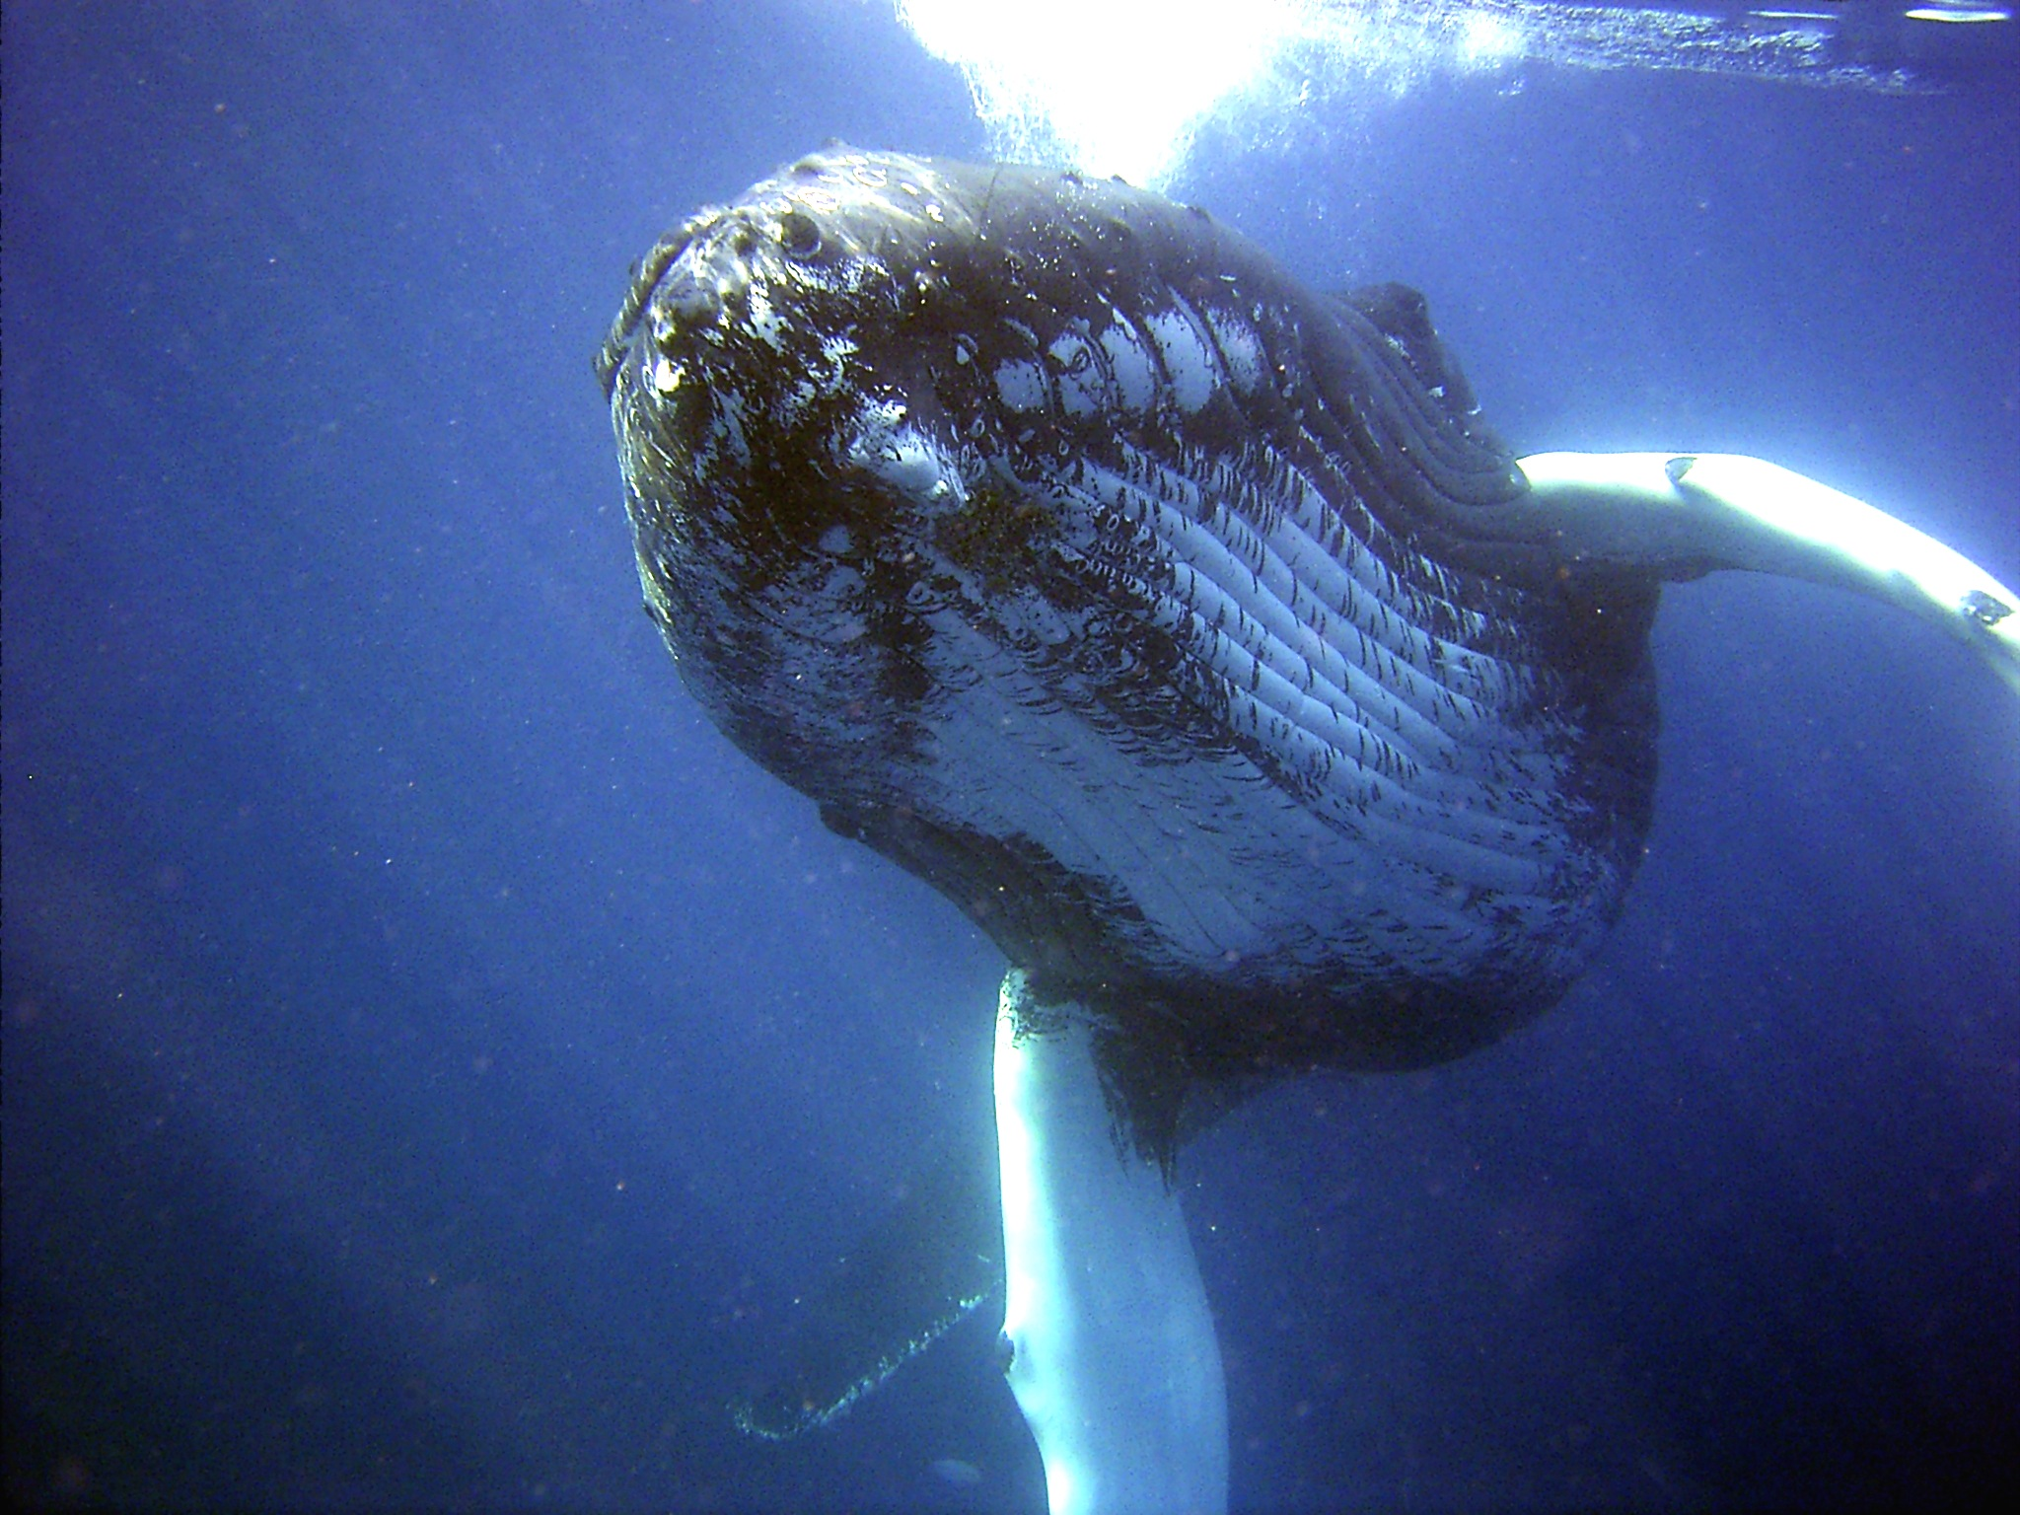  Photo: NOAA  - life span up to 80 years  - adults ~ 50 ft / 60,000 pounds, phenomenally agile and acrobatic  - gestation: 11 – 12 months  - forage: krill and schooling fish; use of bubble nets  - fin structure inspired engineering of wind turbine blades  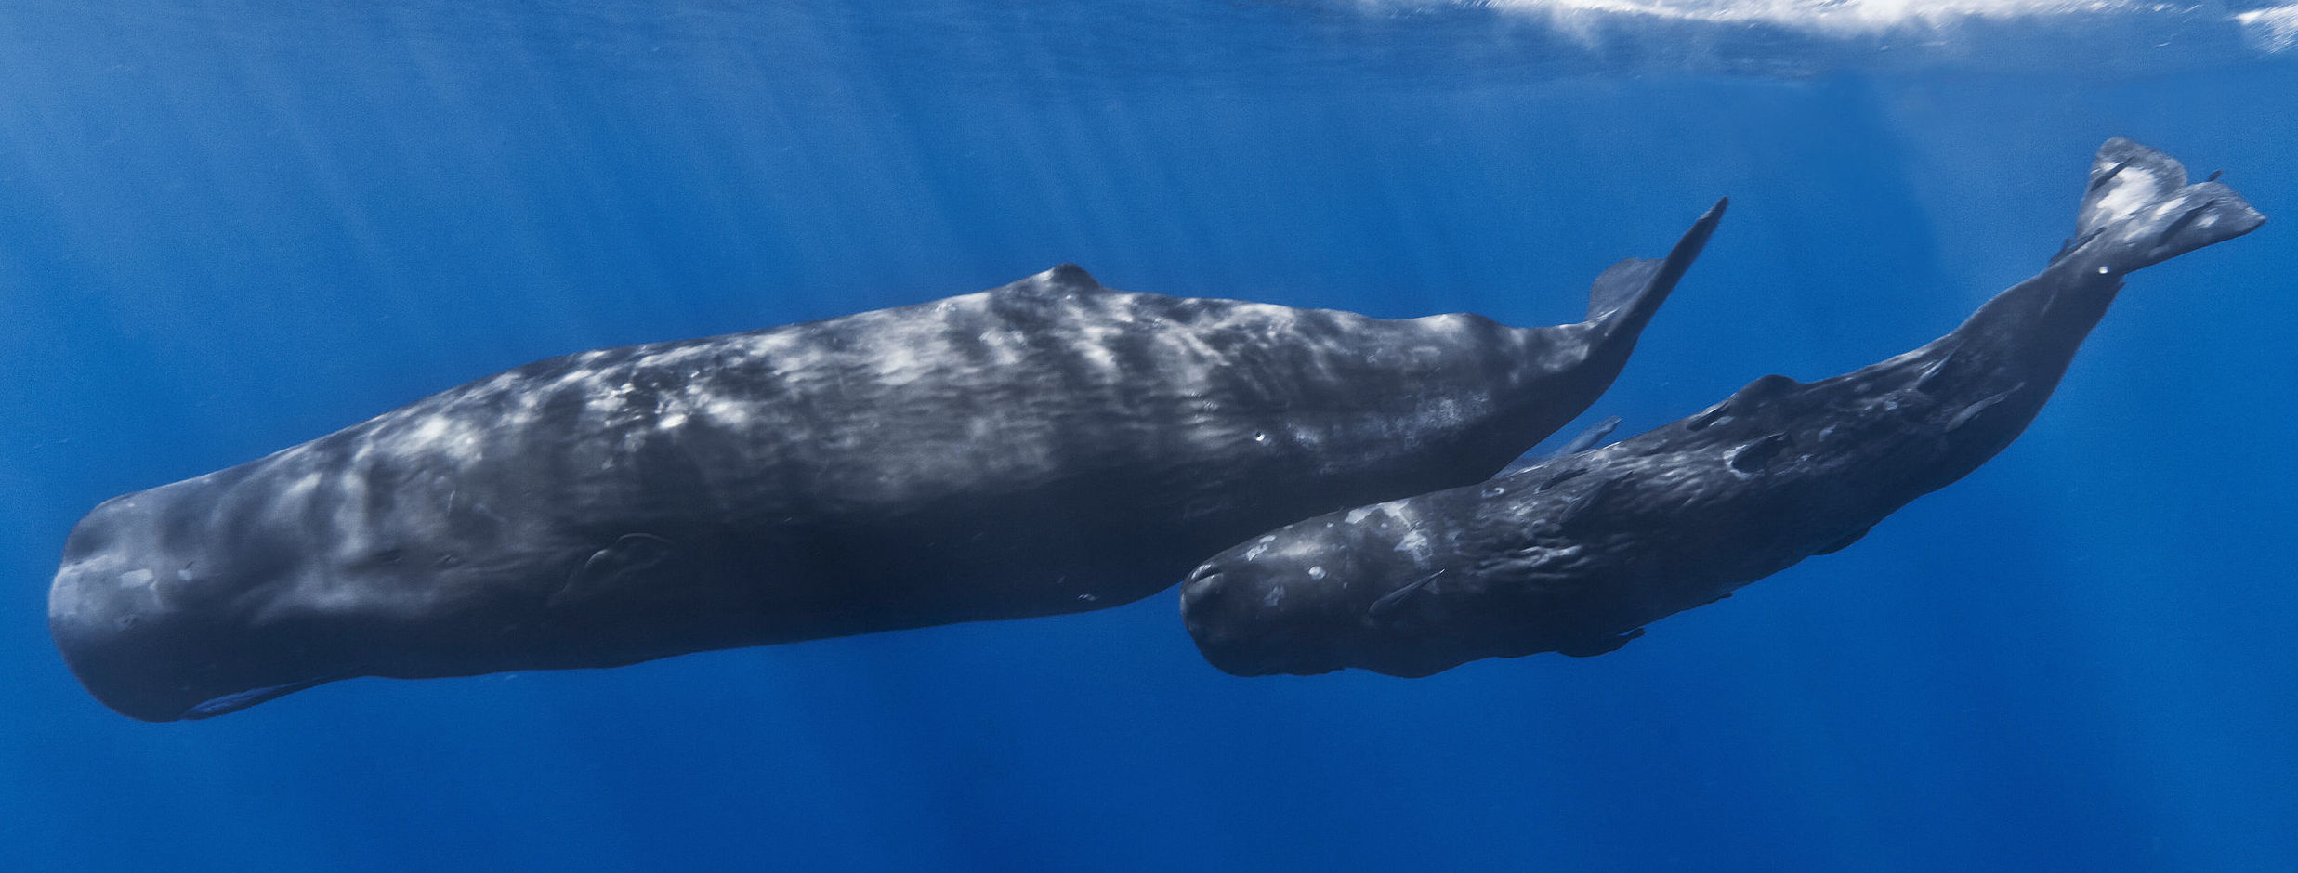  Accompanied by cachalot in final segment…  - largest of toothed whales to ~ 65 ft / 125,000 lbs  - 2nd deepest diving mammal (> 7000 ft)  - largest brain of any animal on Earth; head ¼-1/3 of body length | 4. Pacific white-sided dolphin  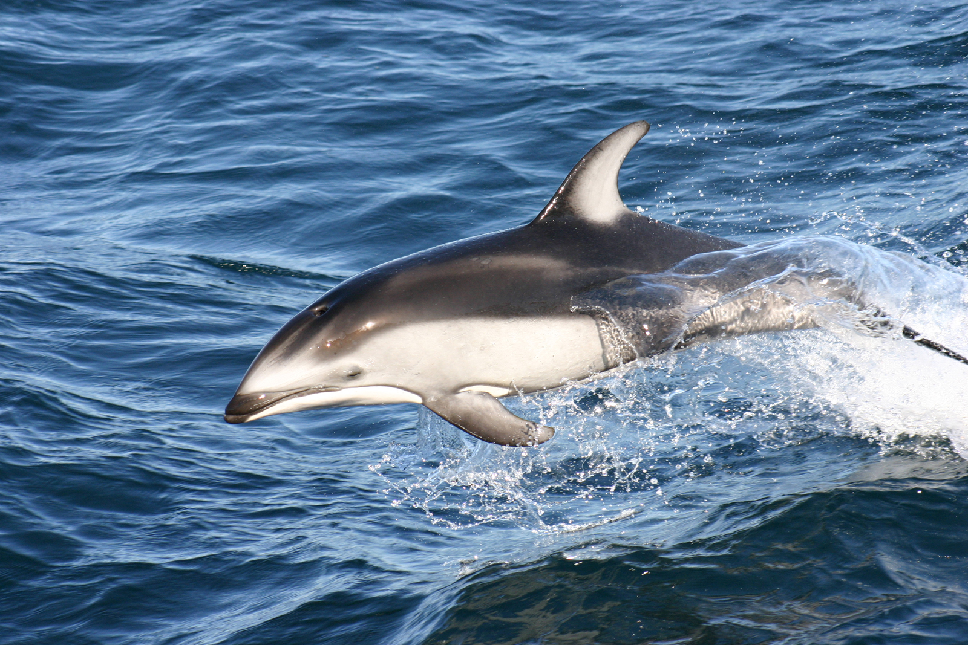  Photo: NOAA  - up to ~ 8 ft, 440 lbs  - Groups of ~90 individuals are common, up to ~300.  - forage: anchovy, squid, herring, cod, salmon, hake  - prefer offshore deep water  - only known predator is orca

5. mammal community  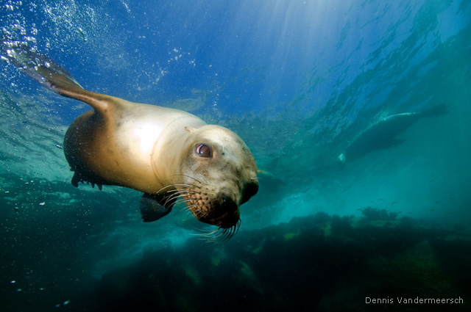 | 6. dolphin  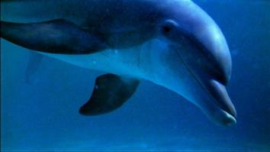  Photo: National Geographic  - clicks are directional and used for echolocation  - often occur in short series called click trains  - click rate increases when approaching an object of interest | 7. earthquakes  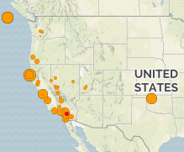  - Tertiary (T-phase) waves from earthquakes become water-borne acoustic waves in the ocean.  - Conversion from seismic to underwater acoustic wave is not well understood. | 8. seal bomb  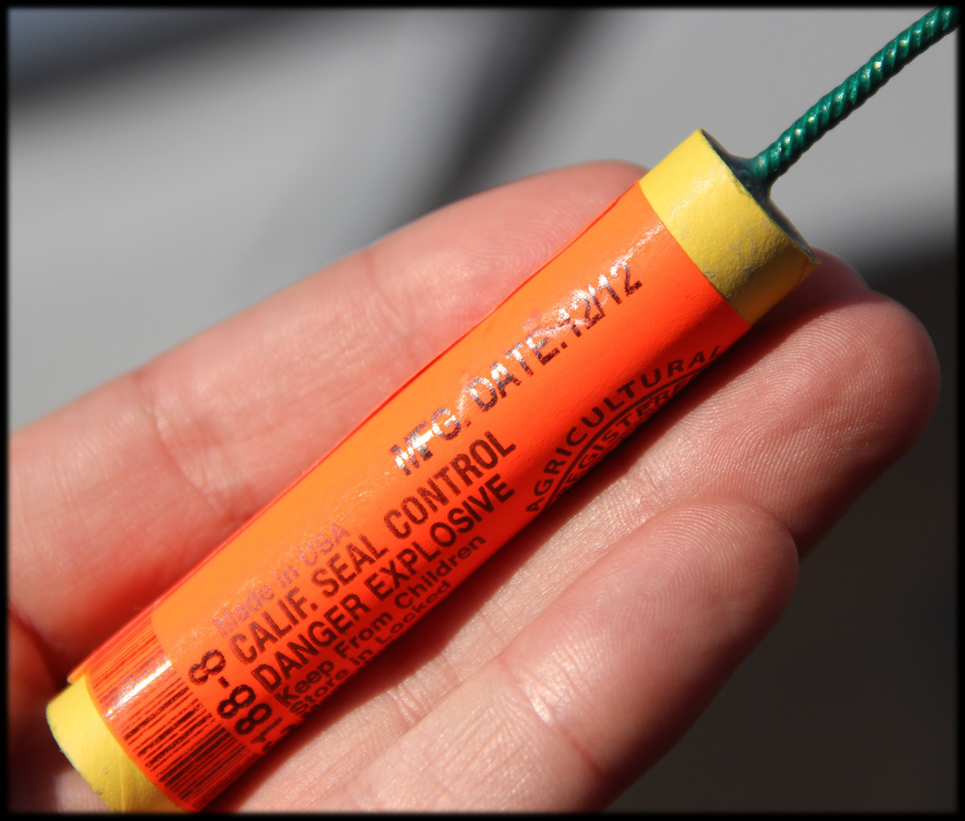  - detonated underwater during some commercial fishing operations  - intended to deter interference from sea lions  - primarily associated with the squid fishery (Scripps study)  - sound pressure levels of concern for cetacean health and behavioral effects  - up to 1000 explosions in 1 month recorded on Smooth Ridge

