MARS In-band Backdoor

General
MARS has an Xbar subsea to allow connection to serial ports on the Cisco’s, EDFA’s and power control. The Xbar also has one port set for loopback.

Accessing
The Xbar must be set to the appropriate port before serial port access can be done. The port can be set by either of two ways.

  - Method 1 – use webpage to select port
Use a browser to connect to 10.1.128.20/cgi-bin/obc_xbar.

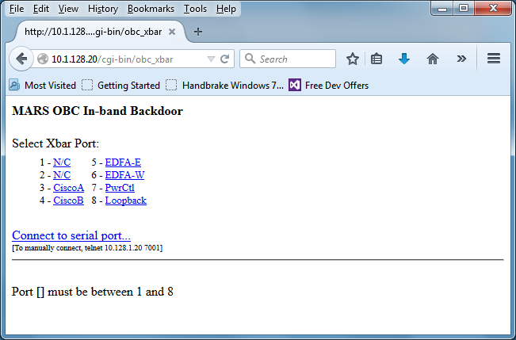

Select the desired port and then connect to 10.1.128.20:7001.

  - Method 2 – Directly specify port
The port can be directly selected of the desired port number is known. Simply use a browser to connect to 10.1.128.20/cgi-bin/obc_xbar?port=x
Where x is one of the following:
- N/C
- N/C
- CiscoA
- CiscoB
- East EDFA
- West EDFA
- Power Controller
- Loopback

