MARS October 2023 Monthly Meeting Agenda & Notes Oct 4, 2023
Time: Oct 4, 2023 10:30 AM Pacific Time (US and Canada)

- APL Electronics Hardware Status
  - BOB (Break Out Board)
    - PCBs received, order placed for assembly
    - Parts kit boxed and sent to assembly house
  - IGB
    - PCBs received, order placed for assembly
    - Parts kit boxed and sent to assembly house
  - HPB
    - Purchase order for PCBs fab placed
  - IPB
    - Will place PCB fab order soon
  - General
    - Having passive components installed by assembly house. Will install expensive parts (large FETS, relays, Vicor DC-DC Converters, etc.) at APL

- APL Software Status Update
  - Seafloor Controller Software
    - Have updated the node controller to the most recent version of Linux and QT framework
    - Have updated the message definitions
    - Working on updating message packaging and sending from the node controller
    - Ready to start testing when electrical hardware is available
  - Shore Computer
    - Data protocol has been defined, ready to start basic communication testing when electrical hardware is available

- Mechanical Status
  - Ready for preliminary mechanical system review
  - Working on updates for new MBARI components
  - Need details on MBARI Serial Splitter
    - Can allow space for small module/board if design not complete

- Documents and Drawings
  - Requirements Document
    - Several iterations with MBARI
    - Need to update the 24V power switching req’ts based on new components
  - APL MARS LVPS Block Diagram
    - Have added APL Controller I/O Paddleboard
      - Adds USB ports for monitor and keyboard for development & testing
      - Adds clock backup battery
        - Need to confirm how long battery will last
      - Could potentially be removed for deployment
    - Have added 2nd MBARI Media Converter and Port Server
      - Assume that we want to use SPARE_0 (currently 2 spares) to switch this or same circuit as the first Media Converter and Port Server.
    - Have added MBARI Serial Splitter
      - Need to confirm functionality, connections, size and other details
      - Do we want to use SPARE_1 (currently 2 spares) to switch this?
    - Need to update wiring, HPB power channels, other details

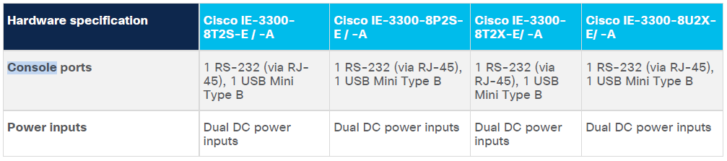

  - MBARI MARS System Block Diagram
    - Last updated Jan 2023
    - Need to add new components
  - APL Bill of Materials
    - Updated with new MBARI components
    - Need details for MBARI Serial Splitter for BOM, when available
    - Need manufacturer and part number of 8-fiber underwater penetrator for BOM
    - Need part number of ODI wet-mate 12-way electrical underwater connector for BOM
  - APL Harnessing Wiring Diagrams
    - Need to add cables for new Media Converter/Port Server, Serial Splitter & Paddleboard
    - All harnessing parts on-hand, will start building cables for PCB testing

- Action Items
  - Dimensions and location details on MBARI Fiber Patch Panel/Box (MBARI)
  - Details on Serial Splitter (MBARI)
  - Need flyback diodes on MBARI Serial Splitter
  - Look at adding larger Lithium cell for Paddleboard back-up battery

