2019 Annual Report

MARS O&M 701127
Accomplishments
Operated and maintained the MARS cabled observatory through 2019
Highlights:
Completed the annual shore-side maintenance without incident
Installed new AC units
Installed backup generator to avoid outages
Up graded the system PCs to Windows 10 to keep in line with IS policy.
During maintenance, Nate Lindsey from Berkeley Seismological Laboratory (BSL) again installed his Distributed Acoustic Sensing (DAS) system on the dark MARS cable. This effectively turns the cable into a 25-30km long seismic sensor capable of seeing pressure waves along the length in real time and record the data. This work from 2018 deployment was published in Science and presented at AGU this past Fall.
Deployed the Quest Institute educational platform, (observation class ROV, hydrophone, Pan/Tilt/Zoom camera, microscope). This experiment is designed to develop education plans for high school students and inspire young people to become involved with Science, Technology, Engineering and Mathematics (STEM).

Deployed the Deep Sea Connect (DSC) system on the MARS node. This project developed wireless power and data system capable of supporting three individual experiments without the use expensive under water mate-able connectors. This project is focused on less well-funded groups such as community colleges and high schools. A Raspberry Shake (https://raspberryshake.org/) is connected to DSC as demonstration project. It is a low cost seismometer. The data from it is flowing to the Citizen Science network found on the website.
Work has started to upgrade the MARS electronics with new power supplies, current data transport equipment and a new timing system. Additional effort is being devoted to upgrading the End of Life operating system (OS) to a supported OS.
A “No Cost Extension” to the MARS NSF grant has been applied for, it is expected to be accepted. The current award expires on Feb 28th 2020.
Deployed the DIEMOS EK60 for the Benoit-Bird (Urmy) lab. 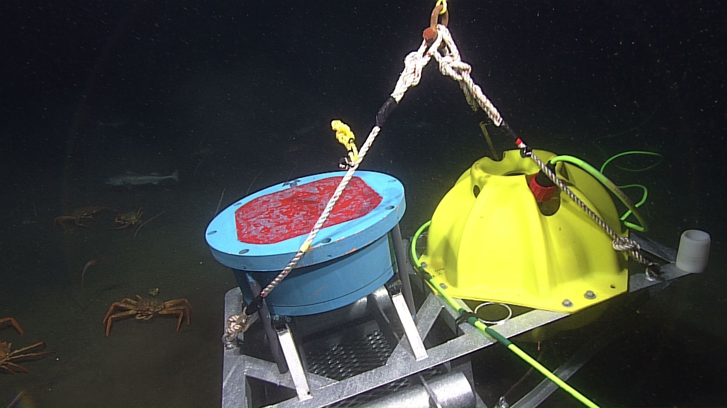
- Awards
- Degrees awarded
- Patents issued
- Invited lectures
MBARI Seminar Series, Nathan Lindsey, Illuminating the seafloor with dark fiber seismology and the MARS cable Oct 2018
- Mentorships
Format: Student name, academic status or MBARI postdoc, university (subject of student project). For instance:

- Publications: Nathan J. Lindsey, T Craig Dawe, Jonathan B. Ajo-Franklin: Illuminating seafloor faults and ocean dynamics with dark fiber distributed acoustic sensing, Science 11/29/2019

Illuminating the seafloor with dark fiber seismology and the MARS cable

Place text and figures in \\atlas\tempbox\barr\2019AnnualReport
>> Deadline: Noon, January 21, 2020 <<

