2015 Annual Report
Place text and figures in \\atlas\tempbox\barr\2015AnnualReport

Project title: MARS O&M III
Project leads: Craig Dawe
Project manager: Craig Dawe
Project team: Ken Heller, Thom Maughan, Paul McGill
Collaborators: National Science Foundation

Project summary
The National Science Foundation (NSF) provides support to maintain and operate the MARS cabled observatory in Monterey Bay. MARS is an observatory facility available to internal and external scientists and developers as both a test bed and a research site. Since November 2008, MARS has been used to test and gather data from a variety of ocean instruments, including a seafloor seismometer, the Environmental Sample Processor, the Free Ocean Carbon Dioxide Enrichment system, the Sediment Event Sensor, and a camera that sends back video images of the seafloor in real time. Current projects connected to MARS include the Monterey Ocean Bottom Broadband (MOBB) Seismometer operated by the Berkeley Seismological Laboratory and the Passive Acoustic Sensor (PAS) operated by a consortium of researchers lead by MBARI’s Dr John Ryan.

Figures
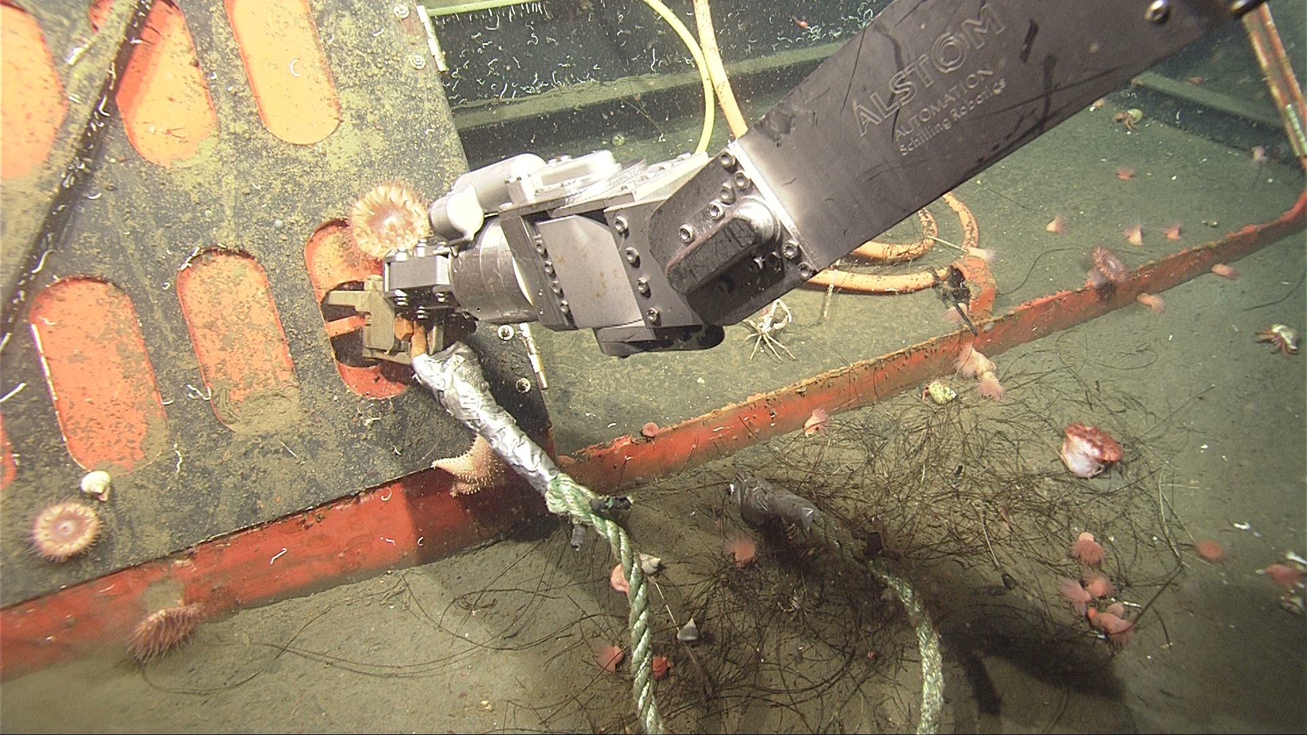Ventana disconnects a Schnittger (MBARI Intern) shackle during the PAS deployment
Addenda
This should include the accomplishments of all members of your group who are MBARI employees. Please follow the format of the addenda in the 2014 Annual Report.
- Awards
- Degrees awarded
- Patents issued
- Invited lectures
- Mentorships
- Education and outreach efforts (for internal use; not to be printed in the annual report):
- Peer-reviewed publications
- Technical publications

>> Deadline: Noon, January 19, 2016 <<

