Project Summary
MARS (Monterey Accelerated Research System) O&M (Operation and Maintenance)
The world oceans are responsible for much of what happens on the planet, making the need to understand the workings of this vast ecosystem of premier importance. The ocean observing community is making strides to this end by providing real time access to data and observations through installations such as IOOS (Integrated Ocean Observing Systems) which utilizes a series of observing systems that sense US Coastal and Great lake waters, Neptune (North East Pacific Time-Series Undersea Networked Experiments) Canada, VENUS (Victoria Experimental Network Under the Sea) , OOI (Ocean Observing Initiative) utilizing coastal global and regional scale observatories. These long term observatories along with international partners provide large amounts of real time multidisciplinary data relevant to understanding the challenges and issues that the ocean plays a role in, natural hazards, the climate system the carbon cycle and other biologically mediated processes. MARS has been recognized as a necessary test bed to develop sensors, develop operational procedures and conduct engineering trials.
This proposal seeks to continue what has been a very successful program of testing and development for sensors and experiments being deployed on ocean observatories by researchers from across the country and around the world. In addition, MARS is an observatory in its own right providing real time data to the Northern California Seismic Network through MOBB (Monterey Ocean Bottom Broadband Seismometer) and physical oceanography data and High Definition video to the Monterey Bay Aquarium and to CeNCOOS (Central and Northern California Ocean Observing System) through their data portal (Dec 2013).
MARS is an operational deep water cabled observatory built to support the U.S. ocean science community. Operating with just 1.6FTEs (Full Time Equivalents), MARS provides an important service to the science community at a very cost effective rate. Ship and ROV services are minimized due to the proximity of the MARS observatory to the MBARI facility in Moss Landing, California (two hours sail). Additionally, MARS users have the advantage of access to skilled operational personnel, technicians, and engineers, along with the MBARI/MARS facilities, a 10m deep test tank and the MARS Wet Node Simulator. Access to these resources can be granted on a daily or hourly rate as needed for testing, deployment and recovery of observatory systems/experiments.
This proposal reports results from the 3rd, 4th and 5th (Nov 2010- Nov 2013) years of full operation and request funding to continue serving the ocean science community and satisfy the terms of permitting agencies.
Project Description: MARS (Monterey Accelerated Research System) O&M
(Operations and Maintenance)—the second three years
1. Results from Prior NSF support
Steve Etchemendy, Director of Marine Operations, MBARI is the PI on the current MARS O&M
grant (NSF OCE- 1114794) for performance period 06/1/2011- 05/31/2014. The second three years of operations have demonstrated a cost effective, reliable, service oriented facility, which has supported science and engineering development effectively. Etchemendy was the Co-PI on the first MARS O&M (NSF OCE-0739828: $1,462,983 Total Award Funds)
Etchemendy was also a Co-PI on a NSF grant subcontract to the University of Washington for Dr. Deborah Kelley (Subcontract: 1 Feb 03 to 15 July 03 - $45,210). The scope of work was to adapt the MBARI multiple barrel drill-sled to the WHOI (Woods Hole Oceanographic Institution) ROV Jason II, by converting it to a portable serial control system. The system worked extremely well, recovering sulfide cores in minimal time. The drilling system was transferred to WHOI on Sept. 1, 2005, to be used by the greater marine geology community.
Craig Dawe, has been the MARS Operations Manager during NSF OCE-1114794 and NSF OCE 0732983 and will assume the role of PI for the renewal.

2. Background
The MARS observatory was originally conceived as a test-bed for equipment and instrumentation destine for the Ocean Observing Initiative’s (OOI) Regional Scale Networks (RSN) and other observatory efforts nationally and internationally. As these installations mature begin to be operational, the need for pre-deployment testing and qualification becomes paramount. Over the past six years of operation MARS has proven its value. The cost and risks associated with deploying untested and unverified equipment is greatly reduced by using the MARS observatory. There is relatively inexpensive and readily available access through MBARI research vessels and ROV systems. The cost of using these assets is greatly reduced by proximity and availability.
The success and experience gained with pioneering coastal observatory projects like LEO(Long-term Ecosystem Observatory) -15 and MVCO (Martha’s Vineyard Cabled Observatory) , as well as open ocean projects like HOTS, BATS, TOGA-TAO and NeMO, have shown the huge potential of observatory-based science. VENUS has provided another step towards ocean bottom observatories with their installations in Saanich Inlet, the Strait of Georgia and the Fraser River Delta. (http://www.venus.uvic.ca/) In part, VENUS served a similar role for Neptune Canada (http://www.oceannetworks.ca/) as MARS now serves for the U.S. OOI observatories by developing operational techniques for observatories near-shore prior to open ocean implementation where the costs and risks are much higher. Neptune Canada, operational since 200, is the world’s largest cabled ocean observatory, http://www.neptunecanada.ca/.
The U.S. Ocean Observing Initiative is currently in the installation phase. MARS has been used as a test bed for the Cyber-infrastructure Initiative (Orcutt and Edgington) to develop instruments and sensors for the RSN (Regional Scale Nodes) for Freitag (ACCOMS), Chadwick (BPR), Kang Ding (CALLISTO), Reimers/Gurguis (BMFC) and to test potential candidates for either OOI or IOOS observatories (Horne’s EK 60 and Scholin’s DESP). MARS has also been used to host an assortment research and engineering efforts including the Monterey Ocean Bottom Seismometer (MOBB), the Free Ocean Carbon Dioxide Enrichment Experiment (FOCE), the Photographic Benthic Observing System (PhoBOS), Eye in the Sea (EITS), Benthic Rover, the Sediment Event Sensor (SES) and the Tongji Experiment.

3. MARS Description
Located on a sediment-covered site on Smooth Ridge, approximately 37 km from Moss Landing,
California, MARS is a single node cabled observatory with eight ODI (Ocean Design Inc.) underwater mate-able science connectors. Connected to the shore station via 52 km of submarine telecom cable, the node lies at 890 m depth. The shore station provides 7.5 kW of power and telemetry via eight single mode fibers. Power is distributed as needed across the eight science ports at both 375 and 48 VDC (Volts, Direct Current). Each science port provides a 100-Mbit per second full duplex Ethernet communication channel. Time distribution is provide by NTP (Network Time Protocol) for accuracies of 10 milliseconds and a 1 PPS (Pulse Per Second) signal providing accuracy of order 10 microseconds.

MARS users can plug instrument clusters into the science ports via "extension” cables. Both of
MBARI’s ROVs have been equipped with cable-laying tool sleds capable of laying four Km of 3/8 inch cable from the MARS node. Longer distances can be achieved by “daisy chaining” extension cables. In addition to surfaced laid cable these tool-sleds can be equipped with a plow that will bury cables up to 0.3 meters in soft substrate. Power delivery at the end of the extension cables is a function of the extension cable length and conductor size.

The primary electronics module is exchangeable by ROV without recovery of the main telecom cable or its termination assembly. This makes maintenance of the sea floor electronics affordable because it requires only one dive to unplug the electronics and recover it for shore side repair and one dive to reconnect it.

MARS is connected to the internet via CENIC, a 100 Gigabit/sec (Gb/s) circuit, which is shared by MBARI and Moss Landing Marine Labs (MLML). Therefore, there is no choke point between the 1 gigabit MARS output to the users’ IP destinations.

http://sanctuarysimon.org/projects/project_info.php?projectID=100391&site=true
4. Accomplishments
MARS became operational November 10, 2008 after an eight month commissioning delay. MARS has been operating with just a few minor interruptions in service for maintenance and repair since. (Nov. 30, 2013) Schedule maintenance will occur in early 2014 to service the shore-side power and optical systems.

As part of the permit and reporting requirements, the MARS facility is required to complete an environmental impact survey every 18 to 24 months. The most recent report can be found at http://sanctuarysimon.org/projects/project_info.php?projectID=100391&site=true The results of this survey reduced the reporting requirements to once every five years, the next due in 2015.

Outreach
MBARI has integrated the MARS Observatory into the Monterey Bay Aquarium 'Discovering
Monterey Canyon' auditorium program as well as in the new MBARI exhibit. The Monterey Bay
Aquarium has over one million visitors a year, thereby providing wide exposure for MARS and
OOI to the public. The EARTH Project, a science teacher outreach effort, has used MARS as a
tool at over 20 presentations to high school educators. See http://www.mbari.org/earth/default.htm for details. The MBARI sponsored PHOBOS data set is available on request from the MBARI Shore Side Data System (SSDS) archive and will soon be available via the CeNCOOS data portal http://www.cencoos.org.

Projects on MARS

Dr. John Orcutt of Scripps Institute of Oceanography deployed an Ocean Bottom Seismograph (OBS) on April 7th, 2010 as part of the Ocean Observatory Initiative Cyber-infrastructure effort and the Laboratory for the Ocean Observatory Knowledge INtegration Grid (LOOKING) project. The recovery was extended till October 26th, 2011. (NSF Cooperative Agreement Number: OCE 04-27974).

The American Geophysical Union (AGU) meeting in December 2012, OOI's Cyberinfrastructure: An Opening, Contributed poster
John Graybeal; Tim Ampe; Matthew Arrott; Alan D. Chave; Rod Cressey; Susanne Jul; Tim McPhail; Michael Meisinger; John A. Orcutt; Cheryl L. Peach; Oscar Schofield; Karen Stocks; Julie Thomas; Frank Vernon
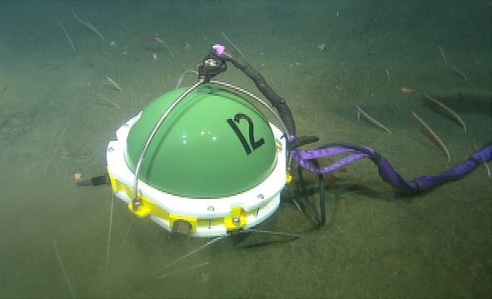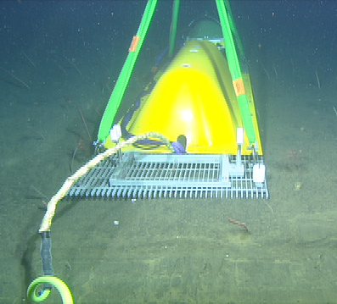
Ocean Bottom Seismometer (OBS) Trawl Resistant Frame

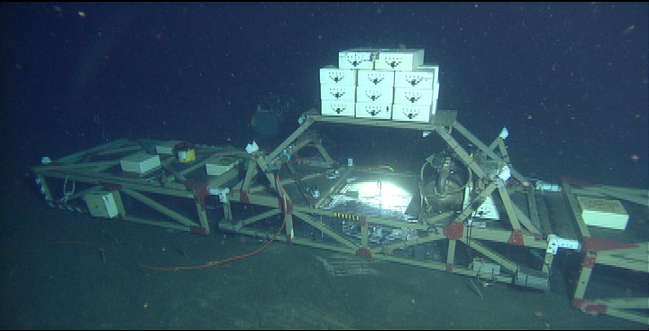
Dr. Peter Brewer of the Monterey Bay Aquarium Research Institute (MBARI) has deployed the Free Ocean Carbon Dioxide Enrichment Experiment (FOCE) numerous times using the MARS facility. FOCE is designed to study the effects of an increasingly acidic ocean on deep-sea biology. Each deployment refines the processes and the engineering design. The most recent deployment was May 4th 2011 with the subsequent recovery October 8th 2012. The FOCE system development conducted on MARS has contribute to the production of several systems deployed and being deployed around the world, Villefranche surMer, France (http://efoce.eu/), Heron Island, Great Barrier Reef, Austrailia (David Kline), and currently atCasey Station, Antarctica (Antarctica).
FOCE Frame with Experimentation Chamber (lighted)

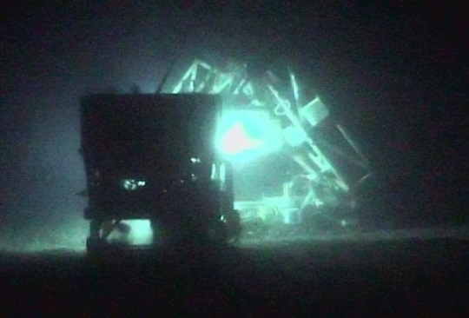
Summary of Talks, Posters and Papers given to date using MARS:
Ocean Sciences Meeting, Portland, OR, February 22-26: Talk: Real-Time Observations of the Tidally Driven pH Signal at the MARS Cabled Observatory in Monterey Bay,T. Maughan & E.T. Peltzer.
Pacific Science Association, 11th Inter-Congress, Papeete, Tahiti, French Polynesia, Mar 2-6, 2009: Contributed talk
FOCE from the PHOBOS imaging system
Recent Advances in FOCE Technology: Building a Better Sea Floor CO₂ Enrichment Experiment. W. J. Kirkwood, E. T. Peltzer, J. P. Barry and P. G. Brewer.

AGU/ASLO/TOS Ocean Sciences Meeting Portland, OR, Feb 22-26, 2010; Contributed talk
Real-Time Observations of the Tidally Driven pH Signal at the MARS Cabled Observatory in Monterey Bay. T. Maughan & E. T. Peltzer.

AGU Fall Meeting, San Francisco, CA, Dec 13-17, 2010: Contributed poster
Real Time Control of CO₂ Enrichment Experiments on the Sea Floor Enabled by the MARS Cabled Observatory. P.G. Brewer, E.T. Peltzer, P.M. Walz, W.J. Kirkwood, K. Headley, R. Herlien, C. Kecy, F. Shane, J. Scholfield, K.A. Salamy, T. Maughan, and T. O’Reilly.

MTS/IEEE OCEANS '11 Kona, Hawai‘i, September 19-22, 2011: Contributed talk
C.D. Kecy, E.T. Peltzer, P.M. Walz, K. Headley, B. Herlien, W. Kirkwood, T. O' Reilly, K.A. Salamy, F. Shane, J. Schofield, and P.G. Brewer. Design and Development of the CO₂ Enriched Seawater Distribution System.
Fall 2011 AGU Meeting, San Francisco, CA. December 5-9, 2011: Contributed talk
Kirkwood, W.J., Peltzer, E.T., Walz, P.M., Shane, F., Kecy, C., Headley, K.L., Herlien, B., Maughan, T., Scholfield, J., Salamy, K.A., O'Reilly, T. & Brewer, P.G. Enriched Seawater Delivery System to Support In Situ Ocean Acidification Experiments using Carbon Dioxide for pH Adjustment of Seawater.

AGU Fall Meeting, San Francisco, CA, Dec 3-7, 2012: Contributed poster
Long-term, High Frequency, High Precision pH Measurements on the MBARI deep-water FOCE Experiment at the MARS Cabled Observatory in Monterey Bay, CA. E.T. Peltzer; T. Maughan; J.P. Barry; P.G. Brewer; K.L. Headley; R. Herlien; W.J. Kirkwood; G.I. Matsumoto; T.C. O'Reilly; K.A. Salamy; J. Scholfield; F.F. Shane; P.M. Walz.

Pending Publication
LOVERA, C. F., E. T. PELTZER, P. M. WALTZ, P. G. BREWER, and J. P. BARRYMonterey Bay Aquarium Research Institute, 7700 Sandholdt Road, Moss Landing, CA 93950, USA (lovera@mbari.org)
Echinoderms are thought to be highly sensitive to ocean acidification driven by increased atmospheric CO₂. The deepFOCE system was used to evaluate the effects of high CO₂ conditions on the behavior of the deep-sea urchin Strongylocentrotus fragilis. We exposed batches of urchins (~30 per treatment) to high (-0.45 pH units) or low CO₂ levels (background seawater pH = 7.62) in FOCE chambers from Sept 19 to Oct 22, 2011 at a depth of 890 m on the continental slope off Monterey, CA. Four trials (days 5, 26, 30, 35) were completed by resetting the experiment with S. fragilis from holding cages in each FOCE chamber. Video and still image recordings of urchin movements enclosed in a 'raceway' were made to examine behavioral changes in response to CO₂ levels. The time taken for urchins to travel ~ 0.75m to a food source (giant kelp) in controls ranged from 20 min. to 27 hrs. Urchins exposed to high CO₂ took from 50 min. to greater than 8 days. Total distance and speed will also be used to compare urchin performance between high CO₂ and control treatments. Several reports for shallow-living taxa have noted impacts of high CO₂ levels on urchins ranging from reduced growth, survival, and calcification of larvae, to reduced growth and higher mortality in adults. The goal of this FOCE experiment was to examine long term, less-studied sub-lethal effects that may display as changes in normal movement, posture and feeding rates.

Dr. William Chadwick deployed a Bottom Pressure Recorder (BPR) coupled with a high resolution tilt meter June 30th, 2010. (NSF OCE-0826490) The instrument package is designed to monitor inflation or deflation in submarine volcanic areas caused by magma movements underground. Scheduled for recovery in June 2011 and extended to November 28th, 2011. The BPR’s final destination is Axial Seamount, a tectonically active area on the margin of the Juan de Fuca plate. http://www.pmel.noaa.gov/vents/geology/mars/

Presentations/Talks
Oceans 2012 MTS/IEEE, Yeosu, Korea, 21–24 May 2012
Nano-resolution technology demonstrates promise for improved local tsunami warnings on the MARS project. Paros, J., C. Meinig, M. Spillane, P. Migliacio, L. Tang, W. Chadwick, T. Schaad, and S. Stalin. In (2012)

In Symposium for Underwater Technology (UT), 2011 IEEE - 2011 Workshop on Scientific Use of Submarine Cables and Related Technologies (SSC), 5-8 April 2011 (2011)
Breakthrough underwater technology holds promise for improved local tsunami warnings
Paros, J., E. Bernard, J. Delaney, C. Meinig, M. Spillane, P. Migliacio, L. Tang, W. Chadwick, T. Schaad, and S. Stalin

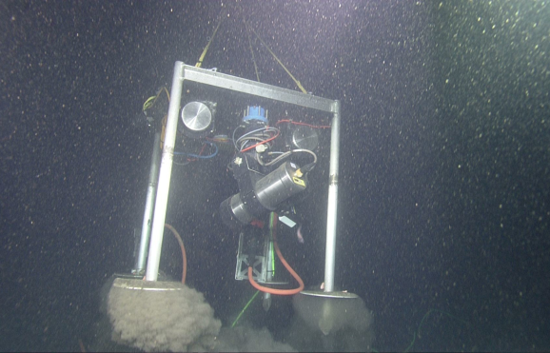
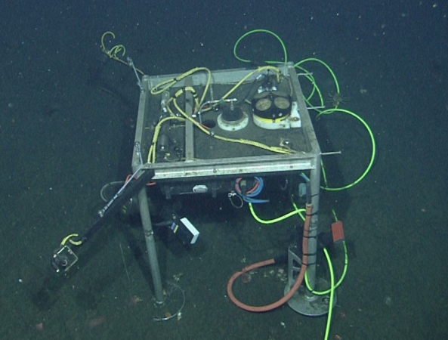
MARS/MBARI has deployed the PHOtographic Benthic Observing System (PHOBOS) to the MARS node on three separate occasions. PHOBOS was originally deployed as a tool to aid in operations at the MARS node from October 2010 to September 2011. It was recovered for repairs and enhancements (new lighting platform) and redeployed in November 2011 till October 2012. During the following maintenance period a new platform was built to accommodate additional sensors and a High Definition (HD) underwater imaging system. It has morphed into an outreach device providing real time HD images to the Monterey Bay Aquarium’s Live from the Deep exhibit and will soon provide data (Acoustic Doppler Current Profiler (ADCP), Conductivity Temperature Depth (CTD), Oxygen, Fluorescence) to the CeNCOOS data portal http://www.cencoos.org. It was redeployed in July 2013. Data collected from the site are also being archived in the MBARI Shore Side Data System (SSDS). SSDS is not public currently however, access to the data can be granted via MBARI’s ftp site on request. Its latest deployment is ongoing.
PHOBOS Recovery
Current PHOBOS on sea floor

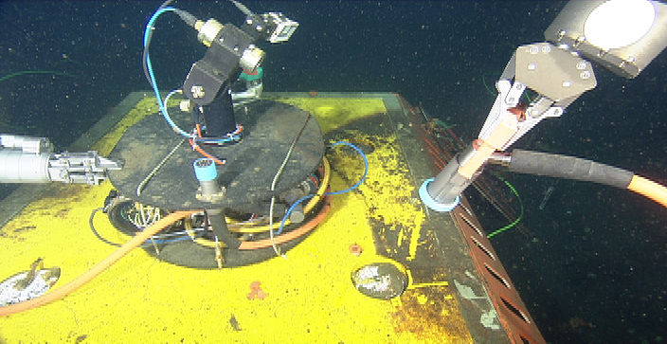
Original PHOBOS on top of the MARS node
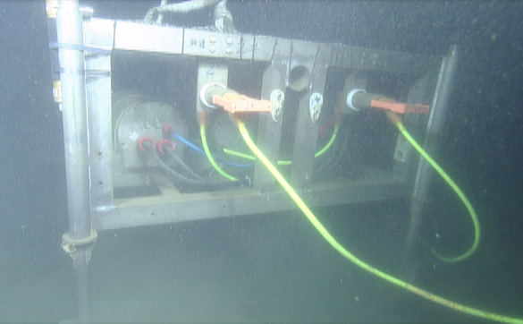
In April 2011 Dr. Huaiyang Zhou of Tongji University deployed the Chinese Observatory on MARS for an initial six week trial. Three separate packages were placed near MARS in a two ship operation using the RV Western Flyer to lower and release each package while the ROV Ventana, provided guidance to the RV Western Flyer to position each package with meter level precision near MARS. The packages were a junction box (distribution center) with a video camera, a chemical monitoring system measuring in-situ anion concentrations, methane, chlorophyll, oxygen, nitrate, as well as pH, and a Dynamics Environment Monitoring System providing CTD and bottom current velocity. The deployment was extended to October 2012.
Tongji Main Electronics Platform

Presented Publication
IEEE Oceans 2011 Development of an Undersea Science Node for Cabled Ocean Observatories
Feng Lu, Huaiyang Zhou, Xiaotong Peng, Jiguang Yue, Bin He, Bangchun Wu. Tongji University, Shanghai, China

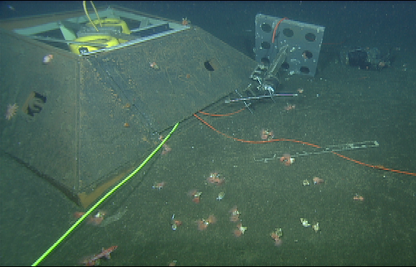
Dr. Barbara Romanowicz operates Monterey Ocean Bottom Broadband seismometer (MOBB) originally funded under NSF/OCE grant OCE-0648302 (now expired). MOBB is a three component, broadband seismometer and the only permanent underwater seismometer west of the San Andreas Fault system. MOBB is connected to MARS via a 3.5 Km cable laid by the MBARI ROV Ventana on February 26, 2009. www.berkeley.edu. During the initial deployment period MOBB was struck by fishing trawls three times, the last breaking the cable and disabling the system. To mitigate these incidents, MBARI developed a plow that works in conjunction with the cable lay tool-sled to bury the cable up to 12 inches in soft seafloor material. MOBB continues operation to date under funding from the Berkeley Seismological Laboratory. Fishing activities continue in the area with no further incidents detected.
Trawl Damage to TRF and Current meter

Pending Review
On the Systematic Long Period Noise Reduction on Ocean Floor Broadband Seismic Sensors Collocated with Differential Pressure Gauges. Taka'aki Taira, Zhao Zheng and Barbara Romanowicz, Berkeley Seismological Laboratory, University of California, Berkeley.

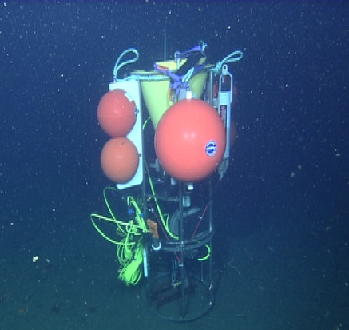
Dr. Ken Smith deployed the Sedimentation Event Sensor (SES) on three occasions, September, October and November 2011. SES is a sediment trap mounted on a rotating plate, allowing the collected sediment to be imaged for composition and size, and measured for chlorophyll content. One of the challenges of this development is creating robust software to control the system both autonomously and for test deployments on MARS. The software framework developed for the Rover is ideally suited to this task, given the similarities of their sensors and actuators (i.e. cameras, lights, motors). To increase the likelihood of success, of the autonomous version of SES was deployed onto MARS. Without these trials on MARS the system would in all likelihood be still under development due to the location of Station M (Lat N35 9.5150 Lon W122 59.0024) where it is currently deployed to monitor episodic sedimentation events in support of the MBARI Biodiversity Initiative.
SES on Seafloor at MARS

Pending Publication:
Sedimentation Event Sensor: new ocean instrument for in-situ imaging and fluorometry of sinking particulate organic carbon. IEEE Journal of Oceanic Engineering.

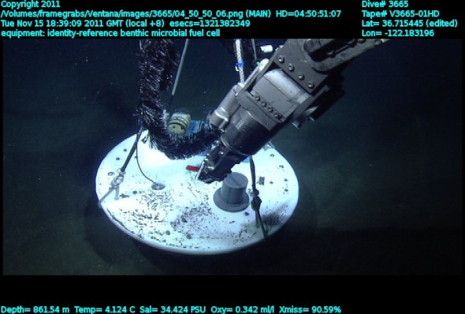
Dr Clare Reimers (OSU) and Dr Peter Guirgus (Harvard) deployed the Benthic Microbial Fuel Cell Project (BMFC) in October of 2011. The BMFC developed an alternative approach to remote seafloor instrumentation deployments by harvesting power from the environment and then relay data acoustically to the MARS cabled observatory. The primary accomplishment of this project was the demonstration of this kind of underwater sensing/acoustic communications-based infrastructure. BMFC was recovered in January 2012. Insertion of BMFC into the sediment
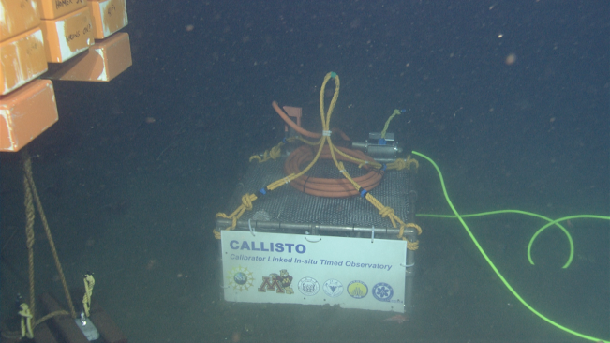
In November 2012 Dr Kang Ding from the Earth Science Department of the University of Minnesota deployed the Calibrator Linked In-situ Timed Observatory (CALLISTO) in Monterey Bay. The pH Calibrator is an instrument for in situ calibration and measurement of chemical species (pH) in aqueous fluids at elevated pressure. It has been transformed from a battery-powered instrument for short-term application into a unit that can be used to take CALLISTO on the seafloor prior to recovery full advantage of cabled-powered observatories that are now online online at a number of locations in marine environments. The MARS deployment was the initial steps in this conversion. This work is supported by US NSF grant 0927615, China National High Technology Research and Development Program funding 2010AA09Z202 and the Knowledge Innovation Project SIDSSE-201204 from Sanya Institute of Deep-sea Science and Engineering. CALLISTO was recovered in January of 2013.

Presentations/Publications:
AGU Fall Meeting, San Francisco, CA, Dec 3-7, 2012: Contributed poster
A remotely operated time-series sampler for collecting gas-tight hydrothermal fluids. Shijun Wu ^{1, 2}, Canjun Yang ¹, Kang Ding ², Chunyang Tan 1. Key Laboratory of Fluid Power Transmission and Control, Zhejiang University, Hangzhou, China 2. Earth Science Department, University of Minnesota, Minneapolis, MN, United States3. Tongji University, Shanghai, China
IEEE/ASME TRANSACTIONS ON MECHATRONICS, VOL. 17, NO. 1, FEBRUARY 2012
Development of an In Situ pH Calibrator in Deep Sea Environments. Chunyang Tan, Kang Ding, Bo Jin, William E. Seyfried Jr., and Ying Chen

MARS ‘success’ story
Dr. Chris Scholin, Deep Environmental Sample Processor (D-ESP), NASA and NSF OCE-0314222
The D-ESP is a microbiology laboratory capable of autonomously running sandwich hybridization and quantitative PCR assays in situ. The D-ESP collects particulates from a water sample (typically 1 liter), lyses these particulates, and washes the lysate over a 35-target probe array. It also can extract nucleic acid from that lysate and perform a single-plex qPCR assay on up to five targets. The D-ESP has just completed a NASA-sponsored 34 week run on the MARS cable. During that time, 24 samples were collected, performed both sandwich hybridization and qPCR on each sample, and collected and preserved a second sample near that same time-point for later analysis in the laboratory.
We had three deployments on the MARS cable in the last three years:
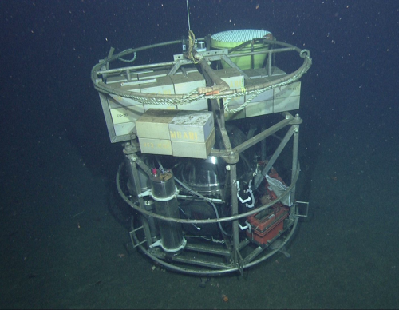
Dec 14, 2009 to Jan 7, 2010 (2+ weeks [DWSM went bad])
Nov 30, 2010 to Jan 4, 2011 (~4 weeks [48V port went bad])
Apr 18, 2013 to Dec 11, 2013 (~34 weeks)
Each deployment provided constant communication with the instrument, and in some cases allowed us to fix instrument issues that normally would cause the mission to abort. The third run on the cable was the longest on record for a microbial laboratory, and allowed us to view not only changes in microbial populations resulting from deep-water changes in the currents, but also microbial changes in the detrital ‘snow’ raining down from the surface through the winter/summer and summer/winter transition periods. Pre Recovery Inspection of ESP

5. Service-Oriented Facility
The MARS facility is designed to provide service to the ocean science community in a cost effective manner. It requires only one full-time position (the MARS Facility Support Technician), providing only essential operations and maintenance services limiting fixed costs. Keeping these costs low results in a cost effective program for NSF because resources are not wasted when the MARS user load is low or self-sufficient users are using the MARS test bed. As a result, MARS users need to request funding for special technical services required by their project in their proposals. During proposal preparation, potential MARS users are provided technical, budget and deployment/recovery advice by the MARS Operations Manager (less than half time position). Once the MARS users are funded, MBARI’s Operations Administrator provides permit support, and Information Services provides the necessary IT support to insure connectivity from the users instrument to the users IP addresses at no cost to NSF or the MARS user. MARS does not provide DMAS (Data Management and Support). MARS does provide facilities to locate user
RAID arrays, computers or routers as needed. MARS users usually need a single test tank day to verify that their instruments are correctly configured to operate on MARS via the wet node simulator. Ship and ROV deployment and recovery is available using either of MBARI’s two ROV-equipped ships, or UNOLS ships. Ocean science users are charged “at cost” rates for MBARI ship/ROV services.
MARS is available to several different funding organizations, including but not limited to: NSF,
ONR, NOAA, NASA, DOE, and DOD. Each of these organizations will benefit from the availability of MARS as an ocean science and technology test site.
Upon inception of the MARS facility, NSF and MARS agreed that the MARS O&M costs should be distributed fairly to the actual users and NSF should not bear the full burden of the ongoing operations and maintenance costs. To achieve this objective, MARS charges a minimal fee for each project funded either by NSF or to those whose objective is to develop technology for OOI observatories using one of the eight MARS ports. The intent of this fee is help pay for maintenance and other costs. MARS also requires a fee equaling a fair share of the operational costs from other U.S. government funding agencies to use MARS, as these agencies may have objectives not directly linked to NSF or OOI. This science port fee rate will be governed by annual discussions with the UNOLS Observatory Oversight Committee with dual objectives of providing a repair reserve and regulating the rate of MARS user science port use. The current MBARI/NSF rate is $1000.00 per month. All other organizations using MARS will be charged $5000.00 per month. This charge begins the day the instrument receives power from MARS and ends on the day MARS power is turned off to the instrument. Partial months are prorated.

Operations Philosophy
The MARS operations team is committed to enabling MARS users, engineers and scientists, to be successful developing and testing their systems on the MARS cabled test bed observatory. Although the NSF-funded MARS team is small, MBARI’s Marine Operations and Engineering
Divisions are dedicated to developing operational capabilities for ocean observing that have common uses. For example, the NSF-sponsored MARS and the MBARI-sponsored MOOS
(Monterey Ocean Observing System) both benefit from projects like the cable laying tool sleds, extension cable developments, SIIMs (Science Instrument Interface Modules), PUCK (Programmable Underwater Connector with Knowledge) and SIAM (Software Infrastructure and Applications for MOOS). Developments to enhance ocean-observing capabilities benefit our common objectives. The SIIM design is available at no charge to users. MARS O&M also takes pride in MARS users’ successes. As indicated above the projects over these past years are a testament to the success of MARS and its value to the Ocean Science community.

What will MARS O&M cost?
Ship/ROV days for maintaining the infrastructure are included in this proposal. Parts and supplies costs are requested. Labor equaling 1.3 FTE (Full Time Equivalents) is requested for the duration of the project. Costs associated with fishermen's association coordination are requested. Costs derived from the permit process include reoccurring benthic biology survey requirements and a minimal fee for right of way through Moss Landing Harbor District property. This proposal is based on guidance from NSF to provide the minimum operations and maintenance costs consistent with a no frills support operation. Extra services can be provided when supported by the user's project funding.
Permit mitigation, insurance and "right-of-way use" lease
The installation of the MARS Cabled Observatory required approval from 13 State and Federal Agencies. Mitigation for issues ranging from seafloor disturbance to right-of-way through
California State lands have resulted in the following on-going costs:
Cable route inspections:
- Ongoing ROV surveys of the cable route preformed are included.
- "Actual Impacts Assessment" surveys (biologic sampling and assay) were required 18 – 24 months after installation now extended to every 60 months for the duration. Costs included in this proposal.
Fisherman Agreement:
- A 24-hour fishermen's hotline has been established at MBARI's expense.
- In the unlikely event that fishing gear gets tangled in the MARS cable/node, costs for fishing gear lost are not provided for in this proposal. A supplemental proposal will be submitted to NSF in the event that this becomes necessary.
Insurance:
• Liability insurance costs are paid for by MBARI.
• Property and D.I.C. (earthquake) coverage estimates are cost prohibitive; MBARI has received a waiver from NSF to exclude property and D.I.C. (earthquake) insurance for the facility.
Right of way:
• A portion of the MARS cable route transverses Moss Landing Harbor District property, costs are included in this proposal.

The MARS staff
The MARS Operations Manager (one third time position) is responsible for maximizing the success of the MARS users' community. Additionally, the MARS Operations Manager is the primary resource to assess deployment “readiness” of science experiments as well as any infrastructure component of MARS. The MARS Operations Manager will function as the MBARI Marine
Operations Technical Manager during the unfunded portion of the year. The logic here is to integrate MARS maintenance and operations requirements with the primary service vessels for MARS as much as possible.
This Position:
• Works with MARS users at the proposal stage to refine experiment designs
• Advises on the development of new equipment such as extension cables, SIIM’s
(Science Instrument Interface Modules) and connectors
• Provides oversight and maintenance plans for all components of system
• Maintains records for all operational issues and assists in reporting this information
• Develops deployment plans for each science and/or engineering mission for MARS
• Coordinates deployment schedules with MBARI’s Division of Marine Operations (DMO)
• Manages MARS finances and cost reporting
• Assists with troubleshooting electronics and communications problems
The MARS Facility Support Technician (full time position) is responsible for the day-to-day operation of the MARS system.
This Position:
• Monitors data streams and adjusts power levels using PMACS (Power Management and Control System).
• Monitors system functional parameters and provides watchdog functions to ensure smooth operations.
• Insures the data store and forward functions are working.
• Maintains the system and manages the day-to-day needs of the MARS computer network.
• Assists with the test tank experiment installations and supports users.

The MARS PIs
Steve Etchemendy, Director of Marine Operations at MBARI, will function as Co PI for MARS. He deals with policy issues, permitting, insurance, staffing, and reporting obligations with NSF. Additionally, Steve will represent MARS O&M for UNOLS ship scheduling functions. (2 mo. / year at no cost to NSF)
Craig Dawe, MBARI Marine Operation Technical Manager and MARS Operations Manager will act as co PI with Steve Etchemendy, providing technical oversight to the project as well as meeting the other obligations of PI.

MARS user costs (not covered by MARS O&M)
A MARS user proposal may request technical support and ship/ROV support from MBARI or may use UNOLS vessels/submersibles or other resources. An example of services available "at cost" from MBARI are provided at the following URL: http://www.mbari.org/mars/new/rates.html
Note: Labor is based on average wage for that group plus fringe and overhead.
Ship/ROV costs are operating costs divided by days/year so they vary each year.

Concept of Operations
• Operations Philosophy - The primary mission of MARS is to provide a facility to test and develop equipment for the ocean science community. In many cases MARS will provide the first long duration sea trials of ocean sensors under development. MARS will enable ocean engineers not only to directly monitor their instrumentation on the sea floor but also to modify their software based on real world sensor inputs. Although primarily a test bed, MARS can be used as an ocean science platform. MOBB, UC Berkley’s broadband seismometer feeds directly into the Northern California Seismic Network. Where it is appropriate, NSF, NOAA or other funding agencies may decide to install science sensors on MARS that are not in the development phase. If recovery of equipment is necessary, it is only two hours away by ship from Moss Landing. To be cost effective MARS staff will operate on a normal (40 hr.) work week schedule. This will minimize personnel costs and is appropriate for a test bed facility.
• Customer support, pre-proposal stage - The overall purpose of the MARS O&M is to provide the platforms and services necessary to test and support prospective technologies destined for use on ocean observatories. MARS O&M will provide prospective users with support to estimate ship/ROV time to deploy and recover their experiments as well as the shore-side technician time that is necessary to test equipment prior to pre-qualification deployments in MBARI's test tank. MBARI does not have sufficient engineering resources to support all potential MARS users but we have assembled a list of recommended engineering resources that can be tailored to a potential user's needs. This list includes freelance engineers as well as medium sized companies like Ocean Design and Ocean Works (Vancouver, B.C.). Even large companies like SAIC are on the MARS engineering support list. MARS O&M will assist potential users by providing a list of engineering resources that could fit their needs.
• Customer support, permits - MARS is located in the Monterey Bay National Marine Sanctuary. As such, some instrumentation will require permits and others may qualify under the MARS general permit. Federal regulations require NSF to assess whether a project meets applicable federal and state permits prior to awarding a proposal grant. NSF will use the standard proposal process to review MARS user proposals. If a proposal is judged acceptable but requires a permit, NSF may fund resources necessary for the permit process prior to granting the proposal. This may range from minor resources to prepare permit documentation to resources sufficient to submit an EIS (Environmental Impact Survey). NSF will submit proposals not covered by the MARS general permit through interagency channels for approval.
• Customer support during operations - A MARS user's instruments deployed on MARS are the sole responsibility of the user. MARS does not have any DMAS (Data Management and Archiving) capability. Instead, MARS will direct data connectivity to a user-supplied IP address. If a MARS user needs power adjustments, instrument recovery, or other support over the course of a deployment, we expect an e-mail message that will be acted on during normal working hours to schedule necessary adjustments.
Governance
The new UNOLS Ocean Observing Science Committee (OOSC) will provide oversight on MARS and other NSF-sponsored observatories.
13. Communications
MARS O&M provides a list server to keep interested parties informed about MARS issues. The MARS technical/schedule discussion list reports on system down time, technical and schedule issues.

REFERENCES CITED
This is a non-research effort

Steve Etchemendy
Monterey Bay Aquarium Research Institute
7700 Sandholdt Road
Moss Landing, CA 95039
831-775-1902
(a) Professional Preparation
University of Washington, B.S., Natural Science, DMG 1972
Air/Mixed Gas/Saturation Diver, Commercial Diving Center, Wilmington, CA. 1979
Atmospheric Diving Systems Certification (Jim/Wasp), Alton, England 1982
Advanced Diving Systems, Supervisor Certification, Aberdeen, Scotland 1984
Department of the Navy, Deep Submergence Operator Certificate 1989
U.S. Coast Guard, U. S. Merchant Marine: Master, Master 100 GT 1996
(b) Appointments
MBARI, Director of Marine Operations, 1989 - present
WHOI, Alvin Pilot/Electrical Section Lead 1987 - 1989
Deep Ocean Engineering, Vice President 1982 - 1986
Oceaneering International, Diving Supervisor 1979 - 1982

(c) Selected Publications
Etchemendy, S. and D. Davis (1991) Designing an ROV for oceanographic research: Monterey
Bay Aquarium Research Institute converted an oil-field ROV into a scientifically usable tool. Sea
Technology 32 (2): 21.

Dawe, T.C., D.S. Stakes, P.R. McGill, J.P. Barry and S. Etchemendy (1998) Subsea instrument deployments: methodology and techniques using a work class Remotely Operated Vehicle
(ROV). Oceans '98, Nice, France, IEEE/OES: 1589-1593. Stakes, D.S., G.L. Holloway, P. Tucker,

T.C. Dawe, D. Burton, J.A.R. McFarlane and S. Etchemendy (1997). Diamond rotary coring from an ROV or submersible for hardrock sample recovery and instrument deployment: The MBARI multiple-barrel rock coring system. Marine Technology Society Journal 31 (3): 11-20

Romanowicz, B., D. Stakes, J.P. Montagner, P. Tarits, R. Uhrhammer, M. Begnaud, E.
Stutzmann, M. Pasyanos, J.-F. Karczewski, S. Etchemendy and D. Neuhauser (1998). MOISE; a
pilot experiment towards long-term sea-floor geophysical observatories. Earth, Planets and
Space 50 (11-12): 927-937.

Stutzmann, E., J.P. Montagner, A. Sebai, W.C. Crawford, J.L. Thirot, P. Tarits, D. Stakes, B.
Romanowicz, J.F. Karczewski, J.C. Koening, J. Savary, D. Neuhauser and S. Etchemendy
(2001). MOISE: A prototype multiparameter ocean-bottom station. Bulletin of the Seismological
Society of America 91 (4): 885-892. (ii)

Stakes, D.S., B. Romanowicz, J.-P. Montagner, P. Tarits, J.-F. Karczewski, S. Etchemendy, T.C.
Dawe, D. Neuhauser, P.R. McGill, J.C. Koening, J. Savary, M. Begnaud and M. Pasyanos (1998). Seismic experiment paves way for long-term seafloor observatories. EOS, Transactions
79 (26): 301, 308-309.

Van Slyke, R.J., J.M. Morgan, T.S. Leach and S.A. Etchemendy (2001). SWATH research
vessel hull strength upgrade. Marine Technology 38 (3): 177-185.

Hutchison, B.L., Mathai, T., Morgan, J.M. and Etchemendy, S., Hydrodynamic Loads on SWATH
Hulls, RINA International Conference on High Speed Craft Motions & Maneuverability, 20 Feb 98, London.

(d) Synergistic Activities
The MBARI Director of Marine Operations manages a facility that provides the services of three vessels, two ROV’s, and three AUVs (http://www.mbari.org/dmo/vessels.htm) and an Observatory (mooring) Group that develops and maintains two technologically advanced oceanographic moorings (http://www.mbari.org/moos/). There are many similarities in the requirements necessary to operate a facility like MARS and the requirements of a diverse Marine Operations Division. Operational techniques for ROV deployed scientific instrumentation and in-situ maintenance has been developed and can be reviewed in the listed publications or online at (http://www.mbari.org/shake/MOBB/default.htm). Reviewers may find data products from MBARI moorings by viewing quick look plots at (http://www.mbari.org/oasis/qc/index.html).

Craig Dawe
Monterey Bay Aquarium Research Institute
7700 Sandholdt Rd. Moss Landing, CA 95039
Phone: (831) 775 – 1910 Fax: (831) 775 – 1652

(a) Professional Preparation
University of Phoenix, B.S., Information Technologies, 2002
British Columbia Institute of Technology, National Diploma of Technology Electrical & Electronics
Program 1984

(b) Appointments
MBARI, Technical Support Manager, Nov 2009 - present
MARS Operations Manager Oct 2007 - present
Chief ROV Pilot Ventana Jan 1995 – present
Seaway Technology PCL, Senior ROV Pilot/ technician 1990-1991
Oceaneering A/S, ROV Senior Supervisor 1989- 1990

(c) Selected Publications
Dawe T. Craig, Bird, Larry, Talkovic, Mark, Brekke, Knute, Osborne, Denver J., Etchemendy,
Stephen, Operational Support of Regional Cabled Observatories, The MARS Facility, Proceedings OCEANS 2005, Washington DC.

Dawe T. Craig, and Stakes, Debra S., McGill, P., Barry, J.P., Etchemendy, S.E SubSea Instrument
Deployments: Methodology and Techniques Using a Work Class Remotely Operated Vehicle .
(ROV) Proceedings OCEANS 1998., Nice, France

Stakes, D.S., B. Romanowicz, J-P. Montagner, P. Taris, J-F. Karczewski, S. Etchemendy, C. Dawe,
D. Neuhauser, P. McGill, J.C. Koenig, J. Savary, and M. Pasyanos, MOISE: Monterey Bay Ocean
Bottom International Seismic Experiment, EOS, Tans. Amer. Geophys. Un., in press, June 24, 1998.

Stakes, D.S., Holloway, G.L., Tucker, P., Dawe C., Diamond Rotary Coring from an ROV or
Submersible for Hardrock Sample Recovery and Instrument Deployment: The MBARI Multiple-Barrel Rock Coring System, Marine Tech. Soc. Jour., 31, 11-20,1997.

(d) Synergistic Activities
The Chief ROV pilot is responsible for operations involving the deployment of research equipment and experiments with the ROV or to the seafloor. This is similar to the tasks required to ensure that researchers are properly advised when deploying equipment on the MARS observatory and that it will interface correctly with the ROV systems at MBARI.
BUDGET JUSTIFICATION – MBARI
Salaries/Wages
A. Senior personnel:
Craig Dawe: (Principle Investigator) He deals with policy issues, permitting, insurance, staffing, and reporting obligations with NSF. In addition to duties as PI, Craig will continue as the MARS Operations Manager (1/3 time position) who is responsible for maximizing the success of the MARS users' community. Additionally, the MARS Operations Manager is the primary resource to assess deployment “readiness” of science experiments as well as any infrastructure component of MARS. The MARS Operations Manager will function as the MBARI Marine Operations Technical Manager and Ventana Chief Pilot during the other 66% unfunded portion of the year. The logic here is to integrate MARS maintenance and operations requirements with the primary service vessels for MARS as much as possible. (8 mo. /year)

Steve Etchemendy (Co Principal Investigator), Director of Marine Operations at MBARI will function as an assistant to the PI for MARS. He deals with policy issues, permitting, insurance, staffing, and reporting obligations with NSF. Additionally, Steve will represent MARS O&M for UNOLS ship scheduling functions. (1 mo. / year at no cost to NSF)

B. Other personnel:
B. 2. Other Professionals:
The MARS Facility Support Technician (full time position) is responsible for the day-to-day control of the MARS system. (12 mo. /year)
This Position:
• Monitors data streams and adjusts power levels using PMACS (Power Management and Control System).
• Monitors system functional parameters and provides watchdog functions to ensure smooth operations.
• Insures the data store and forward functions are working.
• Maintains the system and manages the day-to-day needs of the MARS computer network.
• Assists with the test tank experiment installations and supports users.

C. Fringe Benefits:
Rates are set by MBARI annually. Current rates are 53% salary- full time professionals.

D. Equipment
MARS will require replacement Cisco routers and assorted electronics spares over the three-year term of this proposal. Currently, we have two Cisco Routers immersed in fluorinert in the subsea node and the survivability of these routers is in question. A complete refill of the MARS node’s fluorinert would cost $70,000. Fortunately, we have a very efficient filter and fill system so very little is lost during the process. Only $15K is budgeted for fluorinert loss.The above equipment was not replaced nor was the node recovered for maintenance, this should be included in the new submittal.

E. Travel
E.1. Domestic:
Over the first three years of MARS O&M travel has been necessary to coordinate technical issues with vendors, meet with NSF to discuss policy issues, participate in OOI workshops and go to AGU. The creation of the UNOLS Observatory Oversight Committee will add at least an additional meeting per year. The expectation is that domestic travel will mirror the first three years.

E.2. Foreign:

G. Other Direct Costs:
G.1. Materials and Supplies:
We request funding for tools and small supplies to maintain the electronics.
G.2 Publication Costs: Costs to produce literature for potential MARS users are requested at $500/year.
G.6
Other:
Internal ship time
We are budgeting for five ship/ROV days (R/V Rachel Carson/ROV Ventana 12 hr daily rate of $17000) per year to maintain the MARS subsea node. Periodic maintenance includes servicing the actual site to clear up old cables, and to recover anchors and periodic testing of ports with the Port Test Tool. The recovery of the MARS electronics node and redeployment after servicing takes four days of ship time. Beginning in mid-2014 Survey and sampling operations will be required to meet the terms of permits. In year one we request four (4) Western Flyer days ($26500/ 12hr daily rate) and seven (7) Rachel Carson days ($17000/ 12hr daily rate) to complete that work.
Outside Services
CISCO router maintenance license is only prudent to maintain MARS routers ($8000/year).
Maintenance support for MARS equipment and software build by WHOI, UW etc. is an outside service ($35,000/year).
Right of way:
A portion of the MARS cable route transverses Moss Landing Harbor District (MLHD) property, costs are $1,300 each year raised by the CPI for the year.
Shipping/Postage
Nominal amounts are requested ($1,000/year for shipping) for activities directly assignable to MARS O&M.
I. Indirect Cost - The institutional IDC rate is 53% MTDC. The base excludes capital items, participant support costs, internal ship time and subcontract costs exceeding the first 25K of each subcontract.

Current and Pending Support
Steve Etchemendy, MBARI Co-PI
PENDING:
Title MARS (Monterey Accelerated Research System) O&M (Operations and
Maintenance) (this proposal)
PI Etchemendy, S., Dawe, C.
Sponsor NSF
Dates 06/01/14-05/30/17
Budget $1,605,151
PerMos 2 calendar mo
ACTIVE:
Title MARS Operations and Maintenance
PI Etchemendy, S., Massion, E.
Sponsor NSF
Dates 05/01/11-04/30/14
Budget $1,462,983
PerMos 3 calendar mo
Title MARS Port Fees
PI Etchemendy, S.
Sponsor UC Berkeley
Dates 02/27/09-02/26/10
Budget $12,000
PerMos NA
Title MARS Port Fees
PI Etchemendy, S.
Sponsor UC Berkeley
Dates 02/01/11-7/31/11
Budget $6,000
PerMos NA
Current and Pending Support
Gene Massion, MBARI Co-PI
ACTIVE:
Title MARS Operations and Maintenance
PI Etchemendy, S., Massion, E.
Sponsor NSF
Dates 05/01/11-04/30/14
Budget $1,462,983
PerMos 0.5 calendar mo
Current and Pending Support
Craig Dawe, MBARI Senior Personnel
ACTIVE:
Title MARS Operations and Maintenance
PI Etchemendy, S., Massion, E.
Sponsor NSF
Dates 05/01/11-04/30/14
Budget $1,462,983
PerMos 0.5 calendar mo
Craig Dawe, MBARI PI
PENDING:
Title MARS (Monterey Accelerated Research System) O&M (Operations and
Maintenance) (this proposal)
PI Etchemendy, S., Dawe, C.
Sponsor NSF
Dates 06/01/14-05/30/17
Budget $1,605,151
PerMos 4 calendar mo

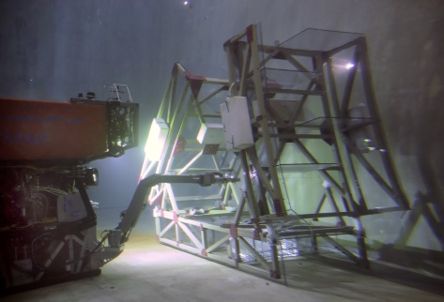
MARS Facilities and Resources
MBARI institutional resources and facilities provide the backbone for at sea capabilities and operations. MBARI's Engineering department consists of 40 highly skilled software, electrical, and mechanical engineers with extensive experience in development of oceanographic vehicles, instruments, and observatories. MBARI's 40-person Division of Marine Operations (DMO) is responsible for deployment, operation, and maintenance of the MOOS, OASIS, and MARS observatories, and thus provides a wealth of practical experience from the standpoint of operational users and divers. Physical access to the ocean is provided by MBARI’s research vessels and Remotely Operated Vehicles (ROVs). MBARI’s dock is just across the street from the main campus, and thus complex equipment can be easily staged directly from laboratory facilities to at-sea operations. MBARI's nine-person Information Systems group provides technical support in planning, deployment, and maintenance of computing facilities and networks. Other relevant MBARI assets include a 10-meter saltwater test tank, high-pressure test facility, electronics fabrication shop, and extensive machine shop facilities.
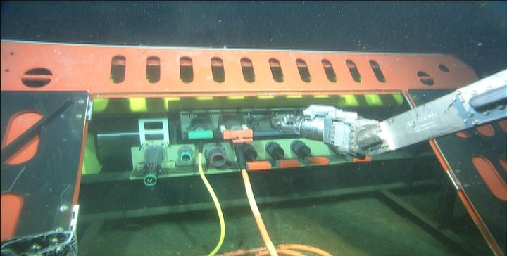
Facilities
MARS control room (850 ft.2) and maintenance areas (850 ft.2) are provided by MBARI. The MARS Cabled observatory is in itself the “Facility”. The actual MARS subsea node is shown opposite and the hut that houses the high voltage power supplies and the MARS control room are shown below.

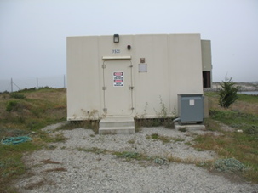
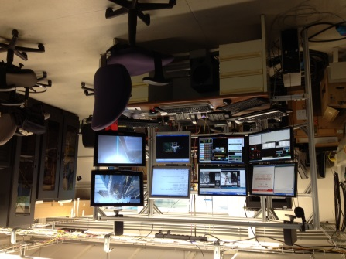
MARS Control Room MARS Shore Station

