Applicant and Project Information

  - Project Title:
  - Applicant Information:
Institute/school:
Phone:
Email:
Co-Applicant:

Others Authorized to work:

  - Project Abstract:
  - Objectives:
  - Intended Use of Results:

Methods

  - Procedures:

Description of the system

BELOW is an Example
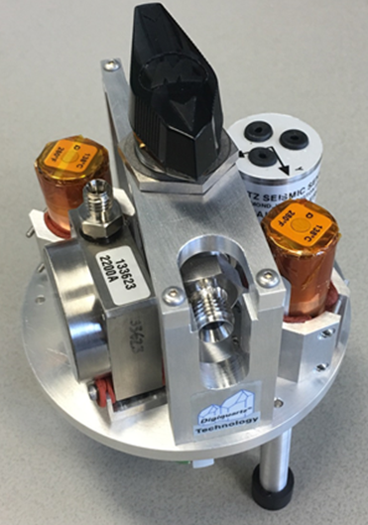 | Figure 2. Prototype of the GODS (Geodesy Ocean Disaster Sensor), which will be inside the GSSM housing. For cabled deployments this will be combined with an actuator to turn the valve, and electronics to acquire data and interface to the cable.

Deployment
In coordination with MARS engineers, we will decide whether the GSSM, on its seafloor monument, can be carried aboard the ROV, or if it will be deployed via elevator. The system will be negatively buoyant and will sit on the seafloor. The in-air and in-water weight will be designed such that the module + monument can reasonably be manipulated by the ROV Ventana.

Operations
The GSSM will be deployed and cabled to the MARS node for a minimum of 6 months. All sensor data will be collected in real time, and A-0-A “calibration” events will be commanded manually from shore approximately twice per month. Each calibration event will actuate the internal valve such that the two bottom pressure sensors will be exposed to the internal housing pressure (~1 atm). Using the internal barometer as a reference, the offset of the dual pressure sensors will be computed and applied to the bottom pressure record for long-term drift correction. The valve will then be commanded to actuate such that the dual pressure sensors are again exposed to ambient seawater pressure. There will be no external motion of the GSSM during the calibration event.

Recovery
The monument/GSSM/SIIM/cable assembly will have features suitable for ROV handling and connection points for recovery via ship’s wire.
  - Collections: Not Applicable

  - Schedule:
10/2016 - 5/2017 Design, assembly, and system test at the University of Washington
5/2017 - 6/2017 Installation on MARS
6/2017 - 6/2018 Test and monitor GSSM
6/2018 and beyond: To be determined - the GSSM will be built for extended multi-year deployments. If the system is working well and there are scientific drivers for leaving the instrument in place on the MARS node, that can be discussed.

Funding:
This project is funded internally by the University of Washington. There is no contractual period of performance, but the project is expected to run 10/2016 through 6/2018.
Environmental Impacts:
The GSSM monument will sit directly on the seafloor and may impact organisms in the sediment directly below (~1 m² area). The system is low power, and does not actively output chemicals, optical transmissions or acoustic signals.

Photographs or schematic representations of equipment to be deployed:

