MARS Mini-node
The MARS Mini-node’s purpose is to replace the primary node during refurbishment and upgrade. Period for this work is currently scheduled for the Winter/Spring of 2022 with Node recovery scheduled for November 2021.
The primary differences between the hardware packages is:
- Mars has eight science ports capable of delivering 375VDC @25A and 48VDC @25A. Mini-node has four science ports capable delivering 350VDC @0.7A and 48VDC @ 2A
- Port Eight is wired for 350VDC only and Gigabit Ethernet
- The data transport system utilizes Lantech switches and a Cisco Router Pair (connected stackwise). The system still uses four fibers to make the connection/cross connection to the subsea switches. These switches are “industrial” switches and generate 12W at full load.
- The Network Electronics Dense Wave Division Multiplexing (DWDM) equipment has been removed.
- The Out of Bands Communication system has been replaced with a Fiber to Copper Ethernet pair and a Digiport TS4 serial port server. The serial ports are connected to the Lantech IGS 5408DSFP console ports and the console port of the Node Power Controller (NPC). The NPC is the same board set used in the existing node and the Wet Node Simulator (WNS).
- The 1 Pulse Per Second (1PPS) system is simplified, a Meinberg GPS Stratum 1 time server provides 1PPS to the subsea via a TTL/Fiber transmitter/receiver pair which is distributed as is the current 1PPS using optically isolated open collector transistor circuit which can be driven by the user. The system delay is 268uSec.
- The Meinberg GPS also serves NTP at 10.91.128.55 and PTP (IEEE1588) at 10.91.128.245. Subsea there is a Meinberg Syncbox N2X slave clock which is conditioned by PTP. This slave clock will serve a 1PPS signal in the event the primary clock fails (switches automatically).
- Switching of the externals loads is still done using the NPC, however, the signals are stepped up up to 24vdc from the TTL level signals using a MBARI manufactured level shift board. These level shifted signals drive solid state relays for power switching the loads and dry contact relays for isolation. Both the subsea Lantech switches can be reset via this same control scheme, all other hardware is switched on at startup.
- The power scheme in the Mini-node is split into three banks of two series connected Pico DC2B-175S DC/DC converters. Each of the three banks is capable of delivering 250W of power. Bank A provides hotel power for the system and 48VDC for the ports. These voltages and currents are monitored using the External Bus Monitor (XBM) printed circuit board. Bank B provides 350VDC @0.7A to ports Two (Benoit-Bird Echo sounder)and Three.(Naval Post-graduate School 3D Hydrophone) And Bank C provides 350VDC @0.7A to ports Five (Quest Deep ROV2)and Eight (Ryan Hydrophone).
- 350 VDC power to the individual ports is routed through a MBARI designed Current and Ground fault monitor board (GF_I_Mon board). The 48 VDC for each of the ports is routed through this board and gets current measured. The ground fault conditions for Bank B is routed through the Port 7 48V analog current channel and the ground fault conditions for Bank C is routed through the Port 8 48V analog current channel. These data items need to be massaged using the Risi developed channel sniffer that looks at all the analog channels sent by the NPC to PMACs. TBD

Using the system
- When starting the PMACS server for the first time or after a reboot, it is important that communications are enabled with the subsea NPC otherwise a connection is not established. To get around this, the PMACS service on the PMACS server can be manually stopped and started.
- Power is controlled manually on the Voltronics Medium Voltage Power Supply (MVPS). Start up should be as is for the regular MARS node:
  - Use the grounding rod to short the sea cable
  - Remove the ground tie on the spade lug in the back of the MVPS rack
  - Remove the grounding rod
  - Ensure the space is secure then lock the cabinet. An interlock switch will prevent the MVPS from starting if the cabinet is not closed.
  - Turn power on to the system (should be LOTO on the breaker in the panel next to the UPS)
  - Turn the breaker on the front panel of the MVPS (Voltronics)
  - Turn the High Voltage ON
  - Slowly turn the HV adjust dial up to 1.04 KV (At approximately 650VDC there should be a current draw increase to approximately 170ma, this value should drop back down to 130-140 ma @1.04KV)
- At this point, the system should be going through its boot up procedure and will start in approximately 5 mins.
- Bring up the following web pages:
  - 10.91.128.1 Cisco routers connected stackwise
  - 10.91.128.101 Lab Lantech switch #1
  - 10.91.128.102 Lab Lantech switch #2
  - 10.91.128.201 Subsea Lantech switch #1
  - 10.91.128.202 Subsea Lantech switch #2
  - 10.91.128.127 Digiport TS4 serial term server (The configuration of these ports needs to be changed to allow access from more than one machine, currently they are only accessible from the laptop Natchez)
  - 10.91.128.240 Mienberg M600 Time server
This will give access to the status of these devices and allow for configuration changes if necessary
- Open a Putty session to com 7 N,8,1 9600 baud, this connection will connect to the console window of the NPC:
  - Login dcs pwd apl1013
  - The login is for access to internal switching and data via the console port
    - “h” will bring up a menu
    - “sets 3 1” will turn off the Lantech #1
    - “sets 3 0” will turn it back on
    - “sets 4 1” will turn off the Lantech #2
    - “sets 4 0” will turn it back on.
    - You can use the help to see other functions of the interface.
    - Do not cycle any other switches (sets) the consequences are TBD.
  - If root access is required for the NPC login root pwd apl1013
A Putty session to com 5/com 6 will open access to the subsea Lantech consoles
- Starting the PMACs software(User Interface) on a client computer, currently, this is the Laptop Natchez (10.91.128.248):
  - Double click the PMACs Icon on the desktop or single click the icon on the taskbar. This should bring up the main page with scrolling windows indicating status and power of the various systems. There will be no data from the Power Supply Controller (PSC) while the Mini-node is running, the unit is not implemented in the system.
If a scrolling data does not appear or a warning window pops up, be patient, you may have started the software before the system completely starts up and is running. It takes a good ten minutes. If the above happens, close the software and restart it after an appropriate amount of time.
  - Once the software has started, open the “Science Node” tab and select the item “All Internal Loads”. This will bring up the internal load control page (Figure 2) where items to be controlled by the Mini-node need to be enabled.
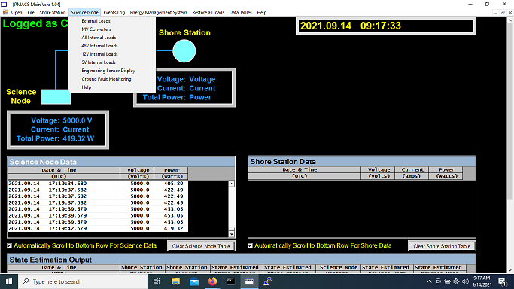
Figure 1 Main Page
  - Loads 5,6,7,8,9,12,10 need to be turned on. (See Figure 2) This will enable the switching of the loads on the “External Loads” page.
As each load is clicked a dialog box will appear and ask if you want to do the action (very windows like), click “yes”.
These switches will have to be cycled if a port experiences an over-current.
  - Loads MRA10-1 and MRA10-2 switch the subsea Lantech switches off and on (wired normally closed) by enabling the switch.

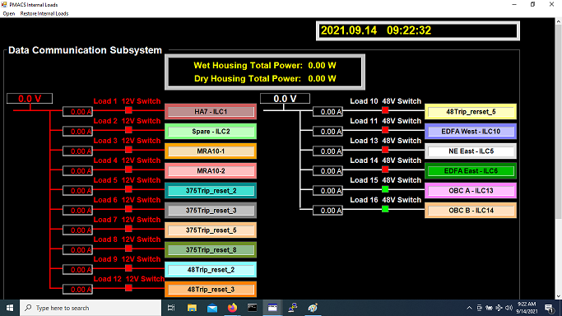
Figure 2 Internal Loads
e) Return to the main page (figure 1) and under the Science Node tab select “External Loads”.

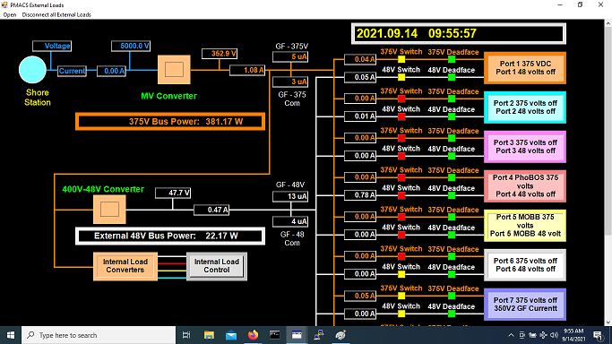
Figure 3 External Loads
f) There are only four Ports viable in the Mini-node and are the cables labelled Two, Three, Five and Eight. Two, Three and Five have both 350VDC and 48VDC available. Port Eight only has 350VDC. The measured currents are from the GF_I_Mon board in the Mini-node and reflect what is happening on the port at any given time. The Ground Fault measurement for the two 350 VDC banks is a little more cryptic. To get the values into the system analog channels for the port 7 48 I and Port 8 48 I have been utilized. An attempt to scale these numbers was undertaken but not displayable using the current GUI. This is also true for many of the temperature sensors in the system. To get around the issue Mike Risi has built an interface that poles the analog channels and can display them on a screen, not integrated but a workable solution. Once I figure out the calibration procedures I will include it in this document. Currently, this tool is running on the PC DMOLAB (10.91.128.xxx). To start the tool:
  - login into the PC DMOLAB/mbarilab
  - navigate to ~/Projects/mars_support/src_new/nodedacq_reader
  - to configure the tool open the .ini file
      - This file allows for configuration of what can be seen in the display
      - Scale and bias the various outputs.
  - To run the tool:
    - Open a terminal window and navigate to the above directory “~/Projects/mars_support/src_new/nodedacq_reader”
    - Run the command “sudo ./ nodedacq_reader nodedacq_reader.ini
    - A scrolling display should present in the terminal window. If this does not occur ensure the PC DMOLAB is connected to the MARS network and the node is powered on.
Min-node Layout and Configuration
- Port one has ODI connector “port 3 “ mounted in its location. It will be configured for Subnet 10.1.11.XXX. (Quest)
- Port three has ODI connector “port 5” mounted in its location and it is configured for Subnet 10.1.13.XXX (NPS 3D Hydrophone)
- Port five has ODI connector “port 8” mounted in its location and configured for Subnet 10.1.12.XXX (Benoit-Bird Echo Sounder)
- Port eight has ODI connector “port 2” mounted in its location and configured for Subnet 10.1.18.XXX (Ryan Hydrophone)
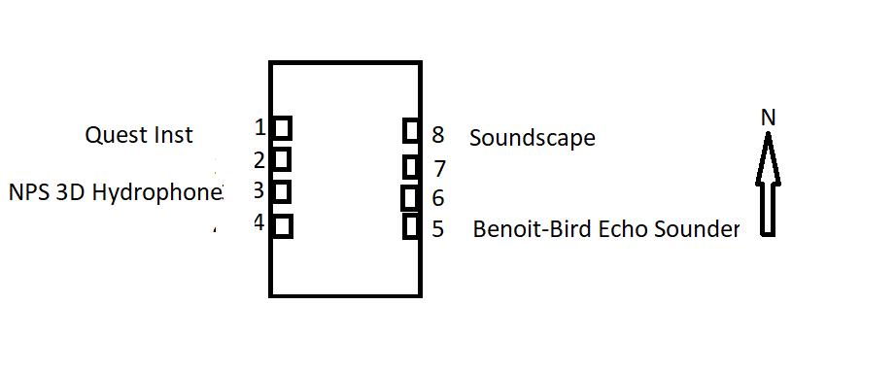
Reasoning for this mixing of labels and connectors
- Quest is the highest drawing device (225W) and Ryan is the lowest (<10W). Cables labeled port 2 and port 3 share a power supply thus distributing the load as evenly as possible and not overloading the supply bank.
- Benoit-Bird Echo Sounder wants gigabit data and only the cabled labeled port 8 is wired for gigabit all others are 100M.

Issues:
- During testing of the Quest system it was discovered that the IP stack used in “new” equipment did not tolerate the “Y” cables installed in the original MARS system. To overcome this issue four 100BaseT 3 port mini switches and one five port 1000BaseT mini switch have been installed in the Mini-node. Ports designated “2”, “3”, “5” and the NPC connection (Lantech 1/2 port 10) have one of the 100BaseT switches between the port and the switches. Port 8 has the 1000BaseT switch installed between the Lantech 1/2 port 8 and the physical port. This scheme introduces a single point of failure for each of the ports but does protect against total failure of an individual Lantech switch.
- The system is built with three banks of power supplies, each capable of delivering 250W @350vdc. Bank A is designated to the hotel load and the 48vdc to the science ports. This bank and the resultant 48vdc are monitored using the Bus Monitor Board built for the original MARS system. The software (PMACS console) displays the:
  - Input Voltage/Current from the Schaefer supplies.
  - Output Voltage and Current from Bank A
  - Ground Fault conditions existing on the Bank A and the 48vdc
  - Each of the Ports 2,3,5,8 350vdc current is monitored via the PMACS software and displayed in the User Interface (Figure 3). The current is sensed via the GF_IMON pcb built for this project, the outputs are feed to the associated analog channels on the Node Power Controller (NPC) and displayed in the PMACS User Interface.
  - Ground fault data for the 350vdc Banks B/C are fed into the Port 7/8 48I channels on the user interface.

