Project Description: MARS (Monterey Accelerated Research System) O&M (Operations and Maintenance)
Results from prior NSF Support
NSF Award Number: OCE- 1514756
Amount: $2,144,419; Project Period: O3/01/2015 to 02/28/2021
Title: MARS (Monterey Accelerated Research System) O&M (Operations and Maintenance)
Michael Kelly is the PI on the current MARS award, MARS (Monterey Accelerated Research System) O&M (Operations and Maintenance) grant (NSF OCE-1514756, award total $2,144,419 for performance period 03/01/2015 – 02/28/2020. A no cost extension and calculations forecast we have sufficient funds to go beyond the renewal date 03/01/2021.These last five plus years have demonstrated a cost effective reliable, service oriented facility, which has supported science and engineering development effectively. Prior to Michael Kelly becoming the PI in July 2020, Craig Dawe ran MARS as PI and Project Manager for the award period and was project manager on both previous supporting awards OCE-1114794 and OCE 0732983. Mr Dawe will retire from active support in June of 2022.
Summary of Results:
Broader Impacts:
MBARI integrated the MARS Observatory into the Monterey Bay Aquarium “Discovering Monterey Canyon” auditorium program as well as in the new MBARI exhibit. The Monterey Bay Aquarium has over a million visitors during normal years, thereby providing wide exposure for MARS and the Ocean Observing Initiative (OOI) to the public. The EARTH Project; a science teacher outreach effort, has used MARS as a tool at over 20 presentations to high school educators, See http://www.mbari.org/earth/default.htm for details. The MBARI sponsored Photographic Benthic Observing System (PhoBOS) data set is still available on request from the Shore Side Data System (SSDS) archive. (PhoBOS has since been decommissioned) The Sanctuary Soundscape project (Ryan Passive Acoustic Sensing Hydrophone 2015) has teamed with NOAA centers to bring the sounds of the ocean to the public through demonstrations in the MBNMS Exploration Center, Santa Cruz and public schools with a portable display. A soon to be added display will be installed at the Coastal Discovery Center in San Simeon, Ca,
Work done by John Ryan (MBARI) and Kevin Smith (Naval Post Graduate School) tracking of blue and fin whale calls can illuminate behaviors and migration patterns of these large animals. Rapid processing of such data could help mitigate ship strike by communication of general locations to merchant vessels off the California coast.
Intellectual Merit:
MARS O&M is a facility built to support scientists and ocean engineers developing and testing new sensors, systems and operational methods to further ocean science capabilities. Therefore, the intellectual merit of MARS is the sum of the progress made by the MARS system users. Listed below are the MARS users for performance period 03/01/2015 – 09/30/2020.
MBARI Operations (Dawe/French) PhoBOS has been deployed on MARS three times, most recently in 2015. It provided real-time video to multiple sources including the Monterey Bay Aquarium and generated a data set of physical ocean characteristics at the MARS node available on request. The PhoBOS system continued to serve as a tool to assist with operations at the MARS node. It has since been recovered and morphed into Serenity.

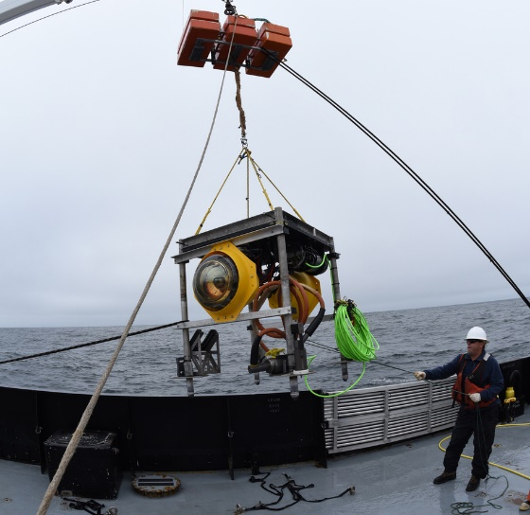
Severine Martini (Institut Méditerranéen d'Océanographie)/Steven Haddock (MBARI) Serenity, Light on MARS. In 2017 as a post-doctoral fellow working with Stephen Haddock (MBARI) deployed a reconfigured PhoBOS platform. The new platform contained two bioluminescence (neutrino) detectors along with an Acoustic Doppler Current Profiler (ADCP), Conductivity Temperature Depth (CTD and) Oxygen sensors. Serenity records light intensity from two sensors every 10ms. Within the first two weeks, we received more than 15 million records. This large, continuous, real-time data set, the first dedicated to deep-sea biology, provides perspective very different from an individual short-term profile of the water. Signal processing methods will allow us to describe the variability of bioluminescence emitted close to the Monterey canyon and to describe links with environmental variables.
Figure 1 Serenity going over the side

Passive Acoustic Sensing (PAS)/Sanctuary Soundscape, John Ryan (MBARI). In 2015, the MBARI / MARS passive acoustic monitoring (PAM) project began as a two-year feasibility study, with the goal of examining how this mode of sensing could support better research and education efforts in Monterey Bay National Marine Sanctuary (MBNMS). During this initial phase all three categories of sound sources – biophony (sounds of marine life), geophony (sounds of Earth), and anthrophony (sounds of human activities) – were examined (Ryan et al., 2016). A mobile Ocean Soundscape exhibit was designed, built, and shared in public venues. This early phase of research and public outreach revealed that the ocean soundscape is a valuable topic for scientific support of informed resource management, and a highly engaging topic for educating people about ocean life and conservation.
With the PAM feasibility study demonstrating high potential, this project was expanded into a full research and education project at MBARI beginning in 2017. Research efforts in biophony have focused on the behavioral ecology of marine mammals, both mysticetes and odontocetes. A study of humpback whale song revealed an unexpected prevalence of song within foraging habitat. Song is considered to be central to reproductive behavior during winter, yet it was detectable within local foraging habitat nine months out of the year. Using extensive environmental data we also found that song occurrence strongly covaries with ecosystem conditions (Ryan et al., 2019). Ongoing work using machine learning is examining how humpback song structure changes through time, as a window in this aspect of the species’ cultural transmission. Blue whales have also been a focal species, and the project has developed signal processing and machine learning approaches to studying their vocal behavior. A study integrating MARS recordings and tag-based metrics from individual whales revealed that the balance of foraging and migration is reflected in day/night patterns of blue whale singing (Oestreich et al., 2020). The newly discovered acoustic signature of migration may be an important tool for protection, for example to provide early warning of migrating whales entering regions with intensive shipping activity. Addition of a directional hydrophone to MARS (led by the Naval Postgraduate School in Monterey) is now enabling spatial tracking of calls from blue and fin whales, both endangered species, toward better understanding their regional presence and patterns of habitat occupancy. Odontocete research from passive acoustic sensing is occurring in collaboration with MBARI researchers using MARS active acoustic sensing, to examine forage species and predator-prey interactions, and it is the basis of a student group project in machine learning at California Polytechnic State University.
Chronic and acute impacts of anthropogenic noise on ocean life, particularly marine mammals, is a growing resource management priority within NOAA. The MARS hydrophone has revealed the patterns of noise from small explosives used in fishing operations, so called ‘seal bombs’ (Simonis et al., 2020). The explosion noise is prevalent during part of the year, and model study reveals that this noise propagates far from the source (tens of kilometers), with implications for the protection of acoustically sensitive species. Another noise study enabled by MARS concerns COVID impacts on low-frequency ocean noise, through slowing of ocean transportation activity. Analysis of MARS sound recordings in this study (Ryan et al., in prep.) is supported by analysis of regional vessel traffic using Automatic Identification System (AIS) data, as well as coast-wide and basin-scale data from the US Department of Transportation (in collaboration with NOAA).
While ongoing development of machine learning and signal processing methods occur at MBARI, we have been sharing the MARS hydrophone data. Data sharing began by responding to requests from students and researchers throughout the U.S., however data access will soon grow exponentially. We are in the process of sharing the entire recording archive, along with decimated data and analysis tools, through a new Open Data project hosted by Amazon Web Services. The project will be launched in autumn / winter 2020.
Education and outreach efforts resulted in production of a resident public exhibit for the NOAA Monterey Bay National Marine Sanctuary Exploration Center, in Santa Cruz, California. This exhibit allows visitors to hear, see, and feel ocean sounds – including whales, dolphins, sea lions, rain, earthquakes, and shipping traffic. Low frequency sounds from earthquakes, large whales, and ships are felt through use of a subwoofer speaker, creating a moving multisensory experience. A second public exhibit, now being built by MBARI for the San Simeon Visitor Center, a collaboration between NOAA and California State Parks. To enable global access to ocean sound recorded through MARS, MBARI developed three resources: (1) a listening library of identified and described sounds, (2) a live stream from MARS, and (3) an Alexa skill that provides access to both the library and live stream (https://www.mbari.org/soundscape-listening-room/). The MARS soundscape project has also achieved outreach goals through documentary films produced by Google (https://www.youtube.com/watch?v=GyCv_S42Tak), and the BBC, shared with PBS (https://www.pbs.org/wnet/nature/whale-detective-preview-fbibbs/20496/).

Quest Institute Ocean Discovery Platform (Stephen Huber) Quest is an enabling institution that promotes Science, Technology, Engineering and Mathematics (STEM) in schools both locally and around the country. The overarching goal of the platform deployed on MARS is to provide young students with direct access to subsea technology and activities to foster excitement and interest in marine sciences and engineering. Marine sciences and engineering has historically been left out of most K-12 curriculums due to high barriers to entry like cost and proximity to the ocean. Students with interest in these fields typically have to wait until university, or even graduate school, to explore their interests in these fields. With the Quest Ocean Discovery platform, we give students early hands-on access to advanced technology, scientific tools, and data to explore at the same level of the professionals and inspire the next generation of marine scientists and engineers. With the challenges of putting equipment in the ocean affecting their first two deployments in 2019 Quest remains undeterred, they are scheduled to be deployed in March of 2021.
Kevin Smith/John Joseph/Paul Leary (Naval Post Graduate School NPS) NPS_3D Hydrophone, The 3D hydrophone adds an additional dimension to the soundscape, direction. Tracking of blue and fin whale calls can illuminate behaviors and migration patterns of these large animals. Rapid processing of such data could also help mitigate ship strike by communicating general locations to merchant vessels off the CA coast.
Improving our understanding of the directional soundscape can support maritime operations that involve acoustics. For example, recent directional measurements of wind-driven ambient noise suggests there may be a strong directional component. Knowledge of the primary direction could promote changes in autonomous system utilization to minimize this impact. Negotiations are underway to add a second 3D device to the system enabling location possibilities.

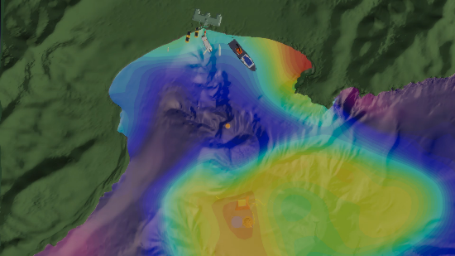
Deep Echo-Integrating Marine Observatory System (DEIMOS), Kelly Benoit-Bird/Sam Urmy (MBARI). DEIMOS has been deployed on MARS in an earlier incantation by John Horne of the University of Washington. DEIMOS has become the center of a number of experiments and a testbed for the integration of acoustics with other tools including eDNA, passive acoustics, and video imaging. LRAUVs with video capability, using a wave glider as a navigational gateway to maintain position inside the beam of the echo sounder to test video capabilities within layers identified by the echo sounder. The project incorporates i2MAP (Dorado class AUV) and Ventana (ROV) to integrate acoustics on all three platforms and video imaging while an echo sounder on Wave glider Hansen was conducting a survey so that we can understand how to scale up the measurements from MARS to the rest of the midwater of Monterey Bay. The project also been supporting Ken Smith's sampling at MARS, exploring the relationship between vertical migration and export.
DEIMOS was the site of a recent series of CANON experiments which brought together pretty much every asset we have along with NOAA Fisheries to understand the role of vertical migration in Monterey Bay's ecology.

Figure 2 Multi Asset Collaboration Animation
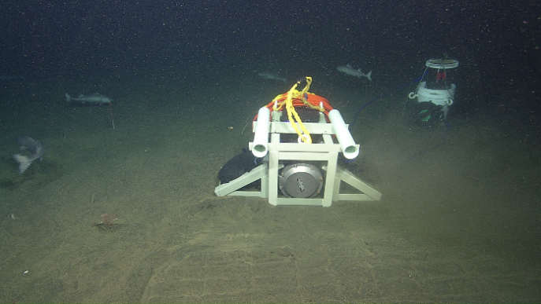
Marine Operations (Kelly/French/Dawe) Deep Sea Connect (DSC). DSC is a carry on project from an earlier attempt to develop wireless power and data transfer in the deep ocean. The goals of the project are to reduce the costs of access to an underwater observatory and simplify the process,
Figure 3 3 Port Wireless Hub Deployed
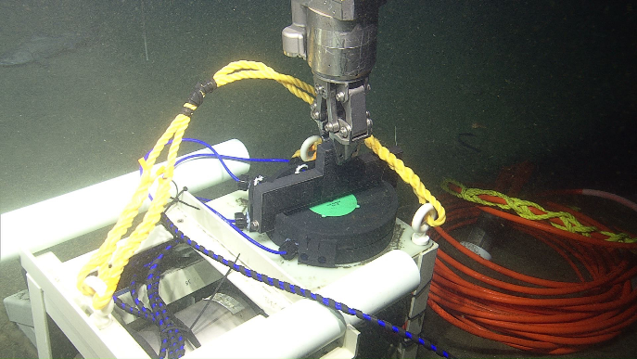
asprocess, as well as provide an expansion of the number of available ports on a cabled observatory. DSC was deployed in December of 2019. Each of the three ports is capable of delivering 25 watts of power wirelessly to receivers connected to the experiment or sensor and a share of the 100mb data bandwidth available from the observatory. For demonstration purposes, a Raspberry Shake seismometer was used as the sensor. Upon connection to MARS, data began streaming to:
Figure 4 Making the Wireless Connection
https://raspberryshake.net/stationview/#?net=AM&sta=R5E0E where the location and data plots were available live to the public along with the other seismometers on the network. This deployment was a first for the Raspberry Shake network; they had never had a sensor placed in the deep ocean and connected. Some technical issues required the device to be recovered. Planning is in process to re-deploy in 2022 after the MARS node is upgraded. Enhancements would include an increase in power transfer and a method to secure the TX and RX pads (fig 4) to avoid being disturbed by fish activities and ocean currents.

Nathan Lindsey (Stanford/Berkeley Seismological Laboratory) Distributed Acoustic Sensing. Distributed fiber-optic sensing technology coupled to existing subsea cables (dark fiber) allows observation of ocean and solid earth phenomena. We used an optical fiber from the cable supporting the Monterey Accelerated Research System during a 4-day maintenance period with a distributed acoustic sensing (DAS) instrument operating onshore, creating a ~10,000-component, 20-kilometer-long seismic array. Recordings of a minor earthquake wave field identified multiple submarine fault zones. Ambient noise was dominated by shoaling ocean surface waves but also contained observations of in situ secondary microseism generation, post–low-tide bores, storm-induced sediment transport, infragravity waves, and breaking internal waves. DAS amplitudes in the microseism band tracked sea-state dynamics during a storm cycle in the Northern Pacific. These observations highlight this method’s potential for marine geophysics.
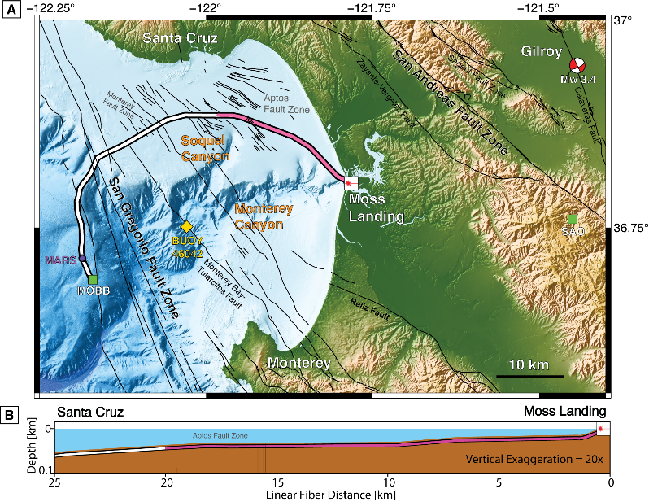
Since 2018 Dr. Lindsey has deployed his DAS equipment on the MARS cable during the annual maintenance period when the system is dark. The most recent test (Aug 2020) was a trial of a new piece of equipment that would extend the array to the full length of the cable. Unfortunately, the equipment was damaged during shipping and provided no useful data. A retest will be conducted in October 2020,
Figure 5 Cable Section Illuminated by DAS
to validate the new equipment and make a determination as to which DAS sensor will be deployed under NSF OCE 2023301. The funded project will use a fiber that was part of the Out of Bands Communication (OBC). The OBC is still functional and delivers 1PPS timing to the node electronics and science ports timing along with other little used support functions.

William Wilcock Geodetic Seismic Sensor Module (University of Washington) The development of GSSM will result in a new geodetic tool for measuring long term vertical motions of the seafloor in tectonically active regions within an accuracy of a few millimeters. In regions where the seafloor is stable, the sensor may provide a means to measure long-term changes in sea-level. 06/13/2017- 12/17/2019.

Publications from award 1514756:
Wilcock, W. S. D. (School of Oceanography, University of Washington), Manalang, D. (Applied Physics Lab, University of Washington), Harrington, M. (Applied Physics Lab, University of Washington), Cram, G. (Applied Physics Lab, University of Washington), Tilley, J. (Applied Physics Lab, University of Washington), Burnett, J. (Applied Physics Laboratory University of Washington,), Martin, D. (Applied Physics Laboratory University of Washington), Paros, J. M. (Paroscientific, Inc. & Quartz Seismic Sensors, Inc.) “A Seafloor Test of the A-0-A Approach to Calibrating Pressure Sensors for Vertical Geodesy”, American Geophysical Union, Fall Meeting 2017

Ryan J. P., Cline D. E., Joseph J. E, Margolina T., Santora J. A., Kudela R. M., Chavez F. P., Pennington J. T., Wahl C., Michisaki R., Benoit-Bird K., Forney K. A., Stimpert A. K., DeVogelaere A., Black N., Fischer M. (2019). Humpback whale song occurrence reflects ecosystem variability in feeding and migratory habitat of the northeast Pacific. PLoS ONE 14(9): e0222456. https://doi.org/10.1371/journal.pone.0222456
Oestreich, WK, Fahlbusch, JA, Cade, DE, Calambokidis, J, Margolina, T, Joseph, J, Friedlaender, AS, McKenna, MF, Stimpert, AK, Southall, BL, Goldbogen, JA, and Ryan, JP. 2020. Animal-borne metrics enable acoustic detection of blue whale migration. Current Biology, in press

“Hiding in the open: how fear structures the ocean's pelagic zone. In review”, Urmy, S.S., Benoit-Bird, K.J.
“Continuous unsupervised classification of odontocete clicks at an ocean observatory” In review, Urmy, S.S., Benoit-Bird, K.J., Ryan, J.P., Margolina, T.

Nathaniel J. Lindsey (Earth and Planetary Science Department, University of California, Berkeley),Craig Dawe (Monterey Bay Aquarium Research Institute), Jonathan Ajo-Franklin (Energy Geosciences Division, Lawrence Berkeley National Laboratory, Department of Earth, Environmental, and Planetary Sciences, Rice University), “Illuminating seafloor faults and ocean dynamics with dark fiber distributed acoustic sensing”, Science 29Nov 2019 Vol. 366, Issue
Conference talks award 1514756:
Urmy, S.S., K.J. Benoit-Bird, J.P. Ryan, J.K. Horne. Predation, fear,
and dynamic vertical structure in the mesopelagic. Association for the
Sciences of Limnology and Oceanography Ocean Sciences Meeting, San Diego
CA February 2020.
Urmy, S.S., K.J. Benoit-Bird, J.P. Ryan, J.K. Horne. Mesopelagic
predator-prey interactions revealed by joint passive and active acoustic
observations. Acoustical Society of America Meeting, San Diego, CA,
December 2019. (published abstract)
Urmy, S.S., K.J. Benoit-Bird, J.P. Ryan, D.E. Cline. Continuous
monitoring of odontocete clicks from an ocean observatory. Acoustical
Society of America Meeting, Victoria BC, November 2018. (published abstract)

Cline DE, Ryan JP. Partnership for Observation of the Global Ocean, Workshop on Machine Learning and Artificial Intelligence in Biological Oceanographic Observations. Ostend, Belgium, May 2019.

Oestreich WK, Cade DE, Calambokidis J, and Goldbogen JA. Phenology of blue whale song indicates migratory flexibility in response to ecosystem cues. World Marine Mammal Conference, Barcelona, Spain, Dec 2019.

Oestreich WK, Cline DE, Cade DE, Calambokidis J, Goldbogen JA, Crowder LB, and Ryan JP. Synthesis of acoustic, biologging, and machine learning methods enhances monitoring of blue whales from individual to population scales. Joint Meeting of the American Fisheries Society and The Wildlife Society, Reno, NV, Sept 2019.

Oestreich WK, Cline DE, Ryan JP, Calambokidis J, Goldbogen J. Enhancing cetacean monitoring using a novel synthesis of passive acoustics, machine learning, and biologging. Bay Area Conservation Biology Symposium, Berkeley, CA, Apr 2019.

Ryan JP, Cline DE, Benoit-Bird KJ, Chavez F, Raanan BY, Urmy SS, Zhang Y, Oestreich WK, Goldbogen J, Joseph JE, Margolina T, DeVogelaere A, Forney K, Kudela RM, Santora JA. Integrative passive acoustic monitoring in Monterey Bay National Marine Sanctuary. 178th Meeting of the Acoustical Society of America, San Diego, December 2019. Invited.

Smith KB, Leary P, Deal TJ. Merchant vessel source level estimation from low-frequency vector sensor systems. 178th Meeting of the Acoustical Society of America, San Diego, December 2019. Invited.

Urmy SS, Benoit-Bird KJ, Ryan JP, Horne JK. Mesopelagic predator-prey interactions revealed by joint passive and active acoustic observations. 178th Meeting of the Acoustical Society of America, San Diego, December 2019.
S. Martini, "Use of bioluminescence as an indicator of biomass, biodiversity and ecosystem function", invited by F. De Leo and J. Aguzzi "Marine cabled
observatories: moving towards applied monitoring for fisheries management, ecosystem functioning and biodiversity" (Barcelona, Spain)
S. Martini, "LIGHT on MARS: Survey of deep sea bioluminescence in Monterey Bay (USA - CA)", "Flash presentations" Atelier instrumentation et experimentation (Lille, France), 2019

S. Martini, "Bioluminescence and environmental time series in the deep ocean from imaging to cabled observatories", invited by B. Ferre "Time series analysis conference and training school" (Tromsø, Norway) 2019
S. Martini "Low light imaging BIOCAM-ROBOT", "Kick-Off meeting ROBOT project" 2019.
Nathaniel Lindsey, Craig Dawe, Jonathan Ajo-Franklin, “Crossing the shoreline with DAS: Photonic seismology in Monterey Bay using the MARS cable” (Invited)
AGU 2019 Fall Meeting San Francisco Ca.

Other talks award 1514756:
Urmy, S.S. The greatest migration on earth: Now playing nightly in your
local ocean! Monterey Bay Aquarium Research Institute annual open house,
Moss Landing, CA, July 2019.
Urmy, S.S. Live from the twilight zone: Acoustic observations of
mesopelagic predators and prey. MBARI Board meeting, Moss Landing CA,
March 2019.
Urmy, S.S. How to study dolphins (without really trying). Center for
Excellence in Education “Bite of Science” presentation
(https://www.cee.org/bite-science) to high-school teachers, Moss
Landing, CA, October 2018.
S. Martini, "La bioluminescence dans l’océan", invited by L. Feuillassier à Océanopolis (Brest, France), 2020

Background
The MARS observatory was originally conceived as a test-bed for equipment and instrumentation destined for the Ocean Observing Initiative's Regional Scale Networks (RSN) and other observatory efforts nationally and internationally. As these installations mature and begin to be operational, the need for pre-deployment testing and qualification becomes paramount. Over the past eleven years of operation, MARS has proven its value. The cost and risks associated with deploying untested and unverified equipment is greatly reduced by using the MARS observatory. As an example, Dr. Bill Chadwick's Bottom Pressure Recorder (BPR) tilt meter was tested on MARS and is the first instrument providing reliable data from the RSN. More recently, William Wilcock’s Geodetic Seismic Sensor Module was tested June 2017 – Dec 2019 and is destined to become a new geodetic tool for measuring long term vertical motions of the seafloor in tectonically active regions within an accuracy of a few millimeters. In regions where the seafloor is stable, the sensor may provide a means to measure long-term changes in sea-level.

MARS became operational November 10, 2008 after an eight month commissioning delay. MARS has been operating with just a few minor interruptions in service for maintenance and repair since. As of October 2020, MARS completed several years of faultless service with no interruptions at all except for planned maintenance outages to test and clean the shore system installation.
There is relatively inexpensive and readily available access through MBARI research vessels and ROV systems. The cost of using these assets is greatly reduced by proximity and availability.

MARS has been used as a test bed to develop instruments and sensors for the RSN;
Including Dr. Freitag's Acoustic Comms Base Station (ACCOMS), Dr. Chadwick's
Bottom Pressure Tilt meter (BPR), Dr. Kang Ding's Calibrator Linked In-situ Timed Observatory (CALLISTO), Drs. Reimers and Girguis' Benthic Microbial Fuel Cell (BMFC).
Additionally MARS has been used to deploy a vast array of devices both for engineering evaluation and research goals. Most recently:
Dr. J. Ryan’s PAS/Sanctuary Soundscape Hydrophone (6/2015 – present),
Dr. Kevin Smith’s (NPS) 3D Hydrophone ((06/20118 – present),
Dr. Ken Smith’s Sedimentation Event Sensor (SES) for engineering development (07 2020 – 09/2020),
Kelly/French/Dawe Deep Sea Connect proof of concept wireless power and data (Dec 2019 – Apr 2020)
Dr K. Benoit-Bird/Dr.S Urmy, DEIMOS echo sounder (Jan 2019 – present)
Quest Institute’s (S. Huber) Educational Platform for STEM education engineering trial (Jul 2019 – Dec 2019)
Drs. Martini/Haddock’s Serenity, Light on MARS bioluminescence detection system (Jul 2017 – Dec 2018).

From previous awards:
Dr. Horne's EK 60 (DEIMOS now re-deployed)
Dr. Scholin's Deep Environmental Sample Processor (DESP).
Dr. Barbara Romanowitz's Monterey Ocean Bottom Seismometer (MOBB) recovered 2015
Dr. Peter Brewer's Free Ocean Carbon Dioxide Enrichment Experiment (FOCE), Dr. Matsumoto/MARS O&M Photographic Benthic Observing System
(PhoBOS)
Dr. Edie Widder's Eye in the Sea (EITS),
Dr. Ken Smith's Benthic Rover, and the Sediment Event Sensor (SES)
Tongji University's (Dr Huiyang Zhou) Chinese Observatory on MARS.
Wireless Power and Data preliminary work.

MARS Description
Located on a sediment-covered site on Smooth Ridge, approximately 37 km from Moss
Landing, California, MARS is a single node cabled observatory with eight ODI (Ocean Design Inc.) underwater mate-able science connectors. Connected to the shore station via 52 km of submarine telecom cable, the node lies at 890 m depth. The shore station provides 7.5 kW of power and telemetry via eight single mode fibers. Power is distributed as needed across the eight science ports at both 375 and 48 VDC (Volts, Direct Current). Each science port provides a 100-Mbit per second full duplex Ethernet communication channel. Time distribution is provide by NTP (Network Time Protocol) for accuracies of 10 milliseconds and a 1 PPS (Pulse Per Second) signal providing accuracy on the order of 10 microseconds. MARS users can plug instrument clusters into the science ports via "extension" cables. Both of MBARl's ROVs have been equipped with cable-laying tool sleds capable of laying four Km of 3/8 inch cable from the MARS node. Longer distances can be achieved by "daisy chaining" extension cables. In addition to surfaced laid cable these tool-sleds can be equipped with a plow that will bury cables up to 0.3 meters in soft substrate. Power delivery at the end of the
extension cables is a function of the extension cable length and conductor size.

The primary electronics module is exchangeable by ROV without recovery of the main telecom cable or its termination assembly. This makes maintenance of the sea floor electronics affordable because it requires only one dive to unplug the electronics and recover it for shore side repair and one dive to reconnect it.

The process has begun to refurbish the node electronics in 2021/2022 with many of the major purchases coming out of a capital project created in the current award. New power supplies new ODI connectors and data transport equipment is in house. Negotiations are ongoing with the University of Washington to upgrade the node low voltage electronics and control software to what is currently deployed on the RSN. This will allow for long-term support and upgrades when required.
Permits
As part of the permitting and reporting requirements, the MARS facility is required to complete an environmental impact survey every five years. The most recent report (2015) can be found at: https://sanctuarysimon.org/regional_docs/monitoring_projects/100391_report_2015.pdf
We have completed the field work for the 2020 environmental impact survey and will post the results when analysis is complete here: https://www.mbari.org/at-sea/cabled-observatory/mars-biology/

Service-Oriented Facility
The MARS facility is designed to provide service to the ocean science community in a cost effective manner. It requires the equivalent of one full-time position (the MARS Facility Support Technician), providing only essential operations and maintenance services limiting fixed costs. Keeping these costs low results in a cost effective program for NSF because resources are not wasted when the MARS user load is low or self-sufficient users are using the MARS test bed. As a result, MARS users need to request funding for special technical services required by their project in their proposals. During proposal preparation, potential MARS users are provided technical, budget and deployment/recovery advice by the MARS Operations Manager (less than
half-time position). Once the MARS users are funded, MBARl's Operations
provides permit support, and Information Services provides the necessary IT support to insure connectivity from the users instrument to the users IP addresses at no cost to NSF or the MARS user. MARS does not provide DMAS (Data Management and Support). MARS does provide facilities to locate user RAID arrays, computers or routers as needed. MARS users usually need a single test tank day to verify that their instruments are correctly configured to operate on MARS via the wet node simulator. Ship and ROV deployment and recovery is available using of MBARl’s two either ROV-equipped ships, or UNOLS ships. Ocean science users are charged "at cost'' rates for MBARI ship/ROV services. MARS is available to several different funding organizations, including but not limited to: NSF, ONR, NOAA, NASA, DOE, and DOD. Each of these organizations will benefit from the availability of MARS as an ocean science and technology test site. Upon inception of the MARS facility, NSF and MARS agreed that the MARS O&M costs should be distributed fairly to the actual users and NSF should not bear the full burden of the ongoing operations and maintenance costs. To achieve this objective, MARS charges a minimal fee for each project funded either by NSF or to those whose objective is to develop technology for OOI observatories using one of the eight MARS ports. The intent of this fee is help pay for maintenance and other costs. MARS also requires a fee equaling a fair share of the operational costs from other U.S. government funding agencies to use MARS, as these agencies may have objectives not directly linked to NSF or OOI. The current MBARI/NSF rate is $1000.00 per month. All other organizations using MARS will be charged $5000.00 per month. This charge begins the day the instrument receives power from MARS and ends on the day
MARS power is turned off to the instrument. Partial months are prorated.

Operations Philosophy
The MARS operations team is committed to enabling MARS users, engineers and scientists, to be successful developing and testing their systems on the MARS cabled test bed observatory. Although the NSF-funded MARS team is small, MBARl's Marine Operations and Engineering Divisions are dedicated to developing operational capabilities for ocean observing that have common uses. For example, the NSF-sponsored MARS and many MBARl-sponsored projects both benefit from developments like the inductive power and data connector, the cable laying tool sleds, extension cable developments, Science Instrument Interface Modules (SIIMs), Programmable Underwater Connector with Knowledge (PUCK) and Software Infrastructure and
Applications for MOOS (SIAM). Developments to enhance ocean-observing capabilities benefit our common objectives. The SIIM design is available at no charge to users. MARS O&M also takes pride in MARS users' successes. As indicated above the projects over these past years are a testament to the success of MARS and its value to the Ocean Science community.

What does MARS O&M cost?
Ship/ROV days for maintaining the infrastructure are included in this proposal. Parts and supplies costs are requested. Labor equaling One Full Time Equivalents (FTE) is requested for each year of the award

Costs derived from the permit process include reoccurring benthic biology survey
requirements Due in year 4.

This proposal is based on guidance from NSF to provide the minimum operations and
maintenance costs consistent with a no frills support operation. Extra services can be provided when supported by the user's project funding.

Permit mitigation, insurance and "right-of-way use" lease
The installation of the MARS Cabled Observatory required approval from 13 State and Federal Agencies. Mitigation for issues ranging from seafloor disturbance to right-of-way through California State lands have resulted in the following on-going costs:
Cable route inspections:
- Ongoing ROV surveys of the cable route preformed are included.
- "Actual Impacts Assessment" surveys (biologic sampling and assay) were required 18-24 months after installation now extended to every five years for the duration. Costs included in this proposal.
Fisherman Agreement:
- A 24-hour fishermen's hotline has been established at MBARl's expense.
- In the unlikely event that fishing gear gets tangled in the MARS cable/node, costs for fishing gear lost are not provided for in this proposal. A supplemental proposal will be submitted to NSF in the event that this becomes necessary.
Insurance:
- Liability insurance costs are paid for by MBARI.
- Property and D.I.C. (earthquake) coverage estimates are cost prohibitive; MBARI has received a waiver from NSF to exclude property and D.I.C. (earthquake) insurance for the facility.
Right of way:
- A portion of the MARS cable route transverses Moss Landing Harbor District property, costs are included in this proposal.

The MARS staff
The MARS Operations Manager Craig Dawe (six months year one, five months year two, 4 months year 3-5) is responsible for maximizing the success of the MARS users' community. Additionally, the MARS Operations Manager is:
- The primary resource to assess deployment "readiness" of science experiments as well as any infrastructure component of MARS.
- Functions as the MARS technician along with other MBARI staff
- Functions as the MBARI Marine Operations Technical Manager during the unfunded portion of the year until retirement in June 2022. The logic here is to integrate MARS maintenance and operations requirements with the primary service vessels for MARS as much as possible
This Position:
- Works with MARS users at the proposal stage to refine experiment designs
- Advises on the development of new equipment such as extension cables, SIIM's
- (Science Instrument Interface Modules) and connectors
- Provides oversight and maintenance plans for all components of system
- Maintains records for all operational issues and assists in reporting this information
- Develops deployment plans for each science and/or engineering mission for MARS
- Coordinates deployment schedules with MBARl's Division of Marine Operations (DMO)
- Manages MARS finances and cost reporting
- Assists with troubleshooting electronics and communications problems

The MARS Facility Support Technician Thompson/French/Dawe(6/2/4 mo. full time position)
- Is responsible for the day-to-day operation of the MARS system.
- Is serviced by the Operations manager and other MBARI technical staff.
This Position:
- Monitors data streams and adjusts power levels using PMACS (Power Management and Control System).
- Monitors system functional parameters and provides watchdog functions to ensure smooth operations.
- Insures the data store and forward functions are working.
- Maintains the system and manages the day-to-day needs of the MARS computer network.
- Assists with the test tank experiment installations and supports users.

The MARS PI
- Michael Kelly, Director of Marine Operations at MBARI, (paid for by MBARI)
This Position:
- Deals with policy issues, permitting, insurance, staffing, and reporting obligations with NSF.
- Will represent MARS O&M for UNOLS ship scheduling functions when required. (At no cost to NSF)

MARS user costs (not covered by MARS O&M)
A MARS user proposal may request technical support and ship/ROV support from MBARI or may use UNOLS vessels/submersibles or other resources. An example of services available "at cost" from MBARI are provided at the following URL: http://www.mbari.org/mars/new/rates.html Note: Labor is based on average wage for that group plus fringe and overhead. Ship/ROV costs are operating costs divided by days/year so they vary each year.

Concept of Operations
• Operations Philosophy- The primary mission of MARS is to provide a facility to test and develop equipment for the ocean science community. In many cases, MARS will provide the first long duration sea trials of ocean sensors under development. MARS will enable ocean engineers not only to directly monitor their instrumentation on the sea floor but also to modify their software based on real world sensor inputs. Although primarily a test bed, MARS can be used as an ocean science platform. Sanctuary Soundscape and the NPS 3D hydrophone are examples of that process, analyzing acoustical data to study to understand both natural and manmade sounds.
Where it is appropriate, NSF, NOAA or other funding agencies may decide to install science sensors on MARS that are not in the development phase. If recovery of equipment is necessary, it is only two hours away by ship from Moss Landing. To be cost effective MARS staff will operate on a normal (40 hr.) work week schedule. This will minimize personnel costs and is appropriate for a test bed facility.

Customer support, pre-proposal stage - The overall purpose of the MARS O&M is to provide the platforms and services necessary to test and support prospective technologies destined for use on ocean observatories. MARS O&M will provide prospective users with support to estimate ship/ROV time to deploy and recover their experiments as well as the shore side technician time that is necessary to test equipment prior to pre-qualification deployments in MBARl's test tank. MBARI does not have sufficient engineering resources to support all potential MARS users but we have assembled a list of recommended engineering resources that can be tailored to a potential user's needs. This list includes freelance engineers as well as
medium sized companies like Ocean Design and Falmat Inc. Even large companies like Maripro Inc are on the MARS engineering support list. MARS O&M will assist potential users by providing a list of engineering resources that could fit their needs.

Customer support permits - MARS is located in the Monterey Bay National Marine
Sanctuary. As such, most new projects will require permits and others may qualify under the MARS general permit. Federal regulations require NSF to assess whether a project meets applicable federal and state permits prior to awarding a proposal grant. NSF will use the standard proposal process to review MARS user proposals. If a proposal is judged acceptable but requires a permit, NSF may fund resources necessary for the permit process prior to granting the proposal. This may range from minor resources to prepare permit documentation to resources sufficient to submit an EIS (Environmental Impact Survey). NSF will submit proposals not covered by the MARS general permit through interagency channels for approval.

Customer support during operations - A MARS user's instruments deployed on MARS are the sole responsibility of the user. MARS does not have any Data Management and Storage (DMAS) capability. Instead, MARS will direct data connectivity to a user-supplied IP address. If a MARS user needs power adjustments, instrument recovery, or other support over the course of a deployment, we expect an e-mail message that will be acted on during normal working hours to schedule necessary adjustments.

Communications
MARS O&M provides a list server to keep interested parties informed about MARS issues. The MARS technical/schedule discussion list reports on system down time, technical and schedule issues.

