MBARI Fiber Installation
Building D MARS Lab to EOI MARS Shore Station
Craig Dawe
November 13 2020
The fiber installation was completed and tested by MSA the week of November 2nd. They used SC apc style connectors which use a mechanical method to secure the fiber in the connector and require no polishing after completion.
Testing by MARS personnel was done using an Exfo FTB-720-23B-EA OTDR connected to the fiber under test with the following set up:
FC-APC ----^{2m}---- ST/ST ----^{100m}----ST/ST ----^{5m}----SC-APC--
A second test on each fiber was done using a Noyes optical laser source (OLS4) and power meter (OPM5) combination using the following connection method. The power meter was zeroed before the test just using the jumpers.
OLS4 SC-APC ----^{5m}----SC-APC/SC-APC -----^{554m fiber run}---- SC-APC/SC-APC----^{10m}----FC-APC OPM5
The results of this test are tabulated below:

Fiber # | A |  | B
Wave length | 1310nm | 1550nm | 1310nm | 1550nm
1 | 2.42 | 1.52 | 1.02 | 1.06
2 | 0.7 | 0.56 | 1.48 | .97
3 | 1.29 | 0.82 | 1.92 | 1.05
4 | 0.89 | 0.75 | 1.41 | 1.41
5 | 1.53 | 1.13 | 1.10 | 0.84
6 | 0.84 | 0.52 | 0.71 | 0.75
7 | 1.38 | 0.99 | 0.74 | 0.52
8 | 0.51 | 0.58 | 1.35 | 1.12
9 | 1.0 | 0.76 | 1.13 | 1.38
10 | 0.95 | 0.66 | 0.92 | 0.70
11 | 0.72 | 0.50 | 0.60 | 0.52
12 | 1.03 | 0.64 | 0.65 | 0.56
13 | 1.85 | 1.07 | 1.10 | 0.77
14 | 1.70 | 1.57 | 0.64 | 0.63
15 | 0.44 | 0.35 | 0.78 | 0.67
16 | 1.15 | 1.17 | 0.41 | 0.75
17 | 0.56 | 0.54 | 0.28 | 0.35
18 | 0.49 | 0.32 | 0.75 | 0.66
19 | 0.76 | 0.69 | 0.58 | 0.53
20 | 1.35 | 0.84 | 0.23 | 0.37
21 | 1.04 | 0.92 | 0.32 | 0.54
22 | 0.35 | 0.44 | 0.53 | 0.53
23 | 0.98 | 0.47 | 3.82 | 3.26
24 | 0.53 | 0.33 | 1.56 | 1.12

Summary of above records:
Fibers highlighted in red have what I consider to be measurements much higher than would be expected from such a short run and are deemed unacceptable in my view. Fiber results highlighted in yellow represent readings which are out of the ordinary, 1550 usually presents with less loss than 1310, the fibers appear to be useable with acceptable loss. Each fiber was tested using two wavelengths 1310nm and 1550nm.
What follows is an OTDR trace and tabulated results for each of the 48 fibers.
Summary of OTDR results:
In looking at the OTDR traces for each fiber and for each wavelength, all of the fiber runs appear to be of good quality with a respectable loss over the length of the run. Fibers that demonstrated more than one decibel (db) of loss including the launch fiber and associated connectors were given additional scrutiny.
The results of this scrutiny are:
Fibers 1A, 1B, 2A, 2B appear to be acceptable for the run and terminations of the fibers at each end. The high loss exhibited was the result of dirty connections on the launch/interface fiber connections.
Fiber 3A exhibited a larger than expected reflective event using 1310nm at the launch point into this fiber 0.899 db. This does not exclude this fiber from use it is just noted that it has a higher than expected loss of 1.199db overall.
Fiber 9B is similar to 3A, with a reflective event at the launch point into the fiber of 0.881db and an overall loss of 1.313db @1550nm. Similar results for 1310nm with reflective event of 1.493db and an overall loss of 1.880db.
Fiber 10A exhibited a very large reflection at the launch point into the fiber with 1310nm, this may indicate other issues but had an overall acceptable loss of less than 1db. The 1550nm trace showed less than 1db of loss.
Fiber 13A is on the edge of scrutiny, with an overall loss of 1.073db most of which originates at the launch point into the fiber with a reflective loss of 0.742db. 1550nm was < 1db.
Fiber 16A like 13A was marginal for scrutiny, with an overall loss of 1.12db on 1310nm wavelength. 1550nm was < 1db.
Fiber 21A showed higher loss on both wavelengths 1550 and 1310nm. 0.633db at launch point and 1.348 overall,1.038db loss at launch and 1.381db overall respectively.
Fiber 23B showed the worst performance of all with 3.522db loss overall and a reflective event of 3.282db at the launch point for 1550nm. 1310nm results showed 3.791db loss overall and a reflective event of 3.397db at the launch point.

OTDR Report

Job Info
Job ID: |  | Operator A:
Company: |  | Operator B:
Customer: |  | File name: | MARS SM-01A.trc
Test date and time: | 2020-11-10 at 12:37 (GMT-5:00)

Cable Info
Fiber ID: | MARS SM-01A | Cable ID:
Location A: |  | Location B:

Wavelength: 1310 nm

Link Measurements
Span loss: | 1.200 dB | Average splice loss: | - - -
Span length: | 663.207 m | Span ORL: | 18.31 dB
Average loss: | 1.810 dB/km

OTDR Trace
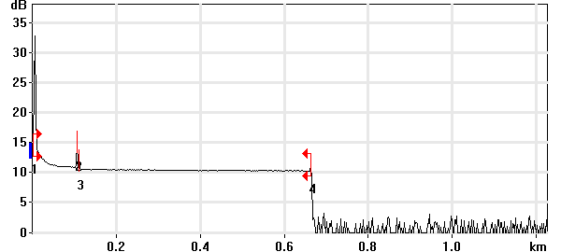

Event Table
No. | Loc. (km)/Length | Event Type | Loss (dB) | Refl. (dB) | Att. (dB/km) | Cumul. (dB)
1 | 0.0000 | Launch Level |  | -24.8 |  | 0.000
 | (0.1041 km) | Fiber Section | 0.177 |  | 1.700 | 0.177
2 | 0.1041 | Reflective Event | 0.392 | -56.9 |  | 0.569
 | (0.0052 km) | Fiber Section | 0.009 |  | 1.700 | 0.578
3 | 0.1093 | Reflective Event | 0.390 | -66.5 |  | 0.967
 | (0.5539 km) | Fiber Section | 0.233 |  | 0.421 | 1.200
4 | 0.6632 | Reflective Event | - - | -63.9 |  | 1.200

Pass/Fail Thresholds
Splice Loss: | 1.000 dB | Span Loss: | 45.000 dB
Connector Loss: | 1.000 dB | Span Length: | 0.000 m
Reflectance: | -40.0 dB | Span ORL: | 15.00 dB
Fiber section attenuation: | 0.400 dB/km

Test and Cable Setup
Wavelength: | 1310 nm (9 µm) | Acq. Time: | 31 s
File name: | MARS SM-01A.trc | IOR: | 1.467700
File Type: | Main | Backscatter: | -79.44 dB
OTDR Model: | FTB-720-23B-EA | Helix Factor: | 0.00 %
Serial No.: | 626283 | Splice Loss Detection: | 0.020 dB
Software Version: | OTDR - iOLM 2.1 | Reflectance Detection: | -72.0 dB
Distance: | 1.2500 km | End-of-Fiber Detection: | 5.000 dB
Pulse Width: | 10 ns

Comments

Wavelength: 1550 nm

Link Measurements
Span loss: | 2.845 dB | Average splice loss: | 0.687 dB
Span length: | 663.004 m | Span ORL: | <21.54 dB
Average loss: | 4.290 dB/km

OTDR Trace
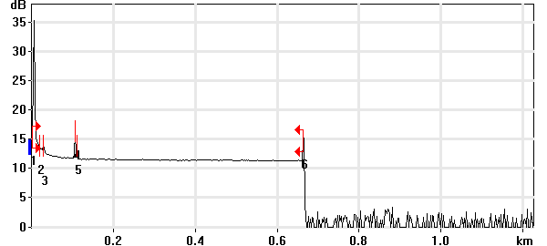

Event Table
No. | Loc. (km)/Length | Event Type | Loss (dB) | Refl. (dB) | Att. (dB/km) | Cumul. (dB)
1 | 0.0000 | Launch Level |  | >-21.6 |  | 0.000
 | (0.0172 km) | Fiber Section | 0.002 |  | 0.100 | 0.002
2 | 0.0172 | Non-Reflective Event | 0.687 |  |  | 0.688
 | (0.0103 km) | Fiber Section | 0.015 |  | 1.500 | 0.704
3 | 0.0275 | Reflective Event | 0.961 | -69.0 |  | 1.665
 | (0.0766 km) | Fiber Section | 0.115 |  | 1.500 | 1.780
4 | 0.1041 | Reflective Event | 0.632 | -58.2 |  | 2.412
 | (0.0051 km) | Fiber Section | 0.001 |  | 0.100 | 2.413
5 | 0.1092 | Reflective Event | 0.194 | -64.9 |  | 2.607
 | (0.5538 km) | Fiber Section | 0.238 |  | 0.430 | 2.845
6 | 0.6630 | Reflective Event | - - | -54.5 |  | 2.845

Pass/Fail Thresholds
Splice Loss: | 1.000 dB | Span Loss: | 45.000 dB
Connector Loss: | 1.000 dB | Span Length: | 0.000 m
Reflectance: | -40.0 dB | Span ORL: | 15.00 dB
Fiber section attenuation: | 0.400 dB/km

Test and Cable Setup
Wavelength: | 1550 nm (9 µm) | Acq. Time: | 30 s
File name: | MARS SM-01A.trc | IOR: | 1.468325
File Type: | Main | Backscatter: | -81.87 dB
OTDR Model: | FTB-720-23B-EA | Helix Factor: | 0.00 %
Serial No.: | 626283 | Splice Loss Detection: | 0.020 dB
Software Version: | OTDR - iOLM 2.1 | Reflectance Detection: | -72.0 dB
Distance: | 1.2500 km | End-of-Fiber Detection: | 5.000 dB
Pulse Width: | 10 ns

Comments

OTDR Report

Job Info
Job ID: |  | Operator A:
Company: |  | Operator B:
Customer: |  | File name: | MARS SM-01B.trc
Test date and time: | 2020-11-10 at 13:42 (GMT-5:00)

Cable Info
Fiber ID: | MARS SM-01B | Cable ID:
Location A: |  | Location B:

Wavelength: 1310 nm

Link Measurements
Span loss: | 0.720 dB | Average splice loss: | - - -
Span length: | 663.207 m | Span ORL: | 17.64 dB
Average loss: | 1.086 dB/km

OTDR Trace
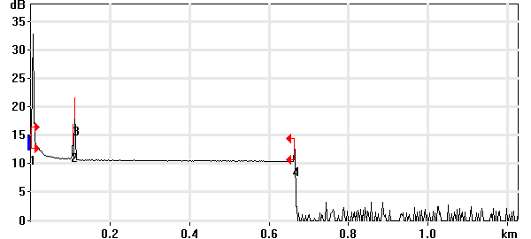

Event Table
No. | Loc. (km)/Length | Event Type | Loss (dB) | Refl. (dB) | Att. (dB/km) | Cumul. (dB)
1 | 0.0000 | Launch Level |  | -24.9 |  | 0.000
 | (0.1042 km) | Fiber Section | 0.177 |  | 1.700 | 0.177
2 | 0.1042 | Reflective Event | 0.037 | -57.0 |  | 0.214
 | (0.0049 km) | Fiber Section | 0.001 |  | 0.250 | 0.215
3 | 0.1091 | Reflective Event | 0.290 | -46.0 |  | 0.505
 | (0.5541 km) | Fiber Section | 0.215 |  | 0.388 | 0.720
4 | 0.6632 | Reflective Event | - - | -56.2 |  | 0.720

Pass/Fail Thresholds
Splice Loss: | 1.000 dB | Span Loss: | 45.000 dB
Connector Loss: | 1.000 dB | Span Length: | 0.000 m
Reflectance: | -40.0 dB | Span ORL: | 15.00 dB
Fiber section attenuation: | 0.400 dB/km

Test and Cable Setup
Wavelength: | 1310 nm (9 µm) | Acq. Time: | 30 s
File name: | MARS SM-01B.trc | IOR: | 1.467700
File Type: | Main | Backscatter: | -79.44 dB
OTDR Model: | FTB-720-23B-EA | Helix Factor: | 0.00 %
Serial No.: | 626283 | Splice Loss Detection: | 0.020 dB
Software Version: | OTDR - iOLM 2.1 | Reflectance Detection: | -72.0 dB
Distance: | 1.2500 km | End-of-Fiber Detection: | 5.000 dB
Pulse Width: | 10 ns

Comments

Wavelength: 1550 nm

Link Measurements
Span loss: | 2.982 dB | Average splice loss: | 0.727 dB
Span length: | 663.164 m | Span ORL: | <21.58 dB
Average loss: | 4.496 dB/km

OTDR Trace
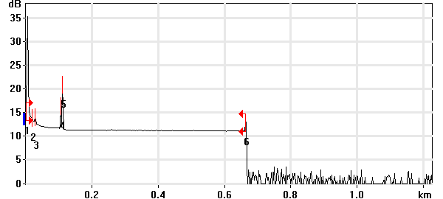

Event Table
No. | Loc. (km)/Length | Event Type | Loss (dB) | Refl. (dB) | Att. (dB/km) | Cumul. (dB)
1 | 0.0000 | Launch Level |  | >-21.6 |  | 0.000
 | (0.0174 km) | Fiber Section | 0.002 |  | 0.100 | 0.002
2 | 0.0174 | Non-Reflective Event | 0.727 |  |  | 0.729
 | (0.0101 km) | Fiber Section | 0.015 |  | 1.500 | 0.744
3 | 0.0275 | Reflective Event | 0.919 | -67.9 |  | 1.663
 | (0.0766 km) | Fiber Section | 0.115 |  | 1.500 | 1.778
4 | 0.1041 | Reflective Event | 0.632 | -58.2 |  | 2.411
 | (0.0049 km) | Fiber Section | 0.007 |  | 1.500 | 2.418
5 | 0.1090 | Reflective Event | 0.321 | -47.7 |  | 2.739
 | (0.5541 km) | Fiber Section | 0.242 |  | 0.438 | 2.982
6 | 0.6632 | Reflective Event | - - | -59.9 |  | 2.982

Pass/Fail Thresholds
Splice Loss: | 1.000 dB | Span Loss: | 45.000 dB
Connector Loss: | 1.000 dB | Span Length: | 0.000 m
Reflectance: | -40.0 dB | Span ORL: | 15.00 dB
Fiber section attenuation: | 0.400 dB/km

Test and Cable Setup
Wavelength: | 1550 nm (9 µm) | Acq. Time: | 30 s
File name: | MARS SM-01B.trc | IOR: | 1.468325
File Type: | Main | Backscatter: | -81.87 dB
OTDR Model: | FTB-720-23B-EA | Helix Factor: | 0.00 %
Serial No.: | 626283 | Splice Loss Detection: | 0.020 dB
Software Version: | OTDR - iOLM 2.1 | Reflectance Detection: | -72.0 dB
Distance: | 1.2500 km | End-of-Fiber Detection: | 5.000 dB
Pulse Width: | 10 ns

Comments

OTDR Report

Job Info
Job ID: |  | Operator A:
Company: |  | Operator B:
Customer: |  | File name: | MARS SM-02A.trc
Test date and time: | 2020-11-10 at 13:46 (GMT-5:00)

Cable Info
Fiber ID: | MARS SM-02A | Cable ID:
Location A: |  | Location B:

Wavelength: 1310 nm

Link Measurements
Span loss: | 1.312 dB | Average splice loss: | - - -
Span length: | 663.047 m | Span ORL: | 18.19 dB
Average loss: | 1.979 dB/km

OTDR Trace
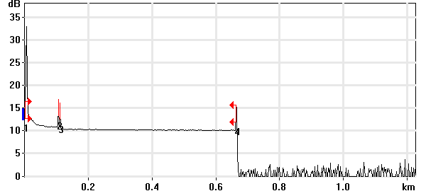

Event Table
No. | Loc. (km)/Length | Event Type | Loss (dB) | Refl. (dB) | Att. (dB/km) | Cumul. (dB)
1 | 0.0000 | Launch Level |  | -24.9 |  | 0.000
 | (0.1041 km) | Fiber Section | 0.177 |  | 1.700 | 0.177
2 | 0.1041 | Reflective Event | 0.409 | -56.8 |  | 0.586
 | (0.0050 km) | Fiber Section | 0.001 |  | 0.250 | 0.587
3 | 0.1092 | Reflective Event | 0.489 | -58.5 |  | 1.076
 | (0.5539 km) | Fiber Section | 0.236 |  | 0.427 | 1.312
4 | 0.6631 | Reflective Event | - - | -49.9 |  | 1.312

Pass/Fail Thresholds
Splice Loss: | 1.000 dB | Span Loss: | 45.000 dB
Connector Loss: | 1.000 dB | Span Length: | 0.000 m
Reflectance: | -40.0 dB | Span ORL: | 15.00 dB
Fiber section attenuation: | 0.400 dB/km

Test and Cable Setup
Wavelength: | 1310 nm (9 µm) | Acq. Time: | 30 s
File name: | MARS SM-02A.trc | IOR: | 1.467700
File Type: | Main | Backscatter: | -79.44 dB
OTDR Model: | FTB-720-23B-EA | Helix Factor: | 0.00 %
Serial No.: | 626283 | Splice Loss Detection: | 0.020 dB
Software Version: | OTDR - iOLM 2.1 | Reflectance Detection: | -72.0 dB
Distance: | 1.2500 km | End-of-Fiber Detection: | 5.000 dB
Pulse Width: | 10 ns

Comments

Wavelength: 1550 nm

Link Measurements
Span loss: | 2.946 dB | Average splice loss: | 1.060 dB
Span length: | 663.004 m | Span ORL: | <21.62 dB
Average loss: | 4.444 dB/km

OTDR Trace
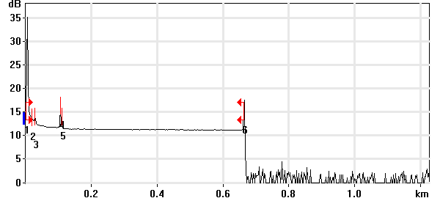

Event Table
No. | Loc. (km)/Length | Event Type | Loss (dB) | Refl. (dB) | Att. (dB/km) | Cumul. (dB)
1 | 0.0000 | Launch Level |  | >-21.7 |  | 0.000
 | (0.0182 km) | Fiber Section | 0.027 |  | 1.500 | 0.027
2 | 0.0182 | Non-Reflective Event | 1.060 |  |  | 1.087
 | (0.0093 km) | Fiber Section | 0.001 |  | 0.100 | 1.088
3 | 0.0275 | Reflective Event | 0.643 | -67.1 |  | 1.731
 | (0.0766 km) | Fiber Section | 0.115 |  | 1.500 | 1.846
4 | 0.1041 | Reflective Event | 0.634 | -58.2 |  | 2.480
 | (0.0051 km) | Fiber Section | 0.008 |  | 1.500 | 2.488
5 | 0.1092 | Reflective Event | 0.233 | -64.1 |  | 2.721
 | (0.5538 km) | Fiber Section | 0.225 |  | 0.407 | 2.946
6 | 0.6630 | Reflective Event | - - | -50.5 |  | 2.946

Pass/Fail Thresholds
Splice Loss: | 1.000 dB | Span Loss: | 45.000 dB
Connector Loss: | 1.000 dB | Span Length: | 0.000 m
Reflectance: | -40.0 dB | Span ORL: | 15.00 dB
Fiber section attenuation: | 0.400 dB/km

Test and Cable Setup
Wavelength: | 1550 nm (9 µm) | Acq. Time: | 30 s
File name: | MARS SM-02A.trc | IOR: | 1.468325
File Type: | Main | Backscatter: | -81.87 dB
OTDR Model: | FTB-720-23B-EA | Helix Factor: | 0.00 %
Serial No.: | 626283 | Splice Loss Detection: | 0.020 dB
Software Version: | OTDR - iOLM 2.1 | Reflectance Detection: | -72.0 dB
Distance: | 1.2500 km | End-of-Fiber Detection: | 5.000 dB
Pulse Width: | 10 ns

OTDR Report

Job Info
Job ID: |  | Operator A:
Company: |  | Operator B:
Customer: |  | File name: | MARS SM-02B.trc
Test date and time: | 2020-11-10 at 13:48 (GMT-5:00)

Cable Info
MARS SM-02B | MARS SM-02B | Cable ID:
Location A: |  | Location B:

Wavelength: 1310 nm

Link Measurements
Span loss: | 2.812 dB | Average splice loss: | 1.331 dB
Span length: | 663.446 m | Span ORL: | 21.77 dB
Average loss: | 4.239 dB/km

OTDR Trace
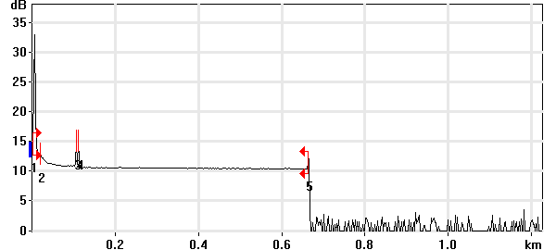

Event Table
No. | Loc. (km)/Length | Event Type | Loss (dB) | Refl. (dB) | Att. (dB/km) | Cumul. (dB)
1 | 0.0000 | Launch Level |  | -21.6 |  | 0.000
 | (0.0183 km) | Fiber Section | 0.031 |  | 1.700 | 0.031
2 | 0.0183 | Non-Reflective Event | 1.331 |  |  | 1.362
 | (0.0859 km) | Fiber Section | 0.146 |  | 1.700 | 1.508
3 | 0.1041 | Reflective Event | 0.781 | -56.5 |  | 2.289
 | (0.0050 km) | Fiber Section | 0.009 |  | 1.700 | 2.298
4 | 0.1092 | Reflective Event | 0.286 | -56.6 |  | 2.584
 | (0.5543 km) | Fiber Section | 0.228 |  | 0.412 | 2.812
5 | 0.6635 | Reflective Event | - - | -58.9 |  | 2.812

Pass/Fail Thresholds
Splice Loss: | 1.000 dB | Span Loss: | 45.000 dB
Connector Loss: | 1.000 dB | Span Length: | 0.000 m
Reflectance: | -40.0 dB | Span ORL: | 15.00 dB
Fiber section attenuation: | 0.400 dB/km

Test and Cable Setup
Wavelength: | 1310 nm (9 µm) | Acq. Time: | 30 s
File name: | MARS SM-02B.trc | IOR: | 1.467700
File Type: | Main | Backscatter: | -79.44 dB
OTDR Model: | FTB-720-23B-EA | Helix Factor: | 0.00 %
Serial No.: | 626283 | Splice Loss Detection: | 0.020 dB
Software Version: | OTDR - iOLM 2.1 | Reflectance Detection: | -72.0 dB
Distance: | 1.2500 km | End-of-Fiber Detection: | 5.000 dB
Pulse Width: | 10 ns

Comments

Wavelength: 1550 nm

Link Measurements
Span loss: | 2.896 dB | Average splice loss: | 0.730 dB
Span length: | 663.403 m | Span ORL: | <21.60 dB
Average loss: | 4.365 dB/km

OTDR Trace
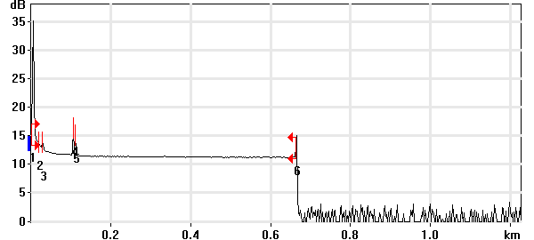

Event Table
No. | Loc. (km)/Length | Event Type | Loss (dB) | Refl. (dB) | Att. (dB/km) | Cumul. (dB)
1 | 0.0000 | Launch Level |  | >-21.7 |  | 0.000
 | (0.0177 km) | Fiber Section | 0.027 |  | 1.500 | 0.027
2 | 0.0177 | Non-Reflective Event | 0.730 |  |  | 0.757
 | (0.0098 km) | Fiber Section | 0.015 |  | 1.500 | 0.771
3 | 0.0275 | Reflective Event | 0.940 | -68.1 |  | 1.711
 | (0.0766 km) | Fiber Section | 0.115 |  | 1.500 | 1.826
4 | 0.1041 | Reflective Event | 0.583 | -58.2 |  | 2.408
 | (0.0050 km) | Fiber Section | 0.008 |  | 1.500 | 2.416
5 | 0.1091 | Reflective Event | 0.264 | -61.0 |  | 2.680
 | (0.5543 km) | Fiber Section | 0.215 |  | 0.388 | 2.896
6 | 0.6634 | Reflective Event | - - | -57.5 |  | 2.896

Pass/Fail Thresholds
Splice Loss: | 1.000 dB | Span Loss: | 45.000 dB
Connector Loss: | 1.000 dB | Span Length: | 0.000 m
Reflectance: | -40.0 dB | Span ORL: | 15.00 dB
Fiber section attenuation: | 0.400 dB/km

Test and Cable Setup
Wavelength: | 1550 nm (9 µm) | Acq. Time: | 30 s
File name: | MARS SM-02B.trc | IOR: | 1.468325
File Type: | Main | Backscatter: | -81.87 dB
OTDR Model: | FTB-720-23B-EA | Helix Factor: | 0.00 %
Serial No.: | 626283 | Splice Loss Detection: | 0.020 dB
Software Version: | OTDR - iOLM 2.1 | Reflectance Detection: | -72.0 dB
Distance: | 1.2500 km | End-of-Fiber Detection: | 5.000 dB
Pulse Width: | 10 ns

Comments

OTDR Report

Job Info
Job ID: |  | Operator A:
Company: |  | Operator B:
Customer: |  | File name: | MARS SM-03A.trc
Test date and time: | 2020-11-10 at 13:54 (GMT-5:00)

Cable Info
Fiber ID: | MARS SM-03A | Cable ID:
Location A: |  | Location B:

Wavelength: 1310 nm

Link Measurements
Span loss: | 1.199 dB | Average splice loss: | - - -
Span length: | 663.366 m | Span ORL: | 37.26 dB
Average loss: | 1.807 dB/km

OTDR Trace
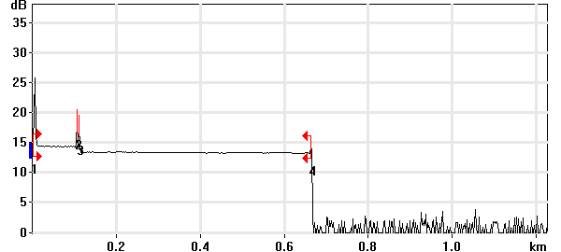

Event Table
No. | Loc. (km)/Length | Event Type | Loss (dB) | Refl. (dB) | Att. (dB/km) | Cumul. (dB)
1 | 0.0000 | Launch Level |  | -38.5 |  | 0.000
 | (0.1041 km) | Fiber Section | 0.105 |  | 1.004 | 0.105
2 | 0.1041 | Reflective Event | 0.050 | -56.8 |  | 0.155
 | (0.0051 km) | Fiber Section | 0.001 |  | 0.250 | 0.156
3 | 0.1092 | Reflective Event | 0.889 | -58.4 |  | 1.045
 | (0.5541 km) | Fiber Section | 0.154 |  | 0.279 | 1.199
4 | 0.6634 | Reflective Event | - - | -61.0 |  | 1.199

Pass/Fail Thresholds
Splice Loss: | 1.000 dB | Span Loss: | 45.000 dB
Connector Loss: | 1.000 dB | Span Length: | 0.000 m
Reflectance: | -40.0 dB | Span ORL: | 15.00 dB
Fiber section attenuation: | 0.400 dB/km

Test and Cable Setup
Wavelength: | 1310 nm (9 µm) | Acq. Time: | 30 s
File name: | MARS SM-03A.trc | IOR: | 1.467700
File Type: | Main | Backscatter: | -79.44 dB
OTDR Model: | FTB-720-23B-EA | Helix Factor: | 0.00 %
Serial No.: | 626283 | Splice Loss Detection: | 0.020 dB
Software Version: | OTDR - iOLM 2.1 | Reflectance Detection: | -72.0 dB
Distance: | 1.2500 km | End-of-Fiber Detection: | 5.000 dB
Pulse Width: | 10 ns

Comments

Wavelength: 1550 nm

Link Measurements
Span loss: | 0.670 dB | Average splice loss: | - - -
Span length: | 663.244 m | Span ORL: | 38.51 dB
Average loss: | 1.011 dB/km

OTDR Trace
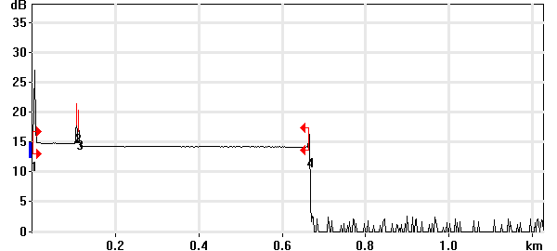

Event Table
No. | Loc. (km)/Length | Event Type | Loss (dB) | Refl. (dB) | Att. (dB/km) | Cumul. (dB)
1 | 0.0000 | Launch Level |  | -39.8 |  | 0.000
 | (0.1041 km) | Fiber Section | 0.066 |  | 0.633 | 0.066
2 | 0.1041 | Reflective Event | 0.033 | -58.0 |  | 0.099
 | (0.0051 km) | Fiber Section | 0.008 |  | 1.500 | 0.107
3 | 0.1092 | Reflective Event | 0.461 | -59.7 |  | 0.569
 | (0.5541 km) | Fiber Section | 0.102 |  | 0.184 | 0.670
4 | 0.6632 | Reflective Event | - - | -60.5 |  | 0.670

Pass/Fail Thresholds
Splice Loss: | 1.000 dB | Span Loss: | 45.000 dB
Connector Loss: | 1.000 dB | Span Length: | 0.000 m
Reflectance: | -40.0 dB | Span ORL: | 15.00 dB
Fiber section attenuation: | 0.400 dB/km

Test and Cable Setup
Wavelength: | 1550 nm (9 µm) | Acq. Time: | 30 s
File name: | MARS SM-03A.trc | IOR: | 1.468325
File Type: | Main | Backscatter: | -81.87 dB
OTDR Model: | FTB-720-23B-EA | Helix Factor: | 0.00 %
Serial No.: | 626283 | Splice Loss Detection: | 0.020 dB
Software Version: | OTDR - iOLM 2.1 | Reflectance Detection: | -72.0 dB
Distance: | 1.2500 km | End-of-Fiber Detection: | 5.000 dB
Pulse Width: | 10 ns

Comments

OTDR Report

Job Info
Job ID: |  | Operator A:
Company: |  | Operator B:
Customer: |  | File name: | MARS SM-03B.trc
Test date and time: | 2020-11-10 at 17:08 (GMT-5:00)

Cable Info
Fiber ID: | MARS SM-03B | Cable ID:
Location A: |  | Location B:

Wavelength: 1310 nm

Link Measurements
Span loss: | 0.941 dB | Average splice loss: | - - -
Span length: | 662.888 m | Span ORL: | 36.91 dB
Average loss: | 1.419 dB/km

OTDR Trace
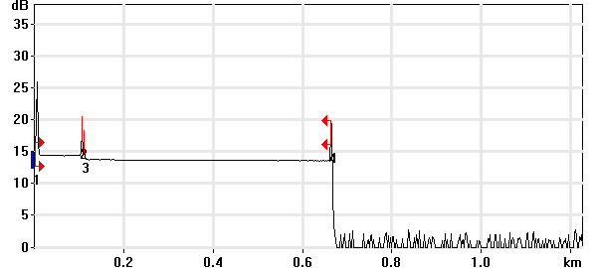

Event Table
No. | Loc. (km)/Length | Event Type | Loss (dB) | Refl. (dB) | Att. (dB/km) | Cumul. (dB)
1 | 0.0000 | Launch Level |  | -38.4 |  | 0.000
 | (0.1040 km) | Fiber Section | 0.116 |  | 1.111 | 0.116
2 | 0.1040 | Reflective Event | 0.025 | -56.9 |  | 0.141
 | (0.0052 km) | Fiber Section | 0.009 |  | 1.700 | 0.150
3 | 0.1092 | Reflective Event | 0.612 | -62.4 |  | 0.762
 | (0.5537 km) | Fiber Section | 0.179 |  | 0.324 | 0.941
4 | 0.6629 | Reflective Event | - - | -48.1 |  | 0.941

Pass/Fail Thresholds
Splice Loss: | 1.000 dB | Span Loss: | 45.000 dB
Connector Loss: | 1.000 dB | Span Length: | 0.000 m
Reflectance: | -40.0 dB | Span ORL: | 15.00 dB
Fiber section attenuation: | 0.400 dB/km

Test and Cable Setup
Wavelength: | 1310 nm (9 µm) | Acq. Time: | 30 s
File name: | MARS SM-03B.trc | IOR: | 1.467700
File Type: | Main | Backscatter: | -79.44 dB
OTDR Model: | FTB-720-23B-EA | Helix Factor: | 0.00 %
Serial No.: | 626283 | Splice Loss Detection: | 0.020 dB
Software Version: | OTDR - iOLM 2.1 | Reflectance Detection: | -72.0 dB
Distance: | 1.2500 km | End-of-Fiber Detection: | 5.000 dB
Pulse Width: | 10 ns

Comments

Wavelength: 1550 nm

Link Measurements
Span loss: | 0.835 dB | Average splice loss: | - - -
Span length: | 662.925 m | Span ORL: | 38.52 dB
Average loss: | 1.259 dB/km

OTDR Trace
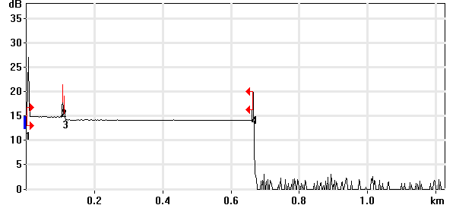

Event Table
No. | Loc. (km)/Length | Event Type | Loss (dB) | Refl. (dB) | Att. (dB/km) | Cumul. (dB)
1 | 0.0000 | Launch Level |  | -39.9 |  | 0.000
 | (0.1041 km) | Fiber Section | 0.101 |  | 0.969 | 0.101
2 | 0.1041 | Reflective Event | 0.048 | -58.1 |  | 0.148
 | (0.0051 km) | Fiber Section | 0.008 |  | 1.500 | 0.156
3 | 0.1092 | Reflective Event | 0.597 | -63.7 |  | 0.753
 | (0.5537 km) | Fiber Section | 0.081 |  | 0.147 | 0.835
4 | 0.6629 | Reflective Event | - - | -51.3 |  | 0.835

Pass/Fail Thresholds
Splice Loss: | 1.000 dB | Span Loss: | 45.000 dB
Connector Loss: | 1.000 dB | Span Length: | 0.000 m
Reflectance: | -40.0 dB | Span ORL: | 15.00 dB
Fiber section attenuation: | 0.400 dB/km

Test and Cable Setup
Wavelength: | 1550 nm (9 µm) | Acq. Time: | 30 s
File name: | MARS SM-03B.trc | IOR: | 1.468325
File Type: | Main | Backscatter: | -81.87 dB
OTDR Model: | FTB-720-23B-EA | Helix Factor: | 0.00 %
Serial No.: | 626283 | Splice Loss Detection: | 0.020 dB
Software Version: | OTDR - iOLM 2.1 | Reflectance Detection: | -72.0 dB
Distance: | 1.2500 km | End-of-Fiber Detection: | 5.000 dB
Pulse Width: | 10 ns

Comments

OTDR Report

Job Info
Job ID: |  | Operator A:
Company: |  | Operator B:
Customer: |  | File name: | MARS SM-04A.trc
Test date and time: | 2020-11-10 at 17:12 (GMT-5:00)

Cable Info
Fiber ID: | MARS SM-04A | Cable ID:
Location A: |  | Location B:

Wavelength: 1310 nm

Link Measurements
Span loss: | 0.458 dB | Average splice loss: | - - -
Span length: | 663.047 m | Span ORL: | 36.77 dB
Average loss: | 0.690 dB/km

OTDR Trace
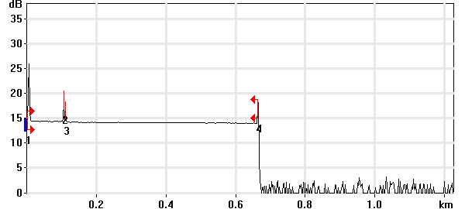

Event Table
No. | Loc. (km)/Length | Event Type | Loss (dB) | Refl. (dB) | Att. (dB/km) | Cumul. (dB)
1 | 0.0000 | Launch Level |  | -38.4 |  | 0.000
 | (0.1040 km) | Fiber Section | 0.103 |  | 0.991 | 0.103
2 | 0.1040 | Reflective Event | 0.036 | -56.9 |  | 0.139
 | (0.0052 km) | Fiber Section | 0.009 |  | 1.700 | 0.148
3 | 0.1092 | Reflective Event | 0.108 | -62.2 |  | 0.256
 | (0.5538 km) | Fiber Section | 0.202 |  | 0.364 | 0.458
4 | 0.6631 | Reflective Event | - - | -52.2 |  | 0.458

Pass/Fail Thresholds
Splice Loss: | 1.000 dB | Span Loss: | 45.000 dB
Connector Loss: | 1.000 dB | Span Length: | 0.000 m
Reflectance: | -40.0 dB | Span ORL: | 15.00 dB
Fiber section attenuation: | 0.400 dB/km

Test and Cable Setup
Wavelength: | 1310 nm (9 µm) | Acq. Time: | 30 s
File name: | MARS SM-04A.trc | IOR: | 1.467700
File Type: | Main | Backscatter: | -79.44 dB
OTDR Model: | FTB-720-23B-EA | Helix Factor: | 0.00 %
Serial No.: | 626283 | Splice Loss Detection: | 0.020 dB
Software Version: | OTDR - iOLM 2.1 | Reflectance Detection: | -72.0 dB
Distance: | 1.2500 km | End-of-Fiber Detection: | 5.000 dB
Pulse Width: | 10 ns

Comments

Wavelength: 1550 nm

Link Measurements
Span loss: | 0.467 dB | Average splice loss: | - - -
Span length: | 663.004 m | Span ORL: | 38.21 dB
Average loss: | 0.704 dB/km

OTDR Trace
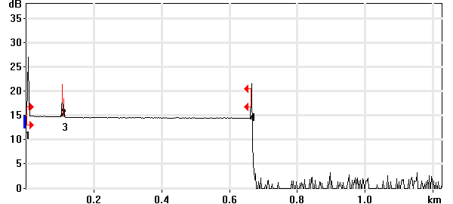

Event Table
No. | Loc. (km)/Length | Event Type | Loss (dB) | Refl. (dB) | Att. (dB/km) | Cumul. (dB)
1 | 0.0000 | Launch Level |  | -39.8 |  | 0.000
 | (0.1041 km) | Fiber Section | 0.114 |  | 1.091 | 0.114
2 | 0.1041 | Reflective Event | 0.010 | -58.1 |  | 0.123
 | (0.0052 km) | Fiber Section | 0.008 |  | 1.500 | 0.131
3 | 0.1093 | Reflective Event | 0.238 | -65.9 |  | 0.369
 | (0.5537 km) | Fiber Section | 0.098 |  | 0.177 | 0.467
4 | 0.6630 | Reflective Event | - - | -49.2 |  | 0.467

Pass/Fail Thresholds
Splice Loss: | 1.000 dB | Span Loss: | 45.000 dB
Connector Loss: | 1.000 dB | Span Length: | 0.000 m
Reflectance: | -40.0 dB | Span ORL: | 15.00 dB
Fiber section attenuation: | 0.400 dB/km

Test and Cable Setup
Wavelength: | 1550 nm (9 µm) | Acq. Time: | 30 s
File name: | MARS SM-04A.trc | IOR: | 1.468325
File Type: | Main | Backscatter: | -81.87 dB
OTDR Model: | FTB-720-23B-EA | Helix Factor: | 0.00 %
Serial No.: | 626283 | Splice Loss Detection: | 0.020 dB
Software Version: | OTDR - iOLM 2.1 | Reflectance Detection: | -72.0 dB
Distance: | 1.2500 km | End-of-Fiber Detection: | 5.000 dB
Pulse Width: | 10 ns

Comments

OTDR Report

Job Info
Job ID: |  | Operator A:
Company: |  | Operator B:
Customer: |  | File name: | MARS SM-04B.trc
Test date and time: | 2020-11-10 at 17:15 (GMT-5:00)

Cable Info
Fiber ID: | MARS SM-04B | Cable ID:
Location A: |  | Location B:

Wavelength: 1310 nm

Link Measurements
Span loss: | 0.518 dB | Average splice loss: | - - -
Span length: | 663.127 m | Span ORL: | 36.79 dB
Average loss: | 0.781 dB/km

OTDR Trace
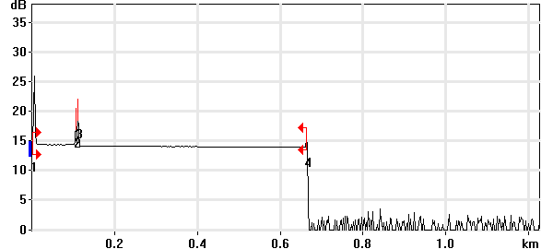

Event Table
No. | Loc. (km)/Length | Event Type | Loss (dB) | Refl. (dB) | Att. (dB/km) | Cumul. (dB)
1 | 0.0000 | Launch Level |  | -38.4 |  | 0.000
 | (0.1041 km) | Fiber Section | 0.096 |  | 0.921 | 0.096
2 | 0.1041 | Reflective Event | 0.046 | -56.9 |  | 0.142
 | (0.0049 km) | Fiber Section | 0.008 |  | 1.700 | 0.150
3 | 0.1091 | Reflective Event | 0.175 | -52.3 |  | 0.325
 | (0.5541 km) | Fiber Section | 0.193 |  | 0.348 | 0.518
4 | 0.6631 | Reflective Event | - - | -60.1 |  | 0.518

Pass/Fail Thresholds
Splice Loss: | 1.000 dB | Span Loss: | 45.000 dB
Connector Loss: | 1.000 dB | Span Length: | 0.000 m
Reflectance: | -40.0 dB | Span ORL: | 15.00 dB
Fiber section attenuation: | 0.400 dB/km

Test and Cable Setup
Wavelength: | 1310 nm (9 µm) | Acq. Time: | 30 s
File name: | MARS SM-04B.trc | IOR: | 1.467700
File Type: | Main | Backscatter: | -79.44 dB
OTDR Model: | FTB-720-23B-EA | Helix Factor: | 0.00 %
Serial No.: | 626283 | Splice Loss Detection: | 0.020 dB
Software Version: | OTDR - iOLM 2.1 | Reflectance Detection: | -72.0 dB
Distance: | 1.2500 km | End-of-Fiber Detection: | 5.000 dB
Pulse Width: | 10 ns

Comments

Wavelength: 1550 nm

Link Measurements
Span loss: | 0.422 dB | Average splice loss: | - - -
Span length: | 663.164 m | Span ORL: | 38.41 dB
Average loss: | 0.636 dB/km

OTDR Trace
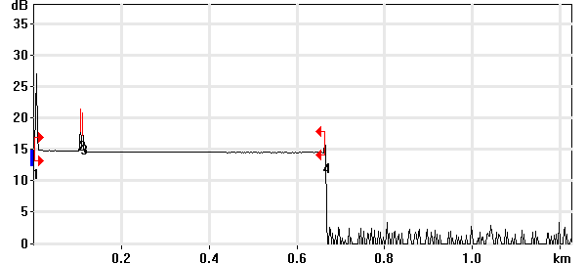

Event Table
No. | Loc. (km)/Length | Event Type | Loss (dB) | Refl. (dB) | Att. (dB/km) | Cumul. (dB)
1 | 0.0000 | Launch Level |  | -39.8 |  | 0.000
 | (0.1041 km) | Fiber Section | 0.122 |  | 1.175 | 0.122
2 | 0.1041 | Reflective Event | 0.016 | -58.0 |  | 0.138
 | (0.0050 km) | Fiber Section | 0.008 |  | 1.500 | 0.146
3 | 0.1091 | Reflective Event | 0.179 | -58.9 |  | 0.325
 | (0.5541 km) | Fiber Section | 0.096 |  | 0.174 | 0.422
4 | 0.6632 | Reflective Event | - - | -61.6 |  | 0.422

Pass/Fail Thresholds
Splice Loss: | 1.000 dB | Span Loss: | 45.000 dB
Connector Loss: | 1.000 dB | Span Length: | 0.000 m
Reflectance: | -40.0 dB | Span ORL: | 15.00 dB
Fiber section attenuation: | 0.400 dB/km

Test and Cable Setup
Wavelength: | 1550 nm (9 µm) | Acq. Time: | 30 s
File name: | MARS SM-04B.trc | IOR: | 1.468325
File Type: | Main | Backscatter: | -81.87 dB
OTDR Model: | FTB-720-23B-EA | Helix Factor: | 0.00 %
Serial No.: | 626283 | Splice Loss Detection: | 0.020 dB
Software Version: | OTDR - iOLM 2.1 | Reflectance Detection: | -72.0 dB
Distance: | 1.2500 km | End-of-Fiber Detection: | 5.000 dB
Pulse Width: | 10 ns

Comments

OTDR Report

Job Info
Job ID: |  | Operator A:
Company: |  | Operator B:
Customer: |  | File name: | MARS SM-05A.trc
Test date and time: | 2020-11-10 at 17:18 (GMT-5:00)

Cable Info
Fiber ID: | MARS SM-05A | Cable ID:
Location A: |  | Location B:

Wavelength: 1310 nm

Link Measurements
Span loss: | 0.408 dB | Average splice loss: | - - -
Span length: | 662.808 m | Span ORL: | 35.90 dB
Average loss: | 0.616 dB/km

OTDR Trace
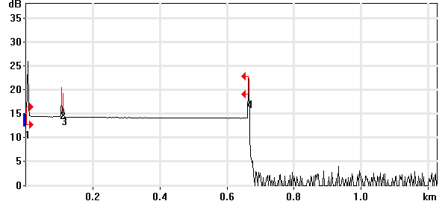

Event Table
No. | Loc. (km)/Length | Event Type | Loss (dB) | Refl. (dB) | Att. (dB/km) | Cumul. (dB)
1 | 0.0000 | Launch Level |  | -38.4 |  | 0.000
 | (0.1041 km) | Fiber Section | 0.101 |  | 0.973 | 0.101
2 | 0.1041 | Reflective Event | 0.005 | -56.9 |  | 0.106
 | (0.0050 km) | Fiber Section | 0.009 |  | 1.700 | 0.115
3 | 0.1092 | Reflective Event | 0.105 | -59.6 |  | 0.220
 | (0.5537 km) | Fiber Section | 0.189 |  | 0.341 | 0.408
4 | 0.6628 | Reflective Event | - - | -42.0 |  | 0.408

Pass/Fail Thresholds
Splice Loss: | 1.000 dB | Span Loss: | 45.000 dB
Connector Loss: | 1.000 dB | Span Length: | 0.000 m
Reflectance: | -40.0 dB | Span ORL: | 15.00 dB
Fiber section attenuation: | 0.400 dB/km

Test and Cable Setup
Wavelength: | 1310 nm (9 µm) | Acq. Time: | 30 s
File name: | MARS SM-05A.trc | IOR: | 1.467700
File Type: | Main | Backscatter: | -79.44 dB
OTDR Model: | FTB-720-23B-EA | Helix Factor: | 0.00 %
Serial No.: | 626283 | Splice Loss Detection: | 0.020 dB
Software Version: | OTDR - iOLM 2.1 | Reflectance Detection: | -72.0 dB
Distance: | 1.2500 km | End-of-Fiber Detection: | 5.000 dB
Pulse Width: | 10 ns

Comments

Wavelength: 1550 nm

Link Measurements
Span loss: | 0.266 dB | Average splice loss: | - - -
Span length: | 662.526 m | Span ORL: | 37.01 dB
Average loss: | 0.402 dB/km

OTDR Trace
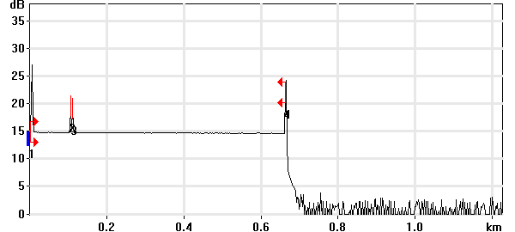

Event Table
No. | Loc. (km)/Length | Event Type | Loss (dB) | Refl. (dB) | Att. (dB/km) | Cumul. (dB)
1 | 0.0000 | Launch Level |  | -39.8 |  | 0.000
 | (0.1040 km) | Fiber Section | 0.102 |  | 0.980 | 0.102
2 | 0.1040 | Reflective Event | 0.036 | -58.1 |  | 0.138
 | (0.0051 km) | Fiber Section | 0.008 |  | 1.500 | 0.146
3 | 0.1091 | Reflective Event | -0.012 | -58.4 |  | 0.134
 | (0.5534 km) | Fiber Section | 0.133 |  | 0.240 | 0.266
4 | 0.6625 | Reflective Event | - - | -42.3 |  | 0.266

Pass/Fail Thresholds
Splice Loss: | 1.000 dB | Span Loss: | 45.000 dB
Connector Loss: | 1.000 dB | Span Length: | 0.000 m
Reflectance: | -40.0 dB | Span ORL: | 15.00 dB
Fiber section attenuation: | 0.400 dB/km

Test and Cable Setup
Wavelength: | 1550 nm (9 µm) | Acq. Time: | 30 s
File name: | MARS SM-05A.trc | IOR: | 1.468325
File Type: | Main | Backscatter: | -81.87 dB
OTDR Model: | FTB-720-23B-EA | Helix Factor: | 0.00 %
Serial No.: | 626283 | Splice Loss Detection: | 0.020 dB
Software Version: | OTDR - iOLM 2.1 | Reflectance Detection: | -72.0 dB
Distance: | 1.2500 km | End-of-Fiber Detection: | 5.000 dB
Pulse Width: | 10 ns

Comments

OTDR Report

Job Info
Job ID: |  | Operator A:
Company: |  | Operator B:
Customer: |  | File name: | MARS SM-05B.trc
Test date and time: | 2020-11-10 at 17:20 (GMT-5:00)

Cable Info
Fiber ID: | MARS SM-05B | Cable ID:
Location A: |  | Location B:

Wavelength: 1310 nm

Link Measurements
Span loss: | 0.795 dB | Average splice loss: | - - -
Span length: | 662.329 m | Span ORL: | 35.47 dB
Average loss: | 1.200 dB/km

OTDR Trace
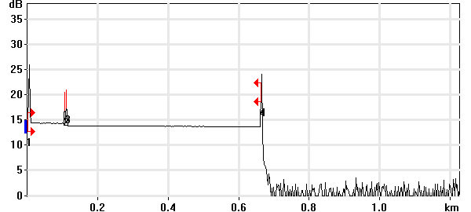

Event Table
No. | Loc. (km)/Length | Event Type | Loss (dB) | Refl. (dB) | Att. (dB/km) | Cumul. (dB)
1 | 0.0000 | Launch Level |  | -38.4 |  | 0.000
 | (0.1041 km) | Fiber Section | 0.093 |  | 0.894 | 0.093
2 | 0.1041 | Reflective Event | 0.043 | -56.9 |  | 0.136
 | (0.0049 km) | Fiber Section | 0.008 |  | 1.700 | 0.145
3 | 0.1091 | Reflective Event | 0.464 | -55.0 |  | 0.609
 | (0.5533 km) | Fiber Section | 0.186 |  | 0.336 | 0.795
4 | 0.6623 | Reflective Event | - - | -39.0 |  | 0.795

Pass/Fail Thresholds
Splice Loss: | 1.000 dB | Span Loss: | 45.000 dB
Connector Loss: | 1.000 dB | Span Length: | 0.000 m
Reflectance: | -40.0 dB | Span ORL: | 15.00 dB
Fiber section attenuation: | 0.400 dB/km

Test and Cable Setup
Wavelength: | 1310 nm (9 µm) | Acq. Time: | 30 s
File name: | MARS SM-05B.trc | IOR: | 1.467700
File Type: | Main | Backscatter: | -79.44 dB
OTDR Model: | FTB-720-23B-EA | Helix Factor: | 0.00 %
Serial No.: | 626283 | Splice Loss Detection: | 0.020 dB
Software Version: | OTDR - iOLM 2.1 | Reflectance Detection: | -72.0 dB
Distance: | 1.2500 km | End-of-Fiber Detection: | 5.000 dB
Pulse Width: | 10 ns

Comments

Wavelength: 1550 nm

Link Measurements
Span loss: | 0.487 dB | Average splice loss: | - - -
Span length: | 662.845 m | Span ORL: | 35.83 dB
Average loss: | 0.735 dB/km

OTDR Trace
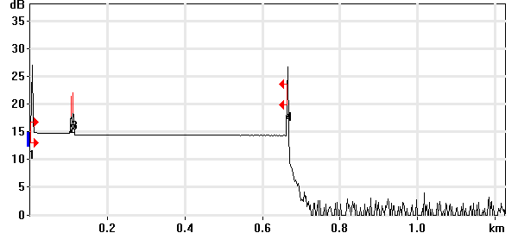

Event Table
No. | Loc. (km)/Length | Event Type | Loss (dB) | Refl. (dB) | Att. (dB/km) | Cumul. (dB)
1 | 0.0000 | Launch Level |  | -39.8 |  | 0.000
 | (0.1041 km) | Fiber Section | 0.091 |  | 0.872 | 0.091
2 | 0.1041 | Reflective Event | 0.033 | -58.1 |  | 0.124
 | (0.0050 km) | Fiber Section | 0.008 |  | 1.500 | 0.132
3 | 0.1091 | Reflective Event | 0.275 | -55.4 |  | 0.406
 | (0.5537 km) | Fiber Section | 0.081 |  | 0.146 | 0.487
4 | 0.6628 | Reflective Event | - - | -38.4 |  | 0.487

Pass/Fail Thresholds
Splice Loss: | 1.000 dB | Span Loss: | 45.000 dB
Connector Loss: | 1.000 dB | Span Length: | 0.000 m
Reflectance: | -40.0 dB | Span ORL: | 15.00 dB
Fiber section attenuation: | 0.400 dB/km

Test and Cable Setup
Wavelength: | 1550 nm (9 µm) | Acq. Time: | 30 s
File name: | MARS SM-05B.trc | IOR: | 1.468325
File Type: | Main | Backscatter: | -81.87 dB
OTDR Model: | FTB-720-23B-EA | Helix Factor: | 0.00 %
Serial No.: | 626283 | Splice Loss Detection: | 0.020 dB
Software Version: | OTDR - iOLM 2.1 | Reflectance Detection: | -72.0 dB
Distance: | 1.2500 km | End-of-Fiber Detection: | 5.000 dB
Pulse Width: | 10 ns

Comments

OTDR Report

Job Info
Job ID: |  | Operator A:
Company: |  | Operator B:
Customer: |  | File name: | MARS SM-06A.trc
Test date and time: | 2020-11-10 at 17:22 (GMT-5:00)

Cable Info
Fiber ID: | MARS SM-06A | Cable ID:
Location A: |  | Location B:

Wavelength: 1310 nm

Link Measurements
Span loss: | 0.418 dB | Average splice loss: | - - -
Span length: | 665.521 m | Span ORL: | 36.77 dB
Average loss: | 0.628 dB/km

OTDR Trace
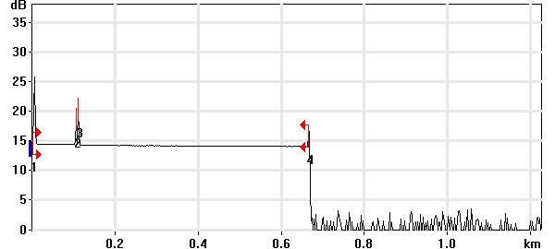

Event Table
No. | Loc. (km)/Length | Event Type | Loss (dB) | Refl. (dB) | Att. (dB/km) | Cumul. (dB)
1 | 0.0000 | Launch Level |  | -38.5 |  | 0.000
 | (0.1041 km) | Fiber Section | 0.094 |  | 0.901 | 0.094
2 | 0.1041 | Reflective Event | 0.023 | -56.9 |  | 0.117
 | (0.0049 km) | Fiber Section | 0.008 |  | 1.700 | 0.125
3 | 0.1091 | Reflective Event | 0.104 | -52.2 |  | 0.229
 | (0.5564 km) | Fiber Section | 0.189 |  | 0.340 | 0.418
4 | 0.6655 | Reflective Event | - - | -56.7 |  | 0.418

Pass/Fail Thresholds
Splice Loss: | 1.000 dB | Span Loss: | 45.000 dB
Connector Loss: | 1.000 dB | Span Length: | 0.000 m
Reflectance: | -40.0 dB | Span ORL: | 15.00 dB
Fiber section attenuation: | 0.400 dB/km

Test and Cable Setup
Wavelength: | 1310 nm (9 µm) | Acq. Time: | 30 s
File name: | MARS SM-06A.trc | IOR: | 1.467700
File Type: | Main | Backscatter: | -79.44 dB
OTDR Model: | FTB-720-23B-EA | Helix Factor: | 0.00 %
Serial No.: | 626283 | Splice Loss Detection: | 0.020 dB
Software Version: | OTDR - iOLM 2.1 | Reflectance Detection: | -72.0 dB
Distance: | 1.2500 km | End-of-Fiber Detection: | 5.000 dB
Pulse Width: | 10 ns

Comments

Wavelength: 1550 nm

Link Measurements
Span loss: | 0.383 dB | Average splice loss: | - - -
Span length: | 665.397 m | Span ORL: | 38.26 dB
Average loss: | 0.576 dB/km

OTDR Trace
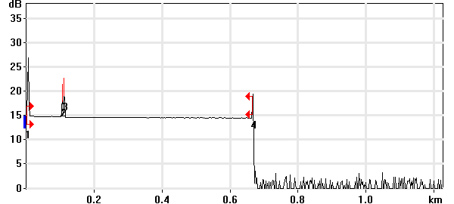

Event Table
No. | Loc. (km)/Length | Event Type | Loss (dB) | Refl. (dB) | Att. (dB/km) | Cumul. (dB)
1 | 0.0000 | Launch Level |  | -39.8 |  | 0.000
 | (0.1041 km) | Fiber Section | 0.086 |  | 0.830 | 0.086
2 | 0.1041 | Reflective Event | -0.007 | -58.1 |  | 0.079
 | (0.0050 km) | Fiber Section | 0.008 |  | 1.500 | 0.087
3 | 0.1091 | Reflective Event | 0.181 | -54.2 |  | 0.268
 | (0.5563 km) | Fiber Section | 0.116 |  | 0.208 | 0.383
4 | 0.6654 | Reflective Event | - - | -54.3 |  | 0.383

Pass/Fail Thresholds
Splice Loss: | 1.000 dB | Span Loss: | 45.000 dB
Connector Loss: | 1.000 dB | Span Length: | 0.000 m
Reflectance: | -40.0 dB | Span ORL: | 15.00 dB
Fiber section attenuation: | 0.400 dB/km

Test and Cable Setup
Wavelength: | 1550 nm (9 µm) | Acq. Time: | 30 s
File name: | MARS SM-06A.trc | IOR: | 1.468325
File Type: | Main | Backscatter: | -81.87 dB
OTDR Model: | FTB-720-23B-EA | Helix Factor: | 0.00 %
Serial No.: | 626283 | Splice Loss Detection: | 0.020 dB
Software Version: | OTDR - iOLM 2.1 | Reflectance Detection: | -72.0 dB
Distance: | 1.2500 km | End-of-Fiber Detection: | 5.000 dB
Pulse Width: | 10 ns

Comments

OTDR Report

Job Info
Job ID: |  | Operator A:
Company: |  | Operator B:
Customer: |  | File name: | MARS SM-06B.trc
Test date and time: | 2020-11-10 at 17:29 (GMT-5:00)

Cable Info
Fiber ID: | MARS SM-06B | Cable ID:
Location A: |  | Location B:

Wavelength: 1310 nm

Link Measurements
Span loss: | 0.425 dB | Average splice loss: | - - -
Span length: | 665.680 m | Span ORL: | 36.77 dB
Average loss: | 0.638 dB/km

OTDR Trace
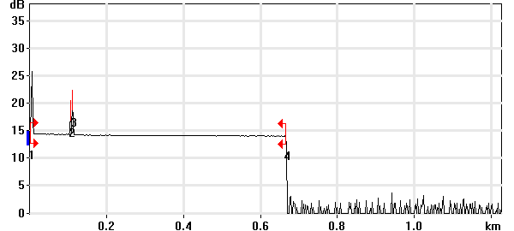

Event Table
No. | Loc. (km)/Length | Event Type | Loss (dB) | Refl. (dB) | Att. (dB/km) | Cumul. (dB)
1 | 0.0000 | Launch Level |  | -38.4 |  | 0.000
 | (0.1041 km) | Fiber Section | 0.096 |  | 0.927 | 0.096
2 | 0.1041 | Reflective Event | 0.012 | -56.9 |  | 0.108
 | (0.0049 km) | Fiber Section | 0.008 |  | 1.700 | 0.116
3 | 0.1091 | Reflective Event | 0.119 | -51.8 |  | 0.236
 | (0.5566 km) | Fiber Section | 0.189 |  | 0.340 | 0.425
4 | 0.6657 | Reflective Event | - - | -68.5 |  | 0.425

Pass/Fail Thresholds
Splice Loss: | 1.000 dB | Span Loss: | 45.000 dB
Connector Loss: | 1.000 dB | Span Length: | 0.000 m
Reflectance: | -40.0 dB | Span ORL: | 15.00 dB
Fiber section attenuation: | 0.400 dB/km

Test and Cable Setup
Wavelength: | 1310 nm (9 µm) | Acq. Time: | 30 s
File name: | MARS SM-06B.trc | IOR: | 1.467700
File Type: | Main | Backscatter: | -79.44 dB
OTDR Model: | FTB-720-23B-EA | Helix Factor: | 0.00 %
Serial No.: | 626283 | Splice Loss Detection: | 0.020 dB
Software Version: | OTDR - iOLM 2.1 | Reflectance Detection: | -72.0 dB
Distance: | 1.2500 km | End-of-Fiber Detection: | 5.000 dB
Pulse Width: | 10 ns

Comments

Wavelength: 1550 nm

Link Measurements
Span loss: | 0.483 dB | Average splice loss: | - - -
Span length: | 665.397 m | Span ORL: | 38.43 dB
Average loss: | 0.726 dB/km

OTDR Trace
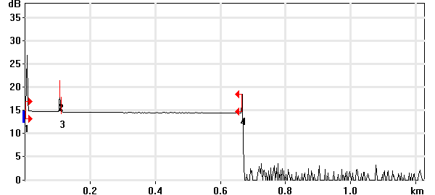

Event Table
No. | Loc. (km)/Length | Event Type | Loss (dB) | Refl. (dB) | Att. (dB/km) | Cumul. (dB)
1 | 0.0000 | Launch Level |  | -39.8 |  | 0.000
 | (0.1042 km) | Fiber Section | 0.143 |  | 1.373 | 0.143
2 | 0.1042 | Reflective Event | 0.020 | -58.0 |  | 0.163
 | (0.0051 km) | Fiber Section | 0.008 |  | 1.500 | 0.171
3 | 0.1093 | Reflective Event | 0.168 | -68.7 |  | 0.339
 | (0.5561 km) | Fiber Section | 0.144 |  | 0.259 | 0.483
4 | 0.6654 | Reflective Event | - - | -56.3 |  | 0.483

Pass/Fail Thresholds
Splice Loss: | 1.000 dB | Span Loss: | 45.000 dB
Connector Loss: | 1.000 dB | Span Length: | 0.000 m
Reflectance: | -40.0 dB | Span ORL: | 15.00 dB
Fiber section attenuation: | 0.400 dB/km

Test and Cable Setup
Wavelength: | 1550 nm (9 µm) | Acq. Time: | 30 s
File name: | MARS SM-06B.trc | IOR: | 1.468325
File Type: | Main | Backscatter: | -81.87 dB
OTDR Model: | FTB-720-23B-EA | Helix Factor: | 0.00 %
Serial No.: | 626283 | Splice Loss Detection: | 0.020 dB
Software Version: | OTDR - iOLM 2.1 | Reflectance Detection: | -72.0 dB
Distance: | 1.2500 km | End-of-Fiber Detection: | 5.000 dB
Pulse Width: | 10 ns

Comments

OTDR Report

Job Info
Job ID: |  | Operator A:
Company: |  | Operator B:
Customer: |  | File name: | MARS SM-07A.trc
Test date and time: | 2020-11-10 at 17:26 (GMT-5:00)

Cable Info
Fiber ID: | MARS SM-07A | Cable ID:
Location A: |  | Location B:

Wavelength: 1310 nm

Link Measurements
Span loss: | 0.825 dB | Average splice loss: | - - -
Span length: | 665.122 m | Span ORL: | 36.92 dB
Average loss: | 1.240 dB/km

OTDR Trace
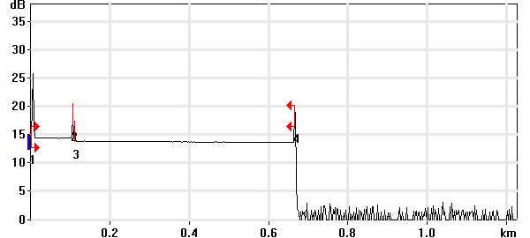

Event Table
No. | Loc. (km)/Length | Event Type | Loss (dB) | Refl. (dB) | Att. (dB/km) | Cumul. (dB)
1 | 0.0000 | Launch Level |  | -38.5 |  | 0.000
 | (0.1041 km) | Fiber Section | 0.090 |  | 0.868 | 0.090
2 | 0.1041 | Reflective Event | 0.048 | -56.9 |  | 0.138
 | (0.0052 km) | Fiber Section | 0.009 |  | 1.700 | 0.147
3 | 0.1093 | Reflective Event | 0.473 | -65.8 |  | 0.621
 | (0.5558 km) | Fiber Section | 0.204 |  | 0.368 | 0.825
4 | 0.6651 | Reflective Event | - - | -48.6 |  | 0.825

Pass/Fail Thresholds
Splice Loss: | 1.000 dB | Span Loss: | 45.000 dB
Connector Loss: | 1.000 dB | Span Length: | 0.000 m
Reflectance: | -40.0 dB | Span ORL: | 15.00 dB
Fiber section attenuation: | 0.400 dB/km

Test and Cable Setup
Wavelength: | 1310 nm (9 µm) | Acq. Time: | 30 s
File name: | MARS SM-07A.trc | IOR: | 1.467700
File Type: | Main | Backscatter: | -79.44 dB
OTDR Model: | FTB-720-23B-EA | Helix Factor: | 0.00 %
Serial No.: | 626283 | Splice Loss Detection: | 0.020 dB
Software Version: | OTDR - iOLM 2.1 | Reflectance Detection: | -72.0 dB
Distance: | 1.2500 km | End-of-Fiber Detection: | 5.000 dB
Pulse Width: | 10 ns

Comments

Wavelength: 1550 nm

Link Measurements
Span loss: | 0.700 dB | Average splice loss: | - - -
Span length: | 664.998 m | Span ORL: | 38.24 dB
Average loss: | 1.053 dB/km

OTDR Trace
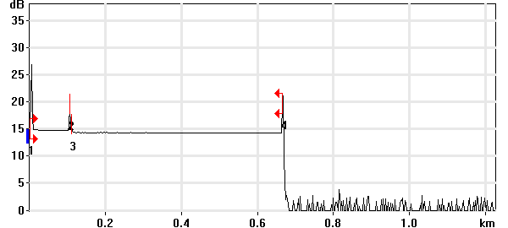

Event Table
No. | Loc. (km)/Length | Event Type | Loss (dB) | Refl. (dB) | Att. (dB/km) | Cumul. (dB)
1 | 0.0000 | Launch Level |  | -39.9 |  | 0.000
 | (0.1041 km) | Fiber Section | 0.137 |  | 1.311 | 0.137
2 | 0.1041 | Reflective Event | 0.051 | -58.0 |  | 0.188
 | (0.0053 km) | Fiber Section | 0.008 |  | 1.500 | 0.195
3 | 0.1093 | Reflective Event | 0.390 | -69.4 |  | 0.585
 | (0.5557 km) | Fiber Section | 0.115 |  | 0.207 | 0.700
4 | 0.6650 | Reflective Event | - - | -48.0 |  | 0.700

Pass/Fail Thresholds
Splice Loss: | 1.000 dB | Span Loss: | 45.000 dB
Connector Loss: | 1.000 dB | Span Length: | 0.000 m
Reflectance: | -40.0 dB | Span ORL: | 15.00 dB
Fiber section attenuation: | 0.400 dB/km

Test and Cable Setup
Wavelength: | 1550 nm (9 µm) | Acq. Time: | 30 s
File name: | MARS SM-07A.trc | IOR: | 1.468325
File Type: | Main | Backscatter: | -81.87 dB
OTDR Model: | FTB-720-23B-EA | Helix Factor: | 0.00 %
Serial No.: | 626283 | Splice Loss Detection: | 0.020 dB
Software Version: | OTDR - iOLM 2.1 | Reflectance Detection: | -72.0 dB
Distance: | 1.2500 km | End-of-Fiber Detection: | 5.000 dB
Pulse Width: | 10 ns

Comments

OTDR Report

Job Info
Job ID: |  | Operator A:
Company: |  | Operator B:
Customer: |  | File name: | MARS SM-07B.trc
Test date and time: | 2020-11-10 at 17:32 (GMT-5:00)

Cable Info
Fiber ID: | MARS SM-07B | Cable ID:
Location A: |  | Location B:

Wavelength: 1310 nm

Link Measurements
Span loss: | 0.445 dB | Average splice loss: | - - -
Span length: | 664.962 m | Span ORL: | 36.82 dB
Average loss: | 0.669 dB/km

OTDR Trace
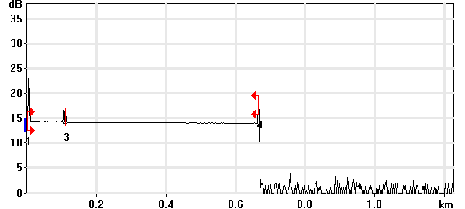

Event Table
No. | Loc. (km)/Length | Event Type | Loss (dB) | Refl. (dB) | Att. (dB/km) | Cumul. (dB)
1 | 0.0000 | Launch Level |  | -38.4 |  | 0.000
 | (0.1041 km) | Fiber Section | 0.094 |  | 0.906 | 0.094
2 | 0.1041 | Reflective Event | -0.015 | -56.9 |  | 0.080
 | (0.0052 km) | Fiber Section | 0.009 |  | 1.700 | 0.089
3 | 0.1093 | Reflective Event | 0.164 | -67.4 |  | 0.252
 | (0.5557 km) | Fiber Section | 0.193 |  | 0.347 | 0.445
4 | 0.6650 | Reflective Event | - - | -53.8 |  | 0.445

Pass/Fail Thresholds
Splice Loss: | 1.000 dB | Span Loss: | 45.000 dB
Connector Loss: | 1.000 dB | Span Length: | 0.000 m
Reflectance: | -40.0 dB | Span ORL: | 15.00 dB
Fiber section attenuation: | 0.400 dB/km

Test and Cable Setup
Wavelength: | 1310 nm (9 µm) | Acq. Time: | 30 s
File name: | MARS SM-07B.trc | IOR: | 1.467700
File Type: | Main | Backscatter: | -79.44 dB
OTDR Model: | FTB-720-23B-EA | Helix Factor: | 0.00 %
Serial No.: | 626283 | Splice Loss Detection: | 0.020 dB
Software Version: | OTDR - iOLM 2.1 | Reflectance Detection: | -72.0 dB
Distance: | 1.2500 km | End-of-Fiber Detection: | 5.000 dB
Pulse Width: | 10 ns

Comments

Wavelength: 1550 nm

Link Measurements
Span loss: | 0.462 dB | Average splice loss: | - - -
Span length: | 664.998 m | Span ORL: | 38.36 dB
Average loss: | 0.694 dB/km

OTDR Trace
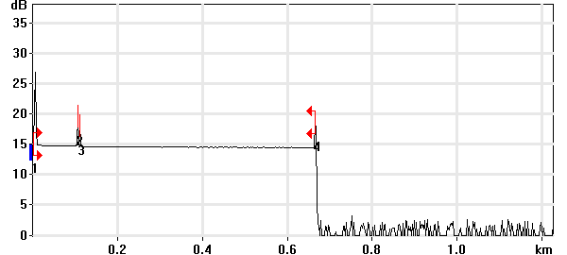

Event Table
No. | Loc. (km)/Length | Event Type | Loss (dB) | Refl. (dB) | Att. (dB/km) | Cumul. (dB)
1 | 0.0000 | Launch Level |  | -39.8 |  | 0.000
 | (0.1041 km) | Fiber Section | 0.145 |  | 1.392 | 0.145
2 | 0.1041 | Reflective Event | 0.048 | -58.0 |  | 0.193
 | (0.0051 km) | Fiber Section | 0.001 |  | 0.100 | 0.193
3 | 0.1092 | Reflective Event | 0.141 | -61.2 |  | 0.335
 | (0.5558 km) | Fiber Section | 0.127 |  | 0.229 | 0.462
4 | 0.6650 | Reflective Event | - - | -54.0 |  | 0.462

Pass/Fail Thresholds
Splice Loss: | 1.000 dB | Span Loss: | 45.000 dB
Connector Loss: | 1.000 dB | Span Length: | 0.000 m
Reflectance: | -40.0 dB | Span ORL: | 15.00 dB
Fiber section attenuation: | 0.400 dB/km

Test and Cable Setup
Wavelength: | 1550 nm (9 µm) | Acq. Time: | 30 s
File name: | MARS SM-07B.trc | IOR: | 1.468325
File Type: | Main | Backscatter: | -81.87 dB
OTDR Model: | FTB-720-23B-EA | Helix Factor: | 0.00 %
Serial No.: | 626283 | Splice Loss Detection: | 0.020 dB
Software Version: | OTDR - iOLM 2.1 | Reflectance Detection: | -72.0 dB
Distance: | 1.2500 km | End-of-Fiber Detection: | 5.000 dB
Pulse Width: | 10 ns

Comments

OTDR Report

Job Info
Job ID: |  | Operator A:
Company: |  | Operator B:
Customer: |  | File name: | MARS SM-08A.trc
Test date and time: | 2020-11-10 at 17:34 (GMT-5:00)

Cable Info
Fiber ID: | MARS SM-08A | Cable ID:
Location A: |  | Location B:

Wavelength: 1310 nm

Link Measurements
Span loss: | 0.490 dB | Average splice loss: | - - -
Span length: | 664.962 m | Span ORL: | 36.87 dB
Average loss: | 0.737 dB/km

OTDR Trace
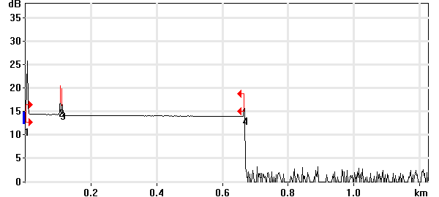

Event Table
No. | Loc. (km)/Length | Event Type | Loss (dB) | Refl. (dB) | Att. (dB/km) | Cumul. (dB)
1 | 0.0000 | Launch Level |  | -38.4 |  | 0.000
 | (0.1041 km) | Fiber Section | 0.095 |  | 0.912 | 0.095
2 | 0.1041 | Reflective Event | 0.039 | -56.9 |  | 0.134
 | (0.0050 km) | Fiber Section | 0.009 |  | 1.700 | 0.142
3 | 0.1092 | Reflective Event | 0.172 | -57.8 |  | 0.314
 | (0.5558 km) | Fiber Section | 0.176 |  | 0.316 | 0.490
4 | 0.6650 | Reflective Event | - - | -56.4 |  | 0.490

Pass/Fail Thresholds
Splice Loss: | 1.000 dB | Span Loss: | 45.000 dB
Connector Loss: | 1.000 dB | Span Length: | 0.000 m
Reflectance: | -40.0 dB | Span ORL: | 15.00 dB
Fiber section attenuation: | 0.400 dB/km

Test and Cable Setup
Wavelength: | 1310 nm (9 µm) | Acq. Time: | 30 s
File name: | MARS SM-08A.trc | IOR: | 1.467700
File Type: | Main | Backscatter: | -79.44 dB
OTDR Model: | FTB-720-23B-EA | Helix Factor: | 0.00 %
Serial No.: | 626283 | Splice Loss Detection: | 0.020 dB
Software Version: | OTDR - iOLM 2.1 | Reflectance Detection: | -72.0 dB
Distance: | 1.2500 km | End-of-Fiber Detection: | 5.000 dB
Pulse Width: | 10 ns

Comments

Wavelength: 1550 nm

Link Measurements
Span loss: | 0.584 dB | Average splice loss: | - - -
Span length: | 664.998 m | Span ORL: | 38.37 dB
Average loss: | 0.878 dB/km

OTDR Trace
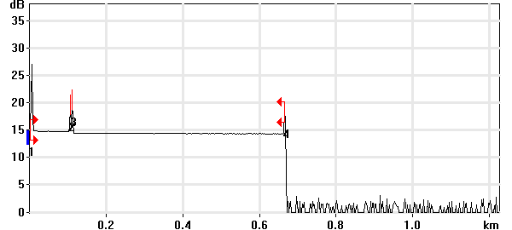

Event Table
No. | Loc. (km)/Length | Event Type | Loss (dB) | Refl. (dB) | Att. (dB/km) | Cumul. (dB)
1 | 0.0000 | Launch Level |  | -39.8 |  | 0.000
 | (0.1041 km) | Fiber Section | 0.127 |  | 1.221 | 0.127
2 | 0.1041 | Reflective Event | 0.012 | -58.0 |  | 0.139
 | (0.0050 km) | Fiber Section | 0.008 |  | 1.500 | 0.146
3 | 0.1091 | Reflective Event | 0.334 | -54.8 |  | 0.481
 | (0.5559 km) | Fiber Section | 0.103 |  | 0.186 | 0.584
4 | 0.6650 | Reflective Event | - - | -54.9 |  | 0.584

Pass/Fail Thresholds
Splice Loss: | 1.000 dB | Span Loss: | 45.000 dB
Connector Loss: | 1.000 dB | Span Length: | 0.000 m
Reflectance: | -40.0 dB | Span ORL: | 15.00 dB
Fiber section attenuation: | 0.400 dB/km

Test and Cable Setup
Wavelength: | 1550 nm (9 µm) | Acq. Time: | 30 s
File name: | MARS SM-08A.trc | IOR: | 1.468325
File Type: | Main | Backscatter: | -81.87 dB
OTDR Model: | FTB-720-23B-EA | Helix Factor: | 0.00 %
Serial No.: | 626283 | Splice Loss Detection: | 0.020 dB
Software Version: | OTDR - iOLM 2.1 | Reflectance Detection: | -72.0 dB
Distance: | 1.2500 km | End-of-Fiber Detection: | 5.000 dB
Pulse Width: | 10 ns

Comments

OTDR Report

Job Info
Job ID: |  | Operator A:
Company: |  | Operator B:
Customer: |  | File name: | MARS SM-08B.trc
Test date and time: | 2020-11-10 at 17:38 (GMT-5:00)

Cable Info
Fiber ID: | MARS SM-08B | Cable ID:
Location A: |  | Location B:

Wavelength: 1310 nm

Link Measurements
Span loss: | 0.802 dB | Average splice loss: | - - -
Span length: | 665.122 m | Span ORL: | 33.55 dB
Average loss: | 1.206 dB/km

OTDR Trace
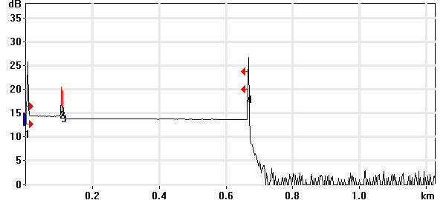

Event Table
No. | Loc. (km)/Length | Event Type | Loss (dB) | Refl. (dB) | Att. (dB/km) | Cumul. (dB)
1 | 0.0000 | Launch Level |  | -38.5 |  | 0.000
 | (0.1041 km) | Fiber Section | 0.106 |  | 1.019 | 0.106
2 | 0.1041 | Reflective Event | 0.046 | -56.9 |  | 0.152
 | (0.0050 km) | Fiber Section | 0.009 |  | 1.700 | 0.160
3 | 0.1092 | Reflective Event | 0.473 | -58.2 |  | 0.634
 | (0.5560 km) | Fiber Section | 0.169 |  | 0.303 | 0.802
4 | 0.6651 | Reflective Event | - - | -34.3 |  | 0.802

Pass/Fail Thresholds
Splice Loss: | 1.000 dB | Span Loss: | 45.000 dB
Connector Loss: | 1.000 dB | Span Length: | 0.000 m
Reflectance: | -40.0 dB | Span ORL: | 15.00 dB
Fiber section attenuation: | 0.400 dB/km

Test and Cable Setup
Wavelength: | 1310 nm (9 µm) | Acq. Time: | 30 s
File name: | MARS SM-08B.trc | IOR: | 1.467700
File Type: | Main | Backscatter: | -79.44 dB
OTDR Model: | FTB-720-23B-EA | Helix Factor: | 0.00 %
Serial No.: | 626283 | Splice Loss Detection: | 0.020 dB
Software Version: | OTDR - iOLM 2.1 | Reflectance Detection: | -72.0 dB
Distance: | 1.2500 km | End-of-Fiber Detection: | 5.000 dB
Pulse Width: | 10 ns

Comments

Wavelength: 1550 nm

Link Measurements
Span loss: | 0.564 dB | Average splice loss: | - - -
Span length: | 665.078 m | Span ORL: | 28.48 dB
Average loss: | 0.848 dB/km

OTDR Trace
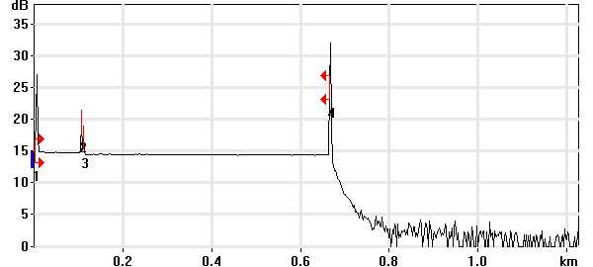

Event Table
No. | Loc. (km)/Length | Event Type | Loss (dB) | Refl. (dB) | Att. (dB/km) | Cumul. (dB)
1 | 0.0000 | Launch Level |  | -39.9 |  | 0.000
 | (0.1041 km) | Fiber Section | 0.147 |  | 1.411 | 0.147
2 | 0.1041 | Reflective Event | 0.005 | -58.0 |  | 0.152
 | (0.0052 km) | Fiber Section | 0.001 |  | 0.100 | 0.152
3 | 0.1093 | Reflective Event | 0.298 | -64.3 |  | 0.450
 | (0.5558 km) | Fiber Section | 0.114 |  | 0.205 | 0.564
4 | 0.6651 | Reflective Event | - - | -28.0 |  | 0.564

Pass/Fail Thresholds
Splice Loss: | 1.000 dB | Span Loss: | 45.000 dB
Connector Loss: | 1.000 dB | Span Length: | 0.000 m
Reflectance: | -40.0 dB | Span ORL: | 15.00 dB
Fiber section attenuation: | 0.400 dB/km

Test and Cable Setup
Wavelength: | 1550 nm (9 µm) | Acq. Time: | 30 s
File name: | MARS SM-08B.trc | IOR: | 1.468325
File Type: | Main | Backscatter: | -81.87 dB
OTDR Model: | FTB-720-23B-EA | Helix Factor: | 0.00 %
Serial No.: | 626283 | Splice Loss Detection: | 0.020 dB
Software Version: | OTDR - iOLM 2.1 | Reflectance Detection: | -72.0 dB
Distance: | 1.2500 km | End-of-Fiber Detection: | 5.000 dB
Pulse Width: | 10 ns

Comments

OTDR Report

Job Info
Job ID: |  | Operator A:
Company: |  | Operator B:
Customer: |  | File name: | MARS SM-09A.trc
Test date and time: | 2020-11-10 at 17:41 (GMT-5:00)

Cable Info
Fiber ID: | MARS SM-09A | Cable ID:
Location A: |  | Location B:

Wavelength: 1310 nm

Link Measurements
Span loss: | 0.792 dB | Average splice loss: | - - -
Span length: | 665.122 m | Span ORL: | 37.04 dB
Average loss: | 1.191 dB/km

OTDR Trace
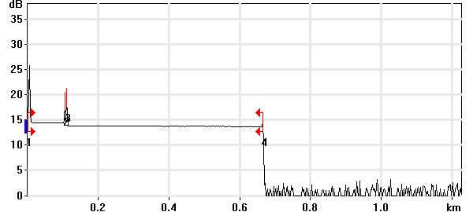

Event Table
No. | Loc. (km)/Length | Event Type | Loss (dB) | Refl. (dB) | Att. (dB/km) | Cumul. (dB)
1 | 0.0000 | Launch Level |  | -38.5 |  | 0.000
 | (0.1041 km) | Fiber Section | 0.096 |  | 0.920 | 0.096
2 | 0.1041 | Reflective Event | 0.019 | -56.9 |  | 0.115
 | (0.0050 km) | Fiber Section | 0.009 |  | 1.700 | 0.123
3 | 0.1092 | Reflective Event | 0.509 | -54.1 |  | 0.632
 | (0.5560 km) | Fiber Section | 0.160 |  | 0.288 | 0.792
4 | 0.6651 | Reflective Event | - - | -66.6 |  | 0.792

Pass/Fail Thresholds
Splice Loss: | 1.000 dB | Span Loss: | 45.000 dB
Connector Loss: | 1.000 dB | Span Length: | 0.000 m
Reflectance: | -40.0 dB | Span ORL: | 15.00 dB
Fiber section attenuation: | 0.400 dB/km

Test and Cable Setup
Wavelength: | 1310 nm (9 µm) | Acq. Time: | 30 s
File name: | MARS SM-09A.trc | IOR: | 1.467700
File Type: | Main | Backscatter: | -79.44 dB
OTDR Model: | FTB-720-23B-EA | Helix Factor: | 0.00 %
Serial No.: | 626283 | Splice Loss Detection: | 0.020 dB
Software Version: | OTDR - iOLM 2.1 | Reflectance Detection: | -72.0 dB
Distance: | 1.2500 km | End-of-Fiber Detection: | 5.000 dB
Pulse Width: | 10 ns

Comments

Wavelength: 1550 nm

Link Measurements
Span loss: | 0.528 dB | Average splice loss: | - - -
Span length: | 665.078 m | Span ORL: | 38.40 dB
Average loss: | 0.794 dB/km

OTDR Trace
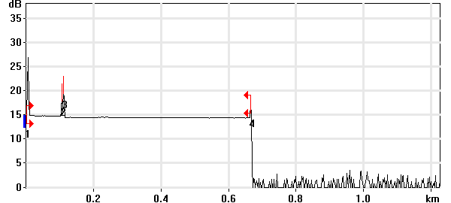

Event Table
No. | Loc. (km)/Length | Event Type | Loss (dB) | Refl. (dB) | Att. (dB/km) | Cumul. (dB)
1 | 0.0000 | Launch Level |  | -39.9 |  | 0.000
 | (0.1041 km) | Fiber Section | 0.118 |  | 1.136 | 0.118
2 | 0.1041 | Reflective Event | 0.003 | -58.0 |  | 0.121
 | (0.0050 km) | Fiber Section | 0.001 |  | 0.100 | 0.121
3 | 0.1091 | Reflective Event | 0.309 | -53.6 |  | 0.430
 | (0.5560 km) | Fiber Section | 0.098 |  | 0.176 | 0.528
4 | 0.6651 | Reflective Event | - - | -59.2 |  | 0.528

Pass/Fail Thresholds
Splice Loss: | 1.000 dB | Span Loss: | 45.000 dB
Connector Loss: | 1.000 dB | Span Length: | 0.000 m
Reflectance: | -40.0 dB | Span ORL: | 15.00 dB
Fiber section attenuation: | 0.400 dB/km

Test and Cable Setup
Wavelength: | 1550 nm (9 µm) | Acq. Time: | 30 s
File name: | MARS SM-09A.trc | IOR: | 1.468325
File Type: | Main | Backscatter: | -81.87 dB
OTDR Model: | FTB-720-23B-EA | Helix Factor: | 0.00 %
Serial No.: | 626283 | Splice Loss Detection: | 0.020 dB
Software Version: | OTDR - iOLM 2.1 | Reflectance Detection: | -72.0 dB
Distance: | 1.2500 km | End-of-Fiber Detection: | 5.000 dB
Pulse Width: | 10 ns

Comments

OTDR Report

Job Info
Job ID: |  | Operator A:
Company: |  | Operator B:
Customer: |  | File name: | MARS SM-09B.trc
Test date and time: | 2020-11-10 at 17:43 (GMT-5:00)

Cable Info
Fiber ID: | MARS SM-09B | Cable ID:
Location A: |  | Location B:

Wavelength: 1310 nm

Link Measurements
Span loss: | 1.880 dB | Average splice loss: | 1.493 dB
Span length: | 664.962 m | Span ORL: | 27.40 dB
Average loss: | 2.827 dB/km

OTDR Trace
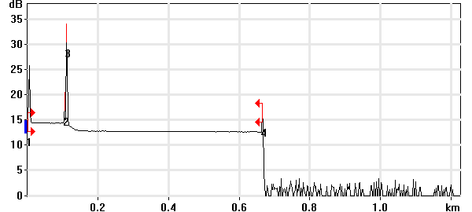

Event Table
No. | Loc. (km)/Length | Event Type | Loss (dB) | Refl. (dB) | Att. (dB/km) | Cumul. (dB)
1 | 0.0000 | Launch Level |  | -38.5 |  | 0.000
 | (0.1041 km) | Fiber Section | 0.100 |  | 0.959 | 0.100
2 | 0.1041 | Reflective Event | -0.036 | -56.9 |  | 0.064
 | (0.0048 km) | Fiber Section | 0.001 |  | 0.250 | 0.065
3 | 0.1089 | Non-Reflective Event | 1.493 |  |  | 1.558
 | (0.5561 km) | Fiber Section | 0.322 |  | 0.578 | 1.880
4 | 0.6650 | Reflective Event | - - | -53.8 |  | 1.880

Pass/Fail Thresholds
Splice Loss: | 1.000 dB | Span Loss: | 45.000 dB
Connector Loss: | 1.000 dB | Span Length: | 0.000 m
Reflectance: | -40.0 dB | Span ORL: | 15.00 dB
Fiber section attenuation: | 0.400 dB/km

Test and Cable Setup
Wavelength: | 1310 nm (9 µm) | Acq. Time: | 30 s
File name: | MARS SM-09B.trc | IOR: | 1.467700
File Type: | Main | Backscatter: | -79.44 dB
OTDR Model: | FTB-720-23B-EA | Helix Factor: | 0.00 %
Serial No.: | 626283 | Splice Loss Detection: | 0.020 dB
Software Version: | OTDR - iOLM 2.1 | Reflectance Detection: | -72.0 dB
Distance: | 1.2500 km | End-of-Fiber Detection: | 5.000 dB
Pulse Width: | 10 ns

Comments

Wavelength: 1550 nm

Link Measurements
Span loss: | 1.313 dB | Average splice loss: | 0.881 dB
Span length: | 664.839 m | Span ORL: | 27.76 dB
Average loss: | 1.975 dB/km

OTDR Trace
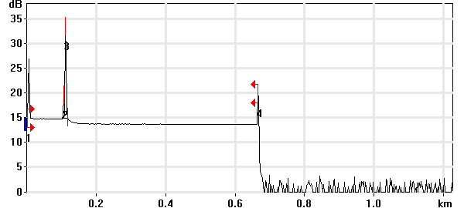

Event Table
No. | Loc. (km)/Length | Event Type | Loss (dB) | Refl. (dB) | Att. (dB/km) | Cumul. (dB)
1 | 0.0000 | Launch Level |  | -39.8 |  | 0.000
 | (0.1041 km) | Fiber Section | 0.123 |  | 1.179 | 0.123
2 | 0.1041 | Reflective Event | 0.073 | -58.1 |  | 0.195
 | (0.0048 km) | Fiber Section | 0.000 |  | 0.100 | 0.196
3 | 0.1089 | Merged Reflective Event | 0.881 |  |  | 1.076
 | (0.5560 km) | Fiber Section | 0.237 |  | 0.426 | 1.313
4 | 0.6648 | Reflective Event | - - | -48.8 |  | 1.313

Pass/Fail Thresholds
Splice Loss: | 1.000 dB | Span Loss: | 45.000 dB
Connector Loss: | 1.000 dB | Span Length: | 0.000 m
Reflectance: | -40.0 dB | Span ORL: | 15.00 dB
Fiber section attenuation: | 0.400 dB/km

Test and Cable Setup
Wavelength: | 1550 nm (9 µm) | Acq. Time: | 30 s
File name: | MARS SM-09B.trc | IOR: | 1.468325
File Type: | Main | Backscatter: | -81.87 dB
OTDR Model: | FTB-720-23B-EA | Helix Factor: | 0.00 %
Serial No.: | 626283 | Splice Loss Detection: | 0.020 dB
Software Version: | OTDR - iOLM 2.1 | Reflectance Detection: | -72.0 dB
Distance: | 1.2500 km | End-of-Fiber Detection: | 5.000 dB
Pulse Width: | 10 ns

Comments

OTDR Report

Job Info
Job ID: |  | Operator A:
Company: |  | Operator B:
Customer: |  | File name: | MARS SM-10A.trc
Test date and time: | 2020-11-10 at 17:45 (GMT-5:00)

Cable Info
Fiber ID: | MARS SM-10A | Cable ID:
Location A: |  | Location B:

Wavelength: 1310 nm

Link Measurements
Span loss: | 0.580 dB | Average splice loss: | - - -
Span length: | 665.042 m | Span ORL: | 26.94 dB
Average loss: | 0.872 dB/km

OTDR Trace
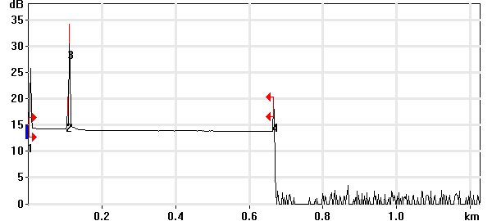

Event Table
No. | Loc. (km)/Length | Event Type | Loss (dB) | Refl. (dB) | Att. (dB/km) | Cumul. (dB)
1 | 0.0000 | Launch Level |  | -38.3 |  | 0.000
 | (0.1041 km) | Fiber Section | 0.104 |  | 0.997 | 0.104
2 | 0.1041 | Reflective Event | -0.063 | -56.9 |  | 0.040
 | (0.0048 km) | Fiber Section | 0.008 |  | 1.700 | 0.049
3 | 0.1089 | Reflective Event | 0.319 | -27.2 |  | 0.368
 | (0.5561 km) | Fiber Section | 0.212 |  | 0.381 | 0.580
4 | 0.6650 | Reflective Event | - - | -50.2 |  | 0.580

Pass/Fail Thresholds
Splice Loss: | 1.000 dB | Span Loss: | 45.000 dB
Connector Loss: | 1.000 dB | Span Length: | 0.000 m
Reflectance: | -40.0 dB | Span ORL: | 15.00 dB
Fiber section attenuation: | 0.400 dB/km

Test and Cable Setup
Wavelength: | 1310 nm (9 µm) | Acq. Time: | 30 s
File name: | MARS SM-10A.trc | IOR: | 1.467700
File Type: | Main | Backscatter: | -79.44 dB
OTDR Model: | FTB-720-23B-EA | Helix Factor: | 0.00 %
Serial No.: | 626283 | Splice Loss Detection: | 0.020 dB
Software Version: | OTDR - iOLM 2.1 | Reflectance Detection: | -72.0 dB
Distance: | 1.2500 km | End-of-Fiber Detection: | 5.000 dB
Pulse Width: | 10 ns

Comments

Wavelength: 1550 nm

Link Measurements
Span loss: | 0.565 dB | Average splice loss: | - - -
Span length: | 664.998 m | Span ORL: | 36.41 dB
Average loss: | 0.849 dB/km

OTDR Trace
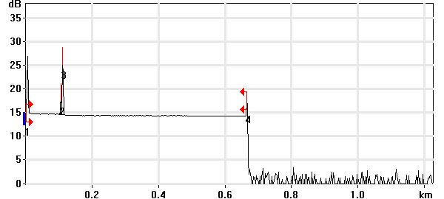

Event Table
No. | Loc. (km)/Length | Event Type | Loss (dB) | Refl. (dB) | Att. (dB/km) | Cumul. (dB)
1 | 0.0000 | Launch Level |  | -39.8 |  | 0.000
 | (0.1041 km) | Fiber Section | 0.129 |  | 1.244 | 0.129
2 | 0.1041 | Reflective Event | 0.039 | -58.0 |  | 0.168
 | (0.0049 km) | Fiber Section | 0.007 |  | 1.500 | 0.176
3 | 0.1090 | Reflective Event | 0.282 | -40.4 |  | 0.458
 | (0.5560 km) | Fiber Section | 0.107 |  | 0.192 | 0.565
4 | 0.6650 | Reflective Event | - - | -56.6 |  | 0.565

Pass/Fail Thresholds
Splice Loss: | 1.000 dB | Span Loss: | 45.000 dB
Connector Loss: | 1.000 dB | Span Length: | 0.000 m
Reflectance: | -40.0 dB | Span ORL: | 15.00 dB
Fiber section attenuation: | 0.400 dB/km

Test and Cable Setup
Wavelength: | 1550 nm (9 µm) | Acq. Time: | 30 s
File name: | MARS SM-10A.trc | IOR: | 1.468325
File Type: | Main | Backscatter: | -81.87 dB
OTDR Model: | FTB-720-23B-EA | Helix Factor: | 0.00 %
Serial No.: | 626283 | Splice Loss Detection: | 0.020 dB
Software Version: | OTDR - iOLM 2.1 | Reflectance Detection: | -72.0 dB
Distance: | 1.2500 km | End-of-Fiber Detection: | 5.000 dB
Pulse Width: | 10 ns

Comments

OTDR Report

Job Info
Job ID: |  | Operator A:
Company: |  | Operator B:
Customer: |  | File name: | MARS SM-10B.trc
Test date and time: | 2020-11-10 at 17:48 (GMT-5:00)

Cable Info
Fiber ID: | MARS SM-10B | Cable ID:
Location A: |  | Location B:

Wavelength: 1310 nm

Link Measurements
Span loss: | 0.578 dB | Average splice loss: | - - -
Span length: | 665.042 m | Span ORL: | 36.72 dB
Average loss: | 0.870 dB/km

OTDR Trace
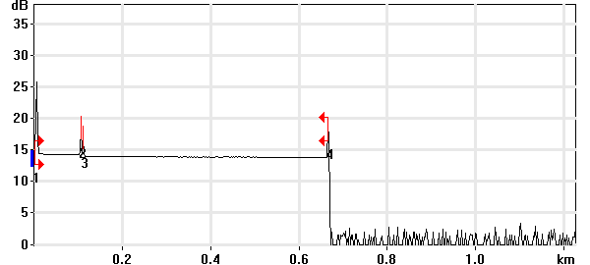

Event Table
No. | Loc. (km)/Length | Event Type | Loss (dB) | Refl. (dB) | Att. (dB/km) | Cumul. (dB)
1 | 0.0000 | Launch Level |  | -38.3 |  | 0.000
 | (0.1041 km) | Fiber Section | 0.098 |  | 0.941 | 0.098
2 | 0.1041 | Reflective Event | 0.006 | -56.9 |  | 0.104
 | (0.0050 km) | Fiber Section | 0.009 |  | 1.700 | 0.113
3 | 0.1092 | Reflective Event | 0.293 | -60.8 |  | 0.406
 | (0.5559 km) | Fiber Section | 0.173 |  | 0.310 | 0.578
4 | 0.6650 | Reflective Event | - - | -50.4 |  | 0.578

Pass/Fail Thresholds
Splice Loss: | 1.000 dB | Span Loss: | 45.000 dB
Connector Loss: | 1.000 dB | Span Length: | 0.000 m
Reflectance: | -40.0 dB | Span ORL: | 15.00 dB
Fiber section attenuation: | 0.400 dB/km

Test and Cable Setup
Wavelength: | 1310 nm (9 µm) | Acq. Time: | 30 s
File name: | MARS SM-10B.trc | IOR: | 1.467700
File Type: | Main | Backscatter: | -79.44 dB
OTDR Model: | FTB-720-23B-EA | Helix Factor: | 0.00 %
Serial No.: | 626283 | Splice Loss Detection: | 0.020 dB
Software Version: | OTDR - iOLM 2.1 | Reflectance Detection: | -72.0 dB
Distance: | 1.2500 km | End-of-Fiber Detection: | 5.000 dB
Pulse Width: | 10 ns

Comments

Wavelength: 1550 nm

Link Measurements
Span loss: | 0.556 dB | Average splice loss: | - - -
Span length: | 664.918 m | Span ORL: | 38.19 dB
Average loss: | 0.837 dB/km

OTDR Trace
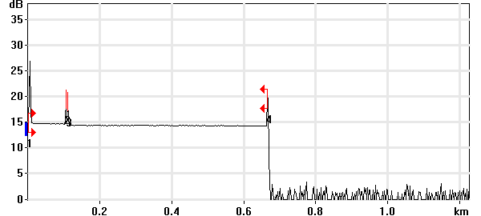

Event Table
No. | Loc. (km)/Length | Event Type | Loss (dB) | Refl. (dB) | Att. (dB/km) | Cumul. (dB)
1 | 0.0000 | Launch Level |  | -39.7 |  | 0.000
 | (0.1041 km) | Fiber Section | 0.132 |  | 1.271 | 0.132
2 | 0.1041 | Reflective Event | 0.025 | -58.0 |  | 0.157
 | (0.0051 km) | Fiber Section | 0.008 |  | 1.500 | 0.165
3 | 0.1092 | Reflective Event | 0.303 | -58.3 |  | 0.468
 | (0.5557 km) | Fiber Section | 0.089 |  | 0.160 | 0.556
4 | 0.6649 | Reflective Event | - - | -50.0 |  | 0.556

Pass/Fail Thresholds
Splice Loss: | 1.000 dB | Span Loss: | 45.000 dB
Connector Loss: | 1.000 dB | Span Length: | 0.000 m
Reflectance: | -40.0 dB | Span ORL: | 15.00 dB
Fiber section attenuation: | 0.400 dB/km

Test and Cable Setup
Wavelength: | 1550 nm (9 µm) | Acq. Time: | 30 s
File name: | MARS SM-10B.trc | IOR: | 1.468325
File Type: | Main | Backscatter: | -81.87 dB
OTDR Model: | FTB-720-23B-EA | Helix Factor: | 0.00 %
Serial No.: | 626283 | Splice Loss Detection: | 0.020 dB
Software Version: | OTDR - iOLM 2.1 | Reflectance Detection: | -72.0 dB
Distance: | 1.2500 km | End-of-Fiber Detection: | 5.000 dB
Pulse Width: | 10 ns

Comments

OTDR Report

Job Info
Job ID: |  | Operator A:
Company: |  | Operator B:
Customer: |  | File name: | MARS SM-11A.trc
Test date and time: | 2020-11-10 at 17:51 (GMT-5:00)

Cable Info
Fiber ID: | MARS SM-11A | Cable ID:
Location A: |  | Location B:

Wavelength: 1310 nm

Link Measurements
Span loss: | 0.408 dB | Average splice loss: | - - -
Span length: | 665.042 m | Span ORL: | 36.74 dB
Average loss: | 0.614 dB/km

OTDR Trace
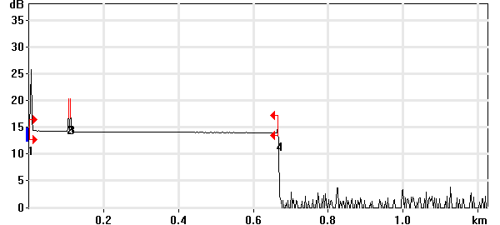

Event Table
No. | Loc. (km)/Length | Event Type | Loss (dB) | Refl. (dB) | Att. (dB/km) | Cumul. (dB)
1 | 0.0000 | Launch Level |  | -38.3 |  | 0.000
 | (0.1041 km) | Fiber Section | 0.102 |  | 0.984 | 0.102
2 | 0.1041 | Reflective Event | -0.023 | -56.9 |  | 0.079
 | (0.0050 km) | Fiber Section | 0.009 |  | 1.700 | 0.088
3 | 0.1092 | Reflective Event | 0.138 | -56.7 |  | 0.225
 | (0.5559 km) | Fiber Section | 0.183 |  | 0.329 | 0.408
4 | 0.6650 | Reflective Event | - - | -63.7 |  | 0.408

Pass/Fail Thresholds
Splice Loss: | 1.000 dB | Span Loss: | 45.000 dB
Connector Loss: | 1.000 dB | Span Length: | 0.000 m
Reflectance: | -40.0 dB | Span ORL: | 15.00 dB
Fiber section attenuation: | 0.400 dB/km

Test and Cable Setup
Wavelength: | 1310 nm (9 µm) | Acq. Time: | 30 s
File name: | MARS SM-11A.trc | IOR: | 1.467700
File Type: | Main | Backscatter: | -79.44 dB
OTDR Model: | FTB-720-23B-EA | Helix Factor: | 0.00 %
Serial No.: | 626283 | Splice Loss Detection: | 0.020 dB
Software Version: | OTDR - iOLM 2.1 | Reflectance Detection: | -72.0 dB
Distance: | 1.2500 km | End-of-Fiber Detection: | 5.000 dB
Pulse Width: | 10 ns

Comments

Wavelength: 1550 nm

Link Measurements
Span loss: | 0.352 dB | Average splice loss: | - - -
Span length: | 664.839 m | Span ORL: | 38.30 dB
Average loss: | 0.529 dB/km

OTDR Trace
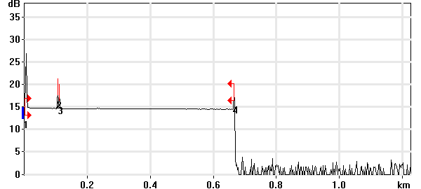

Event Table
No. | Loc. (km)/Length | Event Type | Loss (dB) | Refl. (dB) | Att. (dB/km) | Cumul. (dB)
1 | 0.0000 | Launch Level |  | -39.7 |  | 0.000
 | (0.1041 km) | Fiber Section | 0.127 |  | 1.223 | 0.127
2 | 0.1041 | Reflective Event | 0.027 | -58.1 |  | 0.154
 | (0.0051 km) | Fiber Section | 0.001 |  | 0.100 | 0.155
3 | 0.1092 | Reflective Event | 0.056 | -60.5 |  | 0.211
 | (0.5557 km) | Fiber Section | 0.141 |  | 0.254 | 0.352
4 | 0.6648 | Reflective Event | - - | -56.4 |  | 0.352

Pass/Fail Thresholds
Splice Loss: | 1.000 dB | Span Loss: | 45.000 dB
Connector Loss: | 1.000 dB | Span Length: | 0.000 m
Reflectance: | -40.0 dB | Span ORL: | 15.00 dB
Fiber section attenuation: | 0.400 dB/km

Test and Cable Setup
Wavelength: | 1550 nm (9 µm) | Acq. Time: | 30 s
File name: | MARS SM-11A.trc | IOR: | 1.468325
File Type: | Main | Backscatter: | -81.87 dB
OTDR Model: | FTB-720-23B-EA | Helix Factor: | 0.00 %
Serial No.: | 626283 | Splice Loss Detection: | 0.020 dB
Software Version: | OTDR - iOLM 2.1 | Reflectance Detection: | -72.0 dB
Distance: | 1.2500 km | End-of-Fiber Detection: | 5.000 dB
Pulse Width: | 10 ns

Comments

OTDR Report

Job Info
Job ID: |  | Operator A:
Company: |  | Operator B:
Customer: |  | File name: | MARS SM-11B.trc
Test date and time: | 2020-11-11 at 9:37 (GMT-5:00)

Cable Info
Fiber ID: | MARS SM-11B | Cable ID:
Location A: |  | Location B:

Wavelength: 1310 nm

Link Measurements
Span loss: | 0.716 dB | Average splice loss: | - - -
Span length: | 665.042 m | Span ORL: | 37.06 dB
Average loss: | 1.077 dB/km

OTDR Trace
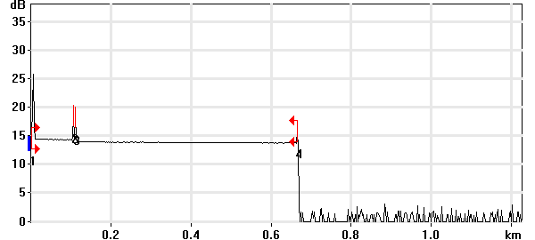

Event Table
No. | Loc. (km)/Length | Event Type | Loss (dB) | Refl. (dB) | Att. (dB/km) | Cumul. (dB)
1 | 0.0000 | Launch Level |  | -38.5 |  | 0.000
 | (0.1041 km) | Fiber Section | 0.104 |  | 1.002 | 0.104
2 | 0.1041 | Reflective Event | 0.063 | -57.0 |  | 0.167
 | (0.0050 km) | Fiber Section | 0.009 |  | 1.700 | 0.176
3 | 0.1092 | Reflective Event | 0.352 | -57.2 |  | 0.528
 | (0.5559 km) | Fiber Section | 0.188 |  | 0.339 | 0.716
4 | 0.6650 | Reflective Event | - - | -59.8 |  | 0.716

Pass/Fail Thresholds
Splice Loss: | 1.000 dB | Span Loss: | 45.000 dB
Connector Loss: | 1.000 dB | Span Length: | 0.000 m
Reflectance: | -40.0 dB | Span ORL: | 15.00 dB
Fiber section attenuation: | 0.400 dB/km

Test and Cable Setup
Wavelength: | 1310 nm (9 µm) | Acq. Time: | 30 s
File name: | MARS SM-11B.trc | IOR: | 1.467700
File Type: | Main | Backscatter: | -79.44 dB
OTDR Model: | FTB-720-23B-EA | Helix Factor: | 0.00 %
Serial No.: | 626283 | Splice Loss Detection: | 0.020 dB
Software Version: | OTDR - iOLM 2.1 | Reflectance Detection: | -72.0 dB
Distance: | 1.2500 km | End-of-Fiber Detection: | 5.000 dB
Pulse Width: | 10 ns

Comments

Wavelength: 1550 nm

Link Measurements
Span loss: | 0.482 dB | Average splice loss: | - - -
Span length: | 664.998 m | Span ORL: | 38.60 dB
Average loss: | 0.725 dB/km

OTDR Trace
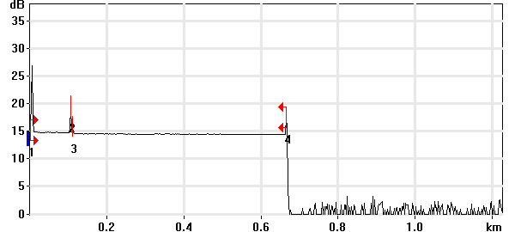

Event Table
No. | Loc. (km)/Length | Event Type | Loss (dB) | Refl. (dB) | Att. (dB/km) | Cumul. (dB)
1 | 0.0000 | Launch Level |  | -40.0 |  | 0.000
 | (0.1042 km) | Fiber Section | 0.104 |  | 0.994 | 0.104
2 | 0.1042 | Reflective Event | 0.048 | -58.2 |  | 0.151
 | (0.0051 km) | Fiber Section | 0.008 |  | 1.500 | 0.159
3 | 0.1093 | Reflective Event | 0.208 | -69.5 |  | 0.367
 | (0.5557 km) | Fiber Section | 0.115 |  | 0.207 | 0.482
4 | 0.6650 | Reflective Event | - - | -58.0 |  | 0.482

Pass/Fail Thresholds
Splice Loss: | 1.000 dB | Span Loss: | 45.000 dB
Connector Loss: | 1.000 dB | Span Length: | 0.000 m
Reflectance: | -40.0 dB | Span ORL: | 15.00 dB
Fiber section attenuation: | 0.400 dB/km

Test and Cable Setup
Wavelength: | 1550 nm (9 µm) | Acq. Time: | 30 s
File name: | MARS SM-11B.trc | IOR: | 1.468325
File Type: | Main | Backscatter: | -81.87 dB
OTDR Model: | FTB-720-23B-EA | Helix Factor: | 0.00 %
Serial No.: | 626283 | Splice Loss Detection: | 0.020 dB
Software Version: | OTDR - iOLM 2.1 | Reflectance Detection: | -72.0 dB
Distance: | 1.2500 km | End-of-Fiber Detection: | 5.000 dB
Pulse Width: | 10 ns

Comments

OTDR Report

Job Info
Job ID: |  | Operator A:
Company: |  | Operator B:
Customer: |  | File name: | MARS SM-12A.trc
Test date and time: | 2020-11-11 at 9:39 (GMT-5:00)

Cable Info
Fiber ID: | MARS SM-12A | Cable ID:
Location A: |  | Location B:

Wavelength: 1310 nm

Link Measurements
Span loss: | 0.620 dB | Average splice loss: | - - -
Span length: | 664.962 m | Span ORL: | 37.03 dB
Average loss: | 0.932 dB/km

OTDR Trace
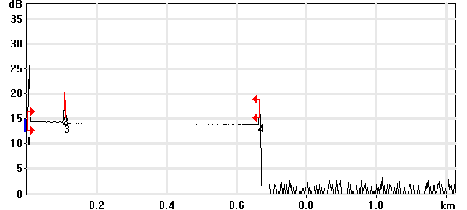

Event Table
No. | Loc. (km)/Length | Event Type | Loss (dB) | Refl. (dB) | Att. (dB/km) | Cumul. (dB)
1 | 0.0000 | Launch Level |  | -38.6 |  | 0.000
 | (0.1041 km) | Fiber Section | 0.119 |  | 1.143 | 0.119
2 | 0.1041 | Reflective Event | 0.068 | -57.0 |  | 0.187
 | (0.0050 km) | Fiber Section | 0.001 |  | 0.250 | 0.189
3 | 0.1092 | Reflective Event | 0.243 | -60.6 |  | 0.432
 | (0.5558 km) | Fiber Section | 0.188 |  | 0.339 | 0.620
4 | 0.6650 | Reflective Event | - - | -55.6 |  | 0.620

Pass/Fail Thresholds
Splice Loss: | 1.000 dB | Span Loss: | 45.000 dB
Connector Loss: | 1.000 dB | Span Length: | 0.000 m
Reflectance: | -40.0 dB | Span ORL: | 15.00 dB
Fiber section attenuation: | 0.400 dB/km

Test and Cable Setup
Wavelength: | 1310 nm (9 µm) | Acq. Time: | 30 s
File name: | MARS SM-12A.trc | IOR: | 1.467700
File Type: | Main | Backscatter: | -79.44 dB
OTDR Model: | FTB-720-23B-EA | Helix Factor: | 0.00 %
Serial No.: | 626283 | Splice Loss Detection: | 0.020 dB
Software Version: | OTDR - iOLM 2.1 | Reflectance Detection: | -72.0 dB
Distance: | 1.2500 km | End-of-Fiber Detection: | 5.000 dB
Pulse Width: | 10 ns

Comments

Wavelength: 1550 nm

Link Measurements
Span loss: | 0.472 dB | Average splice loss: | - - -
Span length: | 664.918 m | Span ORL: | 38.54 dB
Average loss: | 0.710 dB/km

OTDR Trace
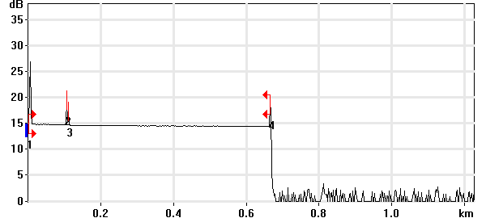

Event Table
No. | Loc. (km)/Length | Event Type | Loss (dB) | Refl. (dB) | Att. (dB/km) | Cumul. (dB)
1 | 0.0000 | Launch Level |  | -40.0 |  | 0.000
 | (0.1041 km) | Fiber Section | 0.115 |  | 1.103 | 0.115
2 | 0.1041 | Reflective Event | 0.006 | -58.2 |  | 0.121
 | (0.0051 km) | Fiber Section | 0.008 |  | 1.500 | 0.128
3 | 0.1092 | Reflective Event | 0.226 | -63.7 |  | 0.354
 | (0.5557 km) | Fiber Section | 0.118 |  | 0.212 | 0.472
4 | 0.6649 | Reflective Event | - - | -54.3 |  | 0.472

Pass/Fail Thresholds
Splice Loss: | 1.000 dB | Span Loss: | 45.000 dB
Connector Loss: | 1.000 dB | Span Length: | 0.000 m
Reflectance: | -40.0 dB | Span ORL: | 15.00 dB
Fiber section attenuation: | 0.400 dB/km

Test and Cable Setup
Wavelength: | 1550 nm (9 µm) | Acq. Time: | 30 s
File name: | MARS SM-12A.trc | IOR: | 1.468325
File Type: | Main | Backscatter: | -81.87 dB
OTDR Model: | FTB-720-23B-EA | Helix Factor: | 0.00 %
Serial No.: | 626283 | Splice Loss Detection: | 0.020 dB
Software Version: | OTDR - iOLM 2.1 | Reflectance Detection: | -72.0 dB
Distance: | 1.2500 km | End-of-Fiber Detection: | 5.000 dB
Pulse Width: | 10 ns

Comments

OTDR Report

Job Info
Job ID: |  | Operator A:
Company: |  | Operator B:
Customer: |  | File name: | MARS SM-12B.trc
Test date and time: | 2020-11-11 at 9:41 (GMT-5:00)

Cable Info
Fiber ID: | MARS SM-12B | Cable ID:
Location A: |  | Location B:

Wavelength: 1310 nm

Link Measurements
Span loss: | 0.468 dB | Average splice loss: | - - -
Span length: | 665.042 m | Span ORL: | 36.85 dB
Average loss: | 0.704 dB/km

OTDR Trace
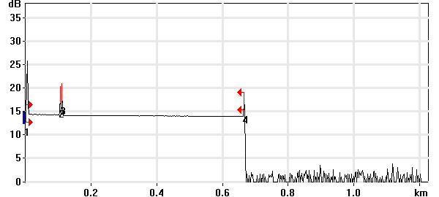

Event Table
No. | Loc. (km)/Length | Event Type | Loss (dB) | Refl. (dB) | Att. (dB/km) | Cumul. (dB)
1 | 0.0000 | Launch Level |  | -38.5 |  | 0.000
 | (0.1041 km) | Fiber Section | 0.104 |  | 0.995 | 0.104
2 | 0.1041 | Reflective Event | 0.022 | -57.0 |  | 0.125
 | (0.0050 km) | Fiber Section | 0.009 |  | 1.700 | 0.134
3 | 0.1092 | Reflective Event | 0.145 | -54.8 |  | 0.279
 | (0.5559 km) | Fiber Section | 0.190 |  | 0.341 | 0.468
4 | 0.6650 | Reflective Event | - - | -54.6 |  | 0.468

Pass/Fail Thresholds
Splice Loss: | 1.000 dB | Span Loss: | 45.000 dB
Connector Loss: | 1.000 dB | Span Length: | 0.000 m
Reflectance: | -40.0 dB | Span ORL: | 15.00 dB
Fiber section attenuation: | 0.400 dB/km

Test and Cable Setup
Wavelength: | 1310 nm (9 µm) | Acq. Time: | 30 s
File name: | MARS SM-12B.trc | IOR: | 1.467700
File Type: | Main | Backscatter: | -79.44 dB
OTDR Model: | FTB-720-23B-EA | Helix Factor: | 0.00 %
Serial No.: | 626283 | Splice Loss Detection: | 0.020 dB
Software Version: | OTDR - iOLM 2.1 | Reflectance Detection: | -72.0 dB
Distance: | 1.2500 km | End-of-Fiber Detection: | 5.000 dB
Pulse Width: | 10 ns

Comments

Wavelength: 1550 nm

Link Measurements
Span loss: | 0.442 dB | Average splice loss: | - - -
Span length: | 665.078 m | Span ORL: | 38.47 dB
Average loss: | 0.664 dB/km

OTDR Trace
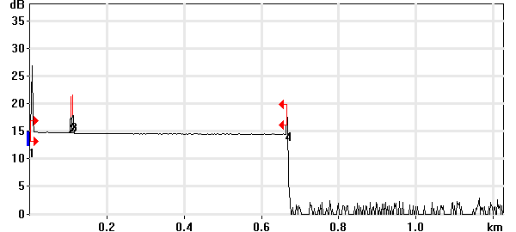

Event Table
No. | Loc. (km)/Length | Event Type | Loss (dB) | Refl. (dB) | Att. (dB/km) | Cumul. (dB)
1 | 0.0000 | Launch Level |  | -40.0 |  | 0.000
 | (0.1041 km) | Fiber Section | 0.127 |  | 1.218 | 0.127
2 | 0.1041 | Reflective Event | 0.056 | -58.2 |  | 0.182
 | (0.0050 km) | Fiber Section | 0.001 |  | 0.100 | 0.183
3 | 0.1091 | Reflective Event | 0.147 | -56.9 |  | 0.330
 | (0.5560 km) | Fiber Section | 0.111 |  | 0.200 | 0.442
4 | 0.6651 | Reflective Event | - - | -55.4 |  | 0.442

Pass/Fail Thresholds
Splice Loss: | 1.000 dB | Span Loss: | 45.000 dB
Connector Loss: | 1.000 dB | Span Length: | 0.000 m
Reflectance: | -40.0 dB | Span ORL: | 15.00 dB
Fiber section attenuation: | 0.400 dB/km

Test and Cable Setup
Wavelength: | 1550 nm (9 µm) | Acq. Time: | 30 s
File name: | MARS SM-12B.trc | IOR: | 1.468325
File Type: | Main | Backscatter: | -81.87 dB
OTDR Model: | FTB-720-23B-EA | Helix Factor: | 0.00 %
Serial No.: | 626283 | Splice Loss Detection: | 0.020 dB
Software Version: | OTDR - iOLM 2.1 | Reflectance Detection: | -72.0 dB
Distance: | 1.2500 km | End-of-Fiber Detection: | 5.000 dB
Pulse Width: | 10 ns

Comments

OTDR Report

Job Info
Job ID: |  | Operator A:
Company: |  | Operator B:
Customer: |  | File name: | MARS SM-13A.trc
Test date and time: | 2020-11-11 at 12:06 (GMT-5:00)

Cable Info
Fiber ID: | MARS SM-13A | Cable ID:
Location A: |  | Location B:

Wavelength: 1310 nm

Link Measurements
Span loss: | 1.073 dB | Average splice loss: | - - -
Span length: | 665.202 m | Span ORL: | 36.70 dB
Average loss: | 1.614 dB/km

OTDR Trace
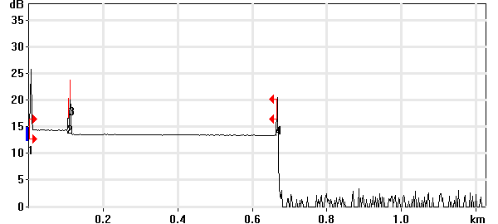

Event Table
No. | Loc. (km)/Length | Event Type | Loss (dB) | Refl. (dB) | Att. (dB/km) | Cumul. (dB)
1 | 0.0000 | Launch Level |  | -38.6 |  | 0.000
 | (0.1041 km) | Fiber Section | 0.100 |  | 0.962 | 0.100
2 | 0.1041 | Reflective Event | 0.033 | -57.0 |  | 0.133
 | (0.0049 km) | Fiber Section | 0.008 |  | 1.700 | 0.141
3 | 0.1090 | Reflective Event | 0.742 | -48.6 |  | 0.884
 | (0.5562 km) | Fiber Section | 0.190 |  | 0.341 | 1.073
4 | 0.6652 | Reflective Event | - - | -45.9 |  | 1.073

Pass/Fail Thresholds
Splice Loss: | 1.000 dB | Span Loss: | 45.000 dB
Connector Loss: | 1.000 dB | Span Length: | 0.000 m
Reflectance: | -40.0 dB | Span ORL: | 15.00 dB
Fiber section attenuation: | 0.400 dB/km

Test and Cable Setup
Wavelength: | 1310 nm (9 µm) | Acq. Time: | 30 s
File name: | MARS SM-13A.trc | IOR: | 1.467700
File Type: | Main | Backscatter: | -79.44 dB
OTDR Model: | FTB-720-23B-EA | Helix Factor: | 0.00 %
Serial No.: | 626283 | Splice Loss Detection: | 0.020 dB
Software Version: | OTDR - iOLM 2.1 | Reflectance Detection: | -72.0 dB
Distance: | 1.2500 km | End-of-Fiber Detection: | 5.000 dB
Pulse Width: | 10 ns

Comments

Wavelength: 1550 nm

Link Measurements
Span loss: | 0.712 dB | Average splice loss: | - - -
Span length: | 664.440 m | Span ORL: | 35.61 dB
Average loss: | 1.071 dB/km

OTDR Trace
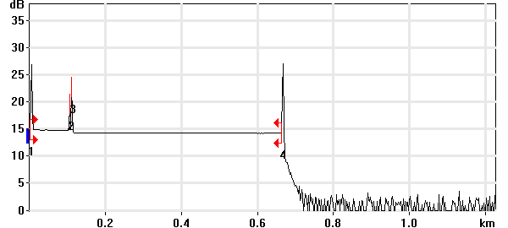

Event Table
No. | Loc. (km)/Length | Event Type | Loss (dB) | Refl. (dB) | Att. (dB/km) | Cumul. (dB)
1 | 0.0000 | Launch Level |  | -40.1 |  | 0.000
 | (0.1042 km) | Fiber Section | 0.119 |  | 1.146 | 0.119
2 | 0.1042 | Reflective Event | 0.068 | -58.2 |  | 0.187
 | (0.0049 km) | Fiber Section | 0.007 |  | 1.500 | 0.195
3 | 0.1090 | Reflective Event | 0.423 | -49.8 |  | 0.618
 | (0.5554 km) | Fiber Section | 0.094 |  | 0.169 | 0.712
4 | 0.6644 | Reflective Event | - - | -37.4 |  | 0.712

Pass/Fail Thresholds
Splice Loss: | 1.000 dB | Span Loss: | 45.000 dB
Connector Loss: | 1.000 dB | Span Length: | 0.000 m
Reflectance: | -40.0 dB | Span ORL: | 15.00 dB
Fiber section attenuation: | 0.400 dB/km

Test and Cable Setup
Wavelength: | 1550 nm (9 µm) | Acq. Time: | 30 s
File name: | MARS SM-13A.trc | IOR: | 1.468325
File Type: | Main | Backscatter: | -81.87 dB
OTDR Model: | FTB-720-23B-EA | Helix Factor: | 0.00 %
Serial No.: | 626283 | Splice Loss Detection: | 0.020 dB
Software Version: | OTDR - iOLM 2.1 | Reflectance Detection: | -72.0 dB
Distance: | 1.2500 km | End-of-Fiber Detection: | 5.000 dB
Pulse Width: | 10 ns

Comments

OTDR Report

Job Info
Job ID: |  | Operator A:
Company: |  | Operator B:
Customer: |  | File name: | MARS SM-13B.trc
Test date and time: | 2020-11-11 at 12:09 (GMT-5:00)

Cable Info
Fiber ID: | MARS SM-13B | Cable ID:
Location A: |  | Location B:

Wavelength: 1310 nm

Link Measurements
Span loss: | 0.551 dB | Average splice loss: | - - -
Span length: | 665.361 m | Span ORL: | 36.98 dB
Average loss: | 0.828 dB/km

OTDR Trace
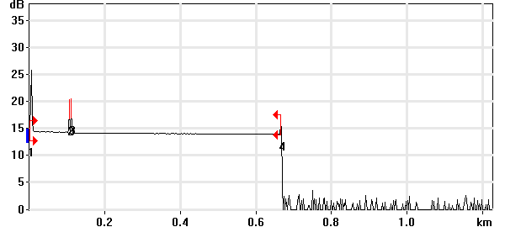

Event Table
No. | Loc. (km)/Length | Event Type | Loss (dB) | Refl. (dB) | Att. (dB/km) | Cumul. (dB)
1 | 0.0000 | Launch Level |  | -38.6 |  | 0.000
 | (0.1040 km) | Fiber Section | 0.128 |  | 1.228 | 0.128
2 | 0.1040 | Reflective Event | 0.012 | -57.0 |  | 0.140
 | (0.0050 km) | Fiber Section | 0.009 |  | 1.700 | 0.149
3 | 0.1091 | Reflective Event | 0.208 | -56.1 |  | 0.357
 | (0.5563 km) | Fiber Section | 0.194 |  | 0.349 | 0.551
4 | 0.6654 | Reflective Event | - - | -58.3 |  | 0.551

Pass/Fail Thresholds
Splice Loss: | 1.000 dB | Span Loss: | 45.000 dB
Connector Loss: | 1.000 dB | Span Length: | 0.000 m
Reflectance: | -40.0 dB | Span ORL: | 15.00 dB
Fiber section attenuation: | 0.400 dB/km

Test and Cable Setup
Wavelength: | 1310 nm (9 µm) | Acq. Time: | 30 s
File name: | MARS SM-13B.trc | IOR: | 1.467700
File Type: | Main | Backscatter: | -79.44 dB
OTDR Model: | FTB-720-23B-EA | Helix Factor: | 0.00 %
Serial No.: | 626283 | Splice Loss Detection: | 0.020 dB
Software Version: | OTDR - iOLM 2.1 | Reflectance Detection: | -72.0 dB
Distance: | 1.2500 km | End-of-Fiber Detection: | 5.000 dB
Pulse Width: | 10 ns

Comments

Wavelength: 1550 nm

Link Measurements
Span loss: | 0.409 dB | Average splice loss: | - - -
Span length: | 665.317 m | Span ORL: | 38.53 dB
Average loss: | 0.615 dB/km

OTDR Trace
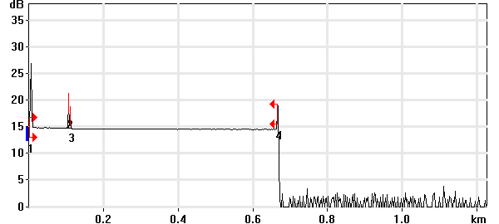

Event Table
No. | Loc. (km)/Length | Event Type | Loss (dB) | Refl. (dB) | Att. (dB/km) | Cumul. (dB)
1 | 0.0000 | Launch Level |  | -40.1 |  | 0.000
 | (0.1041 km) | Fiber Section | 0.108 |  | 1.039 | 0.108
2 | 0.1041 | Reflective Event | 0.025 | -58.2 |  | 0.133
 | (0.0051 km) | Fiber Section | 0.008 |  | 1.500 | 0.141
3 | 0.1092 | Reflective Event | 0.159 | -64.6 |  | 0.300
 | (0.5561 km) | Fiber Section | 0.109 |  | 0.197 | 0.409
4 | 0.6653 | Reflective Event | - - | -54.4 |  | 0.409

Pass/Fail Thresholds
Splice Loss: | 1.000 dB | Span Loss: | 45.000 dB
Connector Loss: | 1.000 dB | Span Length: | 0.000 m
Reflectance: | -40.0 dB | Span ORL: | 15.00 dB
Fiber section attenuation: | 0.400 dB/km

Test and Cable Setup
Wavelength: | 1550 nm (9 µm) | Acq. Time: | 30 s
File name: | MARS SM-13B.trc | IOR: | 1.468325
File Type: | Main | Backscatter: | -81.87 dB
OTDR Model: | FTB-720-23B-EA | Helix Factor: | 0.00 %
Serial No.: | 626283 | Splice Loss Detection: | 0.020 dB
Software Version: | OTDR - iOLM 2.1 | Reflectance Detection: | -72.0 dB
Distance: | 1.2500 km | End-of-Fiber Detection: | 5.000 dB
Pulse Width: | 10 ns

Comments

OTDR Report

Job Info
Job ID: |  | Operator A:
Company: |  | Operator B:
Customer: |  | File name: | MARS SM-14A.trc
Test date and time: | 2020-11-11 at 15:39 (GMT-5:00)

Cable Info
Fiber ID: | MARS SM-14A | Cable ID:
Location A: |  | Location B:

Wavelength: 1310 nm

Link Measurements
Span loss: | 0.818 dB | Average splice loss: | - - -
Span length: | 667.037 m | Span ORL: | 34.43 dB
Average loss: | 1.226 dB/km

OTDR Trace
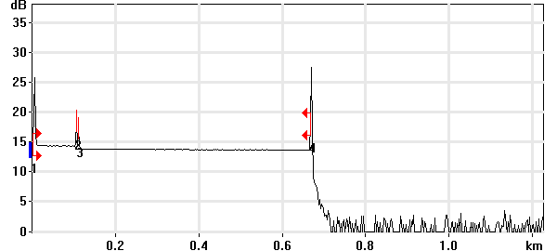

Event Table
No. | Loc. (km)/Length | Event Type | Loss (dB) | Refl. (dB) | Att. (dB/km) | Cumul. (dB)
1 | 0.0000 | Launch Level |  | -38.7 |  | 0.000
 | (0.1041 km) | Fiber Section | 0.111 |  | 1.069 | 0.111
2 | 0.1041 | Reflective Event | 0.006 | -57.1 |  | 0.118
 | (0.0050 km) | Fiber Section | 0.009 |  | 1.700 | 0.126
3 | 0.1092 | Reflective Event | 0.520 | -59.7 |  | 0.646
 | (0.5579 km) | Fiber Section | 0.172 |  | 0.309 | 0.818
4 | 0.6670 | Reflective Event | - - | -35.9 |  | 0.818

Pass/Fail Thresholds
Splice Loss: | 1.000 dB | Span Loss: | 45.000 dB
Connector Loss: | 1.000 dB | Span Length: | 0.000 m
Reflectance: | -40.0 dB | Span ORL: | 15.00 dB
Fiber section attenuation: | 0.400 dB/km

Test and Cable Setup
Wavelength: | 1310 nm (9 µm) | Acq. Time: | 30 s
File name: | MARS SM-14A.trc | IOR: | 1.467700
File Type: | Main | Backscatter: | -79.44 dB
OTDR Model: | FTB-720-23B-EA | Helix Factor: | 0.00 %
Serial No.: | 626283 | Splice Loss Detection: | 0.020 dB
Software Version: | OTDR - iOLM 2.1 | Reflectance Detection: | -72.0 dB
Distance: | 1.2500 km | End-of-Fiber Detection: | 5.000 dB
Pulse Width: | 10 ns

Comments

Wavelength: 1550 nm

Link Measurements
Span loss: | 0.814 dB | Average splice loss: | - - -
Span length: | 667.710 m | Span ORL: | 30.93 dB
Average loss: | 1.218 dB/km

OTDR Trace
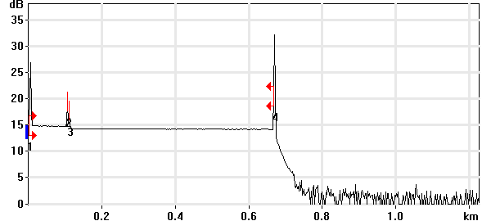

Event Table
No. | Loc. (km)/Length | Event Type | Loss (dB) | Refl. (dB) | Att. (dB/km) | Cumul. (dB)
1 | 0.0000 | Launch Level |  | -40.2 |  | 0.000
 | (0.1041 km) | Fiber Section | 0.156 |  | 1.498 | 0.156
2 | 0.1041 | Reflective Event | 0.047 | -58.2 |  | 0.203
 | (0.0051 km) | Fiber Section | 0.008 |  | 1.500 | 0.211
3 | 0.1092 | Reflective Event | 0.513 | -62.2 |  | 0.724
 | (0.5585 km) | Fiber Section | 0.090 |  | 0.160 | 0.814
4 | 0.6677 | Reflective Event | - - | -30.3 |  | 0.814

Pass/Fail Thresholds
Splice Loss: | 1.000 dB | Span Loss: | 45.000 dB
Connector Loss: | 1.000 dB | Span Length: | 0.000 m
Reflectance: | -40.0 dB | Span ORL: | 15.00 dB
Fiber section attenuation: | 0.400 dB/km

Test and Cable Setup
Wavelength: | 1550 nm (9 µm) | Acq. Time: | 30 s
File name: | MARS SM-14A.trc | IOR: | 1.468325
File Type: | Main | Backscatter: | -81.87 dB
OTDR Model: | FTB-720-23B-EA | Helix Factor: | 0.00 %
Serial No.: | 626283 | Splice Loss Detection: | 0.020 dB
Software Version: | OTDR - iOLM 2.1 | Reflectance Detection: | -72.0 dB
Distance: | 1.2500 km | End-of-Fiber Detection: | 5.000 dB
Pulse Width: | 10 ns

Comments

OTDR Report

Job Info
Job ID: |  | Operator A:
Company: |  | Operator B:
Customer: |  | File name: | MARS SM-14B.trc
Test date and time: | 2020-11-11 at 15:43 (GMT-5:00)

Cable Info
Fiber ID: | MARS SM-14B | Cable ID:
Location A: |  | Location B:

Wavelength: 1310 nm

Link Measurements
Span loss: | 0.400 dB | Average splice loss: | - - -
Span length: | 667.994 m | Span ORL: | 29.38 dB
Average loss: | 0.598 dB/km

OTDR Trace
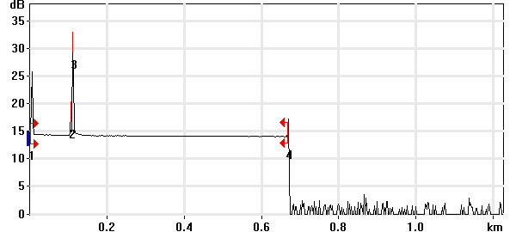

Event Table
No. | Loc. (km)/Length | Event Type | Loss (dB) | Refl. (dB) | Att. (dB/km) | Cumul. (dB)
1 | 0.0000 | Launch Level |  | -38.6 |  | 0.000
 | (0.1040 km) | Fiber Section | 0.099 |  | 0.952 | 0.099
2 | 0.1040 | Reflective Event | -0.105 | -57.1 |  | -0.006
 | (0.0049 km) | Fiber Section | 0.001 |  | 0.250 | -0.005
3 | 0.1089 | Reflective Event | 0.191 | -30.1 |  | 0.186
 | (0.5591 km) | Fiber Section | 0.214 |  | 0.382 | 0.400
4 | 0.6680 | Reflective Event | - - | -57.7 |  | 0.400

Pass/Fail Thresholds
Splice Loss: | 1.000 dB | Span Loss: | 45.000 dB
Connector Loss: | 1.000 dB | Span Length: | 0.000 m
Reflectance: | -40.0 dB | Span ORL: | 15.00 dB
Fiber section attenuation: | 0.400 dB/km

Test and Cable Setup
Wavelength: | 1310 nm (9 µm) | Acq. Time: | 30 s
File name: | MARS SM-14B.trc | IOR: | 1.467700
File Type: | Main | Backscatter: | -79.44 dB
OTDR Model: | FTB-720-23B-EA | Helix Factor: | 0.00 %
Serial No.: | 626283 | Splice Loss Detection: | 0.020 dB
Software Version: | OTDR - iOLM 2.1 | Reflectance Detection: | -72.0 dB
Distance: | 1.2500 km | End-of-Fiber Detection: | 5.000 dB
Pulse Width: | 10 ns

Comments

Wavelength: 1550 nm

Link Measurements
Span loss: | 0.434 dB | Average splice loss: | - - -
Span length: | 667.949 m | Span ORL: | 32.44 dB
Average loss: | 0.650 dB/km

OTDR Trace
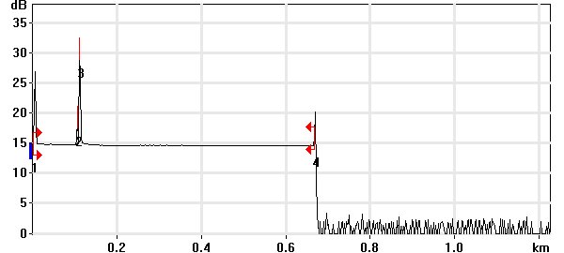

Event Table
No. | Loc. (km)/Length | Event Type | Loss (dB) | Refl. (dB) | Att. (dB/km) | Cumul. (dB)
1 | 0.0000 | Launch Level |  | -40.1 |  | 0.000
 | (0.1041 km) | Fiber Section | 0.156 |  | 1.500 | 0.156
2 | 0.1041 | Reflective Event | 0.040 | -58.2 |  | 0.196
 | (0.0049 km) | Fiber Section | 0.007 |  | 1.500 | 0.204
3 | 0.1090 | Reflective Event | 0.103 | -33.4 |  | 0.307
 | (0.5590 km) | Fiber Section | 0.127 |  | 0.227 | 0.434
4 | 0.6680 | Reflective Event | - - | -55.1 |  | 0.434

Pass/Fail Thresholds
Splice Loss: | 1.000 dB | Span Loss: | 45.000 dB
Connector Loss: | 1.000 dB | Span Length: | 0.000 m
Reflectance: | -40.0 dB | Span ORL: | 15.00 dB
Fiber section attenuation: | 0.400 dB/km

Test and Cable Setup
Wavelength: | 1550 nm (9 µm) | Acq. Time: | 30 s
File name: | MARS SM-14B.trc | IOR: | 1.468325
File Type: | Main | Backscatter: | -81.87 dB
OTDR Model: | FTB-720-23B-EA | Helix Factor: | 0.00 %
Serial No.: | 626283 | Splice Loss Detection: | 0.020 dB
Software Version: | OTDR - iOLM 2.1 | Reflectance Detection: | -72.0 dB
Distance: | 1.2500 km | End-of-Fiber Detection: | 5.000 dB
Pulse Width: | 10 ns

Comments

OTDR Report

Job Info
Job ID: |  | Operator A:
Company: |  | Operator B:
Customer: |  | File name: | MARS SM-15A.trc
Test date and time: | 2020-11-11 at 15:58 (GMT-5:00)

Cable Info
Fiber ID: | MARS SM-15A | Cable ID:
Location A: |  | Location B:

Wavelength: 1310 nm

Link Measurements
Span loss: | 0.429 dB | Average splice loss: | - - -
Span length: | 668.154 m | Span ORL: | 37.03 dB
Average loss: | 0.643 dB/km

OTDR Trace
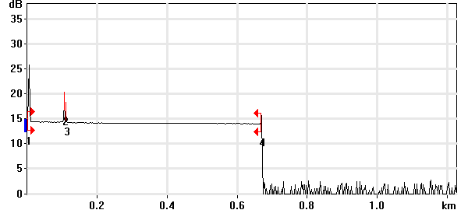

Event Table
No. | Loc. (km)/Length | Event Type | Loss (dB) | Refl. (dB) | Att. (dB/km) | Cumul. (dB)
1 | 0.0000 | Launch Level |  | -38.7 |  | 0.000
 | (0.1041 km) | Fiber Section | 0.098 |  | 0.940 | 0.098
2 | 0.1041 | Reflective Event | 0.022 | -57.1 |  | 0.120
 | (0.0051 km) | Fiber Section | 0.009 |  | 1.700 | 0.128
3 | 0.1092 | Reflective Event | 0.110 | -62.1 |  | 0.238
 | (0.5589 km) | Fiber Section | 0.191 |  | 0.342 | 0.429
4 | 0.6682 | Reflective Event | - - | -62.1 |  | 0.429

Pass/Fail Thresholds
Splice Loss: | 1.000 dB | Span Loss: | 45.000 dB
Connector Loss: | 1.000 dB | Span Length: | 0.000 m
Reflectance: | -40.0 dB | Span ORL: | 15.00 dB
Fiber section attenuation: | 0.400 dB/km

Test and Cable Setup
Wavelength: | 1310 nm (9 µm) | Acq. Time: | 30 s
File name: | MARS SM-15A.trc | IOR: | 1.467700
File Type: | Main | Backscatter: | -79.44 dB
OTDR Model: | FTB-720-23B-EA | Helix Factor: | 0.00 %
Serial No.: | 626283 | Splice Loss Detection: | 0.020 dB
Software Version: | OTDR - iOLM 2.1 | Reflectance Detection: | -72.0 dB
Distance: | 1.2500 km | End-of-Fiber Detection: | 5.000 dB
Pulse Width: | 10 ns

Comments

Wavelength: 1550 nm

Link Measurements
Span loss: | 0.414 dB | Average splice loss: | - - -
Span length: | 668.188 m | Span ORL: | 38.62 dB
Average loss: | 0.619 dB/km

OTDR Trace
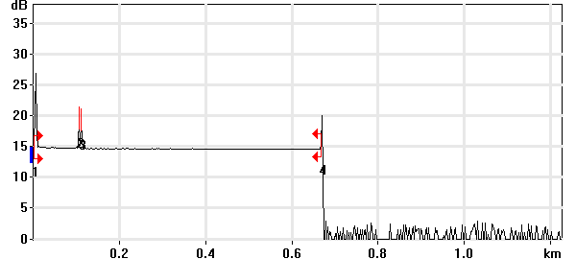

Event Table
No. | Loc. (km)/Length | Event Type | Loss (dB) | Refl. (dB) | Att. (dB/km) | Cumul. (dB)
1 | 0.0000 | Launch Level |  | -40.2 |  | 0.000
 | (0.1041 km) | Fiber Section | 0.148 |  | 1.419 | 0.148
2 | 0.1041 | Reflective Event | -0.008 | -58.2 |  | 0.140
 | (0.0051 km) | Fiber Section | 0.008 |  | 1.500 | 0.147
3 | 0.1092 | Reflective Event | 0.181 | -58.2 |  | 0.329
 | (0.5590 km) | Fiber Section | 0.085 |  | 0.152 | 0.414
4 | 0.6682 | Reflective Event | - - | -56.2 |  | 0.414

Pass/Fail Thresholds
Splice Loss: | 1.000 dB | Span Loss: | 45.000 dB
Connector Loss: | 1.000 dB | Span Length: | 0.000 m
Reflectance: | -40.0 dB | Span ORL: | 15.00 dB
Fiber section attenuation: | 0.400 dB/km

Test and Cable Setup
Wavelength: | 1550 nm (9 µm) | Acq. Time: | 30 s
File name: | MARS SM-15A.trc | IOR: | 1.468325
File Type: | Main | Backscatter: | -81.87 dB
OTDR Model: | FTB-720-23B-EA | Helix Factor: | 0.00 %
Serial No.: | 626283 | Splice Loss Detection: | 0.020 dB
Software Version: | OTDR - iOLM 2.1 | Reflectance Detection: | -72.0 dB
Distance: | 1.2500 km | End-of-Fiber Detection: | 5.000 dB
Pulse Width: | 10 ns

Comments

OTDR Report

Job Info
Job ID: |  | Operator A:
Company: |  | Operator B:
Customer: |  | File name: | MARS SM-15B.trc
Test date and time: | 2020-11-11 at 16:02 (GMT-5:00)

Cable Info
Fiber ID: | MARS SM-15B | Cable ID:
Location A: |  | Location B:

Wavelength: 1310 nm

Link Measurements
Span loss: | 0.675 dB | Average splice loss: | - - -
Span length: | 668.074 m | Span ORL: | 37.10 dB
Average loss: | 1.011 dB/km

OTDR Trace
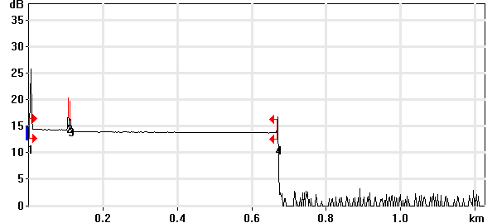

Event Table
No. | Loc. (km)/Length | Event Type | Loss (dB) | Refl. (dB) | Att. (dB/km) | Cumul. (dB)
1 | 0.0000 | Launch Level |  | -38.6 |  | 0.000
 | (0.1040 km) | Fiber Section | 0.095 |  | 0.910 | 0.095
2 | 0.1040 | Reflective Event | 0.016 | -57.1 |  | 0.111
 | (0.0051 km) | Fiber Section | 0.009 |  | 1.700 | 0.120
3 | 0.1092 | Reflective Event | 0.372 | -58.2 |  | 0.492
 | (0.5589 km) | Fiber Section | 0.183 |  | 0.328 | 0.675
4 | 0.6681 | Reflective Event | - - | -58.3 |  | 0.675

Pass/Fail Thresholds
Splice Loss: | 1.000 dB | Span Loss: | 45.000 dB
Connector Loss: | 1.000 dB | Span Length: | 0.000 m
Reflectance: | -40.0 dB | Span ORL: | 15.00 dB
Fiber section attenuation: | 0.400 dB/km

Test and Cable Setup
Wavelength: | 1310 nm (9 µm) | Acq. Time: | 30 s
File name: | MARS SM-15B.trc | IOR: | 1.467700
File Type: | Main | Backscatter: | -79.44 dB
OTDR Model: | FTB-720-23B-EA | Helix Factor: | 0.00 %
Serial No.: | 626283 | Splice Loss Detection: | 0.020 dB
Software Version: | OTDR - iOLM 2.1 | Reflectance Detection: | -72.0 dB
Distance: | 1.2500 km | End-of-Fiber Detection: | 5.000 dB
Pulse Width: | 10 ns

Comments

Wavelength: 1550 nm

Link Measurements
Span loss: | 0.646 dB | Average splice loss: | - - -
Span length: | 668.109 m | Span ORL: | 38.73 dB
Average loss: | 0.967 dB/km

OTDR Trace
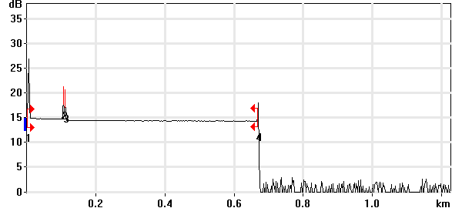

Event Table
No. | Loc. (km)/Length | Event Type | Loss (dB) | Refl. (dB) | Att. (dB/km) | Cumul. (dB)
1 | 0.0000 | Launch Level |  | -40.2 |  | 0.000
 | (0.1042 km) | Fiber Section | 0.149 |  | 1.431 | 0.149
2 | 0.1042 | Reflective Event | 0.026 | -58.3 |  | 0.175
 | (0.0050 km) | Fiber Section | 0.008 |  | 1.500 | 0.182
3 | 0.1092 | Reflective Event | 0.358 | -59.1 |  | 0.540
 | (0.5589 km) | Fiber Section | 0.106 |  | 0.190 | 0.646
4 | 0.6681 | Reflective Event | - - | -59.6 |  | 0.646

Pass/Fail Thresholds
Splice Loss: | 1.000 dB | Span Loss: | 45.000 dB
Connector Loss: | 1.000 dB | Span Length: | 0.000 m
Reflectance: | -40.0 dB | Span ORL: | 15.00 dB
Fiber section attenuation: | 0.400 dB/km

Test and Cable Setup
Wavelength: | 1550 nm (9 µm) | Acq. Time: | 30 s
File name: | MARS SM-15B.trc | IOR: | 1.468325
File Type: | Main | Backscatter: | -81.87 dB
OTDR Model: | FTB-720-23B-EA | Helix Factor: | 0.00 %
Serial No.: | 626283 | Splice Loss Detection: | 0.020 dB
Software Version: | OTDR - iOLM 2.1 | Reflectance Detection: | -72.0 dB
Distance: | 1.2500 km | End-of-Fiber Detection: | 5.000 dB
Pulse Width: | 10 ns

Comments

OTDR Report

Job Info
Job ID: |  | Operator A:
Company: |  | Operator B:
Customer: |  | File name: | MARS SM-16A.trc
Test date and time: | 2020-11-11 at 16:05 (GMT-5:00)

Cable Info
Fiber ID: | MARS SM-16A | Cable ID:
Location A: |  | Location B:

Wavelength: 1310 nm

Link Measurements
Span loss: | 1.120 dB | Average splice loss: | - - -
Span length: | 667.914 m | Span ORL: | 37.15 dB
Average loss: | 1.677 dB/km

OTDR Trace
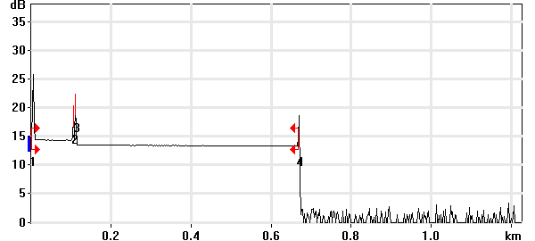

Event Table
No. | Loc. (km)/Length | Event Type | Loss (dB) | Refl. (dB) | Att. (dB/km) | Cumul. (dB)
1 | 0.0000 | Launch Level |  | -38.6 |  | 0.000
 | (0.1041 km) | Fiber Section | 0.088 |  | 0.843 | 0.088
2 | 0.1041 | Reflective Event | 0.063 | -57.1 |  | 0.150
 | (0.0049 km) | Fiber Section | 0.008 |  | 1.700 | 0.159
3 | 0.1091 | Reflective Event | 0.781 | -51.4 |  | 0.940
 | (0.5588 km) | Fiber Section | 0.180 |  | 0.322 | 1.120
4 | 0.6679 | Reflective Event | - - | -53.0 |  | 1.120

Pass/Fail Thresholds
Splice Loss: | 1.000 dB | Span Loss: | 45.000 dB
Connector Loss: | 1.000 dB | Span Length: | 0.000 m
Reflectance: | -40.0 dB | Span ORL: | 15.00 dB
Fiber section attenuation: | 0.400 dB/km

Test and Cable Setup
Wavelength: | 1310 nm (9 µm) | Acq. Time: | 30 s
File name: | MARS SM-16A.trc | IOR: | 1.467700
File Type: | Main | Backscatter: | -79.44 dB
OTDR Model: | FTB-720-23B-EA | Helix Factor: | 0.00 %
Serial No.: | 626283 | Splice Loss Detection: | 0.020 dB
Software Version: | OTDR - iOLM 2.1 | Reflectance Detection: | -72.0 dB
Distance: | 1.2500 km | End-of-Fiber Detection: | 5.000 dB
Pulse Width: | 10 ns

Comments

Wavelength: 1550 nm

Link Measurements
Span loss: | 0.883 dB | Average splice loss: | - - -
Span length: | 667.790 m | Span ORL: | 38.26 dB
Average loss: | 1.322 dB/km

OTDR Trace
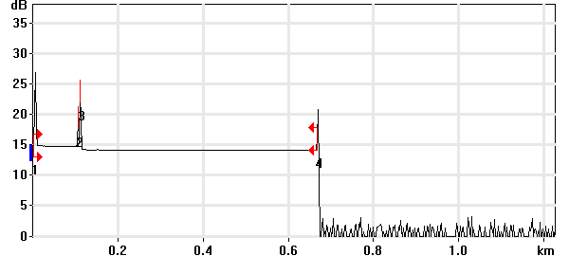

Event Table
No. | Loc. (km)/Length | Event Type | Loss (dB) | Refl. (dB) | Att. (dB/km) | Cumul. (dB)
1 | 0.0000 | Launch Level |  | -40.1 |  | 0.000
 | (0.1041 km) | Fiber Section | 0.156 |  | 1.500 | 0.156
2 | 0.1041 | Reflective Event | 0.003 | -58.2 |  | 0.159
 | (0.0049 km) | Fiber Section | 0.007 |  | 1.500 | 0.167
3 | 0.1090 | Reflective Event | 0.626 | -47.7 |  | 0.793
 | (0.5588 km) | Fiber Section | 0.090 |  | 0.161 | 0.883
4 | 0.6678 | Reflective Event | - - | -52.6 |  | 0.883

Pass/Fail Thresholds
Splice Loss: | 1.000 dB | Span Loss: | 45.000 dB
Connector Loss: | 1.000 dB | Span Length: | 0.000 m
Reflectance: | -40.0 dB | Span ORL: | 15.00 dB
Fiber section attenuation: | 0.400 dB/km

Test and Cable Setup
Wavelength: | 1550 nm (9 µm) | Acq. Time: | 30 s
File name: | MARS SM-16A.trc | IOR: | 1.468325
File Type: | Main | Backscatter: | -81.87 dB
OTDR Model: | FTB-720-23B-EA | Helix Factor: | 0.00 %
Serial No.: | 626283 | Splice Loss Detection: | 0.020 dB
Software Version: | OTDR - iOLM 2.1 | Reflectance Detection: | -72.0 dB
Distance: | 1.2500 km | End-of-Fiber Detection: | 5.000 dB
Pulse Width: | 10 ns

Comments

OTDR Report

Job Info
Job ID: |  | Operator A:
Company: |  | Operator B:
Customer: |  | File name: | MARS SM-16B.trc
Test date and time: | 2020-11-11 at 17:25 (GMT-5:00)

Cable Info
Fiber ID: | MARS SM-16B | Cable ID:
Location A: |  | Location B:

Wavelength: 1310 nm

Link Measurements
Span loss: | 0.518 dB | Average splice loss: | - - -
Span length: | 668.074 m | Span ORL: | 36.94 dB
Average loss: | 0.775 dB/km

OTDR Trace
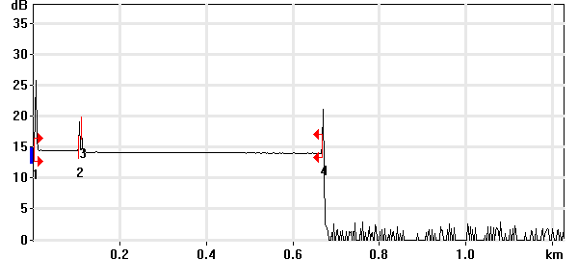

Event Table
No. | Loc. (km)/Length | Event Type | Loss (dB) | Refl. (dB) | Att. (dB/km) | Cumul. (dB)
1 | 0.0000 | Launch Level |  | -38.8 |  | 0.000
 | (0.1038 km) | Fiber Section | 0.096 |  | 0.922 | 0.096
2 | 0.1038 | Reflective Event | 0.046 | -55.8 |  | 0.142
 | (0.0053 km) | Fiber Section | 0.009 |  | 1.700 | 0.151
3 | 0.1092 | Reflective Event | 0.175 | -57.7 |  | 0.326
 | (0.5589 km) | Fiber Section | 0.192 |  | 0.343 | 0.518
4 | 0.6681 | Reflective Event | - - | -50.1 |  | 0.518

Pass/Fail Thresholds
Splice Loss: | 1.000 dB | Span Loss: | 45.000 dB
Connector Loss: | 1.000 dB | Span Length: | 0.000 m
Reflectance: | -40.0 dB | Span ORL: | 15.00 dB
Fiber section attenuation: | 0.400 dB/km

Test and Cable Setup
Wavelength: | 1310 nm (9 µm) | Acq. Time: | 30 s
File name: | MARS SM-16B.trc | IOR: | 1.467700
File Type: | Main | Backscatter: | -79.44 dB
OTDR Model: | FTB-720-23B-EA | Helix Factor: | 0.00 %
Serial No.: | 626283 | Splice Loss Detection: | 0.020 dB
Software Version: | OTDR - iOLM 2.1 | Reflectance Detection: | -72.0 dB
Distance: | 1.2500 km | End-of-Fiber Detection: | 5.000 dB
Pulse Width: | 10 ns

Comments

Wavelength: 1550 nm

Link Measurements
Span loss: | 0.402 dB | Average splice loss: | - - -
Span length: | 668.029 m | Span ORL: | 38.39 dB
Average loss: | 0.602 dB/km

OTDR Trace
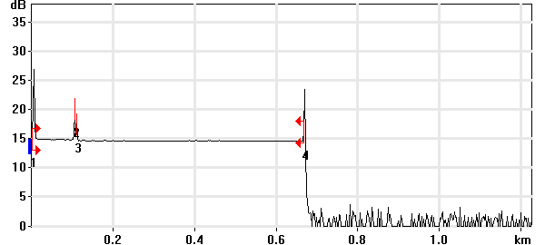

Event Table
No. | Loc. (km)/Length | Event Type | Loss (dB) | Refl. (dB) | Att. (dB/km) | Cumul. (dB)
1 | 0.0000 | Launch Level |  | -40.2 |  | 0.000
 | (0.1041 km) | Fiber Section | 0.102 |  | 0.982 | 0.102
2 | 0.1041 | Reflective Event | 0.023 | -57.0 |  | 0.125
 | (0.0051 km) | Fiber Section | 0.008 |  | 1.500 | 0.133
3 | 0.1092 | Reflective Event | 0.189 | -63.2 |  | 0.322
 | (0.5588 km) | Fiber Section | 0.081 |  | 0.144 | 0.402
4 | 0.6680 | Reflective Event | - - | -49.1 |  | 0.402

Pass/Fail Thresholds
Splice Loss: | 1.000 dB | Span Loss: | 45.000 dB
Connector Loss: | 1.000 dB | Span Length: | 0.000 m
Reflectance: | -40.0 dB | Span ORL: | 15.00 dB
Fiber section attenuation: | 0.400 dB/km

Test and Cable Setup
Wavelength: | 1550 nm (9 µm) | Acq. Time: | 30 s
File name: | MARS SM-16B.trc | IOR: | 1.468325
File Type: | Main | Backscatter: | -81.87 dB
OTDR Model: | FTB-720-23B-EA | Helix Factor: | 0.00 %
Serial No.: | 626283 | Splice Loss Detection: | 0.020 dB
Software Version: | OTDR - iOLM 2.1 | Reflectance Detection: | -72.0 dB
Distance: | 1.2500 km | End-of-Fiber Detection: | 5.000 dB
Pulse Width: | 10 ns

Comments

OTDR Report

Job Info
Job ID: |  | Operator A:
Company: |  | Operator B:
Customer: |  | File name: | MARS SM-17A.trc
Test date and time: | 2020-11-11 at 17:45 (GMT-5:00)

Cable Info
Fiber ID: | MARS SM-17A | Cable ID:
Location A: |  | Location B:

Wavelength: 1310 nm

Link Measurements
Span loss: | 0.436 dB | Average splice loss: | - - -
Span length: | 667.755 m | Span ORL: | 37.03 dB
Average loss: | 0.653 dB/km

OTDR Trace
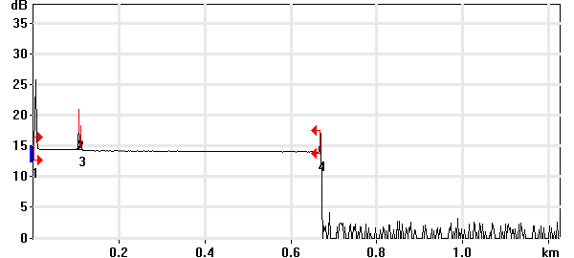

Event Table
No. | Loc. (km)/Length | Event Type | Loss (dB) | Refl. (dB) | Att. (dB/km) | Cumul. (dB)
1 | 0.0000 | Launch Level |  | -38.7 |  | 0.000
 | (0.1040 km) | Fiber Section | 0.082 |  | 0.791 | 0.082
2 | 0.1040 | Reflective Event | 0.037 | -55.9 |  | 0.120
 | (0.0052 km) | Fiber Section | 0.009 |  | 1.700 | 0.129
3 | 0.1092 | Reflective Event | 0.124 | -62.2 |  | 0.253
 | (0.5585 km) | Fiber Section | 0.183 |  | 0.328 | 0.436
4 | 0.6678 | Reflective Event | - - | -56.3 |  | 0.436

Pass/Fail Thresholds
Splice Loss: | 1.000 dB | Span Loss: | 45.000 dB
Connector Loss: | 1.000 dB | Span Length: | 0.000 m
Reflectance: | -40.0 dB | Span ORL: | 15.00 dB
Fiber section attenuation: | 0.400 dB/km

Test and Cable Setup
Wavelength: | 1310 nm (9 µm) | Acq. Time: | 30 s
File name: | MARS SM-17A.trc | IOR: | 1.467700
File Type: | Main | Backscatter: | -79.44 dB
OTDR Model: | FTB-720-23B-EA | Helix Factor: | 0.00 %
Serial No.: | 626283 | Splice Loss Detection: | 0.020 dB
Software Version: | OTDR - iOLM 2.1 | Reflectance Detection: | -72.0 dB
Distance: | 1.2500 km | End-of-Fiber Detection: | 5.000 dB
Pulse Width: | 10 ns

Comments

Wavelength: 1550 nm

Link Measurements
Span loss: | 0.341 dB | Average splice loss: | - - -
Span length: | 667.710 m | Span ORL: | 38.61 dB
Average loss: | 0.511 dB/km

OTDR Trace
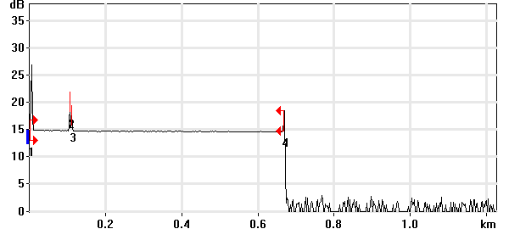

Event Table
No. | Loc. (km)/Length | Event Type | Loss (dB) | Refl. (dB) | Att. (dB/km) | Cumul. (dB)
1 | 0.0000 | Launch Level |  | -40.2 |  | 0.000
 | (0.1042 km) | Fiber Section | 0.106 |  | 1.018 | 0.106
2 | 0.1042 | Reflective Event | 0.029 | -57.1 |  | 0.136
 | (0.0050 km) | Fiber Section | 0.008 |  | 1.500 | 0.143
3 | 0.1092 | Reflective Event | 0.106 | -63.1 |  | 0.249
 | (0.5585 km) | Fiber Section | 0.092 |  | 0.165 | 0.341
4 | 0.6677 | Reflective Event | - - | -56.7 |  | 0.341

Pass/Fail Thresholds
Splice Loss: | 1.000 dB | Span Loss: | 45.000 dB
Connector Loss: | 1.000 dB | Span Length: | 0.000 m
Reflectance: | -40.0 dB | Span ORL: | 15.00 dB
Fiber section attenuation: | 0.400 dB/km

Test and Cable Setup
Wavelength: | 1550 nm (9 µm) | Acq. Time: | 30 s
File name: | MARS SM-17A.trc | IOR: | 1.468325
File Type: | Main | Backscatter: | -81.87 dB
OTDR Model: | FTB-720-23B-EA | Helix Factor: | 0.00 %
Serial No.: | 626283 | Splice Loss Detection: | 0.020 dB
Software Version: | OTDR - iOLM 2.1 | Reflectance Detection: | -72.0 dB
Distance: | 1.2500 km | End-of-Fiber Detection: | 5.000 dB
Pulse Width: | 10 ns

Comments

OTDR Report

Job Info
Job ID: |  | Operator A:
Company: |  | Operator B:
Customer: |  | File name: | MARS SM-17B.trc
Test date and time: | 2020-11-11 at 18:57 (GMT-5:00)

Cable Info
Fiber ID: | MARS SM-17B | Cable ID:
Location A: |  | Location B:

Wavelength: 1310 nm

Link Measurements
Span loss: | 0.423 dB | Average splice loss: | - - -
Span length: | 667.914 m | Span ORL: | 37.03 dB
Average loss: | 0.633 dB/km

OTDR Trace
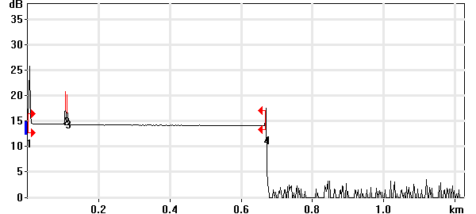

Event Table
No. | Loc. (km)/Length | Event Type | Loss (dB) | Refl. (dB) | Att. (dB/km) | Cumul. (dB)
1 | 0.0000 | Launch Level |  | -38.8 |  | 0.000
 | (0.1040 km) | Fiber Section | 0.103 |  | 0.991 | 0.103
2 | 0.1040 | Reflective Event | 0.061 | -56.1 |  | 0.164
 | (0.0051 km) | Fiber Section | 0.009 |  | 1.700 | 0.172
3 | 0.1092 | Reflective Event | 0.067 | -57.1 |  | 0.240
 | (0.5588 km) | Fiber Section | 0.183 |  | 0.328 | 0.423
4 | 0.6679 | Reflective Event | - - | -56.6 |  | 0.423

Pass/Fail Thresholds
Splice Loss: | 1.000 dB | Span Loss: | 45.000 dB
Connector Loss: | 1.000 dB | Span Length: | 0.000 m
Reflectance: | -40.0 dB | Span ORL: | 15.00 dB
Fiber section attenuation: | 0.400 dB/km

Test and Cable Setup
Wavelength: | 1310 nm (9 µm) | Acq. Time: | 30 s
File name: | MARS SM-17B.trc | IOR: | 1.467700
File Type: | Main | Backscatter: | -79.44 dB
OTDR Model: | FTB-720-23B-EA | Helix Factor: | 0.00 %
Serial No.: | 626283 | Splice Loss Detection: | 0.020 dB
Software Version: | OTDR - iOLM 2.1 | Reflectance Detection: | -72.0 dB
Distance: | 1.2500 km | End-of-Fiber Detection: | 5.000 dB
Pulse Width: | 10 ns

Comments

Wavelength: 1550 nm

Link Measurements
Span loss: | 0.317 dB | Average splice loss: | - - -
Span length: | 667.869 m | Span ORL: | 38.60 dB
Average loss: | 0.474 dB/km

OTDR Trace
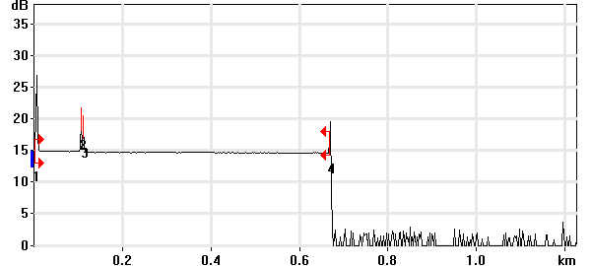

Event Table
No. | Loc. (km)/Length | Event Type | Loss (dB) | Refl. (dB) | Att. (dB/km) | Cumul. (dB)
1 | 0.0000 | Launch Level |  | -40.2 |  | 0.000
 | (0.1041 km) | Fiber Section | 0.086 |  | 0.828 | 0.086
2 | 0.1041 | Reflective Event | 0.032 | -57.3 |  | 0.118
 | (0.0051 km) | Fiber Section | 0.001 |  | 0.100 | 0.119
3 | 0.1092 | Reflective Event | 0.099 | -59.7 |  | 0.218
 | (0.5587 km) | Fiber Section | 0.099 |  | 0.178 | 0.317
4 | 0.6679 | Reflective Event | - - | -55.9 |  | 0.317

Pass/Fail Thresholds
Splice Loss: | 1.000 dB | Span Loss: | 45.000 dB
Connector Loss: | 1.000 dB | Span Length: | 0.000 m
Reflectance: | -40.0 dB | Span ORL: | 15.00 dB
Fiber section attenuation: | 0.400 dB/km

Test and Cable Setup
Wavelength: | 1550 nm (9 µm) | Acq. Time: | 30 s
File name: | MARS SM-17B.trc | IOR: | 1.468325
File Type: | Main | Backscatter: | -81.87 dB
OTDR Model: | FTB-720-23B-EA | Helix Factor: | 0.00 %
Serial No.: | 626283 | Splice Loss Detection: | 0.020 dB
Software Version: | OTDR - iOLM 2.1 | Reflectance Detection: | -72.0 dB
Distance: | 1.2500 km | End-of-Fiber Detection: | 5.000 dB
Pulse Width: | 10 ns

Comments

OTDR Report

Job Info
Job ID: |  | Operator A:
Company: |  | Operator B:
Customer: |  | File name: | MARS SM-18A.trc
Test date and time: | 2020-11-12 at 19:11 (GMT-5:00)

Cable Info
Fiber ID: | MARS SM-18A | Cable ID:
Location A: |  | Location B:

Wavelength: 1310 nm

Link Measurements
Span loss: | 0.567 dB | Average splice loss: | - - -
Span length: | 667.835 m | Span ORL: | 37.08 dB
Average loss: | 0.849 dB/km

OTDR Trace
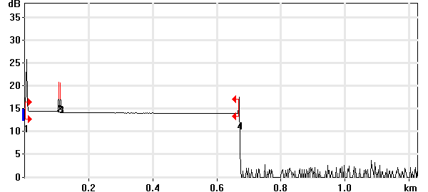

Event Table
No. | Loc. (km)/Length | Event Type | Loss (dB) | Refl. (dB) | Att. (dB/km) | Cumul. (dB)
1 | 0.0000 | Launch Level |  | -38.8 |  | 0.000
 | (0.1040 km) | Fiber Section | 0.089 |  | 0.855 | 0.089
2 | 0.1040 | Reflective Event | 0.054 | -56.1 |  | 0.143
 | (0.0051 km) | Fiber Section | 0.002 |  | 0.455 | 0.145
3 | 0.1092 | Reflective Event | 0.209 | -55.9 |  | 0.354
 | (0.5587 km) | Fiber Section | 0.213 |  | 0.381 | 0.567
4 | 0.6678 | Reflective Event | - - | -55.8 |  | 0.567

Pass/Fail Thresholds
Splice Loss: | 1.000 dB | Span Loss: | 45.000 dB
Connector Loss: | 1.000 dB | Span Length: | 0.000 m
Reflectance: | -40.0 dB | Span ORL: | 15.00 dB
Fiber section attenuation: | 0.400 dB/km

Test and Cable Setup
Wavelength: | 1310 nm (9 µm) | Acq. Time: | 30 s
File name: | MARS SM-18A.trc | IOR: | 1.467700
File Type: | Main | Backscatter: | -79.44 dB
OTDR Model: | FTB-720-23B-EA | Helix Factor: | 0.00 %
Serial No.: | 626283 | Splice Loss Detection: | 0.020 dB
Software Version: | OTDR - iOLM 2.1 | Reflectance Detection: | -72.0 dB
Distance: | 1.2500 km | End-of-Fiber Detection: | 5.000 dB
Pulse Width: | 10 ns

Comments

Wavelength: 1550 nm

Link Measurements
Span loss: | 0.458 dB | Average splice loss: | - - -
Span length: | 667.869 m | Span ORL: | 38.61 dB
Average loss: | 0.685 dB/km

OTDR Trace
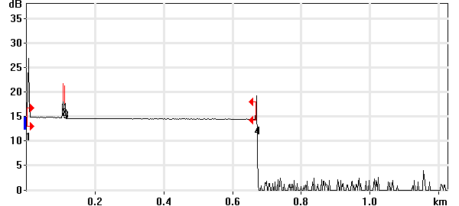

Event Table
No. | Loc. (km)/Length | Event Type | Loss (dB) | Refl. (dB) | Att. (dB/km) | Cumul. (dB)
1 | 0.0000 | Launch Level |  | -40.2 |  | 0.000
 | (0.1041 km) | Fiber Section | 0.085 |  | 0.815 | 0.085
2 | 0.1041 | Reflective Event | 0.034 | -57.3 |  | 0.119
 | (0.0050 km) | Fiber Section | 0.008 |  | 1.500 | 0.126
3 | 0.1091 | Reflective Event | 0.222 | -57.4 |  | 0.348
 | (0.5588 km) | Fiber Section | 0.109 |  | 0.196 | 0.458
4 | 0.6679 | Reflective Event | - - | -55.8 |  | 0.458

Pass/Fail Thresholds
Splice Loss: | 1.000 dB | Span Loss: | 45.000 dB
Connector Loss: | 1.000 dB | Span Length: | 0.000 m
Reflectance: | -40.0 dB | Span ORL: | 15.00 dB
Fiber section attenuation: | 0.400 dB/km

Test and Cable Setup
Wavelength: | 1550 nm (9 µm) | Acq. Time: | 30 s
File name: | MARS SM-18A.trc | IOR: | 1.468325
File Type: | Main | Backscatter: | -81.87 dB
OTDR Model: | FTB-720-23B-EA | Helix Factor: | 0.00 %
Serial No.: | 626283 | Splice Loss Detection: | 0.020 dB
Software Version: | OTDR - iOLM 2.1 | Reflectance Detection: | -72.0 dB
Distance: | 1.2500 km | End-of-Fiber Detection: | 5.000 dB
Pulse Width: | 10 ns

Comments

OTDR Report

Job Info
Job ID: |  | Operator A:
Company: |  | Operator B:
Customer: |  | File name: | MARS SM-18B.trc
Test date and time: | 2020-11-12 at 19:17 (GMT-5:00)

Cable Info
Fiber ID: | MARS SM-18B | Cable ID:
Location A: |  | Location B:

Wavelength: 1310 nm

Link Measurements
Span loss: | 0.628 dB | Average splice loss: | - - -
Span length: | 667.914 m | Span ORL: | 37.20 dB
Average loss: | 0.940 dB/km

OTDR Trace
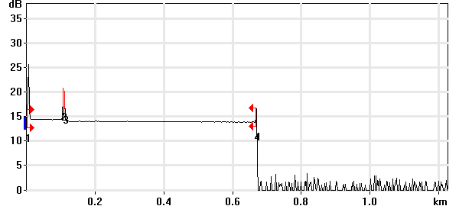

Event Table
No. | Loc. (km)/Length | Event Type | Loss (dB) | Refl. (dB) | Att. (dB/km) | Cumul. (dB)
1 | 0.0000 | Launch Level |  | -38.8 |  | 0.000
 | (0.1040 km) | Fiber Section | 0.097 |  | 0.929 | 0.097
2 | 0.1040 | Reflective Event | 0.058 | -56.1 |  | 0.154
 | (0.0051 km) | Fiber Section | 0.009 |  | 1.700 | 0.163
3 | 0.1092 | Reflective Event | 0.282 | -57.2 |  | 0.445
 | (0.5588 km) | Fiber Section | 0.182 |  | 0.327 | 0.628
4 | 0.6679 | Reflective Event | - - | -57.6 |  | 0.628

Pass/Fail Thresholds
Splice Loss: | 1.000 dB | Span Loss: | 45.000 dB
Connector Loss: | 1.000 dB | Span Length: | 0.000 m
Reflectance: | -40.0 dB | Span ORL: | 15.00 dB
Fiber section attenuation: | 0.400 dB/km

Test and Cable Setup
Wavelength: | 1310 nm (9 µm) | Acq. Time: | 30 s
File name: | MARS SM-18B.trc | IOR: | 1.467700
File Type: | Main | Backscatter: | -79.44 dB
OTDR Model: | FTB-720-23B-EA | Helix Factor: | 0.00 %
Serial No.: | 626283 | Splice Loss Detection: | 0.020 dB
Software Version: | OTDR - iOLM 2.1 | Reflectance Detection: | -72.0 dB
Distance: | 1.2500 km | End-of-Fiber Detection: | 5.000 dB
Pulse Width: | 10 ns

Comments

Wavelength: 1550 nm

Link Measurements
Span loss: | 0.452 dB | Average splice loss: | - - -
Span length: | 667.311 m | Span ORL: | 38.71 dB
Average loss: | 0.678 dB/km

OTDR Trace
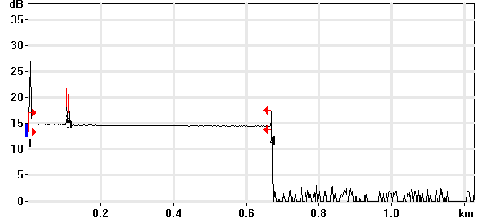

Event Table
No. | Loc. (km)/Length | Event Type | Loss (dB) | Refl. (dB) | Att. (dB/km) | Cumul. (dB)
1 | 0.0000 | Launch Level |  | -40.3 |  | 0.000
 | (0.1042 km) | Fiber Section | 0.101 |  | 0.965 | 0.101
2 | 0.1042 | Reflective Event | 0.014 | -57.4 |  | 0.114
 | (0.0050 km) | Fiber Section | 0.008 |  | 1.500 | 0.122
3 | 0.1092 | Reflective Event | 0.158 | -59.3 |  | 0.280
 | (0.5581 km) | Fiber Section | 0.172 |  | 0.309 | 0.452
4 | 0.6673 | Reflective Event | - - | -60.3 |  | 0.452

Pass/Fail Thresholds
Splice Loss: | 1.000 dB | Span Loss: | 45.000 dB
Connector Loss: | 1.000 dB | Span Length: | 0.000 m
Reflectance: | -40.0 dB | Span ORL: | 15.00 dB
Fiber section attenuation: | 0.400 dB/km

Test and Cable Setup
Wavelength: | 1550 nm (9 µm) | Acq. Time: | 30 s
File name: | MARS SM-18B.trc | IOR: | 1.468325
File Type: | Main | Backscatter: | -81.87 dB
OTDR Model: | FTB-720-23B-EA | Helix Factor: | 0.00 %
Serial No.: | 626283 | Splice Loss Detection: | 0.020 dB
Software Version: | OTDR - iOLM 2.1 | Reflectance Detection: | -72.0 dB
Distance: | 1.2500 km | End-of-Fiber Detection: | 5.000 dB
Pulse Width: | 10 ns

Comments

OTDR Report

Job Info
Job ID: |  | Operator A:
Company: |  | Operator B:
Customer: |  | File name: | MARS SM-19A.trc
Test date and time: | 2020-11-12 at 10:57 (GMT-5:00)

Cable Info
Fiber ID: | MARS SM-19A | Cable ID:
Location A: |  | Location B:

Wavelength: 1310 nm

Link Measurements
Span loss: | 0.492 dB | Average splice loss: | - - -
Span length: | 667.755 m | Span ORL: | 35.59 dB
Average loss: | 0.736 dB/km

OTDR Trace
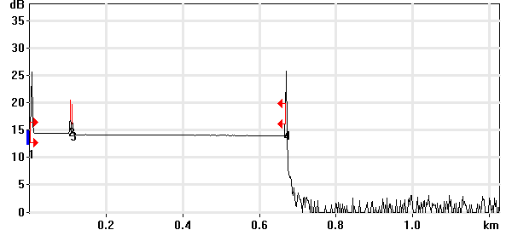

Event Table
No. | Loc. (km)/Length | Event Type | Loss (dB) | Refl. (dB) | Att. (dB/km) | Cumul. (dB)
1 | 0.0000 | Launch Level |  | -38.8 |  | 0.000
 | (0.1041 km) | Fiber Section | 0.080 |  | 0.768 | 0.080
2 | 0.1041 | Reflective Event | 0.051 | -56.7 |  | 0.131
 | (0.0050 km) | Fiber Section | 0.009 |  | 1.700 | 0.139
3 | 0.1092 | Reflective Event | 0.159 | -58.1 |  | 0.298
 | (0.5586 km) | Fiber Section | 0.194 |  | 0.347 | 0.492
4 | 0.6678 | Reflective Event | - - | -39.6 |  | 0.492

Pass/Fail Thresholds
Splice Loss: | 1.000 dB | Span Loss: | 45.000 dB
Connector Loss: | 1.000 dB | Span Length: | 0.000 m
Reflectance: | -40.0 dB | Span ORL: | 15.00 dB
Fiber section attenuation: | 0.400 dB/km

Test and Cable Setup
Wavelength: | 1310 nm (9 µm) | Acq. Time: | 30 s
File name: | MARS SM-19A.trc | IOR: | 1.467700
File Type: | Main | Backscatter: | -79.44 dB
OTDR Model: | FTB-720-23B-EA | Helix Factor: | 0.00 %
Serial No.: | 626283 | Splice Loss Detection: | 0.020 dB
Software Version: | OTDR - iOLM 2.1 | Reflectance Detection: | -72.0 dB
Distance: | 1.2500 km | End-of-Fiber Detection: | 5.000 dB
Pulse Width: | 10 ns

Comments

Wavelength: 1550 nm

Link Measurements
Span loss: | 0.310 dB | Average splice loss: | - - -
Span length: | 666.833 m | Span ORL: | 31.82 dB
Average loss: | 0.464 dB/km

OTDR Trace
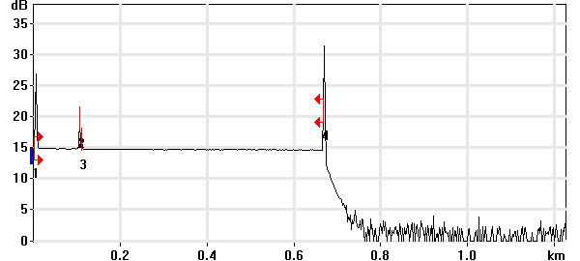

Event Table
No. | Loc. (km)/Length | Event Type | Loss (dB) | Refl. (dB) | Att. (dB/km) | Cumul. (dB)
1 | 0.0000 | Launch Level |  | -40.3 |  | 0.000
 | (0.1042 km) | Fiber Section | 0.097 |  | 0.935 | 0.097
2 | 0.1042 | Reflective Event | 0.046 | -57.8 |  | 0.144
 | (0.0052 km) | Fiber Section | 0.008 |  | 1.500 | 0.152
3 | 0.1093 | Reflective Event | 0.073 | -67.2 |  | 0.225
 | (0.5575 km) | Fiber Section | 0.085 |  | 0.153 | 0.310
4 | 0.6668 | Reflective Event | - - | -32.3 |  | 0.310

Pass/Fail Thresholds
Splice Loss: | 1.000 dB | Span Loss: | 45.000 dB
Connector Loss: | 1.000 dB | Span Length: | 0.000 m
Reflectance: | -40.0 dB | Span ORL: | 15.00 dB
Fiber section attenuation: | 0.400 dB/km

Test and Cable Setup
Wavelength: | 1550 nm (9 µm) | Acq. Time: | 30 s
File name: | MARS SM-19A.trc | IOR: | 1.468325
File Type: | Main | Backscatter: | -81.87 dB
OTDR Model: | FTB-720-23B-EA | Helix Factor: | 0.00 %
Serial No.: | 626283 | Splice Loss Detection: | 0.020 dB
Software Version: | OTDR - iOLM 2.1 | Reflectance Detection: | -72.0 dB
Distance: | 1.2500 km | End-of-Fiber Detection: | 5.000 dB
Pulse Width: | 10 ns

Comments

OTDR Report

Job Info
Job ID: |  | Operator A:
Company: |  | Operator B:
Customer: |  | File name: | MARS SM-19B.trc
Test date and time: | 2020-11-12 at 11:03 (GMT-5:00)

Cable Info
Fiber ID: | MARS SM-19B | Cable ID:
Location A: |  | Location B:

Wavelength: 1310 nm

Link Measurements
Span loss: | 0.907 dB | Average splice loss: | - - -
Span length: | 667.755 m | Span ORL: | 37.31 dB
Average loss: | 1.358 dB/km

OTDR Trace
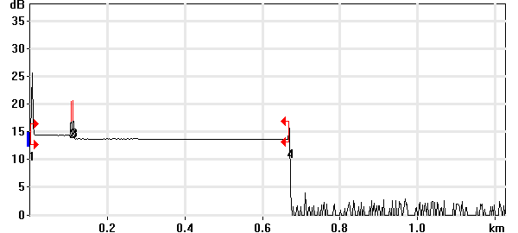

Event Table
No. | Loc. (km)/Length | Event Type | Loss (dB) | Refl. (dB) | Att. (dB/km) | Cumul. (dB)
1 | 0.0000 | Launch Level |  | -38.8 |  | 0.000
 | (0.1041 km) | Fiber Section | 0.116 |  | 1.113 | 0.116
2 | 0.1041 | Reflective Event | 0.065 | -56.6 |  | 0.180
 | (0.0050 km) | Fiber Section | 0.009 |  | 1.700 | 0.189
3 | 0.1092 | Reflective Event | 0.579 | -55.5 |  | 0.767
 | (0.5586 km) | Fiber Section | 0.140 |  | 0.250 | 0.907
4 | 0.6678 | Reflective Event | - - | -58.1 |  | 0.907

Pass/Fail Thresholds
Splice Loss: | 1.000 dB | Span Loss: | 45.000 dB
Connector Loss: | 1.000 dB | Span Length: | 0.000 m
Reflectance: | -40.0 dB | Span ORL: | 15.00 dB
Fiber section attenuation: | 0.400 dB/km

Test and Cable Setup
Wavelength: | 1310 nm (9 µm) | Acq. Time: | 30 s
File name: | MARS SM-19B.trc | IOR: | 1.467700
File Type: | Main | Backscatter: | -79.44 dB
OTDR Model: | FTB-720-23B-EA | Helix Factor: | 0.00 %
Serial No.: | 626283 | Splice Loss Detection: | 0.020 dB
Software Version: | OTDR - iOLM 2.1 | Reflectance Detection: | -72.0 dB
Distance: | 1.2500 km | End-of-Fiber Detection: | 5.000 dB
Pulse Width: | 10 ns

Comments

Wavelength: 1550 nm

Link Measurements
Span loss: | 0.649 dB | Average splice loss: | - - -
Span length: | 667.790 m | Span ORL: | 38.78 dB
Average loss: | 0.971 dB/km

OTDR Trace
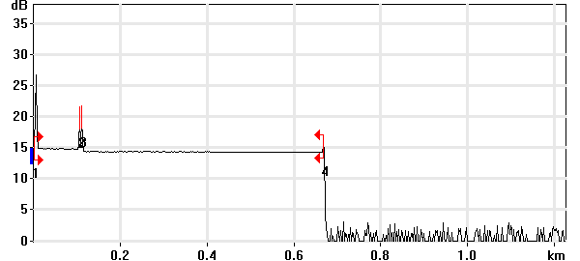

Event Table
No. | Loc. (km)/Length | Event Type | Loss (dB) | Refl. (dB) | Att. (dB/km) | Cumul. (dB)
1 | 0.0000 | Launch Level |  | -40.2 |  | 0.000
 | (0.1041 km) | Fiber Section | 0.092 |  | 0.884 | 0.092
2 | 0.1041 | Reflective Event | 0.061 | -57.8 |  | 0.153
 | (0.0050 km) | Fiber Section | 0.001 |  | 0.100 | 0.154
3 | 0.1091 | Reflective Event | 0.372 | -56.2 |  | 0.526
 | (0.5587 km) | Fiber Section | 0.122 |  | 0.219 | 0.649
4 | 0.6678 | Reflective Event | - - | -63.4 |  | 0.649

Pass/Fail Thresholds
Splice Loss: | 1.000 dB | Span Loss: | 45.000 dB
Connector Loss: | 1.000 dB | Span Length: | 0.000 m
Reflectance: | -40.0 dB | Span ORL: | 15.00 dB
Fiber section attenuation: | 0.400 dB/km

Test and Cable Setup
Wavelength: | 1550 nm (9 µm) | Acq. Time: | 30 s
File name: | MARS SM-19B.trc | IOR: | 1.468325
File Type: | Main | Backscatter: | -81.87 dB
OTDR Model: | FTB-720-23B-EA | Helix Factor: | 0.00 %
Serial No.: | 626283 | Splice Loss Detection: | 0.020 dB
Software Version: | OTDR - iOLM 2.1 | Reflectance Detection: | -72.0 dB
Distance: | 1.2500 km | End-of-Fiber Detection: | 5.000 dB
Pulse Width: | 10 ns

Comments

OTDR Report

Job Info
Job ID: |  | Operator A:
Company: |  | Operator B:
Customer: |  | File name: | MARS SM-20A.trc
Test date and time: | 2020-11-12 at 11:06 (GMT-5:00)

Cable Info
Fiber ID: | MARS SM-20A | Cable ID:
Location A: |  | Location B:

Wavelength: 1310 nm

Link Measurements
Span loss: | 0.482 dB | Average splice loss: | - - -
Span length: | 667.515 m | Span ORL: | 36.75 dB
Average loss: | 0.722 dB/km

OTDR Trace
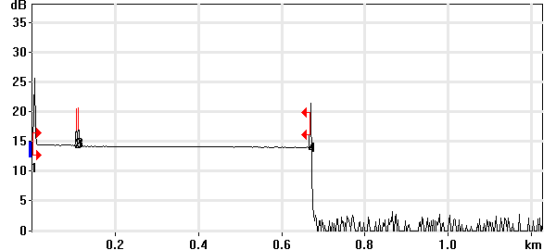

Event Table
No. | Loc. (km)/Length | Event Type | Loss (dB) | Refl. (dB) | Att. (dB/km) | Cumul. (dB)
1 | 0.0000 | Launch Level |  | -38.8 |  | 0.000
 | (0.1040 km) | Fiber Section | 0.113 |  | 1.083 | 0.113
2 | 0.1040 | Reflective Event | 0.045 | -56.6 |  | 0.158
 | (0.0050 km) | Fiber Section | 0.009 |  | 1.700 | 0.167
3 | 0.1091 | Reflective Event | 0.131 | -55.6 |  | 0.298
 | (0.5584 km) | Fiber Section | 0.184 |  | 0.329 | 0.482
4 | 0.6675 | Reflective Event | - - | -46.7 |  | 0.482

Pass/Fail Thresholds
Splice Loss: | 1.000 dB | Span Loss: | 45.000 dB
Connector Loss: | 1.000 dB | Span Length: | 0.000 m
Reflectance: | -40.0 dB | Span ORL: | 15.00 dB
Fiber section attenuation: | 0.400 dB/km

Test and Cable Setup
Wavelength: | 1310 nm (9 µm) | Acq. Time: | 30 s
File name: | MARS SM-20A.trc | IOR: | 1.467700
File Type: | Main | Backscatter: | -79.44 dB
OTDR Model: | FTB-720-23B-EA | Helix Factor: | 0.00 %
Serial No.: | 626283 | Splice Loss Detection: | 0.020 dB
Software Version: | OTDR - iOLM 2.1 | Reflectance Detection: | -72.0 dB
Distance: | 1.2500 km | End-of-Fiber Detection: | 5.000 dB
Pulse Width: | 10 ns

Comments

Wavelength: 1550 nm

Link Measurements
Span loss: | 0.457 dB | Average splice loss: | - - -
Span length: | 667.471 m | Span ORL: | 37.97 dB
Average loss: | 0.684 dB/km

OTDR Trace
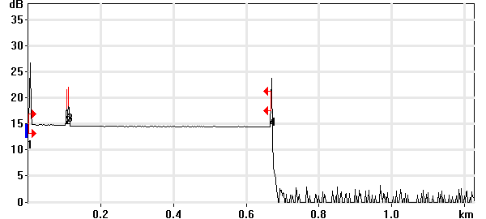

Event Table
No. | Loc. (km)/Length | Event Type | Loss (dB) | Refl. (dB) | Att. (dB/km) | Cumul. (dB)
1 | 0.0000 | Launch Level |  | -40.2 |  | 0.000
 | (0.1041 km) | Fiber Section | 0.096 |  | 0.924 | 0.096
2 | 0.1041 | Reflective Event | 0.049 | -57.9 |  | 0.145
 | (0.0050 km) | Fiber Section | 0.008 |  | 1.500 | 0.152
3 | 0.1091 | Reflective Event | 0.198 | -55.7 |  | 0.351
 | (0.5584 km) | Fiber Section | 0.106 |  | 0.190 | 0.457
4 | 0.6675 | Reflective Event | - - | -45.2 |  | 0.457

Pass/Fail Thresholds
Splice Loss: | 1.000 dB | Span Loss: | 45.000 dB
Connector Loss: | 1.000 dB | Span Length: | 0.000 m
Reflectance: | -40.0 dB | Span ORL: | 15.00 dB
Fiber section attenuation: | 0.400 dB/km

Test and Cable Setup
Wavelength: | 1550 nm (9 µm) | Acq. Time: | 30 s
File name: | MARS SM-20A.trc | IOR: | 1.468325
File Type: | Main | Backscatter: | -81.87 dB
OTDR Model: | FTB-720-23B-EA | Helix Factor: | 0.00 %
Serial No.: | 626283 | Splice Loss Detection: | 0.020 dB
Software Version: | OTDR - iOLM 2.1 | Reflectance Detection: | -72.0 dB
Distance: | 1.2500 km | End-of-Fiber Detection: | 5.000 dB
Pulse Width: | 10 ns

Comments

OTDR Report

Job Info
Job ID: |  | Operator A:
Company: |  | Operator B:
Customer: |  | File name: | MARS SM-20B.trc
Test date and time: | 2020-11-12 at 11:10 (GMT-5:00)

Cable Info
Fiber ID: | MARS SM-20B | Cable ID:
Location A: |  | Location B:

Wavelength: 1310 nm

Link Measurements
Span loss: | 0.430 dB | Average splice loss: | - - -
Span length: | 667.994 m | Span ORL: | 37.01 dB
Average loss: | 0.644 dB/km

OTDR Trace
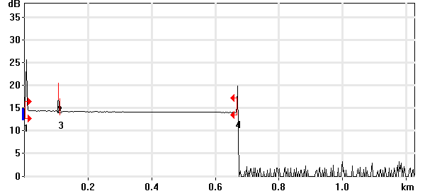

Event Table
No. | Loc. (km)/Length | Event Type | Loss (dB) | Refl. (dB) | Att. (dB/km) | Cumul. (dB)
1 | 0.0000 | Launch Level |  | -38.8 |  | 0.000
 | (0.1040 km) | Fiber Section | 0.106 |  | 1.019 | 0.106
2 | 0.1040 | Reflective Event | 0.027 | -56.6 |  | 0.133
 | (0.0053 km) | Fiber Section | 0.009 |  | 1.700 | 0.142
3 | 0.1093 | Reflective Event | 0.094 | -67.7 |  | 0.236
 | (0.5587 km) | Fiber Section | 0.194 |  | 0.347 | 0.430
4 | 0.6680 | Reflective Event | - - | -52.2 |  | 0.430

Pass/Fail Thresholds
Splice Loss: | 1.000 dB | Span Loss: | 45.000 dB
Connector Loss: | 1.000 dB | Span Length: | 0.000 m
Reflectance: | -40.0 dB | Span ORL: | 15.00 dB
Fiber section attenuation: | 0.400 dB/km

Test and Cable Setup
Wavelength: | 1310 nm (9 µm) | Acq. Time: | 30 s
File name: | MARS SM-20B.trc | IOR: | 1.467700
File Type: | Main | Backscatter: | -79.44 dB
OTDR Model: | FTB-720-23B-EA | Helix Factor: | 0.00 %
Serial No.: | 626283 | Splice Loss Detection: | 0.020 dB
Software Version: | OTDR - iOLM 2.1 | Reflectance Detection: | -72.0 dB
Distance: | 1.2500 km | End-of-Fiber Detection: | 5.000 dB
Pulse Width: | 10 ns

Comments

Wavelength: 1550 nm

Link Measurements
Span loss: | 0.432 dB | Average splice loss: | 0.090 dB
Span length: | 668.029 m | Span ORL: | 38.69 dB
Average loss: | 0.646 dB/km

OTDR Trace
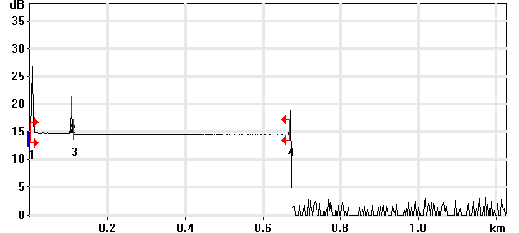

Event Table
No. | Loc. (km)/Length | Event Type | Loss (dB) | Refl. (dB) | Att. (dB/km) | Cumul. (dB)
1 | 0.0000 | Launch Level |  | -40.2 |  | 0.000
 | (0.1041 km) | Fiber Section | 0.109 |  | 1.048 | 0.109
2 | 0.1041 | Reflective Event | 0.090 | -57.9 |  | 0.199
 | (0.0053 km) | Fiber Section | 0.008 |  | 1.500 | 0.207
3 | 0.1093 | Non-Reflective Event | 0.090 |  |  | 0.297
 | (0.5587 km) | Fiber Section | 0.135 |  | 0.242 | 0.432
4 | 0.6680 | Reflective Event | - - | -58.2 |  | 0.432

Pass/Fail Thresholds
Splice Loss: | 1.000 dB | Span Loss: | 45.000 dB
Connector Loss: | 1.000 dB | Span Length: | 0.000 m
Reflectance: | -40.0 dB | Span ORL: | 15.00 dB
Fiber section attenuation: | 0.400 dB/km

Test and Cable Setup
Wavelength: | 1550 nm (9 µm) | Acq. Time: | 30 s
File name: | MARS SM-20B.trc | IOR: | 1.468325
File Type: | Main | Backscatter: | -81.87 dB
OTDR Model: | FTB-720-23B-EA | Helix Factor: | 0.00 %
Serial No.: | 626283 | Splice Loss Detection: | 0.020 dB
Software Version: | OTDR - iOLM 2.1 | Reflectance Detection: | -72.0 dB
Distance: | 1.2500 km | End-of-Fiber Detection: | 5.000 dB
Pulse Width: | 10 ns

Comments

OTDR Report

Job Info
Job ID: |  | Operator A:
Company: |  | Operator B:
Customer: |  | File name: | MARS SM-21A.trc
Test date and time: | 2020-11-12 at 11:15 (GMT-5:00)

Cable Info
Fiber ID: | MARS SM-21A | Cable ID:
Location A: |  | Location B:

Wavelength: 1310 nm

Link Measurements
Span loss: | 1.381 dB | Average splice loss: | - - -
Span length: | 667.914 m | Span ORL: | 37.35 dB
Average loss: | 2.068 dB/km

OTDR Trace
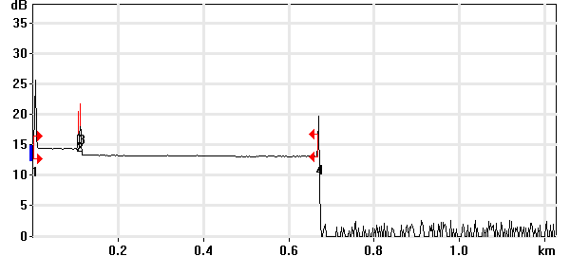

Event Table
No. | Loc. (km)/Length | Event Type | Loss (dB) | Refl. (dB) | Att. (dB/km) | Cumul. (dB)
1 | 0.0000 | Launch Level |  | -38.8 |  | 0.000
 | (0.1041 km) | Fiber Section | 0.097 |  | 0.932 | 0.097
2 | 0.1041 | Reflective Event | 0.030 | -56.7 |  | 0.127
 | (0.0050 km) | Fiber Section | 0.001 |  | 0.250 | 0.129
3 | 0.1092 | Reflective Event | 1.038 | -53.1 |  | 1.167
 | (0.5588 km) | Fiber Section | 0.214 |  | 0.384 | 1.381
4 | 0.6679 | Reflective Event | - - | -50.2 |  | 1.381

Pass/Fail Thresholds
Splice Loss: | 1.000 dB | Span Loss: | 45.000 dB
Connector Loss: | 1.000 dB | Span Length: | 0.000 m
Reflectance: | -40.0 dB | Span ORL: | 15.00 dB
Fiber section attenuation: | 0.400 dB/km

Test and Cable Setup
Wavelength: | 1310 nm (9 µm) | Acq. Time: | 30 s
File name: | MARS SM-21A.trc | IOR: | 1.467700
File Type: | Main | Backscatter: | -79.44 dB
OTDR Model: | FTB-720-23B-EA | Helix Factor: | 0.00 %
Serial No.: | 626283 | Splice Loss Detection: | 0.020 dB
Software Version: | OTDR - iOLM 2.1 | Reflectance Detection: | -72.0 dB
Distance: | 1.2500 km | End-of-Fiber Detection: | 5.000 dB
Pulse Width: | 10 ns

Comments

Wavelength: 1550 nm

Link Measurements
Span loss: | 0.900 dB | Average splice loss: | 0.633 dB
Span length: | 667.869 m | Span ORL: | 35.89 dB
Average loss: | 1.348 dB/km

OTDR Trace
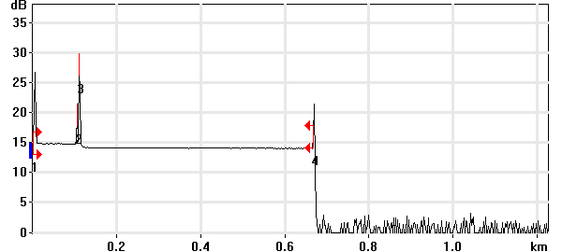

Event Table
No. | Loc. (km)/Length | Event Type | Loss (dB) | Refl. (dB) | Att. (dB/km) | Cumul. (dB)
1 | 0.0000 | Launch Level |  | -40.2 |  | 0.000
 | (0.1041 km) | Fiber Section | 0.118 |  | 1.135 | 0.118
2 | 0.1041 | Reflective Event | 0.028 | -57.9 |  | 0.146
 | (0.0049 km) | Fiber Section | 0.000 |  | 0.100 | 0.146
3 | 0.1090 | Non-Reflective Event | 0.633 |  |  | 0.779
 | (0.5589 km) | Fiber Section | 0.121 |  | 0.217 | 0.900
4 | 0.6679 | Reflective Event | - - | -51.2 |  | 0.900

Pass/Fail Thresholds
Splice Loss: | 1.000 dB | Span Loss: | 45.000 dB
Connector Loss: | 1.000 dB | Span Length: | 0.000 m
Reflectance: | -40.0 dB | Span ORL: | 15.00 dB
Fiber section attenuation: | 0.400 dB/km

Test and Cable Setup
Wavelength: | 1550 nm (9 µm) | Acq. Time: | 30 s
File name: | MARS SM-21A.trc | IOR: | 1.468325
File Type: | Main | Backscatter: | -81.87 dB
OTDR Model: | FTB-720-23B-EA | Helix Factor: | 0.00 %
Serial No.: | 626283 | Splice Loss Detection: | 0.020 dB
Software Version: | OTDR - iOLM 2.1 | Reflectance Detection: | -72.0 dB
Distance: | 1.2500 km | End-of-Fiber Detection: | 5.000 dB
Pulse Width: | 10 ns

Comments

OTDR Report

Job Info
Job ID: |  | Operator A:
Company: |  | Operator B:
Customer: |  | File name: | MARS SM-21B.trc
Test date and time: | 2020-11-12 at 11:32 (GMT-5:00)

Cable Info
Fiber ID: | MARS SM-21B | Cable ID:
Location A: |  | Location B:

Wavelength: 1310 nm

Link Measurements
Span loss: | 0.720 dB | Average splice loss: | - - -
Span length: | 668.074 m | Span ORL: | 37.24 dB
Average loss: | 1.078 dB/km

OTDR Trace
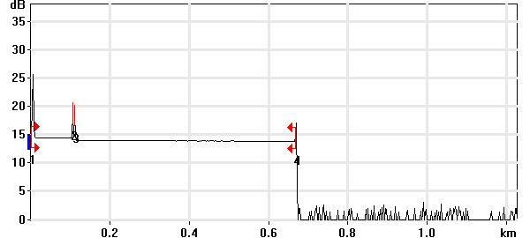

Event Table
No. | Loc. (km)/Length | Event Type | Loss (dB) | Refl. (dB) | Att. (dB/km) | Cumul. (dB)
1 | 0.0000 | Launch Level |  | -38.9 |  | 0.000
 | (0.1041 km) | Fiber Section | 0.109 |  | 1.051 | 0.109
2 | 0.1041 | Reflective Event | 0.043 | -56.6 |  | 0.152
 | (0.0050 km) | Fiber Section | 0.009 |  | 1.700 | 0.161
3 | 0.1092 | Reflective Event | 0.339 | -56.8 |  | 0.500
 | (0.5589 km) | Fiber Section | 0.220 |  | 0.394 | 0.720
4 | 0.6681 | Reflective Event | - - | -57.8 |  | 0.720

Pass/Fail Thresholds
Splice Loss: | 1.000 dB | Span Loss: | 45.000 dB
Connector Loss: | 1.000 dB | Span Length: | 0.000 m
Reflectance: | -40.0 dB | Span ORL: | 15.00 dB
Fiber section attenuation: | 0.400 dB/km

Test and Cable Setup
Wavelength: | 1310 nm (9 µm) | Acq. Time: | 30 s
File name: | MARS SM-21B.trc | IOR: | 1.467700
File Type: | Main | Backscatter: | -79.44 dB
OTDR Model: | FTB-720-23B-EA | Helix Factor: | 0.00 %
Serial No.: | 626283 | Splice Loss Detection: | 0.020 dB
Software Version: | OTDR - iOLM 2.1 | Reflectance Detection: | -72.0 dB
Distance: | 1.2500 km | End-of-Fiber Detection: | 5.000 dB
Pulse Width: | 10 ns

Comments

Wavelength: 1550 nm

Link Measurements
Span loss: | 0.570 dB | Average splice loss: | - - -
Span length: | 667.949 m | Span ORL: | 38.73 dB
Average loss: | 0.854 dB/km

OTDR Trace
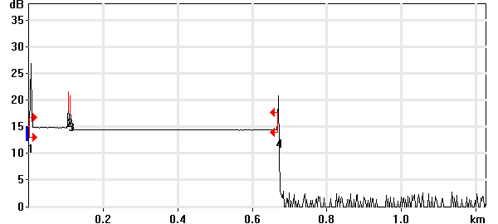

Event Table
No. | Loc. (km)/Length | Event Type | Loss (dB) | Refl. (dB) | Att. (dB/km) | Cumul. (dB)
1 | 0.0000 | Launch Level |  | -40.3 |  | 0.000
 | (0.1041 km) | Fiber Section | 0.098 |  | 0.943 | 0.098
2 | 0.1041 | Reflective Event | 0.037 | -57.9 |  | 0.135
 | (0.0051 km) | Fiber Section | 0.008 |  | 1.500 | 0.143
3 | 0.1092 | Reflective Event | 0.344 | -59.0 |  | 0.487
 | (0.5588 km) | Fiber Section | 0.083 |  | 0.149 | 0.570
4 | 0.6680 | Reflective Event | - - | -53.6 |  | 0.570

Pass/Fail Thresholds
Splice Loss: | 1.000 dB | Span Loss: | 45.000 dB
Connector Loss: | 1.000 dB | Span Length: | 0.000 m
Reflectance: | -40.0 dB | Span ORL: | 15.00 dB
Fiber section attenuation: | 0.400 dB/km

Test and Cable Setup
Wavelength: | 1550 nm (9 µm) | Acq. Time: | 30 s
File name: | MARS SM-21B.trc | IOR: | 1.468325
File Type: | Main | Backscatter: | -81.87 dB
OTDR Model: | FTB-720-23B-EA | Helix Factor: | 0.00 %
Serial No.: | 626283 | Splice Loss Detection: | 0.020 dB
Software Version: | OTDR - iOLM 2.1 | Reflectance Detection: | -72.0 dB
Distance: | 1.2500 km | End-of-Fiber Detection: | 5.000 dB
Pulse Width: | 10 ns

Comments

OTDR Report

Job Info
Job ID: |  | Operator A:
Company: |  | Operator B:
Customer: |  | File name: | MARS SM-22A.trc
Test date and time: | 2020-11-12 at 11:37 (GMT-5:00)

Cable Info
Fiber ID: | MARS SM-22A | Cable ID:
Location A: |  | Location B:

Wavelength: 1310 nm

Link Measurements
Span loss: | 0.570 dB | Average splice loss: | - - -
Span length: | 668.074 m | Span ORL: | 37.13 dB
Average loss: | 0.853 dB/km

OTDR Trace
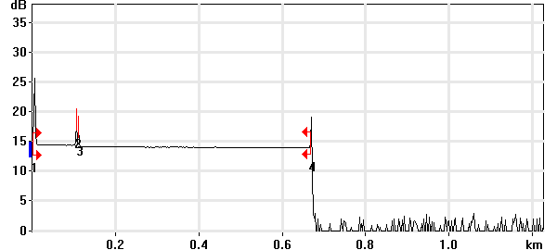

Event Table
No. | Loc. (km)/Length | Event Type | Loss (dB) | Refl. (dB) | Att. (dB/km) | Cumul. (dB)
1 | 0.0000 | Launch Level |  | -38.8 |  | 0.000
 | (0.1040 km) | Fiber Section | 0.110 |  | 1.058 | 0.110
2 | 0.1040 | Reflective Event | 0.063 | -56.6 |  | 0.173
 | (0.0052 km) | Fiber Section | 0.009 |  | 1.700 | 0.182
3 | 0.1092 | Reflective Event | 0.196 | -59.5 |  | 0.378
 | (0.5588 km) | Fiber Section | 0.192 |  | 0.344 | 0.570
4 | 0.6681 | Reflective Event | - - | -54.2 |  | 0.570

Pass/Fail Thresholds
Splice Loss: | 1.000 dB | Span Loss: | 45.000 dB
Connector Loss: | 1.000 dB | Span Length: | 0.000 m
Reflectance: | -40.0 dB | Span ORL: | 15.00 dB
Fiber section attenuation: | 0.400 dB/km

Test and Cable Setup
Wavelength: | 1310 nm (9 µm) | Acq. Time: | 30 s
File name: | MARS SM-22A.trc | IOR: | 1.467700
File Type: | Main | Backscatter: | -79.44 dB
OTDR Model: | FTB-720-23B-EA | Helix Factor: | 0.00 %
Serial No.: | 626283 | Splice Loss Detection: | 0.020 dB
Software Version: | OTDR - iOLM 2.1 | Reflectance Detection: | -72.0 dB
Distance: | 1.2500 km | End-of-Fiber Detection: | 5.000 dB
Pulse Width: | 10 ns

Comments

Wavelength: 1550 nm

Link Measurements
Span loss: | 0.641 dB | Average splice loss: | - - -
Span length: | 668.109 m | Span ORL: | 38.76 dB
Average loss: | 0.959 dB/km

OTDR Trace
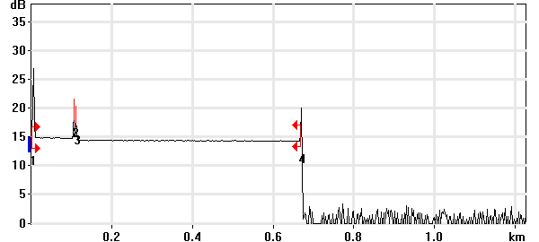

Event Table
No. | Loc. (km)/Length | Event Type | Loss (dB) | Refl. (dB) | Att. (dB/km) | Cumul. (dB)
1 | 0.0000 | Launch Level |  | -40.2 |  | 0.000
 | (0.1041 km) | Fiber Section | 0.108 |  | 1.038 | 0.108
2 | 0.1041 | Reflective Event | 0.051 | -57.9 |  | 0.159
 | (0.0051 km) | Fiber Section | 0.008 |  | 1.500 | 0.167
3 | 0.1092 | Reflective Event | 0.360 | -60.2 |  | 0.527
 | (0.5589 km) | Fiber Section | 0.114 |  | 0.204 | 0.641
4 | 0.6681 | Reflective Event | - - | -55.3 |  | 0.641

Pass/Fail Thresholds
Splice Loss: | 1.000 dB | Span Loss: | 45.000 dB
Connector Loss: | 1.000 dB | Span Length: | 0.000 m
Reflectance: | -40.0 dB | Span ORL: | 15.00 dB
Fiber section attenuation: | 0.400 dB/km

Test and Cable Setup
Wavelength: | 1550 nm (9 µm) | Acq. Time: | 30 s
File name: | MARS SM-22A.trc | IOR: | 1.468325
File Type: | Main | Backscatter: | -81.87 dB
OTDR Model: | FTB-720-23B-EA | Helix Factor: | 0.00 %
Serial No.: | 626283 | Splice Loss Detection: | 0.020 dB
Software Version: | OTDR - iOLM 2.1 | Reflectance Detection: | -72.0 dB
Distance: | 1.2500 km | End-of-Fiber Detection: | 5.000 dB
Pulse Width: | 10 ns

Comments

OTDR Report

Job Info
Job ID: |  | Operator A:
Company: |  | Operator B:
Customer: |  | File name: | MARS SM-22B.trc
Test date and time: | 2020-11-12 at 11:38 (GMT-5:00)

Cable Info
Fiber ID: | MARS SM-22B | Cable ID:
Location A: |  | Location B:

Wavelength: 1310 nm

Link Measurements
Span loss: | 0.624 dB | Average splice loss: | - - -
Span length: | 668.393 m | Span ORL: | 37.16 dB
Average loss: | 0.934 dB/km

OTDR Trace
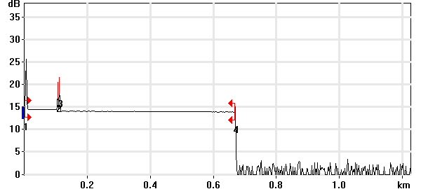

Event Table
No. | Loc. (km)/Length | Event Type | Loss (dB) | Refl. (dB) | Att. (dB/km) | Cumul. (dB)
1 | 0.0000 | Launch Level |  | -38.8 |  | 0.000
 | (0.1041 km) | Fiber Section | 0.098 |  | 0.943 | 0.098
2 | 0.1041 | Reflective Event | 0.065 | -56.7 |  | 0.164
 | (0.0050 km) | Fiber Section | 0.009 |  | 1.700 | 0.172
3 | 0.1092 | Reflective Event | 0.263 | -53.4 |  | 0.435
 | (0.5592 km) | Fiber Section | 0.189 |  | 0.338 | 0.624
4 | 0.6684 | Reflective Event | - - | -63.9 |  | 0.624

Pass/Fail Thresholds
Splice Loss: | 1.000 dB | Span Loss: | 45.000 dB
Connector Loss: | 1.000 dB | Span Length: | 0.000 m
Reflectance: | -40.0 dB | Span ORL: | 15.00 dB
Fiber section attenuation: | 0.400 dB/km

Test and Cable Setup
Wavelength: | 1310 nm (9 µm) | Acq. Time: | 30 s
File name: | MARS SM-22B.trc | IOR: | 1.467700
File Type: | Main | Backscatter: | -79.44 dB
OTDR Model: | FTB-720-23B-EA | Helix Factor: | 0.00 %
Serial No.: | 626283 | Splice Loss Detection: | 0.020 dB
Software Version: | OTDR - iOLM 2.1 | Reflectance Detection: | -72.0 dB
Distance: | 1.2500 km | End-of-Fiber Detection: | 5.000 dB
Pulse Width: | 10 ns

Comments

Wavelength: 1550 nm

Link Measurements
Span loss: | 0.507 dB | Average splice loss: | - - -
Span length: | 668.188 m | Span ORL: | 38.68 dB
Average loss: | 0.758 dB/km

OTDR Trace
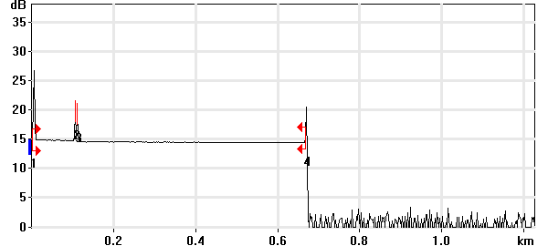

Event Table
No. | Loc. (km)/Length | Event Type | Loss (dB) | Refl. (dB) | Att. (dB/km) | Cumul. (dB)
1 | 0.0000 | Launch Level |  | -40.2 |  | 0.000
 | (0.1041 km) | Fiber Section | 0.111 |  | 1.064 | 0.111
2 | 0.1041 | Reflective Event | 0.054 | -57.9 |  | 0.164
 | (0.0050 km) | Fiber Section | 0.008 |  | 1.500 | 0.172
3 | 0.1091 | Reflective Event | 0.230 | -58.0 |  | 0.402
 | (0.5591 km) | Fiber Section | 0.105 |  | 0.188 | 0.507
4 | 0.6682 | Reflective Event | - - | -55.2 |  | 0.507

Pass/Fail Thresholds
Splice Loss: | 1.000 dB | Span Loss: | 45.000 dB
Connector Loss: | 1.000 dB | Span Length: | 0.000 m
Reflectance: | -40.0 dB | Span ORL: | 15.00 dB
Fiber section attenuation: | 0.400 dB/km

Test and Cable Setup
Wavelength: | 1550 nm (9 µm) | Acq. Time: | 30 s
File name: | MARS SM-22B.trc | IOR: | 1.468325
File Type: | Main | Backscatter: | -81.87 dB
OTDR Model: | FTB-720-23B-EA | Helix Factor: | 0.00 %
Serial No.: | 626283 | Splice Loss Detection: | 0.020 dB
Software Version: | OTDR - iOLM 2.1 | Reflectance Detection: | -72.0 dB
Distance: | 1.2500 km | End-of-Fiber Detection: | 5.000 dB
Pulse Width: | 10 ns

Comments

OTDR Report

Job Info
Job ID: |  | Operator A:
Company: |  | Operator B:
Customer: |  | File name: | MARS SM-23A.trc
Test date and time: | 2020-11-12 at 11:40 (GMT-5:00)

Cable Info
Fiber ID: | MARS SM-23A | Cable ID:
Location A: |  | Location B:

Wavelength: 1310 nm

Link Measurements
Span loss: | 0.523 dB | Average splice loss: | - - -
Span length: | 667.755 m | Span ORL: | 36.69 dB
Average loss: | 0.783 dB/km

OTDR Trace
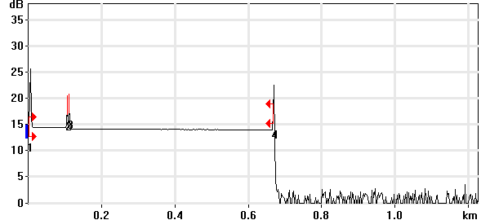

Event Table
No. | Loc. (km)/Length | Event Type | Loss (dB) | Refl. (dB) | Att. (dB/km) | Cumul. (dB)
1 | 0.0000 | Launch Level |  | -38.8 |  | 0.000
 | (0.1040 km) | Fiber Section | 0.103 |  | 0.987 | 0.103
2 | 0.1040 | Reflective Event | 0.063 | -56.7 |  | 0.166
 | (0.0050 km) | Fiber Section | 0.009 |  | 1.700 | 0.175
3 | 0.1091 | Reflective Event | 0.163 | -55.4 |  | 0.337
 | (0.5587 km) | Fiber Section | 0.185 |  | 0.332 | 0.523
4 | 0.6678 | Reflective Event | - - | -45.7 |  | 0.523

Pass/Fail Thresholds
Splice Loss: | 1.000 dB | Span Loss: | 45.000 dB
Connector Loss: | 1.000 dB | Span Length: | 0.000 m
Reflectance: | -40.0 dB | Span ORL: | 15.00 dB
Fiber section attenuation: | 0.400 dB/km

Test and Cable Setup
Wavelength: | 1310 nm (9 µm) | Acq. Time: | 30 s
File name: | MARS SM-23A.trc | IOR: | 1.467700
File Type: | Main | Backscatter: | -79.44 dB
OTDR Model: | FTB-720-23B-EA | Helix Factor: | 0.00 %
Serial No.: | 626283 | Splice Loss Detection: | 0.020 dB
Software Version: | OTDR - iOLM 2.1 | Reflectance Detection: | -72.0 dB
Distance: | 1.2500 km | End-of-Fiber Detection: | 5.000 dB
Pulse Width: | 10 ns

Comments

Wavelength: 1550 nm

Link Measurements
Span loss: | 0.349 dB | Average splice loss: | - - -
Span length: | 667.630 m | Span ORL: | 37.29 dB
Average loss: | 0.522 dB/km

OTDR Trace
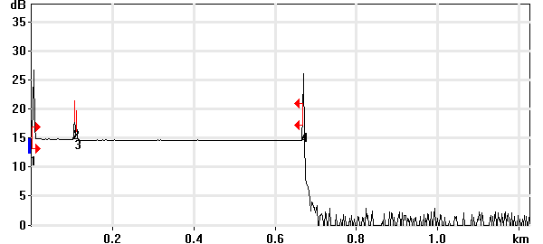

Event Table
No. | Loc. (km)/Length | Event Type | Loss (dB) | Refl. (dB) | Att. (dB/km) | Cumul. (dB)
1 | 0.0000 | Launch Level |  | -40.2 |  | 0.000
 | (0.1042 km) | Fiber Section | 0.113 |  | 1.089 | 0.113
2 | 0.1042 | Reflective Event | 0.052 | -57.9 |  | 0.165
 | (0.0050 km) | Fiber Section | 0.001 |  | 0.100 | 0.166
3 | 0.1092 | Reflective Event | 0.103 | -61.8 |  | 0.269
 | (0.5584 km) | Fiber Section | 0.080 |  | 0.143 | 0.349
4 | 0.6676 | Reflective Event | - - | -42.3 |  | 0.349

Pass/Fail Thresholds
Splice Loss: | 1.000 dB | Span Loss: | 45.000 dB
Connector Loss: | 1.000 dB | Span Length: | 0.000 m
Reflectance: | -40.0 dB | Span ORL: | 15.00 dB
Fiber section attenuation: | 0.400 dB/km

Test and Cable Setup
Wavelength: | 1550 nm (9 µm) | Acq. Time: | 30 s
File name: | MARS SM-23A.trc | IOR: | 1.468325
File Type: | Main | Backscatter: | -81.87 dB
OTDR Model: | FTB-720-23B-EA | Helix Factor: | 0.00 %
Serial No.: | 626283 | Splice Loss Detection: | 0.020 dB
Software Version: | OTDR - iOLM 2.1 | Reflectance Detection: | -72.0 dB
Distance: | 1.2500 km | End-of-Fiber Detection: | 5.000 dB
Pulse Width: | 10 ns

Comments

OTDR Report

Job Info
Job ID: |  | Operator A:
Company: |  | Operator B:
Customer: |  | File name: | MARS SM-23B.trc
Test date and time: | 2020-11-12 at 11:49 (GMT-5:00)

Cable Info
Fiber ID: | MARS SM-23B | Cable ID:
Location A: |  | Location B:

Wavelength: 1310 nm

Link Measurements
Span loss: | 3.791 dB | Average splice loss: | - - -
Span length: | 668.473 m | Span ORL: | 37.40 dB
Average loss: | 5.671 dB/km

OTDR Trace
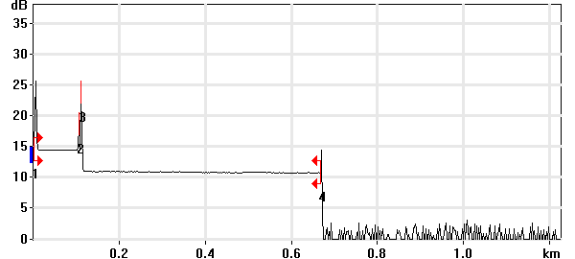

Event Table
No. | Loc. (km)/Length | Event Type | Loss (dB) | Refl. (dB) | Att. (dB/km) | Cumul. (dB)
1 | 0.0000 | Launch Level |  | -38.8 |  | 0.000
 | (0.1041 km) | Fiber Section | 0.098 |  | 0.940 | 0.098
2 | 0.1041 | Reflective Event | 0.014 | -56.7 |  | 0.112
 | (0.0049 km) | Fiber Section | 0.008 |  | 1.700 | 0.120
3 | 0.1090 | Reflective Event | 3.397 | -44.8 |  | 3.517
 | (0.5595 km) | Fiber Section | 0.273 |  | 0.489 | 3.791
4 | 0.6685 | Reflective Event | - - | -58.0 |  | 3.791

Pass/Fail Thresholds
Splice Loss: | 1.000 dB | Span Loss: | 45.000 dB
Connector Loss: | 1.000 dB | Span Length: | 0.000 m
Reflectance: | -40.0 dB | Span ORL: | 15.00 dB
Fiber section attenuation: | 0.400 dB/km

Test and Cable Setup
Wavelength: | 1310 nm (9 µm) | Acq. Time: | 30 s
File name: | MARS SM-23B.trc | IOR: | 1.467700
File Type: | Main | Backscatter: | -79.44 dB
OTDR Model: | FTB-720-23B-EA | Helix Factor: | 0.00 %
Serial No.: | 626283 | Splice Loss Detection: | 0.020 dB
Software Version: | OTDR - iOLM 2.1 | Reflectance Detection: | -72.0 dB
Distance: | 1.2500 km | End-of-Fiber Detection: | 5.000 dB
Pulse Width: | 10 ns

Comments

Wavelength: 1550 nm

Link Measurements
Span loss: | 3.522 dB | Average splice loss: | - - -
Span length: | 668.348 m | Span ORL: | 39.07 dB
Average loss: | 5.269 dB/km

OTDR Trace
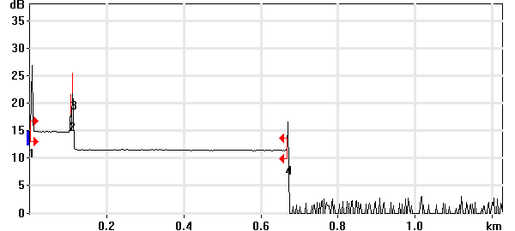

Event Table
No. | Loc. (km)/Length | Event Type | Loss (dB) | Refl. (dB) | Att. (dB/km) | Cumul. (dB)
1 | 0.0000 | Launch Level |  | -40.2 |  | 0.000
 | (0.1041 km) | Fiber Section | 0.102 |  | 0.983 | 0.102
2 | 0.1041 | Reflective Event | 0.023 | -57.9 |  | 0.125
 | (0.0049 km) | Fiber Section | 0.007 |  | 1.500 | 0.133
3 | 0.1090 | Reflective Event | 3.282 | -48.3 |  | 3.415
 | (0.5593 km) | Fiber Section | 0.107 |  | 0.191 | 3.522
4 | 0.6684 | Reflective Event | - - | -57.1 |  | 3.522

Pass/Fail Thresholds
Splice Loss: | 1.000 dB | Span Loss: | 45.000 dB
Connector Loss: | 1.000 dB | Span Length: | 0.000 m
Reflectance: | -40.0 dB | Span ORL: | 15.00 dB
Fiber section attenuation: | 0.400 dB/km

Test and Cable Setup
Wavelength: | 1550 nm (9 µm) | Acq. Time: | 30 s
File name: | MARS SM-23B.trc | IOR: | 1.468325
File Type: | Main | Backscatter: | -81.87 dB
OTDR Model: | FTB-720-23B-EA | Helix Factor: | 0.00 %
Serial No.: | 626283 | Splice Loss Detection: | 0.020 dB
Software Version: | OTDR - iOLM 2.1 | Reflectance Detection: | -72.0 dB
Distance: | 1.2500 km | End-of-Fiber Detection: | 5.000 dB
Pulse Width: | 10 ns

Comments

OTDR Report

Job Info
Job ID: |  | Operator A:
Company: |  | Operator B:
Customer: |  | File name: | MARS SM-24A.trc
Test date and time: | 2020-11-12 at 11:52 (GMT-5:00)

Cable Info
Fiber ID: | MARS SM-24A | Cable ID:
Location A: |  | Location B:

Wavelength: 1310 nm

Link Measurements
Span loss: | 0.365 dB | Average splice loss: | - - -
Span length: | 668.473 m | Span ORL: | 37.07 dB
Average loss: | 0.546 dB/km

OTDR Trace
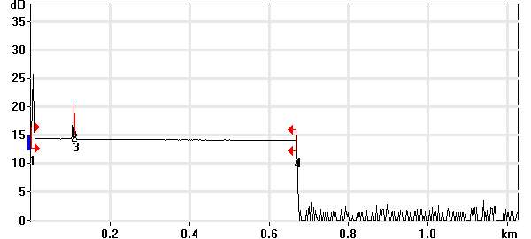

Event Table
No. | Loc. (km)/Length | Event Type | Loss (dB) | Refl. (dB) | Att. (dB/km) | Cumul. (dB)
1 | 0.0000 | Launch Level |  | -38.8 |  | 0.000
 | (0.1040 km) | Fiber Section | 0.097 |  | 0.937 | 0.097
2 | 0.1040 | Reflective Event | 0.039 | -56.7 |  | 0.136
 | (0.0053 km) | Fiber Section | 0.009 |  | 1.700 | 0.145
3 | 0.1092 | Reflective Event | 0.032 | -61.0 |  | 0.177
 | (0.5592 km) | Fiber Section | 0.188 |  | 0.336 | 0.365
4 | 0.6685 | Reflective Event | - - | -65.2 |  | 0.365

Pass/Fail Thresholds
Splice Loss: | 1.000 dB | Span Loss: | 45.000 dB
Connector Loss: | 1.000 dB | Span Length: | 0.000 m
Reflectance: | -40.0 dB | Span ORL: | 15.00 dB
Fiber section attenuation: | 0.400 dB/km

Test and Cable Setup
Wavelength: | 1310 nm (9 µm) | Acq. Time: | 30 s
File name: | MARS SM-24A.trc | IOR: | 1.467700
File Type: | Main | Backscatter: | -79.44 dB
OTDR Model: | FTB-720-23B-EA | Helix Factor: | 0.00 %
Serial No.: | 626283 | Splice Loss Detection: | 0.020 dB
Software Version: | OTDR - iOLM 2.1 | Reflectance Detection: | -72.0 dB
Distance: | 1.2500 km | End-of-Fiber Detection: | 5.000 dB
Pulse Width: | 10 ns

Comments

Wavelength: 1550 nm

Link Measurements
Span loss: | 0.363 dB | Average splice loss: | - - -
Span length: | 668.348 m | Span ORL: | 38.68 dB
Average loss: | 0.543 dB/km

OTDR Trace
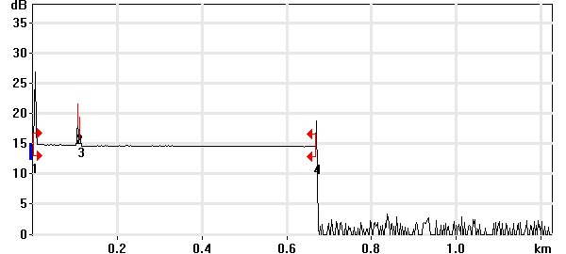

Event Table
No. | Loc. (km)/Length | Event Type | Loss (dB) | Refl. (dB) | Att. (dB/km) | Cumul. (dB)
1 | 0.0000 | Launch Level |  | -40.2 |  | 0.000
 | (0.1041 km) | Fiber Section | 0.116 |  | 1.118 | 0.116
2 | 0.1041 | Reflective Event | 0.062 | -57.9 |  | 0.178
 | (0.0051 km) | Fiber Section | 0.001 |  | 0.100 | 0.179
3 | 0.1092 | Reflective Event | 0.092 | -62.7 |  | 0.271
 | (0.5592 km) | Fiber Section | 0.092 |  | 0.165 | 0.363
4 | 0.6684 | Reflective Event | - - | -59.5 |  | 0.363

Pass/Fail Thresholds
Splice Loss: | 1.000 dB | Span Loss: | 45.000 dB
Connector Loss: | 1.000 dB | Span Length: | 0.000 m
Reflectance: | -40.0 dB | Span ORL: | 15.00 dB
Fiber section attenuation: | 0.400 dB/km

Test and Cable Setup
Wavelength: | 1550 nm (9 µm) | Acq. Time: | 30 s
File name: | MARS SM-24A.trc | IOR: | 1.468325
File Type: | Main | Backscatter: | -81.87 dB
OTDR Model: | FTB-720-23B-EA | Helix Factor: | 0.00 %
Serial No.: | 626283 | Splice Loss Detection: | 0.020 dB
Software Version: | OTDR - iOLM 2.1 | Reflectance Detection: | -72.0 dB
Distance: | 1.2500 km | End-of-Fiber Detection: | 5.000 dB
Pulse Width: | 10 ns

Comments

OTDR Report

Job Info
Job ID: |  | Operator A:
Company: |  | Operator B:
Customer: |  | File name: | MARS SM-24B.trc
Test date and time: | 2020-11-12 at 12:08 (GMT-5:00)

Cable Info
Fiber ID: | MARS SM-24B | Cable ID:
Location A: |  | Location B:

Wavelength: 1310 nm

Link Measurements
Span loss: | 1.019 dB | Average splice loss: | - - -
Span length: | 667.994 m | Span ORL: | 35.19 dB
Average loss: | 1.525 dB/km

OTDR Trace
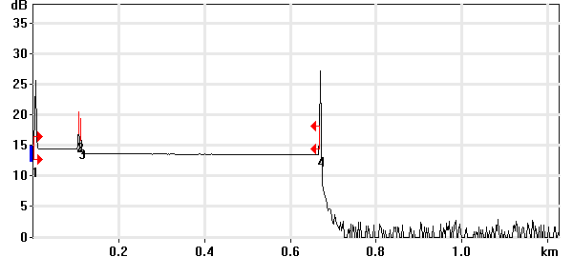

Event Table
No. | Loc. (km)/Length | Event Type | Loss (dB) | Refl. (dB) | Att. (dB/km) | Cumul. (dB)
1 | 0.0000 | Launch Level |  | -38.8 |  | 0.000
 | (0.1041 km) | Fiber Section | 0.089 |  | 0.859 | 0.089
2 | 0.1041 | Reflective Event | 0.074 | -56.7 |  | 0.164
 | (0.0050 km) | Fiber Section | 0.001 |  | 0.250 | 0.165
3 | 0.1092 | Reflective Event | 0.652 | -59.1 |  | 0.817
 | (0.5588 km) | Fiber Section | 0.202 |  | 0.362 | 1.019
4 | 0.6680 | Reflective Event | - - | -36.9 |  | 1.019

Pass/Fail Thresholds
Splice Loss: | 1.000 dB | Span Loss: | 45.000 dB
Connector Loss: | 1.000 dB | Span Length: | 0.000 m
Reflectance: | -40.0 dB | Span ORL: | 15.00 dB
Fiber section attenuation: | 0.400 dB/km

Test and Cable Setup
Wavelength: | 1310 nm (9 µm) | Acq. Time: | 30 s
File name: | MARS SM-24B.trc | IOR: | 1.467700
File Type: | Main | Backscatter: | -79.44 dB
OTDR Model: | FTB-720-23B-EA | Helix Factor: | 0.00 %
Serial No.: | 626283 | Splice Loss Detection: | 0.020 dB
Software Version: | OTDR - iOLM 2.1 | Reflectance Detection: | -72.0 dB
Distance: | 1.2500 km | End-of-Fiber Detection: | 5.000 dB
Pulse Width: | 10 ns

Comments

Wavelength: 1550 nm

Link Measurements
Span loss: | 0.696 dB | Average splice loss: | - - -
Span length: | 667.869 m | Span ORL: | 35.94 dB
Average loss: | 1.042 dB/km

OTDR Trace
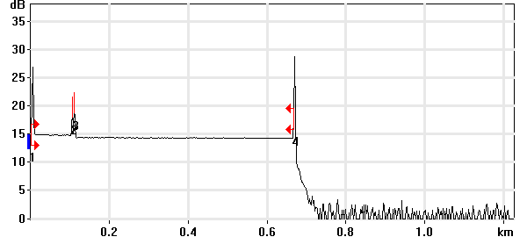

Event Table
No. | Loc. (km)/Length | Event Type | Loss (dB) | Refl. (dB) | Att. (dB/km) | Cumul. (dB)
1 | 0.0000 | Launch Level |  | -40.3 |  | 0.000
 | (0.1041 km) | Fiber Section | 0.121 |  | 1.167 | 0.121
2 | 0.1041 | Reflective Event | 0.066 | -57.9 |  | 0.188
 | (0.0050 km) | Fiber Section | 0.001 |  | 0.100 | 0.188
3 | 0.1091 | Reflective Event | 0.410 | -54.8 |  | 0.599
 | (0.5588 km) | Fiber Section | 0.098 |  | 0.175 | 0.696
4 | 0.6679 | Reflective Event | - - | -37.8 |  | 0.696

Pass/Fail Thresholds
Splice Loss: | 1.000 dB | Span Loss: | 45.000 dB
Connector Loss: | 1.000 dB | Span Length: | 0.000 m
Reflectance: | -40.0 dB | Span ORL: | 15.00 dB
Fiber section attenuation: | 0.400 dB/km

Test and Cable Setup
Wavelength: | 1550 nm (9 µm) | Acq. Time: | 30 s
File name: | MARS SM-24B.trc | IOR: | 1.468325
File Type: | Main | Backscatter: | -81.87 dB
OTDR Model: | FTB-720-23B-EA | Helix Factor: | 0.00 %
Serial No.: | 626283 | Splice Loss Detection: | 0.020 dB
Software Version: | OTDR - iOLM 2.1 | Reflectance Detection: | -72.0 dB
Distance: | 1.2500 km | End-of-Fiber Detection: | 5.000 dB
Pulse Width: | 10 ns

Comments

