NEPTUNE Canada
Seaproof Media Converter Pressure Housing Failure
Summary – June 28th, 2010
The Bottom Pressure Recorder NE in the NEPTUNE Canada ODP 1027 node area failed to respond after 2010.02.21 11:45 UTC. The current spiked to 8A and there was an indication of an isolation fault on the Node. On visiting the Junction Box site on the seafloor May 12, 2010 (see location details in table below), an imploded media convertor can was discovered, specifically with the 1 atmosphere section of the can and penetrator for the ODI hose imploded from the end, and the locking ring not apparent. Note that the PVC cradle of the media convertor can is fractured at one end, however there is no other apparent damage to the platform or other PVC cradles.

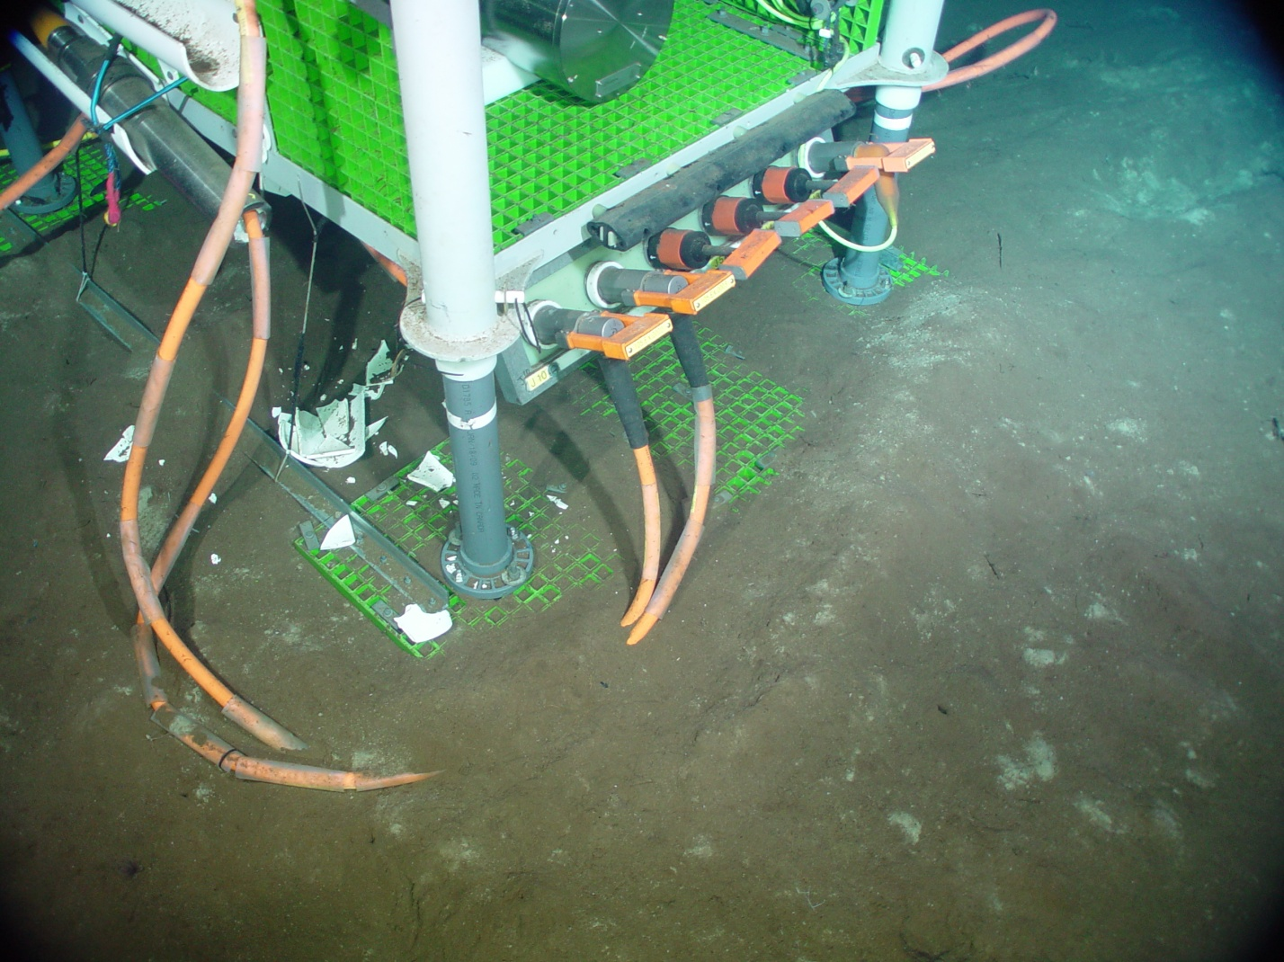

Assessment of the Failure
The internal volume of the one atmosphere pressure housing is 2.826 litres. (Internal length 360mm, Internal Diameter 100mm).
There was an initial pressure test of the Media Converter housing done to qualify them for 3000m. The housing passed this test.
Unfortunately recent analysis by both Seaproof and independent consultants now suggests that the locking ring failed, and at these depths this is a systematic problem with all of the Media Converter cans. We are currently awaiting an assessment of what depth would be safe.
Currently installed media convertor cans are at the following locations at depths, observed failure is at the ODP 1026A/B JB location, where two other cans are also located:

Site Id | Site Name | Node Location | Depth (m) | Latitude | Longitude
100051 | BPR NE | ODP1027 | 2644.7 | 47°48.1887' | -127°36.4718'
100034 | BPR NW | ODP1027 | 2623.5 | 47°49.8395' | -127°53.2116'
100035 | BPR S | ODP1027 | 2668.0 | 47°39.1054' | -127°46.9178'
100037 | ODP1026A/B (JB-13) | ODP1027 | 2660.5 | 47°45.7629' | -127°45.5207'
100097 | ODP889 Platform May2010 | ODP889 | 1258.0 | 48°40.2515' | -126°50.8794'
100096 | Compliance Apparatus September 2010 | ODP889 | 1256.0 | 48°40.1715' | -126°51.1104'
100016 | BC Axis (POD 1) | Barkley Canyon | 984.4 | 48°19.0073' | -126°03.0074'
100049 | BC Hydrates | Barkley Canyon | 870.0 | 48°18.7266' | -126°03.9480'
100013 | BC MidWest (POD 4) | Barkley Canyon | 899.5 | 48°18.8955' | -126°03.4813'

In addition to the volume and depth information above, we have some indirect lines of evidence as to the force involved in the implosion. First there is the damage of the PVC cradle, but lack of other damage to adjacent PVC cradles or other elements of the platform, as noted above. A 2.45 decibar spike was recorded 11:45:59 UTC by both the surface and borehole pressure sensors in the ODP 1026B CORK, at ~50m from the media can implosion site.
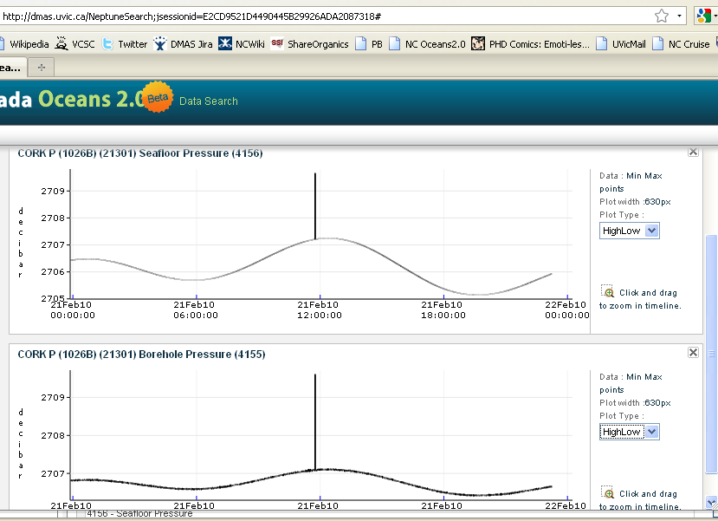
The pressure sampling is at 1 Hz, and the spike was not seen in the datapoints before or after that record, therefore within 1 Hz is the average the pressure wave. The pressure sensor is a Paroscientific Digiquartz 8B4000-2 rated to sense 0-4000m of water with a 1.2 times over pressure safety factor. This sensor didn’t over range. There is no maximum shock rating for the pressure sensor. The sensors have crystals that are mounted in foam.
The pressure wave is expected to be a directed one. In the case of the risk at ODP 1026B CORK, the remaining two Media convertor cans in cradles on the same JB platform (50m away) are oriented at right angles to the direction of the 1026B CORK, not towards it.
Failure analysis is ongoing.

