Geodetic and Seismic Sensor Module (GSSM) Test on MARS
Principal Investigators: Dana Manalang and William Wilcock, University of Washington

Purpose
Geophysical observations on the seafloor in seismically active areas are essential for understanding plate tectonic processes and for assessing and mitigating seismic hazards. Because electromagnetic waves do not penetrate seawater, the GPS receivers that are routinely used on land to measure plate tectonic motions are not an option for geodetic measurements on the seafloor. One method for measuring vertical deformation of the seafloor is to make precise measurements of seafloor pressure. After correcting for tides and other oceanic effects, long-term changes in seafloor pressure can be linked to changes in the elevation of the seafloor.

The challenge of making such measurements is that the sensor typically drifts at rates that are at least ten times the expected rates of uplift or subsidence from plate tectonic motions. The Paroscientific Geodesy Ocean Disaster Sensor (GODS) is a new instrument that seeks to correct for sensor drift by periodically calibrating its pressure sensor against the internal pressure in the instrument pressure housing. Laboratory tests of this method, termed A-0-A, are promising, but it needs to be evaluated on the seafloor. The GODS sensor also includes a new type of accelerometer that is designed to monitor for earthquakes.

Objectives
The objectives of this project are to test a new geophysical sensor, the Paroscientific GODS sensor, on the MARS cabled observatory for at least one year. The sensor provides continuous time series data for: (1) seafloor pressure calibrated to remove sensor drift, and (2) the acceleration of the seafloor.

Activities in 2018
The system was deployed on 06/13/2017, and remained deployed throughout 2018.

Plans for 2019
The system deployment was extended and is currently scheduled to be recovered in approximately late September 2019. If additional collaborators are secured, this deployment may be extended again.
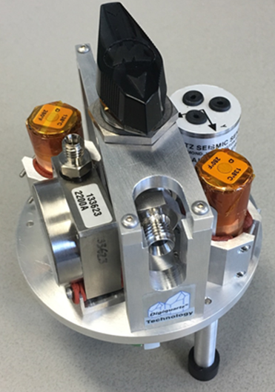

Figure 1. Prototype of the GODS (Geodesy Ocean Disaster Sensor), which will be inside the GSSM housing. For cabled deployments, this will be combined with an actuator to turn the valve and electronics to acquire data and interface to the cable.

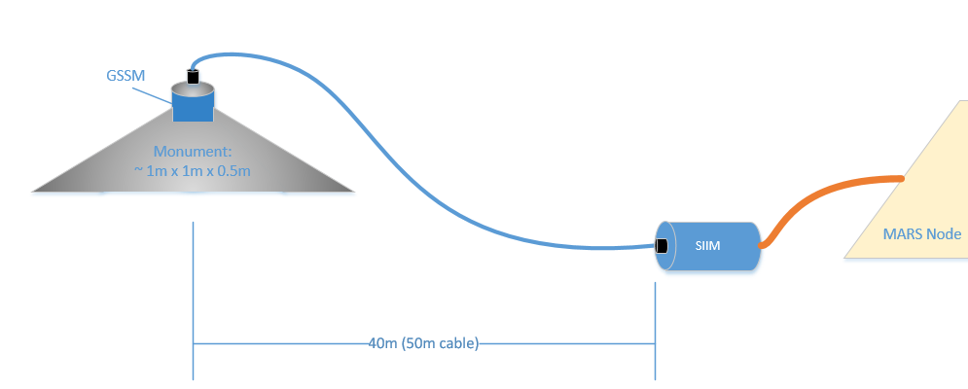

Figure 2. Schematic of the deployed system.

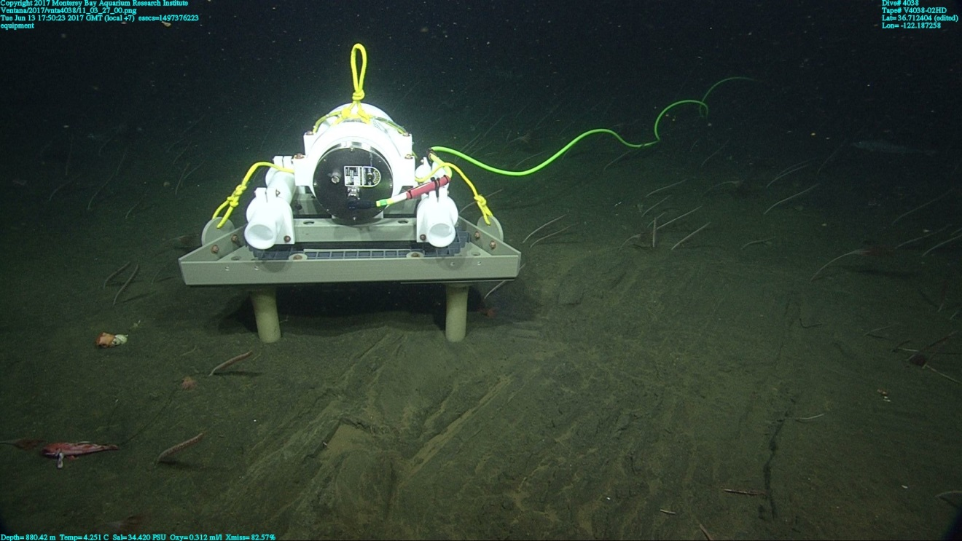

Figure 3. The GSSM system as deployed on MARS.

