Applicant and Project Information
  - Project Title
Test of Long-Term Seafloor Observatory Instruments with MARS
  - Applicant Information
Primary applicant 1
Name: Huaiyang Zhou. Title: Professor. Adress: 1239, Siping Road, Shanghai.
Telephone number: +86 21 6598 3385. Fax number: +86 21 6598 7615.
Email address: zhouhy@tongji.edu.cn
Affiliation: School of Marine and Earth Science, Tongji University.
Primary applicant 2
Name: Xiaotong Peng. Title: Professor. Adress: 1239, Siping Road, Shanghai.
Telephone number: +86 21 6598 7961. Fax number: +86 21 6598 7615.
Email address: xtpeng@tongji.edu.cn
Affiliation: School of Marine and Earth Science, Tongji University.
Additional colleagues
Canjun Yang: Department of Mechanical Engineering, Zhejiang University.
Dejun Li: Department of Mechanical Engineering, Zhejiang University
Bo Jin: Department of Mechanical Engineering, Zhejiang University
Peiliang Li: College of Physical and Environmental Oceangraphy, Ocean University of China
  - Project Abstract
The geological, chemical, physical and biological properties and behaviors of the water column and seafloor play an important role in vast research fields such as seismology, geodynamics, marine environments, ecology and biology. To increase our understanding geological, biological and chemical processes in ocean, it is required to develop appropriate tools that are capable of providing the real-time, long-term data from water column and seafloor. The submarine cabled observatory technology is the most effective system to develop a new kind of scientific network in which various kinds of instruments and sensors can be installed. Recently, China has begun to devote effort to construct the underwater cable-network for scientific seafloor observation. In 2007, a project for key technology of long-term seafloor observatory proposed by Tongji University and other participants was initiated and supported by the Ministry of Science and Technology of China. Junction boxes, in-situ chemistry monitoring subsystem, dynamics environment monitoring subsystem and underwater optical imaging subsystem have been developed. We attempt to test these instruments onto MARS in 2011 after all of the necessary tests in pressure vessel, water tank, and shallow costal ocean, to check the work capability of the entire integrated system and acquire the experience for developing submarine cable network in China.
  - Objectives
The aim of this project is to develop some key technology for long-term cabled seafloor observatory. The essential technology here consists of in-situ chemistry monitoring system, dynamics environment monitoring system, junction boxes and underwater optical imaging system and provision for efficient deployment, operations, maintenance, and recovery. Tongji University plans to install these oceanographic instruments on MARS to test data connectivity, sensor control, and the long duration survivability of sensors and the electronics required to build an oceanographic observatory (Fig.1).

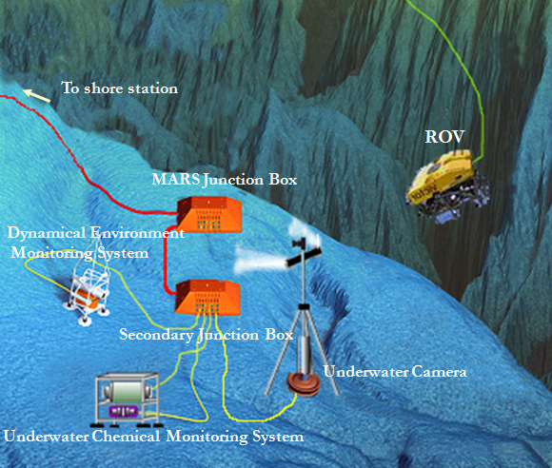
Fig.1 The schematic of China instruments tested on MARS

  - Intended Use of Results
As we all know, our present knowledge about the functioning of the ocean in the earth system is mainly based on seagoing expeditions and shipboard operation of equipments. The data sets thus obtained are constrained in time and space, and generally lack sufficient knowledge of the temporal and spatial variability of parameters. As the importance of the oceans to society grows, so does the need to understand their variation on many temporal and spatial scales. Long term observing systems will enable the study of processes in the ocean over varying timescales and spatial scales. Tongji University and other participants are developing a cabled deep sea observatory for long term investigation of seafloor processes, providing the scientific basis for addressing important societal concerns such as climate change, natural hazards, industrial exploitation and the health and viability of living and non-living resources along our coasts and in the open ocean. The application area of this ocean observatory mainly includes sedimentation rates, marine ecosystems and biodiversity, tidal dynamics, seismology, mineral resources, and so on.

Methods – Describe how the proposed methods and analytical techniques will achieve the activity objectives. This description should include the following, as applicable:
  - Procedures
Generally, proposed activities mainly include three different phases, deployment, observation, and their withdrawal.
Deployments of observatory instruments
The deployment of our scientific instruments mainly depends on MARS’s marine operation supports which are basically composed of ROV and ships.
1. Science Instrument Testing in MBARI Test Tank
Before the deployments, all scientific instruments must been tested in MBARI test tank to examine various constitutes to ensure their validities although we have examined in our lab.
2. Ship and elevator deployed junction box and other scientific subsystem
Before the deployments of others scientific instruments, Junction box packages would be firstly deployed by ship directly. Then, all kinds of scientific instruments are deployed. MBARI ships can deploy loads up to 5000 lbs. in air weight.
3. Connection between scientific subsystem and secondary junction box
After the deployments, the ROV would install ODI connectors of scientific subsystems to secondary junction box to connect them.
4. Connection between secondary junction box and MARS’s junction box
Observation of our observatory node
Constitutes of observation node are shown in Fig.1. Key components include the secondary junction box, in-situ chemistry monitoring subsystem, dynamics environment monitoring subsystem, and underwater optical imaging system.
1. Secondary junction boxes
The essential function of the secondary junction box is to replicate the connector/port on the observatory primary junction box at remote locations. On the secondary junction box 10 ports will be provided. Ports can be used to link the secondary “backbone” system (10 kV/10 kW, 100 Mbps Ethernet, timing) as well as for more than three science instruments. A micro-controller will be used to control the secondary junction box and to communicate with the shore Observatory Control System (OCS). Most of the control logic will reside on shore with the local inputs and outputs implemented by the node controller. A major function will be load monitoring and control (i.e., switching connected instruments on and off). One of its functions will be to keep the local clock synchronized with the backbone time and report differences between multiple input timing signals. This controller will look just like another instrument to the OCS and the Data Management and Archive System (DMAS). For communications, a high reliability commercial Ethernet switch will be used that takes multiple input/outputs and sends the packets to the appropriate locations, whether they are commands to instruments or data to the archive and scientist on shore. The secondary 48-V and 400-V power supplies will have similar load monitoring and control as the primary science node (i.e., switching, ground fault, and over current protection).
2. In-situ Chemistry Monitoring Subsystem
In-situ Chemistry Monitoring System includes an in situ anion analyzer and an assembly of chemical sensors. Anion analyzer is designed to detect the anion compositions of seawater (Cl⁻, SO₄²⁻, NO₃⁻, et al.) and collect the real-time data with high precision. This instrument mainly includes sampling inlet, separation equipment, detection equipment, control and memory equipment and working station, and the analytical system is connected with the secondary junction box. The main aim of testing is get continuous anion concentration of seawater.
Another part of system is the assembly of several chemical sensors. It includes AMT pH sensor, Oxygen Optode, Chlorophyll Flourometer, METS methane sensor and ISUS nitrate sensor. These sensors are assembled in a data logger connected with anion analyzer to supply the power and store data. The function of this part is to get proper content of dissolved substances.
3. Dynamics Environment Monitoring System
The node will integrates ADCP, ADV, CTD and Turbidity sensor to monitor the bottom physical oceanography parameters. Long and short term measurements of near bottom current profiling can be done with a 300 kHz ADCP (acoustic Doppler current profiler) manufactured by RDI with a max depth of 6000 m. The ADV (Acoustic Doppler Velocimeter, SonTek/YSI 6-MHz) is a proven, accurate solution for high-precision, 3-axis (3D), velocity measurements in a wide variety of settings from the laboratory to the ocean. Others parameters such as conductivity and temperature are monitored by a high precision CTD (SBE-19 plus SEACAT). Sea water turbidity is monitored by a standard 0.25-m path length Transmissiometer and optical backscatter devices.
4. Underwater optical imaging system
This unit mainly includes underwater lighting equipments and underwater camera, which is developed to enable a projective reconstruction of small-scale scenes from underwater video equipments and still camera. The system is connected with secondary junction box to collect high quality images and data.
Withdrawal of observation node
It is the converse procedure to the deployments.
  - Collections
Except for little amounts of seawater, our system doesn’t collect any other samples. One of the basic purposes is to detect various environmental parameters and testify our system whether could work well.
Junction Box
Junction box just monitors voltage, current and temperature of every sub-system.
Underwater optical imaging system
A video camera system is attached in junction box, which could take images and video data.
Chemistry Monitoring System
Little amounts of sea water will be collected by use of peristaltic pump to analyze the sea water anion concentration with an undersea in-situ anion analyzer. Collection frequency is about 10 ml every time and 5 times each day. In addition, concentrations of methane, chlorophyll, oxygen, nitrate, as well as pH would be measured by sensors.
Dynamics Environment Monitoring System
Basic parameters about physical oceanography such as salinity, temperature, turbidity and velocity of bottom current will be measured.
  - Schedule
March. 01 to March. 10, 2011
All the instruments are transported to the USA and tested in MABRI test tank
March. 11 to March. 15, 2011
Secondary junction box and other scientific instruments are deployed to the seafloor and connected to the MARS junction box.
March. 16 to April 16, 2011
Observation node begins to work and collect various in situ parameters.
April 17 to April 20, 2011
recovery the node and all fieldworks finish.
April 21 to April 25, 2011
Return to China.
April. 26 to May. 30, 2011
Analyze various parameters, and complete the project report.
Funding: Provide contract number, performance period, and name of sponsoring agency, as applicable.
- Contract number: 2007AA091201
- Performance period: Dec. 01, 2007 to Dec. 01, 2011.
- Sponsoring agency: the Ministry of Science and Technology of the People’s Republic of China
Environmental Impacts: Summarize the direct and indirect impacts (effects) of the proposed activity. Direct impacts are those caused by the permitted action which occur at the same time and place. Indirect impacts are those caused by the action that are later in time or farther removed in distance, but still reasonably foreseeable. Explain how the benefits of the research will outweigh the disadvantages or environmental consequences in both the short and long term.
Generally, our node has hardly direct impacts to the surrounding environments. All the materials are corrosion resistant except for sacrificial anodes. We also don’t produce any wastes and pollutants. The only thing discharged from our node is sodium carbonate solution (Na₂CO₃) with the concentration of 1 g/L, and the quantity is about 1 liter each day. So the impacts to the environments are ignorable.
Photographs or schematic representations of equipment to be deployed: Please provide images or drawings that will help to visualize the proposed equipment to be deployed. Also indicate weights, dimensions, or any other information that would assist with understanding the size of the system to be deployed.
- Junction Box with underwater optical imaging system (Fig.2)
Weight of Junction Box
about 900 kg in air, and 400 kg in water
Dimension of Junction Box
about 2.0 m×1.0 m×1.0 m
Connector and Cable with MARS node
400 V, Ethernet, 12 pins ODI wet-mate connector
Power consumption of Junction Box
Node itself may consume power about 150 W.
400 V- 48 V convertor
Ability > 1 kW, efficiency > 90%
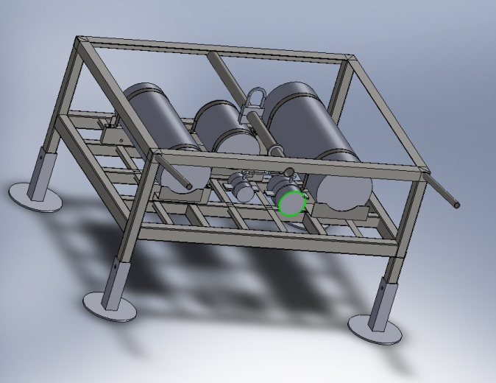
Fig.2 Schematic of junction box subsystem
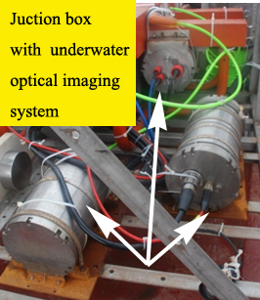
Fig.3 Junction box subsystem
- Chemistry Monitoring System
All the instruments of the chemistry monitoring subsystem are fixed in a big frame. The detailed information is as follows:
Total weight
300 kg in air, 120 kg in water
Dimension of Junction Box
about 2.0 m×1.0 m×1.0 m
Connector and Cable with Junction Box
12-pin Subconn MC BH-12M
Power consumption of the system
No more than 320 W.
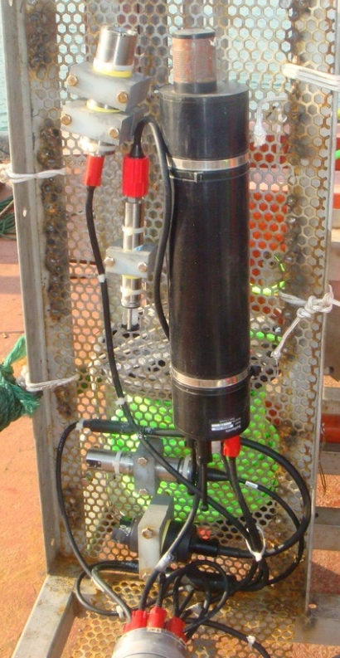
Fig.4 Chemical sensors (pH sensor, oxygen sensor, chlorophyll sensor, methane sensor and nitrate sensor)
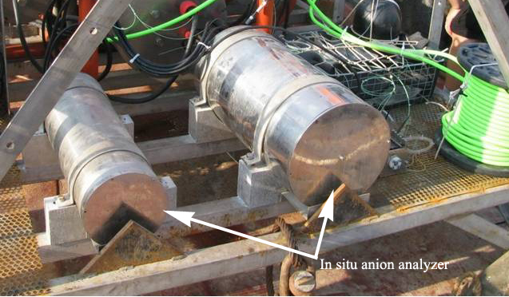
Fig. 5 In situ anion analyzer
- Dynamics Environment Monitoring System
Total weight
200 kg approx. in air, 80 kg approx. in water
Connector and Cable with Junction Box
12-pin Subconn MC BH-12M
Power consumption of the system
160 W max.
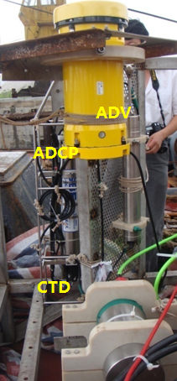
Fig.6 Dynamics environment monitoring subsystem

