MARS Upgrade
Interface Control Document
This document describes the interfaces and subsystems that are in the MARS hardware and software. The system can be broken down into sections:
Medium Voltage System (MVS)
Medium Voltage Power Supply (MVPS) (Shore Station)
Schaefer K1979 1500vdc output
Outputs
Input Power OK logic high (5V DC), input voltage is OK
Logic low (0V DC), input voltage is out of specified
Range. Not Latching
DC Output OK logic high (5V DC), output voltage is OK
Logic low (0V DC), output voltage is out of specified
Range. Not Latching
Over Voltage Shutdown Signal
Logic high (5V DC), Over voltage shutdown signal is not activated
Logic low (0V DC), Over voltage shutdown is tripped. Latching signal
Over Temperature shutdown Signal
Logic high (5V DC), Over temperature shutdown signal is not activated
Logic low (0V DC), Over temperature shutdown is tripped. Latching signal
Over Current Shutdown Signal
Logic high (5V DC), Over current shutdown signal is not activated
Logic low (0V DC), Over current shutdown is tripped. Latching signal
Inputs
Inhibit (remote on/off) logic high (5V DC), Power supply is on
Logic low (0V DC), Power supply is off
( A latched signal can be reset by cycling the remote ON/OFF signal)
PC104 (Current) to monitor data from power supply. This controller will need to be able to provide the input described above and read status signals to/from the MVPS. The MARS software has to display the status signals and provide an input signal via the software to inhibit/enable the supply. THIS SIGNAL SHOULD HAVE AN INTERLOCK THAT ASKS IF THE ACTION REQUESTED IS WHAT IS WANTED.

Room Alert system to monitor (monitors for phase loss)
AC input from Utility/generator 3 x digital signals
AC output from UPS 3 x digital signals
Motion sensor
Door Sensor

Medium Voltage Converter (subsea) X2 All sensors galvanically isolated
Schaefer K1846R
V_{in} 0-5vdc = 0v-2250v
I_{in} 0-5vdc =0-1A
V_{out} 0-5vdc = 0v-375
I_{out} 0-5vdc = 0- 2.33A
Schaefer K1846L
V_{in} 0-5vdc = 0v-2250v
I_{in} 0-5vdc =0-1A
V_{out} 0-5vdc = 0v-375
I_{out} 0-5vdc = 0- 2.33A

Low Voltage System (LVS)
Internal Loads
Power switching for: min 8 dig outs (not including LV electronics)
Lantech 5408 switch 1 (Dual 18~57VDC, 10W)
Lantech 5408 switch 2 (Dual 18~57VDC, 10W)
Meinberg Sync Box N2X (48VDC nom,20-60VDC max, 7.5W)
Digi One TS4 (12W (1A @ 12Vdc)

Cable Rack 2xSFP Slot Media Converter/2x 1000M Ethernet Ports (5VDC 10W)

3x Cable Rack Media Converter 1000SX/LX SFP Slot to 10/100/1000TX (5VDC 10W)

AFL FO-TTL Media converter (24VDC 10W) Not switched

JBox Controller (?VDC)

LV Hardware that requires Switching

Load Sensing/current monitoring (17 analog inputs)

5VDC Bus I,V

12VDC Bus I,V

24VDC Bus I,V

48VDC Bus I,V

Current sensing for each of the switched internal loads

Temperature sensing

LM35/serial or equivalent on:

Lantech 1

Lantech 2

Housing top

Housing bottom

Any LV boards that support temp sensing ie Bus Monitor
External Loads 30 digital output signals
8 x power switching for 375 VDC 1500W/4A
8x dry contact isolation for 375 VDC
7 x power switching for 48 VDC 200W/4A
7 x dry contact isolation
Current Sensing on all channels (15 analog signals)
Ground Fault Sensing
Currently 4 channels are sensed using one analog and 4 digital select bits
375 Line
375 Common
Ext 48 Line
Ext 48 Common
Seawater ground Eng Data
Data Communication System (DCS)
The DCS consist of two primary systems:
Ethernet connectivity for science ports and control
Cisco 3750 Router
2x Lantech 5424 cw 80km SM SFPs
2x Lantech 5408 cw 80km SM SFPs
4 fibers

The main part of MARS/WNS Networks are composed of four Lantech switches. Each of these switches
have three trunk connections to every other switch in the network. Additionally each pair of switches
(Surface and Node) have assigned ports for the relevant Science VLANs. The connection out of MARS
and WNS, as well as all the routing between the MARS/WNS VLANs, is done by the Cisco 3750
attached to that switched network.
Address translation is done on the firewall that the 3750 is connected to. For MARS, this is MBARI’s
PaloAlto firewall. For WNS, it is done by the WNS Cisco PIX. Address translation is needed to convert
the non-routable IP space (the 10.0.0.0 network) of the system into IP Addresses that can be accessed
for anyone else of network. See the tables at the end of this write up to see the specific translations.
Global access to the MARS/WNS Network are restricted on the firewalls as well. These are the rules that
grant access to specific hosts and VLANs from outside of the MARS network. Outbound traffic from
MARS or WNS is not blocked in any way (although this is a possibility if needed). Access to and from the
MARS/WNS Networks can be limited by individual IP Address, ranges of IP Addresses, or VLANS/
subnets/Networks.
Putting all this together, you get a network that looks like the following:
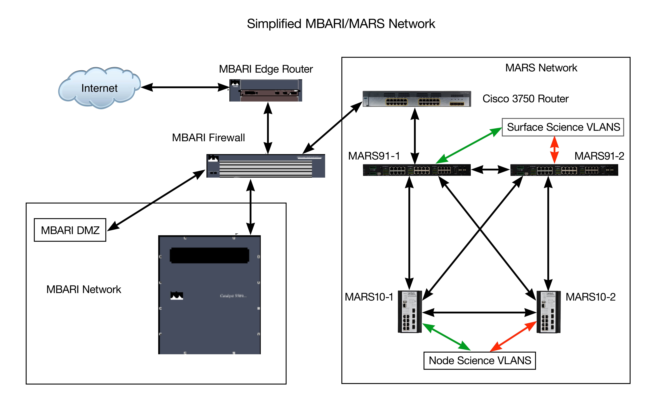
Pete Braccio (2018)
.
The Lantech Switches are monitored using the Web interface on each switch. All science ports and the controller are “Y” connected to each switch and the ports must be enabled manually in the event of a failure. In testing, there was no capability for automatic fail over. In the event of a network failure due to a switch or fiber issue, the switch Console port can be accessed via a back door.
To facilitate access to port 8 (ODI Hybrid connector) two Cable Rack Media Converter 1000SX/LX 10km SFP Slot to 10/100/1000TX (5VDC 10W) are installed in the node electronics chassis. These are switchable via the Jbox controller/LV power electronics. (fibers 1,2 in the ODI hybrid)
Two spare fibers from the main MARS cable are married (butt spliced) to fibers 3,4 in the ODI hybrid.

Back Door Connectivity (OBC)
Each device subsea that has a console port is connected to the back door via serial ports. The following hardware accomplishes this:

Cable Rack Media Converter 1000SX/LX 80km SFP Slot to 10/100/1000TX (5VDC 10W)

Cable Rack 1x80km SFP Slot/1x Cu SFP Media Converter/2x 1000M Ethernet Ports (5VDC 10W)
Digi One TS4 Ethernet to Serial converter
One SM fiber
The surface media converter is connected into the control vlan 10.91.128.XXX. The counterpart subsea media converter (one in FO and 3 out Cu) is also part of the control vlan. It is connected to an Ethernet to serial device 10.91.128.127. The ports are configured as follows:
- Digi serial port 1 10.91.128.127:2101 Lantech 5408 #1 (MARS10-1)
- Digi serial port 2 10.91.128.127:2102 Lantech 5408 #2 (MARS10-2)
- Digi serial port 3 10.91.128.127:2103 JBox Controller
- Digi serial port 4 10.91.128.127:2104 Spare

Timing Subsystem
The timing subsystem is based on a Meinberg M600 GPS clock. The clock outputs:
- Network Time Protocol (NTP) 10.91.128.
- IEEE 1588 Precision Time Protocol (PTP) 10.91.128.
- One Pulse Per Second 1PPS
PTP and NTP clients can subscribe at the above addresses.
1PPS is broadcast to the node via a dedicated fiber using:
A.A. Lab Systems AFL-300 Digital Fiber Optic Link
Subsea, the signal is received by a distribution board that looks for the presence of the 1PPS then distributes that signal to the science ports. If the signal fails the board will switch to the local 1PPS signal which is generated by a Meinberg Syncbox N2X

The Lantech Switch commissioning/configuration is done using the web interface, in the event of a primary communications failure the switch console ports can be accessed via the OBC depending on the failure the appropriate ports need to be turned off or on.
10.91.128.101 | 10.91.128.102 |  | 10.91.128.201 | 10.91.128.202
 |  |  | 1 |  | Y connected to each of the Science Ports
 |  |  | 2 |  | “
 |  |  | 3 |  | “
12 Meinberg M600 Stratum 1  Time server |  |  | 4 |  | “
14 PTP  10.91.128. |  |  | 5 |  | “
 |  |  | 6 |  | “
 |  |  | 7 |  | “
24 From Cisco 3750 (23) | 24 From Cisco 3750 (24) |  | 8 |  | “
25 FO to 25 of MRA 91-2 | 25 FO to 25 of MRA 91-1 |  | 9 |  | Copper between the two switches
26 FO to 26 of MRA 91-2 | 26 FO to 26 of MRA 91-1 |  | 10 |  | Copper Y connection to the NPC
27 FO to MRA 10-2 (11)  10.91.128.202 | 27 FO to MRA 10-1 (11)  10.91.128.201 |  | 11 FO to MRA 91-2 (27)  10.91.128.102 | FO to MRA 91-1 (27)  10.91.128.101
28 FO to MRA 10-2 (12)  10.91.128.201 | FO to MRA 91-2 (12)  10.91.128.202 |  | 12 FO to MRA 91-1 (27)  10,91.128.101 | FO to MRA 91-2 (28)  10.91.128.102

If communication is lost with the subsea node not as a result of loss of power:
- Check functionality of the two surface switches:
http:// 10.91.129.101/102
These should be up on a display in the control center. If not, username= marstech
pwd = dial8911
You should be able to reach the subsea switches 10.91.128.201/202
- If they appear healthy then either the fiber system has an issue or one or possibly both of the subsea switches have issues
- Check functionality of the two surface switches:
http:// 10.91.129.101/102
These should be up on a display in the control center. If not, username= marstech
pwd = dial8911
If they appear healthy then either the fiber system has an issue or one or possibly both of the subsea switches have issues.
- Attempt to log into the subsea switch
http:// 10.91.129.101/102
These should be up on a display in the control centerin the control. If not, username= marstech pwd = dial8911
If they appear healthy then either the fiber system has an issue or one or possibly both of the subsea switches have issues.

