The volume of the bumper is 43 cm2, so that's about 45 g of resin. You can mix 60-80 g of resin to have plenty of margin. I used a 60 cm2 syringe and it was fine. I'll bring you a couple.

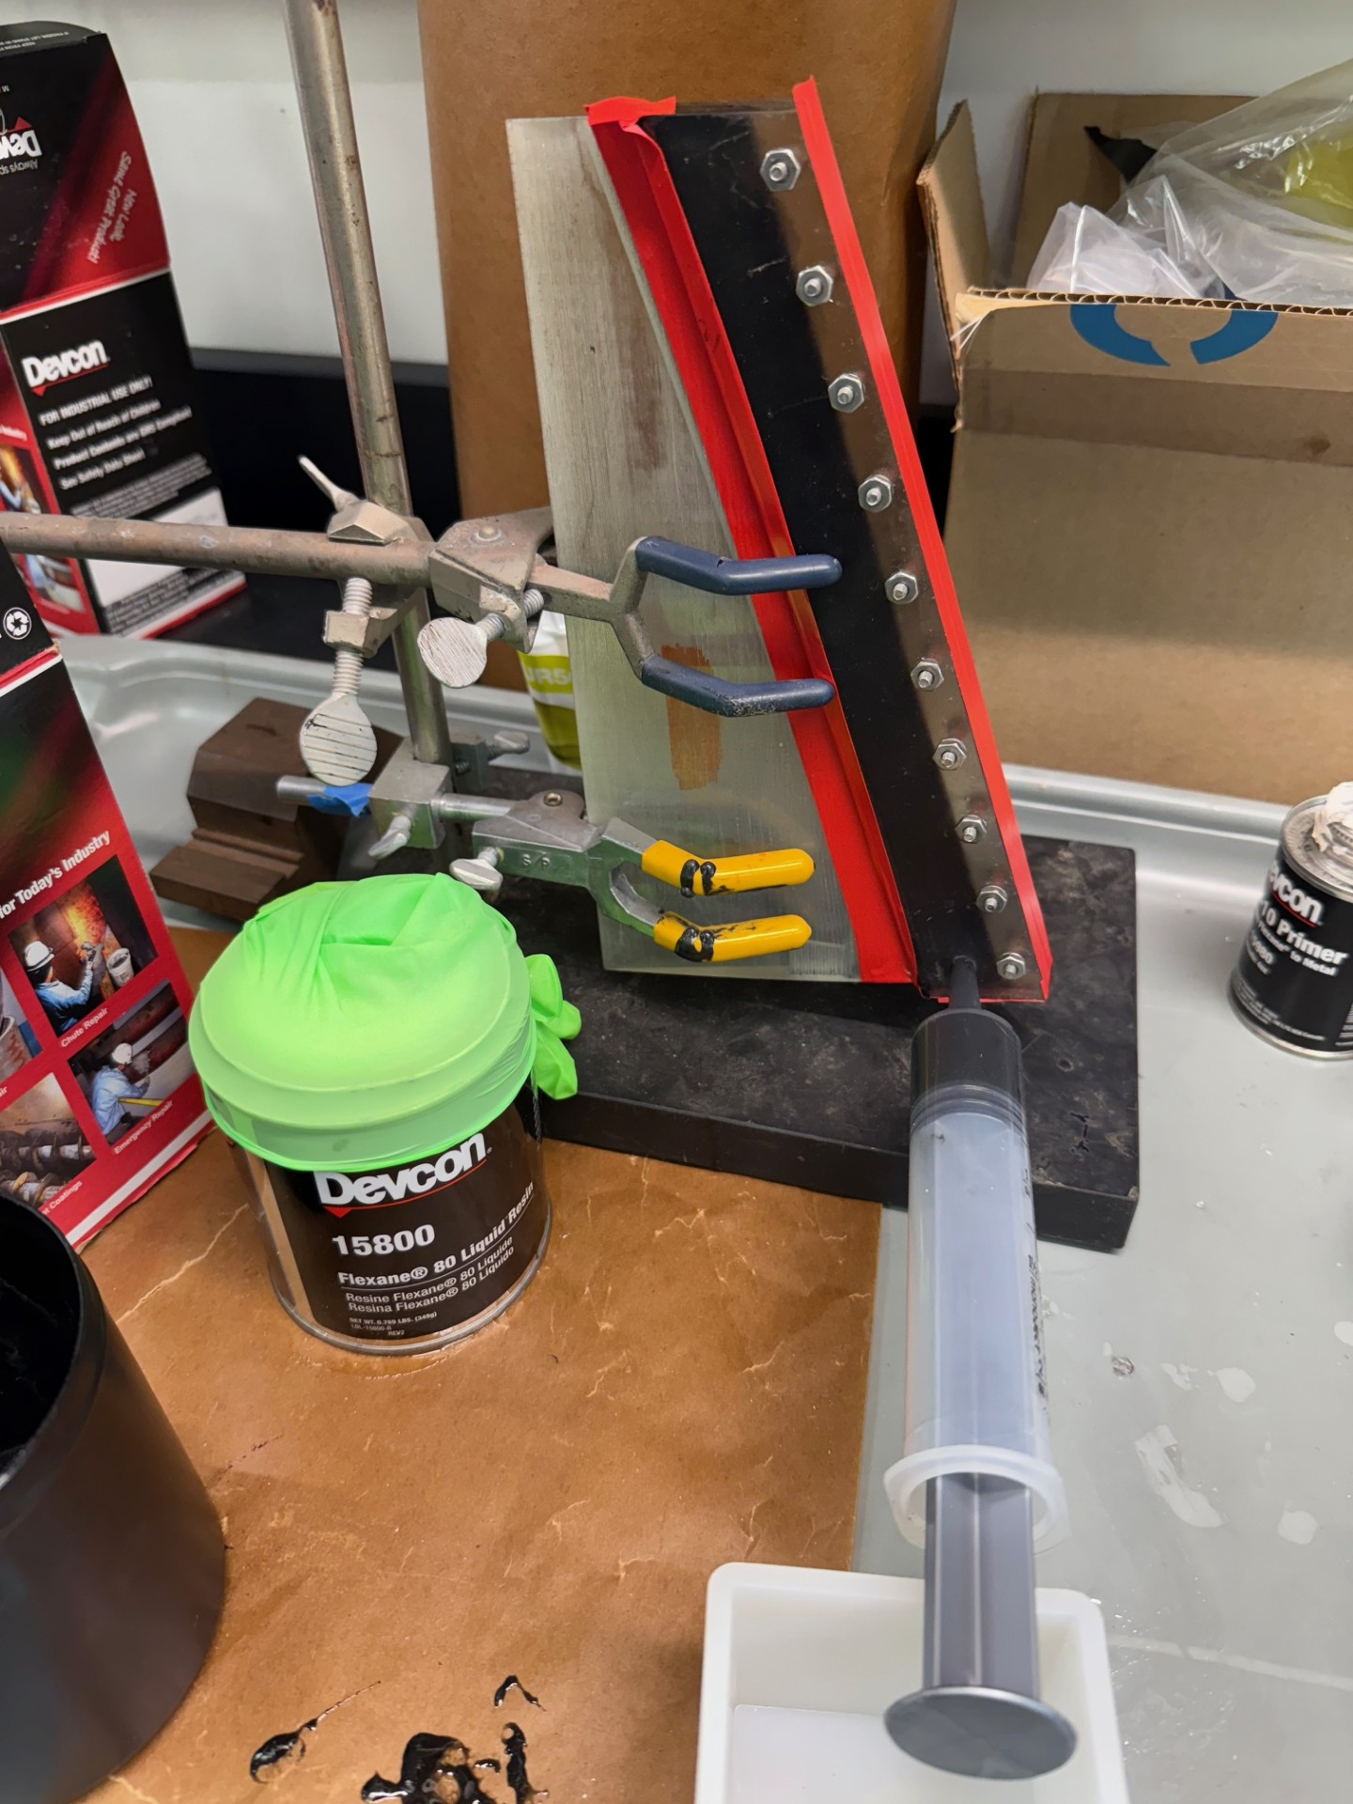

Tape fin ¼” from grooved edge with painters tape – Guide for mold
Wash groove with soap and water and dry with clean air - let sit
In fume hood, brush on 2 coats of FL20 primer with a 20min dry between coats, and a 20min dry before potting
Spray mold release into mold pieces… 2 coats
Clamp mold halves on fin at edge of alignment tape, and tighten screws
Remove alignment tape, and re-tape with electrical tape to seal mold/fin seam, and seam all around mold
Rig in stand with top of fin level
Mix resin in the ratio of 77:23 resin:curing agent
To mix 70g of resin, use 53.9g resin and 16.1g curing agent. This will give plenty left over in case you spill during potting

