The volume of the bumper is 43 cm2, so that's about 45 g of resin. You can mix 60-80 g of resin to have plenty of margin. I used a 60 cm2 syringe and it was fine. I'll bring you a couple.

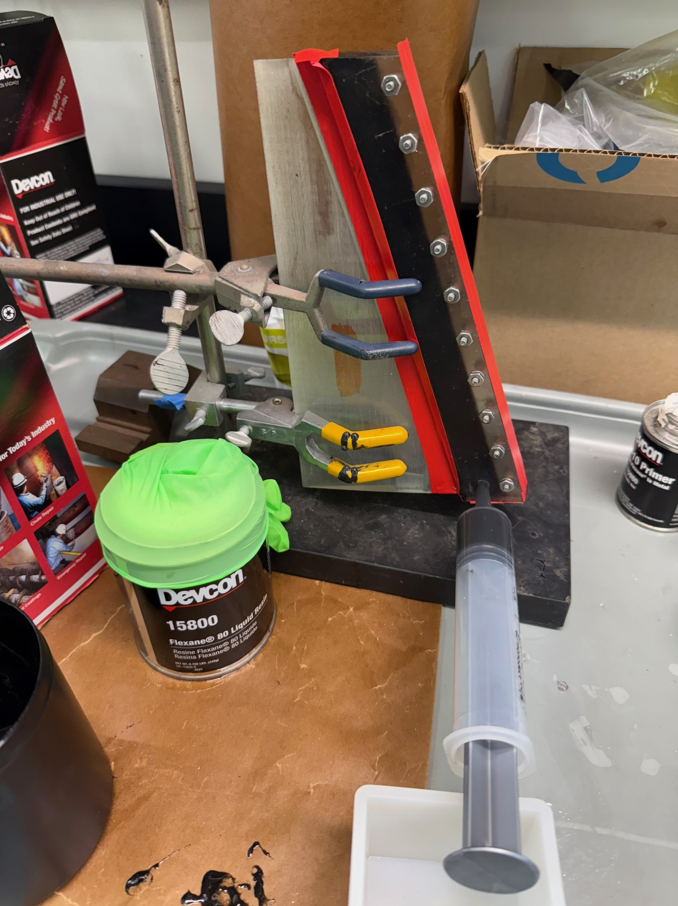

Make sure that the fin axle can be seated correctly into its location in the base of the fin. If not, first clean up the hole/slot before making the bumper.

Set up potting stand ahead of time so you are ready to place fin in position with minimal handling once it is clean and coated with primer.
Rough the bonding surface of the fin (the groove) with sandpaper ~180 grit. Blow off particles. Wash groove with soap and water to remove oils. Dry with clean air, and let sit to let all water evaporate.
Tape fin 1/4” from grooved edge with painters tape – this will be a guide for clamping the mold. 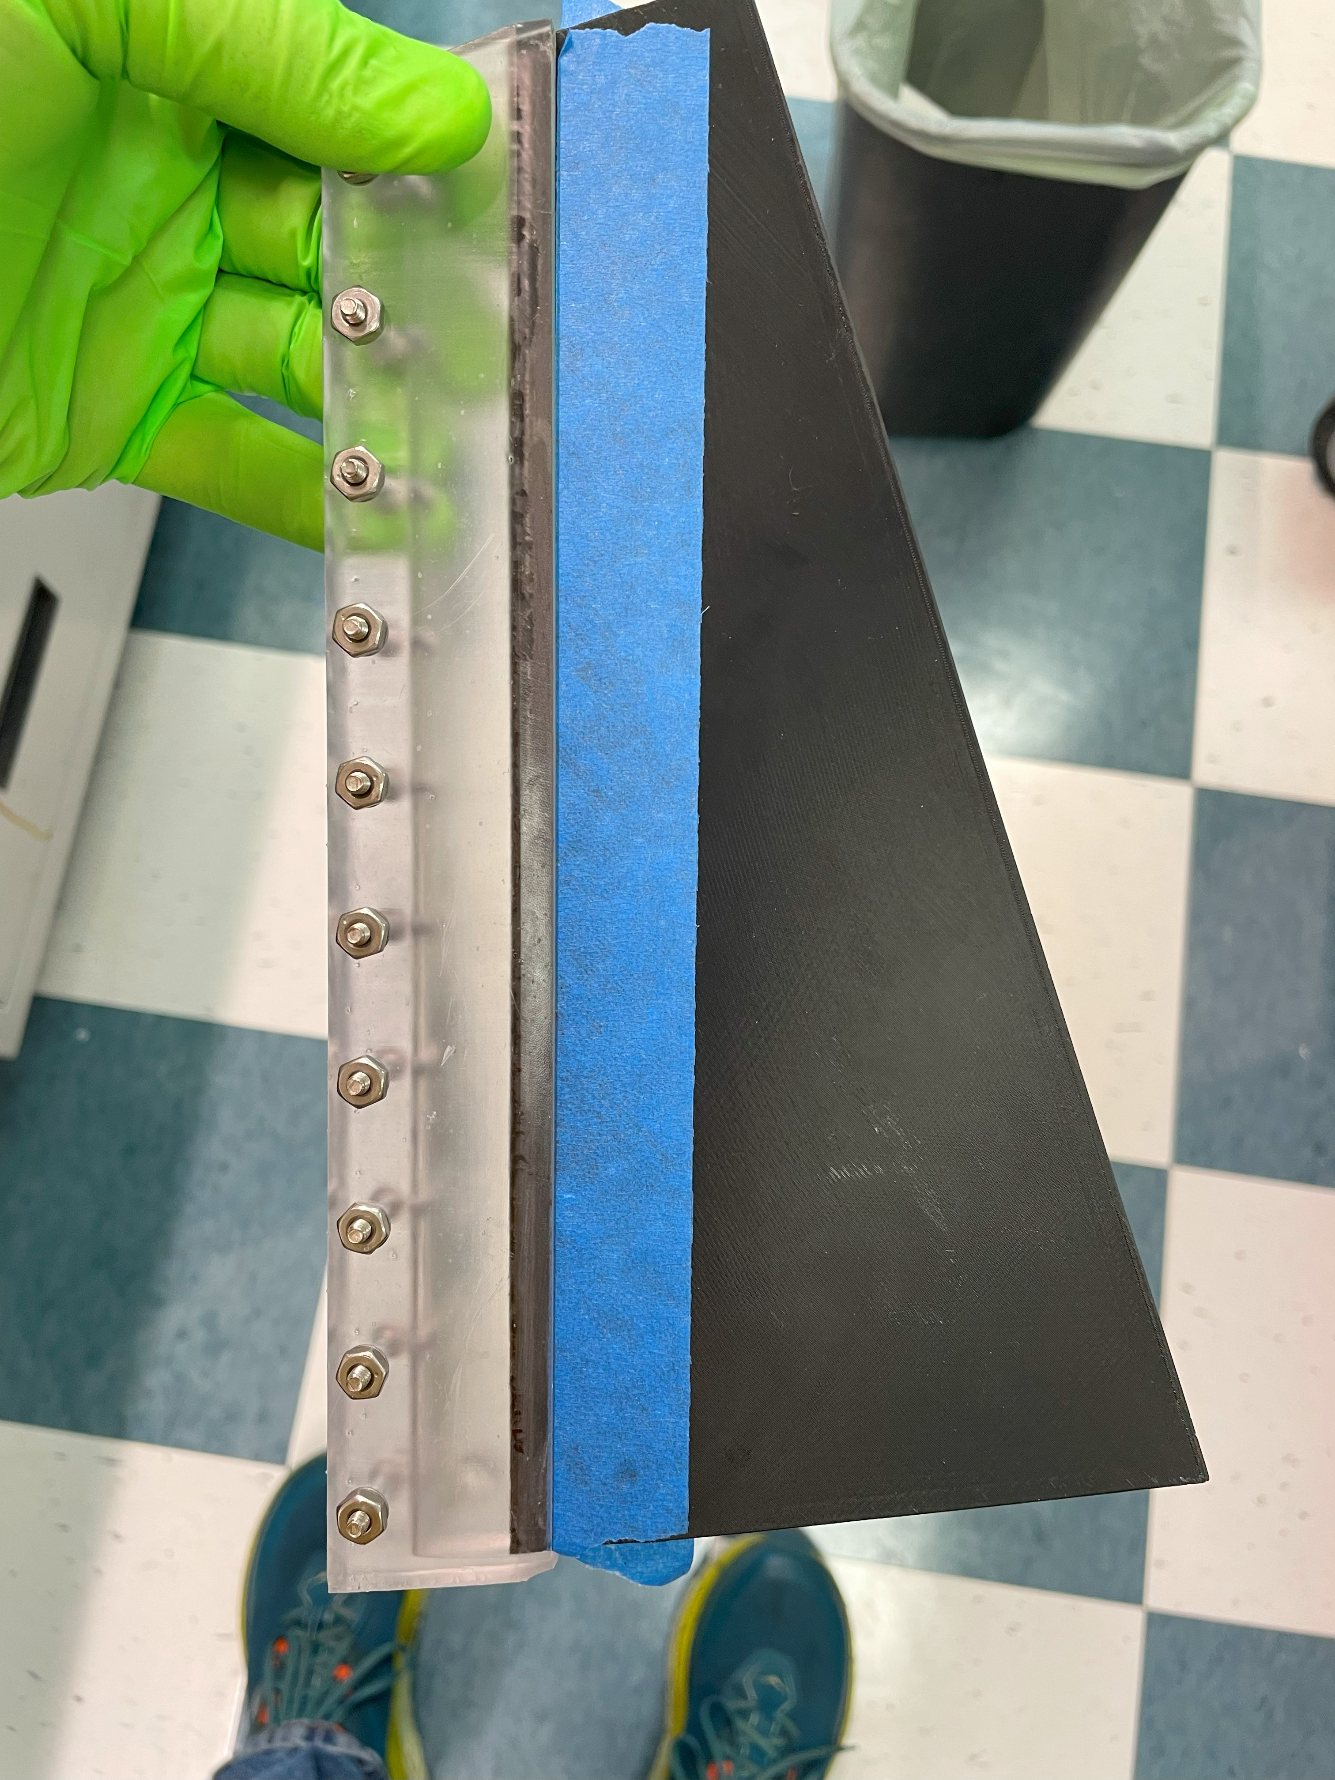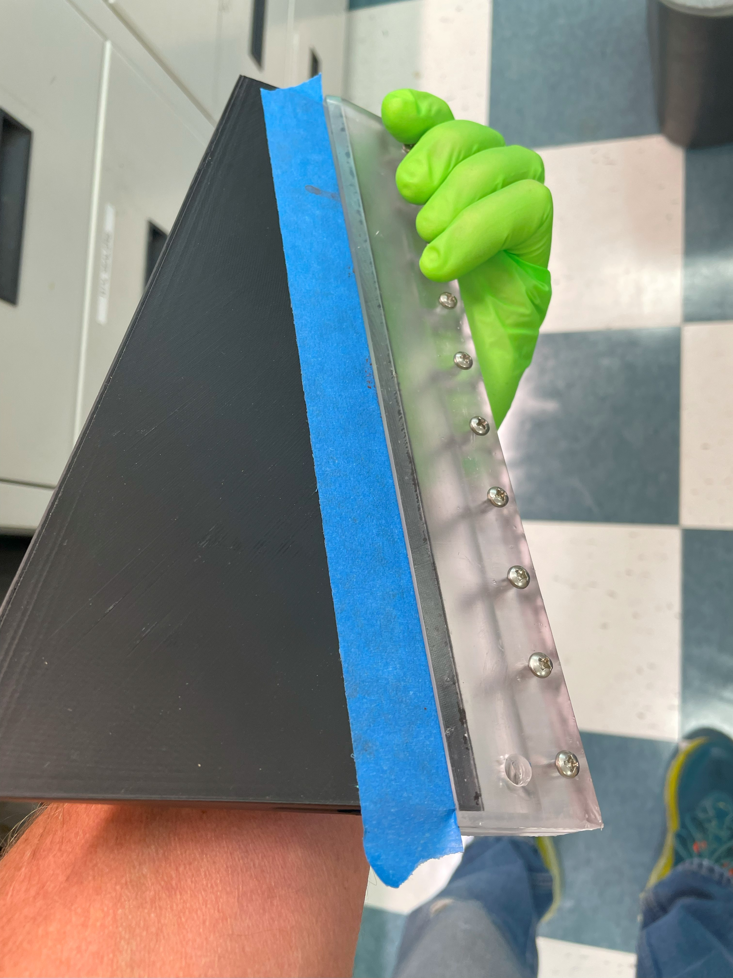

In fume hood, brush on one coat of FL20 primer, let sit for 20min, and then brush on a 2nd coat. Let sit another 20min in the hood before potting. While this is drying, spray mold release into mold pieces… 2 coats
Clamp mold halves on fin at edge of alignment tape, and tighten screws.
Remove alignment tape, and re-tape with electrical tape to seal mold/fin seam, and the seam all around mold. Make sure you seal this tightly to avoid leaks from around the seams and tape.
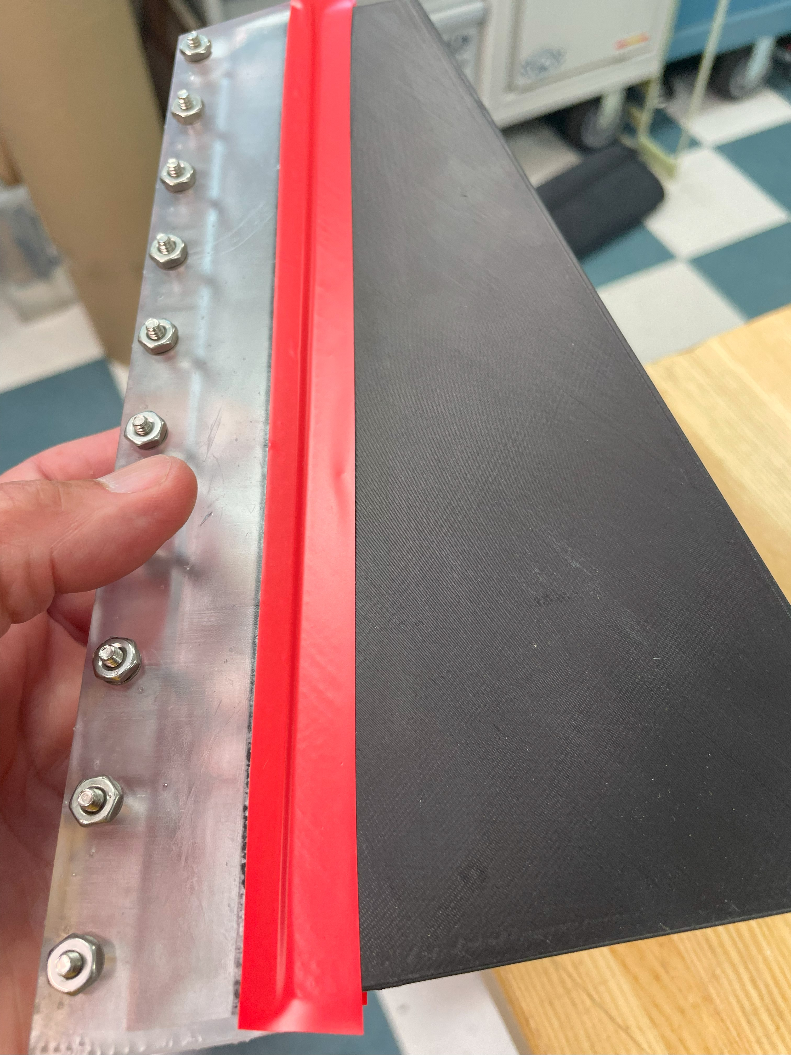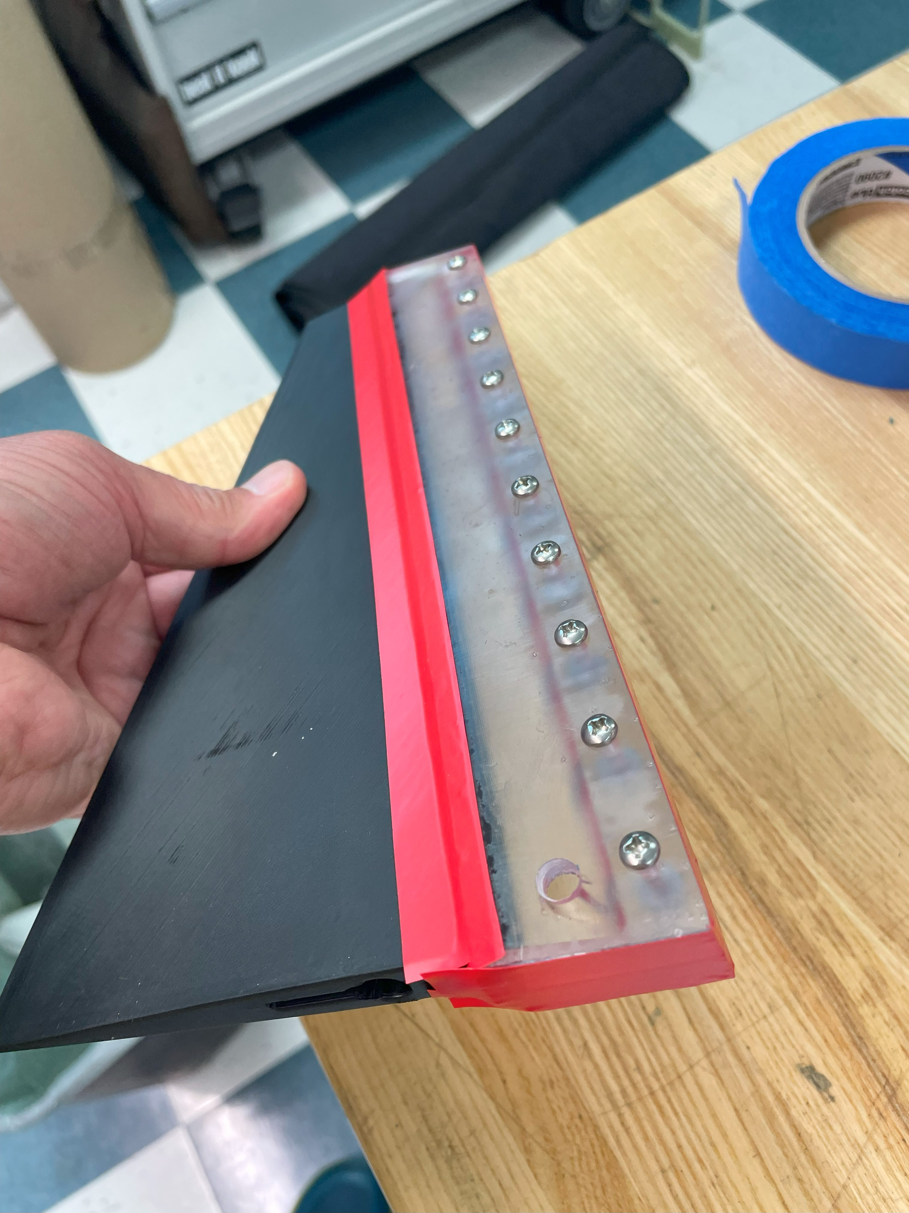
Rig in stand with top of fin level
Mix resin in the ratio of 77:23 resin:curing agent per instructions.
To mix 70g of resin, use 53.9g resin and 16.1g curing agent. This will give plenty left over in case you spill during potting. Once mixed, there is a 30min pot life.
Pour resin into a 60mL syringe, and push out any entrapped air. Then press the tip of the syringe into the hole in the bottom of the mold, and slowly depress the plunger to fill the mold space with resin. Overfill the resin so there is a convex meniscus (“bubble”) of resin extending above the mold. This will shrink as the resin cures.
Support the end of the syringe so it stays firmly in the injection hole, and doesn’t leak resin around the edges.
