McStar Wrapup
November 2010
Gene Massion

- Introduction
This report will provide a wrap up of the current state of the McStar project and present the results from a brief look at the data acquired during the January-February 2010 deployment.

- Data Description
The files for the McStar project are stored in 2 locations. Data is stored on \\Tempest\McStarData. Data from the Jan-Feb2010 deployment is stored in \\Tempest\McStarData\DeploymentJan22-2010\R2010-021-16-28-19. There are 2 subdirectories: \R00000 and \Gene. \R00000 has all the data files and only the data files from the deployment hard disk. \Gene has all my analysis routines, figures, matlab .mat results files, and everything else I used to generate these results. The 2nd location, \\Tempest\ProjectLibrary\McStar\BeagleBoard has all the design documentation.

NOTE: The times you see associated with each file using Windows file explorer are 8 hours behind the actual Pacific Standard Time (PST) when each file was written. This is due to the differences between how the Linux system on McStar records time and how Windows records time. In any event, 8 hours (1/3 of a day) needs to be added to the file times you see in Windows explorer to reflect the correct PST. Local time is used in this report. To help verify file times, the following timeline shows some important events and the times extracted from the MBARI Expedition Database.

Friday January 22, 2010 0835 PST Start of Dive 3495:Start of Vrijenhoek dive
Friday January 22, 2010 1159 PST End of Dive 3495:Start of Vrijenhoek dive
Friday January 22, 2010 1404 PST Start of Dive 3496: McStar Deployment dive
Friday January 22, 2010 1445 PST End of Dive 3496: McStar Deployment dive
Friday January 22, 2010 1505 PST Start of Dive 3496: STED Deployment dive
Friday January 22, 2010 1543 PST End of Dive 3496: STED Deployment dive

Friday February 19, 2010 0754 PST Start of Dive 3521: McStar Recovery dive
Friday February 19, 2010 0841 PST End of Dive 3521: McStar Recovery dive

The Sted released on Feb 5th, 2010 at about 15:46. A plot of the STED float depth vs time is shown here.

- Analysis tools
Matlab is the primary analysis tool. A number of Matlab scripts (.m files) have been written to help analyze the data.

processMcStarVer004_0.m
This script takes a user defined set of files (1 file to all files) and calculates any or all of the following statistics: 1) the RMS value of a user specified length of time, 2) a histogram of analog to digital converter (ADC) values for a user specific length of time and 3) a power spectral density (PSD) with user specified parameters. Please note that the roughly 30 days of data represent approximately 250 Gbytes of data and special attention must be paid in Matlab to make sure you don’t run out of memory. Generally this is handles with one value in the script that set how many files are processed before the data is written to disk and the old date in memory is cleared.

procAllSpectrums.m
This script runs through a user specified sequence of files and calculates just the PSD.
buildRecord.m
This script simply builds runs through the files from a user specified start time for a user specified time duration and builds a vector of ADC samples for use in further analysis. This is a useful utility for looking at an interesting segment of data using standard Matlab tools in conjunction with McStar scripts like the McStarPlayer.

McStarPlayer.m
This script allows a user to listen to a time record of McStar data (like a record generated with buildRecord.m. The user can scroll back and forth through the data at 1X, 2X,. 4X and 8X real time. In addition a PSD of the data currently playing is calculated and plotted. This is a custom Matlab GUI and the files are in the AudioPlayer subdirectory.

gramScroll.m
This scripts takes a previously generated 2D PSD array and first plots a spectrogram of the entire record in one figure. A second figure displays a user specified subset, both in time and/or frequency band, of the entire record. Figure 2 scrolls through the entire record in time each time the user hits a key. Please note that this script uses the Matlab function imagesc which, as noted earlier, is much more effective than the surf function.

A typical workflow would be to use buildRecord to generate a time history of interest. The Matlab SPTool GUI allows the user to visualize the data in the time domain, calculate PSDs, filter out noise or look only at desired frequencies. McStarPlayer can then be used to listen to the processed data and get a quick look at the PSD. gramScroll can then be used to look at the PSDs in much more detail. This process can of course be repeated as desired with new user specified parameters.

- Results
I’ve taken a brief look at the data and the results are described here. Please note this “first look” at the data is not a substitute for a thorough analysis. The first figure shows a waterfall plot of the power spectral density of the acoustic data from all of the data from the time McStar was started on deck until the system was stopped after the system was recovered and on shore. This figure is generated using the following Matlab commands (with some customization of the figure using the figure property editor). Proc60Hz is a McStar Matlab .m file and calculates 1 spectrum using the Welch method for each data file. Each data file is 5 minutes of data. The spectrums have a 0.73 Hz frequency bin size.

proc60Hz;
surf(freq,times,double(Pxx),'EdgeColor', 'none');
datetick('y')
view(25, 30)
help xlabel
xlabel('Frequency (Hz)')
ylabel('Date');

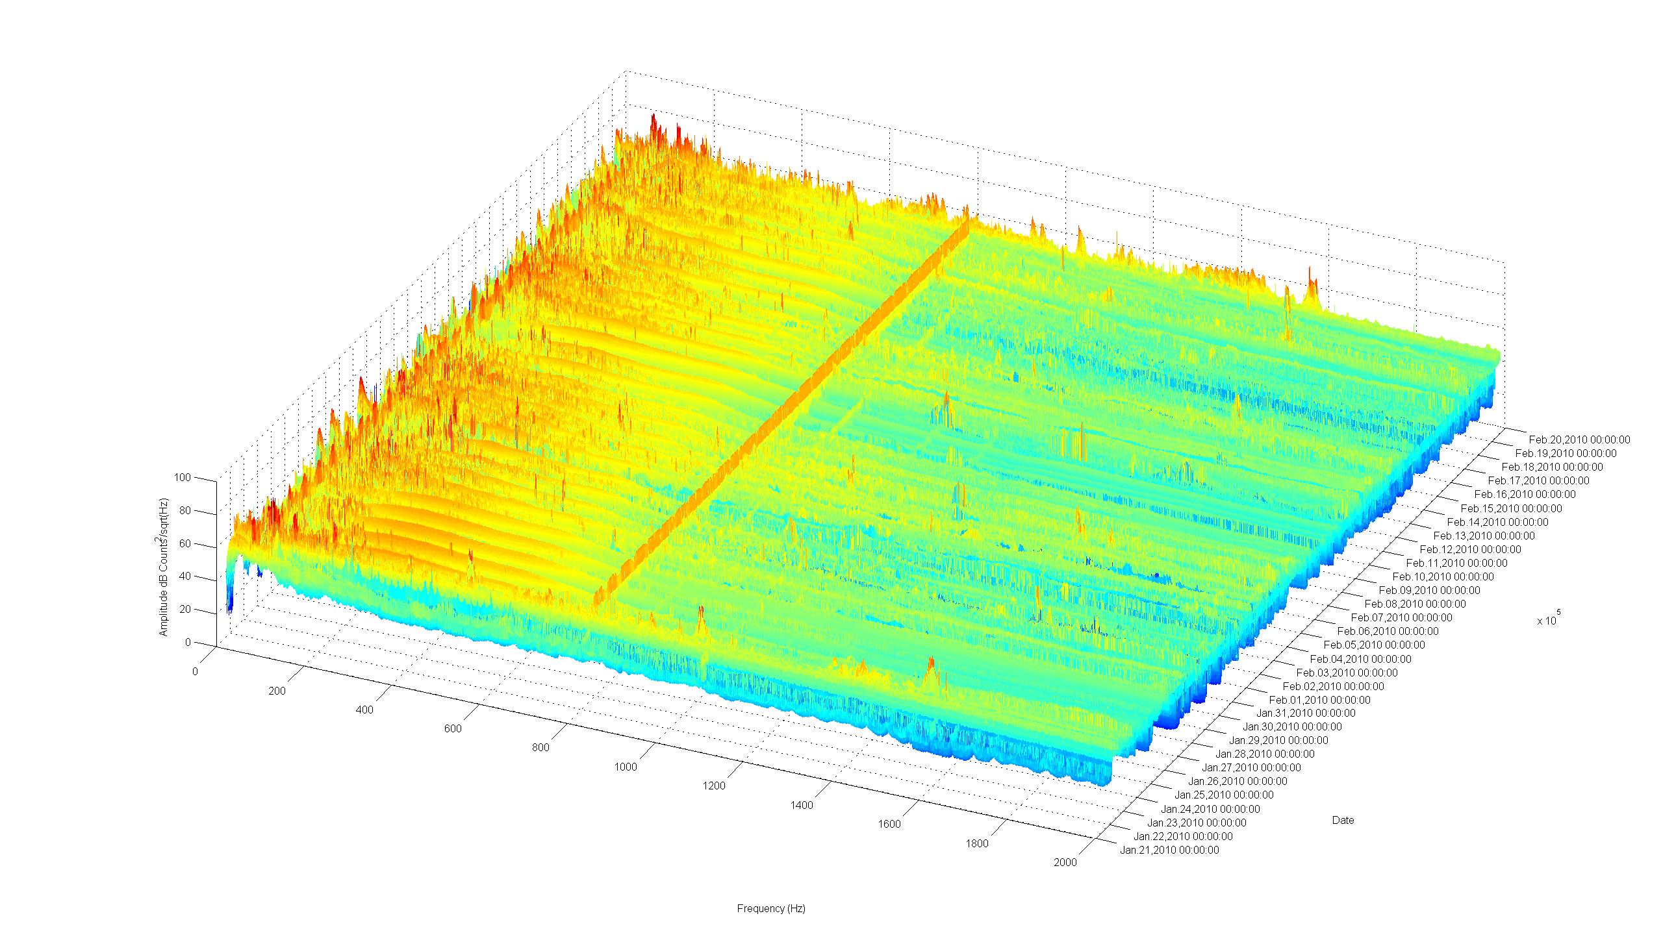
There is a clear line at about 800 Hz although there is some periodicity in the amplitude. A daily increase in low frequency (LF) noise is also evident. A 60 Hz line is also evident but has some significant periodicity. Subsequent figures also show these lines.
The second figure is a spectrogram, i.e, the same waterfall plot as above looking down on the data from above. Once the waterfall figure is generated the view(2) Matlab command give the spectrogram.
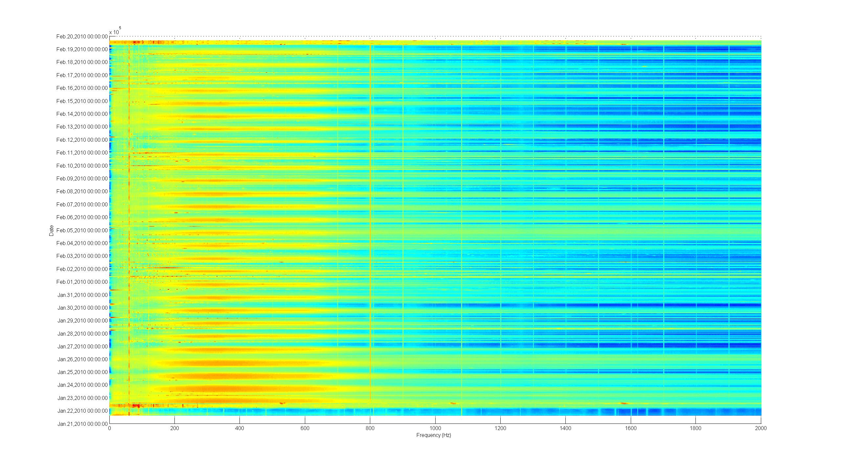
A look at the first 3 days shows 3 distinct sections, A) McStar on deck, B) McStar in the water with the Lobos in the vicinity (“contaminated” data) and the start of the “uncontaminated” record. You can also see obvious differences in the spectrum when the Lobos is in the vicinity and when it is not. There seems to be some significant banding in the time axis, i.e, that data seems constant for about 100 minutes. Further work showed that plotting the data with the Matlab function imagesc instead of surf is much more effective; no banding is evident and the plot generates much more quickly.
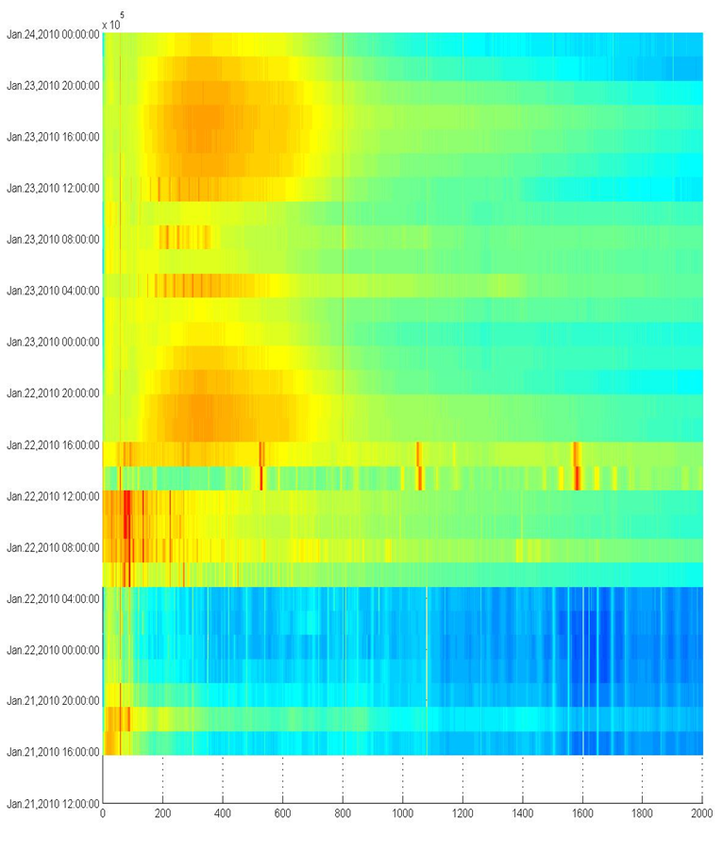
Might be when we moved McStar onto Ventana front porch
Start of deployment dive

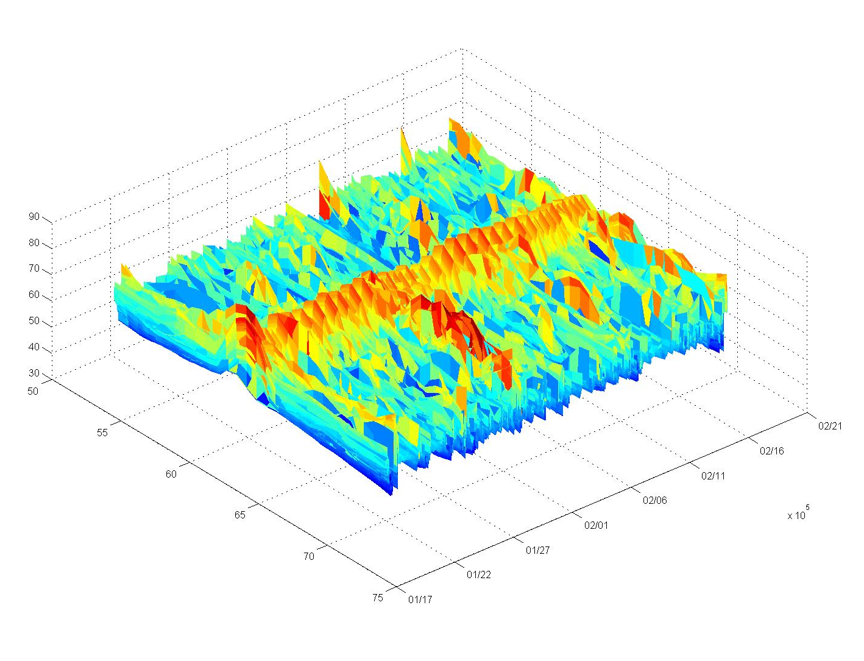
The 60 Hz line is something of a mystery given McStar is entirely battery powered and we don’t see this line in the lab records with the hydrophone disconnected and the hydrophone inputs to McStar connected together. We’re speculating this 60 Hz line is generated by our proximity to the Moss Landing power plant. We’re trying to get a record of the power plant’s power output to see if it correlates with our acoustic record. Here is the waterfall (same axes and units as previous waterfall).

Here is the spectrogram
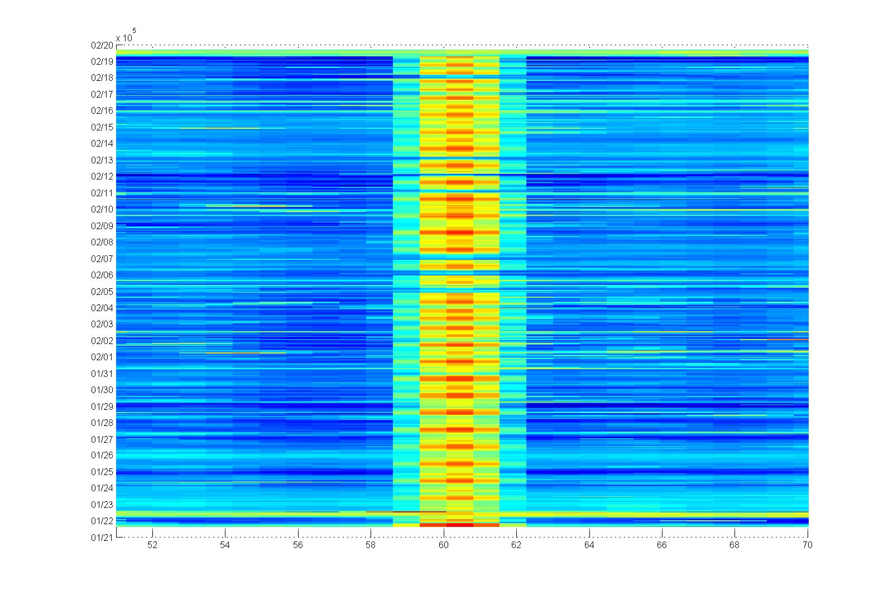

Here is an arbitrary 4 day slice that emphasizes the periodicity.
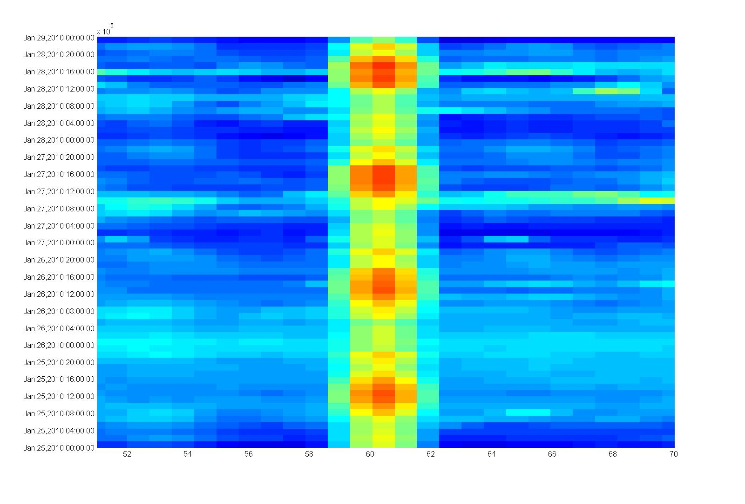

A line plot of just the PSD amplitudes at 60.05 Hz (the closest bin to 60 Hz and also the bin near 60 Hz with the highest amplitude) for the entire deployment also shows the periodicity. Calculating the PSD of this data show a clear line with 24 hour period as well as higher frequency (lower period) harmonics

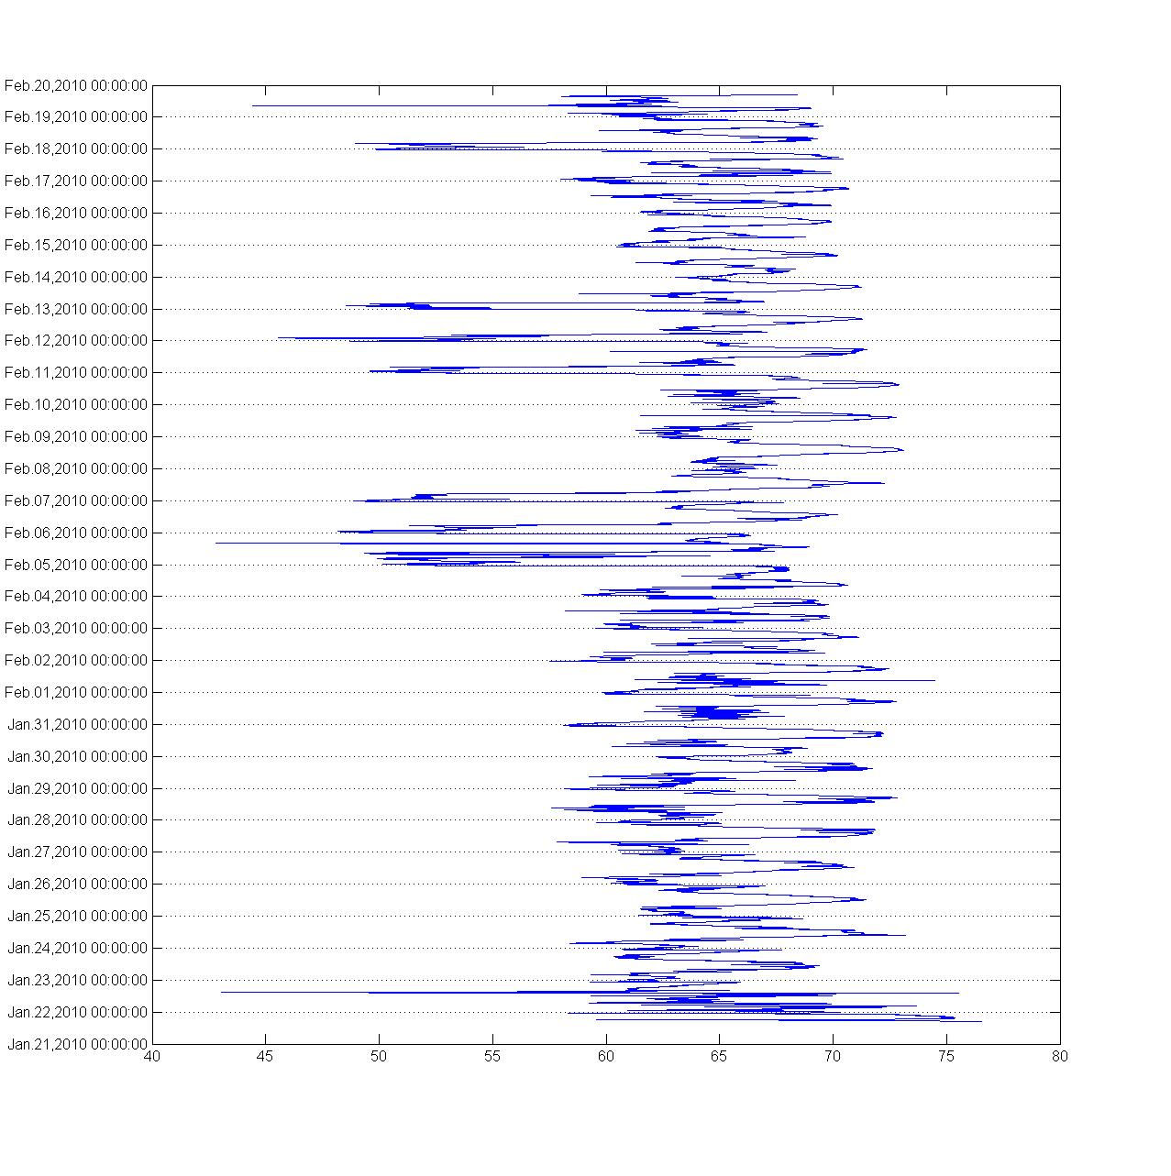

gramScroll was used to look at the PSD around the STED event of February 5th. A spectrogram (using imagesc) of the entire record (minus a few days at the end) is shown here.

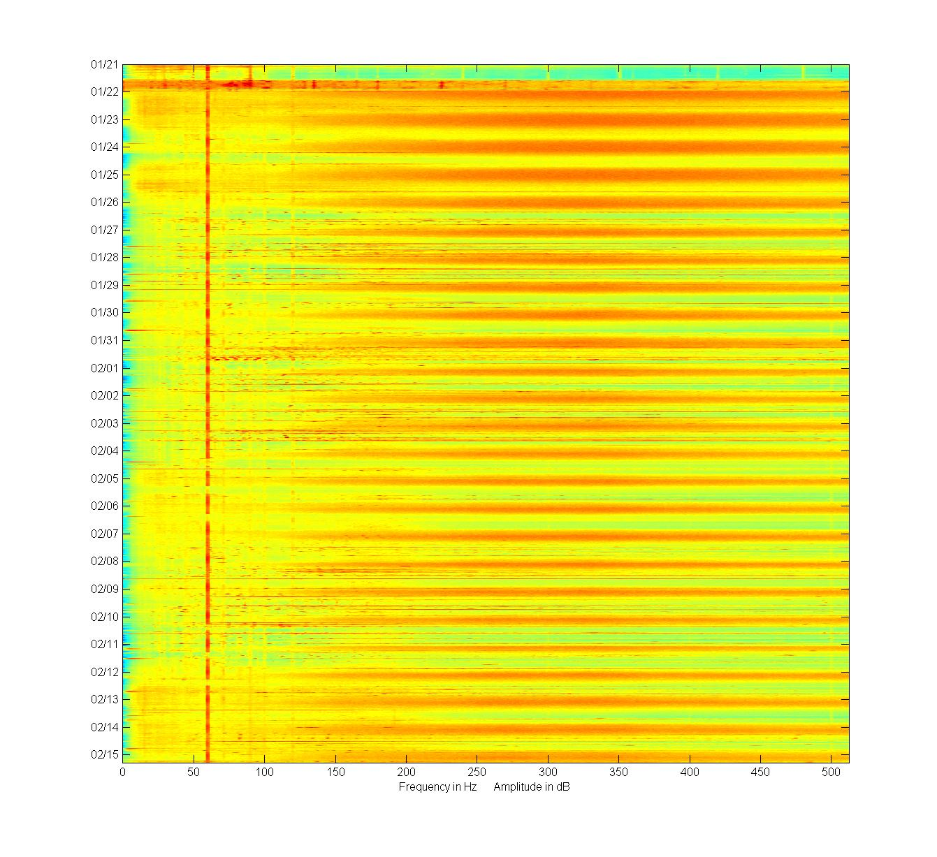
This is a spectrogram zooming in on Feb 5th, the day of the event

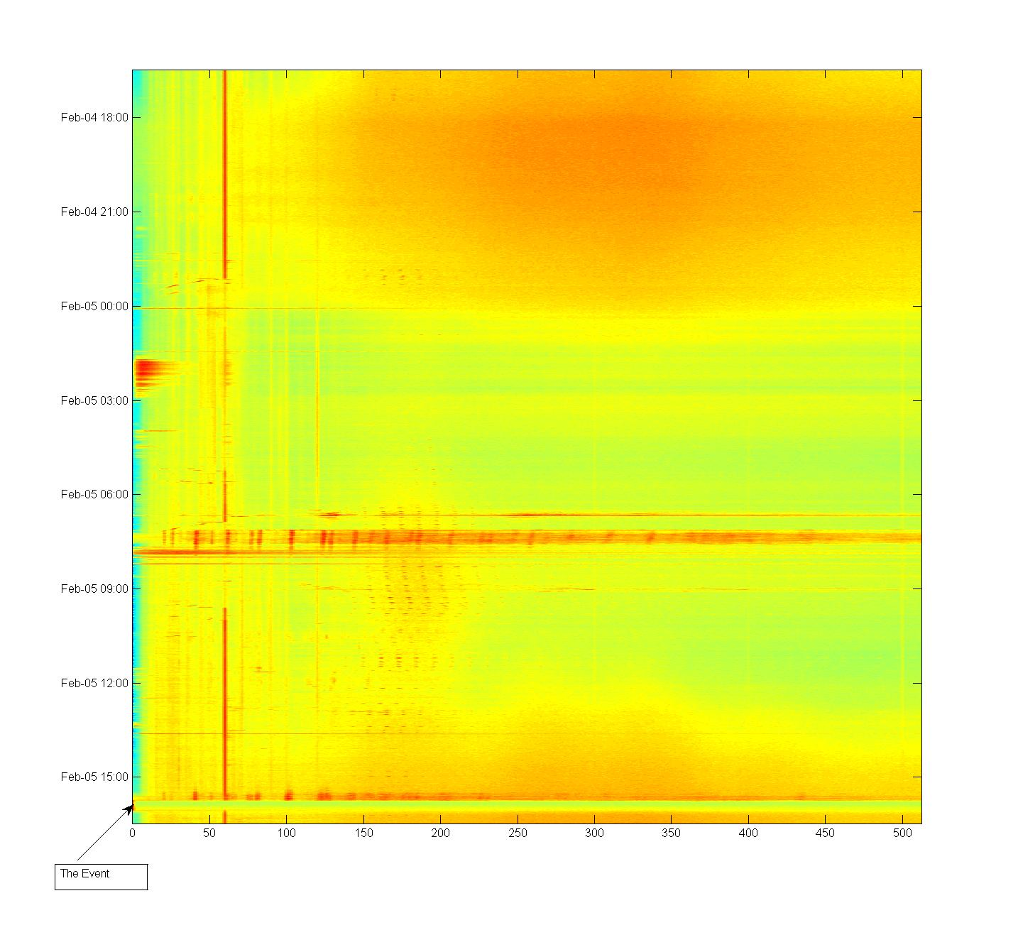

Zooming in on just the event:
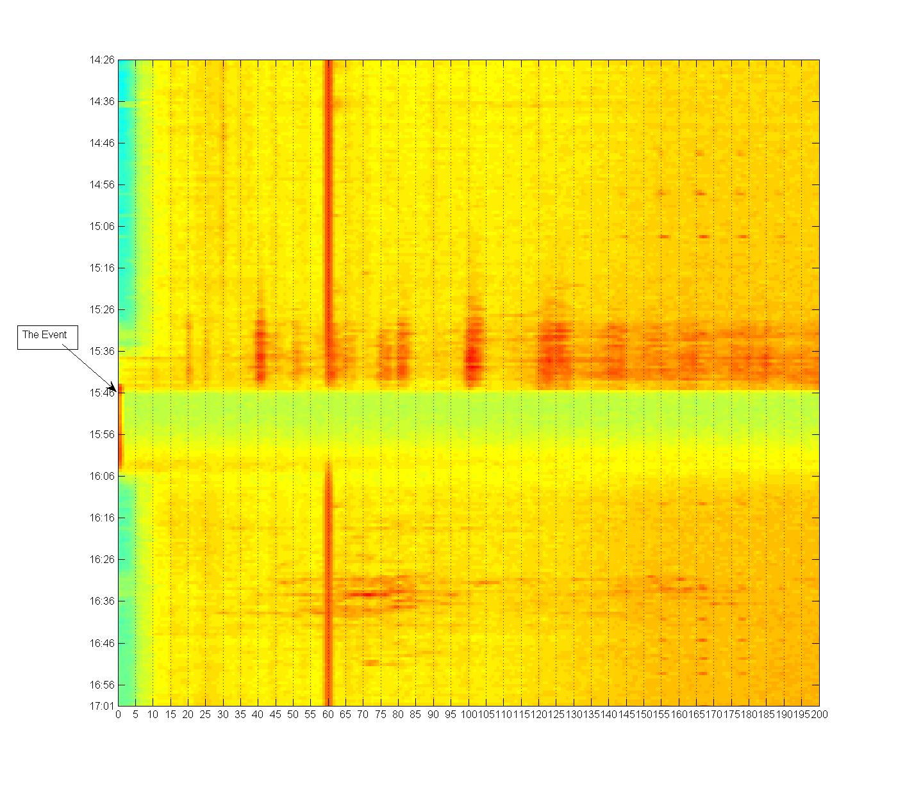

We know the event saturated the McStar ADC and the data is clipped during the loudest part of the vent, a period of about 12 minutes according to this spectrogram. Although the spectrogram shows all the energy during the clipping part of the event at around 1 Hz, this won’t be accurate because of the clipping. However, we can see some obvious bands of energy leading up to the event (before the clipping) centered around 41, 60 (of course), 82, 102 and 125 Hz. One important question we’re trying to answer is whether we can identify a unique “signature” for a sediment transport event. Although this first look is not enough to answer this question, looking through the data to date shows no clipping events of this duration. However, energy in similar bands does show up in other parts of the record. Again, a more detailed look at the data is required to understand what may be happening.

- Notes for future work

The following comments are taken from the McStar Brown Bag Seminar version 2.

Current Status
- The basic McStar system functions with several issues
  - 500 GB of storage
  - ~85 dB of dynamic range
  - ~60 days of battery life based on measured power draw and conservative D-cell W-hrs (both analog and digital battery stacks)
  - ~60 days of disk storage (16 bits, 48000 samples/sec, 1X 500 GB HD)
  - Plenty of unused processing power
- 2 systems exist – 1 deployment system and 1 test system
- The Matlab script works OK
  - I used it extensively for the brown bag presentation
  - Calculates RMS, histograms and power spectrums
    - 2D plots, waterfalls and spectrograms
  - Extremely large data sets require extra attention
Issues
- Need more dynamic range
- Frequency “banding” is obvious in deployed data spectrograms but not apparent in bench data
- Periodic “click”
- Starting the system could be simpler
- We may be oversampling by a factor of 10 – 20
Sample rate strongly drives the mission duration, …

To Do List
- “Must” be done
  - Understand where the banding, clicking and 60 Hz line comes from
    - Radiated noise on the Hydrophone power supply lines?
    - Hydrophone hard mount?
    - data burp between files?
    - Fix what needs to be fixed
  - Better understand the required dynamic range and meet it
  - Make the system start with 1 “button”
  - Replace current wet connectors
  - Make sure the test unit is identical to deployable unit
    - e.g., the Instr. Amp. power DB9 is wired differently
  - Need to shut down before power dies
  - Fix the time stamp so everything is in local time
- Nice to do
  - Increase mission duration
  - Improve acoustic directionality
  - Replace primary alkalines with rechargeable lithiums
  - Decrease turnaround time, maybe without opening the elex housing
  - Might want to add a ROV readable heartbeat

Note: The caption in this figure is wrong. The hydrophone was replaced with the National Instruments Dynamic Signal Analyzer analog output set at 512 Hz. However, there are no significant lines at anything (like 60 or 800 Hz) other than 512 Hz.

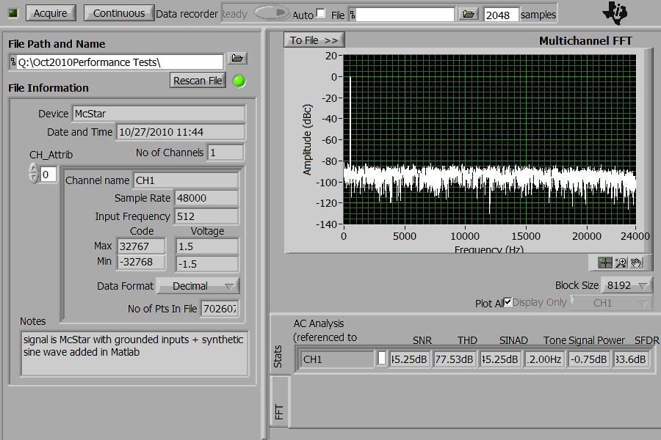
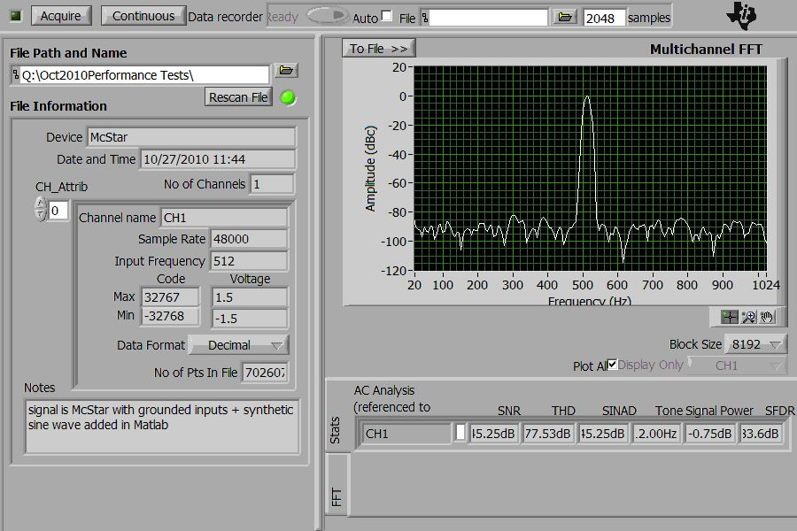
Dynamic range test with no hydrophone and inputs grounded at internal hydrophone connector
Note – no banding

