Primary productivity in the global ocean observed from Argo oxygen floats

Kenneth S. Johnson and Mariana B. Bif¹

The biological transformation of dissolved inorganic carbon to organic carbon during photosynthesis in the ocean, marine primary production, is a fundamental driver of biogeochemical cycling, ocean health and the earth’s climate system, . The organic matter created supports oceanic food webs including fisheries and is the biological pump’s first step, an essential control on atmospheric carbon dioxide levels. Marine primary productivity is sensitive to changes due to climate forcing, but observing the response at the global scale remains a significant challenge. Sparsely distributed productivity measurements are made using samples collected and analyzed on research vessels^{2,} . However, there are never enough ships and scientists to enable direct observations at the global scale with seasonal to annual resolution. Today, productivity with such resolution is estimated using remote sensing ocean colour observations and linked models that are calibrated with the sparse shipboard measurements, , but there have been no direct measurements. Here we demonstrate the measurement of gross oxygen production by photosynthesis using the diel cycle of oxygen concentration detected with the array of Biogeochemical-Argo (BGC-Argo) profiling floats. The global ocean net primary productivity computed from this data is 39 Pg C y⁻¹, which will be a significant constraint on satellite and GCM model-based estimates of the ocean productivity.

Global ocean productivity is estimated to be near half of the Earth’s total productivity and represents the autotrophic biomass that is readily available for the remaining food web. Uptake of inorganic carbon and sinking as organic matter sequesters atmospheric carbon into the ocean, a process known as the biological carbon pump³ that may reduce atmospheric CO2 by 200 ppm. Measuring metabolic rates via daily photosynthetic generation of oxygen (gross oxygen production, GOP), total carbon dioxide reduction (gross primary production, GPP) and net primary production (NPP, GPP minus autotroph respiration to sustain self-metabolism) have been valuable tools to assess the marine ecosystem status and productivity². In a changing ocean, primary productivity is observed to be changing spatially, seasonally and in magnitude^{2,} .

The earliest measurements of primary productivity in the ocean were based on the Light Bottle/Dark Bottle (LBDB) methodology, resulting in GOP rates⁶. Poor sensitivity and bottle artifacts led to replacement of the LBDB method by ¹⁴C-bicarbonate labeled incubations as the most generally utilized method. It is interpreted to yield net primary productivity estimates^{6, ,} , although bottle artifacts may still occur. The first assessments of global primary productivity were based on extrapolation of ¹⁴C-labeled NPP measurements to the entire ocean. More recently, methods based on the fractionation of the three isotopes of oxygen have been used to determine GOP rates using samples collected without incubation, . However, there are never enough of any of these measurements to enable the extrapolation to a global extent with seasonal to annual resolution.

With the advent of satellite based observations of chlorophyll near the sea surface, a variety of methods to estimate the ocean’s biological productivity were developed. These estimates were based on models of primary production, that are tuned to a limited set of ¹⁴C-uptake NPP observations (Figure 1a) and driven by the satellite fields of chlorophyll, and, in some cases, light scattering. More recently, global estimates of ocean primary productivity have been generated using general circulation models with embedded biogeochemical models, . These methods generate net primary productivity rates in the range of 30 to 60 Pg C/yr for the global ocean^{7, 21,} . These are not direct observations of ocean productivity, however. They are estimates derived from models with documented limitations^{7, 8, 22} . For instance, these models have difficulty reproducing observations at ocean time series stations and may be impacted by changing phytoplankton physiology.

In an approach derived from the original LBDB method, autonomous platforms equipped with oxygen sensors are now capable of measuring the diel cycle of oxygen production and respiration directly in the open ocean without enclosing samples, . This has enabled direct observations of GOP and community respiration (CR, respiration at all trophic levels) in oligotrophic waters, , . These approaches are based on multiple observations over the course of each day from a single autonomous platform. The energy demand for multiple vertical profiles in each day and the likelihood of biofouling due to sustained presence near the surface would make these autonomous approaches difficult to replicate to the global scale.

Here we use the profiling floats of the Biogeochemical-Argo array to detect the diel cycle of oxygen (GOP) and compute net primary productivity at the global scale (Figure 1b). BGC-Argo floats typically make each vertical profile at ~5 to ~10 day intervals over float lifetimes that average 4 to 6 years. The low profiling frequency would seem to be incompatible with the need for multiple measurements during one day to detect a diel oxygen cycle. However, the diel cycle of oxygen is a signal that is phase locked to the solar cycle. This signal is present in euphotic zone oxygen concentrations throughout the ocean and can be resolved using the methods shown here. Exact calibration of the oxygen sensors in the array is not required. Any biases in sensor performance from individual floats are present equally in all 24 hours of the day and these calibration offsets do not affect the timing or amplitude of the diel cycle that is extracted from the array data.

Detecting diel cycles from the Argo array has been demonstrated previously. Gille found that the diel cycle of temperature in the upper ocean is observable when the array is used as a collective set of sensors. Gille introduced one additional protocol to improve the statistical performance of such calculations. That is, considering the temperature anomaly of the profiling float observations relative to a reference value rather than the float temperature alone. The reference for temperature observations was the temperature measured at local noon (or midnight) near each float profile by orbiting satellites. The use of temperature anomalies further reduced the statistical variability in the data. In the case of profiling float oxygen, we use the anomaly of oxygen concentration relative to atmospheric saturation for our GOP estimations.

To illustrate the phase locked oxygen signal, the oxygen concentration anomaly (oxygen – atmospheric saturation concentration in the same sample) data in the upper 20 m from 60°N to 10°N are shown versus the local hour of day when the samples were obtained (Figure 2a). Although the individual profile data are scattered, a diel signal is clear when the mean oxygen anomaly value in each hour of the pseudo-daily cycle is computed (Figure 2b). This plot was made with adjusted oxygen data from all floats in the Argo Global Data Assembly Center that have sampled all hours of the day evenly (see Methods) from 2010 through 2020. 14,294 profiles of 50,736 oxygen profiles from this region have the required float timing with all hours of the day sampled at nearly even occurrences. The remaining profiles could not be used to assess the diel cycle because those floats sampled at one or a few fixed hours of the day. Any calibration offsets in floats that sample at fixed times will corrupt the diel signal by biasing only the few sampled hours of the day.

A GOP annual rate of 2.2±0.3 (1 Std. Error, N=14,294) mmol O₂ m⁻³ d⁻¹ was obtained from the data in Figure 2a, which is a somewhat spatially biased sample of the Northern Hemisphere from 60°N to 10°N (Figure 1b). The procedure used to fit the GOP rate (Methods) is based on the approach outlined by Barone et al.²⁸. The annually averaged and vertically integrated GOP rate (Figure 2d) is 66±26 mmol O₂ m⁻² d⁻¹. The only limitation on resolving the diel signal and obtaining a GOP rate by this approach is having sufficient profiles in the geographic and temporal region that sample all hours of the day. These limits are considered below.

The oceanographic consistency of the GOP values obtained with BGC-Argo floats was tested with float profiles near the Hawaii Ocean Time-series (HOT) station and the Bermuda Atlantic Time-series Station (BATS). Extensive measurements of GOP, including diel cycles of oxygen in surface water, are available at these sites. The pseudo-daily cycle (Figure 3a) was determined from 1791 vertical profiles collected from 2010 to 2020 within a geographic box (21 to 25°N, 165 to 150°W; Figure 1b) that encompasses HOT. The hourly binned data (Figure 3b) show the daily cycle with a 0.8 µmol kg⁻¹ daily amplitude in the upper 20 m. A statistically significant (p<0.0005) GOP of 1.5±0.3 mmol O₂ m⁻³ d⁻¹ in the upper 20 m was obtained from the fit to the data in Figure 3a. This represents an annual mean GOP over the past 11 years. Barone et al.²⁸ have tabulated 11 reports of GOP in the mixed layer at HOT with a mean of 1.3±0.5 (1 SD) mmol O₂ m⁻³ d⁻¹. The integrated GOP from Figure 2c is 89±38 mmol O₂ m⁻² d⁻¹. The mean integral observed by Juranek and Quay on four cruises near HOT in 2002 and 2003 is 111±51 (1 SD) mmol O₂ m⁻² d⁻¹ while Quay et al. found 103±43 mmol O₂ m⁻² d⁻¹ on multiple cruises from 2006 to 2008 using the triple oxygen isotope method.

The annual cycle of GOP in the upper 20 m near HOT was computed from the float data with 2 month resolution (Figure 3c). This is the highest temporal frequency that can be resolved, consistent with the need for ~300 to 500 samples in each fraction of the year (see below). The monthly mean NPP rates in the upper 20 m measured by ¹⁴C-labeled incubations from the HOT program are shown for comparison. The ratio of GOP/NPP was found to be consistently near 2.7 during the JGOFS program¹³ and between 2 to 3 at HOT³⁴. The NPP rates measured at HOT (Figure 3c, d) are plotted on a scale that is a factor of 2.5 smaller than the GOP scale. Both sets of data show a relatively flat seasonal cycle with GOP about 2.5 times greater than the NPP. The vertical profile of GOP at 10 m intervals is shown in Figure 3d. GOP decreases with depth in parallel with the observed decrease in NPP and is approximately 2.5 times greater than the NPP profile, consistent with the observations of Quay et al.³⁴ at HOT.

Figures 3e-f show similar results for float profiles in the geographic box (28 to 38°N, 75 to 55°W; Figure 1b) that encompasses BATS. There are relatively fewer profiles in this region, with 741 that are suitable for analysis. A statistically significant (p<0.014) diel signal with a GOP rate of 2.3±0.9 mmol O₂ m⁻³ d⁻¹ in the upper 20 m was obtained for all data in the 2010 through 2020 period. The vertically integrated GOP rate at BATS (Figure 3h) is 84±30 mmol O₂ m⁻² d⁻¹. In comparison, Luz and Barakan found a mean GOP value of 70±24 mmol O₂ m⁻² d⁻¹ on 6 cruises. The annual cycle derived from float data (Fig. 3g) was computed at quarterly intervals because of the smaller number of profiles near BATS. In contrast to HOT, the GOP values decrease appreciably over the course of the year. This decrease is mirrored in the NPP data observed at BATS. The high productivity in late winter results from entrainment of nitrate into the mixed layer. The GOP/NPP ratios at BATS during winter and late fall are consistent with the canonical value of 2.7 reported for JGOFS samples¹³. During summer, the ratios of GOP/NPP in Figure 3g are higher than 2.7, with values up to 5. Higher ratios of GOP/NPP at BATS during spring and summer, in the range of 3 to 7, have been noted previously^{17, 18}. This change in GOP/NPP may result from the production of Gel-Like Organic Matter (GLOM) during NPP incubations that is not trapped on filters. GLOM would lead to an underestimate of primary productivity and elevated GOP/NPP ratios.

The diel cycles of oxygen can be used to compute ocean GOP, GPP, and NPP rates between 60°N to 60°S in the waters deeper than 2000 m that are sampled by floats. To minimize biases due to clusters of profiles in various regions (Figure 1b), we have computed zonal mean GOP by 10° bands of latitude from 60°N to 60°S using all data in each band (Table 1). This is a balance between spatial resolution and having sufficient float profiles to minimize errors in GOP. The photosynthetic quotient relating oxygen production to carbon fixed (PQ = GOP/GPP), which is used to compute GPP, is shown in Table 1 (see Methods). We assume a value of 2.7 for the GOP/NPP ratio^{13, 18}.

A GOP rate of 9.0±2.4 Pmol O₂ y⁻¹, GPP rate of 88±24 Pg C y⁻¹, and a net primary productivity of 33±9 Pg C y⁻¹ are obtained by summing the values in each latitude band (Table 1). Errors reflect only the uncertainty in the GOP values and not the GOP/NPP or PQ values. The total GOP rate falls near the lower end of the range estimated for global GOP (9.5 to 12.6 Pmol O₂ y⁻¹) using a neural network fitted to a global set of LBDB and triple oxygen isotope measurements. Adjustment of the float GOP to a global extent is consistent with the neural network total. The net primary productivity values derived from the diel oxygen cycles are compared to values derived from satellite ocean color data using the VGPM²⁰, CBPM²³, and CAFE productivity models in Table 1 and Supplemental Figure 2. The satellite sums were limited to waters with a depth greater than 2000 m. They were also limited to latitudes from 50°N to 50°S because monthly climatologies poleward have missing data during many months. The VGPM total is similar (34 Pg C y⁻¹) to the observed float value while the CBPM and CAFE models are somewhat higher (46 and 48 Pg C y⁻¹) (Table 1). There are apparent differences in the distribution of primary productivity with latitude (Table 1; Supplemental Figure 2). The CBPM and CAFE models match the float data closely at the equator, but are substantially higher between 10° to 30° in both hemispheres. The VGPM model matches the float data more closely in the 10° to 30° region, but it is substantially lower near the equator. All of the models are in reasonable agreement with the float data at latitudes poleward of 30°. If the profiling float productivity result is adjusted to the globe by adding the mean difference of global satellite NPP rates (44, 52, and 52 Pg C y⁻¹, respectively) from the 50°N to 50°S values, then a global NPP of 39 Pg C y⁻¹ is obtained.

The spatial resolution of the GOP measurements obtained from profiling floats is inherently limited by the number of operating floats. Diel oxygen anomaly cycles have an amplitude near 1 µmol kg⁻¹ in the tropics and 3 µmol kg⁻¹ in the most productive regions of the open ocean (Table 1). The standard deviation of oxygen anomaly values may range from 2 µmol kg⁻¹ in the tropics (Figure 3a) to 8 µmol kg⁻¹ at high latitudes (Figure 2a). Confidently resolving the diel cycle requires the hourly binned data that have a 90% confidence interval near half the amplitude, an approximation as the statistical analysis is performed with unbinned data. This suggests that ~500 to ~1200 total profiles (20 to 50 per each hour of the pseudo daily cycle) are required to clearly resolve the signal. With 36 profiles per year at the standard 10 day cycle time, accurate GOP determination of annual cycles will require 12 (tropics) to 30 (high latitude) float years of data. The Biogeochemical-Argo Implementation Plan calls for a global array of 1000 floats, versus 377 floats now operating, although less than one half are operating with the required cycle timing. The low number of floats available in any one year was overcome in this work by binning 11 calendar years of data. In the future, the size of the BGC-Argo fleet will increase as the recently funded Global Ocean Biogeochemistry Array (GO-BGC) will produce an array of 500 floats that are evenly distributed and which will operate with the required timing properties needed to detect diel oxygen cycles. However, even at a maximum array size of 1000 floats and with all floats operating with appropriate cycle timing, the GOP or NPP rates derived from arrays with a mean of 20 float years of data would resolve only 50 regions in the ocean, so this method cannot alone approach the resolution obtained by satellites. It is likely that assimilating the observed diel cycles at low resolution into high resolution GCMs along with satellite chlorophyll fields will mitigate this issue and contribute to a more accurate representation of the ocean productivity, as envisioned by Mati Kahru.

References

Table 1. Gross Oxygen Production rates from 60°N to 60°S in water deeper than 2000 m. Annual GOP rates were calculated using all data in each latitude band. Volumetric GOP rates in column 4 are for the upper 20 m. GOP integrals in column 5 are to the 5% light level. VGPM, CBPM, and CAFE NPP values were calculated for years 2010 to 2019 using monthly values downloaded from the Oregon State University Ocean Productivity site (see Methods). All data sets were masked for depth using the ETOPO5 topography. Errors are 1 Standard Error.
Latitude  ±5° | Area 10¹³ km² | Depth 5% light | GOP  mmol O₂ m⁻³ d⁻¹ | GOP  mmol O₂ m⁻² d⁻¹ | PQ  mol C mol O₂⁻¹ | GPP  Pg C y⁻¹ | Float  NPP  Pg C y⁻¹ | VGPM NPP  Pg C y⁻¹ | CBPM NPP  Pg C y⁻¹ | CAFE NPP  Pg C y⁻¹
55 | 1.09 | 30 | 3.5±1.3 | 80±39 | 1.25 | 3.1 | 1.1
45 | 1.50 | 30 | 2.1±1.3 | 56±39 | 1.25 | 2.9 | 1.1 | 2.8 | 2.0 | 2.3
35 | 2.08 | 40 | 2.1±0.5 | 73±15 | 1.25 | 5.3 | 2.0 | 2.9 | 2.5 | 2.8
25 | 2.51 | 60 | 1.2±0.3 | 53±9 | 1.15 | 5.1 | 1.9 | 2.2 | 3.6 | 3.5
15 | 3.16 | 40 | 2.0±0.7 | 33±20 | 1.15 | 4.0 | 1.5 | 3.1 | 5.7 | 5.4
5 | 3.42 | 40 | 3.8±1.1 | 171±33 | 1.25 | 20.5 | 7.6 | 3.5 | 7.3 | 6.9
-5 | 3.38 | 40 |  | 171* | 1.25 | 20.2* | 7.5* | 4.0 | 7.7 | 7.2
-15 | 3.35 | 60 |  | 33* | 1.15 | 4.2* | 1.6* | 3.2 | 6.1 | 6.1
-25 | 3.10 | 60 | 0.8±0.3 | 30±9 | 1.15 | 3.5 | 1.3 | 2.7 | 4.4 | 4.3
-35 | 3.23 | 40 | 1.7±0.5 | 77±15 | 1.25 | 8.7 | 3.2 | 4.4 | 3.9 | 4.6
-45 | 3.04 | 40 | 2.9±0.4 | 97±12 | 1.25 | 10.3 | 3.8 | 4.2 | 3.0 | 4.5
-55 | 2.53 | 50 | 0.4±0.5 | 4±15 | 1.25 | 0.2 | 0.1
Sum |  |  |  |  |  | 88±24 | 33±9† | 33 | 46 | 48
*GOP values were estimated from corresponding rates in Northern Hemisphere due to low number of float profiles.
†32 Pg C y⁻¹ without 55°N and 55°S bands.

Figure 1 Profile locations where primary production has been determined. a) Red dots are ¹⁴C profiles from the Oregon State University Ocean Productivity database, which includes profiles used to optimize the primary productivity model embedded in many satellite products (Behrenfeld and Falkowski, 1997; Westberry et al., 2008). Blue dots are the ¹⁴C profiles used, in addition to the OSU database, to optimize a GCM model of ocean productivity (Buitenhuis et al., 2012). b) Float profile locations for floats with adjusted oxygen data and appropriate cycle timing. Green squares are the boundaries for float profiles used to determine GOP near HOT and BATS. Stations dots in both plots are the same size.

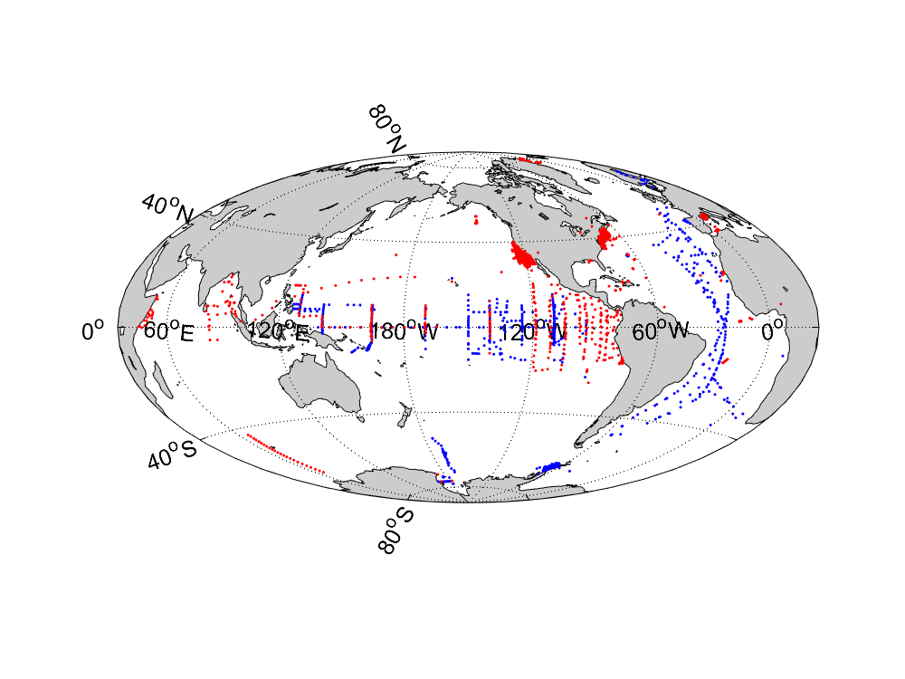
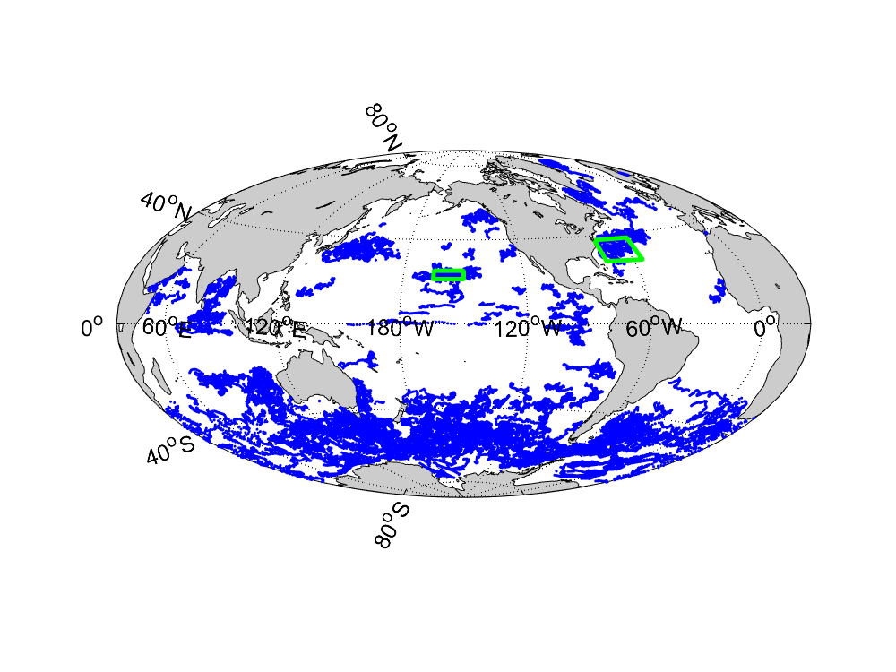
Figure 2 Northern hemisphere (60°N to 10°N) oxygen and GOP values. a) Mean oxygen anomaly in the upper 20 m from each profile with acceptable cycle timing (N=14,294) versus local hour of the day. Data from all days of year from 2010 to 2021 are included. b) Mean oxygen anomaly in each hourly interval and the least squares fit of Equation 2 to the data shown in a) with GOP = 2.2±0.3 mmol O₂ m⁻³ d⁻¹. c) GOP determined each 2 months in the upper 20 m versus Day of Year. d) Depth profile of GOP rates for all days of the year. Error bars are one standard error.

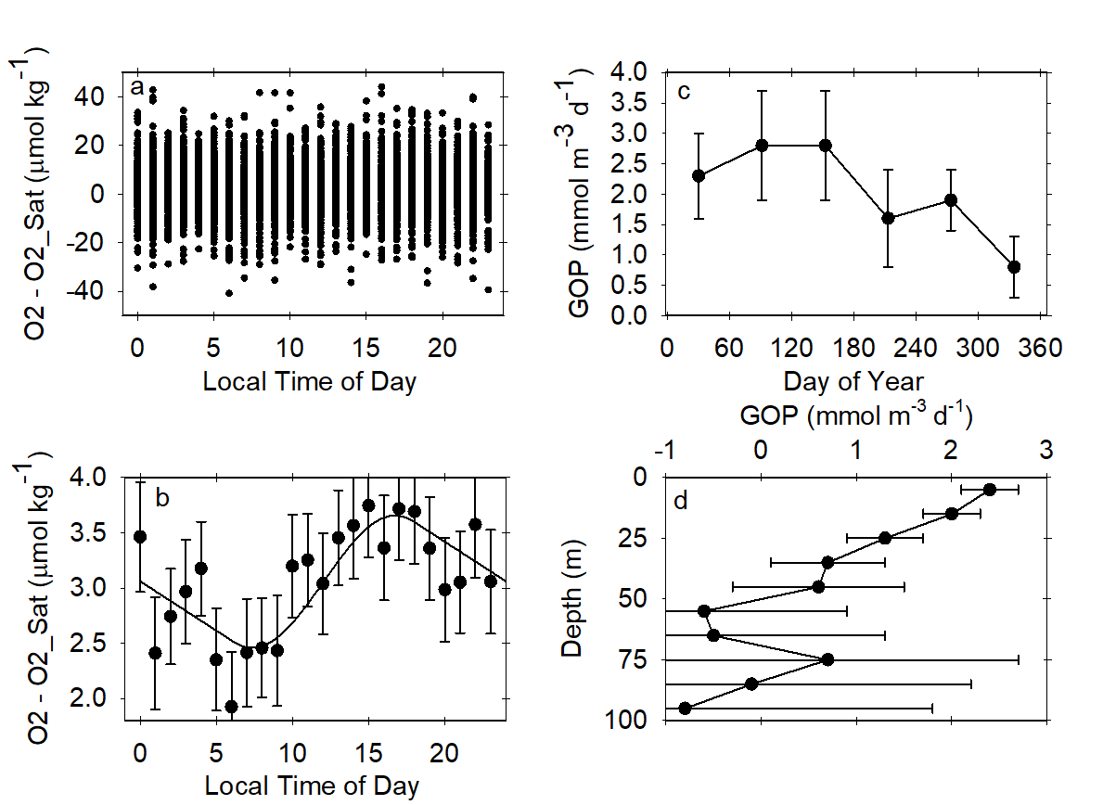

Figure 3. Oxygen anomalies and GOP near the HOT and BATS time series stations. a) Mean oxygen anomaly in the upper 20 m on each of 1791 profiles in the geographic box between 21° to 25°N and 165° to 150°W that includes HOT versus hour of the day (Local Time) that the profile was collected. Data were collected from 2010 through 2020 and include all days of the year. b) Hourly mean oxygen anomaly values for samples near HOT and the least squares fit of Equation 2 to the data shown in a). The best fit GOP rate value was 1.5 mmol O₂ m⁻³ d⁻¹. c) GOP rates in the upper 20 m calculated at 2 month intervals using data shown in a) and the monthly mean NPP values observed at the HOT station ALOHA from 2010 to 2019. d) Vertical profile of GOP and the annual mean NPP rates at standard depths observed at the HOT station ALOHA. Panels e-f are the same for a region surrounding BATS (28° to 38°N, 75° to 55°W) using 740 profiles with appropriate profile timing. The best fit GOP rate was 2.3 mmol O₂ m⁻³ d⁻¹. ¹⁴C primary productivity data are from the BATS station for 2010 to 2016, which was the most recent online data. Error bars are 1 standard error.
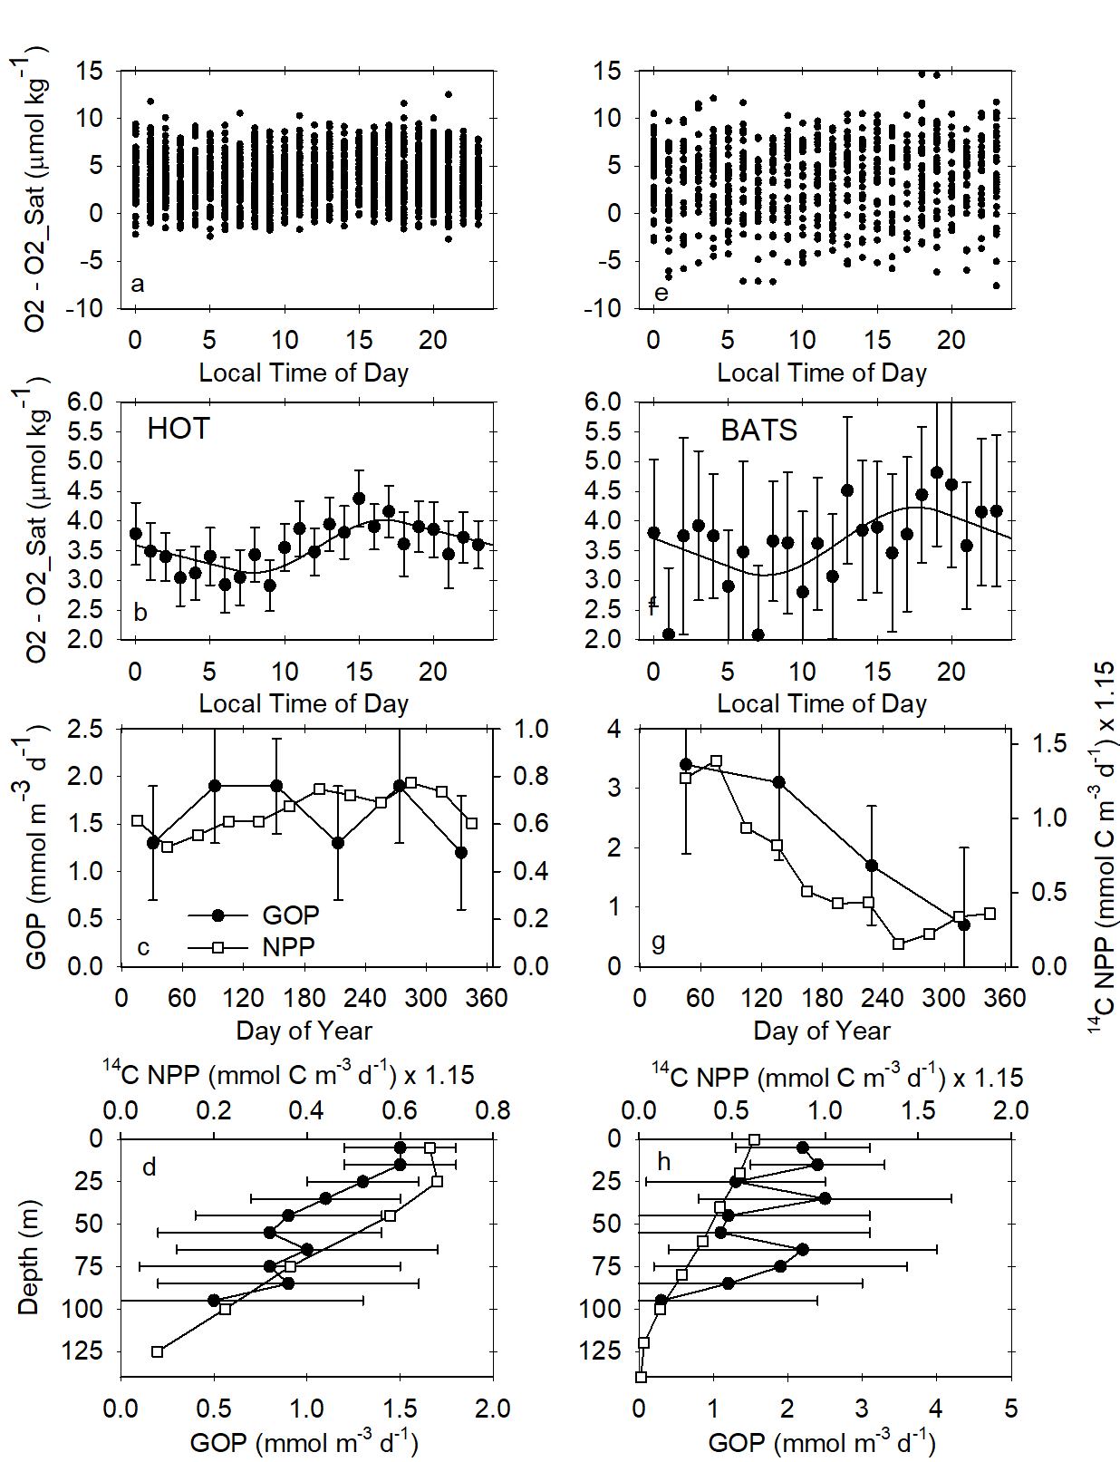
Methods and Data

The Sprof profile files from all Argo floats with oxygen sensors (N=1276) were downloaded from the Argo Global Data Assembly Center in December 2020. Only oxygen profiles with oxygen data that has been adjusted to correct for initial sensor calibration errors, , were used (N=71,451 of 206,521 total Sprof profiles with oxygen data). Only adjusted oxygen values in these profiles with a quality flag equivalent to “good” were used. The data were further quality controlled to eliminate any floats with apparent errors in the adjusted data by plotting the adjusted oxygen percent saturation in the upper 10 m vs time. The corrected data from 9 floats (Supplemental Table S1) had percent saturation values that appeared to be oceanographically inconsistent and they were removed from the data set. Some of the sensor data will have been corrected using air oxygen observations^{40, , 41} with an accuracy better than 1% of surface oxygen saturation concentration. Other floats, which do not make air oxygen measurements, will have been corrected using methods outlined in Takeshita et al.³⁹ with an accuracy near 3% of surface oxygen saturation concentration. All data was treated equivalently, without regard to the recalibration method, and no additional corrections to the adjusted oxygen concentrations were made.

The analysis used here requires that each float has sampled all hours of the day at a relatively constant proportion. Many floats profile at approximately 5.25 or approximately 10.25 day intervals so that each subsequent profile occurs at a different hour of the day and nearly all hours will be sampled over the lifetime of the float due to variability in timing. Any biases in the oxygen calibration of these floats will be present in all of the hourly samples. These biases would then appear as a constant offset in the diel cycle, but they would not alter the shape or the amplitude of the diel cycle. Other floats sample at one or a few fixed times of the day, often at local noon. Inclusion of the data from such floats in the analysis will introduce significant biases in both the shape and amplitude of the diel cycle because any calibration biases would appear in only a few of the hourly samples. Floats that sampled at only a few hours of the day were, therefore, removed from the analysis. Unfortunately, this latter class of floats constitutes the majority of the BGC-Argo array and their elimination reduced the number of available profiles by two thirds.

Floats that had an uneven hourly sampling period were identified by computing the expected number of samples in each hour (local time) as the total number of profiles divided by 24. If the maximum number of profiles in any of the hourly bins exceeded the expected number by more than a factor of 3, that float was removed from the analysis. Individual data point that exceeded six times the standard deviation of all oxygen anomaly values used in a particular analysis were also removed to avoid influence from large outliers.

The local time of day for each profile from floats with the required profiling times was computed. All of the oxygen anomaly data on individual profiles in each depth interval that was analyzed were averaged to a single value. This was done to avoid different weightings for the profiles from floats that sample at different vertical resolutions. A pseudo-daily cycle was then created from the mean oxygen anomaly data from each profile at the local hour of day for a given region, desired depth range, and for the desired portion of the year. We have not corrected the data for the effects of gas exchange as the merged data set does not represent a continuous time series. In any case, the gas exchange corrections over a single pseudo-day represented by the data would be small, typically less than 10%.

The code developed by Barone et al.²⁸ was used to analyze the pseudo-daily cycles. This code was intended to allow the determination of both GOP and CR from a time series of oxygen data. However, the difference between GOP and CR, equivalent to Net Community Production, is small and typically about 10 to 20% of the GOP and CR values^{6, 27}. A single pseudo-daily cycle of oxygen anomaly is not capable of resolving the difference in GOP and CR over one day, which will be at most a few tenths of 1 µmol kg⁻¹. Further, as noted by Barone et al.²⁸, the GOP and CR values are highly correlated. With only a single daily estimate of the oxygen diel cycle, the best fits to the data may be reached with large, compensating errors in the GOP and CR. To control for this, we have assumed that GOP and CR are equal over a daily cycle. In the original method developed by Barone et al.²⁸, GOP and CR are determined by fitting basis functions to the oxygen data:

O2_Anom(t) = const. + GOP x f(t, E) - CR x t (1)

where f(t, E) is a basis function that describes the variability of GOP with local time (t) and light intensity (E) over a daily cycle. CR is presumed to be a constant rate and its basis function is time. Assuming GOP and CR are equal, we have simplified Equation 1 to:

O2_Anom(t) = const. + GOP x (f(t, E) – t) (2)

GOP was determined by fitting Equation 2 to all of the data in a pseudo-daily cycle. f(t, E) was determined using the Sinusoidal option described in Barone et al.²⁸, which assumes that GOP is directly proportional to the amount of available sunlight. In the Figures 2 and 3, we highlight the quality of the fit by showing hourly averages of oxygen anomaly with the fit to Equation 2. We stress, however, that all of the data from each profile in a region at the selected depth interval and time period were used to create the fit, not the hourly averages.

Several possible, systematic errors are present in the GOP values determined in each region. Diel heating will bias GOP values high. Warmer daytime temperatures reduce the computed oxygen solubility, which increases the oxygen anomaly and apparent GOP. The largest diel temperature amplitudes in summer of around 0.1°C would lead to an overestimate in GOP near 30%, but closer to 15% over an annual cycle. This bias is countered by two processes that tend to lower GOP. Outgassing of O₂ over the course of a pseudo-day will reduce the amplitude of the diel cycle and lower GOP. Given typical piston velocities for gas exchange, this may reduce GOP 10%. The assumption that GOP equals CR will also bias the computed GOP value low in an autotrophic ocean by reducing the daily increase in oxygen concentration. This would amount to a 10 to 20% bias low. The sum of these biases will approach zero and the sum of the three processes has been assumed to have negligible effect on GOP. The reasonable agreement of the observed GOP values near HOT and BATS support this assumption.

Primary production rates are generally integrated vertically, typically to the 1% light level. There are two challenges to integration of the GOP rates reported here. At low light levels, rates become low and GOP cannot be detected. We have found that rates cannot be reliably determined at depths below the approximate 5 to 10% light level. All integrations reported here are limited to depths above our estimate of 5% light. The neglected range between 1 and 5% light generally contributes little to the total integral. Secondly, the variability in oxygen concentration and the oxygen anomaly increases with depth due to the presence of the oxycline and the shallow oxygen maximum. This amplifies the GOP error and rates determined near the 5% light level often have an uncertainty that is much larger in absolute value, than is found near the surface (Figure 2d). The combined error in a vertical integration will be dominated by the deepest values that add the least GOP to the integral, where the uncertainty is obtained by adding the errors at each depth range where GOP was measured. The large error bars on the deepest samples span ranges that are, essentially, impossible. These include large positive values that are unlikely at low light or large negative values. As an approximate solution to this, we sum the errors in the upper 20 m, where the largest GOP values dominate the integral (e.g., Figure 2d), and apply 50% of that error to the remainder of the profile, where GOP rates must decrease.

To assess the depth of the 5% light level, we used chlorophyll profiles observed with fluorometers on BGC-Argo floats in each of the domains analyzed. Total chlorophyll was first corrected for sensor background signals with a modified version of Briggs et al. by correcting each float and sampled year separately. The method was also tuned to accommodate the dataset sampling effort that is different from the high-resolution profiles used by Briggs et al.⁴⁴. The 10% light level for each latitude bin (the primary production zone, PPZ) was then determined as the depth where chlorophyll signals dropped to 10% of the maximum above that depth. The 5% level was then calculated assuming an exponential light profile with a constant attenuation coefficient. To confirm the calculations of light level, the euphotic zone depth (1% light level) was calculated using the equation reported in Morel and the climatological surface chlorophyll concentration observed by the MODIS ocean color satellite. The float based 1% light level is highly correlated with the values derived from MODIS chlro for the 10° latitude bins, but the float based value is 20% shallower. If the satellite values were correct, then the 5% value we compute is, in fact, near the 10% level.

The ratio of oxygen produced to organic carbon produced (PQ) is dependent on the redox state of nitrogen that is assimilated in the organic matter. PQ ranges from 1.1 when ammonium is assimilated to 1.4 when nitrate is assimilated. Following Nicholson et al. (2012), we use 1.15 in regions with low surface nitrate concentrations. We assume a value of 1.25 in regions with nitrate >1 µmol kg⁻¹ during much of the year, which is predicated on a mean ratio of 0.5 for nitrate based primary production to total primary production in these regions.

Methods References

Acknowledgements

This work was supported by the Global Ocean Biogeochemical Array project (NSF #1946578; publication #1), the Southern Ocean Carbon and Climate Observations and Modeling project (NSF PLR -1425989 and OPP-1936222), and the David and Lucile Packard Foundation. We thank Jacki Long for assistance with the satellite data, and Tanya Maurer and Josh Plant for processing data and assistance with coding. Steve Riser and Dana Swift prepared many of the profiling floats whose data were used in this analysis. These data were collected and made freely available by the International Argo Program and the national programs that contribute to it. (https://argo.ucsd.edu, https://www.ocean-ops.org). The Argo Program is part of the Global Ocean Observing System.

Supplemental Table 1. WMO numbers of floats with inconsistent oxygen concentrations and not used in this analysis.

Floats removed
2902087
2902123
4901137
4901140
4901141
4901784
5900420
5901178
7900559

Supplemental Figure 1 Dissolved oxygen and Oxygen Anomaly = Oxygen – Oxygen Saturation in the upper 10 m for all adjusted oxygen data in the Argo Global Data Assembly Center, except for 9 floats listed in Supplemental Table 1.
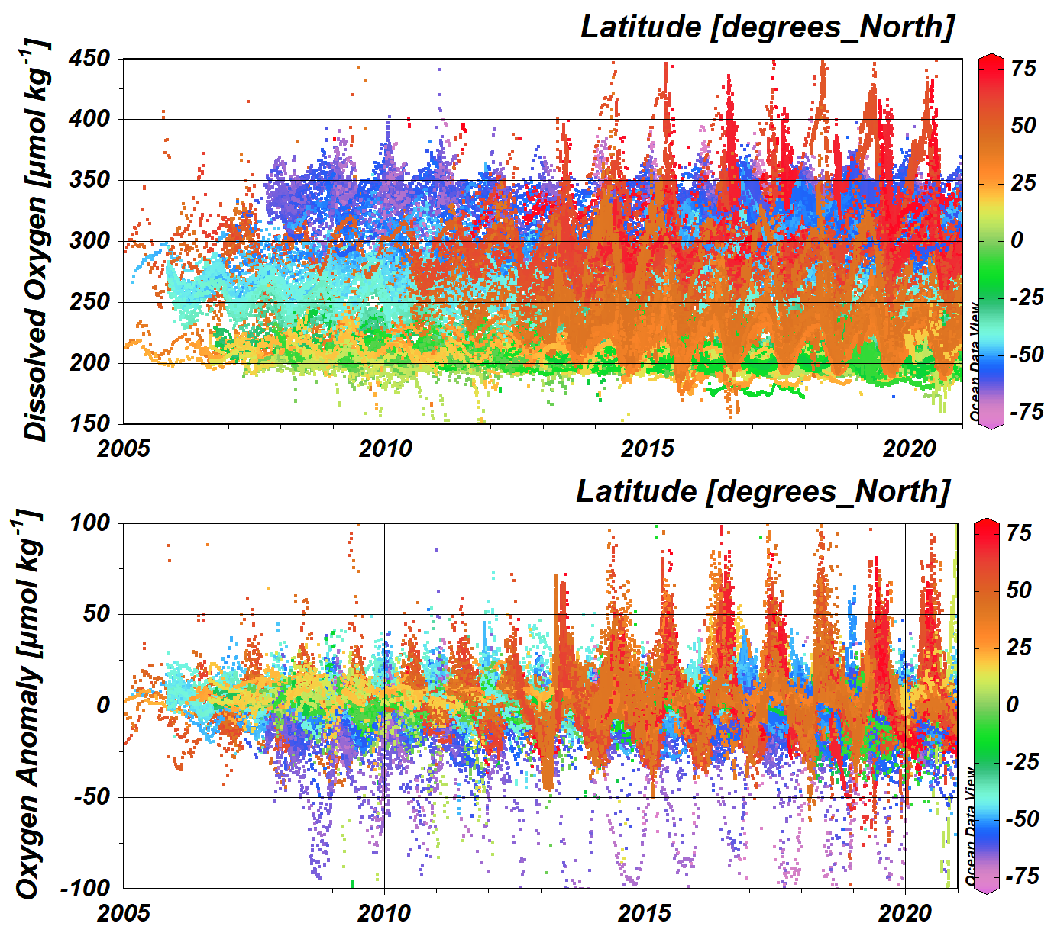

Supplemental Figure 2 Annual mean NPP rates from 2010 to 2020 in each 10° latitude band from 50°N to 50°S. a) Float and satellite NPP rates versus latitude. b) Satellite NPP rates in each 10° latitude band for each model versus float NPP rates. Satellite NPP models include VGPM (Behrenfeld and Falkowski, 1997), CBPM (Westberry et al., 2008), and CAFE (Silsbe et al., 2016). All values from Table 1.
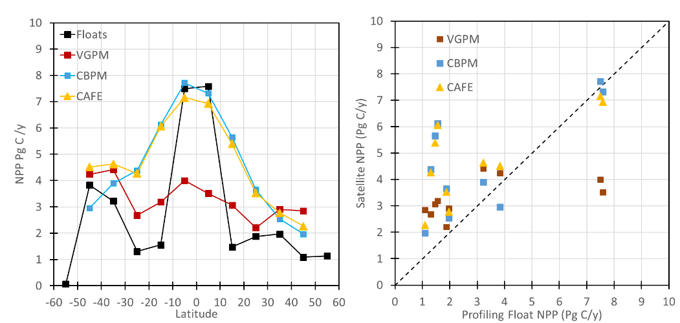

Monterey Bay Aquarium Research Institute, Moss Landing, CA, USA
Falkowski, P. G. The role of phytoplankton photosynthesis in global biogeochemical cycles. Photosynth. Res. 39, 235–258 (1994).
Chavez, F. P., Messié, M. & Pennington, J. T. Marine primary production in relation to climate variability and change. Ann. Rev. Mar. Sci. 3, 227–260 (2011).
Ducklow, H.W., Steinberg, D.K., & Buesseler, K.O. Upper ocean carbon export and the biological pump. Oceanography 14, 50-58 (2001).
Steinacher, M. et al. Projected 21st century decrease in marine productivity: a multi-model analysis. Biogeosci. 7, 979-1005 (2010).
Bryndum-Buchholz, A. et al. Twenty-first-century climate change impacts on marine animal biomass and ecosystem structure across ocean basins. Global Change Biol. 25, 459-472 (2019).
Falkowski, P. G., Laws, E. A., Barber, R. T., & Murray, J. W. (2003) Phytoplankton and their role in primary, new, and export production. In: Fasham M. J. R. (ed). Ocean Biogeochemistry. Springer: New York, NY, USA, pp 99–121.
Carr, M. E. et al. A comparison of global estimates of marine primary production from ocean color. Deep-Sea Res. II 53, 741–770 (2006).
Lee, Z., Marra, J., Perry, M. J. & Kahru M. Estimating oceanic primary productivity from ocean color remote sensing: A strategic assessment. J. Mar. Syst. 149, 50–59, (2015).
Field, C., Behrenfeld, M., Randerson, J. & Falkowski, P. Primary production of the biosphere: integrating terrestrial and oceanic components. Science 281, 237–240 (1998).
Watson, A. J. & Orr, J. C. (2003) Carbon Dioxide Fluxes in the Global Ocean. In: Fasham M. J. R. (ed). Ocean Biogeochemistry. Springer: New York, NY, USA, pp 123-143.
Kavanaugh, M. T., Church, M. J., Davis, C. O., Karl, D. M., Letelier, R. M., Doney, S. C. ALOHA From the Edge: Reconciling Three Decades of in Situ Eulerian Observations and Geographic Variability in the North Pacific Subtropical Gyre. Front. Mar. Sci. 5, 130- (2018).
Steemann Nielsen, E. (1952). The use of radioactive carbon (C¹⁴) for measuring organic production in the sea. ICES Journal of Marine Science, 18(2):117-140.
Marra, J. (2002), Approaches to the measurement of plankton production, in Phytoplankton Productivity: Carbon Assimilation in Marine and Freshwater Ecosystems, edited by P. J. L. Williams, D. N. Thomas, and C. S. Reynolds, pp. 78–108, Blackwell, Malden, Mass.
Marra, J., 2009. Net and gross productivity: weighing in with 14C. Aquatic Microbial Ecology, 56(2-3):123-131.
Fitzwater, S.E., Knauer, G.A. and Martin, J.H., 1982. Metal contamination and its effect on primary production measurements 1. Limnology and Oceanography, 27(3):544-551.
Koblentz-Mischke, O.J., Volkovinsky, V.V., Kabanova, J.G., 1970. Plankton primary production of the world ocean. Sci. Explor. South Pacific, pp. 183–192.
Luz, B. and Barkan, E., 2000. Assessment of oceanic productivity with the triple-isotope composition of dissolved oxygen. Science, 288(5473):2028-2031.
Juranek, L. W. and Quay, P. D., 2013. Using triple isotopes of dissolved oxygen to evaluate global marine productivity. Annu. Rev. Mar. Sci. 2013. 5:503–24.
Antoine, D., André, J.-M. & Morel, A. Oceanic primary production 2. Estimation at global scale from satellite (coastal zone color scanner) chlorophyll. Glob. Biogeochem. Cycles 10, 57–69 (1996).
Behrenfeld MJ, Falkowski PG. 1997. Photosynthetic rates derived from satellite-based chlorophyll concentration. Limnol. Oceanogr. 42:1–20.
Buitenhuis, E. T., Hashioka, T. & Quéré, C. L. Combined constraints on global ocean primary production using observations and models. Glob. Biogeochem. Cycles 27, 847–858 (2013).
Gregg WW, Rousseaux CS (2019) Global ocean primary production trends in the modern ocean color satellite record (1998−2015). Environ Res Lett. 14, 124011.
Westberry, T. K., Behrenfeld, M. J., Siegel, D. A. & Boss, E. Carbon-based primary productivity modeling with vertically resolved photoacclimation. Glob. Biogeochem. Cycles 22, GB2024, (2008).
Saba, V. S., et al. The challenges of modeling depth-integrated marine primary productivity over multiple decades: A case study at BATS and HOT. Glob. Biogeochem. Cycles 24, GB3020 (2010).
Behrenfeld, M. J. et al. Revaluating ocean warming impacts on global phytoplankton. Nat. Clim. Change 6, 323–330 (2016).
Johnson, K. S. Simultaneous measurements of nitrate, oxygen, and carbon dioxide on oceanographic moorings: Observing the Redfield ratio in real time. Limnol. Oceanogr. 55, 615–627 (2010).
Nicholson, D. P., S. T. Wilson, S. C. Doney, and D. M. Karl, 2015. Quantifying subtropical North Paciﬁc gyre mixed layer primary productivity from Seaglider observations of diel oxygen cycles. Geophys. Res. Lett., 42:4032–4039.
Barone, B., Nicholson, D., Ferrón, S., Firing, E., & Karl, D. The estimation of gross oxygen production and community respiration from autonomous time-series measurements in the oligotrophic ocean, Limnol. Oceanogr.-Meth. 17, 650–664 (2019).
Henderikx Freitas, F., White, A. E., & Quay, P. D. Diel measurements of oxygen and carbon based ocean metabolism across a trophic gradient in the North Pacific. Global Biogeochem. Cycles, 34, e2019GB006518. https://doi.org/10.1029/2019GB006518 (2020).
Gordon, C., Fennel, K., Richards, C., Shay, L. K., & Brewster, J. K. Can ocean community production and respiration be determined by measuring high-frequency oxygen profiles from autonomous floats? Biogeosciences 17, 4119–4134, (2020).
Claustre, H., Johnson, K. S. & Takeshita, Y. Observing the global ocean with Biogeochemical-Argo. Annu. Rev. Mar. Sci. 12, 23–48 (2020).
Gille, S. T., Diurnal variability of upper ocean temperatures from microwave satellite measurements and Argo profiles. J. Geophys. Res. 117, C11027, doi:10.1029/2012JC007883. (2012).
Juranek, L. W. & Quay, P. D. In vitro and in situ gross primary and net community production in the North Pacific subtropical gyre using labeled and natural abundance isotopes of dissolved O2. Glob. Biogeochem. Cycles 19, GB3009 (2005).
Quay, P. D., Peacock, C., Bjorkman, K. & Karl, D. M. Measuring primary production rates in the ocean: enigmatic results between incubation and non-incubation methods at Station ALOHA. Glob. Biogeochem. Cycles 24, GB3014 (2010).
Luz, B. & Barkan, E., 2000. Assessment of oceanic productivity with the triple-isotope composition of dissolved oxygen. Science, 288, 2028-2031.
Church, M. J., Lomas, M. W. & Muller-Karger, F. Sea change: Charting the course for biogeochemical time-series research in a new millennium. Deep Sea Res. II 93, 2-15 (2013).
Fawcett, S. E., Johnson, K. S., Riser, S. C., Van Oostende, N. & Sigman, D. M. Low-nutrient organic matter in the Sargasso Sea thermocline: a hypothesis for its role, identity, and carbon cycle implications. Mar Chem. 20, 108–23 (2018).
Huang, Y., Nicholson, D., Huang, B. & Cassar, N. Global estimates of marine gross primary production based on machine-learning upscaling of field observations. Glob. Biogeochem. Cycles https://doi.org/10.1029/2020GB006718 (2021).
Silsbe, G. M., Behrenfeld, M. J., Halsey, K. H., Milligan, A. J. & Westberry, T. K. The CAFE model: A net production model for global ocean phytoplankton. Glob. Biogeochem. Cycles 30, 1756–1777 (2016).
Johnson, K. S. & H. Claustre (eds.) The scientific rationale, design and implementation plan for a Biogeochemical-Argo float array (2016) https://doi.org/10.13155/46601.
Kahru, M. Ocean productivity from space: Commentary. Glob. Biogeochem. Cycles 31, 214-216.
Bittig, H., Wong, A., & Plant, J. BGC-Argo synthetic profile file processing and format on Coriolis GDAC, v1.21 (2021) https://dx.doi.org/10.13155/55637
Takeshita, Y. et al. A climatology‐based quality control procedure for profiling float oxygen data. J. Geophys. Res. Oceans 118, 5640–5650 (2013).
Johnson, K. S., Plant, J. N., Riser, S. C. & Gilbert, D. Air oxygen calibration of oxygen optodes on a profiling float array. J. Atmos. Ocean. Technol. 32, 2160–2172 (2015).
Bittig, H. C. et al. Oxygen optode sensors: principle, characterization, calibration, and application in the ocean. Front. Mar. Sci. 4, 429 (2018).
Johnson, K. S. et al. Biogeochemical sensor performance in the SOCCOM profiling float array. J. Geophys. Res.122, 6416–6436 (2017).
Riser, S. C. & Johnson, K. S. Net production of oxygen in the subtropical ocean. Nature 451, 323–325 (2008).
Briggs, N., Dall’Olmo, G. and Claustre, H., 2020. Major role of particle fragmentation in regulating biological sequestration of CO2 by the oceans. Science, 367(6479):791-793.
Buesseler, K.O., Boyd, P.W., Black, E.E. and Siegel, D.A., 2020. Metrics that matter for assessing the ocean biological carbon pump. Proc. Natl. Acad. Sci. 117, 9679-9687.
Morel, A. et al. Examining the consistency of products derived from various ocean color sensors in open ocean (Case 1) waters in the perspective of a multi-sensor approach. Remote Sens. Environ. 111, 69–88 (2007).
Eppley, R. W. & Peterson, B. J. Particulate organic matter flux and planktonic new production in the deep ocean. Nature 282, 677–680 (1979).

