Request from Dionne Ybarra, director of the Wahines to give a 30 minute talk on Climate Change and Sharks to middle school students from Truckee at the beach on Thurs 2 May 2019 at 9:30am

This was short notice and not a lot of prep, talk by Thom Maughan

Notes:

bring shark fin, tape measure in meters
draw C02 graph in sand to start the climate change talk
connect climate change to habitat shift of juvenile white sharks
use tape measure and a volunteer to show 4m to 6m white shark. Show 18m whale shark (biggest fish).

C02 resource links
http://deepdecarbonization.org/countries/visualization-of-country-scenarios/
http://www.globalcarbonatlas.org/en/CO2-emissions
https://www.climate.gov/news-features/featured-images/ocean-acidification-today-and-future
https://www.co2.earth/ - CO2 ppm
https://www.drawdown.org

Sand graph:
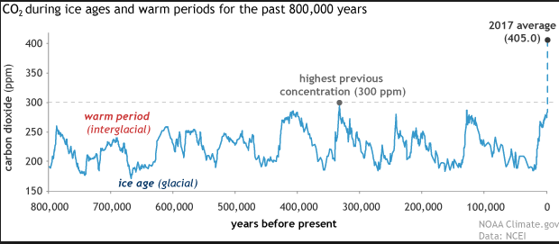

One of the kids said the C02 is 414.8, he was right!

climate change
specifically climate change caused by people. greenhouse gases in the air - c02 (we breathe this out). Our industrial society generates a whole lot!

180 to 280 ppm over the past 800,000 years. It is now at 400! (draw in sand)

There is some good news (and some bad) – the oceans absorb about 30 percent of the c02 and about 90 percent of the heat that results from the increase in greenhouse gas.

Polar ice melting – sea level rise (a meter-ish (2 to 4 feet) by end of century).
Stand at the waters edge, hold hand about 1 meter, then look at how much land is under water. Then mention flat Florida. Most of the kids had heard some form of this already.

Can you tell the ocean is rising?? Hard to tell, takes precise measurements and averaging to tell. Small very accurate measurements are required to understand the global changes (big).

Ocean acidification 8.2 -> 8.1 end of the century 7.9 if we can reduce our C02 production, could be as low as 7.3 if we keep spewing.
https://www.climate.gov/news-features/featured-images/ocean-acidification-today-and-future
http://www.globalcarbonatlas.org/en/CO2-emissions

Talk about measuring the small changes again – the need for knowledge to understand the global meaning of the small changes.

Can you feel or taste the pH change? Small organisms and shellfish are affected first.

Natural disasters will become more disastrous

Warming waters puts Marine life at risk – habit changes, life adapts. If you are a snow person (they are from Truckee) and the snow goes away, you will move to where there is snow. Habit changes, food chain shifts, and migrations.

Baseline measurements of micro organisms and fish distributions in the ocean are not available to make accurate statements about change. Older generations of people that are still alive caught fish off the Monterey pier that were large and easy to catch… This is not the case now.

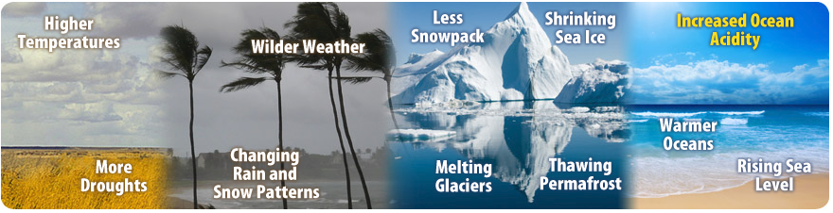

Food chain and top predators (brief discussion). Land based top predators like the wolf have been studied – bad for the animals if the wolves are not around – deer get bad sickness for example. The thought is they same in the ocean. Climate change, fishing and illegal hunting. Removal of a few individuals can have a profound effect on the eco system

white shark - Carcharodon carcharias
Adults: 3m to 6m
most fish are ectothermic (cold blooded), white sharks regulate their temperature
thought to give live birth with gestation of 12 months, birth has not been documented - nursery not known
juvenile california white sharks in southern californa. There is evidence the juveniles are moving north for cooler water

Sharks have 8 unique senses. They are hearing, smell, lateral line, pit organs, vision, Lorenzini, touch, and taste

Very sensitive eyes, like a cat with reflective back that amplifies. Rods can cones in about the same ratio as a human. Blue and green pigment in the eye, not red.

The entire body is the ‘ear’ – sensitive

Electro-reception – eyes on the side that roll up in the head, chasing a fast seal, how to close that last meter – electro-receptors called ampullae de lorenzi

Incredible ‘nose’ – can smell seals a couple miles away. Taste / smell a tiny bit of blubber oil that floats on the surface from 30m to 50m deep.

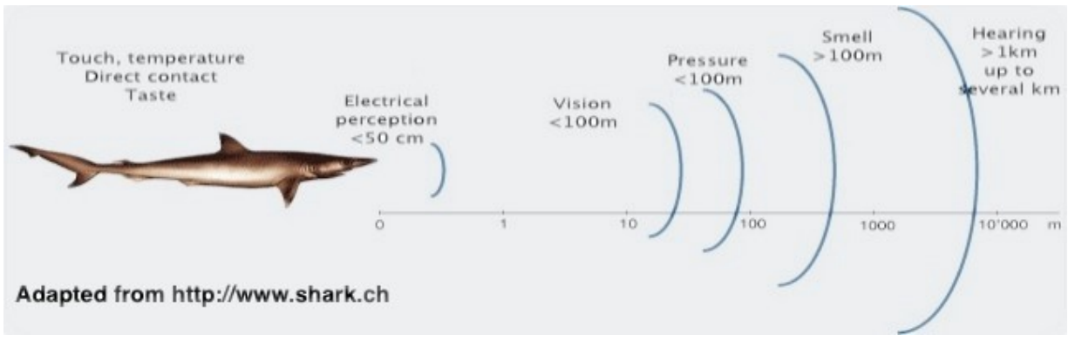

California white sharks – Shark Café
Migrate in the Jan/Feb timeframe to Hawaii. On the way to Hawaii, in the middle of the Pacific about halfway between Baja and Hawaii is the Shark Café – much bigger than Starbucks, the size of Colorado.

At the Café, the do this strange diving behavior. About every 5 minutes, dive to over 250m deep and back to the surface. The interesting behavior is when they are doing this rapid diving behavior and we see that they ‘hang at a depth’ as if chasing something – mating or eating.

whale sharks 18m typical is 8m to 12m Rhincodon typus
is the largest of 3 filter feeders: basking, megamouth and whaleshark
thought to have live birth one had 304 pups
130 years based on the otolith (calcium carbonate) a ‘stone’ in the ear that helps navigation – shark otoliths are the size of a grain of sand – hard to count the rings
polka dots
Plastic can harm or kill them - straws!!!

Junk notes:

bycatch
shark fin soup

top predator and role in the food chain

they dont like orcas

similar role to the wolf in the foodchain - they keep populations of the marine mammals in balance (rather than disease)
removal of a few individuals can have a profound effect on the eco system

climate change:

greenhouse gases in the air - c02 (we breathe this out)

180 to 280 over the past almost million years. It is now at 400! And climbing

There is some good news (and some bad) – the oceans absorb about 30 percent of the c02

Ocean acidification

Polar ice melting – sea level rise (2ft by end of century)

Natural disasters will become more disasterous

Warming waters puts Marine life at risk – habit changes (more about this when we talk about white sharks)

Is It Too Late To Change??

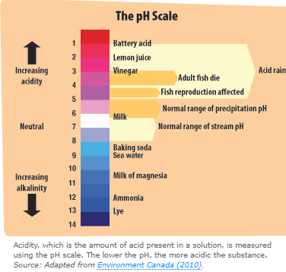

Increasing acidity will make it harder for corals to build skeletons and for shellfish to build the shells they need for protection. Corals are particularly important because they provide homes for many other sea creatures.
