Jim Barry
Sur Ridge Studies
Since the discovery of deep-sea coral and sponge communities on Sur Ridge in 2013, we have been collaborating with the Monterey Bay National Marine Sanctuary, focusing on several questions concerning this exciting region, including:
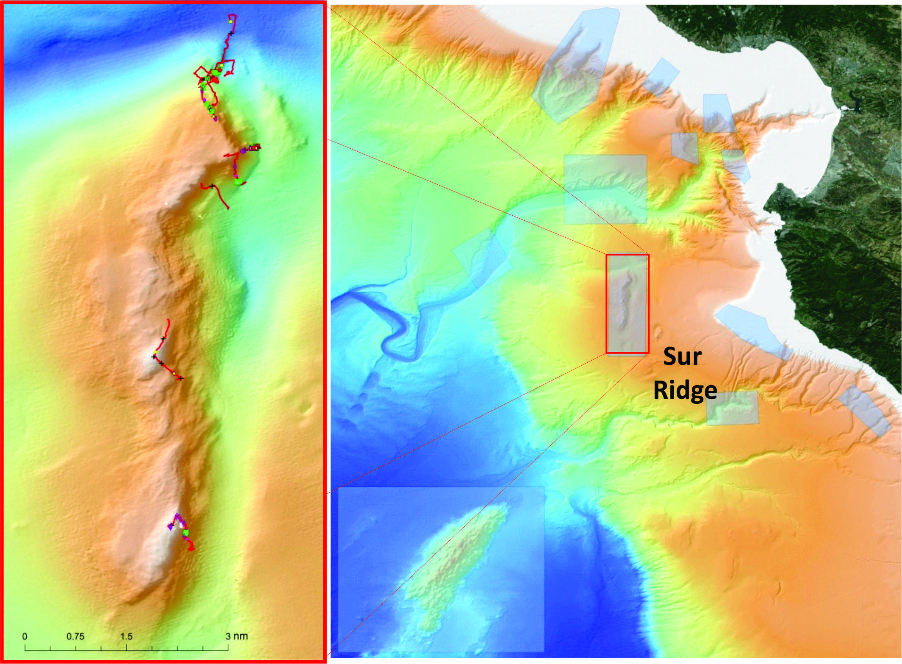Sur Ridge – An MBNMS Ecologically Significant Area (SESA).
- How extensive are the coral and sponge communities that dominate the ridge?
- What is the role of geology, flow, upper ocean productivity, and biology in determining the diversity, abundance, distribution, and dynamics of these coral and sponge ecosystems?
- How vulnerable are these communities to human activities, ranging from fishing to climate change?
We are using some of the new tools at MBARI to make high-resolution measurements of exactly where organisms live in relation to topography—the incredible improvement in our ROV navigation and high-resolution maps allow us to understand more precisely than ever how subsea landscapes influence where animals thrive. Large sponges and corals vary greatly in abundance across the ridge, at least coarsely correlated with seabed slope and rock type.
The rain of organic debris from the surface generally fuels biological productivity on Sur Ridge. However, the details concerning how material and plankton sweeping over the ridge are used by the coral/sponge community are poorly understood. We are combining measurements of flow, suspended particulates, and growth rates for key corals to test the influence of hydrodynamic processes on coral density and size. Are some corals growing like weeds while others are barely eking out a living? Biological interactions also appear to be important. The density of coral predators (sea stars and sea slugs) varies considerably among sites. We are measuring the effects of predation on coral species to determine if this is a minor or major source of their mortality.
In contrast to the corals, sponges are suspension feeders that filter microbes from the water. Flow enters around the base of the sponge, and ciliated cells (collar cells) create an internal current driving water up and out the opening (osculum) at the top. Some actively pump water in this manner while others take advantage of ambient currents and sponge shape to drive flow, thereby reducing the energetic costs of pumping, which may exceed more than 25 percent of their total energy. With new laser imaging methods developed by MBARI Postdoctoral Fellow Kakani Kajita, we are making in situ and laboratory measurements of flow and particle filtration for several sponge species on Sur Ridge.
Concern for the impacts of human activities in deep-sea coral ecosystems is growing. In addition to ocean acidification and deoxygenation, fishing and oil spills threaten these systems. The Deepwater Horizon oil spill devastated deep-sea coral gardens in the Gulf of Mexico. We have translocated corals at Sur Ridge to test potential restoration methods that may one day be applied in the Gulf of Mexico.
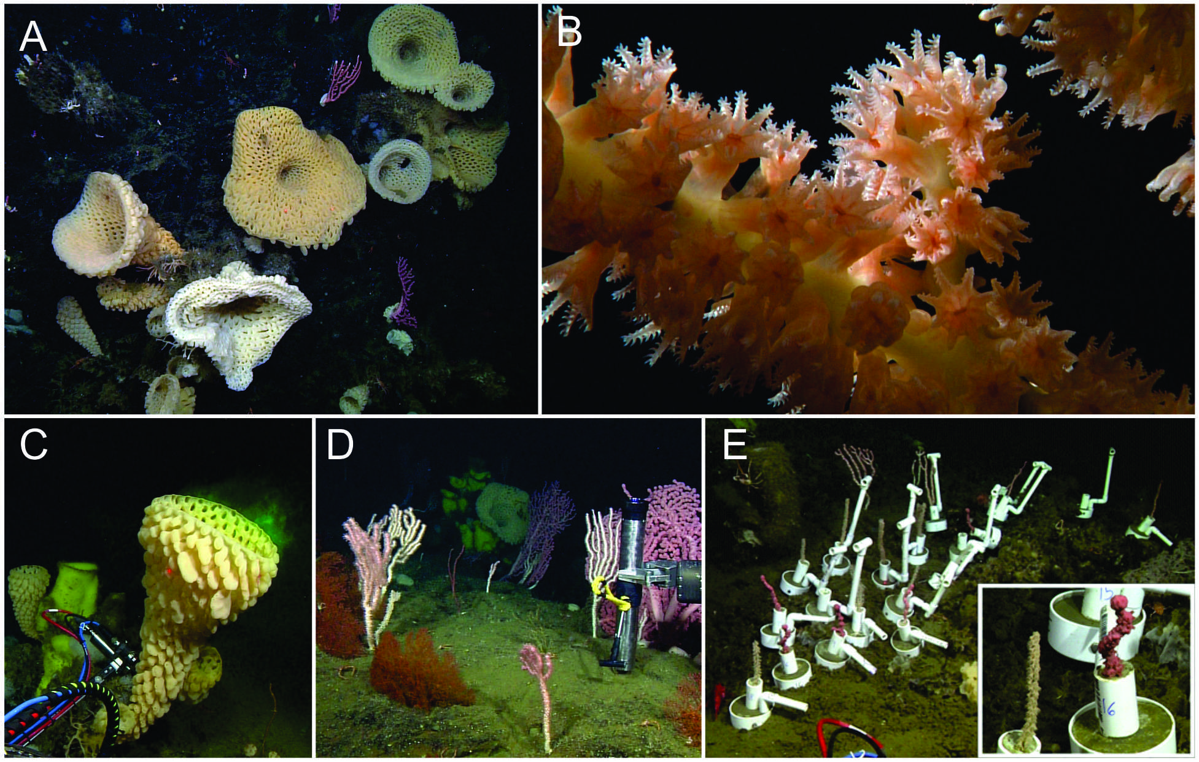(A) Goiter sponges; (B) Close-up of bamboo coral polyps; (C) Dye injected at base of sponge flows out osculum at top; (D) Near-bottom flow measurements; (E) Translocated corals (bamboo, bubblegum) in “vases” (close-up on right).

Recent Professional Activities
Committee and Editorial Board Membership
- 2014- Science Advisory Board, Center for Ocean Solutions
- 2014- Ecosystem Impacts of Oil and Gas Inputs to the Gulf (ECOGIG)
- 2012- Science Advisory Committee, Chair, BIOACID 3

Publications
- Kim, T., Barry, J.P. (in press). Boldness in a deep sea hermit crab to simulated tactile predator attacks is unaffected by ocean acidification. Ocean Science Journal
- Sunday, J.M., Fabricius, K.E., Kroeker, K.J., Anderson, K.M.,Brown, N.E., Barry, J.P., and others (in press) Ocean acidification can mediate biodiversity shifts by changing biogenic habitat. Nature Climate Change.
- Barry, J.P., Taylor, J.R., Kuhnz, L.A., DeVogelaere, A.P. (in press). Symbiosis between the holothurian, Scotoplanes sp. A and the lithodid crab Neolithodes. Marine Ecology

