Command Summary

HELP - display this menu
READ MEM - dump log memory contents
USED MEM – log memory currently in use
ERASE MEM - erase log memory
TIME - display current date and time
STATUS - get controller status
RESET - reset the controller
SAVE - save parameters to non-volatile memory
PARAM - show current parameters
DEFAULT - restore parameters to defaults

CAM ON - turn on camera power
CAM OFF - turn off camera power
LIGHT ON - turn on light power
LIGHT OFF - turn off light power
DVR ON - turn on DVR power
DVR OFF - turn off DVR power
START DVR or REC ON - start recording
STOP DVR or REC OFF - stop recording
TRIG MODE ON - enable trigger mode
TRIG MODE OFF - disable trigger mode
TL MODE ON - enable time lapse mode
TL MODE OFF - disable time lapse mode

SET START DELAY - set start delay in secs
SET STOP DELAY - set stop delay in secs
SET DEBOUNCE - set debounce time in ms
SET HOLD OFF - set hold off time in secs
SET WINDOW - set trigger window in secs
SET TL ON - set time lapse on time in secs
SET TL OFF - set time lapse off time in secs

SET TIME - set current time MM/DD/YY HH:MM:SS DAY

Command Descriptions

HELP

Description

Display a command summary and brief description of each command to the user console.

READ MEM

Description

Display the contents of the logging memory to the user console.

USED MEM

Description

Display the number of bytes currently used by the logging memory to the user console.

ERASE MEM

Description

Erase the contents of the logging memory.

TIME

Description

Display the RTC current time and date to the user console.

STATUS

Description

The STATUS command displays the current state of controller.

DVR POWER – state of DVR power switch
CAM POWER – state of camera power switch
LIGHT POWER – state of light power switch
RECORDING – DVR state (e.g. recording or idle)
TRIGGER MODE – trigger mode enabled or disabled (see operational modes)
TIME LAPSE- time lapse mode enabled or disabled (see operational modes)
TRIGGERS – number of triggers events received since last reset
UPTIME – seconds controller has been running since last reset
TIME – time of on board RTC

Example output of STATUS command:

DVR POWER : ON
CAM POWER : ON
LIGHT POWER : OFF
RECORDING : OFF
TRIGGER MODE: ENABLED
TIME LAPSE : ENABLED
TRIGGERS : 1
UPTIME : 1635 SECS
TIME : Mon Jul 18 14:33:55 2011

RESET

Description

Perform a software reset of the controller.

SAVE

Description

Save the current parameters to non-volatile memory.

PARAM

Description

Display the current parameters to the user console. For a complete description of the parameters see the Parameter Summary section below.

DEFAULT

Description

Set the parameters to the default settings. If the default command is used it must be followed by the SAVE command to store the parameters to non-volatile memory. If the SAVE command is not issued the parameters will revert back to their previous state on power cycle or RESET.

CAM ON

Description

Manually enable camera power switch.

Note: direct manipulation of digital outputs can interfere with operational mode performance and should only be used for system setup and debugging. See Operational Modes below for more information.

CAM OFF

Description

Manually disable camera power switch.

Note: direct manipulation of digital outputs can interfere with operational mode performance and should only be used for system setup and debugging. See Operational Modes below for more information.

LIGHT ON

Description

Manually enable light power switch.

Note: direct manipulation of digital outputs can interfere with operational mode performance and should only be used for system setup and debugging. See Operational Modes below for more information.

LIGHT OFF

Description

Manually disable light power switch.

Note: direct manipulation of digital outputs can interfere with operational mode performance and should only be used for system setup and debugging. See Operational Modes below for more information.

DVR ON

Description

Manually enable DVR power switch.

Note: direct manipulation of digital outputs can interfere with operational mode performance and should only be used for system setup and debugging. See Operational Modes below for more information.

DVR OFF

Description

Manually disable DVR power switch.

Note: direct manipulation of digital outputs can interfere with operational mode performance and should only be used for system setup and debugging. See Operational Modes below for more information.

START DVR or REC ON

Description

Manually start DVR recording.

Note: direct manipulation of digital outputs can interfere with operational mode performance and should only be used for system setup and debugging. See Operational Modes below for more information.

STOP DVR or REC OFF

Description

Manually stop DVR recording.

Note: direct manipulation of digital outputs can interfere with operational mode performance and should only be used for system setup and debugging. See Operational Modes below for more information.

TRIG MODE ON

Description

Enable controller trigger mode. See Operational Modes for further description.

TRIG MODE OFF

Description

Disable controller trigger mode. See Operational Modes for further description.

TL MODE ON

Description

Enable controller time lapse mode. See Operational Modes for further description.

TL MODE OFF

Description

Disable controller time lapse mode. See Operational Modes for further description.

SET START DELAY

Description

Set the amount of time in seconds that the controller waits after power up before starting operation. This is considered the start of the deployment.

SET STOP DELAY

Description

Set the amount of time in seconds that the controller waits after power up before ending operation. This is considered the end of the deployment.

SET DEBOUNCE

Description

Set the debounce time in milliseconds of a trigger event.

SET HOLD OFF

Description

Set the minimum amount of time in seconds that must elapse before another trigger is considered valid and logged. See Trigger Mode for a detailed description of this parameter.

SET WINDOW

Description

Set the amount of time in seconds that the system will record after a trigger event. See Trigger Mode for a detailed description of this parameter.

SET TL ON

Description

Set the amount of time in seconds that the system will record in time lapse mode. See Time Lapse Mode for a detailed description of this parameter.

SET TL OFF

Description

Set the amount of time in seconds that the system will wait idle in time lapse mode. See Time Lapse Mode for a detailed description of this parameter.

SET TIME

Description

Set the time of the RTC.

Usage: SET TIME MM/DD/YY HH:MM:SS DAY (DAY = 1->Sun, 2->Mon, ... , 7->Sat)

Example: To set the time and date to, “2:00:00 PM, Tuesday, July 19th, 2011” the following command would be entered.

SET TIME 7/19/11 14:00:00 3

Operational Modes

The controller supports a time lapse mode and a trigger mode of operation. These modes can be used individually or together depending on the requirements of the deployment. In time lapse mode the controller will start the DVR recording and power up the lights at an interval set via two controller parameters. In trigger mode the controller will start the DVR recording and power up the lights after a trigger event and will record for an interval that is set via a parameter.

Time Lapse Mode

In time lapse mode the controller powers up the lights and starts recording at time intervals set via the controller parameters. The parameters consist of the amount of time the system is idle followed by the amount of time the system is recording as seen in the figure below. This cycle repeats until the STOP DELAY amount of time has elapsed. After the STOP DELAY the controller enters a low power state and waits for recovery. The time lapse mode can be used with the trigger mode. If a trigger event should happen during the TIME LAPSE ON time the DVR recording and lights will stay active until the end of that time or the end of the TRIGGER WINDOW depending on which occurs last. If a trigger event should happen during the TIME LAPSE OFF time, the DVR recording and lights will start immediately.

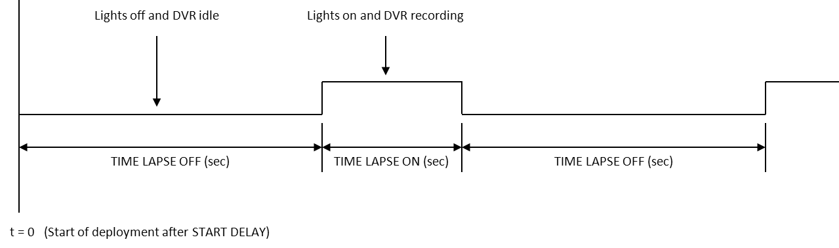

Trigger Mode

When a trigger event occurs it is time stamped using the RTC time and stored to logging memory. The trigger hold off parameter is used to insure multiple trigger events are not logged if the trigger is left asserted for a long duration (e.g. seconds). When the trigger mode is enabled the DVR recording and lights are also activated. The recording and lights stay active for the TRIG WINDOW time. After the TRIG WINDOW time has elapsed the DVR recording stops and the lights are powered down.

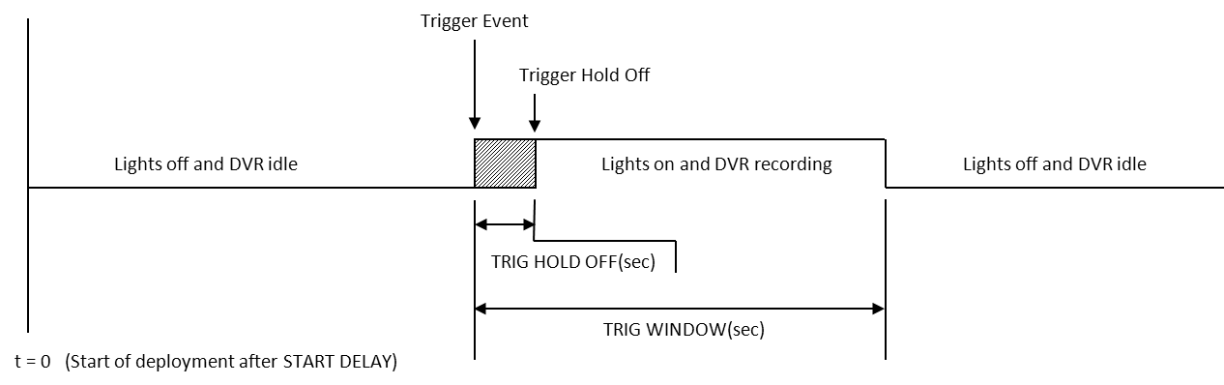

Parameter Summary

Configuration parameters are used to configure the controller for different deployment scenarios. Once the parameters are set for a deployment they can be stored to non-volatile memory so they are available upon the next power up or reset. If the controller parameter is in the it’s default state the characters, “[DFLT]” will appear after the parameter when the PARAM command is issued. To restore all of the parameters to their default state the DEFAULT command can be issued to the user console. Once the parameters have been configured for a deployment the SAVE command should be issued to store them to non-volatile memory. If the SAVE command is not issued after changing a parameter it will revert to its previous state upon power cycle or reset.

Parameter Description:

TRIG MODE – state of trigger mode.
TIME LAPSE MODE – state of time lapse mode.
START DELAY – time in seconds before controller operation begins.
STOP DELAY – time in seconds before controller operation ends.
TRIG DEBOUNCE – debounce time in milliseconds of trigger event.
TRIG HOLD OFF – time in seconds the controller will wait between trigger events.
TRIG WINDOW – amount of time in seconds that the DVR will record after a trigger event.
TIME LAPSE ON – amount of time in seconds that the DVR will record in time lapse mode.
TIME LAPSE OFF – amount of time in seconds that the DVR will idle in time lapse mode.

Example PARAM Output:

TRIG MODE [DFLT] : ON
TIME LAPSE MODE [DFLT] : ON
START DELAY [DFLT] : 1800 SEC
STOP DELAY [DFLT] : 54000 SEC
TRIG DEBOUNCE [DFLT] : 30 MS
TRIG HOLD OFF [DFLT] : 2 SEC
TRIG WINDOW [DFLT] : 300 SEC
TIME LAPSE ON [DFLT] : 120 SEC
TIME LAPSE OFF [DFLT] : 480 SEC

