


Pre-Installation Guide
SeeTrack CoPilot

Commercial in Confidence
June 14th 2013

Table of Contents
1 Introduction 4
2 SeeByte 4
2.1 Points of Contact 4
2.2 Awareness Made Easy 4
2.3 Commitment 4
3 Minimum Requirements 5
3.1 RS232 Interfaces 5
3.1.1 DVL 5
3.1.2 Survey 6
3.1.3 Sonar (Blueview) 6
3.2 Joystick Interface 7
4 Work site and vehicle’s environmental display 7
4.1 Absolute Positioning 7
4.1.1 Acoustic Positioning Sensor 8
4.2 Vector Charts 9
5 Readiness for the Installation 9
5.1 SeeTrack CoPilot unit mounting 9
5.2 Interface box location and wiring 10
5.3 Keyboard and mouse area 11
5.4 Monitor 11
6 System Overview 11
6.1 Front of the unit 11
6.2 Rear of the unit 12
6.3 Wiring Diagram 15

Distribution:

CUSTOMER
SeeByte – All internal

Revision History
Revision | Date | Comment
01 | 14/6/13 | Creating document in new format

Authors: SeeTrack CoPilot Team
This document is commercial in confidence. If you have received it in error, please contact:

SeeByte
Registered in Scotland Number: SC194014
Registered Office: Orchard Brae House, Edinburgh, EH4 2HS
VAT Registration Number: 783656681

Tel: +44 (0) 131 447 4200
Fax: +44 (0) 131 447 4911
www.seebyte.com

Introduction

This document describes the requirements to install a SeeTrack CoPilot unit. Several critical issues are covered to ensure a successful and timely installation.
The document also provides details of the SeeTrack CoPilot hardware interface.
This document is to be delivered together with the SeeTrack CoPilot Interface Questionnaire.

SeeByte

Points of Contact

Benjamin Privat – SeeTrack CoPilot Project Manager
+44 131-447 4200, benjamin.privat@seebyte.com

Awareness Made Easy
We demand ever more of the assets and machines we own and operate. We want them to replace us in carrying out hazardous tasks; to work in increasingly harsh and remote locations; and to tell us before they need to be fixed. We also want them to show us what’s going on in their working environment.
To help them do all this we need to make them aware of their mission; aware of their surroundings; and aware of their own condition. SeeByte makes the software that delivers this Awareness.

Commitment
Our experienced offshore engineering team adhere to strict health and safety procedures and have completed relevant OPITO safety and emergency training and U.K.O.O.A. medical examinations. SeeByte actively pursues policies that promote excellence in safe working practices to ensure there is no harm to people or damage to the environment.

Minimum Requirements
SeeTrack CoPilot requires serial data from a Doppler Velocity Log (DVL) and survey data from the vehicle including heading and depth. Fields such as pitch, roll and altitude are also helpful. These strings go into the unit via RS232 or Ethernet interfaces.
SeeTrack CoPilot also requires access to the ROV joystick.

RS232 Interfaces
Shown below is a diagram describing the pin configuration of the RS232 ports on the SeeTrack CoPilot unit:

Figure 1: RS232 Pin Wiring

All the RS232 connectors on the rear of the unit are male and therefore require a female connector. Ideally the cable should use twisted pairs, generally for most applications only the Tx, Rx and Gnd connections are required.
Each cable shall be validated prior to the arrival of the SeeByte technician to the site. This check will save offshore installation time and is crucial for the success of the installation. For each sensor, the correct transmission shall be confirmed using a serial terminal (ie Hyperterminal) in a computer. The data string must be received in the terminal when using the specified serial settings.

DVL
The DVL shall be correctly configured. The DVL shall be configured into bottom-track mode and should not track the water column as this can give false readings which affect the stability of the system.
SeeByte is not responsible for the well working order of the DVL configuration. Support for this task is available under request.
The DVL sensor data string must be sent to the SeeTrack CoPilot unit via the RS232 interface. The DVL data formats supported by SeeTrack CoPilot are:
- PD0 binary format
- PD0 ASCII format
- PD6 ASCII format
- PD13 ASCII format
A minimum update rate of 3 Hz is required.
Recommended serial settings:
- Baud rate: 9600
- Data bits: 8
- Parity: none
- Stop bits: 1
- Flow Control: none
Recommended format: PD0 binary or PD6 ASCII

Survey

Survey data string must be sent to the SeeTrack CoPilot unit via the RS232 interface.

This string shall provide heading and depth. Fields such as pitch, roll and altitude are also helpful.
The format of this string must be returned to SeeByte by filling in the SeeTrack CoPilot Questionnaire as soon as possible. The questionnaire contains critical information for the success of the trial and optimization of offshore time.

A minimum update rate of 3 Hz is required.

Recommended serial settings:
- Baud rate: 9600
- Data bits: 8
- Parity: none
- Stop bits: 1
- Flow Control: none

Sonar (Blueview)

Sonar (Blueview) interface is Ethernet.

Joystick Interface
SeeTrack CoPilot provides the SeeTrack CoPilot Interface Box. This box interfaces generic controls such as surge, sway, heave and heading with the joystick (Please report to section 6.3 Wiring diagram). Shown below is the pin out diagram for the joystick connectors on the interface box.
The cables that link into this box should be as short as possible. Ideally the box should be placed as close to the ADC converter of the host ROV system as possible.

Work site and vehicle’s environmental display

Absolute Positioning

SeeTrack CoPilot supports vector chart loading, to provide visual references to the pilots. While SeeTrack CoPilot works in a local frame of reference, the display of the structures in the seabed and other objects is in a world frame of reference.

The system requests an absolute positioning input to accurately locate the chart in latitude/longitude coordinates.

This input can be done either automatically (via an acoustic positioning sensor) or manually (if the pilot can type into the system, the vehicle latitude and longitude).

The accuracy required for the latitude and longitude position is 0.5 metres (5 decimal places in decimal notation).

The system, under certain circumstances, may request new latitude and longitude to ensure the visual display is accurate enough. If the sensor is available, this task can be done automatically.

Acoustic Positioning Sensor

The absolute positioning data string should be sent to the SeeTrack CoPilot unit via the RS232 interface.

Wiring wise, this cable must comply with the same principles as the DVL and survey cables.

This string shall provide latitude and longitude with the precision required (0.5 metres or 5 decimal places in decimal notation).

The format of this string must be returned to SeeByte by filling in the SeeTrack CoPilot Questionnaire as soon as possible. This is critical information for the success of the trial and optimization of offshore time.

There is no minimum update rate for this data. The system will take a fix of the position under certain circumstances and it is up to the sensor to have a good data update in such cases.

Recommended serial settings:
- Baud rate: 9600
- Data bits: 8
- Parity: none
- Stop bits: 1
- Flow Control: none

Vector Charts
SeeTrack CoPilot allows the pilot to select, add or remove a vector chart from the world view display. These files are charts of the structures in the seabed. They can be displayed in the screen providing the pilots with a visual reference for the job.

The world display can only display one chart at a time.

Files supported:
- The vector chart must be an AutoCad 14 DXF file in UTM WGS84 format. The chart must not exceed the boundaries of the relevant UTM zone.

The customer must establish a mechanism to provide the ROV crew with these files in the right format. This data is crucial for benefiting from the full functionality from the system.

The chart could be sent to SeeByte in order to be tested on the SeeTrack Offsore system. The UTM zone number (01 to 60) and the UTM zone designator (C to X) should be provided.

Readiness for the Installation
For an overall wiring diagram of the SeeTrack CoPilot, please report to section “6 System Overview”

SeeTrack CoPilot unit mounting
The SeeTrack CoPilot Hardware Interface unit is to be placed in a rack mount cabinet or any other rack mount system. It is advised to add a rear support (shelf or L-brackets) when installing STO into this rack mount system.

Figure 2: Unit Installation to Cabinet

Listed below are the environmental specifications for the unit:
Operating Temperature | 0° C to 40° C
Weight | 10 kg
Size | Standard 19" 2U rack mount

The front panel of the SeeTrack CoPilot unit provides the user with critical information. It indicates if the unit is running properly and also has an Emergency Stop button to press in case of system failure. USB connectors are available for the user to plug in the mouse and keyboard as well as external devices.

It is important that the unit be placed close to the pilot. If this is not feasible, a remote Emergency Stop button is also provided and is connected at the back of the unit.

Interface box location and wiring
The SeeTrack CoPilot Interface Box interfaces generic controls such as surge, sway, heave and heading with the SeeTrack CoPilot unit. The Interface Box connection provides power and switching control lines to allow control to be switched between SeeTrack CoPilot and the default joystick manual control.
This interface box must be located close to the joystick and the unit and the customer must find a safe place to install it.

Figure 3: Interfacing the Vehicle Interface Box to the unit

Keyboard and mouse area
SeeTrack CoPilot provides a keyboard and a mouse. The mouse is the main tool when using the Click & Go functionality and it must be easily reached by the pilot or co-pilot.

Monitor
SeeTrack CoPilot requires a 17 inch VGA monitor to display the user interface. This monitor is not provided with the unit and the customer must supply it.

System Overview
Shown below is a diagram of the front and rear of the SeeTrack CoPilot hardware interface unit and the wiring diagram of the system.

Front of the unit

Figure 4: Front panel layout

PART | DESCRIPTION | TYPE
J1 | On/Off button | Momentary push button
J2 | Power Indicator | LED
J3 | System Indicator | LED
J4 | USB 2.0 port | USB Type A
J5 | USB 2.0 port | USB Type A
J6 | Drive | DVD-RW/CD-RW
J7 | Hard Drive Disk 1 | N/A
J8 | Hard Drive Disk 2 | N/A
J9 | Reset button | Momentary push button
J10 | Fans and filter | N/A
Table 1: Front panel connections

Rear of the unit

Figure 5: Rear panel layout

PART | DESCRIPTION | TYPE
J1 | Mains Input 100-240 VAC 47-63Hz | IEC female
J2 | Mains Input 100-240 VAC 47-63Hz | IEC female
J3 | Mains indicator | LED
J4 | Power supply latch
J5 | Power supply latch
J6 | PSU indicator | LED
J7 | PSU indicator | LED
J8 | Mains ON/OFF | ON/OFF Rocker Switch
J9 | Mains ON/OFF | ON/OFF Rocker Switch
SLOT 1 | E-Stop
J1.1 | Remote Emergency stop | 2-pin round female
SLOT 2 | Display
J2.1 | VGA | 15-way D female
J2.2 | Not used
J2.3 | Not used
SLOT 3 | Serial Communications
J3.1 | Serial ports (up to 4 ports using data cable  provided) | 25-way D male
SLOT 4 | Spare
SLOT 5 | IB power
J5.1 | Interface box power supply | 3-pin round female
SLOT 6 | Fan
SLOT 7 | IO
J7.1 | Not used
J7.2 | 10/100 Base-T Ethernet port (SeeByte use only) | RJ45
J7.3 | 10/100 Base-T Ethernet port (SeeByte use only) | RJ45
J7.4 | USB 2.0 port | USB Type A
J7.5 | USB 2.0 port | USB Type A
Table 2: Rear panel connections

Wiring Diagram

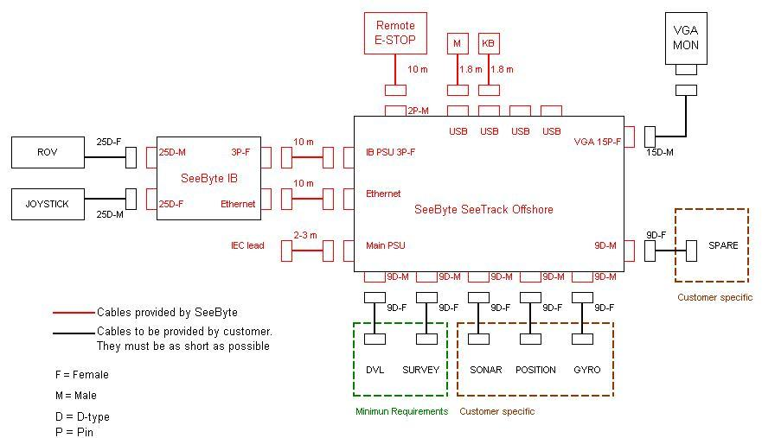

Figure 6: Wiring Diagram

