Project: 901023.00 BEDS / Continental Margins Process
Author: Denis Klimov (EE), with input from Elecia White
Review Document:
- 10020895-bbb1-DRAFT-2 (Schematic of BEDS Bridge Board, draft)
Related documents:
- 10020895-MOB3-2018-02-26.Rev0 (Mother Board schematic)
- 10020895-MOB3_MotherBoard-Assembly-2019-12-18 (Mechanical Drawing of Mother Board Assembly)
- 10020895-AS4_MotherBoard-Plate-Assembly-2019-12-18 (Mechanical Drawing of Mother Board Plate Assembly)
- 10020895-BBB1Rev0_BridgeBoardPCB (Mechanical drawing of a Bridge Board)

BEDS Bridge Board (10020895-bbb1)
Requirements
- Connected to Mother Board using 2ea 10-pin header connectors (U18A and U18B).
  - Connector U18A carries SPI bus signals, power, and IOs from PIC on Mother Board:
    - 4 lines: SPI bus 3.3V logic level between Mother Board (master) and Bridge Board (slave)
      - MOSI1, SCK1, /IMU_CS, MISO1
      - SPI bus is shared between IMU and RTC slave clients.
    - 2 lines: 3.3V power and ground
    - 1 lines: interrupt from Bridge Board to Mother Board (/IMU_INT)
    - 1 line: enable signal for bridge board power (/IMU_ENBL)
    - 2 extra IO lines from PIC on Mother Board (IMU_IO1, IMU_IO2)
  - Connector U18B is for mechanical mounting only
- Bridge Board to house IMU (Inertial Measurement Unit) chip (ICM-20948 selected)
  - Obvious.
- Bridge Board to provides level shifting of logical signals between PIC (3.3V) and IMU (1.8V)
  - Obvious.
- Bridge Board to provide shutdown mode for IMU in order to save battery energy – issue here.
  - Signal (/IMU_ENBL) from Mother Board
  - After reboot, calibration would be required, given enough time. Sensing rotation of the earth. Exact time is unknown (10s of minutes to hours?). Due to type of the software built into the chip.
  - Ability to self-calibrate in place (< 24 hours?) needs to be tested.
- Bridge Board to provide ability to reset IMU by cycling power
  - SPI bus needs to be isolatable from IMU because it is shared with RTC on Mother Board, since:
    - IMU without power could jam up SPI bus communication with RTC, or
    - Active SPI bus signals on IMU could prevent complete shutdown/ reset
  - Need to make sure the IMU power is completely removed in order to reset it (< 0.3V?)
    - Time constant to discharge caps in 1.8 shutdown power is about 5ms.
    - EW: to implement about 100ms power down time.
  - SPI bus isolation can be implemented by a signal from Mother Board (IMU_IO2), or automatically
    - Automatic is good.
  - MISO1 output signal needs to be tri-stated based on /CS signal.
- IMU chip placement have to provide correct coordinate assignment, consistent with existing orientation of X, Y, Z axes relative to Mother Board
  - In IMU chip placement follow fig 12 axes orientation and ignore magnetometer axes orientation.
- Bridge Board has to have low quiescent power consumption
  - <100uA in stand-by mode (when IMU is in shutdown mode)
    - Entire Mother Board (except PIC) takes <150uA at 3.3V and 5V to run
  - As low as possible in IMU read mode
    - Watch cycle => minimize. Is linear acceleration read sufficient?
      - EW: Probably. Need to be tested when there is working Bridge Board.
      - Not clear if Software Fusion needs Gyro in order to stay calibrated.
      - Depends on use case of the system (which sensors are on). If we need to measure slow ‘creep” (change in orientation) on scale of hours and days.
    - Event Cycle => as necessary to capture motion data
- Reset – Software option (page 19 of IMU datasheet)
  - “NOTE: Power up with SCL/SCLK and nCS pins held low is not a supported use case. In case this power up approach is used, software reset is required using the PWR_MGMT_1 register, prior to initialization.”
  - IMU - DS-000189-ICM-20948-v1.3-1385562-Commented.pdf, page 19
  - EW: ok to have, but need hardware reset too.
  - Suggested implementing weak pull-ups on SCL and /CS during power-up.
- Axes orientation – not clear what is axes orientation relative to IMU chip after motion fusion algorithms.
  - Page 83 (IMU - DS-000189-ICM-20948-v1.3-1385562-Commented.pdf)
  - In IMU chip placement follow fig 12 axes orientation and ignore magnetometer axes orientation.
- Temperature read – can this be implemented?
  - Add ability to read this temperature
  - Keep the old sensor for differential temperature measurement
- Can INT1, INT2 signals be made Active High? That way shutting down the IMU would not be mistaken for interrupt. Inverter U7 is there for same purpose
  - Inverter U7 can be placed on either input or output of level shifter U8
  - Get rid of inverter, since active High on interrupts can be set up in both IMU and PIC
  - Software can be set up to ignore interrupt signals during power cycling.
  - EM: Enable output of the 2nd level shifter continuously (do not float)
- /OE (output enable) of level shifters U5, U8 can be controlled by POK (Power OK) signal generated by 1.8V regulator U4, and/or by Mother Board IO.
  - Those signals could also be combined by simple NOR logic (so outputs would be disabled by either OI, or POK)
  - Automatic is better.
- EM: define input of unused invertor.
- Enable signal – active HIGH or LOW?
  - The best if default condition of PIC on reboot is tested.
  - On 3 signals: Modem Enable, Sensor Enable, and IMU enable.
  - EW 2019-12-19 by email: According to the PIC32 Family Reference Manual for PIC32MX, Ch12: IO, all IO port pin are defined as inputs after a power on reset or device reset. (After a software or watchdog reset, they retain their previous value except in the case of some peripheral buses.). Looking at the registers themselves on the board I have, yes, they all come up as input. The three we discussed (SENSORS-ENBL, MODEM-ENBL, /IMU_ENBL) all came up as inputs (and were all zero). They were all set to zero after they were set to outputs during the initialization, then later used as their intended function. In summary: they are tri-stated inputs until the software starts using them. And this is only on power on, not on soft reset.

Power supervisor set point: 90% of 1.8 V: 1.62V; or drop-off of 180mV
The SPI bus specifies four logic signals:
SCLK: Serial Clock (output from master)
MOSI: Master Output Slave Input, or Master Out Slave In (data output from master)
MISO: Master Input Slave Output, or Master In Slave Out (data output from slave)
SS: Slave Select (often active low, output from master)
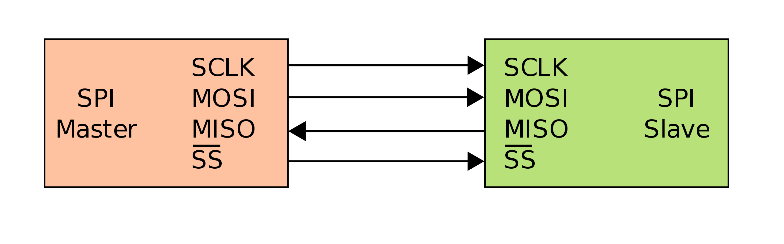
https://en.wikipedia.org/wiki/Serial_Peripheral_Interface

I²C uses only two bidirectional open collector or open drain lines, Serial Data Line (SDA) and Serial Clock Line (SCL), pulled up with resistors.[5] Typical voltages used are +5 V or +3.3 V, although systems with other voltages are permitted.
The I²C reference design has a 7-bit address space, with a rarely-used 10-bit extension.[6] Common I²C bus speeds are the 100 kbit/s standard mode and the 400 kbit/s Fast mode. There is also a 10 kbit/s low-speed mode, but arbitrarily low clock frequencies are also allowed. Recent revisions of I²C can host more nodes and run at faster speeds (400 kbit/s Fast mode, 1 Mbit/s Fast mode plus, 3.4 Mbit/s High Speed mode, and 5 Mbit/s Ultra Fast-mode). These speeds are more widely used on embedded systems than on PCs.
Note the bit rates are quoted for the transfers between master and slave without clock stretching or other hardware overhead. Protocol overheads include a slave address and perhaps a register address within the slave device, as well as per-byte ACK/NACK bits. Thus the actual transfer rate of user data is lower than those peak bit rates alone would imply. For example, if each interaction with a slave inefficiently allows only 1 byte of data to be transferred, the data rate will be less than half the peak bit rate.
The number of nodes which can exist on a given I²C bus is limited by the address space and also by the total bus capacitance of 400 pF, which restricts practical communication distances to a few meters. The relatively high impedance and low noise immunity requires a common ground potential, which again restricts practical use to communication within the same PC board or small system of boards.

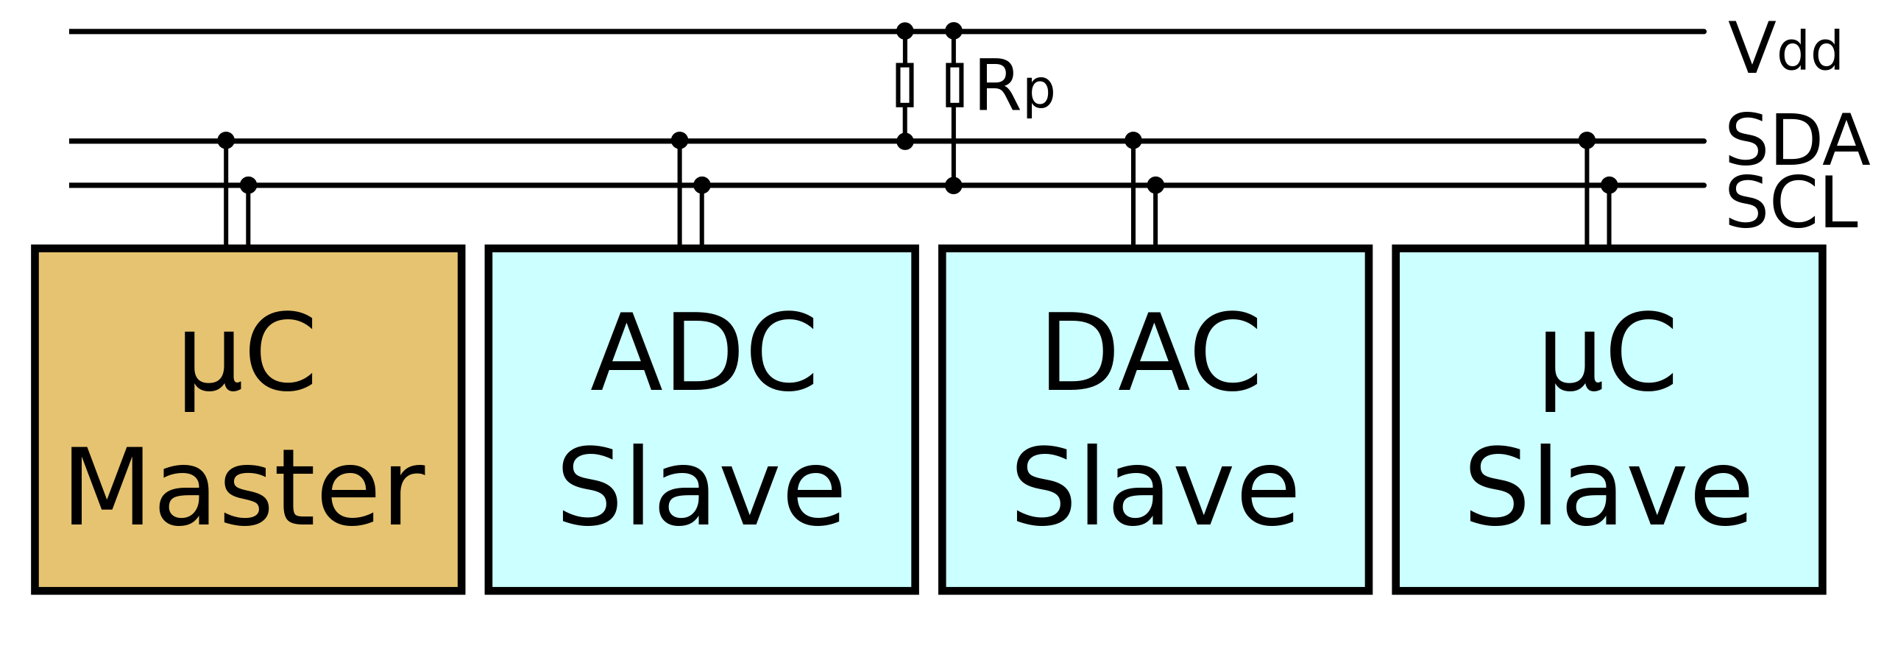
https://en.wikipedia.org/wiki/I%C2%B2C

Note: SPI bust conversion can be made by uni-directional level shifters

Level shifters search
- 74AVC family
  - LEVEL-SHIFTER - 74AVC4TD245PW - 4bits-380Mbps-Separate-Dir-Cntr
    - TSSOP16
    - Have some issues with off-state leakage currents at wide temperature ranges
  - LEVEL-SHIFTER - 74AVC8T245 - 8bits-1Dir-Control
    - 8 bits go one direction is too much

- LEVEL-SHIFTER - ADG3123 - 8 bits-Unidirectional
  - 2.3 V to 5.5 V input voltage range
- LEVEL-SHIFTER - ADG3304 - 36mA-Requirement
  - To ensure correct operation of the ADG3304, the circuit that drives the input of the ADG3304 channels should have an output impedance of less than or equal to 150 Ω and a minimum peak current driving capability of 36 mA.
- LEVEL-SHIFTER - cd40109b - 3-18V
  - 4 circuits; individual enable control for each circuitry
  - 3-18V input range
- LEVEL-SHIFTER - FXL2SD106-D - Bi-directional
  - Bi-directional; Relatively low drive requirements: +/- 200-450 uA
  - 80 Mbps
  - QFN package
- LEVEL-SHIFTER - GTL2005 - 3V-Analog
  - The GTL2005 is a quad translating transceiver designed for 3.3 V system interface with a
  - GTL/GTL+ bus.
- LEVEL-SHIFTER - HEF4104B - 3-15V
  - Uni-directional with both straight and inverted outputs
- LEVEL-SHIFTER - MAX3000E-MAX3012 - 3.6mA-Requirement
  - Family of unidirectional and bidirectional level shifters, but both require similar drive requirements, 3.6 mA for faster uni-polar shifters at 20 Mbps rate
- LEVEL-SHIFTER - MAX3372E-MAX3393E-Commented - Demo-Board-Open-Drain
  - Original demo board level shifter; it has significant power consumption (130-300 uA) and 10k pull-up resistors on each line
- LEVEL-SHIFTER - MAX13013-MAX3023 - 20mA-Requirement
- NLSV Family
  - LEVEL-SHIFTER - NLSV4T240E-D - Nice-Uni-directional-Inverted
    - Not in stock at Digi-key; factory stock only
  - LEVEL-SHIFTER - NLSV4T244E-D - Nice-Uni-directional-Straight
    - NLSV4T244EDTR2G exact part number in TSSOP-14

  - LEVEL-SHIFTER - NLSV8T244-D - Uni-Directional-Straight-8bit
    - 8 bit in one direction is too much
- SN74avc family
  - LEVEL-SHIFTER - sn74avc4t774 - Nice-Bi-directional-individual-control-4bit
    - Texas Instruments
    - 16 uA quiescent current
    - Maximum input currents in Z mode +/-5uA
  - LEVEL-SHIFTER - sn74avc8t245 - 8bits-1Dir-Control
    - 8 bit in one direction is too much
  - SN74AVC4T774PW – TSSOP-16 package
- LEVEL-SHIFTER - txb0104 - Nice-Bi-Directional-2mA-Required
- LEVEL-SHIFTER - txs0104e - Bi-Directional-10k_Pull-Up

Review questions 12/16/2019

- Reset – Software option (page 19 of IMU datasheet)
  - “NOTE: Power up with SCL/SCLK and nCS pins held low is not a supported use case. In case this power up approach is used, software reset is required using the PWR_MGMT_1 register, prior to initialization.”
  - IMU - DS-000189-ICM-20948-v1.3-1385562-Commented.pdf, page 19
  - EW: ok to have, but need hardware reset too.
  - Suggested implementing weak pull-ups on SCL and /CS during power-up.
- Axes orientation – not clear what is axes orientation relative to IMU chip after motion fusion algorithms.
  - Page 83 (IMU - DS-000189-ICM-20948-v1.3-1385562-Commented.pdf)
  - In IMU chip placement follow fig 12 axes orientation and ignore magnetometer axes orientation.
- Temperature read – can this be implemented?
  - Add ability to read this temperature
  - Keep the old sensor for differential temperature measurement
- Can INT1, INT2 signals be made Active High? That way shutting down the IMU would not be mistaken for interrupt. Inverter U7 is there for same purpose
  - Inverter U7 can be placed on either input or output of level shifter U8
  - Get rid of inverter, since active High on interrupts can be set up in both IMU and PIC
  - Software can be set up to ignore interrupt signals during power cycling.
  - EM: Enable output of the 2nd level shifter continuously (do not float)
- /OE (output enable) of level shifters U5, U8 can be controlled by POK (Power OK) signal generated by 1.8V regulator U4, and/or by Mother Board IO.
  - Those signals could also be combined by simple NOR logic (so outputs would be disabled by either OI, or POK)
  - Automatic is better.
- EM: define input of unused invertor.
- Enable signal – active HIGH or LOW?
  - The best if default condition of PIC on reboot is tested.
  - On 3 signals: Modem Enable, Sensor Enable, and IMU enable.

