Version A.1 (10/27/2020): Uses MBARI drawing number as part of the Project Name and automatically populates Design and Board fields.

Starting a new schematic project in EDM:
- Go to Canyon Head and get a new MBARI drawing number. Keep note of the title and drawing number as these will be used when configuring your project.
- Open Capture CIS: Start>CadencePCB 17.4-2019>Capture CIS 17.4
- On the top menu click EDM>Open EDM
- On the log in window click the “Windows” button under “Use another service to log in.”
- Once logged in, change “View” to Hierarchical.
- Click “Projects” to get to the project window.
- Click the “+” button to create a new project.
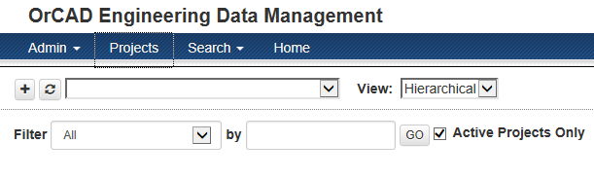
- Fill in the New Project window.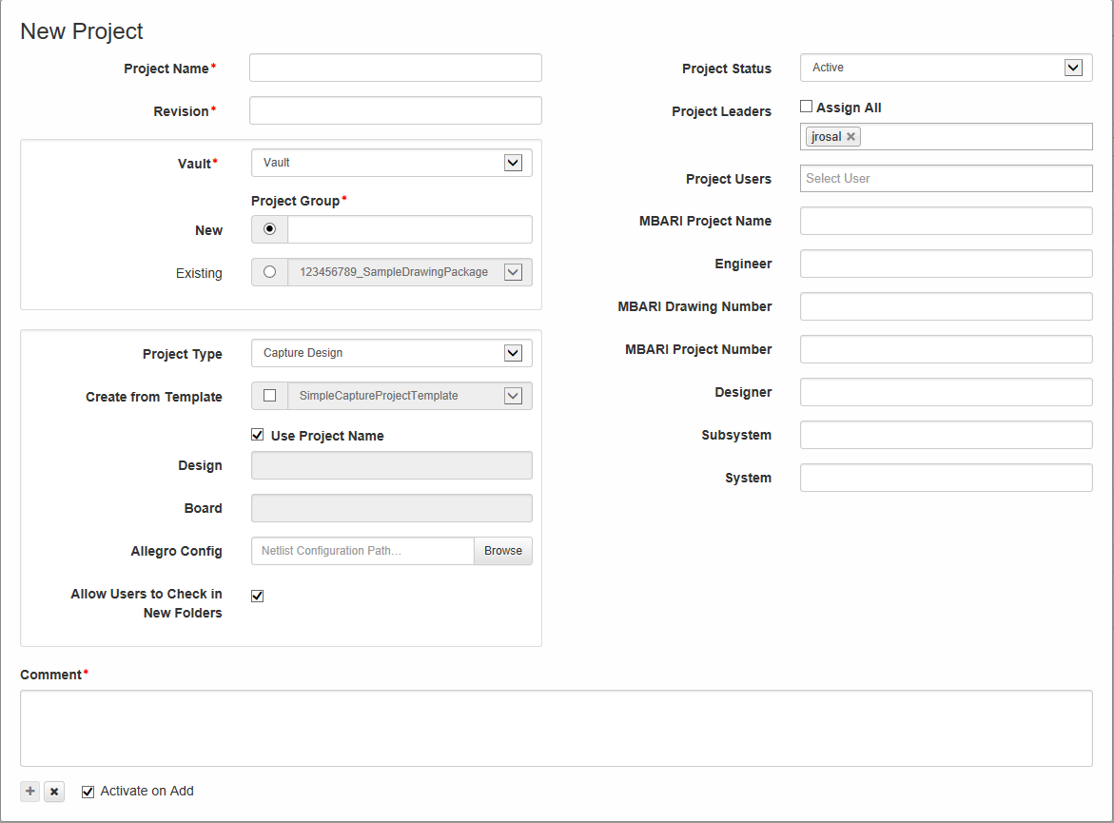
  - Project Name:
    - Use the following naming convention
      - MBARINumber”r””ReleaseLetter”_MBARIProjectName_Short description
      - Ex: 1234567rA_BestProject_PowerBoard
  - Revision:
    - Enter “A”
  - Vault:
    - Select “Vault_Temp”.
  - Project Group:
    - Enter the name of your project if it doesn’t already exist in the drop down menu. Examples:
      - ESP3G
      - LRAUV
      - Power Buoy
      - FOCE
  - Project Type:
    - Select Capture Design from the drop down menu.
      - Used for schematics, layouts, and PSpice models. This should be the default selection.
  - Create from Template:
    - Click the check button and select “MBARI_EDM_TEMPLATE” from the drop down menu.
  - Check “Use Project Name”
  - Design:
    - Not editable. Will default to the name you used for your “Project Name”.
    - This will be the name of your OrCAD Capture DSN file.
  - Board:
    - Not editable. Will default to the name you used for your “Project Name”.
    - This will be the name of you OrCAD PCB Editor BRD file.
  - Netlist Configuration Path:
    - Leave this blank to use the default configuration file.
      - This changes the default configuration file, Allegro.cfg, use by Capture when a netlist is created.
  - Allow Users to Check in New Folders.
    - Check this box as default.
      - Allows users to check in new folders for projects. If this option is not enabled, Project Leaders will need to create folders first before users may check in files to the folder.
  - Project Status:
    - Default selection for new projects should be “Active”
  - Project Leaders and Project Users:
    - Select all project leaders and project users that apply.
  - MBARI Project Name:
    - Should match the name used when generating the drawing number.
  - Engineer:
    - Engineer’s name
  - MBARI Drawing Number:
    - MBARI generated drawing number from Canyon Head.
  - Designer:
    - Name of the PCB Layout designer.
  - Subsystem:
    - Name of the subsystem this project belongs to.
  - System:
    - Name of the System this project belongs to.
  - Comment:
    - You must add a comment to proceed. Since this is a new project, “Initial project creation” might be a good choice.
  - Activate on Add:
    - Check this button to activate the project during its creation.
  - Click the “+” button when done.
- Opening you project for the first time:
  - Click the Projects button on the top of the EDM user interface.
  - Click the “+” button next to the desired group name. This will expand the list of projects that belong to this group.
  - Click the “+” button next to the desired project name. This will expand the list of releases that belong to this project.
  - Select the desired release.
  - The following window should appear.
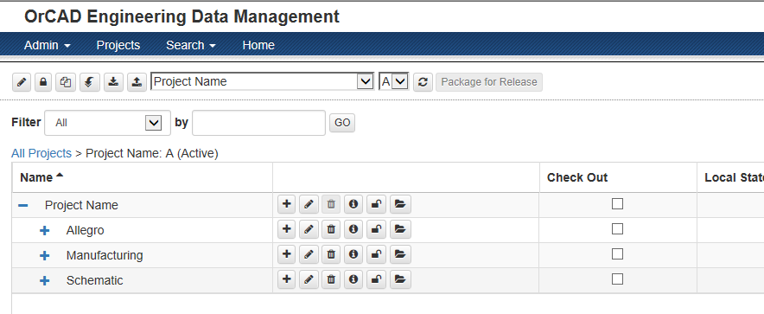
  - Click the “Full Download Project” button. 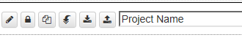
    - This will autogenerate the BRD and DSN files.
  - Click the check button for the DSN File and click the checkout button on top of the page. 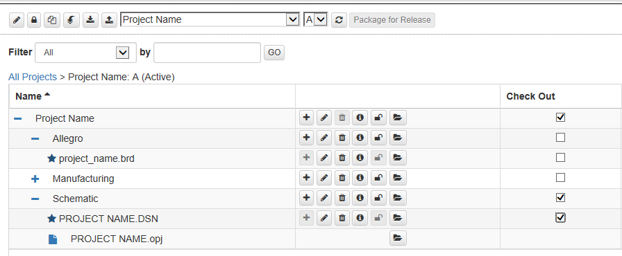
    - This will check out the design file so you can make edits.
  - Click the Open button to open the DSN file for the first time.
  - Your drawing project will open. Go ahead and start adding parts and lines to your schematic.
  - Log out of EDM at this time to free up the network license seat for others to use.
    - 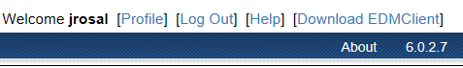
  - You will notice that the title block will NOT be filled correctly at first. DO NOT edit the title block at this time. This will be done automatically during the first check in. After you are done with your first edits, save the project and DSN file and close the files.
    - NOTE: In order to use EDM’s version control features, you must check in your file. But in order for this to happen, you must make some sort of edit to be able to check in the drawing for the first time. You may add some text if you are not ready to create a circuit.
    - Example…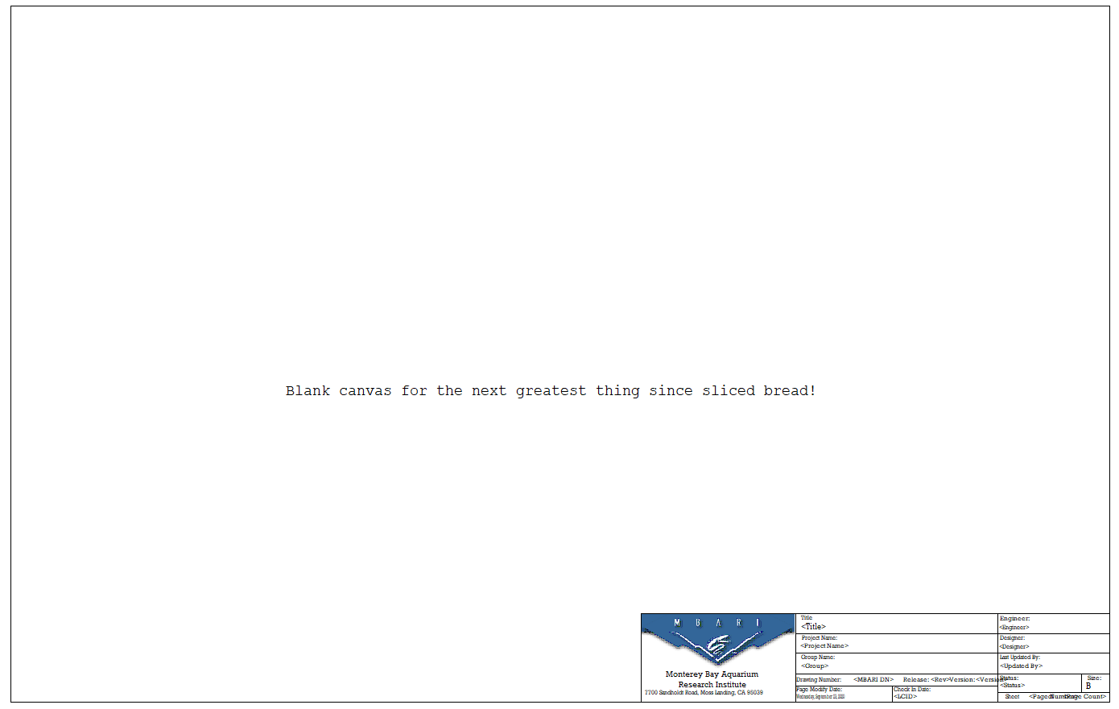
  - When you are ready to check your drawing in, go back to the EDM tab and log back in. Navigate back to your project using the steps 9a-9e.
  - Click the “Check In” button.
  - The check in window will appear. 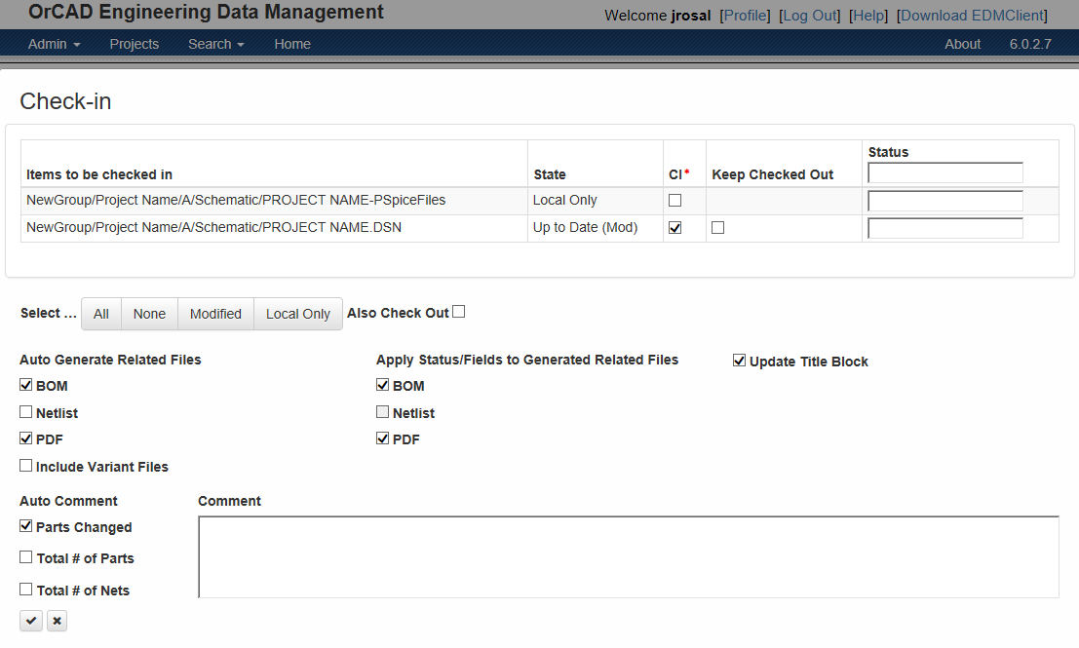
    - Check the DSN “CI” (Check In) button on the top of the screen.
    - “Auto Generation Related Files” and “Apply Status/Fields to Generated Files” are optional.
    - Update Title Block must be checked.
    - Auto Comments are optional.
    - You MUST add a comment in the Comment section.
    - Check the “Save” button on the bottom of the screen when done.
    - The window will flicker as all the auto-generated files are created and the title block is updated with your project information.

