

OrCAD Engineering Data Management (EDM)

Table of Contents: Page 1

First Things First: Page 2

Starting a new project in EDM and your first check in: Page 9

Check in and check out PCB Editor board files: Page 16

Packaging your PCB and schematic for release: Page 19

Creating a new project revision: Page 26

Do’s and Don’ts: Page 28

EDM Project Naming Convention: Page 29

What to Check in: Page 31

First Things First:

Installation:
EDM Install:
- Make sure you are running the latest version of OrCAD before installing the EDM Client software. Go to the following address to run the OrCAD updater: \\atlas\ProjectLibrary\TechServices\Software\0_ProgramInstallFiles\ORCAD_UPDATES\Cadence_17-4\UPDATES

- Run the EDA Client EXE in from the following location:
\\atlas\ProjectLibrary\TechServices\Software\0_ProgramInstallFiles\ORCAD_UPDATES\EDM174\EDM1740P1\CLIENT
  - The installation home screen will open
  - Click Next
  - 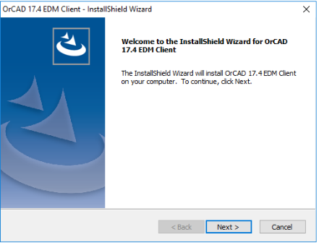
  - Use the default destination location. Click Next.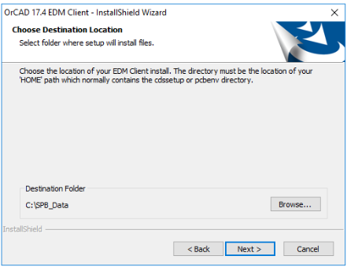
  - Select which shortcuts you want to add then click Next.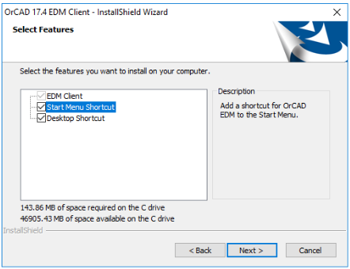
  - Enter: http://water2/edm for the EDM URL then click Next.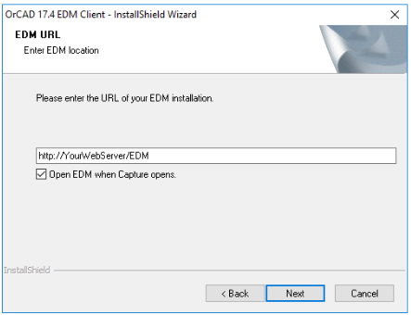
  - Click Install
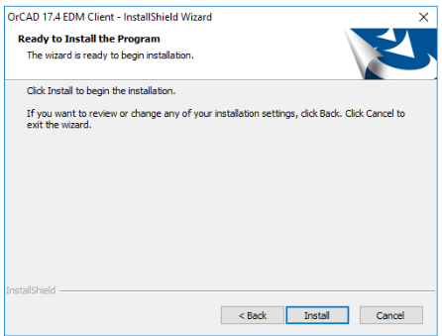

PDF print settings:
EDM can create PDFs of your Capture schematic and PCB Editor artwork/gerber files during every check in and when you use the Package for Release feature as long as you have some sort of PDF interpreter software installed in your computer.
- Download and install a PDF interpreter such as Ghostscript’s PDF interpreter.
  - https://www.ghostscript.com/download/gsdnld.html
- Open OrCAD Capture CIS
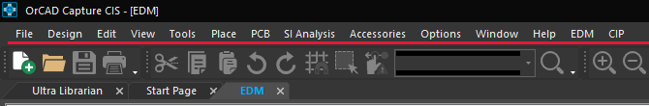
  - Click EDM > Settings from the top menu bar.
  - Enter the address of the executable in the Intelligent PDF Export address box.
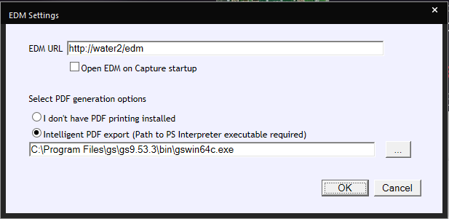
  - Click OK.
Setting up your home workspace folder:
EDM needs a location either on the network or on a local hard drive to act as a workspace for your projects. Once this is set, EDM will transfer the database files to this directory allowing you to review or edit your files until you are ready to check them back in.
It is recommended that everyone use the their “U” drive as it is backed up by IS. This also will allow the user to properly view multi DSN drawing hierarchies as projects of this type require the identical directory addresses.
- Open Capture CIS: Start > CadencePCB 17.4-2019 > Capture CIS 17.4
- On the top menu click EDM > Open EDM
- On the log in window click the “Windows” button under “Use another service to log in.” 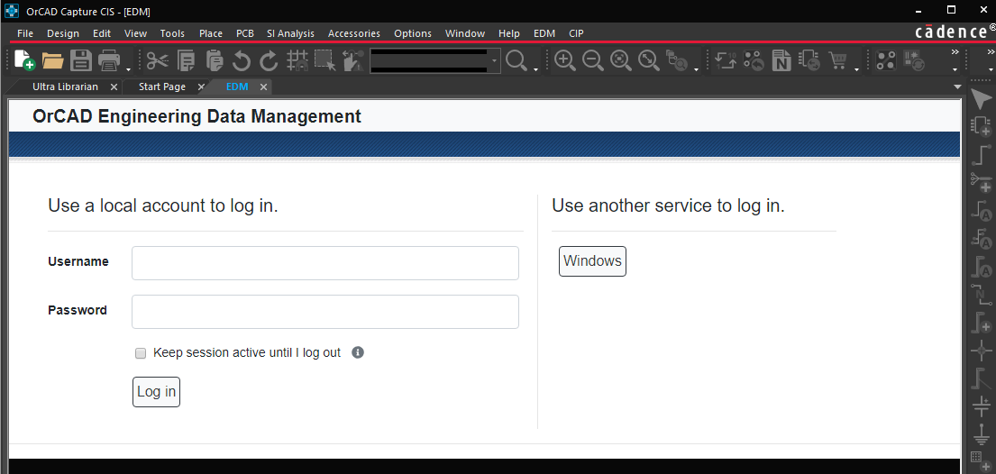
  - Contact Jose Rosal or James McClure if you need help with logging in.
- You will see several menu items on the top left of your screen. You need to click Profile.
- The profile form opens. Click Browse. 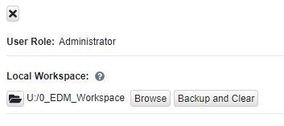
  - Use the following address: U:\0_EDM_Workspace.
Associating DSN files with OrCAD Capture.
You may ignore this step if the DSN file extension on your computer is already associated with OrCAD Capture. If you’re not sure, find an OrCAD DSN file and double click it. If a program other than OrCAD Capture opens, you’ll need to complete the following steps to correct it.
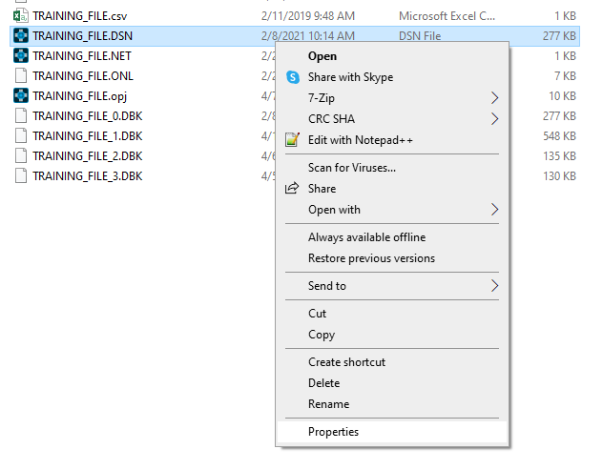
- Find a OrCAD Capture DSN file. Right Click the file and select Properties in the sub menu.
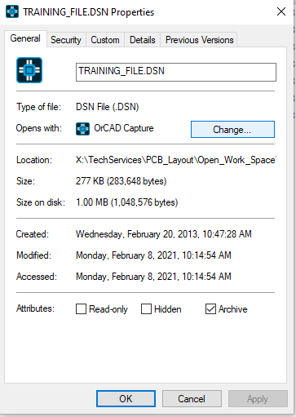
- The Properties window opens. Click the Change button.
- A selection window opens. If you don’t see OrCAD Capture on the list, click “Look For Another App on this PC“.
- In the Open With… window, copy the following address and paste it into the File Name text field.
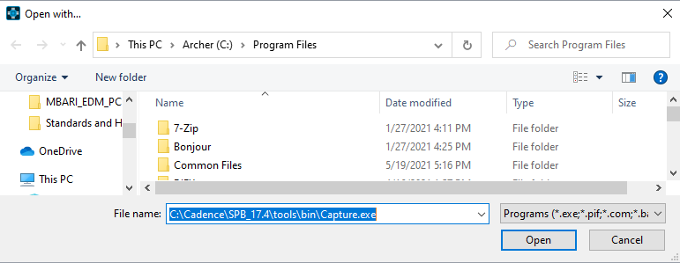
  - C:\Cadence\SPB_17.4\tools\bin\Capture.exe
  - Click Open.
  - Click Apply in the properties window then click OK

OrCAD Capture Design Template:
In order to use the correct titleblock everytime you create a new schematic page within OrCAD Capture, you need to set OrCAD’s Capture’s titleblock default setting to use the EDM specific titleblock.
- Open OrCAD Capture
- Click “Options > Design Template
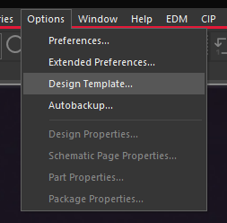
- Click the “Title Block” tab.
- Enter \\water2\EDM\EDM_DesignTemplates\Capture\MBARI_EDM_TITLEBLOCK.OLB in to the Library Name field.
- Enter MBARI_EDM_TITLEBLOCK into the Title Block Name field.
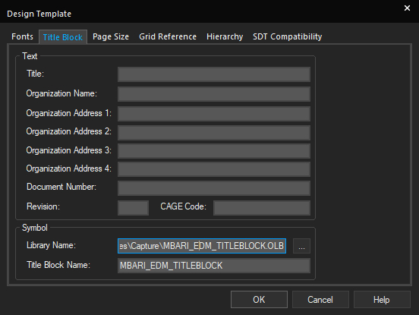
- Click “OK”.

Starting a new project in EDM:
- Go to Canyon Head and get a new unique MBARI drawing number. https://mww.mbari.org/EngDraw/
- Open Capture CIS: Start > CadencePCB 17.4-2019 > Capture CIS 17.4
- On the top menu click EDM > Open EDM
- On the log in window click the “Windows” button under “Use another service to log in.”
  - Contact Jose Rosal or James McClure if you need help with logging in.
- Once logged in, change “View” to Hierarchical.
- Click “Projects” to get to the project window.
- Click the “+” button to create a new project.
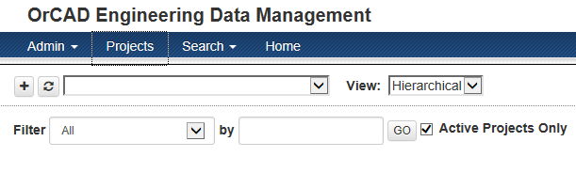
- Fill in the New Project window. 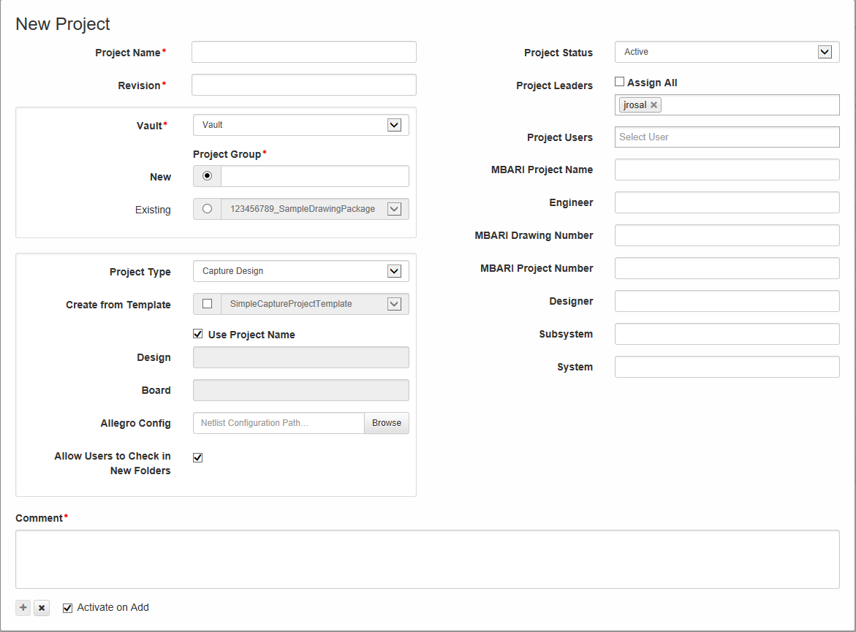
  - Project Name:
    - This name must be unique across all EDM projects. Use the naming convention in the “EDM Project Naming Convention” section at the end of this manual.
  - Revision:
    - Enter “A” if this is will be the first release of your project.
    - Use the naming convention in the “EDM Project Naming Convention” section at the end of this manual for more information.
  - Vault:
    - Select “Vault”.
  - Project Group:
    - Enter the name of your project group if it doesn’t already exist in the drop down menu. Make sure the name you choose does not contain spaces. Use the naming convention in the “EDM Project Naming Convention” section at the end of this manual.
  - Project Type:
    - Select Capture Design from the drop down menu.
      - Used for schematics, layouts, and PSpice models. This should be the default selection.
  - Create from Template:
    - You MUST use one of the templates listed in this menu. Click the check button and select one of the options from the drop down menu.
      - MBARI_EDM_TEMPLATE_2LYR: Creates files needed for 2 layer PCB.
      - MBARI_EDM_TEMPLATE_4LYR: Creates files needed for 4 layer PCB.
      - MBARI_EDM_TEMPLATE_WIRING: Does not contain folders and output files needed to create a PCB.
  - Check “Use Project Name”
  - Netlist Configuration Path:
    - Leave this blank to use the default configuration file.
  - Allow Users to Check in New Folders.
    - This box as checked by default.
      - Allows users to check in new folders for projects. If this option is not enabled, Project Leaders will need to create folders first before users can check in files to custom folders.
  - Project Status:
    - Default selection for new projects should be “Active”. You can use “Released” or obsolete for archiving old projects that were not entered into the EDM workspace.
  - Project Leaders and Project Users:
    - Select all project leaders and project users that apply.
      - Only assigned Project Leaders are able to create folders and manage the project. Project leaders can check in/out projects, delete files, create folders, and assign new project users.
      - Project users or user group members are only able to check out and check in files, pages and symbols that they have been assigned.
  - MBARI Project Name:
    - Enter the MBARI Project Name. Example:
      - ESP
      - LRAUV
  - Engineer:
    - Engineer’s name
  - MBARI Drawing Number:
    - MBARI generated drawing number from Canyon Head. Use the drawing number you created from step 1.
  - Designer (can be filled in at a later time):
    - Name of the PCB Layout designer.
  - Subsystem (can be filled in at a later time):
    - Name of the subsystem this project belongs to.
      - Example: LRAUV Tail Cone Assembly
  - System (can be filled in at a later time):
    - Name of the System this project belongs to.
  - Comment:
    - You must add a comment to proceed. Since this is a new project, “Initial project creation” is a good choice.
  - Activate on Add:
    - Check this button to activate the project during its creation.
  - Click the “+” button when done.
- Opening your project:
  - Click the Projects button on the top of the EDM user interface.
  - Click the “+” button next to the desired group name. This will expand the list of projects that belong to this group.
  - Click the “+” button next to the desired project name. This will expand the list of releases that belong to this project.
  - Select the desired release.
  - The following window should appear.

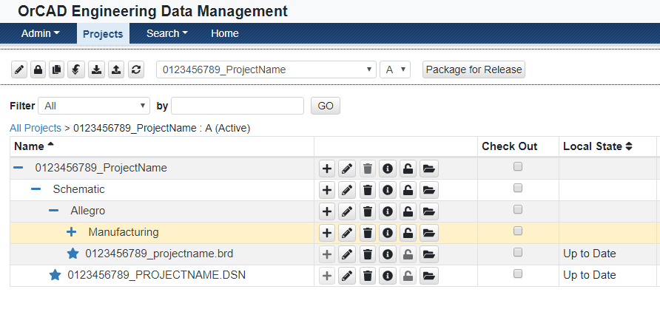

  - Click the “Full Download Project” button. 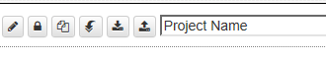
    - This will autogenerate the BRD and DSN files and download them into your working directory.
  - Click the Check Out button for the DSN File and click the Checkout button on top of the page. 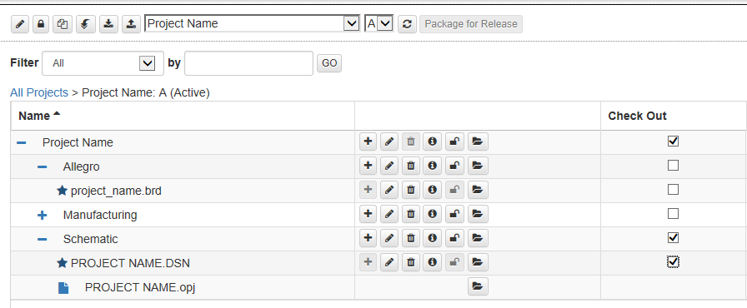
    - This will check out the design file so you can make edits.
  - Click the Open button next to the OPJ file to open the project.
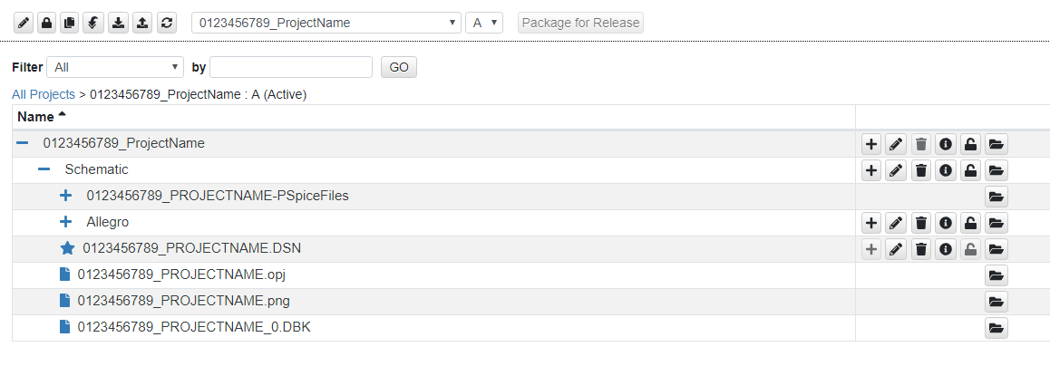
  - Your drawing project will open. You will notice that the title block will NOT be filled correctly at first. DO NOT edit the title block at this time. This will be done automatically during each check in. After you are done with your first edits, save the project and DSN file and close the files.
    - NOTE: In order to use EDM’s version control features such as its automatic title block fill in feature, you must make some sort of edit to your schematic (add text, add a part, etc…). You must also use the EDM client within Capture CIS when checking your schematic back into the EDM database. EDM will not check in your work if the files in your workspace matches what is available in the database.
    - NOTE: The “Page Title” title block field will automatically take the name of your schematic page. Change the name of your schematic page in the OrCAD project window to modify this value.
    - Example of the title block before first check in: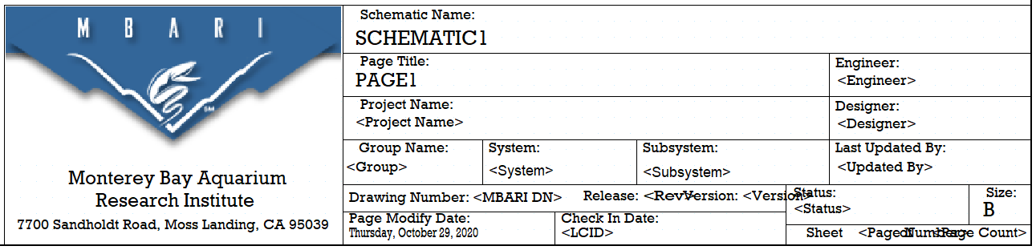

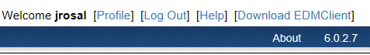
  - Log out of EDM at this time to free up the network license seat for others to use. At this point, you can edit your schematic until you are ready to check it back in.
  - When you are ready to check your drawing in, go back to the EDM tab in the OrCAD Capture and log back in. If the EDM tab is not available, click EMD > Open EDM using the top menus in OrCAD Capture CIS. Note, you need to use the client EDM software WITHIN Capture to be able to update your Capture title block. Navigate back to your project using the steps 9a-9e.
  - Click the “Check In” button.
  - The check in window will appear. 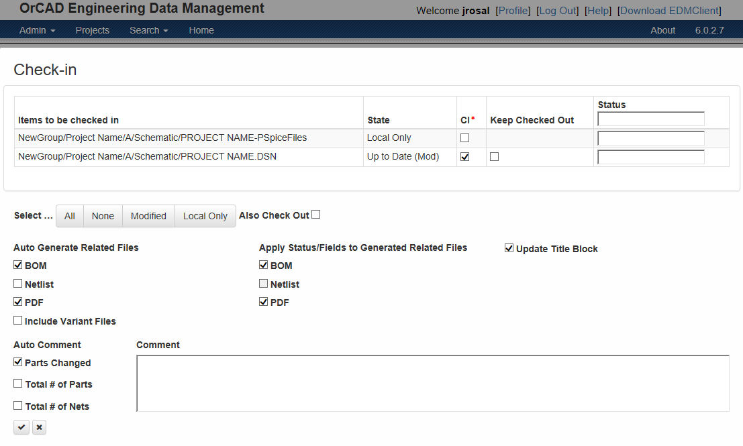
    - Ensure that the .DSN “CI” (Check In) button on the top of the screen is checked.
    - Under “Auto Generation Related Files”, you may choose PDF and BOM now to start the database association process. This will create PDFs of all your schematic pages and your bill of material. You will have the option to update these files every time you check in your schematic. You may also choose to wait until you are further along with your design before creating them. Just keep in mind that these items must be created BEFORE using EDM’s Package for Release feature. The EDM packager can only add these files and cannot create them.
    - Update Title Block must be checked.
    - Auto Comments create the described comment.
    - You MUST add a comment in the Comment section if you don’t choose one of the auto comments.
    - Check the “Save” button on the bottom of the screen when done.
    - The window will flicker as all the auto-generated files are created and the title block is updated with your project information.
    - The following is an example of the title block after the first check in. 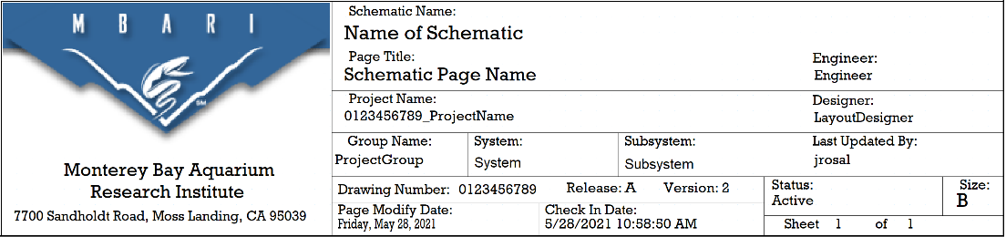

How to check in and check out PCB board files
- Open the EDM Client 17.4 Desktop application. Go to the windows search bar and type “EDM” to locate the application.
- On the log in window click the “Windows” button under “Use another service to log in.” 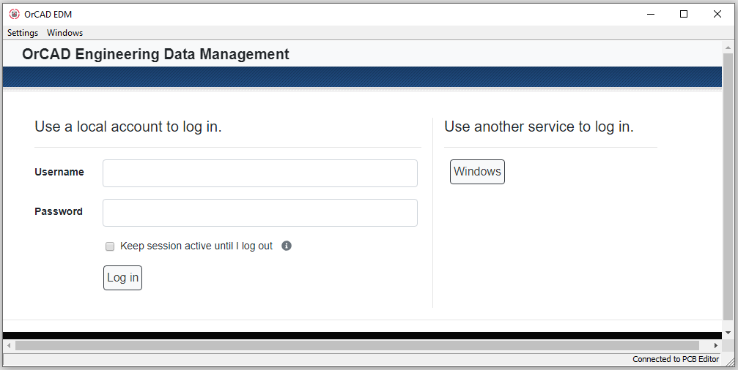
  - Contact Jose Rosal or James McClure if you need help with logging in.
- Click the Projects button on the top of the EDM user interface.
- Click the “+” button next to the desired group name. This will expand the list of projects that belong to this group.
- Click the “+” button next to the desired project name. This will expand the list of revisions that belong to this project.
- Select the desired revision.
- The following window should appear. Note that this was created using the "MBARI_EDM_TEMPLATE_2LYR” template. Using a different template may change the project structure.
- Click the Check Mark button next to the BRD file then click checkout.
- Your file will open in PCB Editor.
  - You will notice that the title block will NOT be filled correctly at first. DO NOT manually edit the text within the title block at this time. This will be done automatically during each check in.
    - NOTE: In order to use EDM’s version control features such as its automatic title block fill in feature, you must check in your PCB Editor file using the EDM desktop application. You must make some sort of edit to your layout file (add text, add a shape, add a part, etc..) to be able to check in your drawing. EDM will not check in your work if the file in your workspace matches what is available in the database.
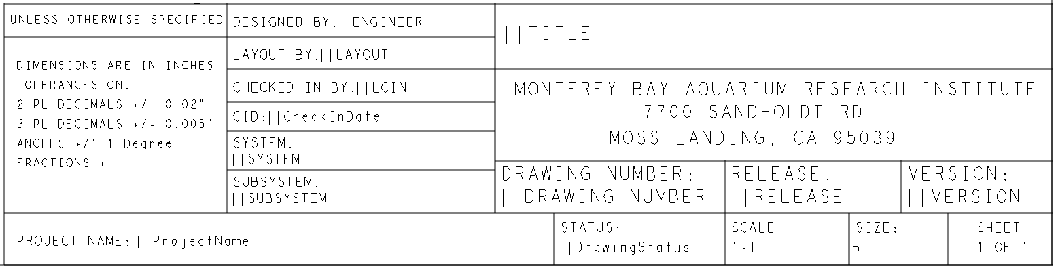
    - Example of the title block before first check in (DO NOT MANUALLY EDIT THE TEXT WITHIN THE TITLEBLOCK)

  - Log out of EDM at this time to free up the network license seat for others to use.
  - When you are ready to check your drawing in, and log back in to EDM using the EDM Desktop Application. Navigate back to your project.
  - Click the Check In button.
  - The check in window opens:
    - Check the CI check mark for the BRD file.
    - Click Update the Title Block
    - Add a comment describing any changes you might have made.
    - Under “Auto Generation Related Files”, you may choose PDF now to start the database association process. This will generate PDFs of all the gerber drawings listed in the Artwork Control Form in PCB Editor. You will have the option to update the PDFs every time you check in your drawing. You may also choose to wait until you are further along with your design before creating them. Just keep in mind that these items must be created BEFORE using EDM’s Package for Release feature. The EDM packager can only add these files and cannot create them.
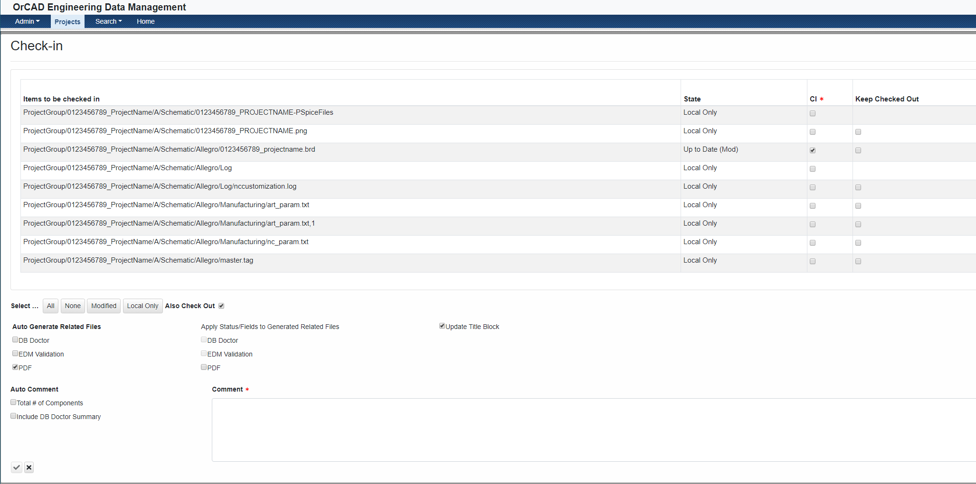
  - Click the Save button on the bottom left of the screen to complete check in.
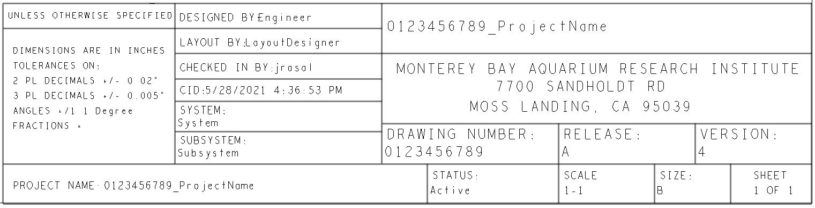
  - The following is an example of the title block after the first check in of your BRD file.

Packaging a project for release.
In this section, you will learn how to create a zip file that contains fabrication and assembly documents and how to lock your project to prevent any further changes that can break the sync between board layout and schematic.
- Check in your OrCAD schematic using the EDM client software within OrCAD Capture CIS. If you haven’t done so already, make sure to pick the option to generate your bill of material if you plan on having the packager include it into your fabrication package.
- Preparing PCB layout for packaging.
  - Open OrCAD PCB Editor.
  - Add a Prefix to your artwork/gerber files
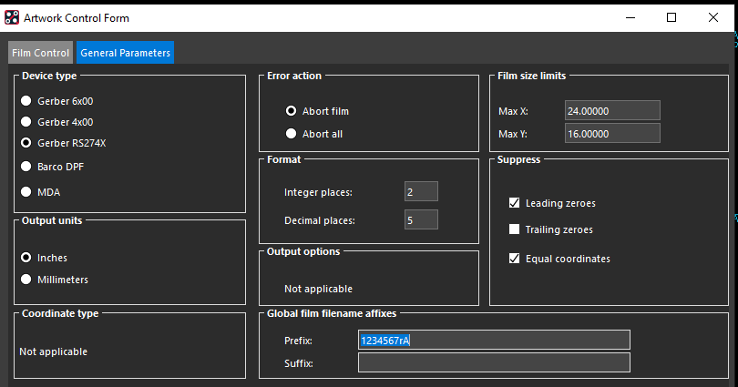
    - Click Manufacture > Artwork
    - The Artwork Control Form opens. Click the General Parameters tab.
    - Use the following prefix naming convention in the Artwork Control Form General Parameters.
    - MBARIDrawingNumber + r + ReleaseLetter
      - Example:
        - 01234567rA
        - 98765432rB
  - Generate NC Drill File. Unfortunately, there is a bug in EDM that does not allow it to automatically create an Enhanced Excellon format drill file while using the project package feature. We need to create this file manually in order to add it to the manufacturing package.
    - In PCB Editor click MANUFACTURE > NC > NC Parameters
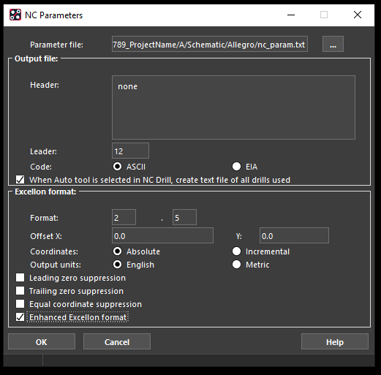
    - Make sure Enhanced Excellon format is checked. Click OK.
    - In the top menu bar of PCB Editor, click MANUFACTURE > NC > NC Drill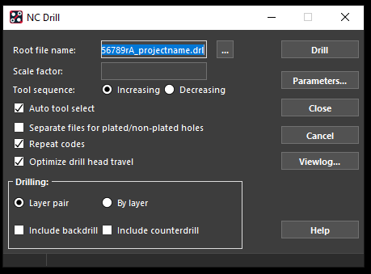
    - Make sure Auto tool select is checked.
    - Next to the Root file name field click the “…” button to open the Save As window.
    - Navigate to the folder called “AdditionalFiles” within your project folder.
      - Note that the folder structure of your project should be the following:
        - Schematic > Allegro > Manufacturing > AdditionalFiles
    - The name of your drill file should use the following naming convention:
      - MBARIDrawingNumber + r + ReleaseLetter + _ + ProjectName
        - Example: 01234567rA_YourProjectNameHere
    - Click Save to close the Save As window.
    - Click Drill. PCB Editor creates a Drill file in the “AdditionalFiles” folder.
    - Click Close to close the NC Drill window.
  - Save and check in your PCB Editor design into EDM using the EDM desktop application.
    - Make sure you select PDF output during the check in stage of your board file if you plan on including the PDFs of your gerbers in the fabrication package.
    - Also check in the following items:
      - Art_param.txt
      - Nc_param.txt
      - The DRL file you just created.
  - Log on to EDM using the desktop application and navigate to your project. Click on the Package for Release button.
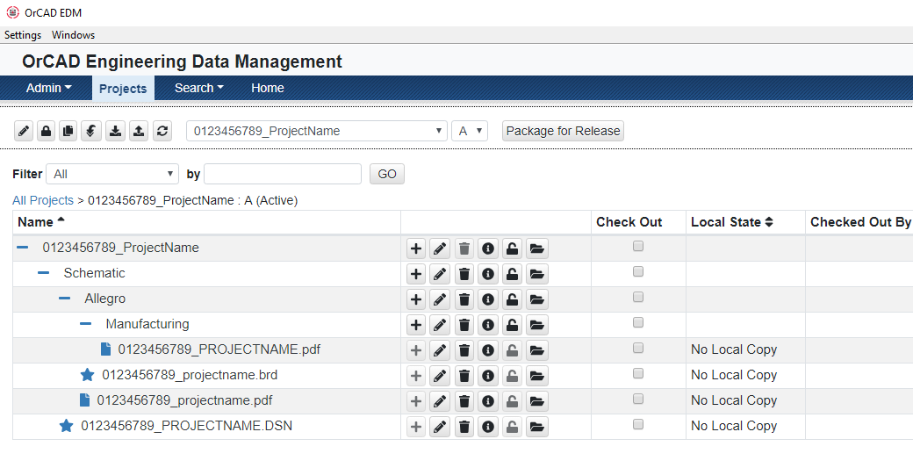
    - Note: You must not have any associated project files open. All workspace files must be checked in and/or identical to the files located within the EDM database.
- The Package for Release form should open. Some options have been pre-selected using the Basic Release Package template. Next to “Include Additional Files”, click Browse.
- Navigate to and select the AdditionalFiles folder mentioned in the last few steps. This will allow you to include the manually created drill file and any other file you might want to include in the manufacturing package.

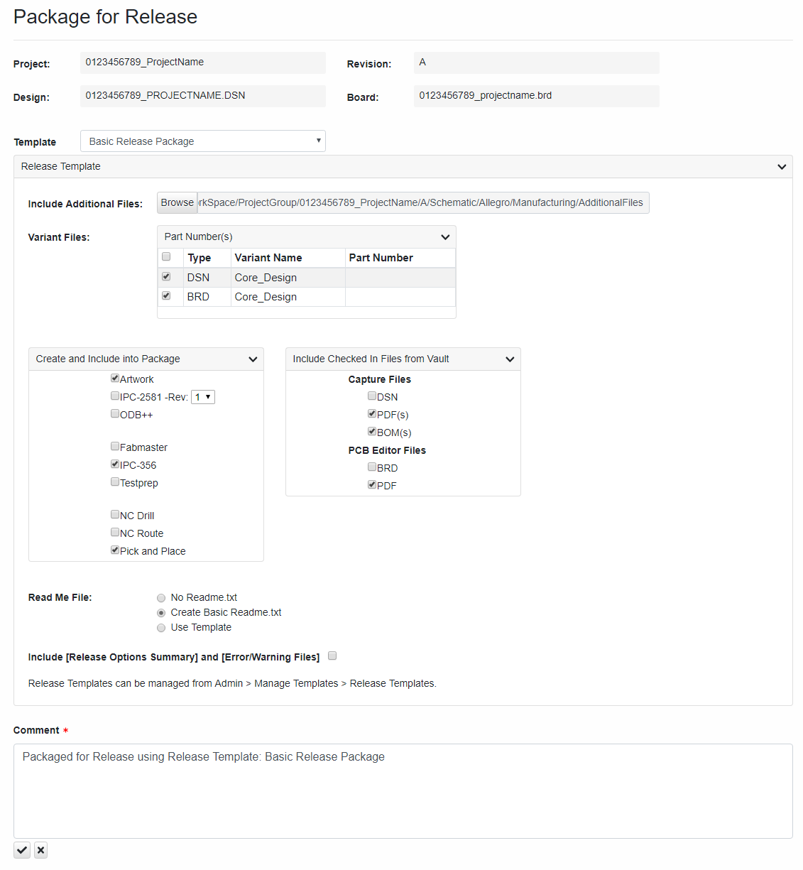
- You may add to the comment field if necessary.
- Press the Package check mark when you’re ready to continue. Several windows will open and close automatically as the project is packaged.
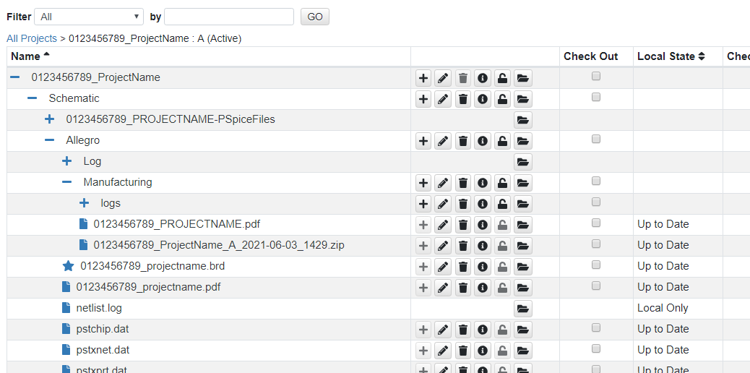
- A ZIP file with all the options you chose will be generated and saved into the EDM database. A copy of the ZIP file will also be in your workspace folder. This can be sent to PCB fabricators or assemblers.
- At this point you can choose to mark this project as “Released” as a reminder to yourself or other users that this project is complete and was released to manufacturing.
  - Go to the project view and expand your project until you see the revision you want to edit.
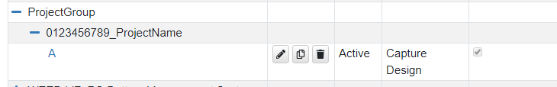
  - Click the Edit button. It’s the one that looks like a pencil.
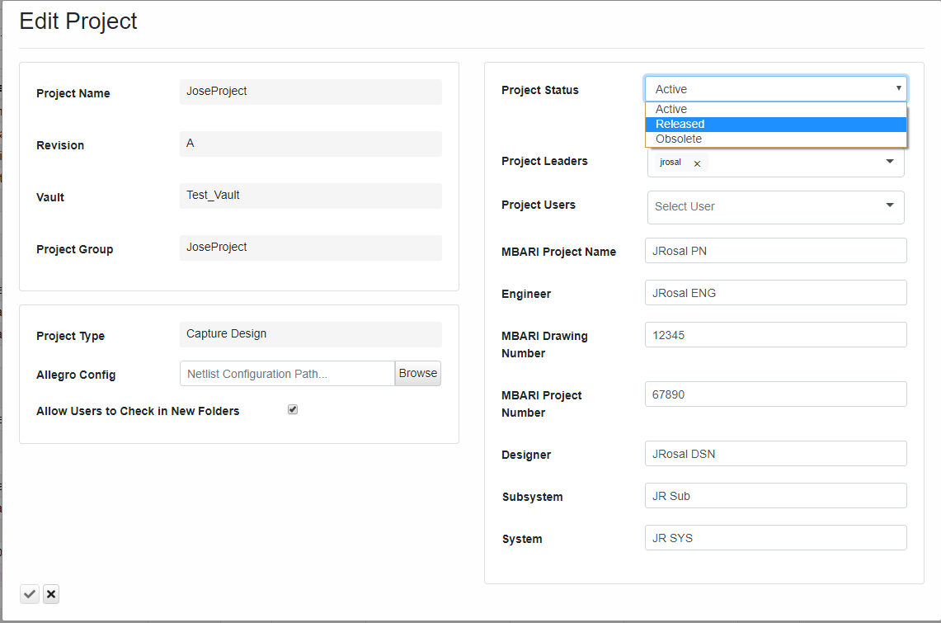
  - The Edit Project form opens. Select Released from the Project Status drop down menu.
  - Click the Save button.
  - Your project will now say Released in the status column.
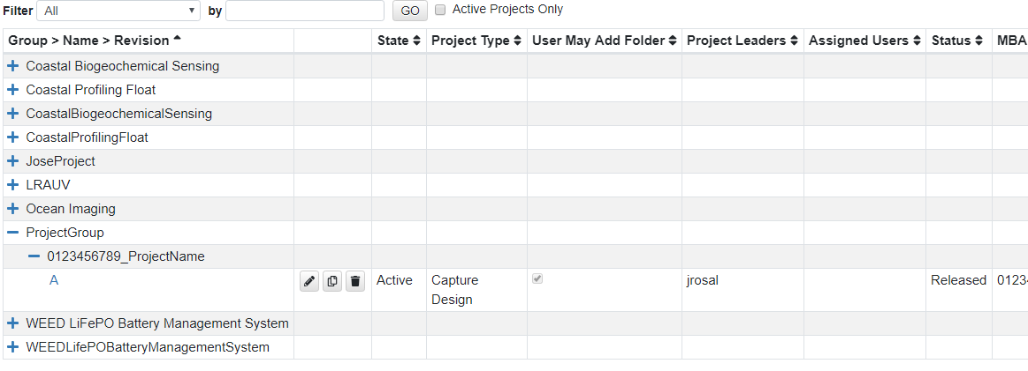

Creating a new Project Revision/Release
- Open the project view window and navigate to your project.
- Expand your project until you see its’ revision information.
- Click on the Copy button that is associated with the revision you want to upgrade.
- The Copy to a New Revision form opens. In this example, the new revision letter will be “B” since the previous revision was “A”. After adding a comment, click Copy button to complete the form.
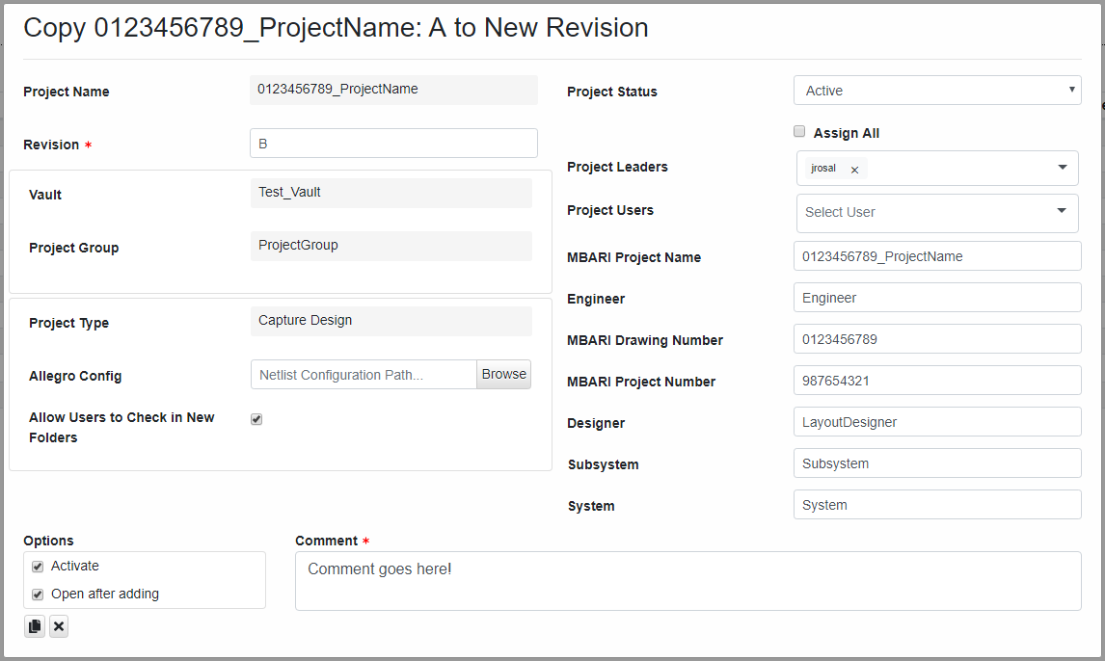
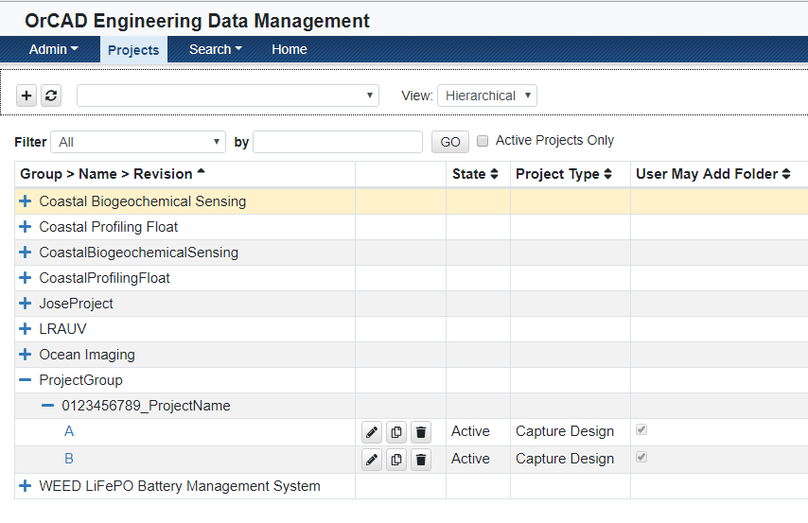
Your new revision should show up in the Projects window.

Do’s and Don’ts

- DO use the EDM client software within OrCAD Capture to check in OrCAD schematic drawings. The EDM desktop application will allow you to check in schematics but it will not give you options to automatically generate other files like the bill of material, netlist, and PDFs. You will also not be able to update OrCAD Capture title blocks if you use the EDM desktop application.
- DO use the EDM desktop application to check in OrCAD PCB Editor drawings. The EDM client software within OrCAD Capture will allow you to check in PCB drawings but it will not give you options to automatically generate other files like manufacturing files and PDFs of your gerbers. You will also not be able to update PCB Editor title blocks if you use the EDM client software within OrCAD Capture.
- DO use the naming conventions provided in this manual. Doing so will help develop a standard for file/project naming. It will also help us avoid any file/project naming errors in the future as some data entry fields must be unique.
- DO use the project folder structure used by the provided project templates. The project templates are set up to use as many of the default settings within OrCAD Capture and PCB Editor when creating output files.
- DON’T edit the text within the schematic or PCB Editor title blocks on your own. Allow EDM to update the title blocks during the Check-In phase.
- DON’T change to a different title block.
- DO log out of EDM when you are not using it. Doing so will allow others to access the database.
- DO use one of the project templates when creating your EDM project. Not doing so will cause great pain and suffering. On top of that, your schematic, board, and bill of materials templates will not have the super cool MBARI logo.
- DON’T create DSN files that contain multiple different PCBs in them. There should only be one PCB design per project.

EDM Project Naming Convention

The depth of the folder structure is fairly shallow in EDM. We have:

Group>Name>Revision

Where…
Group = This is the “main folder” that you will use to group a set of projects together. See below for samples.
Name = The name of the project which is described below
Revision = Is the release letter. Also described below

Group Name Samples:
We have to be fairly creative in our naming of "Group" in order to separate our projects from one another using only one level. For instance, the ESP project has several different systems like the "Sampler", "Seatrac", and "ESP_2G". We can separate the different schematics into easy to find groups.

• ESP_Sampler
○ 1_ESPSampler_SD_SamplerSystemDrawing
○ 7_ESPSampler_WH_SamplerCommsWireHarness
• ESP_Seatrac
○ 2_ESPSeatrac_SD_SeatracSystemDrawing
○ 4_ESPSeatrac_PCB_SeatracCommsBoard
• ESP_2G
○ 5_ESP2G_PCB_CoreBrd

If we named the Group for this project just "ESP", it would mean all the files for all of these separate systems will be grouped in one folder.

• ESP
○ 1_ESPSampler_SD_SamplerSystemDrawing
○ 7_ESPSampler_WH_SamplerCommsWireHarness
○ 2_ESPSeatrac_SD_SeatracSystemDrawing
○ 4_ESPSeatrac_PCB_SeatracCommsBoard
○ 5_ESP2G_PCB_CoreBrd

"Name" Naming scheme:
#########_Subsystem_Type_Description **50 Characters Max**
• #########:
○ MBARI Part Number
• System:
○ System or subsystem name. You can use both.
§ Example: Ocean Imaging has a LASS system and a AUV system
□ Subsystem could be: OI_LASS or OI_AUV
• Type:
○ WH - Wire Harness
○ SD - System Drawing
○ PCB - Printed Circuit board
○ C - Cable
○ AIO - All in one system/wire harness/cable drawing.
- EDM automatic features such as BOM/PDF generations and drawing versioning between different schematics within a DSN do not work well in AIO drawings.
  - Example. I have 5 separate wire harnesses in a drawing. For simplification, each wire harness has a J1 and J2. EDM wants to generate a BOM for all 5 of those wire harnesses at once. You will have a BOM with multiple J1 and J2 references.
    - In this example, you will have to manually make and track the BOMs for each harness.
• Description:
○ Short descriptive name

Revision vs Releases

Revisions/Release:
○ A "Release" is built as is from the fabricator
○ A "Revision" is a fix such as a "blue wire" or BOM change to a release.

Example project life cycle

ExampleProject:
- EDM_Playground
- ○ 1_EDMP_SD_TopLevelDrawing
  - A <- ("A" is a release)
- ○ 2_EDMP_PCB_PwrSupplyBrd
  - A
  - A-1 (Modifications had to be done on release A of the board so a revision "-1" was created)
  - B
- ○ 3_EDMP_PCB_MtrControllerBrd
  - A
  - B <- (Modifications were done to a “A” that resulted in a new PCB “B”)
- ○ 4_EDMP_WH_StepperMotorHarness
  - A

What to Check In?
EDM allows the user to check any file you want with the exception of the OrCAD Capture Project file (*.opj). What to check in really depends on the project leader. Having said that, I suggest you only check in only what you absolutely need.
The folder structure is currently set using either the PCB or Wiring project templates within EDM. EDM automatically places the schematic and PCB design files and post files like PDF, BOM, and Release files into the correct folder.
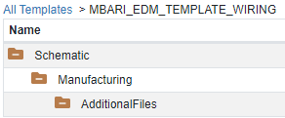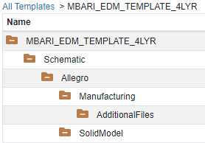
For PCB projects you should have the following files:
- Schematic Design File | - PCB Design File | - PDF of PCB Gerbers
- Netlist files (chip,xnet,xprt) | - Drill File | - Release Zip file
- BOM | - Art Parameter File | - Solid Model of PCB
- PDF of Schematic | - NC Parameter FIle | - SPICE files (if available)

For wiring/cable/top level projects you should have the following files:
- Schematic Design File | - BOM | - PDF of Schematic
- Release Zip File

File Type Descriptions:
- Schematic Design File: OrCAD Capture Design File *.DSN
- Netlist Files: Files needed to translate OrCAD schematics into OrCAD PCB Editor boards. There are 3 files: pstchip.dat, pstxnet.dat, and pstxprt.dat.
- BOM: Schematic bill of material in Excel format. Used for parts procurement and assembly.
- PDF of Schematic and PCB gerber artwork. Allow users to view your schematic or gerber files without having to open the working design files.
- Drill File: Used my manufacturing to drill holes into PCBs during the fabrication process.
- Art and NC parameter files: Files that define the setup of the gerber and drill data files. EDM generates a copy of the database files within its own work space to auto generate gerber files. If you don’t check-in the ART and NC parameter files, EDM will create the gerber and drill files using OrCAD’s default specifications.
- Solid Model of PCB: This can be a Solidworks part or IDF model of your PCB.
- Released Zip File: This zip file is generated using the “Package” feature within EDM. EDM gathers and creates all files needed to fabricate and assemble your project. Currently this includes the following:
  - Schematic and Gerber PDFs.
  - BOM.
  - IPC test files used for netlist verification during fabrication. (PCB projects only)
  - Gerber artwork and NC drill file for fabrication. (PCB projects only)
  - Component pick and place file for assembly. (PCB projects only)
  - Readme.txt file used to describe the contents of the Zip file.
Below is an example project that shows the folder structure described above.
