EDM Install:
- Make sure you are running the latest version of OrCAD before installing the EDM Client software. Go to the following address to run the OrCAD updater: \\atlas\ProjectLibrary\TechServices\Software\ORCAD_UPDATES\Cadence_17-4\HF_018

- Run the EDA Client EXE in from the following location: \\atlas\ProjectLibrary\TechServices\Software\ORCAD_UPDATES\EDM174\EDM1740P1\HF_014
  - The installation home screen will open
  - Click Next
  - 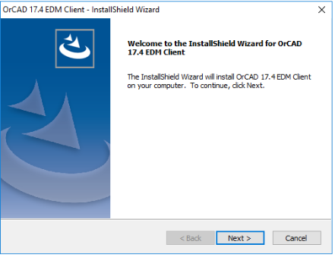
  - Use the default destination location. Click Next.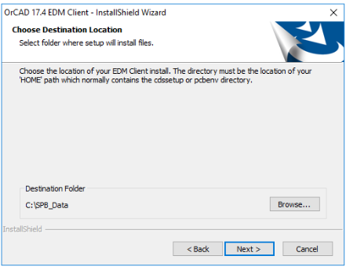
  - Select where you want your shortcuts if any then click Next.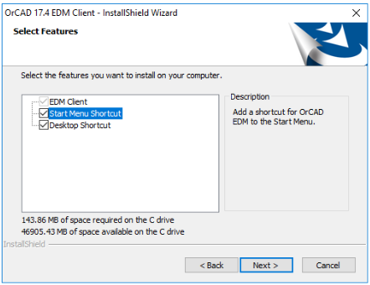
  - For the EDM URL enter: http://water2/edm then click Next.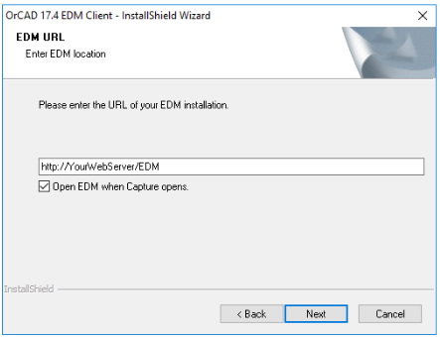
  - Click Install
