The purpose of this document is to guide you through the installation of the following programs.
- OrCAD 23.1 Base Installation
- OrCAD 23.1 Update
- CIP Client
- EDM Client

Preparing for installation:
- Click the following link and download the “SPB231” folder onto your computer. It doesn’t really matter where on your computer you download it to, just make sure you remember where you put it.
  - \\atlas\ProjectLibrary\TechServices\Software\0_ProgramInstallFiles\ORCAD_UPDATES\CADENCE_231
- If you are using OrCAD EDM, please check in all you work prior to installation of the 23.1 software package.

Uninstalling OrCAD 17.4
- Uninstall your current OrCAD 17.4 installation in the following order.
  - OrCAD 17.4-2019 EDM Client
  - OrCAD 17.4-2019 CIP Client
  - Cadence OrCAD and Allegro 17.4
- Reboot your computer.

Base installation of OrCAD

- Browse the folder you just copied to the following address:
  - InstallFileCopy_location\SPB231\SPB2310P4_BASE\PRODUCT\BASE
- Double-Click the installation application “setup.exe”
- Agree to the license agreement.
- Make sure only OrCAD X Products is selected in the Installation Settings window. Then click Next.
  - 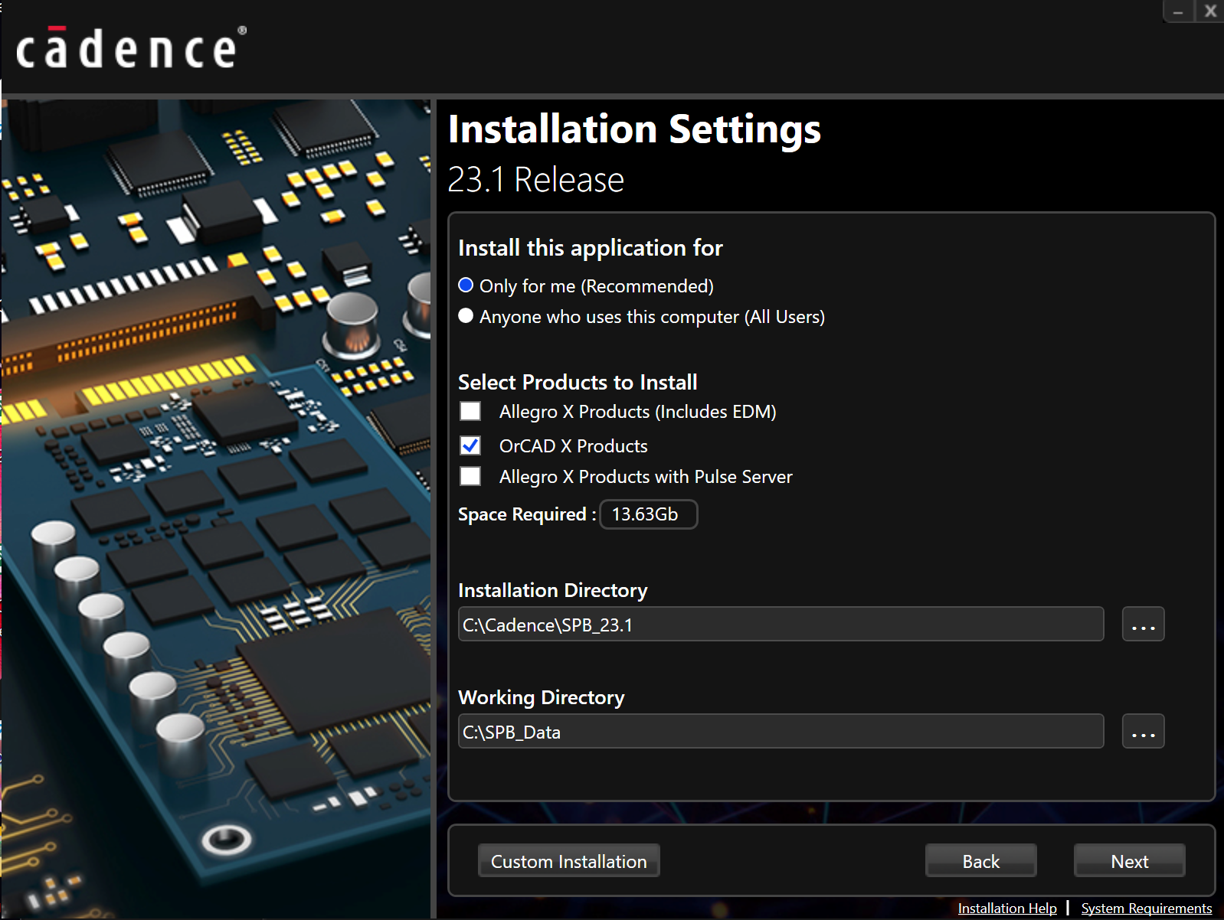
- Input License Details window opens:
  - Select “Connect to Existing License Server”
  - Enter 5280 for the Port Number.
  - Enter Cyclone for the Host Name.
  - Click next. 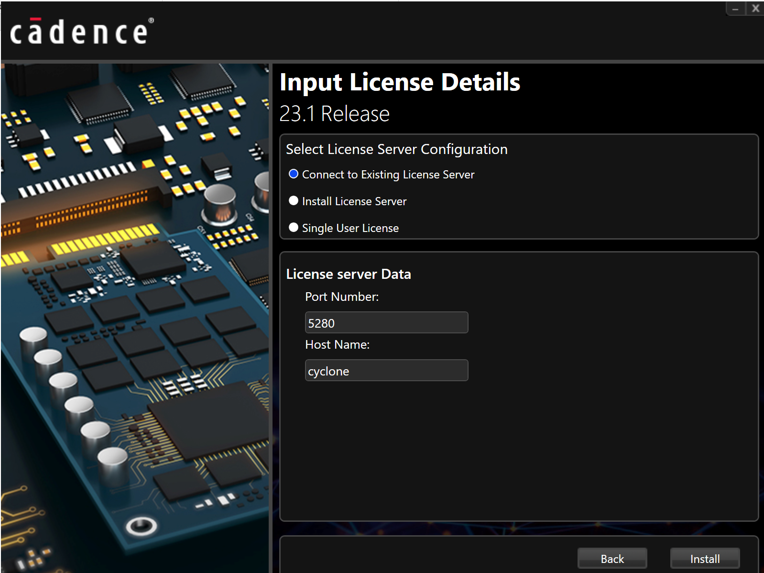
- Installation takes several minutes to several hours depending on the machine.
- Skip the third party tools installation. Click finish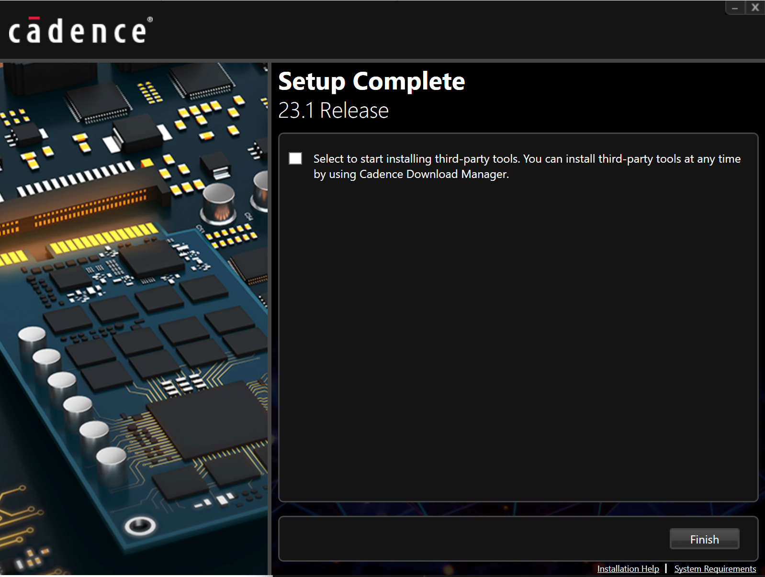

Updating OrCAD X

- Open the following folder:
  - InstallFileCopy_location\SPB231\SPB2310P2\PRODUCT\HF_005
- Double-Click the installation application “setup.exe”
- Agree to the license agreement.
- Click “Install”
  - 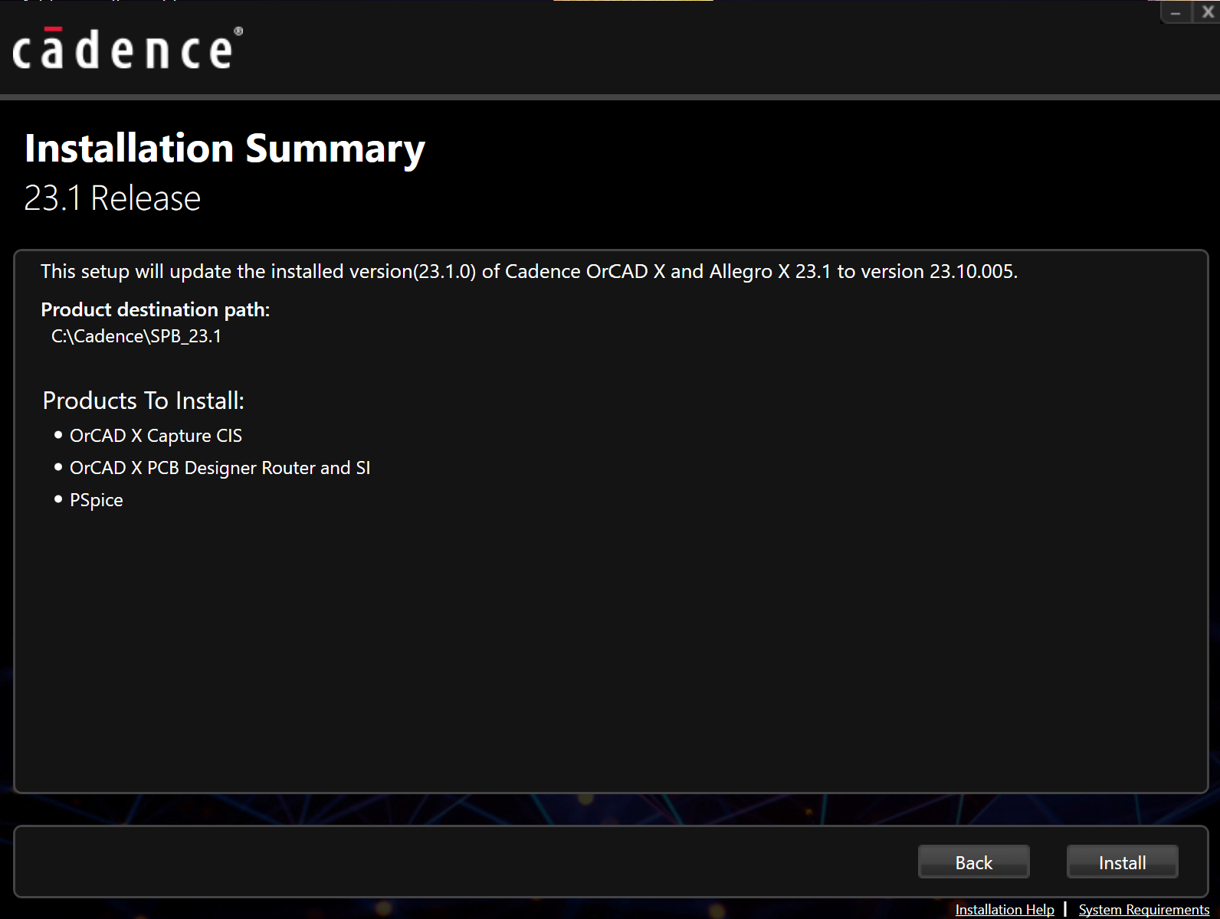
- Installation may 30 minutes to an hour.
- Click “Finish” when installation is complete.
  - 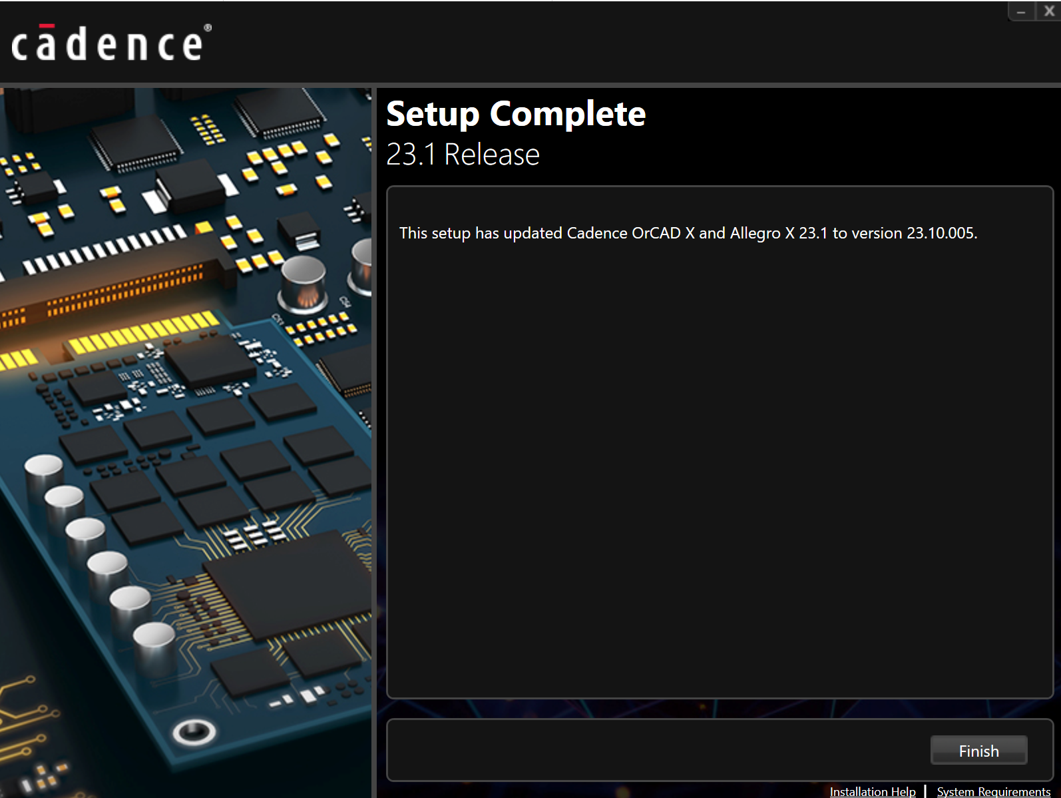

Install CIP Client

- Open the following folder:
  - InstallFileCopy_location\SPB231\CIP2310P1\CLIENT\HF_002
- Double-Click the installation application “CadenceCIPClientSetup”
- InstallShield Wizard window opens. Click Next.
  - 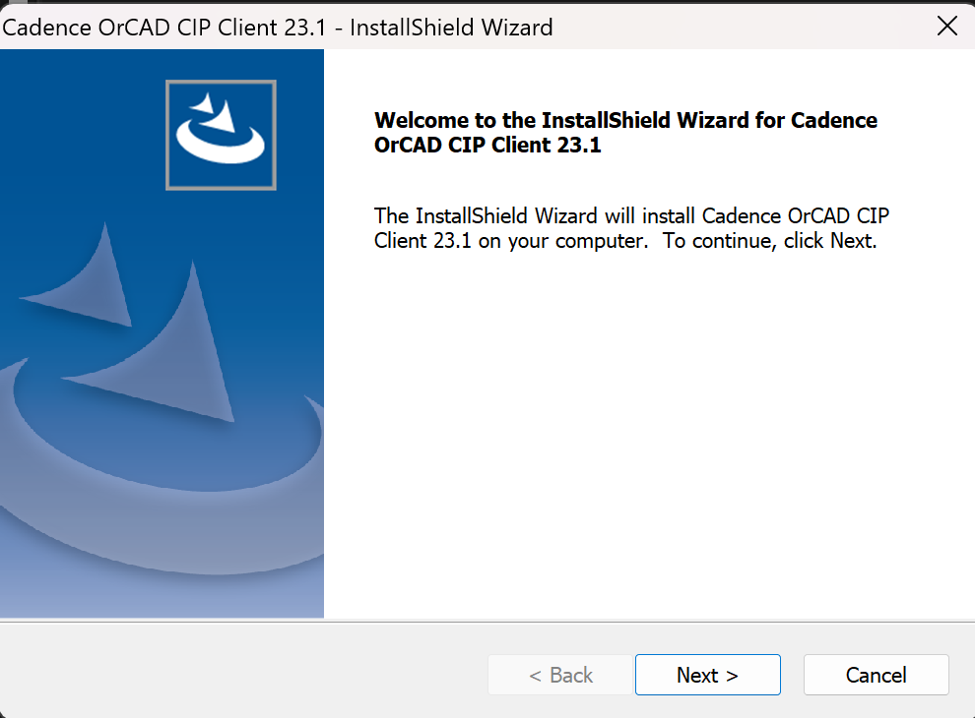
- License Agreement window opens. Accept this and click Next.
  - 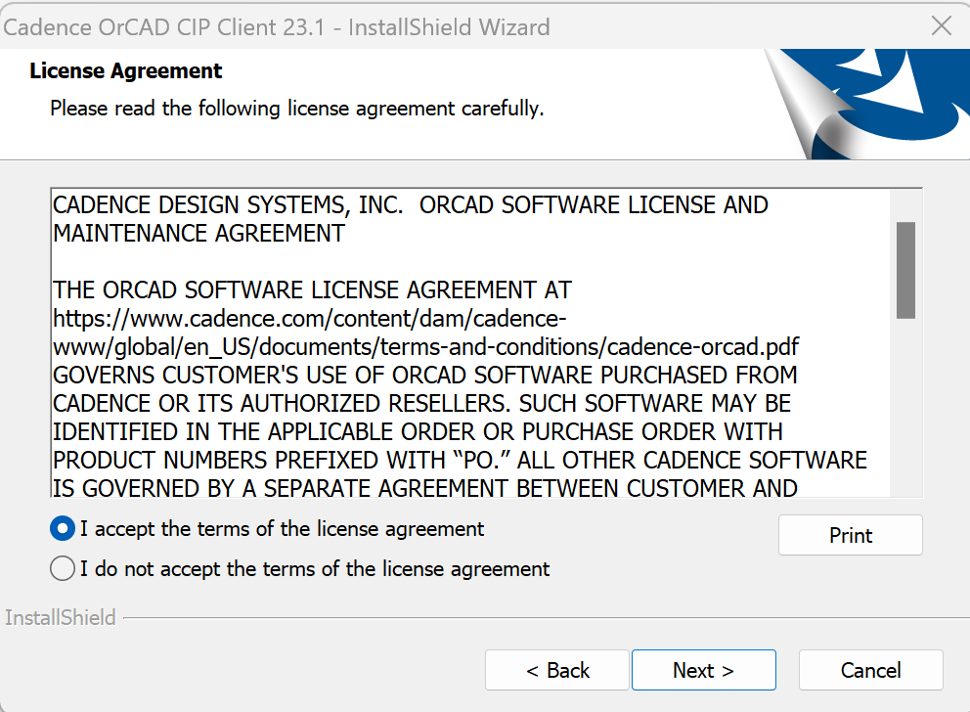
- Select Features window opens. Make sure “OrCAD Capture Plugin” is the only option selected.
  - Click Next.
  - 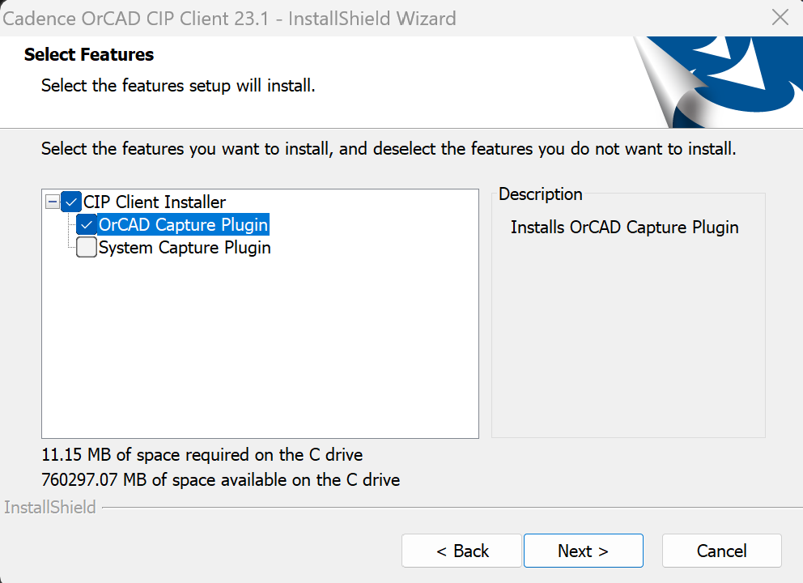
- Destination Folder window opens. Keep the default settings. Click Next.
  - 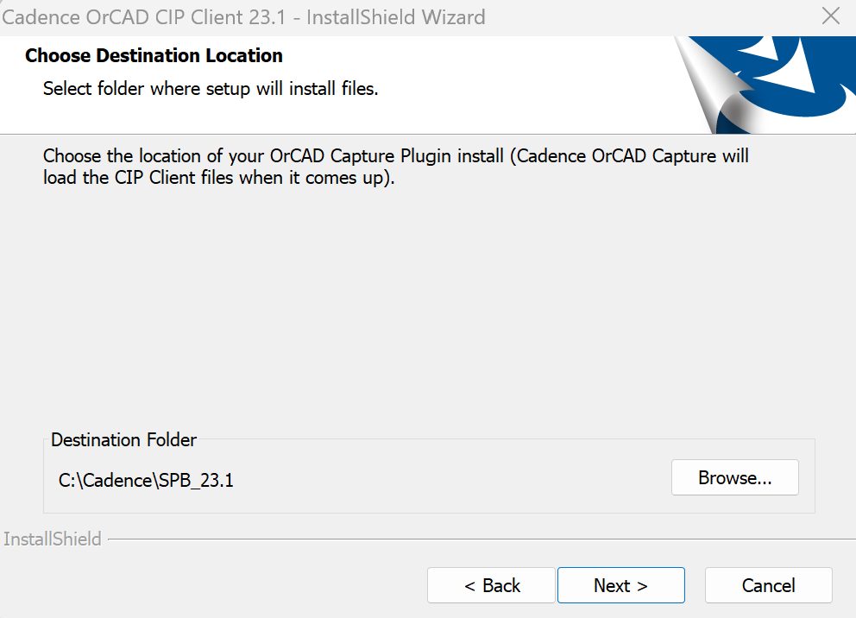
- CIP URL window opens.
  - Enter the following URL: http://water2/cip-e
  - It’s your choice whether or not you want CIP to open when you open Capture.
  - Click Next.
  - 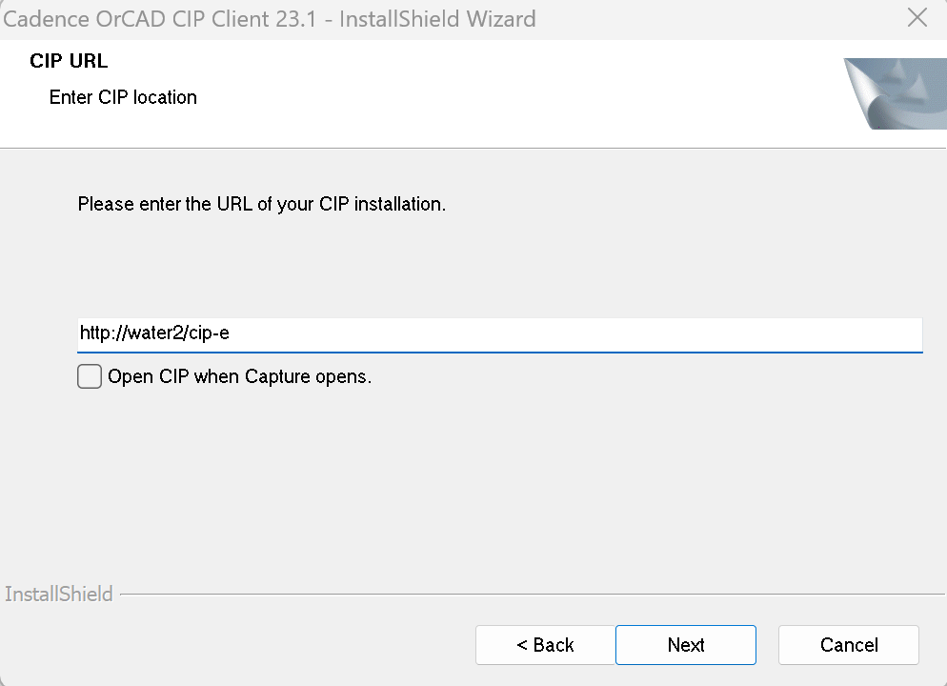
- Library Builder Executable Path window opens.
  - Leave this blank. Click Skip.
  - 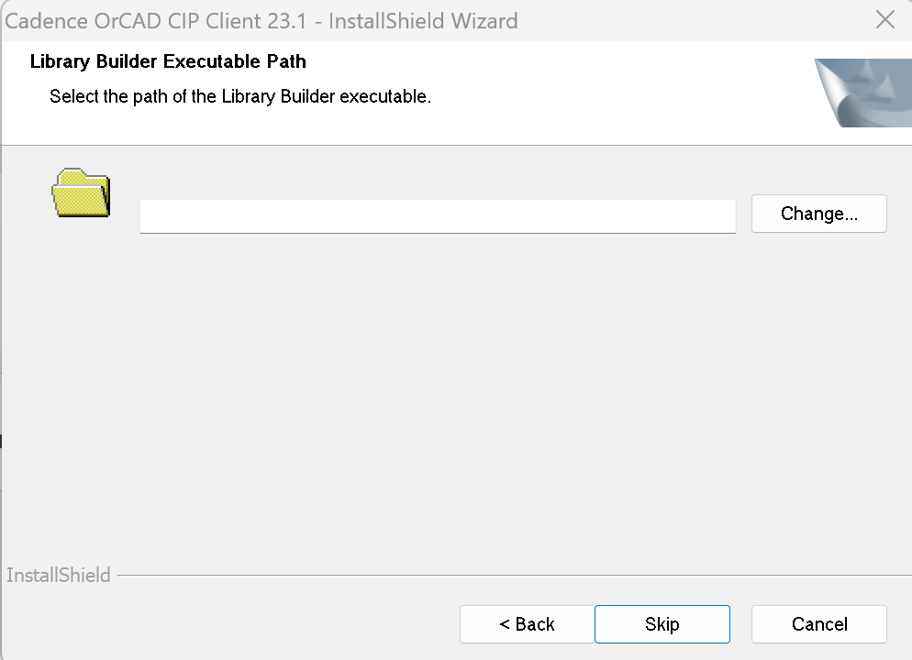
- ODBC Data Source window opens.
  - Enter: perseus
  - Click Next
  - 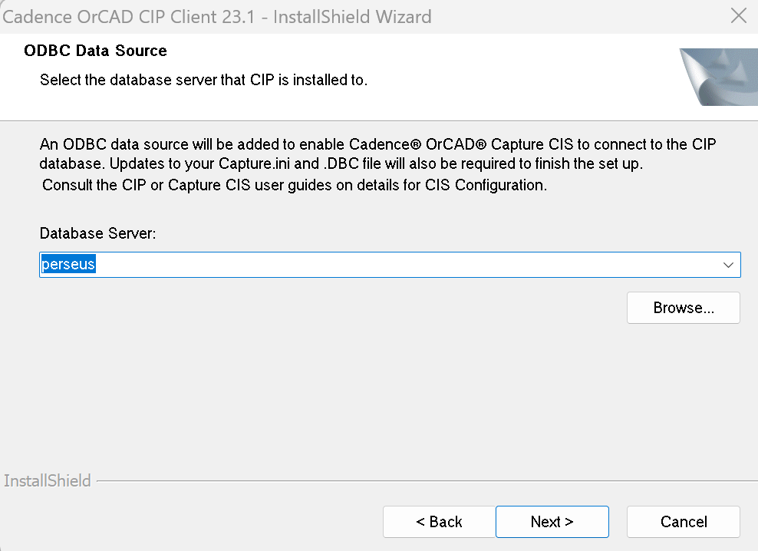
- Ready to install window opens.
  - Click Install.
- Finish window opens.
  - Click Finish.
  - 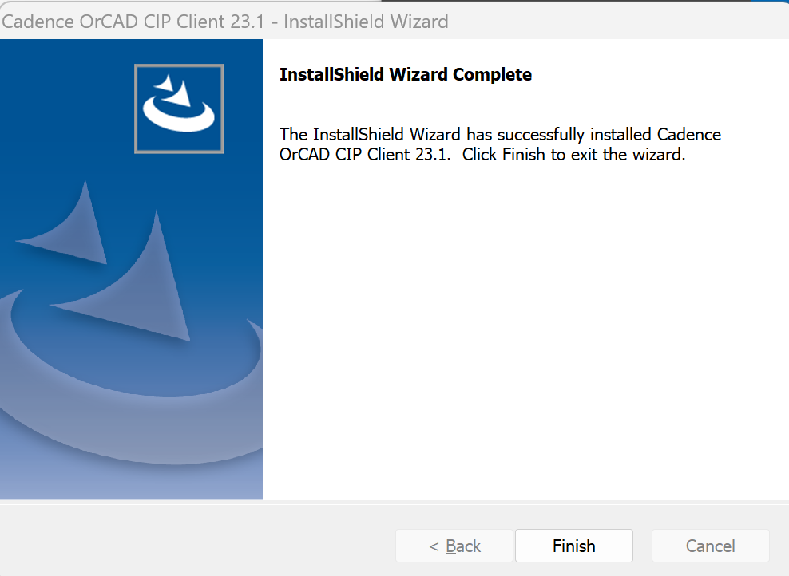
- Updating OrCAD Capture’s .INI file
  - Open OrCAD Capture CIS.
  - There will be a session log letting you know where your INI file is located.
    - 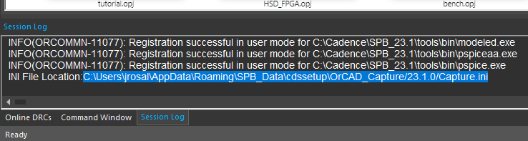
  - Use Windows Explorer to browse to that address and open the INI file.
  - Close OrCAD Capture.
  - Highlight the following lines:

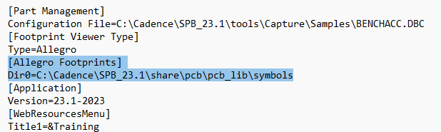

  - Replace the lines you just highlighted with the following:
[Part Library Directories]
Dir0=\\water2\CIP_Resources\Schematic_Symbols
[Allegro Footprints]
Dir0=\\water2\CIP_Resources\Allegro_Library\Symbols
Dir1=\\water2\CIP_Resources\Allegro_Library\Pads
Dir2=\\water2\CIP_Resources\Allegro_Library\17_2_Libraries\Symbols172
Dir3=\\water2\CIP_Resources\Allegro_Library\17_2_Libraries\Pads172
  - 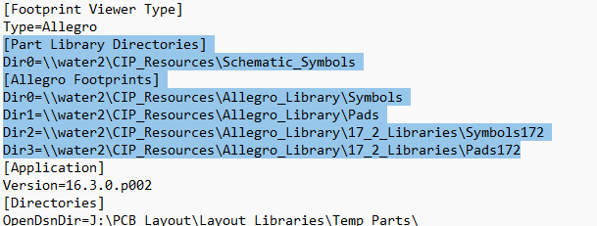
  - Save and close the modified INI file.
- Linking the CIS Configuration File. (This portion of the installation should only be done AFTER the CIP server is updated to 23.1.)
  - Open OrCAD Capture CIS
  - In order to view the correct menu, you will need to open a project file. If this is the first time you’re opening OrCAD capture, there should be a tutorial.opj file available in the recent projects window.
  - Once your project opens, click the DSN file within the project window.
    - 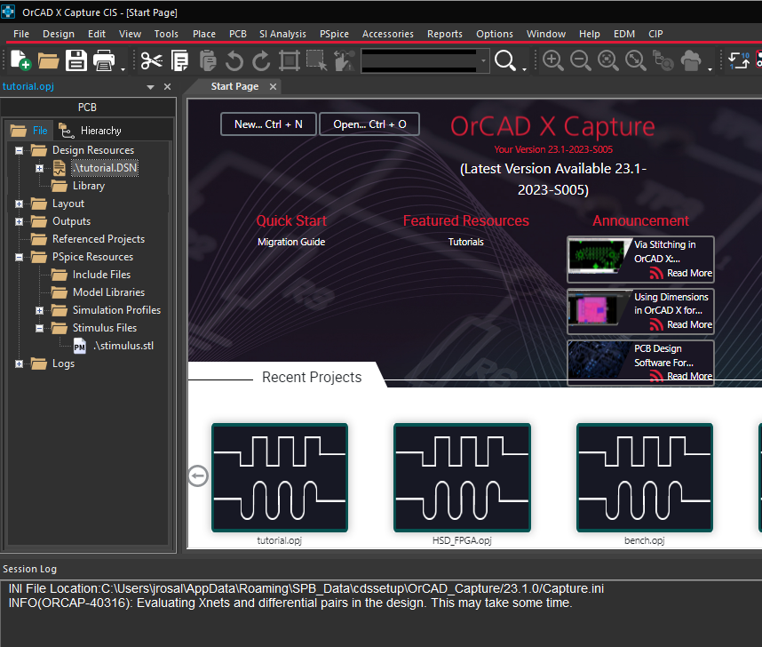
  - Click Options > CIS Configuration
    - 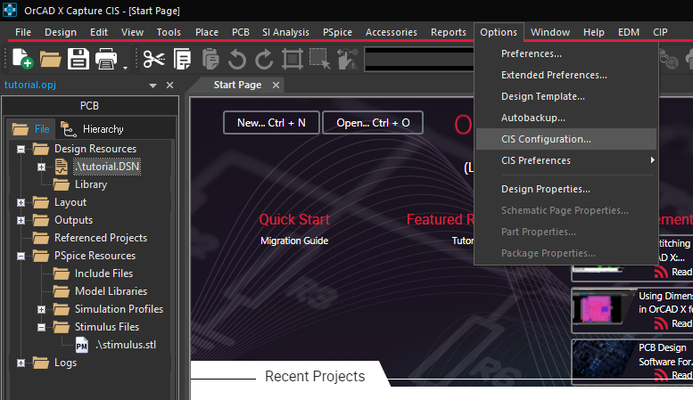
  - CIS Configuration File window opens:
    - Click Browse.
    - 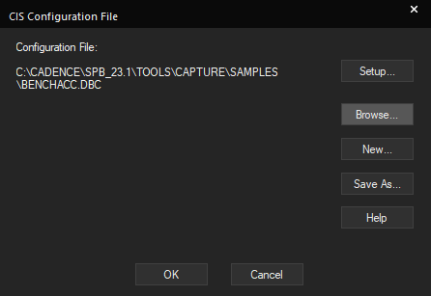
  - Browse to the following location:
    - \\water2\CIP_Resources\Configuration_Files\23-1_CIPconfigFile
  - There should be only one configuration file located in this folder. Select it then click open.
  - Click okay.

Install EDM Client

- Open the following folder:
  - InstallFileCopy_location\SPB231\EDM2310P1\CLIENT\HF_004
- Double-Click the installation application “OrCADEDMClientSetup.exe”
- InstallShield window opens.
  - Click Next
  - 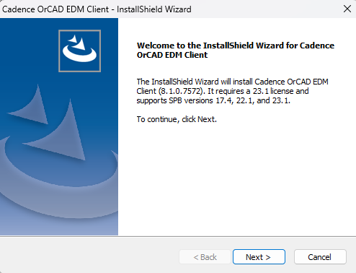
- License agreement window opens:
  - Check accept and then click Next.
  - 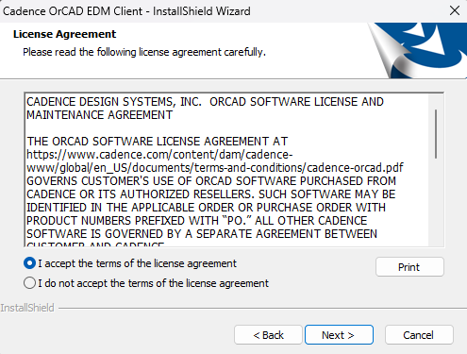
- Choose the destination folder
  - Leave it as the default destination folder then click Next.
  - 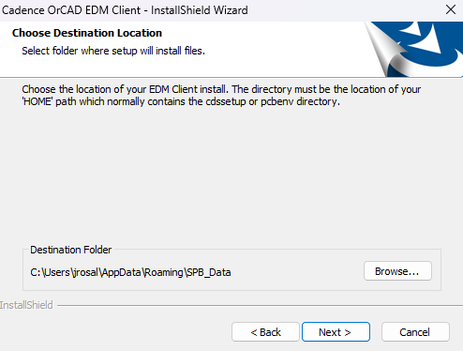
- Select Features window open.
  - Start menu and desktop shortcuts should be selected. Click Next.
  - 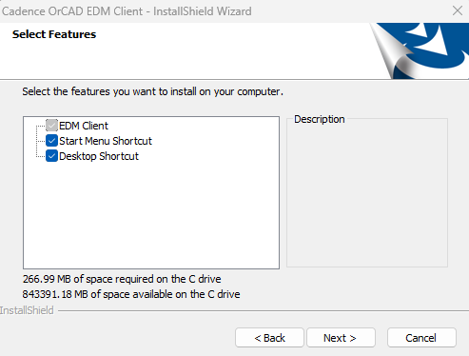
- EDM URL
  - Enter http://water2/edm
  - Click Next.
  - 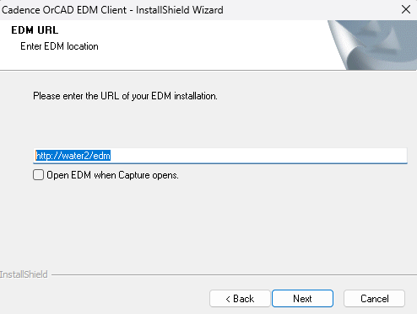
- Ready to Install
  - Click Install.
  - 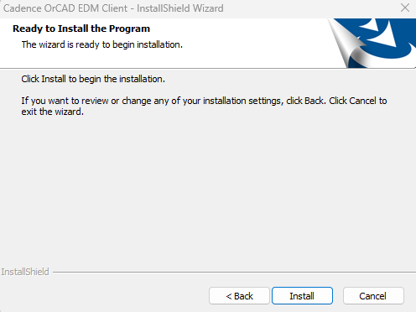
- Installation Complete.
  - Click Finish
  - 