Step-by-Step Instruction for Transferring Tapes to Hard Drive

Generating a VARS .txt File and Preparing for RUNTIME Conversion

- Open VARS Query

- Select Add to include ALL animals (nil: nil|nil|nil) and check Return basic organism phylogeny (any other parameters you need may also be selected) Then click Advanced at the top.

- The following parameters have been selected in the past, however the Bold selections are the most important for generating the videos later. (Some selections are standard, leave them “checked”)

  - Camera Direction: select the return box
  - Alternate Timecode* only needed with SD tapes, however, this timecode is an estimate. Best practice is to use QuickTime player 7 and use the “TimeCode: Non-drop-frame” option under the time pull down window if possible.
  - Video Archive Name: open the search pull down button and locate the video of interest. When you click the video, both the return AND constrain buttons will be checked. Leave them both checked.
  - Annotation Mode: May give a more accurate count of species as individual species may be counted more than once for specific annotations.

- Click Search

- IF, the video was made using Black Magic Media Express, the tape timecode will be visible if you open the file with QuickTime player 7 (using the “TimeCode: Non-drop-frame” option under the time pull down window). However, if you’d like to calculate the Runtime for later versions of QuickTime, please follow the directions below. Keep in mind, if you add logos or alter the video you may lose the embedded timecode on the video or the people you share the video with may not have QT7, so manually generating a timecode may be beneficial in the long run.

- Save the generated list in the Bin folder of Add-runtime and name it according to the archive name ex. D0231_01 (See directions for creating the ADD-runtime app).

- Open the newly created D0231_01.txt file with Excel

- The first 9 rows of information must be moved to another page or deleted. Then, the “#” symbol next to Associations must also be deleted. This information includes what you searched for in VARS and will be lost unless you save this information somewhere else.

- Sort by TapeTimeCode and in your notebook write down the timecode for “starttransect” and “end transect” (this will give you an estimate of how long the tape will be recording so you can set a timer. Not all videos will have transects. Depending on your project, transects may be the best camera direction to use).

- Save and close the Excel document.

Transcoding Video to Shareable Drive

- Submit a New Video Lab Request on the MBARI Video Lab page to obtain the desired video. In the “Problem” window, please briefly describe what the video will be used for. The video lab may be able to suggest videos that are more appropriate to use for your project.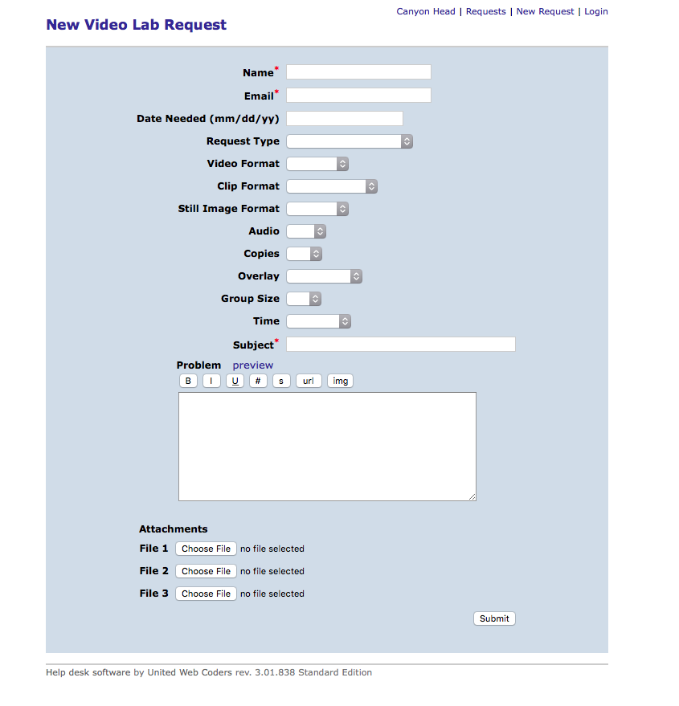
- Place desired video in the Panasonic Digital HD Video Cassette Recorder:
  - Press the Power switch to ON
  - Insert tape, centered, into the cassette slot (DO NOT force, the machine will take the cassette)
  - Be sure to rewind the tape if it has not already been done

- Open “Black Magic Media Express” under applications
  - At the top of the screen, open “media express” drop down
  - Select Preferences
  - Ensure “QuickTime Apple ProRes 422” is selected for Capture File Format. Close this window.
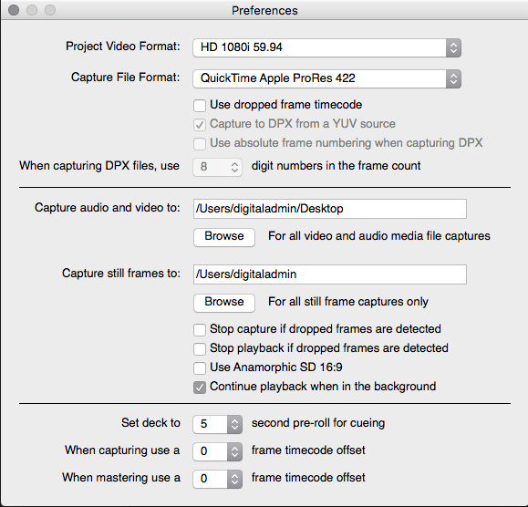
- In Media Express, select the Log and Capture tab (You may see static or a frozen image)

- On the Recorder, press the JOG button \\\
  - Using the dial, scroll through the video until the first frame without static is seen.
  - Annotate the Tape Time Code on the recorder (it should be the same as the one on Media Express)
  - Example: Digital Display will read 05:53:09:14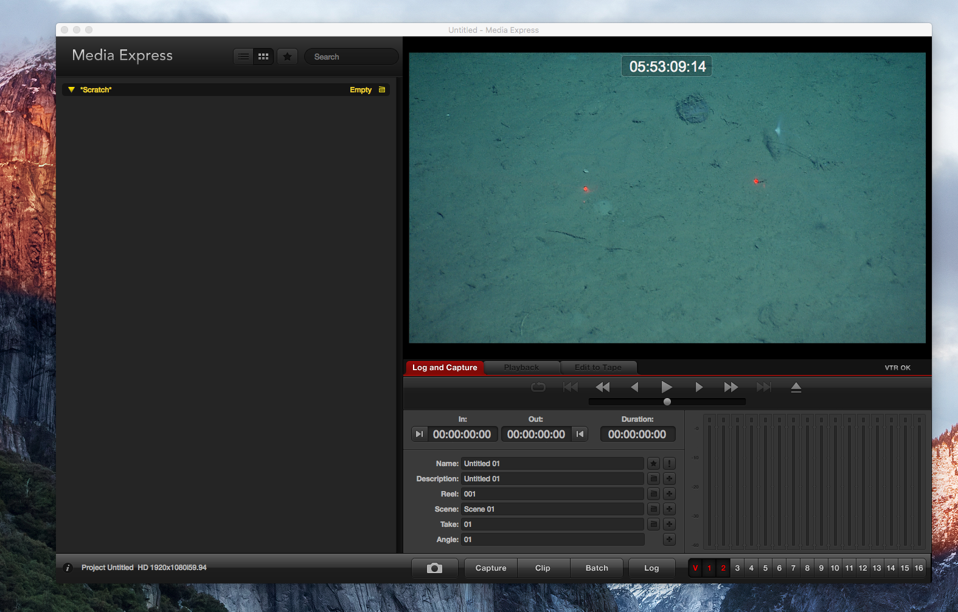
- Before continuing, be sure to deselect the 1 and 2 next to V on Black Magic Media as seen above. This will mute the audio and create a smaller file.

- IF you do not have an Untitled 01.mov already created, you press Capture on Media Express at the SAME TIME as you press the PLAY button on the recorder. You are now recording your tape onto the desktop as Untitled 01.mov. (You will rename it later)

- IF you do have an Untitled 01.mov already created that you wish to save, you will select Capture on Media Express, but Do Not press play yet. 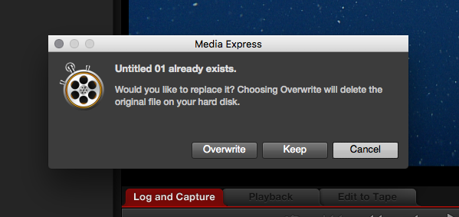 A warning will pop up stating Untitled 01 already exists and will ask if you’d like to overwrite or keep. From here you will select Keep at the SAME TIME as you press the PLAY button on the recorder. You are now recording your tape onto the desktop as Untitled 02.mov. (You will rename it later)

- You may set your alarm based on your estimate of transect length from number 9. When the tape is done, Magic Media will continue recording until you tell it to stop, it is important that you’re ready for the tape to finish.

- When the tape is finished, click Capture on Black Magic Media and the recording will stop.

- Single click the Untitled video that was just created on the left side of the window. This will generate a time In and Out. Record both of these numbers in your notebook. The time In will be your new “ZERO” time for the runtime app. If it does not automatically give you an in and out time, you may need to double click your video box which will bring you to the playback screen, but the times should then be posted. (You may also use the timecode from the start of the video in QT7)

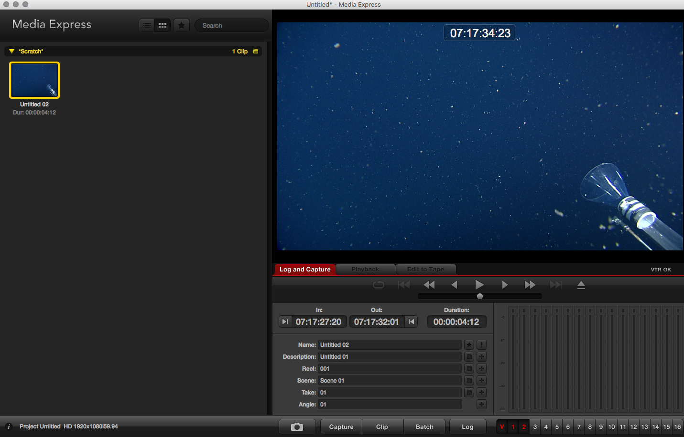

- Your new video can be found on the desktop. Rename your video on the desktop associated with the archive name. You can now save this video to a hard drive (this process takes approximately 30-45 minutes).

- If you have more videos to process, the best way to clear out media express is to close the program. It will ask if you would like to save changes to the project: Don’t Save. You can now re-open Black Magic Media and start from the beginning.

- Please rewind your videos before putting them back in the archive and delete your videos/files from the desktop after you have saved them to a removable source.

Creating Add-Runtime app and Converting TapeTimeCode

- Get the vars-queryparsing-1.2.0-SNAPSHOT.zip and name the file onto the desktop (will be referred to as Add-runtime) to use the re-index script follow these steps:
  - Save VARS query from above into Bin within the Add-runtime folder
  - Open a DOS terminal
  - cd into the bin directory of the extracted files
  - Inside bin use: ./add-runtime-app –h for special instructions
  - To convert Tape timecode into fractions of a minute use: ./add-runtime-app archive_named_file.txt HH:MM:SS:FF (“zero time” from black magic media in step 21 above OR use the timecode from QT7 to find the exact start time and frame) > NEWarchive_named_file.txt

- Example:
mbari1568:~ dhollis$ pwd
/Users/dhollis

mbari1568:~ dhollis$ cd Desktop

mbari1568:Desktop dhollis$ pwd
/Users/dhollis/Desktop

mbari1568:Desktop dhollis$ ls
231data PeniALLvideo
3 organisms list.xlsx Peniagone3types with Video.xlsx
ALLvideoArchive PeniagoneALLVideoCount.xlsx
Add-runtime PeniagoneTapes.xlsx
Additional Info 32106.xlsx Project
AllasCompared to Echinocrepsis Stepbystep.docx
AllasCompared to Echinocrepsis.xlsx TestDataEchinocrepis.xlsx
Climate ChangePeniagone.xlsx TestDataPeniagone.xlsx
D0232-01HDGoogleUPDATE.xlsx TestDataScotoplanes.xlsx
D023201HD.png Top10Videodata.xlsx
D0321-06HDUpdateGoogle.xlsx TotalOrganisms
D0673_05Tester.txt Transect
D0673_05Tester.xlsx VARS Query
First 3 videos Videos to collect.pptx
First 3 videos.xlsx ~$D0673_05Tester.xlsx
Image Collection all 3 ~$PeniagoneTapes.xlsx
Image Collection all 3.xlsx

mbari1568:Desktop dhollis$ cd Add-runtime

mbari1568:Add-runtime dhollis$ pwd
/Users/dhollis/Desktop/Add-runtime

mbari1568:Add-runtime dhollis$ ls
vars-queryparsing-1.2.0-SNAPSHOT vars-queryparsing-1.2.0-SNAPSHOT.zip

mbari1568:Add-runtime dhollis$ cd vars-queryparsing-1.2.0-SNAPSHOT

mbari1568:vars-queryparsing-1.2.0-SNAPSHOT dhollis$ pwd
/Users/dhollis/Desktop/Add-runtime/vars-queryparsing-1.2.0-SNAPSHOT

mbari1568:vars-queryparsing-1.2.0-SNAPSHOT dhollis$ ls
Makefile README.md VERSION bin lib

mbari1568:vars-queryparsing-1.2.0-SNAPSHOT dhollis$ cd bin

mbari1568:bin dhollis$ pwd
/Users/dhollis/Desktop/Add-runtime/vars-queryparsing-1.2.0-SNAPSHOT/bin

mbari1568:bin dhollis$ ls
Additional Info 32106.txt extract_distance.py
D0673_05.txt fetch-pngs-app
add-identity-ref-key-app fetch-pngs-app.bat
add-identity-ref-key-app.bat organize-substrates-app
add-runtime-app organize-substrates-app.bat
add-runtime-app.bat trim-area-measurements-app
calculate-actual-areas-app trim-area-measurements-app.bat
calculate-actual-areas-app.bat unique-annotations-app
extract-distance-app unique-annotations-app.bat
extract-distance-app.bat

mbari1568:bin dhollis$ ./add-runtime-app D0673_04.txt 03:28:03:17 > NewD0673_04.txt

- A new file will be created in the Add-runtime folder. Open this new file
- Create a new column after the RUNTIME column called Runtime_Seconds. This column will be the RUNTIME data*60 (to convert to seconds). Convert all the runtimes into seconds. Save this file.

Synching the Video with the Runtime

- Open the Video you recorded from the archive
- Open the Excel doc you made with converted runtimes
- Note the time of an animal of interest in the Excel doc and match that time with the quicktime movie you created. A good rule of thumb is to compare the time frame for 10-20 organisms.
- The video should line up with the timecodes within 1-2 seconds.
- IF the video does not seem to be lining up, you can adjust the “zero” time and repeat step 1 from above.
- Adjusting “zero” time
  - Ex. your zero time is 14:25:19:05 and the animal of interest is at Quick time video 30 seconds, but the animal does not show up until 32 seconds. You want to adjust your time code by two seconds.
  - To do this, follow step 1 from above and change your zero time to example 14:25:17:05. The organism should now pass at time 32 seconds on the quicktime video.
  - If you pass the organism too soon, you can adjust the other direction and use example 14:25:21:05 and you will pass the organism at quick time video 28 seconds.
- KEEP IN MIND: there will be some “jitter” in the quicktime/Timecode. The video lab does not I.D. organisms on a first seen basis. The only reason the video should be off by more than 3-4 seconds, is if the capture and play buttons were not synched from step 16 or 17 from the beginning steps.
- Once you have the timecode set to the best possible zero time, save the file. If there is still a large average “jitter” >2 seconds, record this “OFFSET” in your notebook.
Additional Photos
